Supplementary Material1

Topic Guide: Focus Groups

Introduction to the topic and instructions:
Hello and welcome to our focus group. Thank you for agreeing to take part. My name is…. and I’ll be facilitating the focus group today.
Before I introduce the topic in a little more detail, I just have some focus group housekeeping I would like to mention.
What we will talk about today is quite a big topic area, and everyone may have a different opinion or experiences to the questions and I am keen to hear as many of your opinions and experiences as I can.
I know I do have a set of questions to ask but we may not stick to them, if you are thinking of things as we go through that are important to you, please feel free to share them.
I am here to learn from you, I will offer questions for you to consider, and hope this will create a discussion between you all, so I encourage you to ask questions to one another.
Please can I invite and encourage everyone to be open and participate in the discussions. You may have similar or different experiences and that’s great, so I would like to hear from you.
If, at any point I ask a question you are unsure of please feel free to ask for clarification.
And then finally, everything discussed today will be treated in confidence, meaning that your name will not be used at any time to be able to identify you.
Before we start do you have any questions or concerns you’d like to raise that have occurred to you since you agreed to take part?
Our research project is concerned with helping people who want to lose weight and who are living on a tight or inconsistent budget to shop more easily for the food items they believe will help them to do that. We are also interested to understand your views about sustainability, and how or if this issue fits in when you are shopping for food.
The focus group should last up to 60 minutes, but it depends on how much or as little you feel you have to say about the things we will talk about today, we are grateful for the time you are giving and the insights you are sharing with us today. There will be time at the end when you can ask any questions you might have. We will be recording today’s discussion. so we don’t miss anything important or have to write down everything you say. If you would like to take a break at any point, you can let me know and we can continue when you are ready. Just to let you know, you will be provided with a £25 shopping voucher as a thank you for taking part.
Do you have any questions before we start?

Opening Question
Thinking about those broad questions our project is focused on:
- How would you describe your experience of shopping for food?
- Prompt: Think about a usual trip to the supermarket, how does it feel when you are shopping?
- Do you shop online as well as in-store? (or vice versa if they discuss online shopping first)
- If yes:
*How do those experiences differ?
*Which do you prefer and why?

Choice of retailer:
Next, we’d like to ask a few questions about where you typically shop:
- Where would you say you normally do the majority of your shopping?
- Prompt: What are the reasons, would you say, that means you normally shop in these places?
- If they state more than one shop/ supermarket, explore: Can you tell us a little bit more about the types of things you buy at the different stores?
- (If not covered above) What are your experiences of shopping at [supermarket/ store]?
- Prompt: What do you like about shopping at [supermarket/ store]? What do you dislike?
- Are there any places or shops that you would not use for food shopping?
- Prompt: Why do you avoid using those shops/ places?
- Have other people in the supermarket, such as supermarket staff, check-out operators, other shoppers had any influence on where you shop?
- If yes, explore: What influence have they had (i.e. shopping habits/ purchases made/ how often they attend/ length of time spent considering what to buy?)

Cost of living
- Over the past year food prices have been increasing. Have you changed how you shop because of this? If so, can you explain how?

Health/Sustainability
We realise it can be a struggle to buy healthy, good quality food and the FIO Food study is looking at ways we can help support people buy the foods they would like to so they can eat well, improve their health and reduce their weight.
- Can I ask what does healthy eating mean to you?
- Prompt: examples from the Eatwell Guide.
- Is the healthiness of the food you buy something you tend to think about when you are shopping?
- If yes: prompt
*In what way does this influence what you buy or eat?
*How do you find out information on the health of the food you buy?
*Do any supermarket communications help you in making those decisions? How? (any specific communications/supermarkets have been helpful)
- If no: prompt
*Would you like to make more healthy food purchases or meals?
If yes: What sort of changes might you like to make?
If no: Would you be willing to share your reasons for not wanting to make these changes? Do you ever notice anything in-store/online/on products about sustainability?
- When you either go to the supermarket or shop online, have you noticed any campaigns or signs that are promoting healthy eating?
- Prompt: If yes:
*What you were?
*Do you take any notice of them?
*Do you like/dislike them?
*Which supermarkets do they think does the best/worst healthy eating promotions?
The FIO Food Study is also interested in the environmental aspect of food, the sustainability or the impact of our diet on the planet. I’m not sure if this is something you have thought about before and it’s completely fine if you haven’t, but I’d like to ask a few questions on sustainability.
- When I say sustainable foods or food sustainability, what does that mean to you?
- Prompt example:
…Greenhouse gas emissions
…Land use
…Water use
…Buying local produce
- Is the environmental impact of the food you buy something you tend to think about when you are shopping?
- If yes prompt:
In what way does this influence what you buy or eat?
How do you find out information on the sustainability of the food you buy?
Do any supermarket communications help you in making those decisions? How? (probe if any specific communications/supermarkets have been helpful)
- If no prompt:
Would you like to make more environmentally sustainable food purchases or meals?
If yes: What sort of changes might you like to make?
…meals with less meat
…meat free meals
…bulking out meals with beans, peas, lentils or other veg
If no: Would you be willing to share your reasons for not wating to make these changes? Do you ever notice anything in store/online/on product about sustainability?
- When you either go the supermarket or shop online, have you noticed any campaigns or signs that are promoting healthy eating?
- If yes prompt:
*What they were?
*Do you take any notice of them?
*Do you like/dislike them?
*Which supermarkets do you think does the best/worst healthy eating promotions?

Supermarket Messaging
Thanks, your views are really useful and so we would now like to ask about some messaging that a retailer has used both in-store and online.

Aldi Price Match (provide handouts of images)
A supermarket recently had an Aldi Price Match campaign where they added new healthy and better-for-you products to the campaign to create a ‘balanced’ basket accompanied by messaging and recipes on balanced diets, with over 150 products that were price matched to the discount supermarket Aldi.
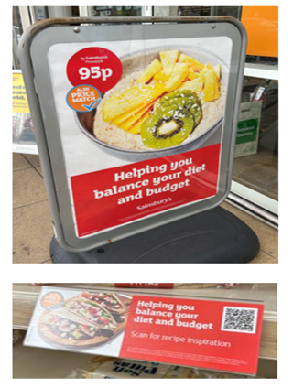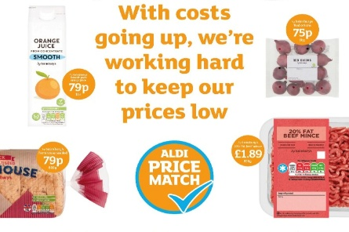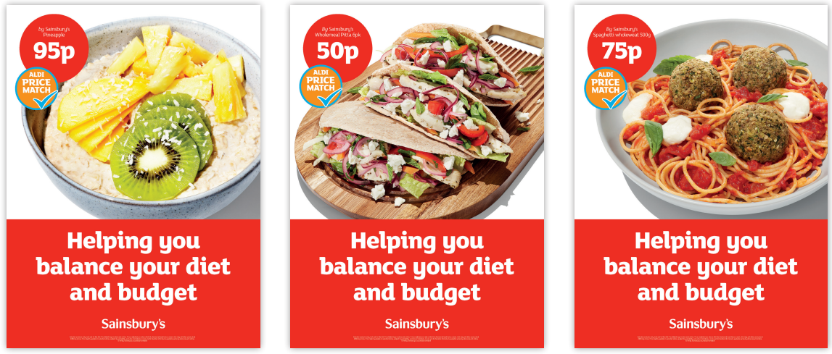
- Has anyone seen any of these adverts before?
- If yes, where? Prompt: in store, press release, direct mail, email, supermarket website?
- What do you think this advert is trying to tell you? Prompt: affordability, healthy eating?
- How do you feel about this advert?
- If you see pictures like this, does it make you want to change how you shop? And the foods you buy?
If yes, how, why? Prompt: If you usually shop at a discount store, does the messaging mean you would shop at this supermarket as the foods would cost the same?
If no, why not? what would, if anything?
- Do you think there could be a better way to present this messaging that would help you make healthier food choices?
- Prompt: Have you seen anything from other brands/retailers?

Sustainable Campaign (provide handouts of images)
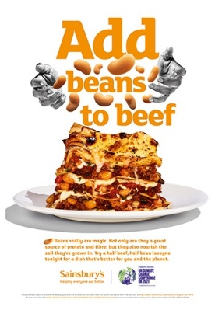
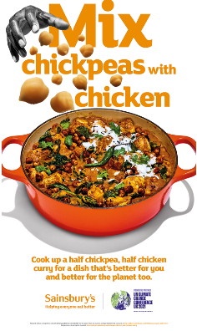
In the autumn a supermarket campaign aimed to show how mixing half pulses with half meat in well-loved recipes like curries, lasagnes, and casseroles can help us to eat better, one plate at a time.
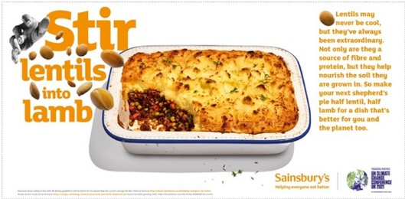
- Has anyone seen any of these adverts before?
- If yes, where? Prompt: in store, press release, TV, radio, supermarket website
- What do you think this advert is trying to tell you? Prompt: affordability, healthy eating, sustainable eating, lower cost?
- How do you feel about this advert?
- Would it make you change where and how you shop?
- If no, what would, if anything?
- Do you think there could be a better way to present this messaging that would help you consider the planet when you are food shopping? Prompt: Have you seen anything from other brands/retailers?
- If you see pictures like this, does it make you want to change how you shop? And the foods you buy?
- If yes, how, why?
- If no, why not?

Overall
- Do you think the supermarkets could do anything to make buying healthier food easier?
- If yes: What could they do?
- Do you think the supermarkets could do anything to make buying environmentally sustainable food easier?
- If yes: What could they do?

Concluding the session:
That’s all the questions I have today. Is there anything else anybody would like to add?
Do you have any other questions before we finish? Your contribution today is appreciated, and we would like to take this opportunity to thank you for taking part.

