Supplemental Data

Prediction of tumour hypoxia status from the washout of positron emitters in beam-monitoring PET: carbon-ion irradiation to tumour rat models

Chie Toramatsu¹⁾, Hidekatsu Wakizaka¹⁾, Hideaki Tashima¹⁾, Hitomi Sudo¹⁾, Go Akamatsu¹⁾, Taiyo Ishikawa^{1), 2)}, Han Gyu Kang¹⁾, Chie Seki¹⁾, Iwao Kanno¹⁾ and Taiga Yamaya^{1), 2)}
¹ National Institutes for Quantum Science and Technology, 4-9-1, Anagawa, Inage-ku, Chiba-shi, Chiba, Japan
² Chiba University, 1-33, Yayoicho, Inage-ku, Chiba-shi, Chiba, 263-8522 Japan

Corresponding author: Chie Toramatsu
National Institutes for Quantum Science and Technology, 4-9-1, Anagawa, Inage-ku, Chiba-shi, Chiba, Japan, Tel: +81-43-206-3260; Fax: +81-43-206-0819; e-mail: toramatsu.chie@qst.go.jp

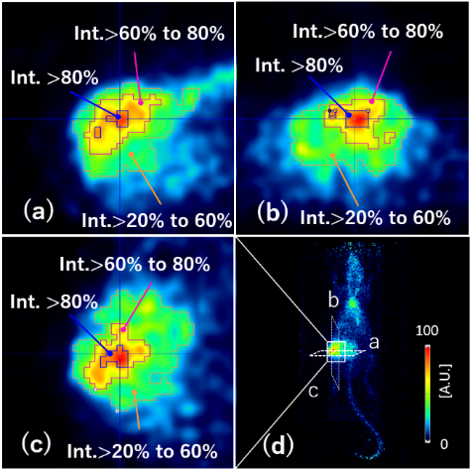
SUPPLEMENTAL FIG. 1 Three segmented areas according to the intensity. Enlarged tumour images of the (a) Axial, (b) sagittal, and (c) coronal slices. (d) The original tumour image.

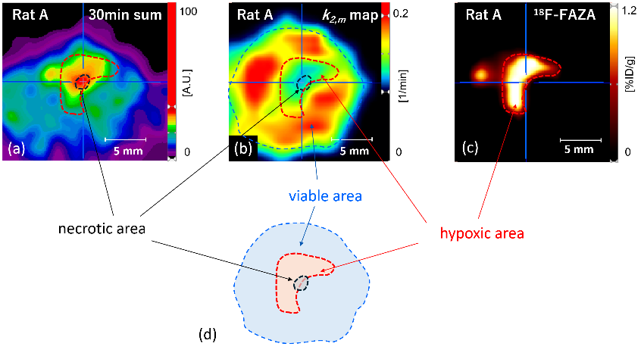
SUPPLEMENTAL FIG. 2 Heterogenous structure of the tumour for Rat-A. (a) Enlarged tumour image and (b) the k_{2,m}-map, obtained with the beam-monitoring PET experiment. (c) Enlarged tumour image obtained with the hypoxia ¹⁸F-FAZA PET experiment. (d) Estimated tumour structure.
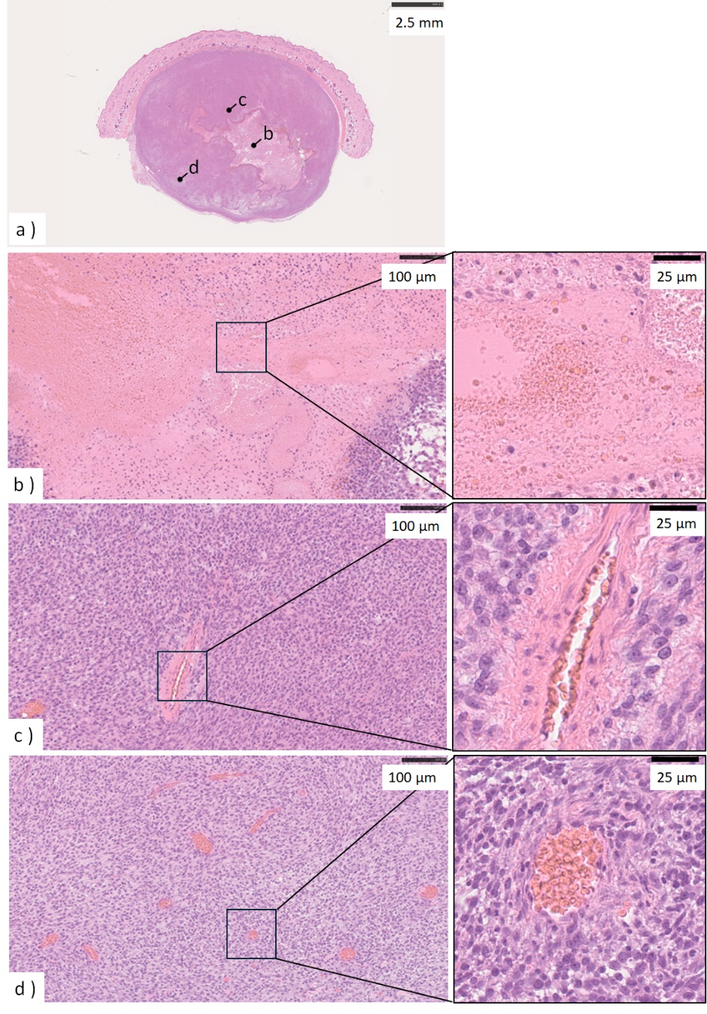
SUPPLEMENTAL FIG. 3 Tumour tissue section (H&E-staining) for Rat-A. (a) The axial slice of the central part of the tumour. (b, c, and d) Enlarged images at point-b, point-c, and point-d, in (a), respectively.

