Supplementary
Figure 1: Comparison of the traditional stroke care model and the Stroke Life Support Central Health Alliance, Registry & Technology Enabled caRe (SLS CHARTER) model
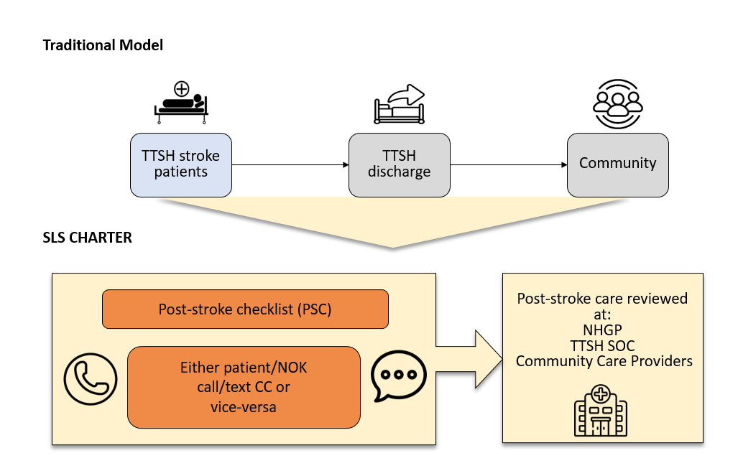
Table 1. Sub-acute rehabilitation institutions examined in the study.
List of sub-acute rehabilitation institutions | Description
Tan Tock Seng Hospital (TTSH) Rehabilitation | Enables TTSH patients to achieve a maximum level of independence and facilitate community reintegration
Ang Mo Kio Community Hospital | Has a close partnership with TTSH; Care is primarily focused on providing rehabilitative and sub-acute care for elderly patients at an affordable price
Ren Ci Community Hospital | Connected to and collaborates strongly with neighbouring TTSH; Provides patients with a smooth transition from medical dependence to functional independence
Integrated Care Hub Rehabilitation | Launched by TTSH; Provides inpatient rehabilitation services with upgraded facilities and technology, that will enable closer coordination of care and patient transfers, ultimately allowing for a faster transition back to the community

Table 2. Specialist Outpatient Centres examined in the study.
List of Tan Tock Seng Hospital (TTSH) Specialist Outpatient Centres
TTSH Physiotherapy (PT)
TTSH Occupational Therapy (OT)
TTSH Speech Therapy (ST)
TTSH Home-based PT
TTSH Home-based OT
TTSH Home-based ST
TTSH Home-based Psychology
TTSH Home-based Nursing
TTSH Home-based Medical Social Worker (MSW)
TTSH Home-based Case Management
TTSH Neurology (NL)
TTSH NL Radiology
TTSH Neurosurgery (NS)
TTSH Rehab
TTSH Psychiatry
TTSH Consultation-Liaison Interventions for the Mind and Brain (CLIMB)
Table 3. Day care centre providers examined in the study.
List of community service providers
Ang Mo Kio Thye Hua Kwan Hospital Day Rehabilitation Centre Physiotherapy/Occupational Therapy
Handicaps Welfare Association Physiotherapy/Occupational Therapy
Kwong Wai Shiu Hospital Physiotherapy/Occupational Therapy
National Trade Union Congress Health Physiotherapy/Occupational Therapy
Ren Ci Day Rehabilitation Centre Physiotherapy/Occupational Therapy
St Luke’s ElderCare Physiotherapy/Occupational Therapy
Society for the Physically Disabled Physiotherapy/Occupational Therapy
Sunlove Physiotherapy/Occupational Therapy
Abilities Beyond Limitations and Expectations Physiotherapy/Occupational Therapy
Asian Women’s Welfare Association Physiotherapy/Occupational Therapy
St Hilda’s Physiotherapy/Occupational Therapy

Table 4. Baseline characteristics of SLS patients who used and did not use Post Stroke Checklist (PSC).
Characteristics | Did not use PSC  (n=13) | Used PSC  (n=193) |  | p-value
Age – Mean (SD) | 71.9 (11.0) | 62.4 (11.7) |  | 0.0048
Gender – n (%) |  |  |  | 0.636
Female | 4 (30.8) | 72 (37.3)
Male | 9 (69.2) | 121 (62.7)
Marital status – n (%) |  |  |  | 0.031
Single | 0 (0.0) | 27 (14.1)
Married | 8 (61.5) | 135 (70.3)
Divorced | 1 (7.7) | 15 (7.8)
Widowed | 4 (30.8) | 15 (7.8)
Living arrangement – n (%) |  |  | 0.001
Alone | 0 (0.0) | 19 (9.8)
Spouse | 5 (38.5) | 36 (18.7)
Spouse and/or children | 7 (53.9) | 104 (53.9)
Other family members | 0 (0.0) | 24 (12.4)
Unrelated caregiver | 1 (7.7) | 0 (0.0)
Others | 0 (0.0) | 10 (5.2)
Premorbid (MRS) – n (%) |  |  |  | 0.170
No symptoms | 11 (84.6) | 185 (95.9)
No significant disability | 2 (15.4) | 8 (3.9)
Slight disability | 0 (0.0) | 1 (0.5)
Moderate disability | 0 (0.0) | 1 (0.5)
Moderate to severe disability | 0 (0.0) | 0 (0.0)
Severe disability | 0 (0.0) | 0 (0.0)
Highest education level – n (%) |  |  |  | 0.211
No formal education | 4 (30.8) | 23 (11.9)
Primary | 3 (23.1) | 55 (28.5)
Secondary | 3 (23.1) | 62 (32.1)
Diploma/Degree | 1 (7.7) | 43 (22.3)
Postgraduate | 1 (7.7) | 5 (2.6)
Pre-University/NITEC | 1 (7.7) | 5 (2.6)
Premorbid caregiver status – n (%) |  |  |  | 0.001
Independent | 11 (84.6) | 191 (99.0)
Family (informal) caregiver | 1 (7.7) | 1 (0.5)
Formal caregiver | 1 (7.7) | 1 (0.5)

