Supplementary Figure 1
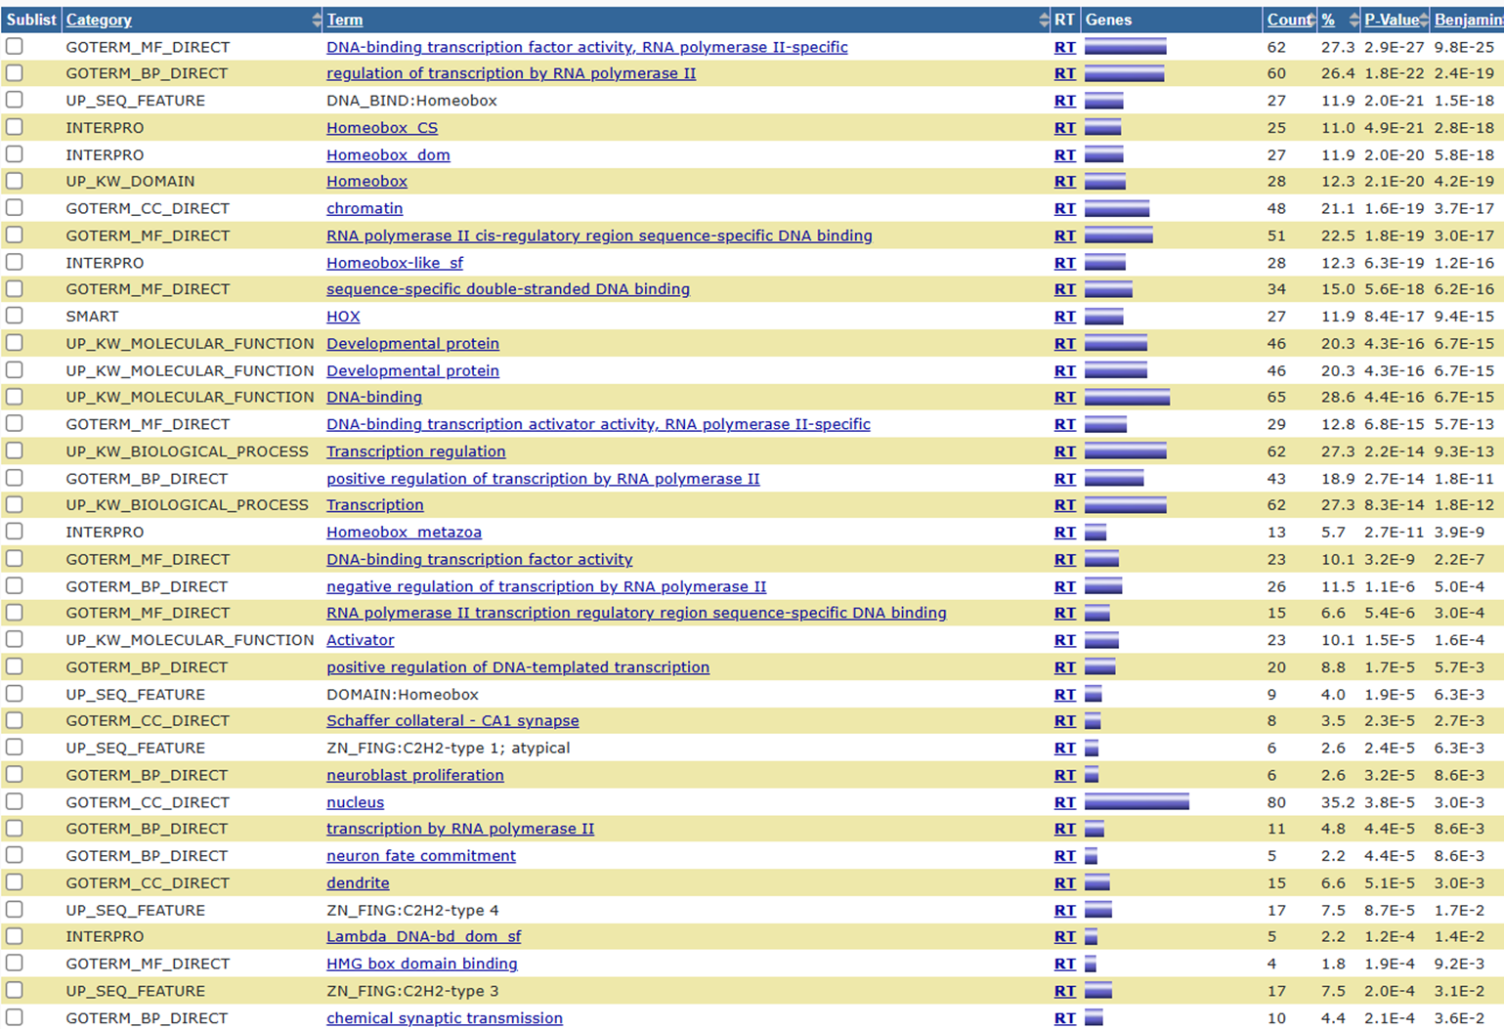
Supplementary Figure 1: Go analysis of 300 top-ranking DMPs according to their Molecular Function (MF), Biological Process (BP), and Cellular Compartment (CC), the gene counts that participate in each category, and statistical significance of gene enrichment in each category.
Abbreviations: GO: Gene Ontology

Supplementary Figure 2
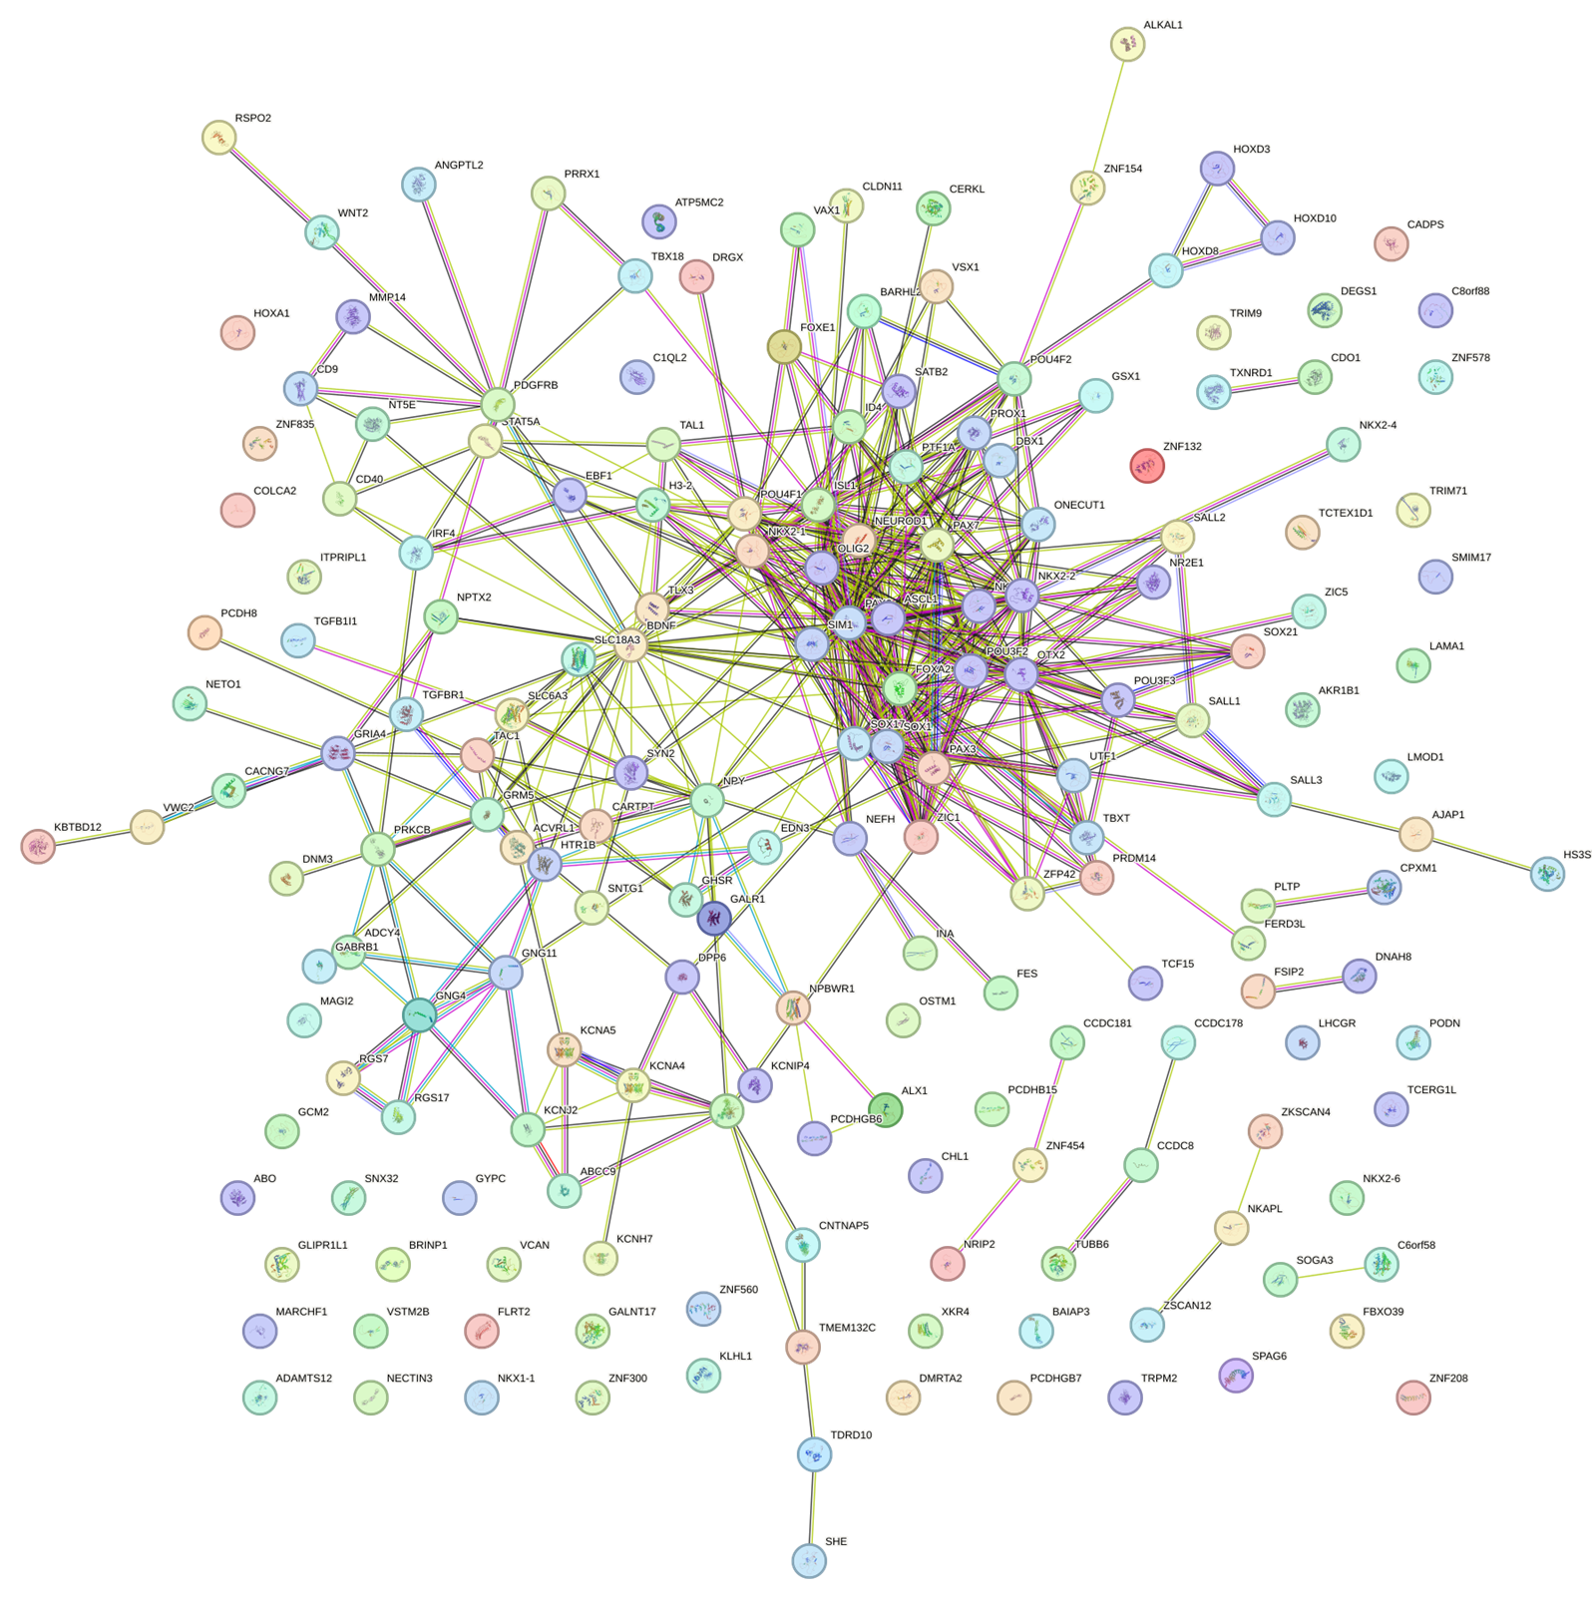

Supplementary Figure 2: PPI network of the 300 DMPs showing statistically significant interactions
Abbreviation: PPI: Protein-Protein Interactions

Supplementary Figure 3
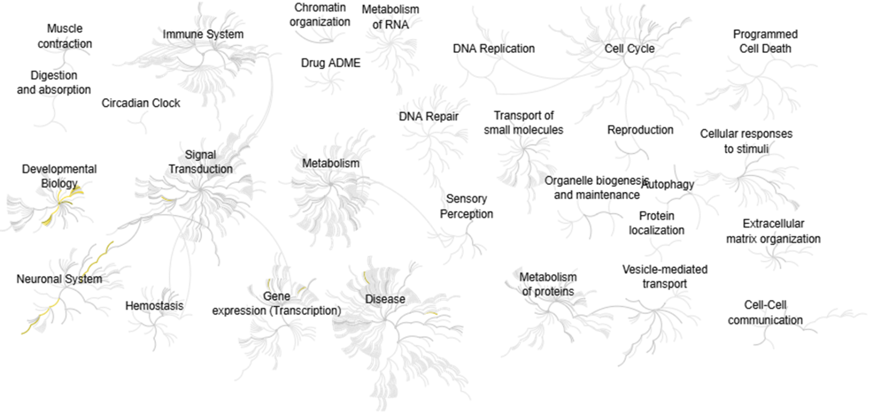
Supplementary Figure 3: REACTOME pathway analysis of the 300 DMPs showing significant enrichment in pathways with yellow highlighting

Supplementary Figure 4
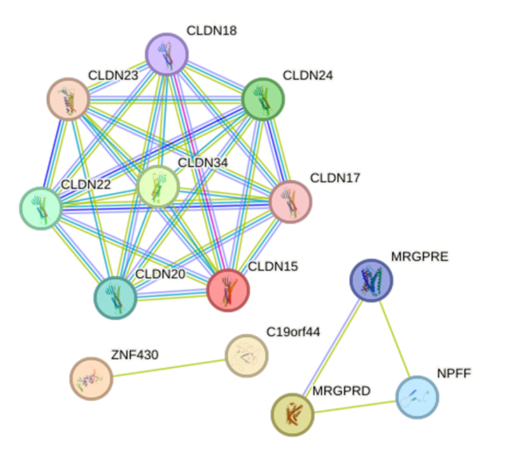
Supplementary Figure 4: PPI network of the identified biomarkers with their neighboring genes g statistically significant interactions

Supplementary Figure 5 Α 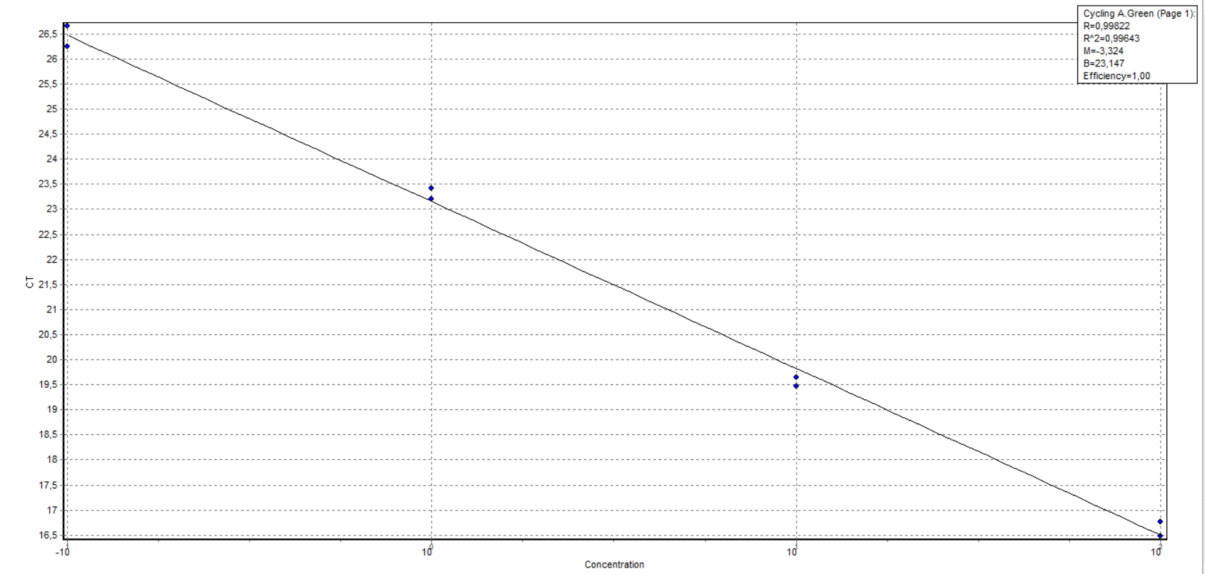
B
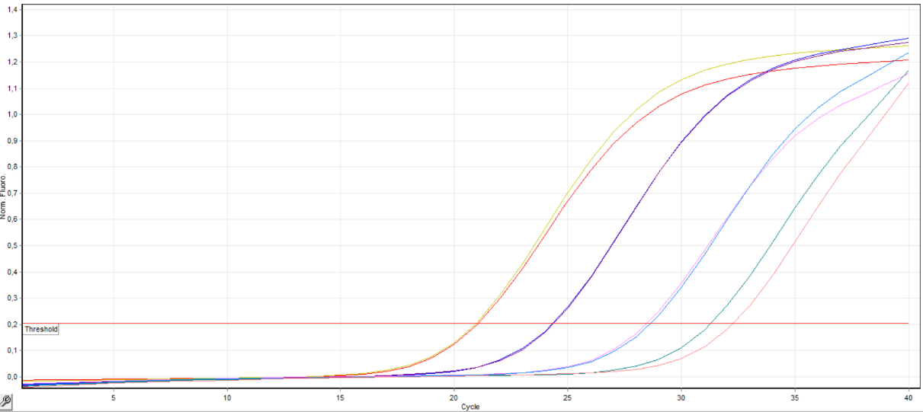
C
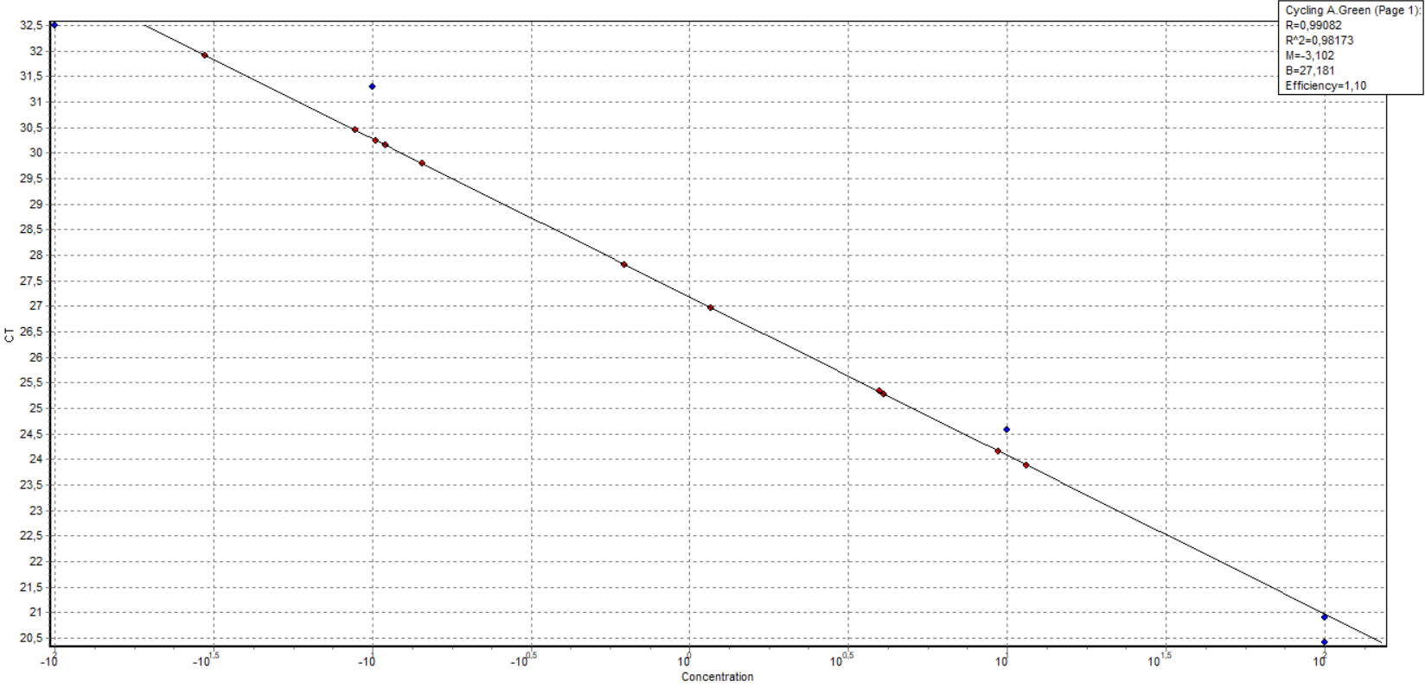
D
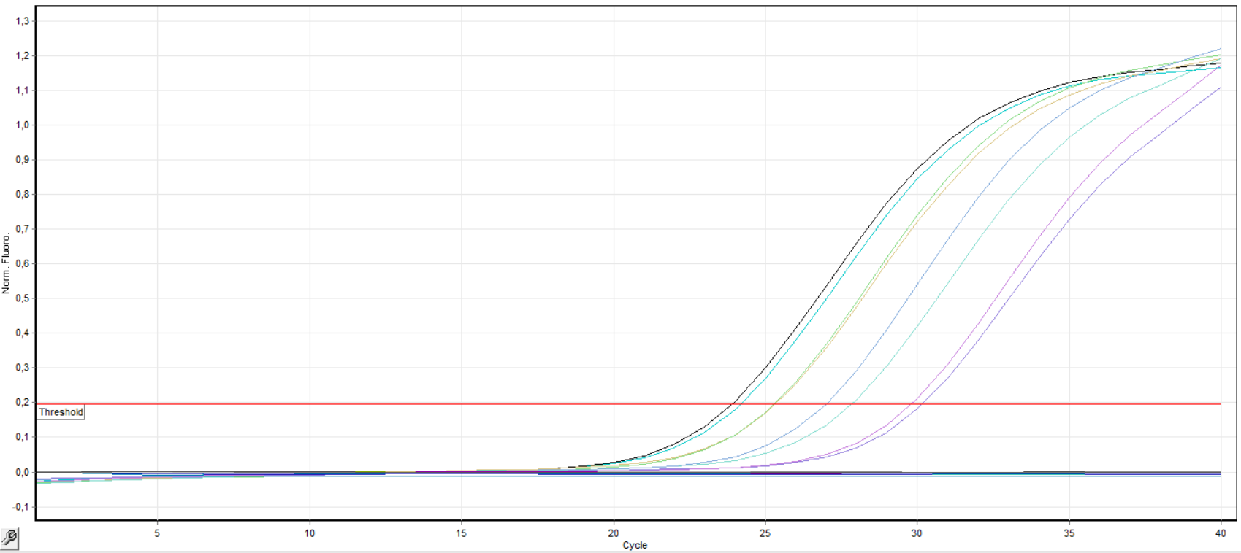

E
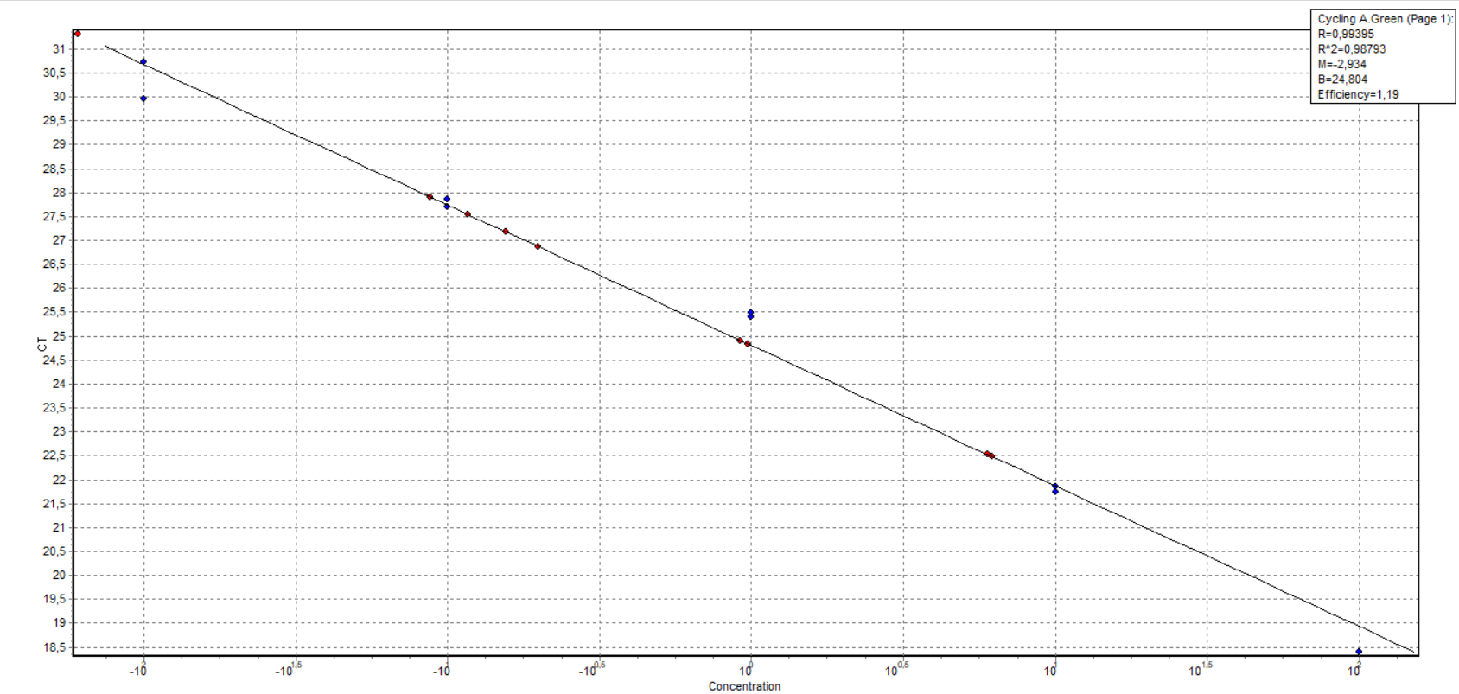
F
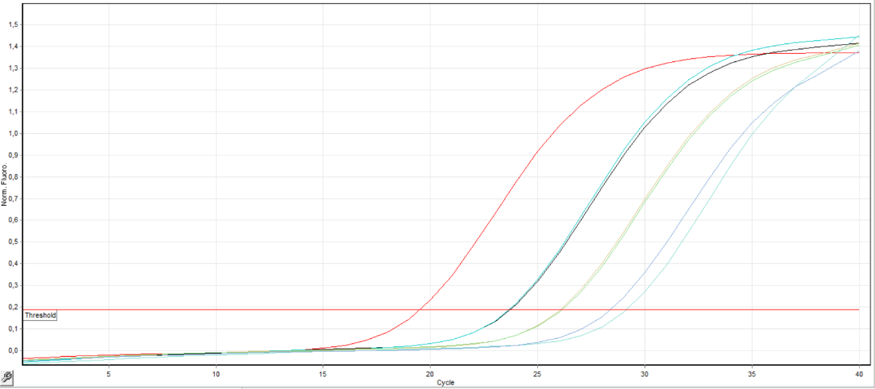
Supplementary Figure 5: Efficiency of qMSP assays using serial dilutions of SB-converted methylated DNA standards in H₂O (100–0.01 ng) that could detect even the 0.01ng methylated DNA for A) MRGPRD, C) CLDN15, E) ZNF430 and sensitivity of assays using a mix of methylated and nonmethylated DNA standards (100%, 50%, 10%, 1%, 0%) that could detect the 1% of methylated alleles among 99% of unmethylated alleles for B) MRGPRD, D)CLDN15, F)ZNF430

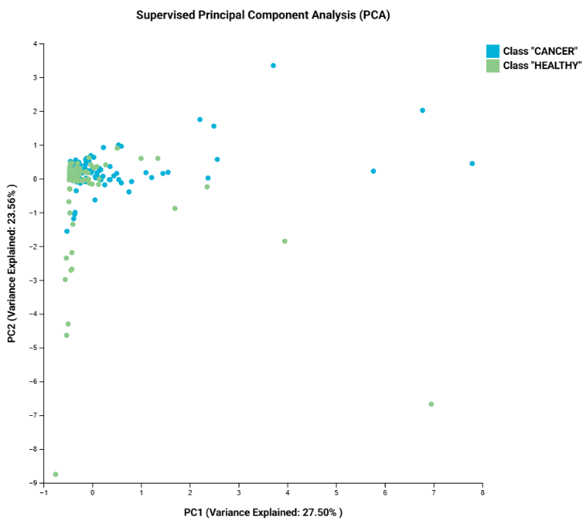
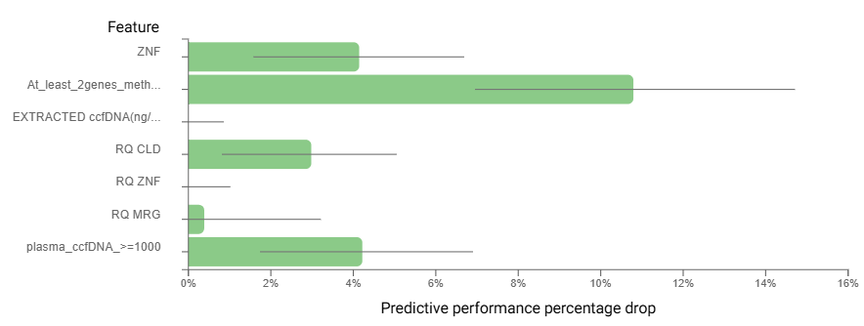
Supplementary Figure 6
A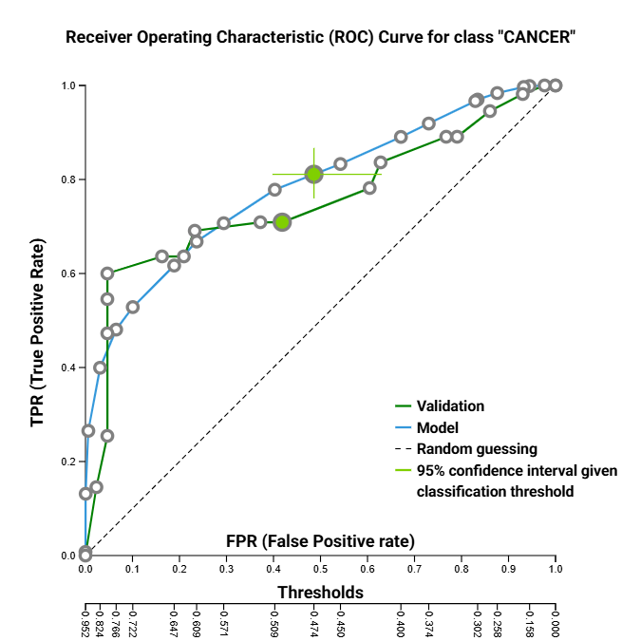
B
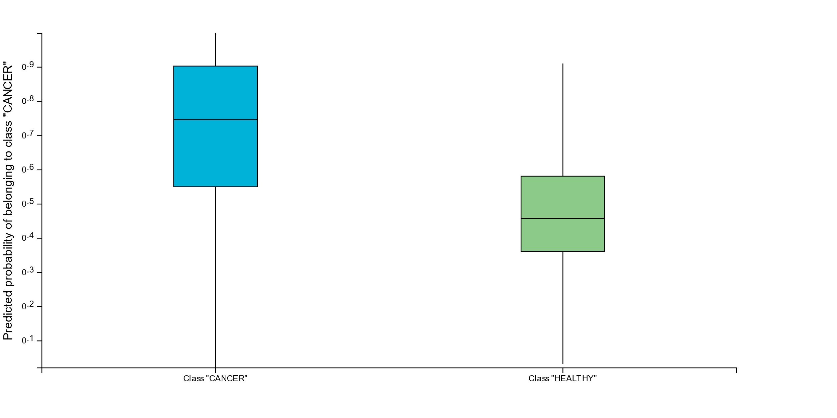
F
D
C

Supplementary Figure 6: BrCa-specific diagnostic biosignature between healthy and BrCa women in the training and validation group. (A)Feature Importance plot in the training group, (B)PCA plot shows the separation between BrCa patients (blue) and healthy individuals (green), (C) ROC curve of the model in the training group (blue) and the validation (green) (D) (B) Predicted Probability Box plot among BrCa patients (blue) and healthy individuals(green).
Abbreviations: ROC: Receiver Operating Characteristic; PCA: Principal Component Analysis
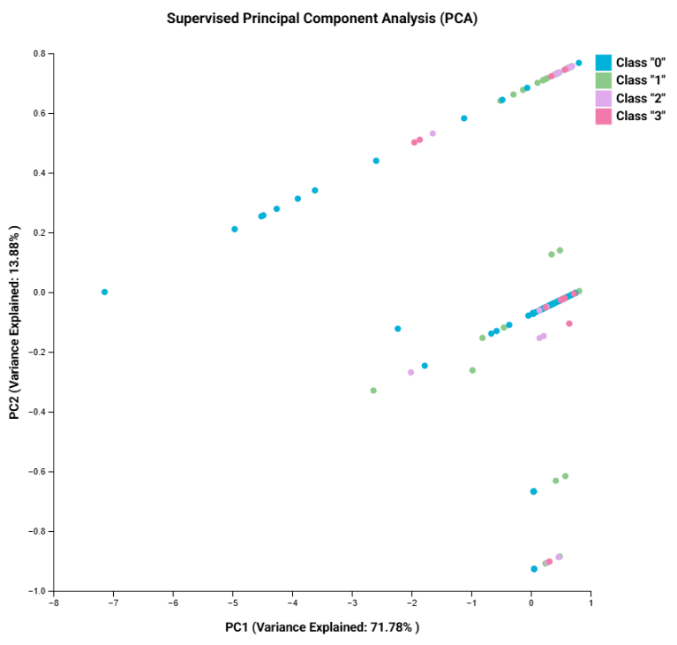
Supplementary Figure 7
B
A
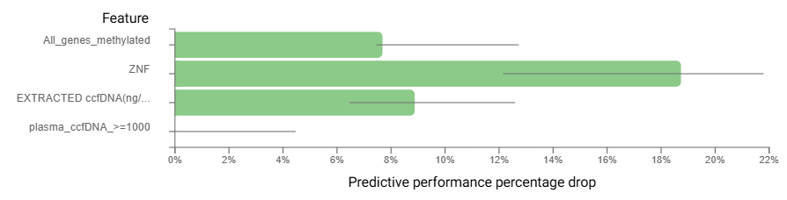

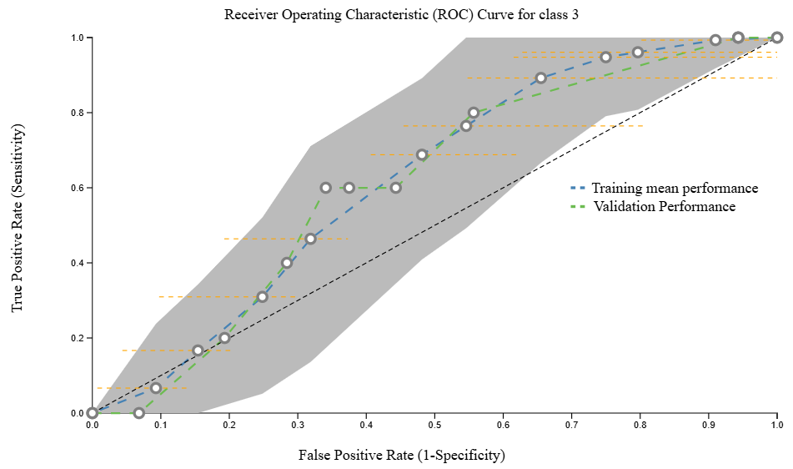
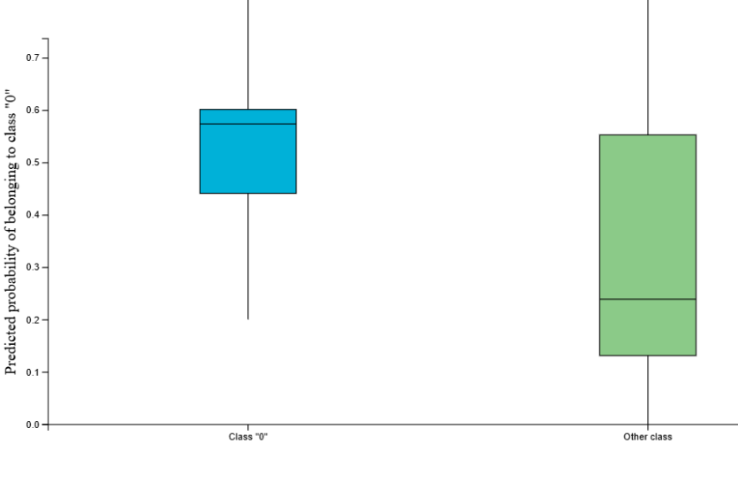
D
C
Supplementary Figure 7: BrCa-specific diagnostic biosignature between healthy, Adjuvant, Metastatic and Neoadjuvant group in the training and validation group. (A)Feature Importance plot of the model in the training group, (B)PCA plot between classes, (C) ROC curve of the model in the training group (blue) and in validation group (green) (D) Box-plot predicted probability between Healthy (blue) and all BrCa groups(green).
Class 0: Healthy, Class 1: Adjuvant, Class 2: Metastatic, Class 3: Neo-adjuvant
Abbreviations: ROC: Receiver Operating Characteristic; PCA: Principal Component Analysis; TPR: True Positive Rate; FPR: False Positive Rate

Supplementary Figure 8
A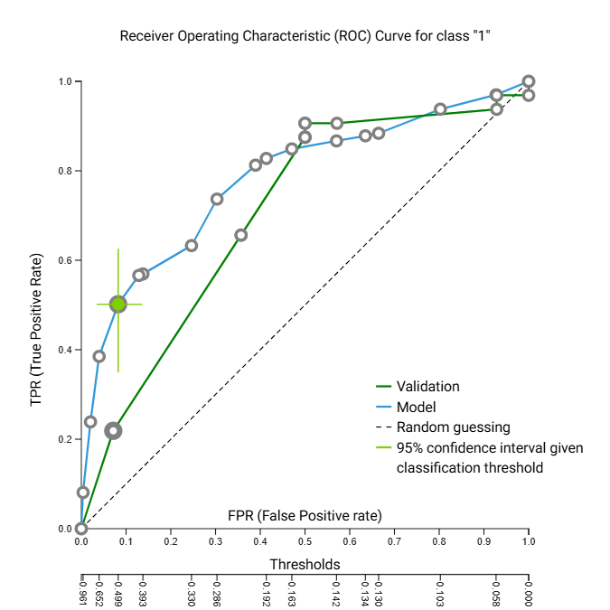
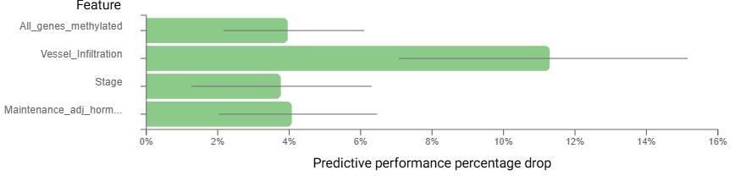

B
C
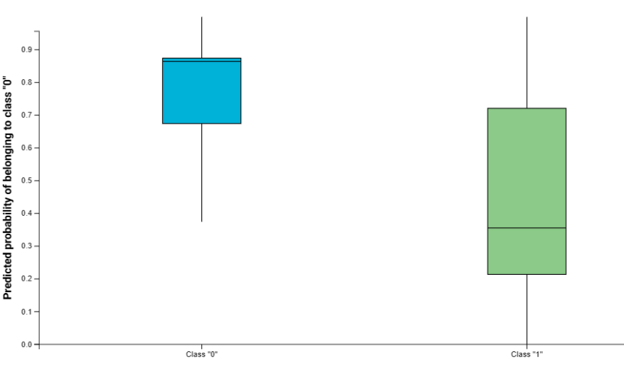
Supplementary Figure 8: BrCa-specific prognostic biosignature predicting relapse in the training and validation group. (A)Feature Importance plot of the model in the training group (B) ROC curve of the model in the training and validation group, (C) Box-plot predicted probability between those patients who relapsed (class 1) and those who did not relapse (class 0) Abbreviations: ROC: Receiver Operating Characteristic

Supplementary Figure 9
B
A
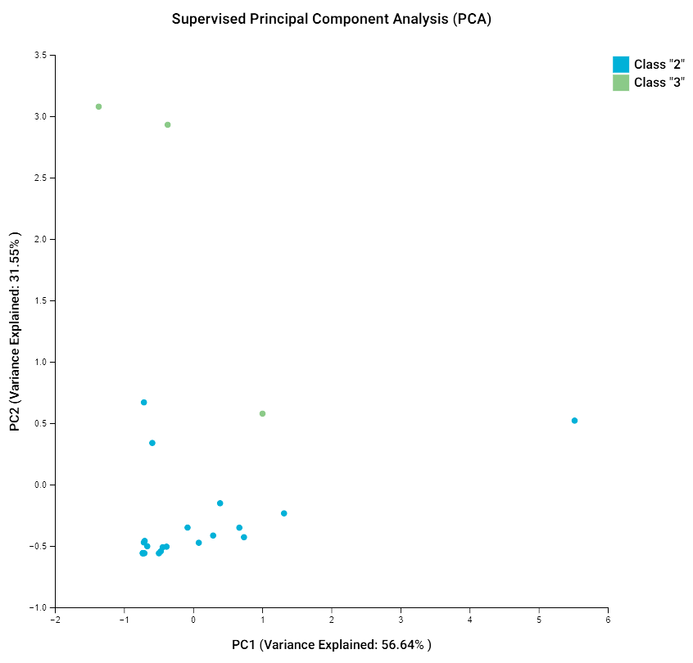
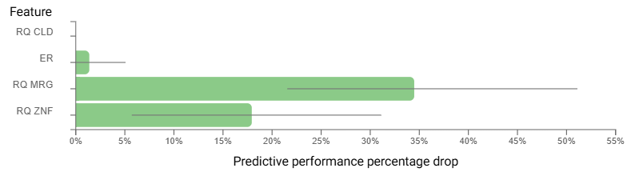
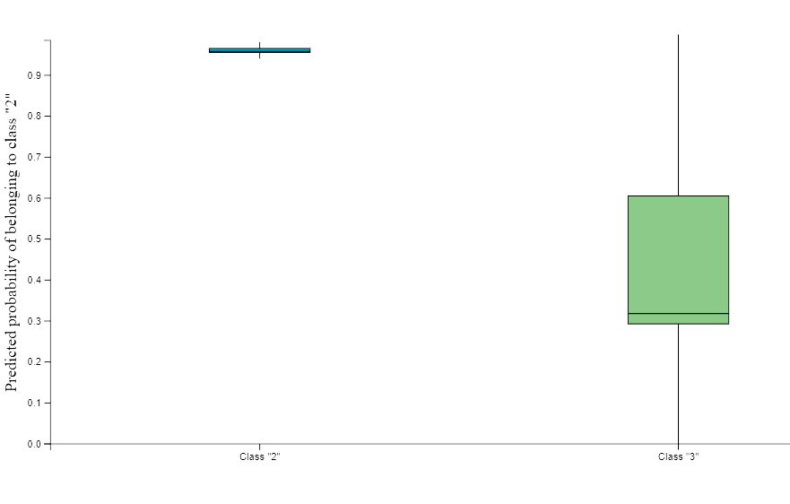
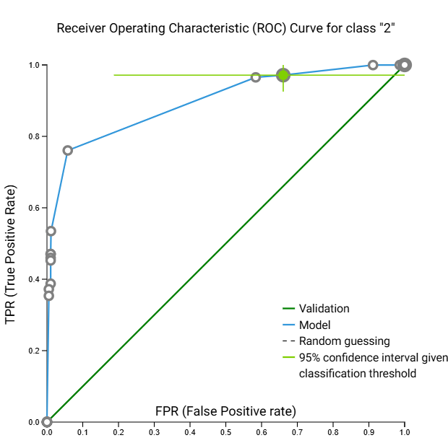
F Supplementary Figure 9: BrCa-specific predictive biosignature of progressive disease in the training and validation group. (A)Feature Importance plot of the model in the training group (B)PCA plot (C)ROC Curve of the I model in the training and validation group (D) Box-plot predicted probability. Class 2: No PD, Class 3: PD
AbAbreviations: ROC: Receiver Operating Characteristic; PCA: Principal Component Analysis
D
C

