SUPPLEMENTARY MATERIAL

Enhanced Risk Stratification of Smoldering Multiple Myeloma with Dynamic Biomarkers: A Multinational, Multicenter Study including 2,270 Participants (PANGEA 2.0)

Authors
Floris Chabrun^{*,1,2,3}, Daniel Schwartz^{*,4}, Susanna Gentile^{*,4,5}, Elias K Mai^{*,6}, Tulika R Gupta⁴, Jacqueline Perry¹, David M Cordas dos Santos^{1,2}, Thomas Hielscher⁷, Annika Werly⁶, Sophia K Schmidt⁶, Foteini Theodorakakou⁸, Despina Fotiou⁸, Christine Ivy Liacos⁸, Nikolaos Kanellias⁸, Noelia Collado Gisbert⁹, Esperanza Martin-Sanchez⁹, Rosalinda Termini⁹, Johannes Waldschmidt¹⁰, Selina J Chavda¹¹, Louise Ainley¹¹, Matteo Claudio Da Vià¹², Claudio de Magistris¹², Loredana Pettine¹², Michael A Timonian^{1,2}, Jean-Baptiste Alberge^{1,2,13}, Vidhi Patel¹, Patrick Costello¹, Catherine Tobia¹, Sally Phan¹, Jennifer Lamb¹, Maria-Theresa Silverio¹, Maya Davis¹, Elizabeth K O’Donnell^{1,2}, Catherine R Marinac^{1,2}, Omar Nadeem^{1,2}, Niccolo Bolli^{12,14}, Kwee Yong¹¹, Martin Kortüm¹⁰, Hermann Einsele¹⁰, María-Victoria Mateos¹⁵, Shaji Kumar¹⁶, Jesus San Miguel⁹, Bruno Paiva⁹, Efstathios Kastritis⁸, Meletios A Dimopoulos^{8,17}, Marc S Raab⁶, Lorenzo Trippa⁺⁴, Irene M Ghobrial^{+,1,2}

Table of contents

Supplementary Tables 3
Supplementary Table S1 3
Supplementary Table S2 4
Supplementary Table S3 5
Supplementary Table S4 6
Supplementary Table S5 7
Supplementary Table S6 8
Supplementary Table S7 9
Supplementary Table S8 10
Supplementary Table S9 11
Supplementary Table S10 12
Supplementary Table S11 13
Supplementary Figures 14
Supplementary Figure S1 14
Supplementary Figure S2 15
Supplementary Figure S3 16
Supplementary Figure S4 17
Supplementary Figure S5 18
Supplementary Figure S6 19

 | Training Cohort | Validation Cohort 1 | Validation Cohort 2 | Validation Cohort 3 | Validation Cohort 4
Hgb (g/dL) | 13.2  (12.2 – 14.2) | 12.8  (11.8 – 13.7) | 13.6  (12.6 – 14.6) | 13.1  (12.0 – 14.1) | 13.1  (12.1 – 14.0)
M-protein (g/dL) | 1.2  (0.6 – 1.8) | 1.3  (0.8 – 2.0) | 1.5  (1.0 – 2.2) | 1.9  (1.4 – 2.5) | 1.9  (1.5 – 2.4)
FLC ratio | 5.8  (2.2 – 16.1) | 3.7  (1.5 – 10.9) | 5.5  (2.3 – 15.2) | 9.0  (3.2 – 21.1) | 8.0  (4.3 – 23.6)
Creatinine (mg/dL) | 0.9  (0.8 – 1.1) | 0.8  (0.6 – 1.0) | 0.8  (0.7 – 1.0) | 0.9  (0.7 – 1.1) | 0.9  (0.8 – 1.0)
BMPC (%) | 15  (10 – 20) | 15  (12 – 20) | 18  (14 – 24) | 13  (10 – 18) | 18  (12 – 25)

Supplementary Table S1: Distribution of biomarkers at baseline, median (IQR).

 | Training Cohort | Validation Cohort 1 | Validation Cohort 2 | Validation Cohort 3 | Validation Cohort 4
Hgb Traj.  % of patients  % of visits  HR (95% CI) | 13.7  3.4  3.21  (1.98 – 5.22) | 26.6  4.8  1.99  (0.98 – 4.02) | 20.1  4.8  1.92  (1.02 – 3.64) | 10.0  4.0  3.47  (0.46 – 26.01) | 20.0  3.1  2.09  (0.18 – 25.03)
M-Protein Traj.  % of patients  % of visits  HR (95% CI) | 46.1  21.2  1.72  (1.20 – 2.47) | 45.0  8.6  2.74  (1.65 – 4.54) | 46.7  24.9  1.96  (1.18 – 2.94) | 35.4  19.8  3.06  (0.93 – 11.35) | 72.7  35.1  4.17  (0.81 – 21.40)
sFLC ratio Traj.  % of patients  % of visits  HR (95% CI) | 9.3  2.9  2.02  (1.23 – 3.31) | 35.9  6.2  2.23  (1.22 – 4.07) | 12.7  5.1  1.85  (1.04 – 3.27) | 10.0  5.7  3.13  (0.65 – 15.06) | 27.3  11.0  1.59  (0.23 – 10.90)
Creatinine Traj.  % of patients  % of visits  HR (95% CI) | 16.3  4.2  1.94  (1.13 – 3.32) | 28.4  7.7  1.18  (0.60 – 2.30) | 13.9  3.0  1.32  (0.46 – 3.79) | 10.0  3.9  N/A  N/A | 27.3  4.4  1.25  (0.12 – 13.35)

Supplementary Table S2: Frequency and hazard ratio of the biomarker trajectory variables in each cohort. We show the percentage of patients who ever have a changing trajectory for each biomarker, as well as the percentage of patient visits (across all patients) at which there is a changing trajectory for each biomarker. Hazard ratios (HR) are calculated by re-estimating the PANGEA 2.0 BM model (Cox model with the same predictor variables) in each cohort’s dataset. N/A: HR estimate (and associated CI) did not converge due to small sample sizes.

 | Hazard Ratio (95% CI)  BM Model | Hazard Ratio (95% CI)  No BM Model
M-Protein | 1.34 (1.13 – 1.59) | 1.53 (1.32 – 1.77)
FLC Ratio (log) | 1.41 (1.23 – 1.62) | 1.55 (1.35 – 1.76)
Creatinine (log) | 1.54 (1.03 – 2.31) | 1.42 (0.97 – 2.08)
Age | 1.03 (1.01 – 1.04) | 1.03 (1.01 – 1.04)
BMPC% | 1.05 (1.04 – 1.06) | -
M-Protein Trajectory | 1.72 (1.20 – 2.47) | 1.98 (1.41 – 2.78)
FLC Ratio Trajectory | 2.02 (1.23 – 3.31) | 2.30 (1.42 – 3.70)
Creatinine Trajectory | 1.94 (1.13 – 3.32) | 2.01 (1.21 – 3.56)
Hemoglobin Trajectory | 3.21 (1.98 – 5.22) | 3.36 (2.10 – 5.39)

Supplementary Table S3: Hazard ratios and 95% confidence intervals for the PANGEA 2.0 Cox models (with and without BMPC%).

 | Pangea 2.0  BM | Pangea 2.0  No BM | Pangea 2.0  BM  (No history) | Pangea 2.0  No BM  (No history) | Rolling 20/2/20
Validation Cohort 1 | 0.839  (0.795-0.882) | 0.830  (0.786-0.873) | 0.821  (0.776-0.867) | 0.813  (0.768-0.857) | 0.761  (0.722-0.8)
Validation Cohort 2 | 0.844  (0.811-0.877) | 0.832  (0.796-0.868) | 0.829  (0.793-0.865) | 0.822  (0.784-0.860) | 0.775  (0.738-0.812)
Validation Cohort 3 | 0.788  (0.701-0.876) | 0.786  (0.726-0.846) | 0.783  (0.695-0.871) | 0.764  (0.700-0.829) | 0.711  (0.646-0.777)
Validation Cohort 4 | 0.731  (0.582-0.881) | 0.733  (0.622-0.843) | 0.709  (0.531-0.888) | 0.717  (0.573-0.861) | 0.733  (0.625-0.841)

Supplementary Table S4: Point estimates and 95% confidence intervals of the overall C-statistic for different models for risk prediction in the validation cohorts.

 |  | Pangea 2.0  BM | Pangea 2.0 No BM | Pangea 1.0  BM | Pangea 1.0  No BM | 20/2/20
Entire Cohort |  | -1.2 | -2.3 | 1.4 | 2.8 | -2.4
20/2/20 | Low | -2.6 | -3.9 | -2.4 | -1.8 | -2.7
20/2/20 | Intermediate | 0.2 | -3.2 | 3.7 | 3.4 | -0.3
20/2/20 | High | -0.7 | 3.1 | 8.1 | 15.5 | -6.9
M-Protein | < 2 | -2.3 | -3.2 | -0.8 | 0.3 | -2.9
M-Protein | >= 2 | 1.2 | -0.5 | 6.4 | 8.4 | -3.2
FLC Ratio | < 20 | -1.0 | -1.3 | 0.2 | 2.2 | -2.7
FLC Ratio | >= 20 | -3.2 | -8.1 | 6.7 | 4.7 | -4.4
% BM | < 20 | -2.7 | -7.1 | -1.1 | -3.0 | -4.2
% BM | >= 20 | 1.1 | 4.5 | 5.4 | 11.3 | -0.9
Creatinine | < 1 | -0.7 | -2.3 | 2.4 | 3.1 | -3.3
Creatinine | >= 1 | -3.1 | -2.2 | -1.9 | 1.9 | 0.2
Age | < 65 | 0.3 | -0.9 | 3.6 | 4.7 | -4.2
Age | >= 65 | -2.8 | -3.7 | -0.9 | 0.9 | -0.6

Supplementary Table S5: Difference (in %) between the actual and the average predicted 2-years risks of progression to MM for each model in different subgroups of Validation Cohort 1.

 |  | Pangea 2.0  BM | Pangea 2.0 No BM | Pangea 1.0  BM | Pangea 1.0  No BM | 20/2/20
Entire Cohort |  | 1.8 | -0.4 | 4.4 | 4.9 | -1.6
20/2/20 | Low | -1.8 | -3.6 | -1.4 | -1.3 | -2.4
20/2/20 | Intermediate | 3 | -1.4 | 5.9 | 4.9 | -1.6
20/2/20 | High | 10.4 | 11.4 | 18.7 | 24 | 1.2
M-Protein | < 2 | -0.7 | -2.7 | 0.6 | 0.9 | -3.3
M-Protein | >= 2 | 8.8 | 5.6 | 14.6 | 15.4 | 1.7
FLC Ratio | < 20 | 0.6 | -0.7 | 1.8 | 3 | -2.8
FLC Ratio | >= 20 | 6.4 | 0.8 | 14 | 12.5 | 2.0
% BM | < 20 | -0.8 | -5.5 | 0.8 | -1.0 | -4.0
% BM | >= 20 | 6.9 | 8.3 | 11.1 | 15.5 | 2.5
Creatinine | < 1 | 1.5 | -0.4 | 4.3 | 5.1 | -3.1
Creatinine | >= 1 | 2.9 | -0.4 | 4.5 | 4.4 | 3.0
Age | < 65 | 2.0 | -0.3 | 4.7 | 5.3 | -3.7
Age | >= 65 | 1.4 | -0.6 | 3.7 | 4.3 | 2.0

Supplementary Table S6: Difference (in %) between the actual and the average predicted 2-years risks of progression to MM for each model in different subgroups of Validation Cohort 2.

 |  | Pangea 2.0  BM | Pangea 2.0 No BM | Pangea 1.0  BM | Pangea 1.0  No BM | 20/2/20
Entire Cohort |  | 14.5 | 2.2 | 16.8 | 9.1 | 6.1
20/2/20 | Low | 4.0 | 1.4 | 4.7 | 4.4 | 3.4
20/2/20 | Intermediate | 14.8 | 1.3 | 16.3 | 8.8 | 7.4
20/2/20 | High | 27.4 | 4.8 | 33.7 | 19.7 | 7.4
M-Protein | < 2 | 9.3 | 3.2 | 11.3 | 7.8 | 5.7
M-Protein | >= 2 | 20.2 | 1.3 | 23.0 | 11.2 | 6.8
FLC Ratio | < 20 | 9.4 | 2.0 | 10.0 | 6.5 | 4.4
FLC Ratio | >= 20 | 25.2 | 1.4 | 32.0 | 14.6 | 8.9
% BM | < 20 | 13.6 | 5.9 | 15.6 | 9.8 | 8.0
% BM | >= 20 | 20.7 | 24.4 | 24.1 | 28.8 | 11.6
Creatinine | < 1 | 13.0 | 1.9 | 16.3 | 8.8 | 4.6
Creatinine | >= 1 | 18.3 | 3.2 | 18.7 | 10.0 | 9.9
Age | < 65 | 12.8 | 3.6 | 15.3 | 10.1 | 2.8
Age | >= 65 | 15.8 | 1.2 | 18.0 | 8.3 | 8.3

Supplementary Table S7: Difference (in %) between the actual and the average predicted 2-years risks of progression to MM for each model in different subgroups of Validation Cohort 3.

 |  | Pangea 2.0  BM | Pangea 2.0 No BM | Pangea 1.0  BM | Pangea 1.0  No BM | 20/2/20
Entire Cohort |  | 4.4 | 5.0 | 8.7 | 12.7 | 8.1
20/2/20 | Low | 8.7 | 7.1 | 7.6 | 9.1 | 13.1
20/2/20 | Intermediate | 4.7 | 5.5 | 6.1 | 11.6 | 7.4
20/2/20 | High | -0.8 | 1.9 | 11.2 | 17.1 | 3.8
M-Protein | < 2 | 4.3 | 1.0 | 4.8 | 5.0 | 4.7
M-Protein | >= 2 | 4.3 | 8.2 | 11.5 | 19.1 | 11.0
FLC Ratio | < 20 | 11.8 | 14.0 | 11.6 | 17.3 | 15.0
FLC Ratio | >= 20 | -6.6 | -7.2 | 4.2 | 6.5 | -2.2
% BM | < 20 | 5.2 | -0.1 | 5.8 | 3.1 | -1.2
% BM | >= 20 | 2.6 | 1.7 | 11.9 | 13.7 | 5.0
Creatinine | < 1 | 3.6 | 4.0 | 9.0 | 12.3 | 4.3
Creatinine | >= 1 | 6.7 | 7.5 | 8.7 | 14.1 | 16.8
Age | < 65 | 9.2 | 8.4 | 15.4 | 17.8 | 5.6
Age | >= 65 | 1.0 | 3.0 | 4.1 | 9.8 | 9.6

Supplementary Table S8: Difference (in %) between the actual and the average predicted 2-years risks of progression to MM for each model in different subgroups of Validation Cohort 4.

 | Patients with marker measured | Patients  positive  for marker | Progressors  positive for marker | Hazard Ratio  (added to PANGEA 2.0) | p-value | Hazard Ratio  (probe-only) | p-value
t(4; 14) | 634 | 29 | 6 | 1.96 | 0.130 | 2.42* | 0.010
t(14; 16) | 633 | 30 | 5 | 2.30* | 0.078 | 1.30 | 0.566
t(14; 20) | 632 | 9 | 3 | 6.06* | 0.004 | 2.74* | 0.085
t(11; 14) | 638 | 116 | 19 | 0.77 | 0.328 | 1.04 | 0.853
1p del | 629 | 6 | 2 | 3.61 | 0.227 | 3.41 | 0.224
17p del | 633 | 21 | 7 | 2.11 | 0.100 | 3.01* | 0.008
1q gain | 880 | 64 | 18 | 1.25 | 0.427 | 3.25* | <0.001
MYC rearr. | 631 | 9 | 2 | 0.37 | 0.335 | 1.37 | 0.756
13q del | 634 | 118 | 29 | 0.72 | 0.211 | 1.17 | 0.474
hyperdiploid | 628 | 29 | 5 | 1.57 | 0.340 | 1.75 | 0.147
Combo 1 | 632 | 15 | 6 | 3.45* | 0.010 | 6.05* | 0.000
Combo 2 | 878 | 3 | 1 | 5.07 | 0.129 | 20.33* | 0.003
IMWG | 632 | 187 | 43 | 1.14 | 0.526 | 1.82 | <0.001

Supplementary Table S9: Analysis of FISH markers in the training cohort. Each hazard ratio (p-value) denoted “added to PANGEA 2.0” is computed separately by including the FISH marker as a single addition predictor to the PANGEA 2.0 BM model. Each hazard ratio (p-value) denoted “probe-only” is computed from a univariate model of the probe as a predictor of progression. “Combo 1” refers to having at least one translocation of t(4; 14), t(14; 16), and t(14; 20) AND also having either 1q gain or 1p deletion. “Combo 2” refers to having 1q gain AND 1p deletion in addition to at least one translocation of t(4; 14), t(14; 16), and t(14; 20). *denotes a significant hazard ratio at the p < 0.10 level. “IMWG” refers to having at least one of hyperdiploidy, 13q deletion, 1q gain, or translocation t(4; 14). p-values are two-sided (for the null hypothesis that the hazard ratio = 1).

 | Patients with marker measured | Patients  positive  for marker | Progressors  positive for marker | Hazard Ratio  (added to PANGEA 2.0) | p-value | Hazard Ratio  (probe-only) | p-value
t(4; 14) | 241 | 26 | 12 | 1.65 | 0.123 | 1.81* | 0.058
t(14; 16) | 239 | 10 | 1 | 0.36 | 0.322 | 0.24 | 0.161
17p del | 248 | 10 | 6 | 2.74* | 0.032 | 3.22* | 0.006
1q gain | 248 | 74 | 25 | 1.11 | 0.688 | 1.08 | 0.747
Combo 3 | 241 | 20 | 7 | 1.09 | 0.830 | 1.10 | 0.815

Supplementary Table S10: Analysis of FISH markers in Validation Cohort 2. Each hazard ratio (p-value) denoted “added to PANGEA 2.0” is computed separately by including the FISH marker as a single addition predictor to the PANGEA 2.0 BM model. Each hazard ratio (p-value) denoted “probe-only” is computed from a univariate model of the probe as a predictor of progression. “Combo 1” refers to having at least one translocation of t(4; 14) and t(14; 16) AND also having 1q gain. p-values are two-sided (for the null hypothesis that the hazard ratio = 1).

Trajectory Definition | Hgb  (g/dL) | M-protein  (g/dL) | FLC Ratio  (involved/ uninvolved) | Creatinine  (mg/dL)
1
X (%) | -10, -20, -25, -30, -40, -50, -60, -70, -75, -80, -90, -100, -150, -200 | 10, 20, 25, 30, 40, 50, 60, 70, 75, 80, 90, 100, 150, 200 | 10, 20, 25, 30, 40, 50, 60, 70, 75, 80, 90, 100, 150, 200, 250, 300 | 10, 20, 25, 30, 40, 50, 60, 70, 75, 80, 90, 100, 150, 200, 250, 300
Y (months) | 3, 6, 9, 12, 15, 18, 21, 24 | 3, 6, 9, 12, 15, 18, 21, 24 | 3, 6, 9, 12, 15, 18, 21, 24 | 3, 6, 9, 12, 15, 18, 21, 24
2
X (abs.) | -0.05 to -3.5  (increments of 0.05) | 0.05 to 3  (increments of 0.05) | 0.5 to 25  (increments of 0.5) | 0.05 to 1  (increments of 0.05)
Y (months) | same as def. 1 | same as def. 1 | same as def. 1 | same as def. 1
3
X (%) | same as def. 1 | same as def. 1 | same as def. 1 | same as def. 1
4
X (abs.) | same as def. 2 | same as def. 2 | same as def. 2 | same as def. 2
5
X (abs.) | same as def. 2 | same as def. 2 | same as def. 2 | same as def. 2
6
X (slope) | -1.5 to 0  (increments of 0.05) | 0 to 0.4  (increments of 0.05) | 1 to 12  (increments of 1) | 0 to 0.4  (increments of 0.05)
Y (months) | 6, 12, 18, 24 | 6, 12, 18, 24 | 6, 12, 18, 24 | 6, 12, 18, 24
7
X (slope) | -3.5 to 0  (increments of 0.05) | 0 to 0.6  (increments of 0.05) | 0 to 30  (increments of 1) | 0 to 0.45  (increments of 0.05)
K (visits) | 3, 4, 5 | 3, 4, 5 | 3, 4, 5 | 3, 4, 5

Supplementary Table S11: Specific X, Y, and K values used for the testing the candidate biomarker trajectory definitions (Methods section, “Defining trajectories and evolving biomarkers”). The X values are defined either as percentage (%) increases, absolute (abs.) increases, or slopes (absolute increase per year). The ranges of values were determined from the training cohort using the observed range of each type of increase for each biomarker.
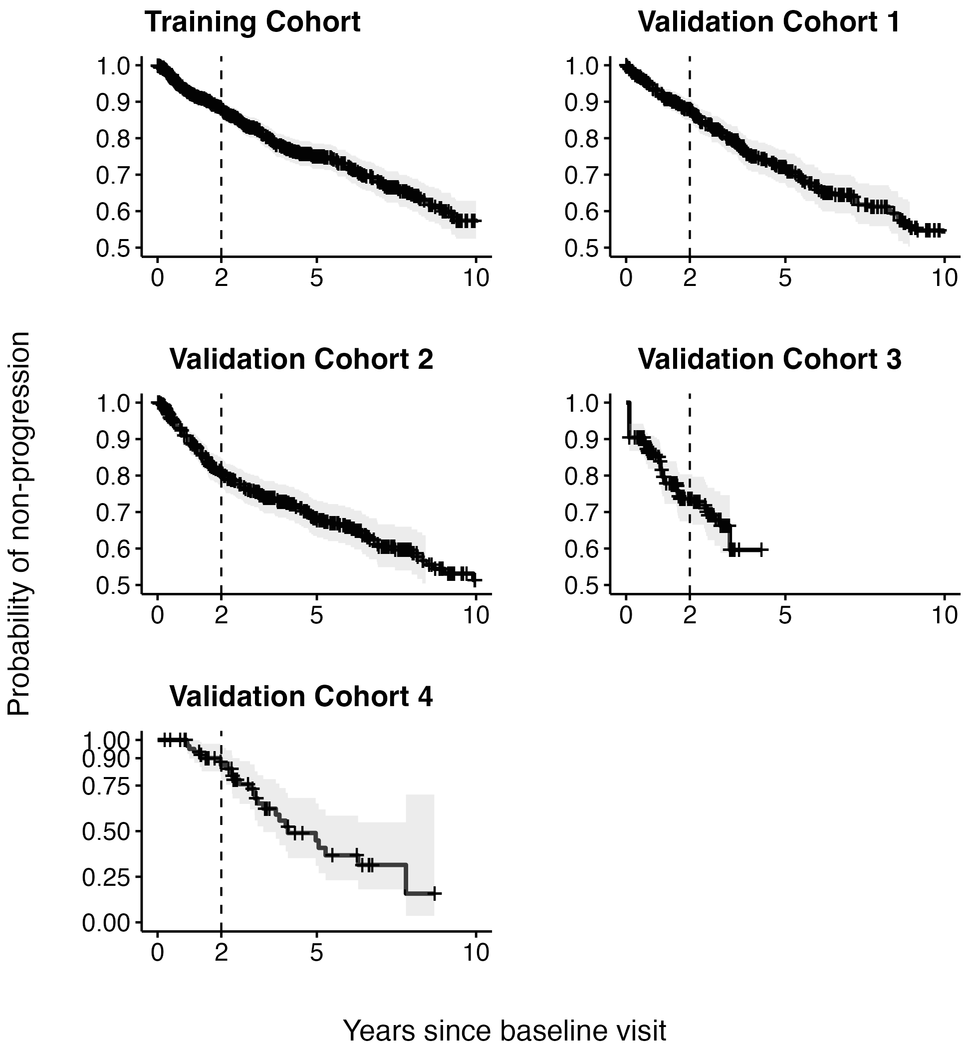
Supplementary Figure S1: Unstratified Kaplan-Meier estimates of non-progression probability for each cohort. Error bands show pointwise 95% confidence intervals for the probability of non-progression by each time point.

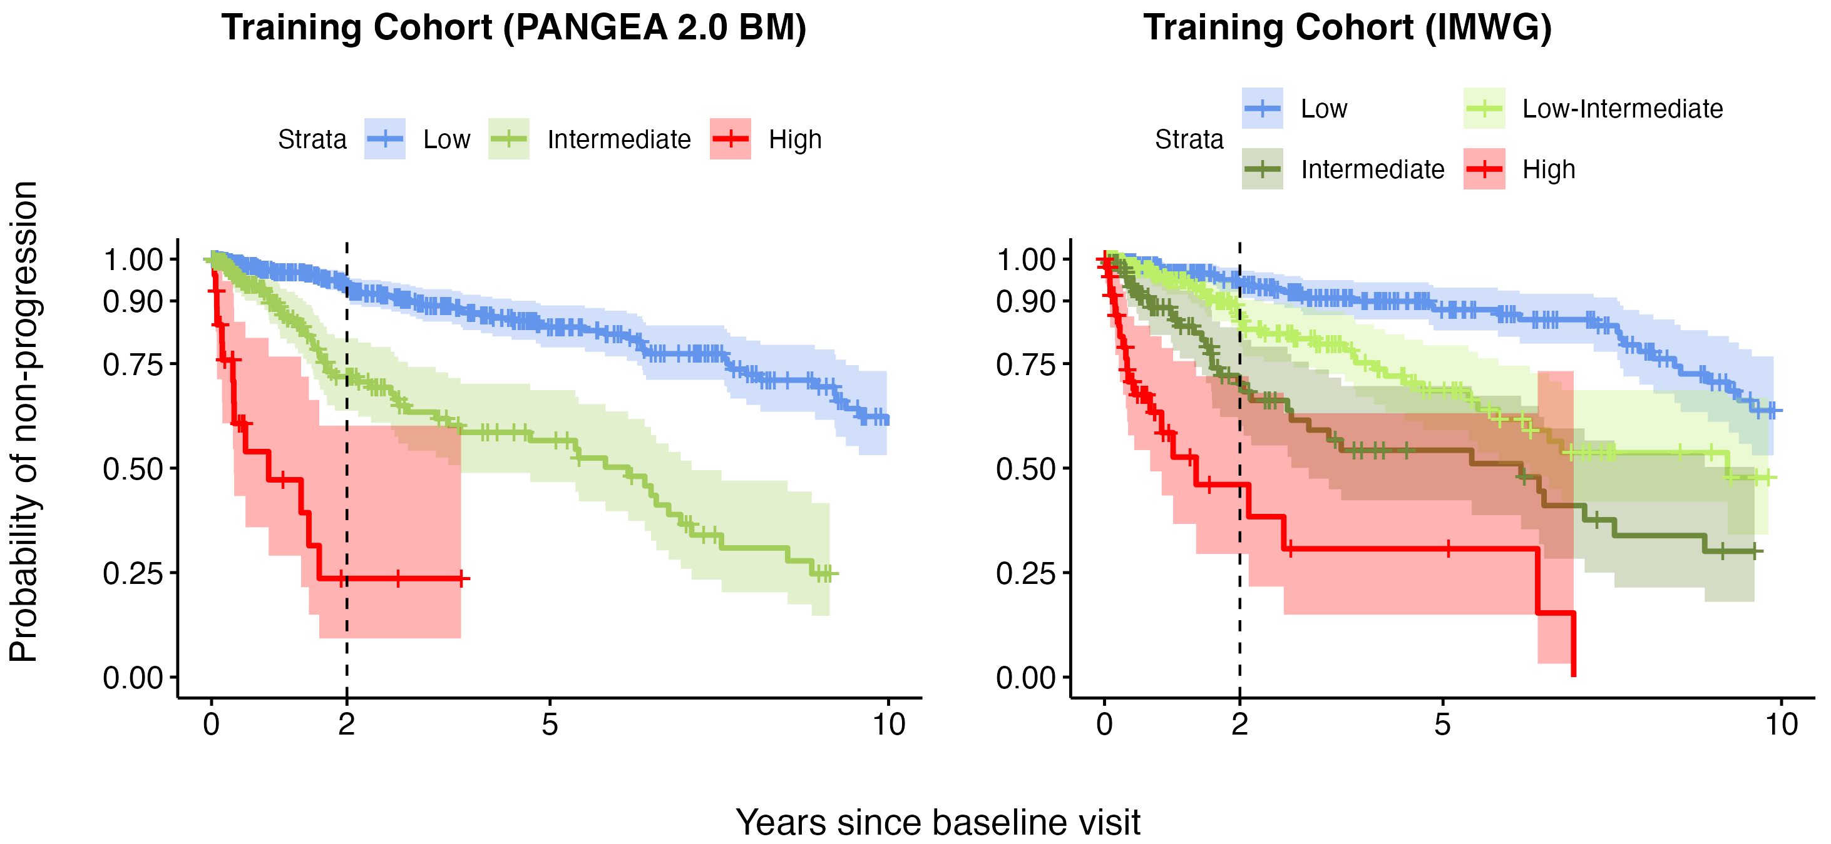

Supplementary Figure S2: Risk stratification of the PANGEA 2.0 trajectory model (BM) compared to rolling 20/2/20 for the training cohort (subset with available IMWG FISH criteria: hyperdiploidy, 13q deletion, 1q gain, or translocation t(4; 14)). Plots show Kaplan-Meier estimates of non-progression probability stratified by risk category (PANGEA 2.0 or IMWG). Error bands show pointwise 95% confidence intervals for the probability of non-progression by each time point.
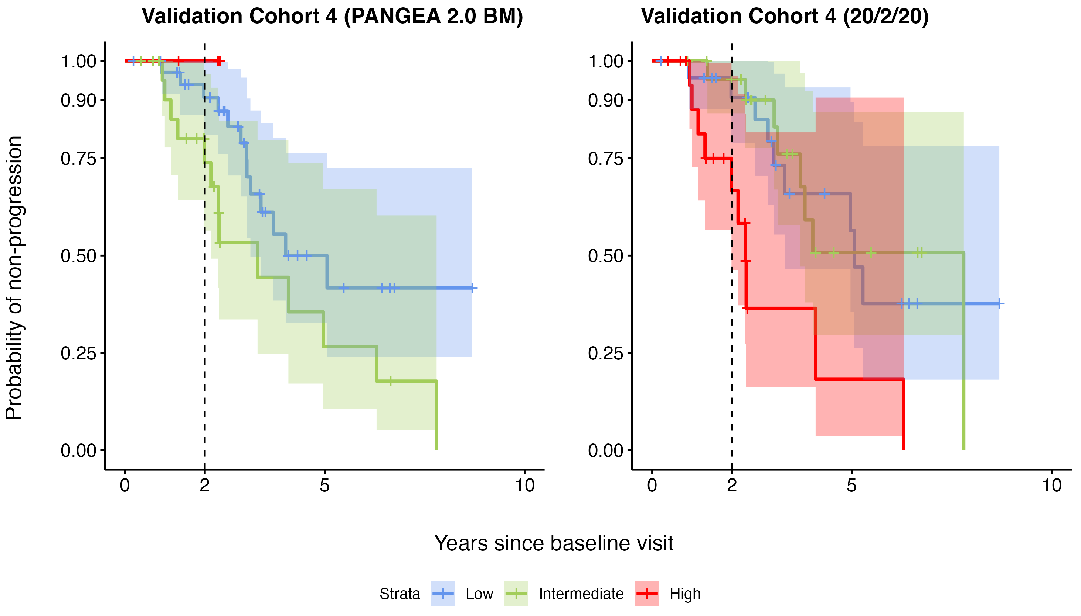
Supplementary Figure S3: Risk stratification of the PANGEA 2.0 trajectory model (BM) compared to rolling 20/2/20 for Validation Cohort 4. Plots show Kaplan-Meier estimates of non-progression probability stratified by risk category (PANGEA 2.0 or 20/2/20). Error bands show pointwise 95% confidence intervals for the probability of non-progression by each time point.

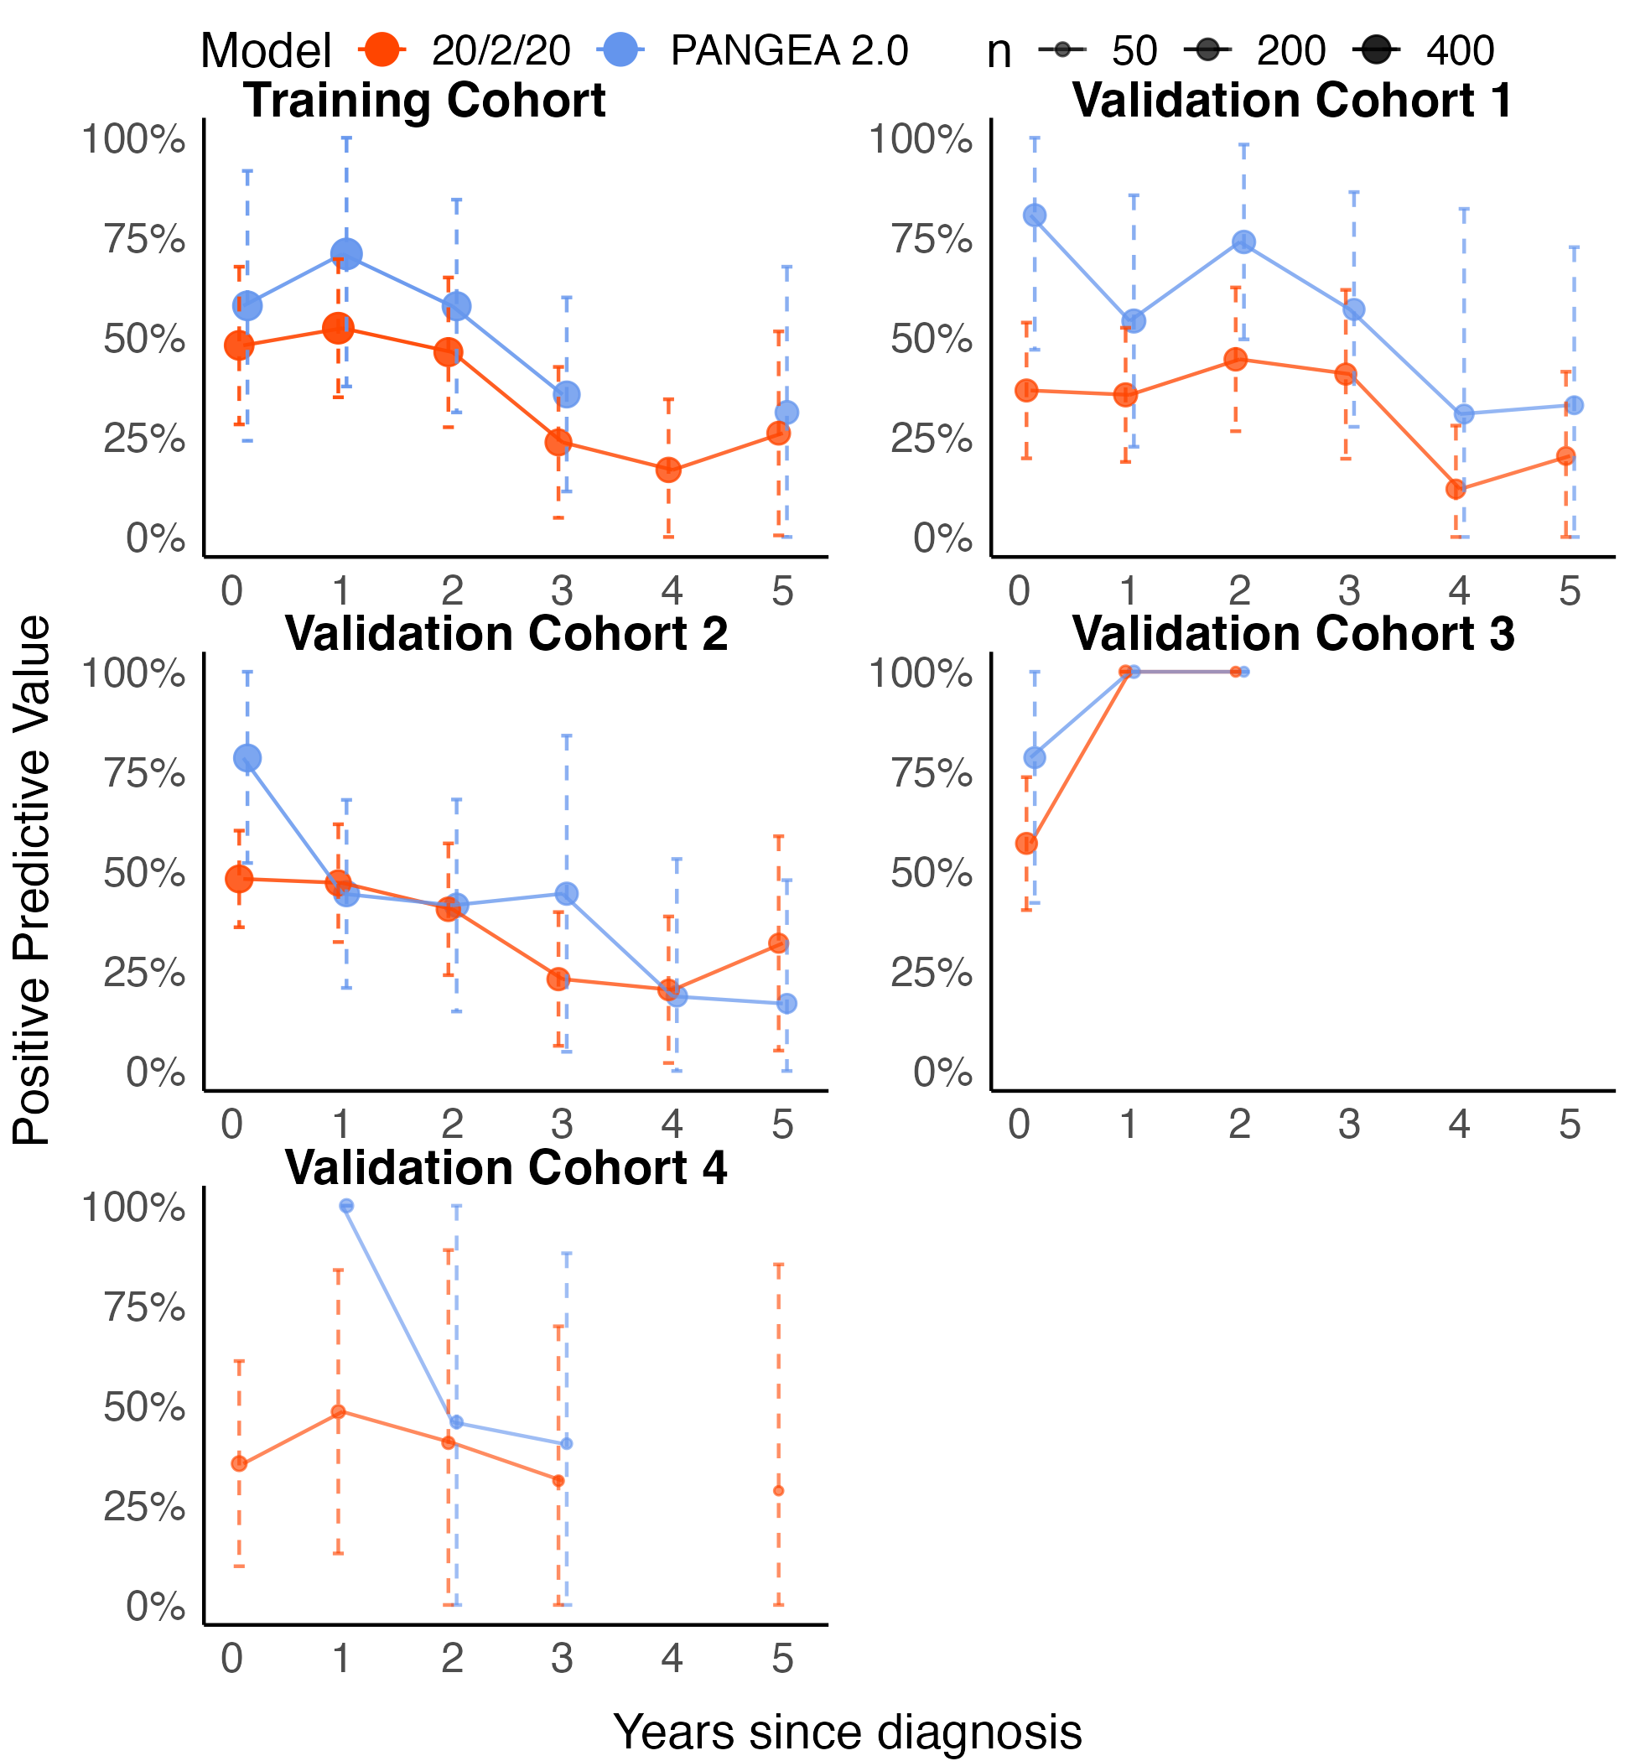
Supplementary Figure S4: Point estimates and 95% confidence intervals of the dynamic positive predictive value for 20/2/20 and the PANGEA 2.0 BM high-risk status in each cohort. The positive predictive value at each time point (x-axis) is computed using only the most recent observation for each remaining patient who is still being followed up that many years after diagnosis and is the probability of progressing to MM within 2 years for patients classified as high-risk. At some time points the positive predictive power could not be computed because sample sizes (esp. the number of 20/2/20 or PANGEA 2.0 high-risk cases) were too small.
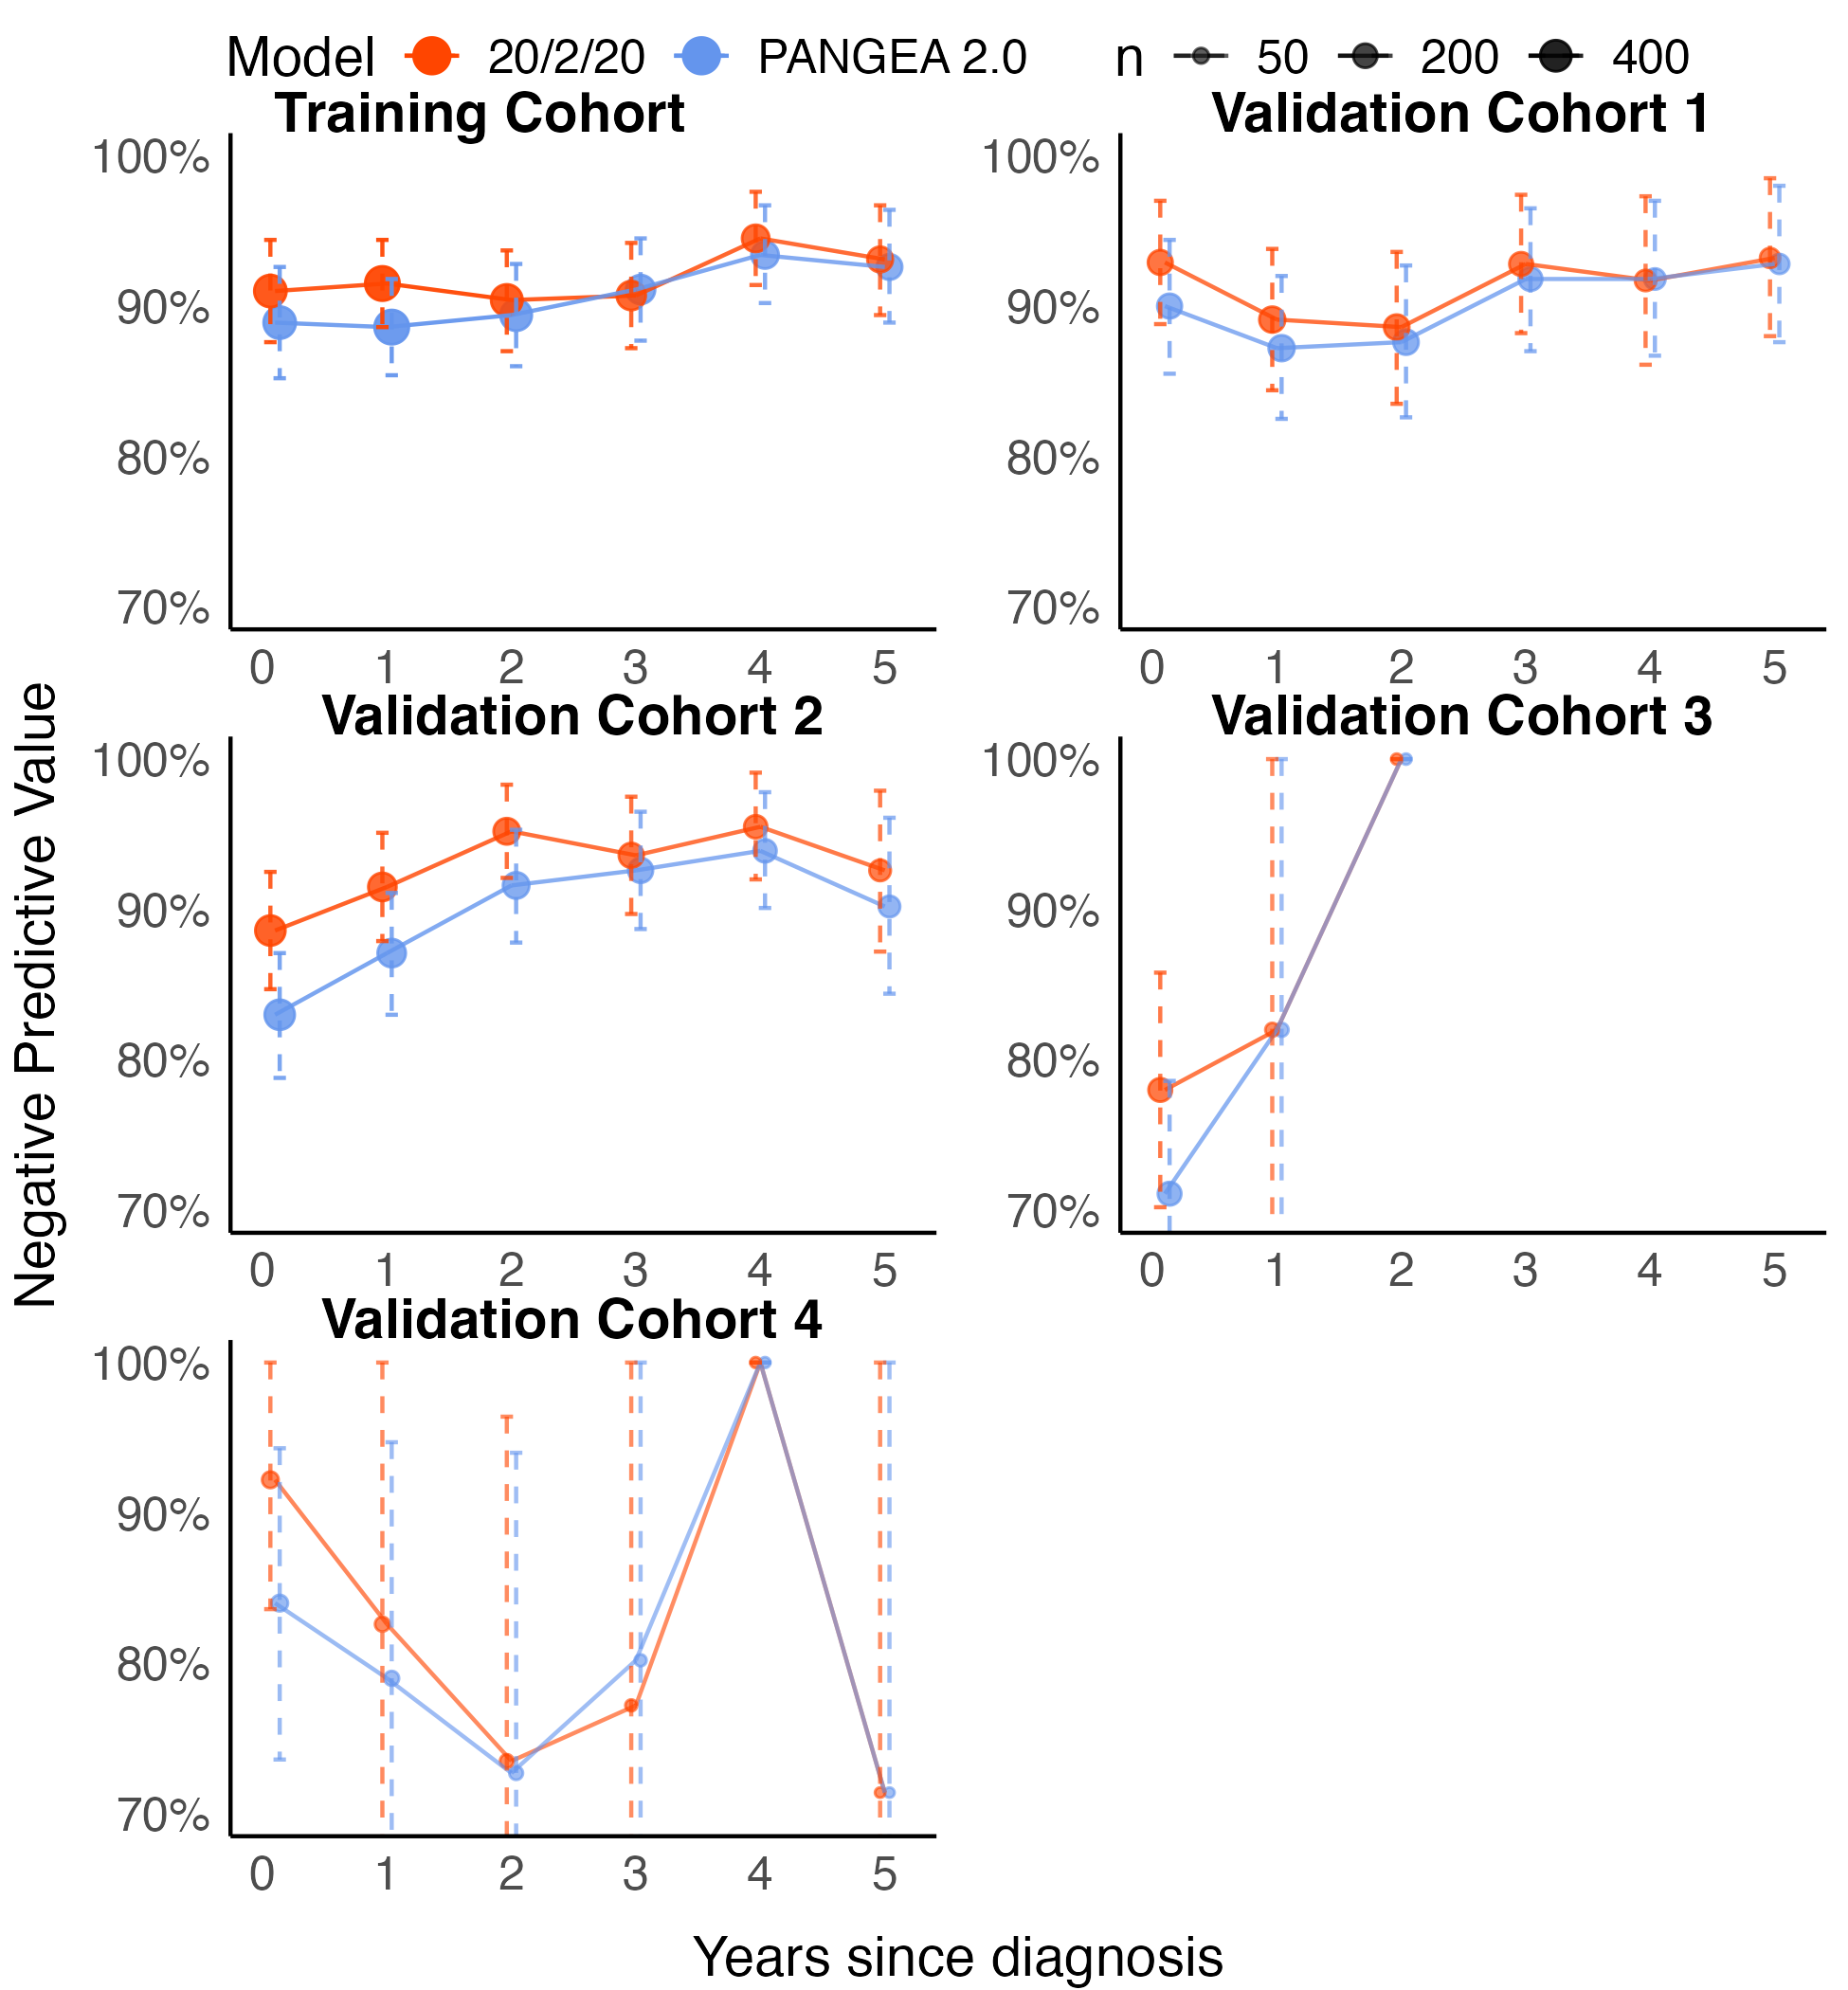
Supplementary Figure S5: Point estimates and 95% confidence intervals of the dynamic negative predictive value for 20/2/20 and the PANGEA 2.0 BM high-risk status in each cohort. The negative predictive value at each time point (x-axis) is computed using only the most recent observation for each remaining patient who is still being followed up that many years after diagnosis and is the probability of not progressing to MM within 2 years for patients classified as low- or intermediate-risk. At some time points the negative predictive power could not be computed because sample sizes (esp. the number of 20/2/20 or PANGEA 2.0 low- or intermediate-risk cases) were too small.
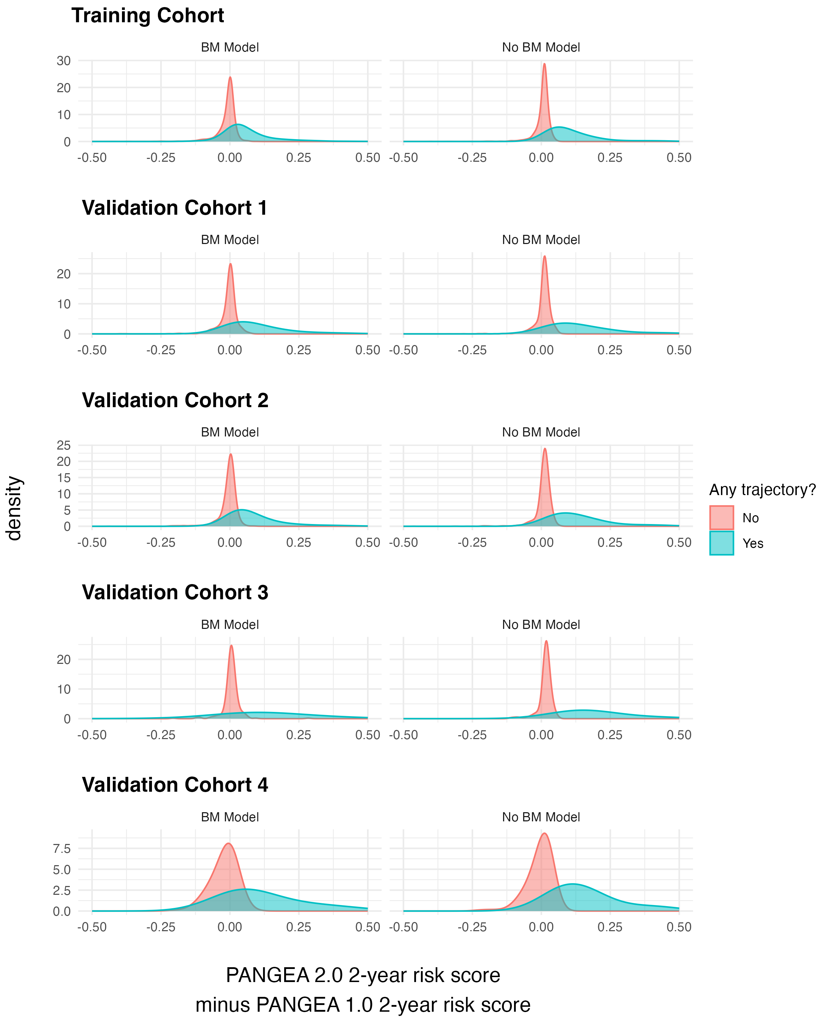
Supplementary Figure S6: Distribution of the difference in PANGEA 2.0 2-year risk scores (2.0 risk minus 1.0 risk) for the BM and No BM models in each cohort. Data include all serial patient visits (multiple per patient) at which the biomarkers needed for PANGEA 2.0 predictions are observed. Distributions are shown for the visits where the 2.0 model did (blue) and did not (red) detect a changing biomarker trajectory.

