- Ethics, Consent to Participate, and Consent to Publish Declaration
The author confirms:
That the work (including any individual details, images or videos) described has not been published before;
That it is not under consideration for publication elsewhere;
That its publication has been approved by all co-authors;
That it is not applicable for clinical trial;
All authors agree to publication in the Journal indicated below and also to publication of the article in English by Discover Oncology in corresponding English-language journal.
The copyright to the English-language article is transferred to Springer effective if and when the article is accepted for publication. The author warrants that his/her contribution is original and that he/she has full power to make this grant. The author accepts responsibility for releasing this material on behalf of any and all co-authors. The copyright transfer covers the exclusive right to reproduce and distribute to article, including reprints, translations, photographic reproductions, microform, electronic form (offline, online) or any other reproductions of similar nature.
Journal: Discover Oncology
Title of article: Subacute Thyroiditis plays an Important Role in the Prevention of Papillary Thyroid Cancer: Mendelian Randomization Analysis
Names of ALL contributing authors: Shengcan Zhang, Hui Ye1, Wei Li, Xue Gu, Xinyu Zhai
Date:2025.4.29

- Availability of Data and Materials
- Data Sourece
The data that support the finding of this study are available in FinnGen database.
finngen_R10_E4_THYROIDITSUBAC.gz:
https://storage.googleapis.com/finngen-public-data-r10/summary_stats/finngen_R10_E4_THYROIDITSUBAC.gz

finngen_R10_C3_THYROID_PAPILLARY_ADENO_EXALLC.gz: https://storage.googleapis.com/finngen-public-data-r10/summary_stats/finngen_R10_C3_THYROID_PAPILLARY_ADENO_EXALLC.gz

- Original Data
2.1 R Data Code
####FinnGen数据库(SAT)####
setwd("thyroiditis")
setwd("Mendelian")
####暴露数据处理
SAT<-fread('finngen_R10_E4_THYROIDITSUBAC.gz', header=T)
SAT<-data.frame(SAT)
head(SAT)
#查找对应的列名，提取所需列。
new_SAT<-SAT[,c("rsids","alt","ref","af_alt","beta","sebeta","pval")]
head(new_SAT)
colnames(new_SAT)<-c("SNP","effect_allele.exposure","other_allele.exposure","eaf.exposure","beta.exposure","se.exposure","pval.exposure")
head(new_SAT)
new_SAT$id.exposure<-"subacute thyroiditis"
new_SAT$exposure<-"subacute thyroiditis"
head(new_SAT)
#更改和补充列名
colnames(new_SAT)<-c("SNP","effect_allele.exposure","other_allele.exposure","eaf.exposure","beta.exposure","se.exposure","pval.exposure")
head(new_SAT)
new_SAT$id.exposure<-"subacute thyroiditis"
new_SAT$exposure<-"subacute thyroiditis"
head(new_SAT)
#筛选与暴露强相关的SNP和独立的SNP。
new_SAT<-subset(new_SAT,pval.exposure<5e-08)#5e-08/1e-7/1e-6/1e-5
#去除不连锁平衡
options(ieugwasr_api = 'gwas-api.mrcieu.ac.uk/')
new_SAT<-clump_data(new_SAT,clump_kb = 10000,clump_r2 = 0.001,clump_p1 = 5e-05,clump_p2 = 5e-05,pop = "EUR")
#如果数据来源人群为亚洲人群应将“EUR”改为“EAS”
head(new_SAT)
write.csv(new_SAT,"new_SAT.csv",quote = F,row.names = F)
#F=β^2/SE^2
####结局数据处理
#增补结局数据框中的列名
#读取非IEU数据库GWAS数据。
PTC<-fread('finngen_R10_C3_THYROID_PAPILLARY_ADENO_EXALLC.gz', header=T)
PTC<-data.frame(PTC)
head(PTC)
#查找对应的列名，提取所需列。#要提取9列才对
#更改和补充列名
new_PTC<-PTC[,c("rsids","alt","ref","af_alt","beta","sebeta","pval")]
head(new_PTC)
colnames(new_PTC)<-c("SNP","effect_allele.outcome","other_allele.outcome","eaf.outcome","beta.outcome","se.outcome","pval.outcome")
head(new_PTC)
new_PTC$id.outcome<-"PTC"
new_PTC$outcome<-"PTC"
head(new_PTC)
#合并数据
total<-merge(new_SAT,new_PTC,by.x="SNP",by.y="SNP",all = F)
#注：merge函数相当于取两个数据中的交集，例如：merge(data1,data2,by.x=”x1”,by.y=”x2”,all=F)解释为取data1与data2两个数据框中data1中x1列与data2中x2列共同的部分
#去除与结局有GWAS显著性的SNPs（y是结局）
total<-subset(total,pval.outcome>5e-08)
#分别取出暴露与结局的数据
EXP<-total[,c("SNP","effect_allele.exposure","other_allele.exposure", "eaf.exposure", "beta.exposure","se.exposure","pval.exposure","id.exposure","exposure")]
OUT<-total[,c("SNP","effect_allele.outcome","other_allele.outcome", "eaf.outcome", "beta.outcome","se.outcome","pval.outcome","id.outcome","outcome")]
OUT_ver<-subset(OUT,pval.outcome>5e-8)
if(dim(OUT)[1]==dim(OUT_ver)[1]){print(paste0('TwoSampleMR获取',dim(OUT)[1],"个工具变量等于验证结果获取的",dim(OUT_ver)[1],",结果一致"))}else{print(paste0('TwoSampleMR获取',dim(OUT)[1],"个工具变量不等于验证结果获取的",dim(OUT_ver)[1],",结果不一致"))}
#colnames(surv.expr)[ ] <- " " #[]内填特定列数字 ""内填写修改的名
#验证无误后，协调数据。
data_h<-harmonise_data(exposure_dat=EXP,outcome_dat=OUT,action=2)
head(data_h)
write.csv(data_h,"ANM.SNP.csv",quote = F,row.names = F)
#进行孟德尔随机化分析
mr_outcome<-mr(data_h)
mr_outcome
#补充“OR”和“95%CI”上下限数据列
mr_outcome$OR<-exp(mr_outcome$b)
mr_outcome$LowerCI<-exp(mr_outcome$b-1.96*mr_outcome$se)
mr_outcome$UowerCI<-exp(mr_outcome$b+1.96*mr_outcome$se)
mr_outcome
write.csv(mr_outcome,"ANM.IVW.csv",quote = F,row.names = F)
#进行孟德尔随机化分析
mr_outcome<-mr(data_h)
mr_outcome
#补充“OR”和“95%CI”上下限数据列
mr_outcome$OR<-exp(mr_outcome$b)
mr_outcome$LowerCI<-exp(mr_outcome$b-1.96*mr_outcome$se)
mr_outcome$UowerCI<-exp(mr_outcome$b+1.96*mr_outcome$se)
mr_outcome
write.csv(mr_outcome,"ANM.IVW.csv",quote = F,row.names = F)

#2.10绘制散点图
p1 <- mr_scatter_plot(mr_outcome, data_h)
p1[[1]]
#绘制森林图
mr_outcome_single <- mr_singlesnp(data_h)
p2 <- mr_forest_plot(mr_outcome_single)
p2[[1]]
#2.11使用留一法（Leave one out）进行敏感性分析
mr_outcome_loo <- mr_leaveoneout(data_h)
p3 <- mr_leaveoneout_plot(mr_outcome_loo)
p3[[1]]
#2.13绘制漏斗图
mr_outcome_single <- mr_singlesnp(data_h)
p4 <- mr_funnel_plot(mr_outcome_single)
p4[[1]]
#2.14异质性检验
H<-mr_heterogeneity(data_h)
H

#MR-PRESSO异常值检测(偏倚的SNP)
presso=run_mr_presso(data_h)
write.csv(presso[[1]]$`MR-PRESSO results`$`Outlier Test`, file="table.MR-PRESSO.csv")

#注：观察IVW和MR egger方法Q值和Q_pval，Q值越大则P值越小，小于0.05则表示有异质性。
#2.15多效性检验
ple <- mr_pleiotropy_test(data_h)
ple
library(tidyverse)
tpms01A_log2 <- read.table("tpms01A_log2.txt",sep = "\t",row.names = 1,check.names = F,stringsAsFactors = F,header = T)
tpms11A_log2 <- read.table("tpms11A_log2.txt",sep = "\t",row.names = 1,check.names = F,stringsAsFactors = F,header = T)
gene <- "CCBE1"#以后修改这里即可 小技巧
#gene <- c("","","")
#如果想多提取几个基因怎么办 集合
a <- tpms01A_log2[gene,]
b <- tpms11A_log2[gene,]
##运用传导符%>% cltrl+shift+M
a <- a %>% t() %>% as.data.frame()
b <- b %>% t() %>% as.data.frame()
write.csv(a, file = "CDKN3_01A.csv")
write.csv(b, file = "CDKN3_11A.csv")
#我喜欢用仙桃学术画图 便于修图 而且免费
#Graphpad等
#R语言代码画图 更快！！！
a <- read.table("tpms_log2.txt",sep = "\t",row.names = 1,check.names = F,stringsAsFactors = F,header = T)
a <- a %>% t() %>% as.data.frame()
#添加分组信息
a <- a %>% mutate(group=factor(ifelse(substr(rownames(a),14,16) == "01A","Tumor","Normal"),levels = c("Normal","Tumor")))
#a$group <- factor(ifelse(substr(rownames(a),14,16) == "01A","Tumor","Normal"),levels = c("Normal","Tumor"))
#levels的顺序反过来会怎么样？
library(ggpubr)
library(ggsci)
ggboxplot(a,
x = "group", y = "CCBE1",#可以画任何一个基因
fill = "group") +
scale_fill_lancet()+
stat_compare_means(comparisons = list(c(1, 2)),
method = "wilcox.test", #设置统计方法
symnum.args=list(cutpoints = c(0, 0.001, 0.01, 0.05, 1),
symbols = c("***", "**", "*", "ns")))
dev.off()
library(DESeq2)
library(tidyverse)
counts_01A<- read.table("counts01A.txt",sep = "\t",row.names = 1,check.names = F,stringsAsFactors = F,header = T)
exp<- read.table("tpms01A_log2.txt", sep = "\t",row.names = 1,check.names = F,header = T)
identical(colnames(counts_01A),colnames(exp))#习惯性判断以防万一
gene <- "CCBE1"#每次运行只改这个基因名
class(exp$`TCGA-01A`)

med=median(as.numeric(exp[gene,]))
#为什么要as.numeric
a <- exp[gene,]
a <- as.numeric(a)
#四分位数
quantile(a)

conditions=data.frame(sample=colnames(exp),
group=factor(ifelse(exp[gene,]>med,"high","low"),levels = c("low","high"))) %>%
column_to_rownames("sample")

dds <- DESeqDataSetFromMatrix(
countData = counts_01A,
colData = conditions,
design = ~ group)

dds <- DESeq(dds)

resultsNames(dds)
res <- results(dds)
save(res,file="DEG_CCBE1.Rda")
####KEGG####
#基因富集于通路
kk <- enrichKEGG(gene = DEG$ENTREZID,
organism = 'hsa',#hsa代表人
pvalueCutoff = 0.1,
qvalueCutoff =0.1)
kk=DOSE::setReadable(kk, OrgDb='org.Hs.eg.db',keyType='ENTREZID')
kk_res <- kk@result
save(kk,kk_res,file = "KEGG_CDKN3_DEG.Rda")

#3. 可视化
##3.1 柱状图
barplot(kk, showCategory = 10,color = "pvalue")
##3.2 气泡图
dotplot(kk, showCategory = 10)
dev.off()
##3.3 网络图
List = DEG$log2FoldChange
names(List)= DEG$ENTREZID
List = sort(List,decreasing = T)

cnetplot(kk, categorySize="pvalue", foldChange = List,colorEdge = TRUE)
##3.4 网络图2
cnetplot(kk, foldChange = List, circular = TRUE, colorEdge = TRUE)
##3.5 热图
heatplot(kk,foldChange = List)

setwd("..")
setwd("TCGAdata")
setwd("TCGA-THCA")
setwd("CLUSTER-original")
setwd("cluster")
#library(BiocManager)
#BiocManager::install('ConsensusClusterPlus')
library(tidyverse)
library(ConsensusClusterPlus)
exp <- read.table("tpms01A_log2.txt",sep = "\t",row.names = 1,check.names = F,stringsAsFactors = F,header = T)

#不学也行我们只需要得到group
d=as.matrix(exp)
gene <- c("ZSCAN12","CCBE1") #修改基因名称即可
#!!!!需要更改的地方
d <- d[gene,]
##了解即可##
mads=apply(d,1,mad)
d=d[rev(order(mads))[1:2],]
d = sweep(d,1, apply(d,1,median,na.rm=T))

title=("JULEI") ##文件夹输出图片的位置
set.seed(1)
results = ConsensusClusterPlus(d,maxK=9,reps=50,pItem=0.8,pFeature=1,
title=title,clusterAlg="hc",distance="pearson",seed=1,plot="pdf")

icl = calcICL(results,title=title,plot="pdf") ##画另一组图片
##了解即可##
##获取分组信息
group<-results[[2]][["consensusClass"]] #精华在此
class(group)
head(group)
group<-as.data.frame(group)
group$group <- factor(group$group,levels=c(1,2))
#factor(需要改变的，改变内容)
#group$group <- as.factor(group$group)
class(group$group)
save(group,file = "group_AY.Rda")
##获取完毕

# 绘制热图
library(pheatmap)
exp_gene <- exp[gene,]
annotation <- group %>% arrange(group)
exp_gene <- exp_gene[,rownames(annotation)]

pheatmap(exp_gene,
annotation = annotation,
annotation_colors = list(group = c("1" ="#01468b","2"= "#ee0000")),
cluster_cols = F,
fontsize=5,
fontsize_row=8,
scale="row",
show_colnames=F,
cluster_row = F,
fontsize_col=3)
dev.off()
a <- read.table("Xcell_res.txt", sep = "\t",row.names = 1,check.names = F,header = T)
#双击打开group_AY.Rda
identical(rownames(a),rownames(group))
a$group <- group$group
a <- a %>% rownames_to_column("sample")
library(ggsci)
library(tidyr)
library(ggpubr)
b <- gather(a,key=Xcell,value = Expression,-c(group,sample))
ggboxplot(b, x = "Xcell", y = "Expression",
fill = "group", palette = "jco")+
stat_compare_means(aes(group = group),
method = "wilcox.test",
label = "p.signif",
symnum.args=list(cutpoints = c(0, 0.001, 0.01, 0.05, 1),
symbols = c("***", "**", "*", "ns")))+
theme(text = element_text(size=10),
axis.text.x = element_text(angle=45, hjust=1))

dev.off()
2.2 The Result in R
#设置工作目录
> setwd("..")
> ####FinnGen数据库(SAT)####
> setwd(thyroiditis)
Error: object 'thyroiditis' not found
> ####FinnGen数据库(SAT)####
> setwd("thyroiditis")
> ####暴露数据处理
> SAT<-fread('finngen_R10_E4_THYROIDITSUBAC.gz', header=T)
Error: 文件 'finngen_R10_E4_THYROIDITSUBAC.gz' 不存在, 或不可读. getwd()=='D:/thyroiditis'
> SAT<-data.frame(SAT)
Error: object 'SAT' not found
> setwd("Mendelian")
> ####暴露数据处理
> SAT<-fread('finngen_R10_E4_THYROIDITSUBAC.gz', header=T)
|--------------------------------------------------|
|==================================================|
> SAT<-data.frame(SAT)
> head(SAT)
X.chrom pos ref alt rsids nearest_genes pval mlogp beta
1 1 13668 G A rs2691328 OR4F5 0.569679 0.244370 0.301370
2 1 14506 G A rs1240557819 OR4F5 0.785205 0.105017 0.154359
3 1 14521 C T rs1378626194 OR4F5 0.434353 0.362157 -0.871075
4 1 14717 G A rs377122907 OR4F5 0.550891 0.258934 1.519610
5 1 14773 C T rs878915777 OR4F5 0.213244 0.671123 -0.380148
6 1 14842 G T rs1422503364 OR4F5 0.379502 0.420786 3.437650
sebeta af_alt af_alt_cases af_alt_controls
1 0.530091 0.005999110 0.006427640 0.005997820
2 0.566367 0.004659320 0.005010270 0.004658270
3 1.114240 0.001073270 0.000748833 0.001074250
4 2.547870 0.000242449 0.000338002 0.000242162
5 0.305414 0.014223900 0.012507900 0.014229100
6 3.911700 0.000223432 0.000309991 0.000223172
> #查找对应的列名，提取所需列。
> new_SAT<-SAT[,c("rsids","alt","ref","af_alt","beta","sebeta","pval")]
> head(new_SAT)
rsids alt ref af_alt beta sebeta pval
1 rs2691328 A G 0.005999110 0.301370 0.530091 0.569679
2 rs1240557819 A G 0.004659320 0.154359 0.566367 0.785205
3 rs1378626194 T C 0.001073270 -0.871075 1.114240 0.434353
4 rs377122907 A G 0.000242449 1.519610 2.547870 0.550891
5 rs878915777 T C 0.014223900 -0.380148 0.305414 0.213244
6 rs1422503364 T G 0.000223432 3.437650 3.911700 0.379502
> colnames(new_SAT)<-c("SNP","effect_allele.exposure","other_allele.exposure","eaf.exposure","beta.exposure","se.exposure","pval.exposure")
> head(new_SAT)
SNP effect_allele.exposure other_allele.exposure eaf.exposure
1 rs2691328 A G 0.005999110
2 rs1240557819 A G 0.004659320
3 rs1378626194 T C 0.001073270
4 rs377122907 A G 0.000242449
5 rs878915777 T C 0.014223900
6 rs1422503364 T G 0.000223432
beta.exposure se.exposure pval.exposure
1 0.301370 0.530091 0.569679
2 0.154359 0.566367 0.785205
3 -0.871075 1.114240 0.434353
4 1.519610 2.547870 0.550891
5 -0.380148 0.305414 0.213244
6 3.437650 3.911700 0.379502
> new_SAT$id.exposure<-"subacute thyroiditis"
> new_SAT$exposure<-"subacute thyroiditis"
> head(new_SAT)
SNP effect_allele.exposure other_allele.exposure eaf.exposure
1 rs2691328 A G 0.005999110
2 rs1240557819 A G 0.004659320
3 rs1378626194 T C 0.001073270
4 rs377122907 A G 0.000242449
5 rs878915777 T C 0.014223900
6 rs1422503364 T G 0.000223432
beta.exposure se.exposure pval.exposure id.exposure
1 0.301370 0.530091 0.569679 subacute thyroiditis
2 0.154359 0.566367 0.785205 subacute thyroiditis
3 -0.871075 1.114240 0.434353 subacute thyroiditis
4 1.519610 2.547870 0.550891 subacute thyroiditis
5 -0.380148 0.305414 0.213244 subacute thyroiditis
6 3.437650 3.911700 0.379502 subacute thyroiditis
exposure
1 subacute thyroiditis
2 subacute thyroiditis
3 subacute thyroiditis
4 subacute thyroiditis
5 subacute thyroiditis
6 subacute thyroiditis
> #更改和补充列名
> colnames(new_SAT)<-c("SNP","effect_allele.exposure","other_allele.exposure","eaf.exposure","beta.exposure","se.exposure","pval.exposure")
> head(new_SAT)
SNP effect_allele.exposure other_allele.exposure eaf.exposure
1 rs2691328 A G 0.005999110
2 rs1240557819 A G 0.004659320
3 rs1378626194 T C 0.001073270
4 rs377122907 A G 0.000242449
5 rs878915777 T C 0.014223900
6 rs1422503364 T G 0.000223432
beta.exposure se.exposure pval.exposure NA
1 0.301370 0.530091 0.569679 subacute thyroiditis
2 0.154359 0.566367 0.785205 subacute thyroiditis
3 -0.871075 1.114240 0.434353 subacute thyroiditis
4 1.519610 2.547870 0.550891 subacute thyroiditis
5 -0.380148 0.305414 0.213244 subacute thyroiditis
6 3.437650 3.911700 0.379502 subacute thyroiditis
NA
1 subacute thyroiditis
2 subacute thyroiditis
3 subacute thyroiditis
4 subacute thyroiditis
5 subacute thyroiditis
6 subacute thyroiditis
> new_SAT$id.exposure<-"subacute thyroiditis"
> new_SAT$exposure<-"subacute thyroiditis"
> head(new_SAT)
SNP effect_allele.exposure other_allele.exposure eaf.exposure
1 rs2691328 A G 0.005999110
2 rs1240557819 A G 0.004659320
3 rs1378626194 T C 0.001073270
4 rs377122907 A G 0.000242449
5 rs878915777 T C 0.014223900
6 rs1422503364 T G 0.000223432
beta.exposure se.exposure pval.exposure NA
1 0.301370 0.530091 0.569679 subacute thyroiditis
2 0.154359 0.566367 0.785205 subacute thyroiditis
3 -0.871075 1.114240 0.434353 subacute thyroiditis
4 1.519610 2.547870 0.550891 subacute thyroiditis
5 -0.380148 0.305414 0.213244 subacute thyroiditis
6 3.437650 3.911700 0.379502 subacute thyroiditis
NA id.exposure exposure
1 subacute thyroiditis subacute thyroiditis subacute thyroiditis
2 subacute thyroiditis subacute thyroiditis subacute thyroiditis
3 subacute thyroiditis subacute thyroiditis subacute thyroiditis
4 subacute thyroiditis subacute thyroiditis subacute thyroiditis
5 subacute thyroiditis subacute thyroiditis subacute thyroiditis
6 subacute thyroiditis subacute thyroiditis subacute thyroiditis
> #筛选与暴露强相关的SNP和独立的SNP。
> new_SAT<-subset(new_SAT,pval.exposure<5e-08)#5e-08/1e-7/1e-6/1e-5
> #去除不连锁平衡
> options(ieugwasr_api = 'gwas-api.mrcieu.ac.uk/')
> new_SAT<-clump_data(new_SAT,clump_kb = 10000,clump_r2 = 0.001,clump_p1 = 5e-05,clump_p2 = 5e-05,pop = "EUR")
Please look at vignettes for options on running this locally if you need to run many instances of this command.
Clumping subacute thyroiditis, 9531 variants, using EUR population reference
Error in api_query("ld/clump", query = list(rsid = dat[["rsid"]], pval = dat[["pval"]], :
The MR-Base server appears to be down, the following error was received:
Error in curl::curl_fetch_memory(url, handle = handle): Could not resolve host: gwas-api.mrcieu.ac.uk
> #查找对应的列名，提取所需列。
> new_SAT<-SAT[,c("rsids","alt","ref","af_alt","beta","sebeta","pval")]
> head(new_SAT)
rsids alt ref af_alt beta sebeta pval
1 rs2691328 A G 0.005999110 0.301370 0.530091 0.569679
2 rs1240557819 A G 0.004659320 0.154359 0.566367 0.785205
3 rs1378626194 T C 0.001073270 -0.871075 1.114240 0.434353
4 rs377122907 A G 0.000242449 1.519610 2.547870 0.550891
5 rs878915777 T C 0.014223900 -0.380148 0.305414 0.213244
6 rs1422503364 T G 0.000223432 3.437650 3.911700 0.379502
> colnames(new_SAT)<-c("SNP","effect_allele.exposure","other_allele.exposure","eaf.exposure","beta.exposure","se.exposure","pval.exposure")
> head(new_SAT)
SNP effect_allele.exposure other_allele.exposure eaf.exposure
1 rs2691328 A G 0.005999110
2 rs1240557819 A G 0.004659320
3 rs1378626194 T C 0.001073270
4 rs377122907 A G 0.000242449
5 rs878915777 T C 0.014223900
6 rs1422503364 T G 0.000223432
beta.exposure se.exposure pval.exposure
1 0.301370 0.530091 0.569679
2 0.154359 0.566367 0.785205
3 -0.871075 1.114240 0.434353
4 1.519610 2.547870 0.550891
5 -0.380148 0.305414 0.213244
6 3.437650 3.911700 0.379502
> new_SAT$id.exposure<-"subacute thyroiditis"
> new_SAT$exposure<-"subacute thyroiditis"
> head(new_SAT)
SNP effect_allele.exposure other_allele.exposure eaf.exposure
1 rs2691328 A G 0.005999110
2 rs1240557819 A G 0.004659320
3 rs1378626194 T C 0.001073270
4 rs377122907 A G 0.000242449
5 rs878915777 T C 0.014223900
6 rs1422503364 T G 0.000223432
beta.exposure se.exposure pval.exposure id.exposure
1 0.301370 0.530091 0.569679 subacute thyroiditis
2 0.154359 0.566367 0.785205 subacute thyroiditis
3 -0.871075 1.114240 0.434353 subacute thyroiditis
4 1.519610 2.547870 0.550891 subacute thyroiditis
5 -0.380148 0.305414 0.213244 subacute thyroiditis
6 3.437650 3.911700 0.379502 subacute thyroiditis
exposure
1 subacute thyroiditis
2 subacute thyroiditis
3 subacute thyroiditis
4 subacute thyroiditis
5 subacute thyroiditis
6 subacute thyroiditis
> #更改和补充列名
> colnames(new_SAT)<-c("SNP","effect_allele.exposure","other_allele.exposure","eaf.exposure","beta.exposure","se.exposure","pval.exposure")
> head(new_SAT)
SNP effect_allele.exposure other_allele.exposure eaf.exposure
1 rs2691328 A G 0.005999110
2 rs1240557819 A G 0.004659320
3 rs1378626194 T C 0.001073270
4 rs377122907 A G 0.000242449
5 rs878915777 T C 0.014223900
6 rs1422503364 T G 0.000223432
beta.exposure se.exposure pval.exposure NA
1 0.301370 0.530091 0.569679 subacute thyroiditis
2 0.154359 0.566367 0.785205 subacute thyroiditis
3 -0.871075 1.114240 0.434353 subacute thyroiditis
4 1.519610 2.547870 0.550891 subacute thyroiditis
5 -0.380148 0.305414 0.213244 subacute thyroiditis
6 3.437650 3.911700 0.379502 subacute thyroiditis
NA
1 subacute thyroiditis
2 subacute thyroiditis
3 subacute thyroiditis
4 subacute thyroiditis
5 subacute thyroiditis
6 subacute thyroiditis
> new_SAT$id.exposure<-"subacute thyroiditis"
> new_SAT$exposure<-"subacute thyroiditis"
> head(new_SAT)
SNP effect_allele.exposure other_allele.exposure eaf.exposure
1 rs2691328 A G 0.005999110
2 rs1240557819 A G 0.004659320
3 rs1378626194 T C 0.001073270
4 rs377122907 A G 0.000242449
5 rs878915777 T C 0.014223900
6 rs1422503364 T G 0.000223432
beta.exposure se.exposure pval.exposure NA
1 0.301370 0.530091 0.569679 subacute thyroiditis
2 0.154359 0.566367 0.785205 subacute thyroiditis
3 -0.871075 1.114240 0.434353 subacute thyroiditis
4 1.519610 2.547870 0.550891 subacute thyroiditis
5 -0.380148 0.305414 0.213244 subacute thyroiditis
6 3.437650 3.911700 0.379502 subacute thyroiditis
NA id.exposure exposure
1 subacute thyroiditis subacute thyroiditis subacute thyroiditis
2 subacute thyroiditis subacute thyroiditis subacute thyroiditis
3 subacute thyroiditis subacute thyroiditis subacute thyroiditis
4 subacute thyroiditis subacute thyroiditis subacute thyroiditis
5 subacute thyroiditis subacute thyroiditis subacute thyroiditis
6 subacute thyroiditis subacute thyroiditis subacute thyroiditis
> #筛选与暴露强相关的SNP和独立的SNP。
> new_SAT<-subset(new_SAT,pval.exposure<5e-08)#5e-08/1e-7/1e-6/1e-5
> #去除不连锁平衡
> options(ieugwasr_api = 'gwas-api.mrcieu.ac.uk/')
> new_SAT<-clump_data(new_SAT,clump_kb = 10000,clump_r2 = 0.001,clump_p1 = 5e-05,clump_p2 = 5e-05,pop = "EUR")
Please look at vignettes for options on running this locally if you need to run many instances of this command.
Clumping subacute thyroiditis, 9531 variants, using EUR population reference
Removing 9525 of 9531 variants due to LD with other variants or absence from LD reference panel
> #如果数据来源人群为亚洲人群应将“EUR”改为“EAS”
> head(new_SAT)
SNP effect_allele.exposure other_allele.exposure eaf.exposure
7284923 rs328836 T C 0.284292
7854363 rs2859348 G A 0.498025
7883606 rs3131933 C T 0.428639
7893607 rs7749442 A T 0.144208
11869331 rs10983701 A G 0.646842
18820428 rs4552110 T A 0.192633
beta.exposure se.exposure pval.exposure NA
7284923 0.252576 0.0462989 4.88799e-08 subacute thyroiditis
7854363 0.326622 0.0430203 3.14340e-14 subacute thyroiditis
7883606 -0.244616 0.0442999 3.35529e-08 subacute thyroiditis
7893607 0.950364 0.0463926 2.91474e-93 subacute thyroiditis
11869331 0.258593 0.0463949 2.49333e-08 subacute thyroiditis
18820428 -0.437778 0.0593740 1.66533e-13 subacute thyroiditis
NA.1 id.exposure exposure
7284923 subacute thyroiditis subacute thyroiditis subacute thyroiditis
7854363 subacute thyroiditis subacute thyroiditis subacute thyroiditis
7883606 subacute thyroiditis subacute thyroiditis subacute thyroiditis
7893607 subacute thyroiditis subacute thyroiditis subacute thyroiditis
11869331 subacute thyroiditis subacute thyroiditis subacute thyroiditis
18820428 subacute thyroiditis subacute thyroiditis subacute thyroiditis
> write.csv(new_SAT,"new_SAT.csv",quote = F,row.names = F)
> #F=β^2/SE^2
> ####结局数据处理
> #增补结局数据框中的列名
> #读取非IEU数据库GWAS数据。
> PTC<-fread('finngen_R10_C3_THYROID_PAPILLARY_ADENO_EXALLC.gz', header=T)
|--------------------------------------------------|
|==================================================|
> PTC<-data.frame(PTC)
> head(PTC)
X.chrom pos ref alt rsids nearest_genes pval mlogp beta
1 1 13668 G A rs2691328 OR4F5 0.210983 0.6757520 -0.5718510
2 1 14506 G A rs1240557819 OR4F5 0.721966 0.1414830 0.1796680
3 1 14521 C T rs1378626194 OR4F5 0.488055 0.3115310 -0.6306600
4 1 14717 G A rs377122907 OR4F5 0.727311 0.1382800 0.8024930
5 1 14773 C T rs878915777 OR4F5 0.884576 0.0532649 -0.0384499
6 1 14842 G T rs1422503364 OR4F5 0.701772 0.1538040 -1.0134300
sebeta af_alt af_alt_cases af_alt_controls
1 0.457164 0.005984110 0.004963240 0.005988890
2 0.504925 0.004682930 0.004791400 0.004682420
3 0.909511 0.001077330 0.000857843 0.001078360
4 2.301350 0.000241035 0.000277067 0.000240866
5 0.264859 0.014170900 0.014057200 0.014171400
6 2.646500 0.000228121 0.000174499 0.000228372
> PTC<-data.frame(PTC)
> head(PTC)
X.chrom pos ref alt rsids nearest_genes pval mlogp beta
1 1 13668 G A rs2691328 OR4F5 0.210983 0.6757520 -0.5718510
2 1 14506 G A rs1240557819 OR4F5 0.721966 0.1414830 0.1796680
3 1 14521 C T rs1378626194 OR4F5 0.488055 0.3115310 -0.6306600
4 1 14717 G A rs377122907 OR4F5 0.727311 0.1382800 0.8024930
5 1 14773 C T rs878915777 OR4F5 0.884576 0.0532649 -0.0384499
6 1 14842 G T rs1422503364 OR4F5 0.701772 0.1538040 -1.0134300
sebeta af_alt af_alt_cases af_alt_controls
1 0.457164 0.005984110 0.004963240 0.005988890
2 0.504925 0.004682930 0.004791400 0.004682420
3 0.909511 0.001077330 0.000857843 0.001078360
4 2.301350 0.000241035 0.000277067 0.000240866
5 0.264859 0.014170900 0.014057200 0.014171400
6 2.646500 0.000228121 0.000174499 0.000228372
> #查找对应的列名，提取所需列。#要提取9列才对
> #更改和补充列名
> new_PTC<-PTC[,c("rsids","alt","ref","af_alt","beta","sebeta","pval")]
> head(new_PTC)
rsids alt ref af_alt beta sebeta pval
1 rs2691328 A G 0.005984110 -0.5718510 0.457164 0.210983
2 rs1240557819 A G 0.004682930 0.1796680 0.504925 0.721966
3 rs1378626194 T C 0.001077330 -0.6306600 0.909511 0.488055
4 rs377122907 A G 0.000241035 0.8024930 2.301350 0.727311
5 rs878915777 T C 0.014170900 -0.0384499 0.264859 0.884576
6 rs1422503364 T G 0.000228121 -1.0134300 2.646500 0.701772
> colnames(new_PTC)<-c("SNP","effect_allele.outcome","other_allele.outcome","eaf.outcome","beta.outcome","se.outcome","pval.outcome")
> head(new_PTC)
SNP effect_allele.outcome other_allele.outcome eaf.outcome beta.outcome
1 rs2691328 A G 0.005984110 -0.5718510
2 rs1240557819 A G 0.004682930 0.1796680
3 rs1378626194 T C 0.001077330 -0.6306600
4 rs377122907 A G 0.000241035 0.8024930
5 rs878915777 T C 0.014170900 -0.0384499
6 rs1422503364 T G 0.000228121 -1.0134300
se.outcome pval.outcome
1 0.457164 0.210983
2 0.504925 0.721966
3 0.909511 0.488055
4 2.301350 0.727311
5 0.264859 0.884576
6 2.646500 0.701772
> new_PTC$id.outcome<-"PTC"
> new_PTC$outcome<-"PTC"
> head(new_PTC)
SNP effect_allele.outcome other_allele.outcome eaf.outcome beta.outcome
1 rs2691328 A G 0.005984110 -0.5718510
2 rs1240557819 A G 0.004682930 0.1796680
3 rs1378626194 T C 0.001077330 -0.6306600
4 rs377122907 A G 0.000241035 0.8024930
5 rs878915777 T C 0.014170900 -0.0384499
6 rs1422503364 T G 0.000228121 -1.0134300
se.outcome pval.outcome id.outcome outcome
1 0.457164 0.210983 PTC PTC
2 0.504925 0.721966 PTC PTC
3 0.909511 0.488055 PTC PTC
4 2.301350 0.727311 PTC PTC
5 0.264859 0.884576 PTC PTC
6 2.646500 0.701772 PTC PTC
> #合并数据
> total<-merge(new_SAT,new_PTC,by.x="SNP",by.y="SNP",all = F)
> #注：merge函数相当于取两个数据中的交集，例如：merge(data1,data2,by.x=”x1”,by.y=”x2”,all=F)解释为取data1与data2两个数据框中data1中x1列与data2中x2列共同的部分
> #去除与结局有GWAS显著性的SNPs（y是结局）
> total<-subset(total,pval.outcome>5e-08)
> #分别取出暴露与结局的数据
> EXP<-total[,c("SNP","effect_allele.exposure","other_allele.exposure", "eaf.exposure", "beta.exposure","se.exposure","pval.exposure","id.exposure","exposure")]
> OUT<-total[,c("SNP","effect_allele.outcome","other_allele.outcome", "eaf.outcome", "beta.outcome","se.outcome","pval.outcome","id.outcome","outcome")]
> OUT_ver<-subset(OUT,pval.outcome>5e-8)
> if(dim(OUT)[1]==dim(OUT_ver)[1]){print(paste0('TwoSampleMR获取',dim(OUT)[1],"个工具变量等于验证结果获取的",dim(OUT_ver)[1],",结果一致"))}else{print(paste0('TwoSampleMR获取',dim(OUT)[1],"个工具变量不等于验证结果获取的",dim(OUT_ver)[1],",结果不一致"))}
[1] "TwoSampleMR获取5个工具变量等于验证结果获取的5,结果一致"
> #colnames(surv.expr)[ ] <- " " #[]内填特定列数字 ""内填写修改的名
> #验证无误后，协调数据。
> data_h<-harmonise_data(exposure_dat=EXP,outcome_dat=OUT,action=2)
Harmonising subacute thyroiditis (subacute thyroiditis) and PTC (PTC)
> head(data_h)
SNP effect_allele.exposure other_allele.exposure effect_allele.outcome
1 rs2859348 G A G
2 rs3131933 C T C
3 rs328836 T C T
4 rs4552110 T A T
5 rs7749442 A T A
other_allele.outcome beta.exposure beta.outcome eaf.exposure eaf.outcome remove
1 A 0.326622 -0.03323210 0.498025 0.498176 FALSE
2 T -0.244616 0.02517160 0.428639 0.429832 FALSE
3 C 0.252576 -0.00119155 0.284292 0.285379 FALSE
4 A -0.437778 0.08328330 0.192633 0.193556 FALSE
5 T 0.950364 -0.13531500 0.144208 0.145456 FALSE
palindromic ambiguous id.outcome se.outcome pval.outcome outcome se.exposure
1 FALSE FALSE PTC 0.0372657 0.3725210 PTC 0.0430203
2 FALSE FALSE PTC 0.0375713 0.5028780 PTC 0.0442999
3 FALSE FALSE PTC 0.0411970 0.9769260 PTC 0.0462989
4 TRUE FALSE PTC 0.0472270 0.0778216 PTC 0.0593740
5 TRUE FALSE PTC 0.0529274 0.0105694 PTC 0.0463926
pval.exposure id.exposure exposure action SNP_index mr_keep
1 3.14340e-14 subacute thyroiditis subacute thyroiditis 2 1 TRUE
2 3.35529e-08 subacute thyroiditis subacute thyroiditis 2 1 TRUE
3 4.88799e-08 subacute thyroiditis subacute thyroiditis 2 1 TRUE
4 1.66533e-13 subacute thyroiditis subacute thyroiditis 2 1 TRUE
5 2.91474e-93 subacute thyroiditis subacute thyroiditis 2 1 TRUE
samplesize.outcome
1 NA
2 NA
3 NA
4 NA
5 NA
> write.csv(data_h,"ANM.SNP.csv",quote = F,row.names = F)
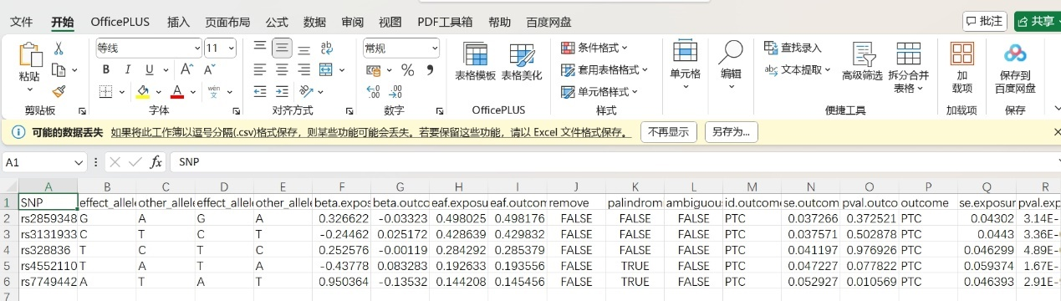
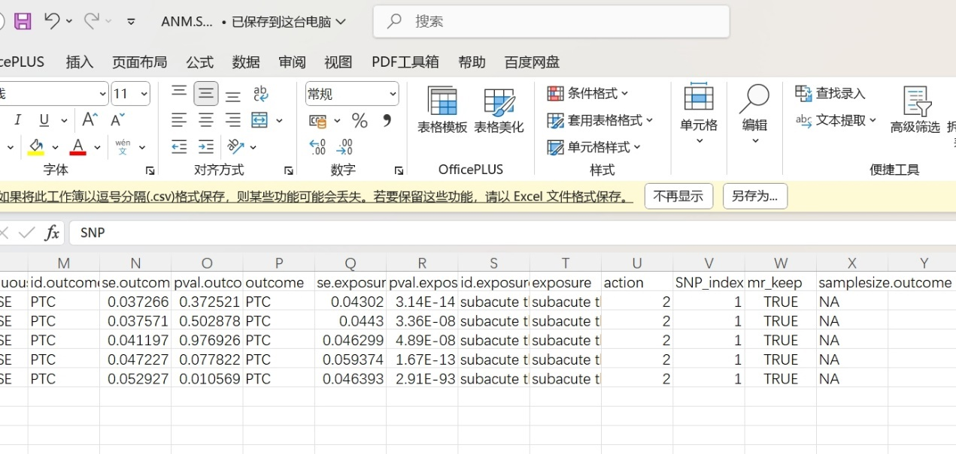
> #进行孟德尔随机化分析
> mr_outcome<-mr(data_h)
Analysing 'subacute thyroiditis' on 'PTC'
> mr_outcome
id.exposure id.outcome outcome exposure
1 subacute thyroiditis PTC PTC subacute thyroiditis
2 subacute thyroiditis PTC PTC subacute thyroiditis
3 subacute thyroiditis PTC PTC subacute thyroiditis
4 subacute thyroiditis PTC PTC subacute thyroiditis
5 subacute thyroiditis PTC PTC subacute thyroiditis
method nsnp b se pval
1 MR Egger 5 -0.1760613 0.08389261 0.126727912
2 Weighted median 5 -0.1342655 0.04742746 0.004640769
3 Inverse variance weighted 5 -0.1320176 0.04206505 0.001698644
4 Simple mode 5 -0.1189805 0.06994979 0.164173635
5 Weighted mode 5 -0.1392647 0.05160900 0.054180779
> #补充“OR”和“95%CI”上下限数据列
> mr_outcome$OR<-exp(mr_outcome$b)
> mr_outcome$LowerCI<-exp(mr_outcome$b-1.96*mr_outcome$se)
> mr_outcome$UowerCI<-exp(mr_outcome$b+1.96*mr_outcome$se)
> mr_outcome
id.exposure id.outcome outcome exposure
1 subacute thyroiditis PTC PTC subacute thyroiditis
2 subacute thyroiditis PTC PTC subacute thyroiditis
3 subacute thyroiditis PTC PTC subacute thyroiditis
4 subacute thyroiditis PTC PTC subacute thyroiditis
5 subacute thyroiditis PTC PTC subacute thyroiditis
method nsnp b se pval OR
1 MR Egger 5 -0.1760613 0.08389261 0.126727912 0.8385666
2 Weighted median 5 -0.1342655 0.04742746 0.004640769 0.8743579
3 Inverse variance weighted 5 -0.1320176 0.04206505 0.001698644 0.8763256
4 Simple mode 5 -0.1189805 0.06994979 0.164173635 0.8878251
5 Weighted mode 5 -0.1392647 0.05160900 0.054180779 0.8699977
LowerCI UowerCI
1 0.7114211 0.9884356
2 0.7967428 0.9595338
3 0.8069730 0.9516385
4 0.7740784 1.0182862
5 0.7862988 0.9626060
> write.csv(mr_outcome,"ANM.IVW.csv",quote = F,row.names = F)
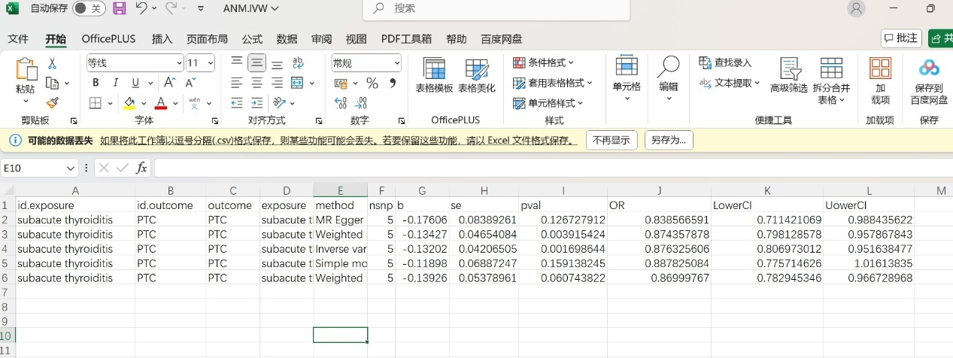
> #进行孟德尔随机化分析
> mr_outcome<-mr(data_h)
Analysing 'subacute thyroiditis' on 'PTC'
> mr_outcome
id.exposure id.outcome outcome exposure
1 subacute thyroiditis PTC PTC subacute thyroiditis
2 subacute thyroiditis PTC PTC subacute thyroiditis
3 subacute thyroiditis PTC PTC subacute thyroiditis
4 subacute thyroiditis PTC PTC subacute thyroiditis
5 subacute thyroiditis PTC PTC subacute thyroiditis
method nsnp b se pval
1 MR Egger 5 -0.1760613 0.08389261 0.126727912
2 Weighted median 5 -0.1342655 0.04654084 0.003915424
3 Inverse variance weighted 5 -0.1320176 0.04206505 0.001698644
4 Simple mode 5 -0.1189805 0.06887247 0.159138245
5 Weighted mode 5 -0.1392647 0.05378961 0.060743822
> #补充“OR”和“95%CI”上下限数据列
> mr_outcome$OR<-exp(mr_outcome$b)
> mr_outcome$LowerCI<-exp(mr_outcome$b-1.96*mr_outcome$se)
> mr_outcome$UowerCI<-exp(mr_outcome$b+1.96*mr_outcome$se)
> mr_outcome
id.exposure id.outcome outcome exposure
1 subacute thyroiditis PTC PTC subacute thyroiditis
2 subacute thyroiditis PTC PTC subacute thyroiditis
3 subacute thyroiditis PTC PTC subacute thyroiditis
4 subacute thyroiditis PTC PTC subacute thyroiditis
5 subacute thyroiditis PTC PTC subacute thyroiditis
method nsnp b se pval OR
1 MR Egger 5 -0.1760613 0.08389261 0.126727912 0.8385666
2 Weighted median 5 -0.1342655 0.04654084 0.003915424 0.8743579
3 Inverse variance weighted 5 -0.1320176 0.04206505 0.001698644 0.8763256
4 Simple mode 5 -0.1189805 0.06887247 0.159138245 0.8878251
5 Weighted mode 5 -0.1392647 0.05378961 0.060743822 0.8699977
LowerCI UowerCI
1 0.7114211 0.9884356
2 0.7981286 0.9578678
3 0.8069730 0.9516385
4 0.7757146 1.0161383
5 0.7829453 0.9667290
> write.csv(mr_outcome,"ANM.IVW.csv",quote = F,row.names = F)
> #2.10绘制散点图
> p1 <- mr_scatter_plot(mr_outcome, data_h)
> p1[[1]]
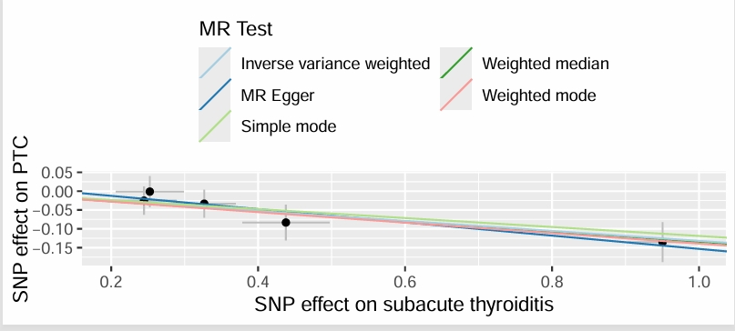
> #绘制森林图
> mr_outcome_single <- mr_singlesnp(data_h)
> p2 <- mr_forest_plot(mr_outcome_single)
> p2[[1]]
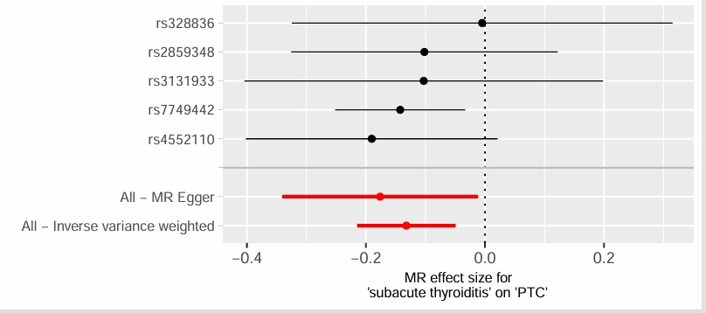
Warning messages:
1: Removed 1 row containing missing values or values outside the scale range
(`geom_errorbarh()`).
2: Removed 1 row containing missing values or values outside the scale range
(`geom_point()`).
> #2.11使用留一法（Leave one out）进行敏感性分析
> mr_outcome_loo <- mr_leaveoneout(data_h)
> p3 <- mr_leaveoneout_plot(mr_outcome_loo)
> p3[[1]]
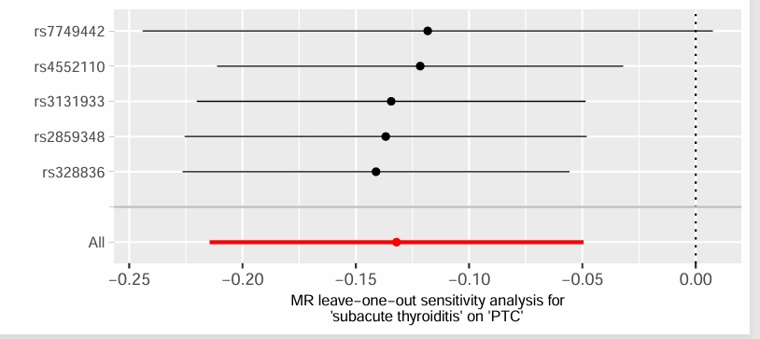
Warning messages:
1: Removed 1 row containing missing values or values outside the scale range
(`geom_errorbarh()`).
2: Removed 1 row containing missing values or values outside the scale range
(`geom_point()`).
> #2.13绘制漏斗图
> mr_outcome_single <- mr_singlesnp(data_h)
> p4 <- mr_funnel_plot(mr_outcome_single)
> p4[[1]]
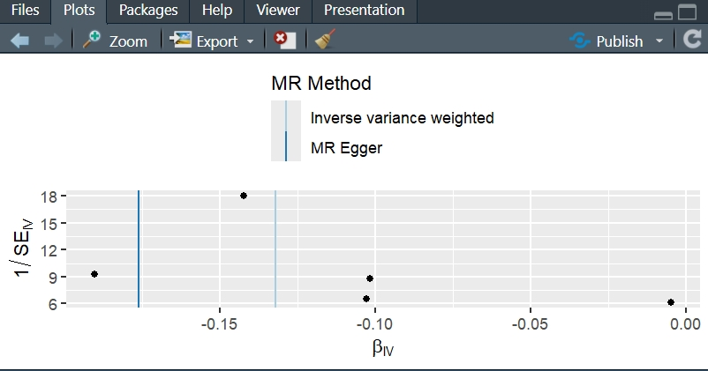
> #2.14异质性检验
> H<-mr_heterogeneity(data_h)
> H
id.exposure id.outcome outcome exposure
1 subacute thyroiditis PTC PTC subacute thyroiditis
2 subacute thyroiditis PTC PTC subacute thyroiditis
method Q Q_df Q_pval
1 MR Egger 0.6731894 3 0.8794912
2 Inverse variance weighted 1.0413870 4 0.9034568
> #MR-PRESSO异常值检测(偏倚的SNP)
> presso=run_mr_presso(data_h)
subacute thyroiditis - PTC
Warning message:
In MRPRESSO::mr_presso(BetaOutcome = "beta.outcome", BetaExposure = "beta.exposure", :
No outlier were identified, therefore the results for the outlier-corrected MR are set to NA
> write.csv(presso[[1]]$`MR-PRESSO results`$`Outlier Test`, file="table.MR-PRESSO.csv")
> #注：观察IVW和MR egger方法Q值和Q_pval，Q值越大则P值越小，小于0.05则表示有异质性。
> #2.15多效性检验
> ple <- mr_pleiotropy_test(data_h)
> ple
id.exposure id.outcome outcome exposure egger_intercept
1 subacute thyroiditis PTC PTC subacute thyroiditis 0.02277639
se pval
1 0.03753569 0.5868301

>

setwd("..")
> setwd("TCGAdata")
> library(tidyverse)
> tpms01A_log2 <- read.table("tpms01A_log2.txt",sep = "\t",row.names = 1,check.names = F,stringsAsFactors = F,header = T)
> tpms11A_log2 <- read.table("tpms11A_log2.txt",sep = "\t",row.names = 1,check.names = F,stringsAsFactors = F,header = T)
> gene <- "CCBE1"#以后修改这里即可 小技巧
> #gene <- c("","","")
> #如果想多提取几个基因怎么办 集合
> a <- tpms01A_log2[gene,]
> b <- tpms11A_log2[gene,]
> ##运用传导符%>% cltrl+shift+M
> a <- a %>% t() %>% as.data.frame()
> b <- b %>% t() %>% as.data.frame()
> #我喜欢用仙桃学术画图 便于修图 而且免费
> #Graphpad等
> #R语言代码画图 更快！！！
> a <- read.table("tpms_log2.txt",sep = "\t",row.names = 1,check.names = F,stringsAsFactors = F,header = T)
> a <- a %>% t() %>% as.data.frame()
> #添加分组信息
> a <- a %>% mutate(group=factor(ifelse(substr(rownames(a),14,16) == "01A","Tumor","Normal"),levels = c("Normal","Tumor")))
> #a$group <- factor(ifelse(substr(rownames(a),14,16) == "01A","Tumor","Normal"),levels = c("Normal","Tumor"))
> #levels的顺序反过来会怎么样？
> library(ggpubr)
Warning message:
程辑包‘ggpubr’是用R版本4.3.3 来建造的
> library(ggsci)
Warning message:
程辑包‘ggsci’是用R版本4.3.2 来建造的
> ggboxplot(a,
+ x = "group", y = "CCBE1",#可以画任何一个基因
+ fill = "group") +
+ scale_fill_lancet()+
+ stat_compare_means(comparisons = list(c(1, 2)),
+ method = "wilcox.test", #设置统计方法
+ symnum.args=list(cutpoints = c(0, 0.001, 0.01, 0.05, 1),
+ symbols = c("***", "**", "*", "ns")))

>

- Computational Formula
$$F=\frac{R^{2}}{1-R^{2}}×\frac{N-K-1}{K}$$

$$R^{2}=2×MAF×\left(1-MAF\right)×{\left(\frac{β}{sd}\right)}^{2}$$

$$R^{2}=\frac{2×β×EAF×\left(1-EAF\right)}{2×β^{2}×\left(1-EAF\right)+2×{SE}^{2}×N×EAF×\left(1-EAF\right)}$$

The value of the F-statistics in this research is calculated using a scientific calculator, so it will not be explain here.

