ellTyping Rules | vimentin | cd45 | cd3e | cd8 | cd4 | foxp3 | cd57 | cd20 | cd21 | cd11b | cd14 | cd68 | cd163 |  | cd31 |  | cd34 |  | col4 |  | sma |  | pancytokeratin |  | ecadherin |  | nakatpase |  | cd45ro |  | granzymeb |  | lag3 |  | pd1 |  | icos |  | g6pd
CD8 T cells | -1 | 2 | 1 | 1 | 0 | -1 | -1 | 0 | 0 | 0 | -1 | -1 | 0 |  | -1 |  | 0 |  | -1 |  | -1 |  | -1 |  | -1 |  | -1 |  | 2 |  | 2 |  | 2 |  | 2 |  | 2 |  | -1
CD4 T cells | -1 | 2 | 1 | 0 | 1 | 0 | -1 | 0 | 0 | 0 | -1 | -1 | 0 |  | -1 |  | 0 |  | -1 |  | -1 |  | -1 |  | -1 |  | -1 |  | 2 |  | 2 |  | 2 |  | 2 |  | 2 |  | -1
CD4 T regs | -1 | 2 | 1 | 0 | 1 | 1 | -1 | 0 | 0 | 0 | -1 | -1 | 0 |  | -1 |  | 0 |  | -1 |  | -1 |  | -1 |  | -1 |  | -1 |  | 2 |  | -1 |  | 2 |  | 2 |  | 2 |  | -1
B cells | -1 | 2 | 0 | 0 | 0 | 0 | -1 | 1 | 2 | 0 | -1 | -1 | 0 |  | -1 |  | 0 |  | -1 |  | -1 |  | 0 |  | 0 |  | -1 |  | 2 |  | 0 |  | 0 |  | -1 |  | 0 |  | -1
Plasma cells | -1 | 1 | 0 | 0 | 0 | 0 | -1 | 0 | -1 | 0 | -1 | -1 | 0 |  | 1 |  | 0 |  | -1 |  | -1 |  | -1 |  | -1 |  | -1 |  | -1 |  | -1 |  | -1 |  | 0 |  | 0 |  | -1
Macrophages | 2 | 2 | 0 | 0 | 2 | 0 | 0 | 0 | 0 | 2 | 2 | 1 | 2 |  | -1 |  | 0 |  | -1 |  | -1 |  | 0 |  | 0 |  | -1 |  | 2 |  | -1 |  | 0 |  | 0 |  | 0 |  | -1
Granulocytes | -1 | 2 | 0 | 0 | 0 | 0 | 0 | 0 | 0 | 1 | 2 | 0 | 0 |  | -1 |  | 0 |  | -1 |  | -1 |  | 0 |  | 0 |  | -1 |  | 2 |  | -1 |  | 0 |  | 0 |  | 0 |  | 2
Myeloid NOS | -1 | 2 | 0 | 0 | 2 | 0 | 0 | 0 | 0 | 0 | 1 | 0 | 0 |  | 0 |  | 0 |  | 0 |  | 0 |  | 0 |  | 0 |  | 0 |  | 2 |  | 0 |  | 0 |  | 0 |  | 0 |  | -1
Immune NOS | 1 | 1 | 0 | 0 | 0 | 0 | -1 | 0 | 0 | 0 | 0 | 0 | 0 |  | 0 |  | 0 |  | 0 |  | 0 |  | 0 |  | 0 |  | -1 |  | -1 |  | 0 |  | 0 |  | 0 |  | 0 |  | -1
Endothelial cells | -1 | 0 | 0 | 0 | 0 | 0 | 0 | 0 | 0 | 0 | 0 | 0 | 0 |  | 1 |  | 2 |  | 2 |  | 2 |  | 0 |  | 0 |  | -1 |  | 0 |  | 0 |  | 0 |  | 0 |  | 0 |  | -1
Fibroblasts | 1 | 0 | 0 | 0 | 0 | 0 | 0 | 0 | 0 | 0 | 0 | 0 | 0 |  | 0 |  | 0 |  | -1 |  | 0 |  | 0 |  | 0 |  | 0 |  | 0 |  | 0 |  | 0 |  | 0 |  | 0 |  | -1
Myofibroblasts | -1 | 0 | 0 | 0 | 0 | 0 | 0 | 0 | 0 | 0 | 0 | 0 | 0 |  | 0 |  | 0 |  | -1 |  | 1 |  | 0 |  | 0 |  | 0 |  | 0 |  | 0 |  | 0 |  | 0 |  | 0 |  | -1
Tumor cells | -1 | 0 | 0 | 0 | -1 | 0 | 0 | 0 | -1 | 0 | -1 | 0 | 0 |  | 0 |  | 0 |  | -1 |  | 0 |  | 2 |  | 2 |  | -1 |  | 0 |  | 0 |  | 0 |  | -1 |  | 0 |  | -1
Other cells | 0 | 0 | 0 | 0 | 0 | 0 | 0 | 0 | 0 | 0 | 0 | 0 | 0 |  | 0 |  | 0 |  | 0 |  | 0 |  | 0 |  | 0 |  | 0 |  | 0 |  | 0 |  | 0 |  | 0 |  | 0 |  | -1
Artifact cells | -1 | -1 | -1 | -1 | -1 | 1 | -1 | 1 | -1 | 1 | 1 | -1 | -1 |  | -1 |  | -1 |  | -1 |  | -1 |  | -1 |  | -1 |  | 1 |  | 1 |  | -1 |  | 1 |  | 1 |  | -1 |  | 1
2 = either one must be postive
1 = must be positive
0 = must be negative
(-1) = ignore
* 26 porteins were used for cell types determination, the rest were ignored for cell typing
Supplementary Table 1: Deep Learning cell type rules

Supplementary Table 2: Clinical summary table
Characteristic | Female  N = 80¹ | Male  N = 86¹ | P value²
Tissue Type |  |  | 0.7
Adrenal metastasis | 1 (1.3%) | 1 (1.2%)
Axillary lymph node | 1 (1.3%) | 0 (0%)
Bone | 1 (1.3%) | 2 (2.3%)
Brain | 8 (10%) | 12 (14%)
Extra spinal metastasis (with bone) | 1 (1.3%) | 0 (0%)
Lymph node | 9 (11%) | 3 (3.5%)
Lung | 43 (54%) | 55 (64%)
Lung recurrence | 0 (0%) | 1 (1.2%)
Mediastinal lymph node | 7 (8.8%) | 5 (5.8%)
Metastatic Soft tissue from spine (with bone) | 1 (1.3%) | 2 (2.3%)
Neck lymph node | 2 (2.5%) | 1 (1.2%)
Pericardium | 1 (1.3%) | 0 (0%)
Pleura | 1 (1.3%) | 0 (0%)
Renal metastasis | 0 (0%) | 1 (1.2%)
Skin metastasis | 1 (1.3%) | 0 (0%)
Small bowel | 1 (1.3%) | 1 (1.2%)
Soft tissue | 0 (0%) | 1 (1.2%)
Supraclavicular lymph node | 1 (1.3%) | 1 (1.2%)
Tumor thoracic spine | 1 (1.3%) | 0 (0%)
Age at diagnosis or ICI | 68 (63, 75) | 66 (58, 76) | 0.5
Sampled Pre or Post ICI |  |  | >0.9
Post | 9 (11%) | 8 (9.3%)
Post (acquired resistance) | 2 (2.5%) | 2 (2.3%)
Pre | 69 (86%) | 76 (88%)
Tobacco Use |  |  | 0.3
Current | 16 (20%) | 15 (17%)
Former | 51 (64%) | 64 (74%)
Never | 12 (15%) | 7 (8.1%)
Unknown | 1 (1.3%) | 0 (0%)
Tumor Stage at Start of ICI Treatment Coarse |  |  | >0.9
Extensive | 2 (2.5%) | 2 (2.3%)
I | 1 (1.3%) | 0 (0%)
II | 2 (2.5%) | 4 (4.7%)
III | 7 (8.8%) | 7 (8.1%)
IV | 68 (85%) | 73 (85%)
Histology |  |  | 0.7
Adenocarcinoma | 56 (70%) | 56 (65%)
Adenosquamous Carcinoma | 2 (2.5%) | 1 (1.2%)
Large-cell Carcinoma | 3 (3.8%) | 1 (1.2%)
Not specified | 3 (3.8%) | 4 (4.7%)
SCLC | 2 (2.5%) | 2 (2.3%)
Squamous Cell Carcinoma | 14 (18%) | 22 (26%)
RECIST Prior to ICI |  |  | 0.027
CR | 2 (2.8%) | 1 (1.4%)
Not evaluable | 2 (2.8%) | 3 (4.1%)
PD | 12 (17%) | 27 (36%)
PR | 25 (35%) | 26 (35%)
SD | 30 (42%) | 17 (23%)
Unknown | 9 | 12
ICI agent |  |  | >0.9
Atezolizumab | 10 (13%) | 12 (14%)
Atezolizumab and epacadostat | 0 (0%) | 1 (1.2%)
Carboplatin and nab-paclitaxel and atezolizumab | 0 (0%) | 1 (1.2%)
Carboplatin and paclitaxel and atezolizumab | 0 (0%) | 1 (1.2%)
Durvalumab | 2 (2.5%) | 2 (2.3%)
Durvalumab and tremelimumab | 2 (2.5%) | 3 (3.5%)
Nivolumab | 34 (43%) | 31 (36%)
Nivolumab and erlotinib | 1 (1.3%) | 0 (0%)
Nivolumab and ipilimumab | 3 (3.8%) | 5 (5.8%)
Pembrolizumab | 28 (35%) | 30 (35%)
Vital Status on last follow up |  |  | 0.7
Alive | 11 (29%) | 11 (26%)
Dead | 27 (71%) | 32 (74%)
Unknown | 42 | 43
BOR |  |  | 0.3
CR | 2 (2.6%) | 1 (1.2%)
Not evaluable | 2 (2.6%) | 0 (0%)
PD | 25 (32%) | 35 (43%)
PR | 19 (24%) | 22 (27%)
SD | 30 (38%) | 24 (29%)
Unknown | 2 | 4
¹n (%); Median (Q1, Q3)
²Fisher's exact test; Wilcoxon rank sum test; Pearson's Chi-squared test

Supplementary Table 3: Akoya antibodies used in PCF panel
Antibody | Barcode # | Cat No | Clone ID | Reporter Dye | Dilution | Cell type | Function | Note
ASCT2 | BX331 | 0 | 0 | 750 | 1/200 |  | Amino Acid Uptake | Akoya Custom
ATPA5 | x | 0 | 0 | 0 | 1/200 |  | ATP Synthesis | Akoya Custom
CD11b | BX524 | NA | NA | 647 | 1/200 | Granulocyte |  | Discontinued
CD14 | BX037 | 4450047 | AKYP0079 | 550 | 1/200 | Monocyte
CD20 | BX007 | 4450018 | AKYP0049 | 750 | 1/200 | B Cell
CD21 | BX032 | 4450027 | AKYP0061 | 550 | 1/200 | Follicular Dendritic cell
CD31 | BX001 | 4450017 | AKYP0047 | 750 | 1/200 | Endothelium
CD34 | BX025 | 4250057 | AKYP0088 | 550 | 1/200 | Endothelium
CD3e | BX045 | 4550119 | AKYP0062 | 647 | 1/200 | T Cell
CD4 | BX003 | 4550112 | AKYP0048 | 647 | 1/200 | CD4 T Cell
CD44 | BX005 | 4450041 | AKYP0073 | 550 | 1/200 |  | T Cell, Tumor adhesion
CD45 | BX021 | 4250099 | AKYP0074 | 550 | 1/200 | Lymphocyte
CD45RO | BX017 | 4550127 | AKYP0059 | 647 | 1/200 |  | Memory T Cell
CD68 | BX015 | 4550113 | AKYP0050 | 647 | 1/200 |  | Macrophage
CD8 | BX026 | 4250012 | AKYP0028 | 550 | 1/200 | CD8 T Cell
Citrate Synthase | BX076 | 0 | 0 | 750 | 1/200 |  | TCA Cyle | Akoya Custom
Collagen IV | BX042 | 4550122 | AKYP0083 | 647 | 1/200 | Stromal ECM
CPT1A | BX500 | 0 | 0 | 647 | 1/200 |  | FA Oxidation | Akoya Custom
E-cadherin | BX014 | 4250021 | AKYP0057 | 550 | 1/200 | Epithelial/Cancer
FOXP3 | BX031 | 4550071 | AKYP0102 | 647 | 1/200 | Treg
G6PD | BX468 | 0 | 0 | 750 | 1/200 |  | Glycolysis | Akoya Custom
GLUT1 | B025 | 0 | 0 | 750 | 1/200 |  | Glycolysis | Akoya Custom
Granzyme B | BX041 | 4250055 | AKYP0086 | 550 | 1/200 |  | Cytotoxic
HLA-A | BX004 | 4450046 | AKYP0078 | 750 | 1/200 |  | MHC I
ICOS | BX054 | 4550117 | AKYP0090 | 647 | 1/200 | CD4 Tfh
IDO1 | BX027 | 4550123 | AKYP0084 | 647 | 1/200 |  | Tryptophan Depletion
Ki67 | BX047 | 4450096 | AKYP0052 | 750 | 1/200 |  | Proliferation
LAG3 | BX055 | 4550058 | AKYP0089 | 647 | 1/200 |  | Exhaustion
Pan-Cytokeratin | BX019 | 4450020 | AKYP0053 | 750 | 1/200 | Epithelial/Cancer
PD-1 | BX046 | 4550038 | AKYP0070 | 647 | 1/200 |  | Exhaustion, CD4 Tfh
PD-L1 | BX043 | 4550072 | AKYP0103 | 647 | 1/200 |  | Self-Tolerance, Immune Evasion
pNRFR2 | BX002 | 0 | 0 | 550 | 1/200 |  | Oxidative Stress Response | Akoya Custom
SMA | BX013 | 4450049 | AKYP0081 | 750 | 1/200 | Myofibroblasts
Vimentin | BX022 | 4450050 | AKYP0082 | 750 | 1/200 | Stromal Cell Intermediate filament

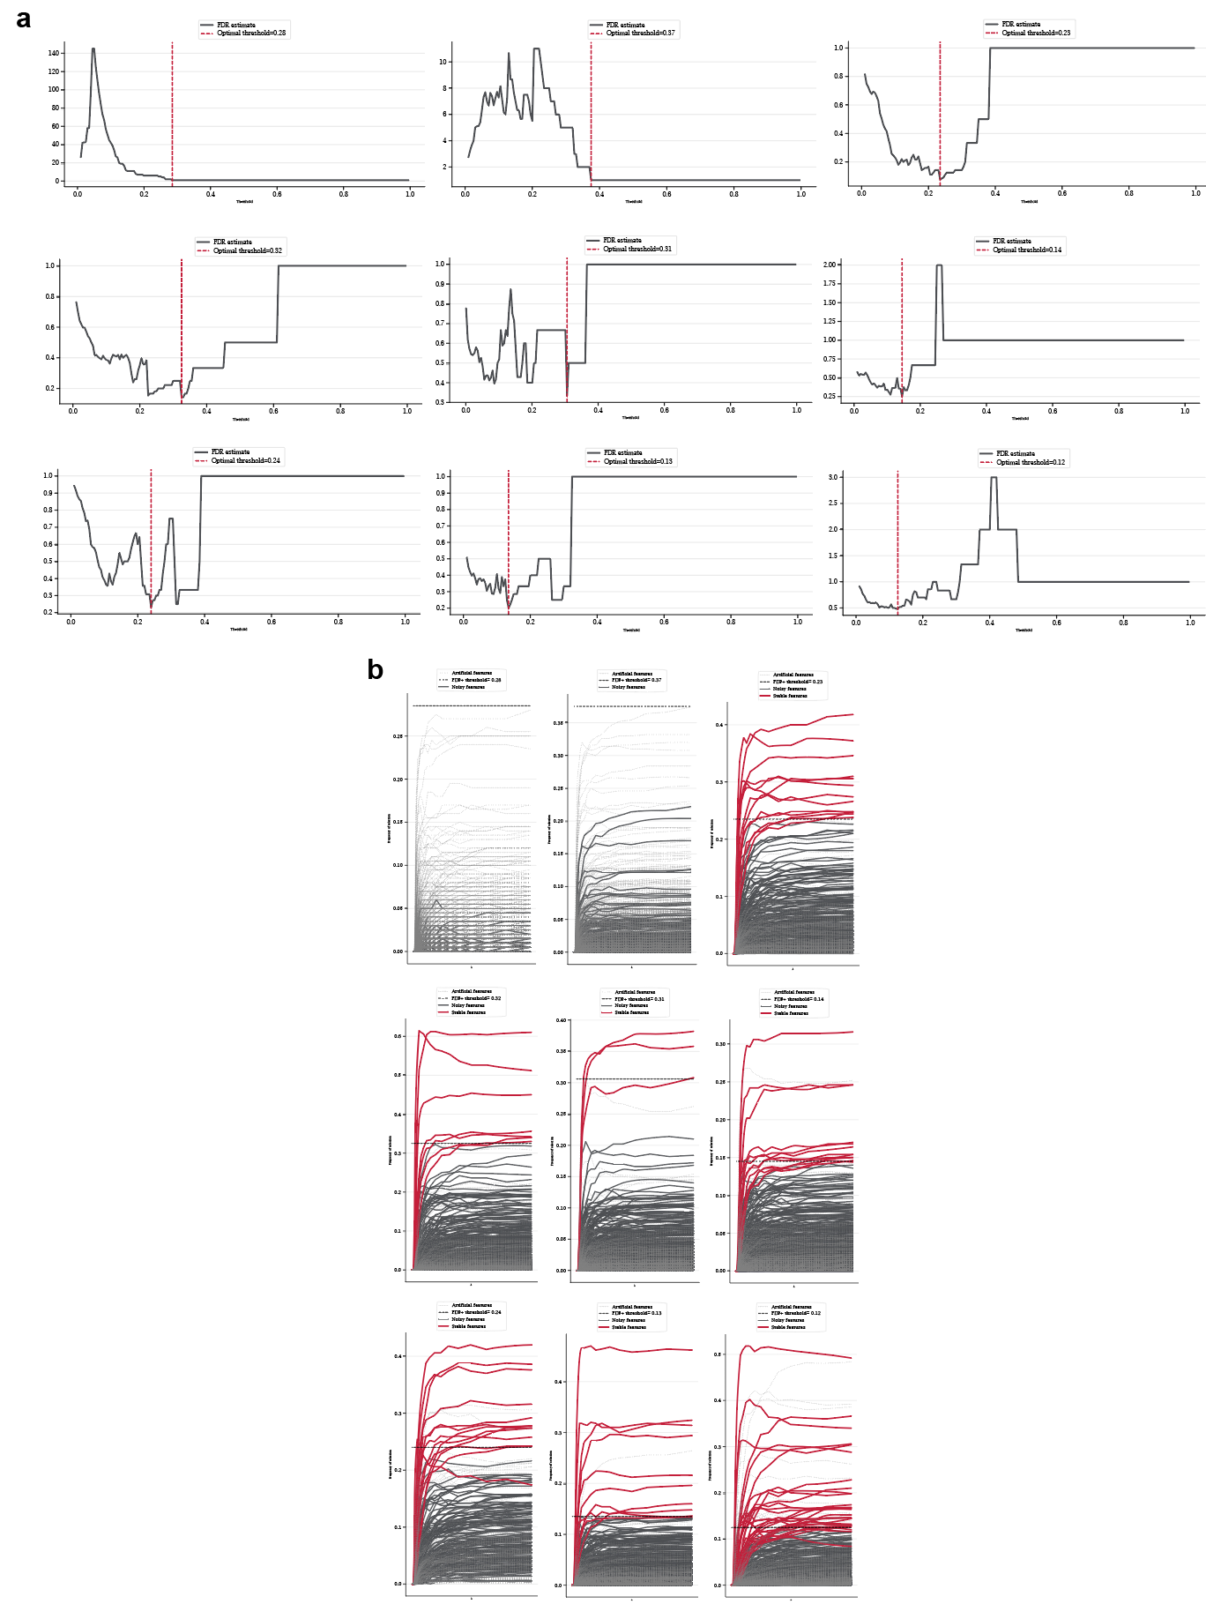Supplementary Figure 1: False-discovery estimates and feature selection paths for each feature family. a) Estimated feature false-discovery rates for each feature family, from left-to-right and top-to-bottom: spatial interaction metrics. b) Feature selection paths across regularization weights for each feature family.
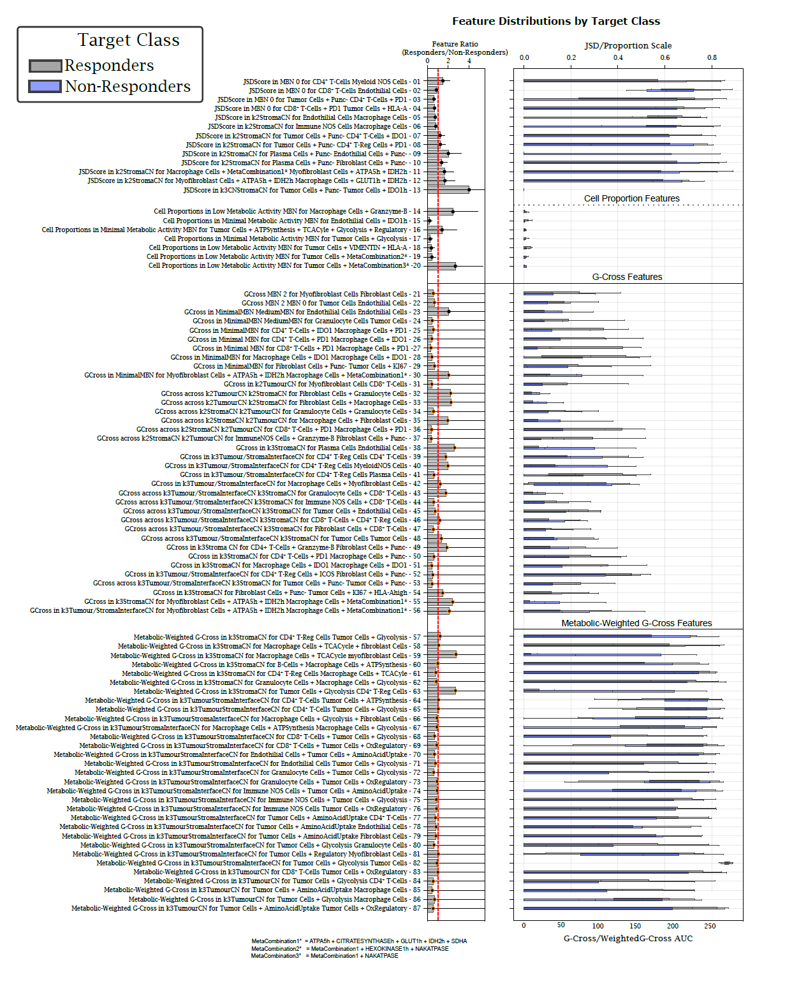
Supplementary Figure 2: Feature distribution by Target Class. Features are separated by feature family and relative importance is shown

