Early Diagnosis of Pancreatic Ductal Adenocarcinoma Using Signal-Enhanced Lateral Flow Immunoassay: SELFI
Sohyeon Jang,^{1†} Minsup Shin,^{1†} Jiseok Han,^{2†} Han-Joo Bae,¹ Yuna Youn,³ Hye-Seong Cho,¹ Kwanghee Yoo,¹ Jun-Sik Chu,¹ Jaehyun An,⁴ Hyejin Chang,⁵ Jin-Hyeok Hwang,^{3,6} Jaehi Kim,^{1*} Jihwan Song,^{2*} Jong-chan Lee,^{3,6*} Luke P. Lee,^{7,8,9*} and Bong-Hyun Jun^{1*}
†These authors contributed equally to this work.
*Correspondence: bjun@konkuk.ac.kr; susia45@gmail.com; jsong@hanbat.ac.kr; ljc0316@snubh.org; lplee@harvard.edu
Supplementary Note, Tables, and Figures
Supplementary Note 1: Human resource data information
We are conducting a National Research Funding project under the BRIDGE Convergence R&D program of the Ministry of Science and ICT of the Republic of Korea, entitled "Development of Early Detection Technology for Pancreatic Cancer via Liquid Biopsy Using Fiber Optic-Based Raman Spectroscopy and Artificial Intelligence System" (Project number: NRF-2021M3C1C3097204).
As part of this project, we established a comprehensive database comprising 150 human subjects at a single tertiary hospital. The subjects were categorized into three distinct groups: 50 healthy controls, 40 patients with early-stage (resectable) pancreatic cancer, and 60 patients with advanced-stage (locally advanced or metastatic) pancreatic cancer. All blood samples and clinical data were collected following meticulous review and approval by the Institutional Review Board (IRB) of Seoul National University Bundang Hospital. This database has been approved for the publication of multiple research papers that focus on various engineering measurement methodologies.
Baseline characteristics
The baseline characteristics are summarized in Supplementary Table 1. The healthy control group was propensity-matched to the cancer group for age and sex, resulting in no statistically significant differences in these variables across the three groups. Tumor location showed no significant difference between the resectable pancreatic cancer (RPC) and advanced pancreatic cancer (APC) groups, with head cancer accounting for 46% of all cases. The tumor size was significantly larger in the APC group (median: 3.8 cm) compared to the RPC group (median: 2.2 cm). All subjects were Southeast Asians.
Ethics approval
Ethical approval was obtained from the Human Bioresource Center of Seoul National University Bundang Hospital (Affiliated College of Medicine, Seoul National University). The protocol was reviewed and approved by the IRB (approval number: X-2011-651-903) and conducted in accordance with the Declaration of Helsinki. Private patient information was anonymized and de-identified before analysis.
Consent to participate
All participants provided informed consent under the condition of guaranteed anonymity when donating their samples to the Human Resources Center at Seoul National University Bundang Hospital. Consent included the following components: (1) donation of blood or tissue samples, (2) provision of basic clinical information, and (3) exemption from the requirement to obtain additional consent for future related research. These provisions were subsequently reviewed by the IRB of Seoul National University Bundang Hospital and confirmed to be exempt from further approval.
Availability of data and material
The data that support the findings of this study are not openly available for reasons of sensitivity but are available from the corresponding author upon reasonable request. Data are stored in controlled-access repositories at the Human Bioresource Center of Seoul National University Bundang Hospital.

Supplementary Table 1: Baseline characteristics of subjects
Variables | Healthy control  (n = 50) | RPC group  (n = 40) | APC group  (n = 60) | Total  (n = 150) | P value
Age | 64 (60–69) | 66 (58–73) | 68 (61–75) | 68 (63–75) | 0.081
Sex, n (%) |  |  |  |  | 0.684
Male | 27 (54) | 18 (45) | 31 (52) | 76 (51)
Female | 23 (46) | 22 (55) | 29 (48) | 74 (49)
Tumor location* |  |  |  |  | 0.675
Head | – | 17 (43) | 29 (48) | 46 (46)
Body | – | 11 (27) | 12 (20) | 23 (23)
Tail | – | 12 (30) | 19 (32) | 31 (31)
Tumor size (cm)* | – | 2.2 (1.5–2.9) | 3.8 (2.5–5.2) | 2.9 (2.2–4.2) | 0.003
Continuous variables are presented as medians with interquartile ranges, while categorical variables are presented as numbers with percentages. Healthy controls were designated and distributed as samples from individuals aged 58 and older at the blood sample distribution stage. *Tumor location and tumor size were analyzed based on a total of 100 individuals, excluding healthy controls.
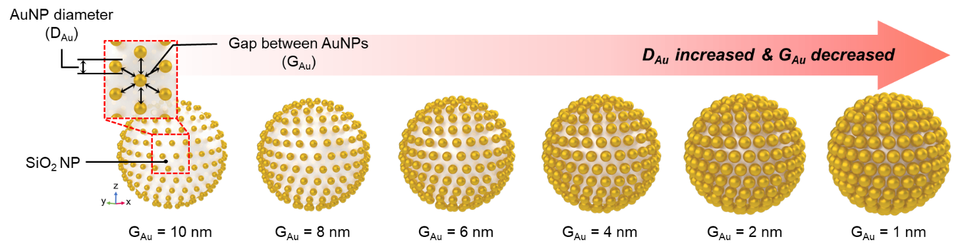
Supplementary Fig. 1: Model geometry of the assembled nanostructure for wave optics simulation and various model geometries for different G_{Au}.
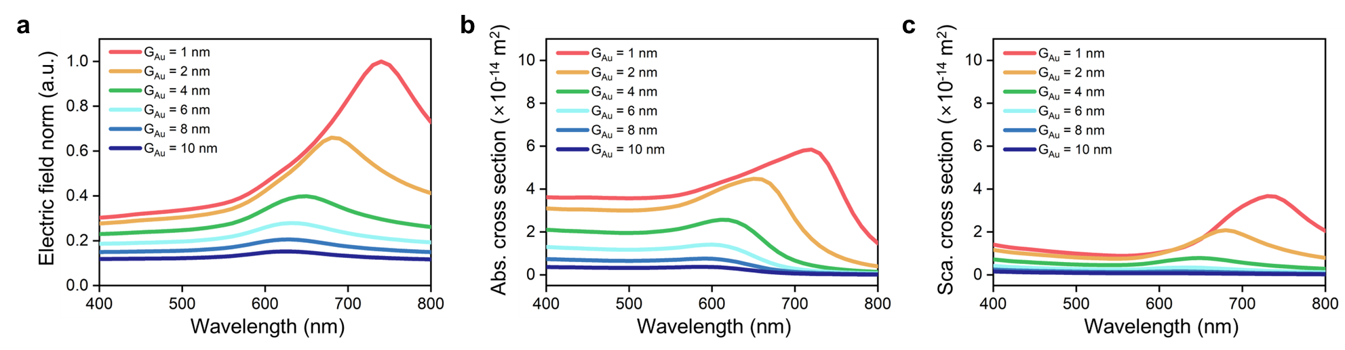
Supplementary Fig. 2: Electric field norm, scattering cross-section, and absorption cross-section spectra for different G_{Au}.
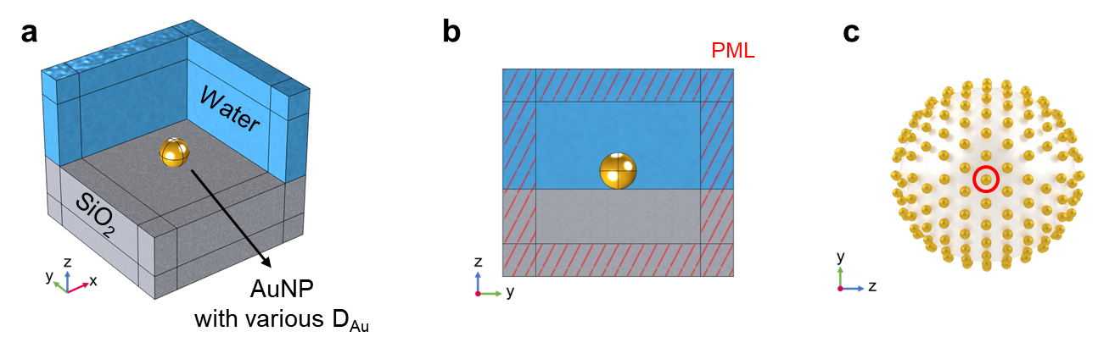
Supplementary Fig. 3: Wave optics simulation of a single AuNP. (a) Simulation domain of a single AuNP on a SiO₂ substrate. (b) Perfectly matched layer in the x-, y-, and z-directions. (c) Comparison of an AuNP on the assembled nanostructure.
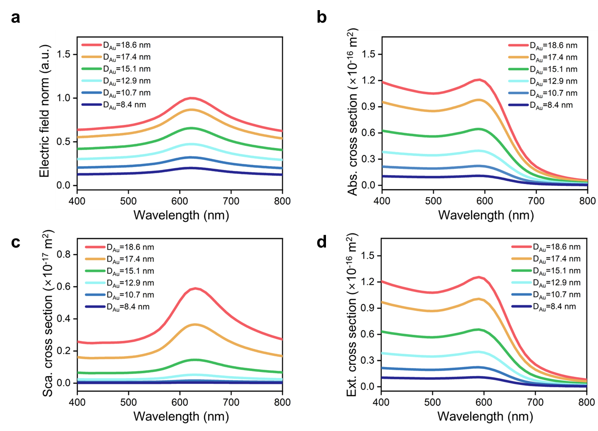
Supplementary Fig. 4: (a) Electric field norm, (b) absorption cross-section, (c) scattering cross-section, and (d) extinction cross-section spectra of a single AuNP depending on D_{Au}.
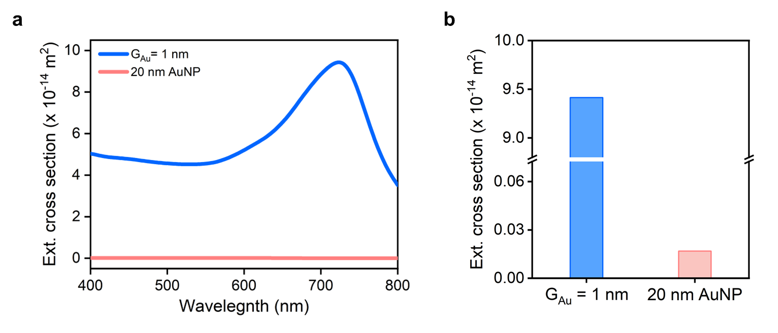
Supplementary Fig. 5: Comparison of extinction cross-sections between a 20 nm AuNP and an assembled nanostructure with a G_{Au} of 1 nm. (a) Extinction cross-section spectra. (b) Extinction cross-section at peak wavelength.
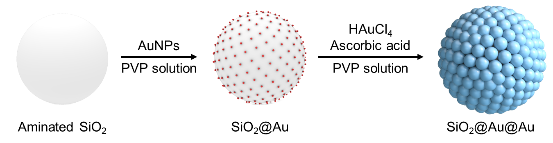
Supplementary Fig. 6: Schematic illustration of the fabrication of SiO₂@Au@Au NPs.
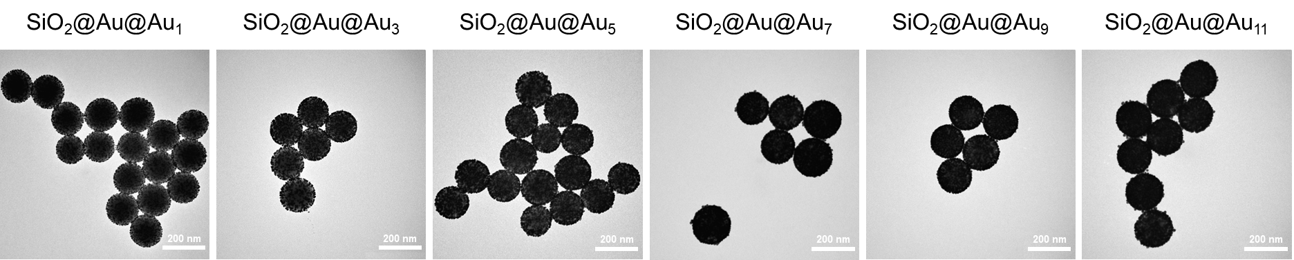

Supplementary Fig. 7: Low-magnification TEM images of SiO₂@Au@Au₁, SiO₂@Au@Au₃, SiO₂@Au@Au₅, SiO₂@Au@Au₇, SiO₂@Au@Au₉, and SiO₂@Au@Au₁₁ NPs. Scale bars, 200 nm.
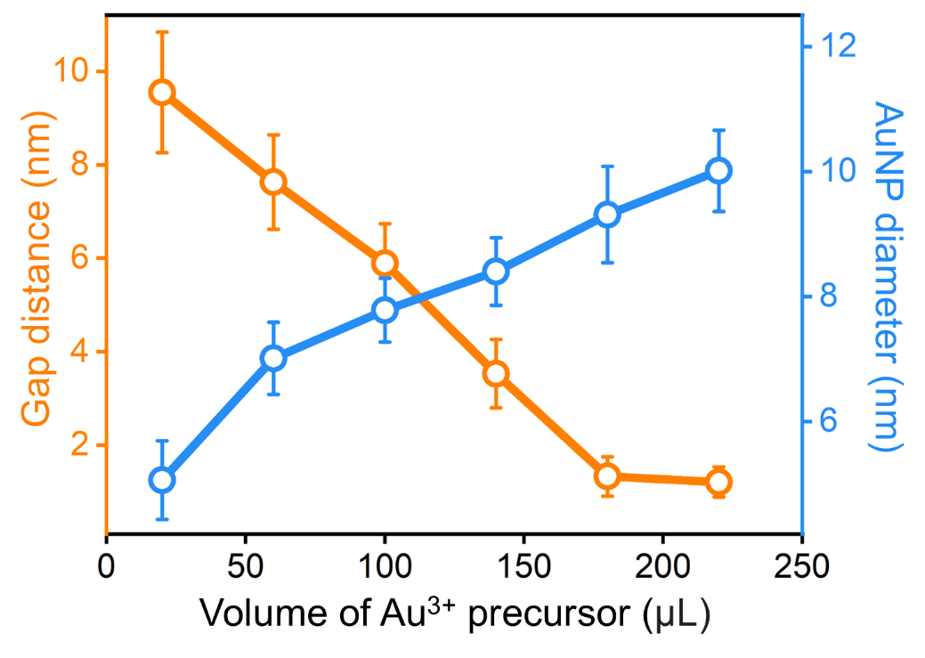
Supplementary Fig. 8: Change in gap distance and diameter of AuNPs on the fabricated nanostructure according to the amount of Au³⁺ precursor used (n = 20).
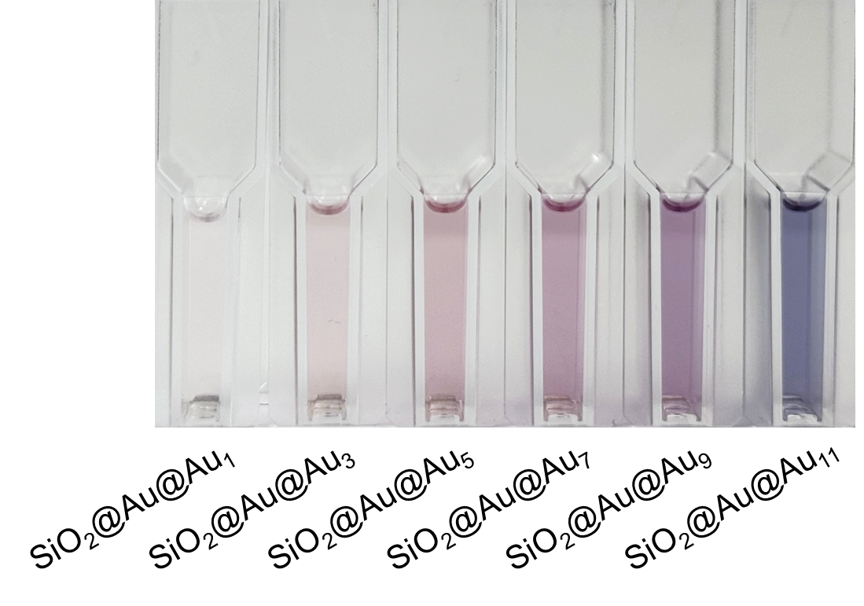
Supplementary Fig. 9: Photograph of the fabricated NP suspension mixture.
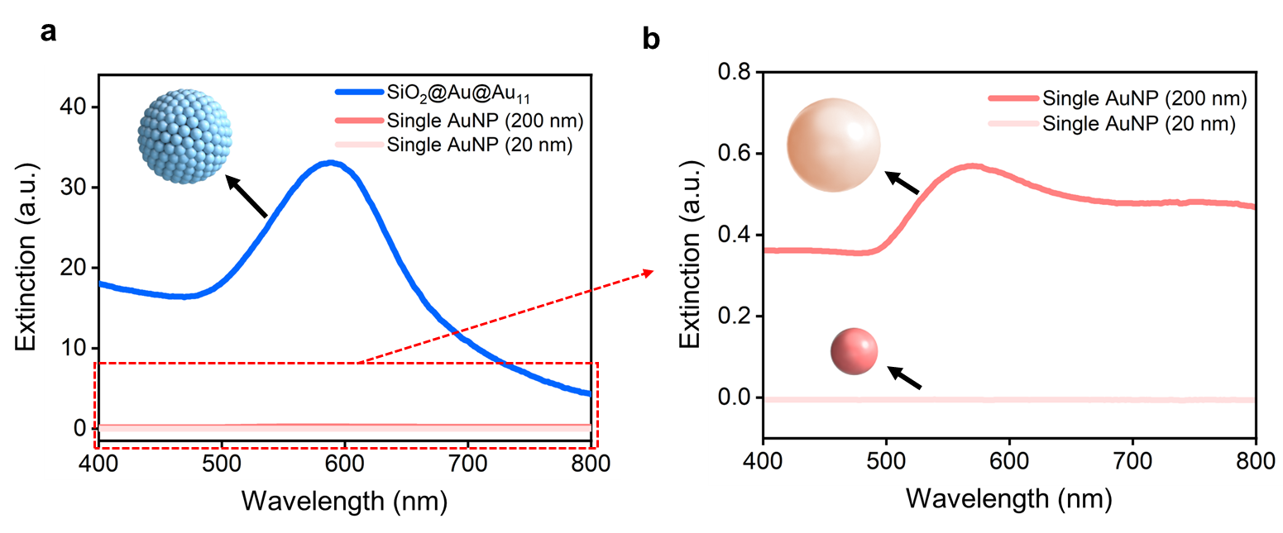

Supplementary Fig. 10: UV-Vis extinction spectra of SiO₂@Au@Au₁₁, 20 nm AuNPs, and 200 nm AuNPs. The particle concentration of all samples was adjusted to the same level.
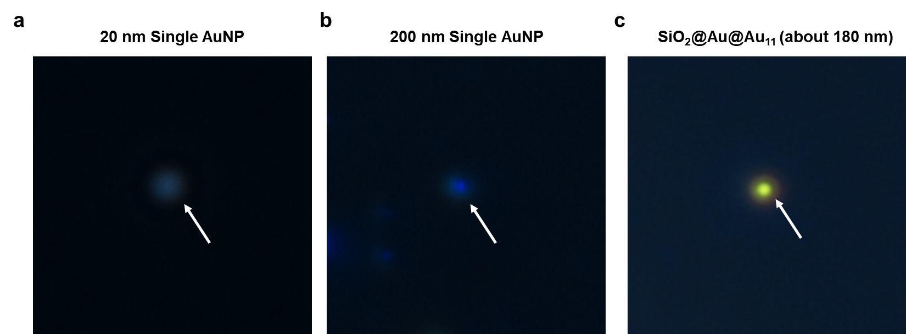

Supplementary Fig. 11: Dark-field images of (a) single AuNPs with a diameter of 20 nm, (b) single AuNPs with a diameter of 200 nm, and (c) SiO₂@Au@A_{u11} NPs. White arrows in the images indicate the corresponding NPs.
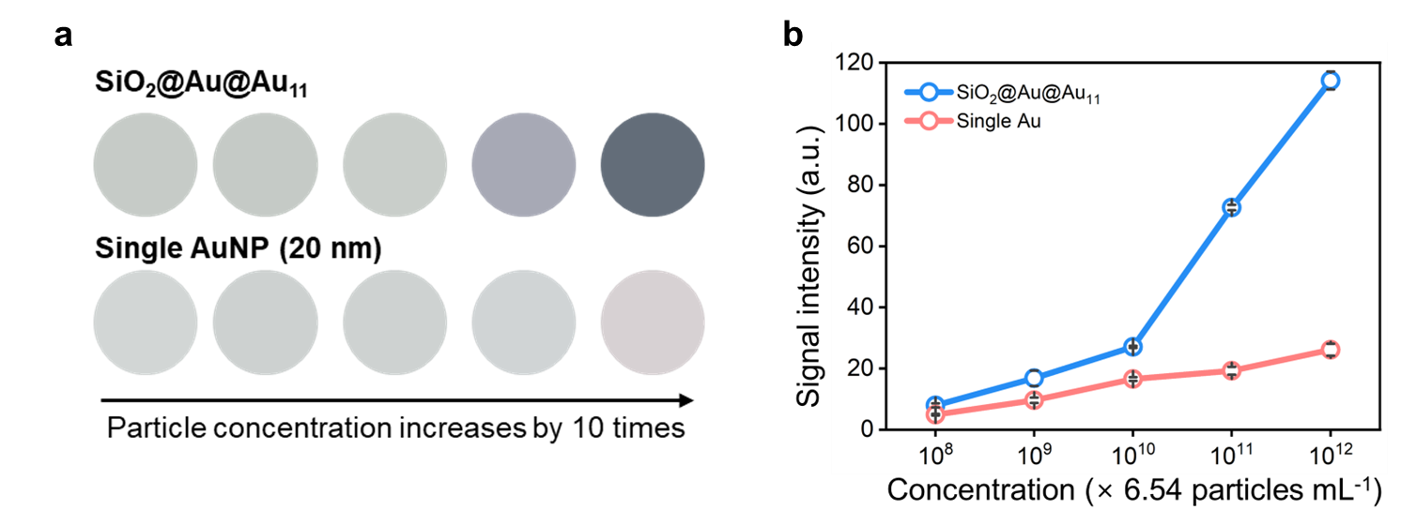
Supplementary Fig. 12: (a) Photographs of NP-dropped NC membrane. (b) Colorimetric signal intensity of NP-dropped NC membrane. The colorimetric signal intensity was measured using the ImageJ software (n = 3).
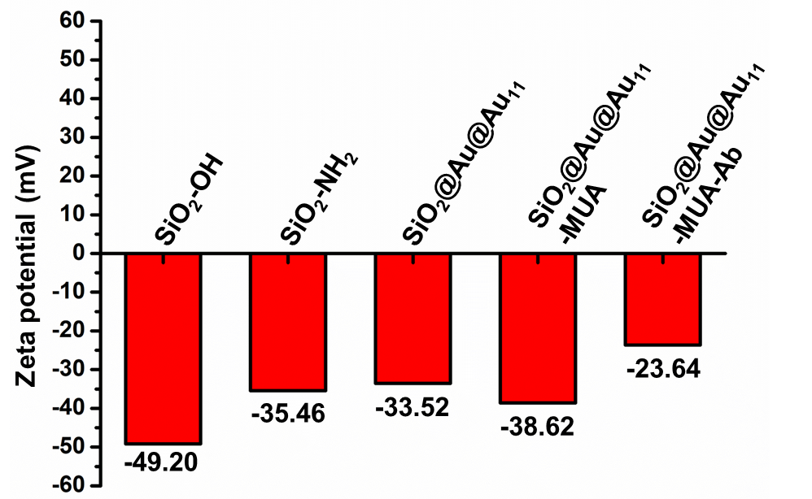

Supplementary Fig. 13: Zeta potential of SiO₂ NPs (SiO₂-OH), aminated SiO₂ NPs (SiO₂-NH₂), SiO₂@Au@Au₁₁ NPs, 11-MUA-attached SiO₂@Au@Au₁₁ NPs (SiO₂@Au@Au₁₁-MUA), and antibody-conjugated SiO₂@Au@Au₁₁ NPs (SiO₂@Au@Au₁₁-MUA-Ab).
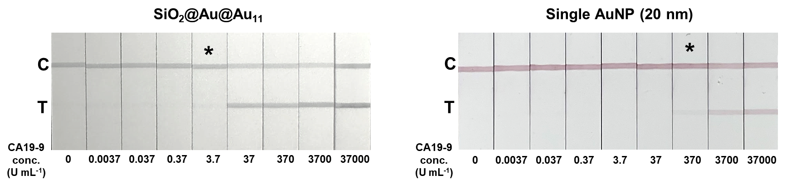
Supplementary Fig. 14: Photographs of the NC membrane after developing the nanoprobes with corresponding concentrations of CA19-9 (C: control line, T: test line, * represents the limit detectable by the naked eye).
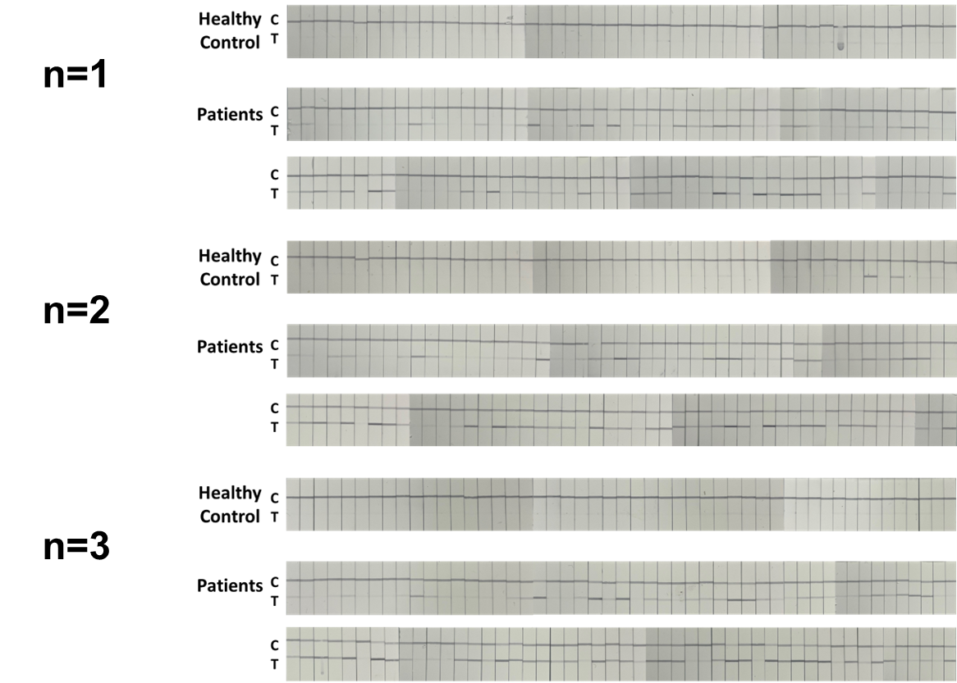

Supplementary Fig. 15: Photographs of the NC membrane after SELFI analysis with serum samples. Serum samples consisted of 50 samples from healthy controls, 40 samples from patients with PDAC in the early-stage, and 60 samples from patients with PDAC in the late-stage.
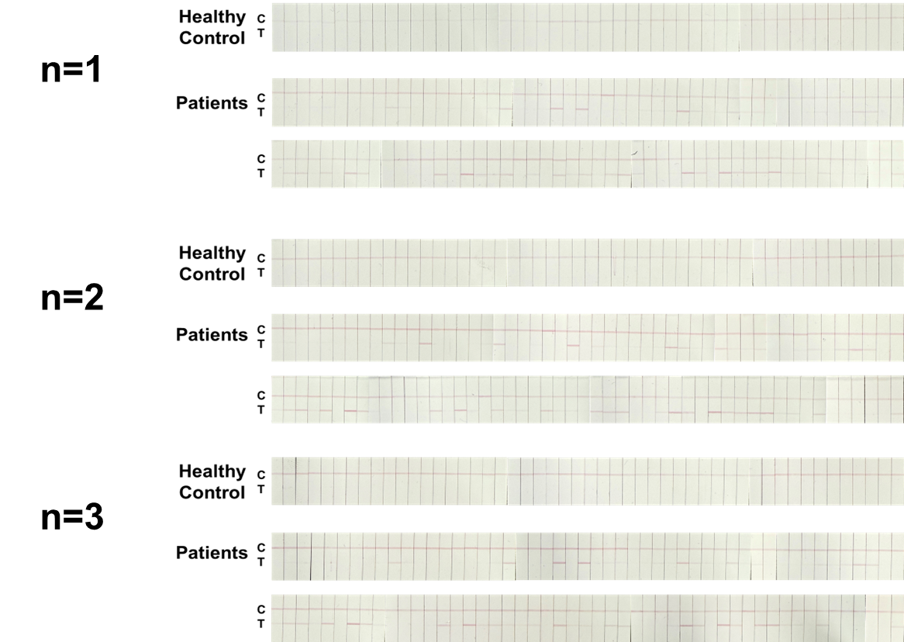

Supplementary Fig. 16: Photographs of the NC membrane after LFIA analysis with serum samples. Serum samples consisted of 50 samples from healthy controls, 40 samples from patients with PDAC in the early-stage, and 60 samples from patients with PDAC in the late-stage.
Supplementary Table 2: Quantitative analysis of CA19-9 in serum samples by ELISA, LFIA, and SELFI. Serum samples consisted of 50 samples from healthy individuals (samples #1 to #50), 40 samples from patients with early-stage PDAC (samples #51 to #90), and 60 samples from patients with late-stage PDAC (samples #91 to #150).
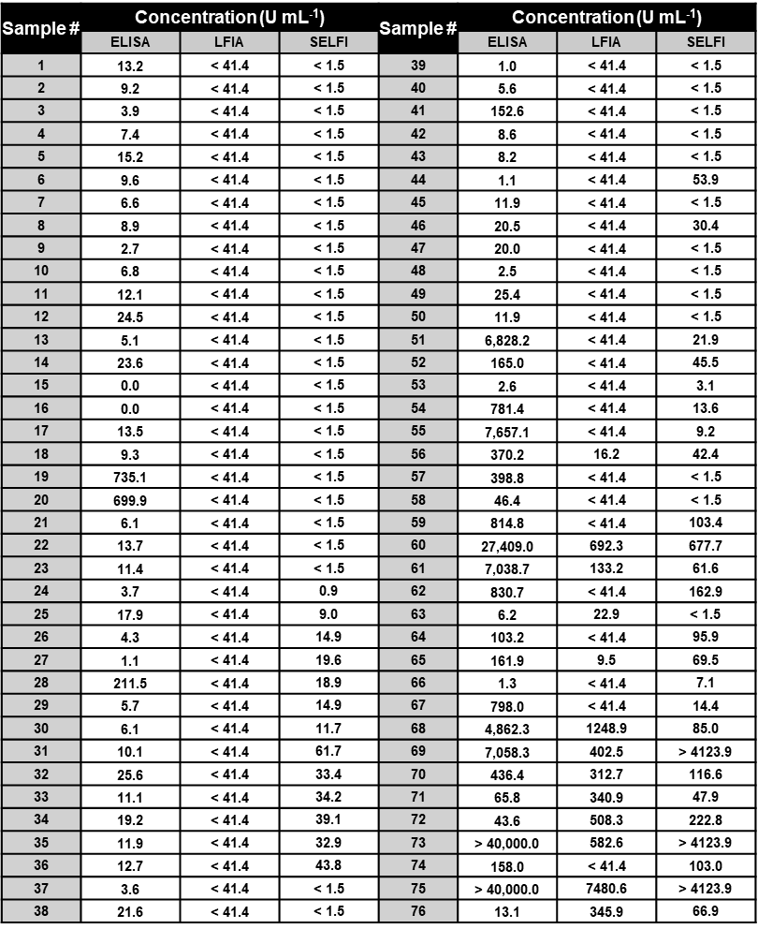
Supplementary Table 2: (continued)
