Supplemental files
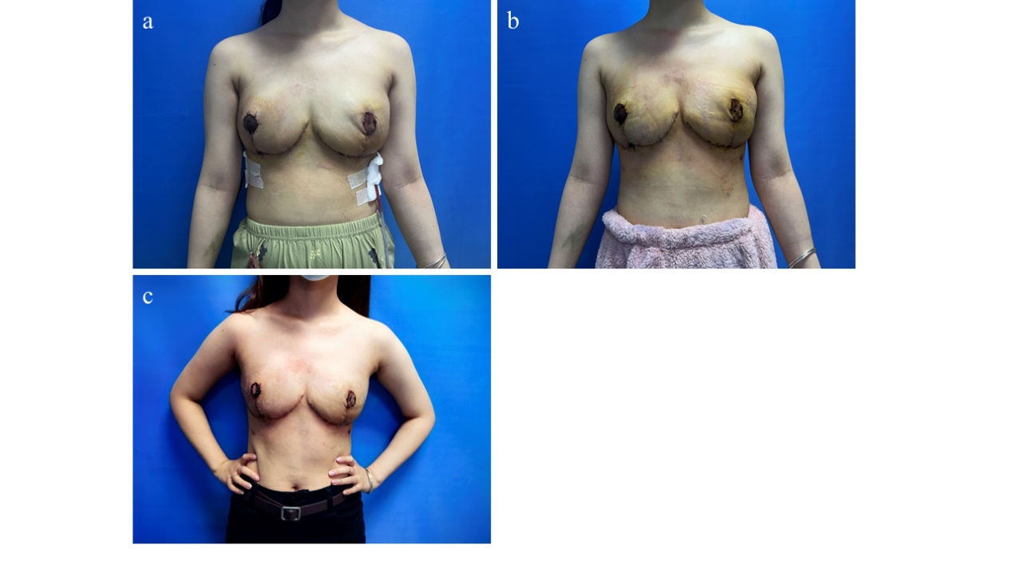
The patient showed satisfactory recovery postoperatively, with good symmetry of the breasts following surgical treatment. (a) February 3, 2024, 4 days postoperative. (b) February 7, 2024, 8 days postoperative. (c) February 15, 2024, 16 days postoperative.

