Supplementary Materials

kinCSM: using graph-based signatures to predict small molecule CDK2 kinase inhibitors
Yunzhuo Zhou^{1,2,3}, Raghad Al-Jarf^{1,2,3}, Azadeh Alavi^{1,2,3,4}, Thanh Binh Nguyen^{1,2,3,4}, Carlos H.M. Rodrigues^{1,2,3}, Douglas E.V. Pires^{1,2,3,5*}, David B. Ascher^{1,2,3,4,6*}
¹Structural Biology and Bioinformatics, Department of Biochemistry, University of Melbourne, Melbourne, Victoria, Australia
²Systems and Computational Biology, Bio21 Institute, University of Melbourne, Melbourne, Victoria, Australia
³Computational Biology and Clinical Informatics, Baker Heart and Diabetes Institute, Melbourne, Victoria, Australia
⁴Baker Department of Cardiometabolic Health, Melbourne Medical School, University of Melbourne, Melbourne, Victoria, Australia
⁵School of Computing and Information Systems, University of Melbourne, Melbourne, Victoria, Australia
⁶Department of Biochemistry, University of Cambridge, 80 Tennis Ct Rd, Cambridge CB2 1GA
*To whom correspondence should be addressed D.B.A. Tel: +61 90354794; Email: david.ascher@unimelb.edu.au. Correspondence may also be addressed to D.E.V.P. douglas.pires@unimelb.edu.au.

TABLES
Table S1. Contingency table for a fragment (the blue fragment in Figure S2) enriched in CDK2 inhibitors.

 | Inhibitors | Non-inhibitors
Cases (with the fragment) | 168 | 7
Controls (without the fragment) | 872 | 587

FIGURES
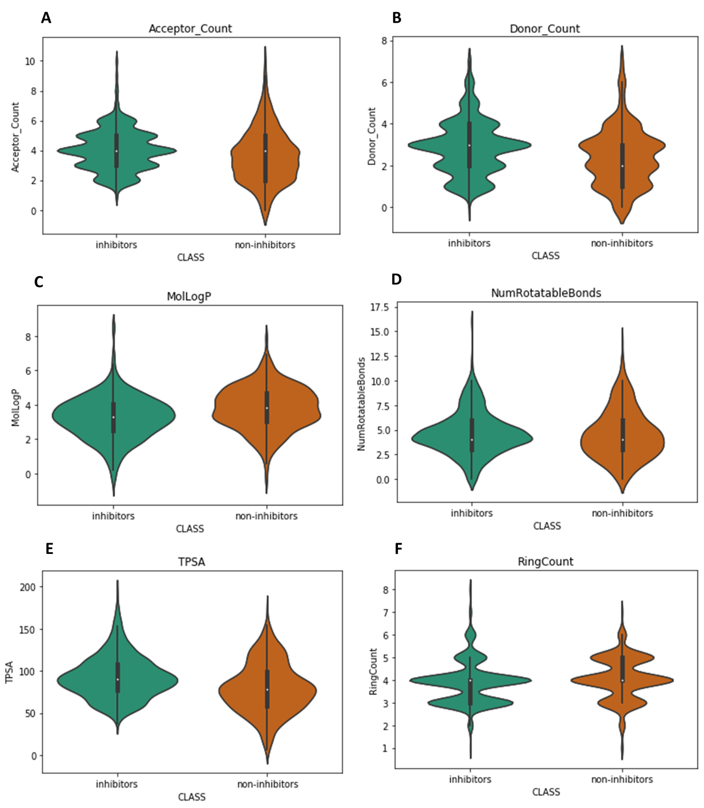
Figure S1. Drug likeness property distributions for CDK2 inhibitors compared to non-inhibitors. The violin plots show distributions of six physicochemical properties evaluating the drug likeness, including hydrogen acceptor and donor counts, log P, number of rotatable bonds, topological polar surface area (TPSA) and ring count. The white dot represents the median, and the range from the first quartile to the third quartile are shaded in black (applied to all the violin plots in this supplementary document). We found both inhibitors (n = 595) and non-inhibitors (n = 1040) obey Lipinski's rule of five (RO5).
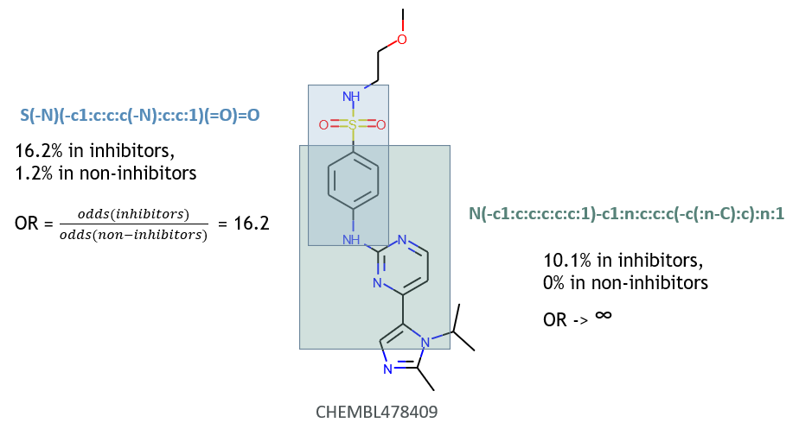

Figure S2. Substructure enrichment in CDK2 inhibitors. The top left fragment (in blue), sulfanilamide contains a sulfonamide and two hydrogen donors (nitrogen atoms at the top and the bottom). It occurs 16.2% in inhibitors, 1.2% in non-inhibitors, with an odds ratio of 16.2. The bottom right fragment, 2-(N-Anilino)pyrimidine contains heterocyclic rings that can mimic the adenine part of the ATP. It occurs 10.1% in inhibitors, never in non-inhibitors, so the odds ratio would tend to infinity.

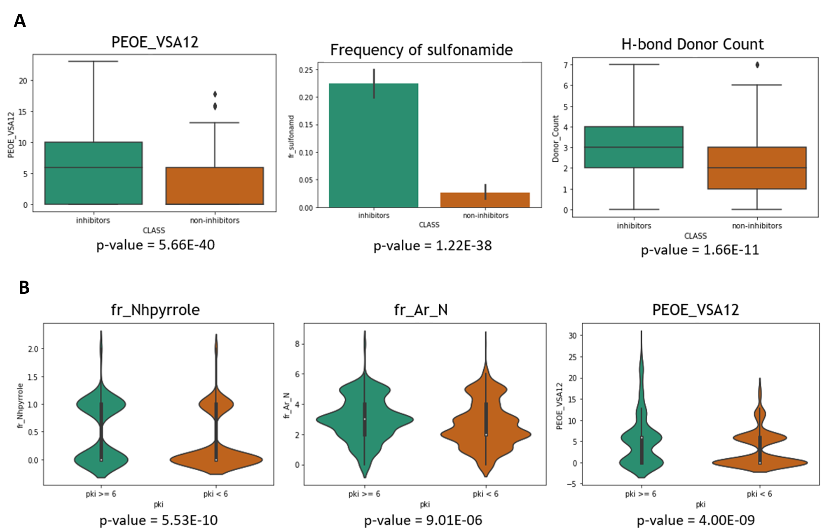
Figure S3. Plots comparing CDK2 inhibitors and non-inhibitors. A) Inhibitors have higher PEOE_VSA12 (which captures partial charges and van der Waals surface area contributions), higher frequency of sulfonamide and hydrogen bond donors compared to non-inhibitors (two-sample Kolmogorov-Smirnov test p-values < 0.001). B) Molecules with higher binding affinity (pK_{i} ≥ 6) are more likely to contain Pyrrole, they also have higher fr_Ar_N and PEOE_VSA12 (two-sample Kolmogorov-Smirnov test p-values < 0.001).

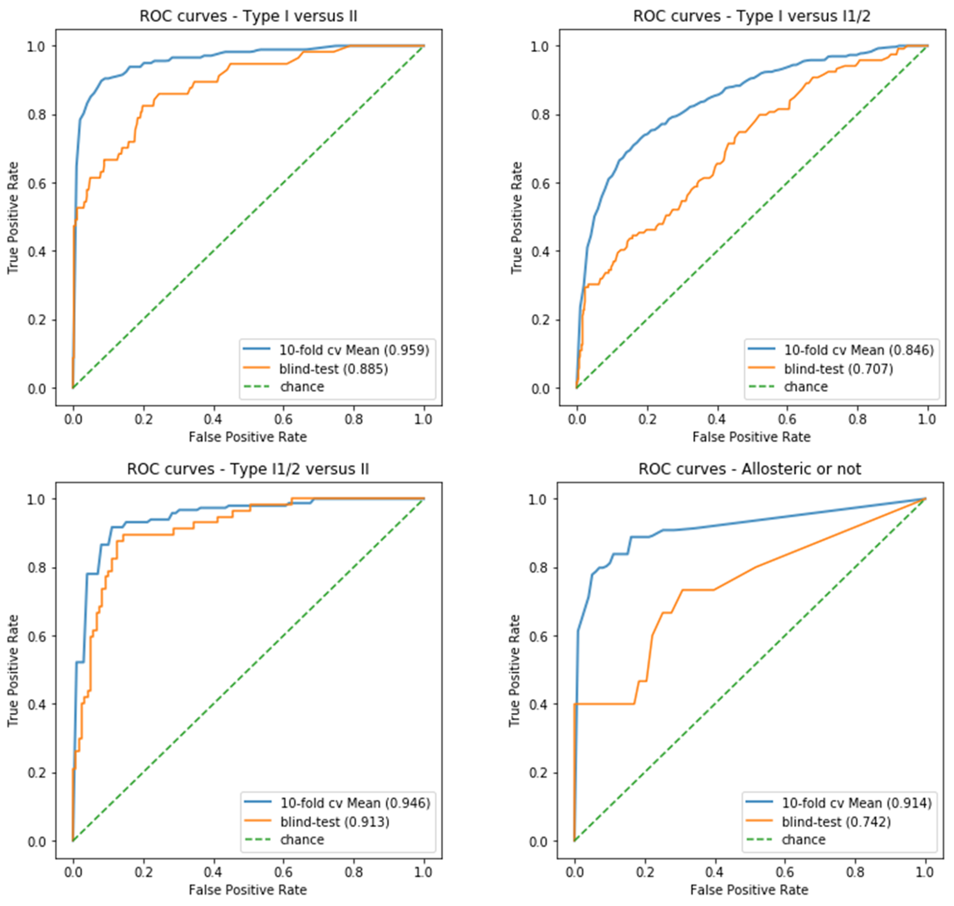
Figure S4. ROC curves for different binding mode classifiers. The ROC curves for type I versus II, type I versus I1/2, type I1/2 versus II and allosteric versus non-allosteric are plotted. The type I1/2 versus II classifier has the highest Area Under the Curve, which means it can achieve higher performance by modifying the learned priors in our model.

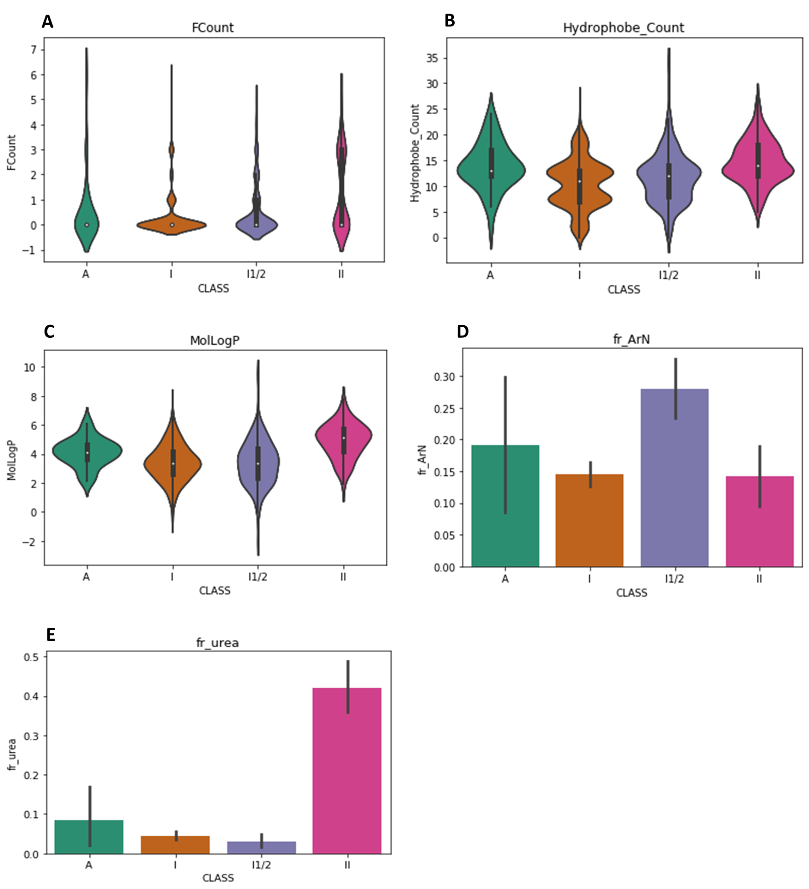
Figure S5. Physicochemical properties of different types of kinase inhibitors. Panels A (FCount) and B (Hydrophobe_Count) show structural continuum of type I, I1/2 and II inhibitors, where type II have the highest fluorine and hydrophobe pharmacophores (two-sample Kolmogorov-Smirnov test p-values < 0.001 compared to both type I and I1/2). Type I1/2 shows a similar distribution of MolLogP with type I (panel C), but higher fr_ArN (panel D) with p-values < 0.001 makes it distinguishable from other types. Type II inhibitors have higher frequency of urea (panel E) with p-values < 0.001. In the bar plots, the ranges from the first quartile to the third quartile are shown in black lines.
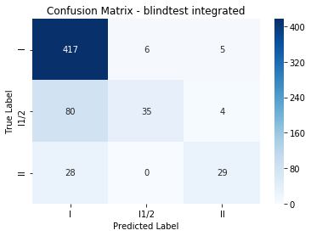
Figure S6. Integrated prediction performance on the blind test set. The prediction outcomes of binary classifiers were merged to enable multi-class classification according to the majority vote.

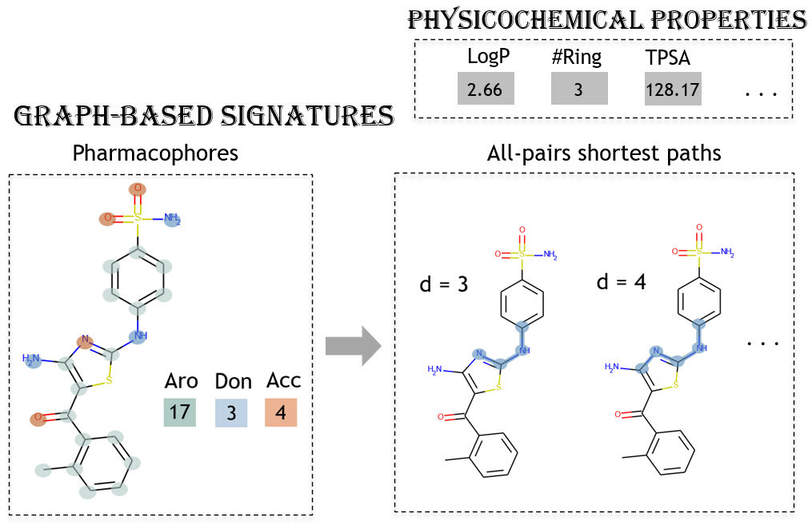Figure S7. Features generated by pkCSM. Two types of features are generated, including molecular properties (top right panel) and distance distribution between pharmacophore pairs (bottom left and bottom right panels). The example molecule is a type I1/2 CDK2 inhibitor, named RC-3-96 (PDB Chemical ID: 99Z).

