Supplementary Materials for

Chip-based 3D Interferometric Nanoscopy
Supplementary Notes:
- Supplementary Notes I: Theoretical analysis of Cramer Rao Lower Bound (CRLB)
- Supplementary Notes II: Influence of fluorophore ‘on’ time variation on SiLM localization precision
- Supplementary Notes III: Characterization of fluorophore ‘on’ time
- Supplementary Notes IV: FOV Alignment in SiLM
Supplementary Figures:
- Supplementary figure S1: Excitation standing wave pattern above Silicon substrate
- Supplementary figure S2: Optimal incidence angles for SiLM imaging
- Supplementary figure S3: Operational principles of SiLM
- Supplementary figure S4: SiLM image processing flowchart
- Supplementary figure S5: Influence of "on" time on localization precision
- Supplementary figure S6: Fourier ring correlation analysis of SiLM
- Supplementary figure S7: Influence of system drift on extracted 3D position in SiLM
- Supplementary figure S8: Versatility of SiLM
- Supplementary figure S9: Dual-Color SiLM imaging of focal adhesions
- Supplementary figure S10: Mapping focal adhesions nanoscale architecture by SiLM
Supplementary Tables:
- Supplementary Table S1: Optimal incidence angles for 3-FOV acquisition
- Supplementary Table S2: Imaging parameters
- Supplementary Table S3: Statistics of FA protein vertical distribution

Supplementary Movies:
Supplementary Movies 1 Raw SiLM dataset
Supplementary Software:
https://github.com/KanchanawongLab/SiLM

Supplementary Notes
- Theoretical analysis of Cramer Rao Lower Bound (CRLB)
The point spread function (PSF) can be approximated using the Gaussian function as follows:
(S1)
With a pixel size denoted by s, the pixelated PSF is defined as:
(S2)
In SiLM, where we have three or more channels, the excitation intensity for each channel varies with the illumination angle. Therefore, for a total photon number N_{ph}, the intensity for each channel is defined as:
(S3)
(S4)
where β_{m} is the ratio between the intensity in one channel and the sum of intensities. Thus, the precision maps can be calculated from 3D Fisher information matrix which has the following form:
(S5)

The Cramer-Rao Lower Bound (CRLB) can be expressed as the diagonal of the inverse of the Fisher information matrix given by:
(S6)
Note that since the PSFs have an inversion symmetry, i.e., I_{m}(x, y) = I_{m}(−x, −y), we have the following relationships between the derivatives of the intensity:
(S7)
This means that the off-diagonal elements between the transverse and the axial localization is 0. Therefore, the lateral precision is the same as in 2D SMLM, which can be approximated as:
(S8)
where the precision is determined by the width of the PSFs. Note that the influence of pixel size is neglected here.
The third diagonal term in the Fisher information matrix is found to be:
(S9)
For the ideal case with no background photons, the axial precision can be approximated to be:
(S10)
where γ is a small constant to avoid division by zero when βm is zero. Equation (S10) can be utilized to compute the optimal angles for various wafer thicknesses. Since the number of angles is typically 3 or in the single digit, the optimization can be performed by an exhaustive search, considering only integral illumination angles, with GPU acceleration to speed up the optimization time. Empirical methods can also be employed to calculate the illumination angles. For example, one angle can initially be set at a fixed value, such as 48 degrees, and then the two other illumination angles are chosen to ensure even spacing in the intensity profile in the axial direction.
- Influence of fluorophore ‘on’ time variation on SiLM localization precision
In traditional Single Molecule Localization Microscopy (SMLM), the localization precision is influenced by the randomness in photon detection in the spatial dimension. In Modulated Excitation SMLM, an additional source of randomness is introduced in the temporal domain, where both the "on" time and the duration of each blinking molecule are random. Consequently, we revise the intensity for each illumination angle as follows:
(S11)
(S12)
where R_{m}(t) represents the influence of the time variation for channel m.
Figure S5a illustrates the simulation details for 𝑅_{𝑚}(𝑡) in 3-FOV case. Each molecule is randomly activated during one of three cycles, with the start time 𝑇_{start} representing the gap between the molecule activation and the nearest sub-cycle. The value of 𝑇_{start} is randomly chosen between 0 and the dwell time, as the molecule can only emit when the laser is on. For each molecule, the random "on" time is denoted as 𝑇_{on}. Therefore, 𝑅_{𝑚}(𝑡) can be directly calculated from 𝑇_{start} and 𝑇_{on}.
We analyzed the influence of "on" time in two scenarios. Firstly, we examine how the "on" time affects typical fluorophores, where 𝑇_{on} follows a distribution as shown in Fig. 2(b), under varying laser intensities. Secondly, we investigate the influence of "on" time within a small range, such as between 12-18 ms and 42-48 ms. In this case, the impact of "on" time on localization precision can be directly observed. Note that the influence of modulation time is also analyzed in Ref. S1, which reports that the influence of ‘on’ time is minimized when the number of cycles reaches around 25 during an exposure time of 50 ms. Our definition here is slightly different, as we use the on-time to cycle ratio instead. In Ref. S1, a higher laser power is used, resulting in an on-time of approximately 15 ms. Therefore, the on-time to cycle time ratio is around 7.5, which is similar to the value of 7 in this context.
For each situation, approximately 15,000 simulated image sets are generated for each axial position and subsequently fitted using SiLM routines. The total photon count is kept constant, while background noise and Poisson noise are incorporated into each sub-image. The localization precision in all three dimensions is calculated by determining the standard deviation of the distribution.
- Characterization of fluorophore ‘on’ time
To characterize the ‘on’ time of different fluorophores, the EMCCD is configured to image a small field of view (FOV) measuring 50 ×50 pixels in frame transfer mode. The exposure time and frame time are set to 4 ms and 6 ms, respectively. The galvo is continuously switched between three illumination angles with a dwell time of 0.9 ms and a movement time of 1.1 ms. Subsequently, 5000 frames are acquired while the detection galvo remains static. The raw images are fitted to extract the intensity and the position for each molecule separately. Localizations that are within a lateral distance of 80 nanometers in consecutive frames are categorized as corresponding to the same molecule. This process generates molecule lists containing information about the frame numbers where the molecules are present and their intensity profiles across frames.
- FOV Alignment in SiLM
The calibration step is essential for ensuring proper alignment of each FOV. SiLM employed two steps in the alignment process: coarse alignment and fine alignment. For 3-FOV alignment the alignment procedure can be described as follows. Coarse alignment involves interactively selecting each FOV in the raw image using a circular pattern that matches the FOV size. Subsequently, the approximate center position of each FOV is determined. Based on the center position obtained through coarse alignment, each FOV is cropped for further processing. Afterward, fine alignment is performed by first calculating the center positions and standard deviations of candidate single-molecule images from each FOV using standard peak detection and localization algorithm. The second FOV, which is centered in the raw images (for 3-FOV acquisition), serves as the reference FOV. The center positions (x_{i}, y_{i}) and standard deviations of the images of each candidate single molecule in this reference FOV are then used to construct a Gaussian mixture model (P):
(S13)
where 𝑁 represents the number of molecules extracted from the reference FOV. Similar to the reference FOV, candidate molecules are extracted from the FOV to be transformed, with the center coordinates of the k^{th} molecule denoted as $x_{k}$ and $y_{k}$. Consequently, the alignment problem between FOVs can be reformulated as determining how to transform the xy-coordinates in the subject FOV to generate new coordinates. These new coordinates are then incorporated into the Gaussian mixture model mentioned earlier to maximize the following objective function:
(S14)
where 𝑀 defines the number of molecules extracted from the FOV to be calibrated, and $x_{k}^{'}$ and $y_{k}^{'}$ are the transformed center coordinates of the k^{th} molecule in the subject FOV. The transformation is defined as:
(S15)
(S16)
where translation parameters (𝑑𝑥, 𝑑𝑦), the scaling parameter , and the rotation angle are the parameters to be determined by solving the maximization function defined in Eq. S14. This optimization problem can be solved using either scipy module in Python via scipy.optimize.minimize function or MATLAB via fmincon function. Once the transformation parameters between the subject FOV and the reference FOV are determined, the transformed images of the subject FOV can be generated using spline interpolation. By leveraging the Gaussian mixture model, this alignment method effectively aligns the FOV, even when the number of localizations and their intensities vary between FOVs.
Supplementary References
[1] Jouchet P, Poüs C, Fort E, et al. Time-modulated excitation for enhanced single-molecule localization microscopy[J]. Philosophical Transactions of the Royal Society A, 2022, 380(2220): 20200299.

Supplementary Figures
Figure S1 Excitation standing wave pattern above Silicon substrate (a) Photograph of SiLM specimen, with a piece of Si wafer placed with specimen-containing SiO₂ side facing down on a glass-bottom dish, forming a structured illumination chamber filled with aqueous imaging buffer. (b) Definition of illumination geometry for SiLM. (c) Theoretical attenuation (γ) of excitation as a function of incidence angle, θ, calculated for 640-nm TE-illumination at the glass/aqueous media interface. (d) Simulated structured excitation field for laser wavelength= 640 nm with intensity (heatmap) as a function of fluorophore position (z) and incidence angle (θ), for different SiO₂ thickness from nominal (1 nm) to 2000 nm. (e) Representative plots of excitation intensity from (d) for θ = 0°, 10°, 20°, 30°, 40°, and 50°. (f-g) Simulated plots of the period and phases of the standing wave as a function of excitation wavelength and incidence angle. The importance of SiO₂ layer thickness is illustrated whereby the thickness above ~λ/2n is necessary to generate a full range (2π) of standing wave phase to enable axial localization using 3 incidence angles.

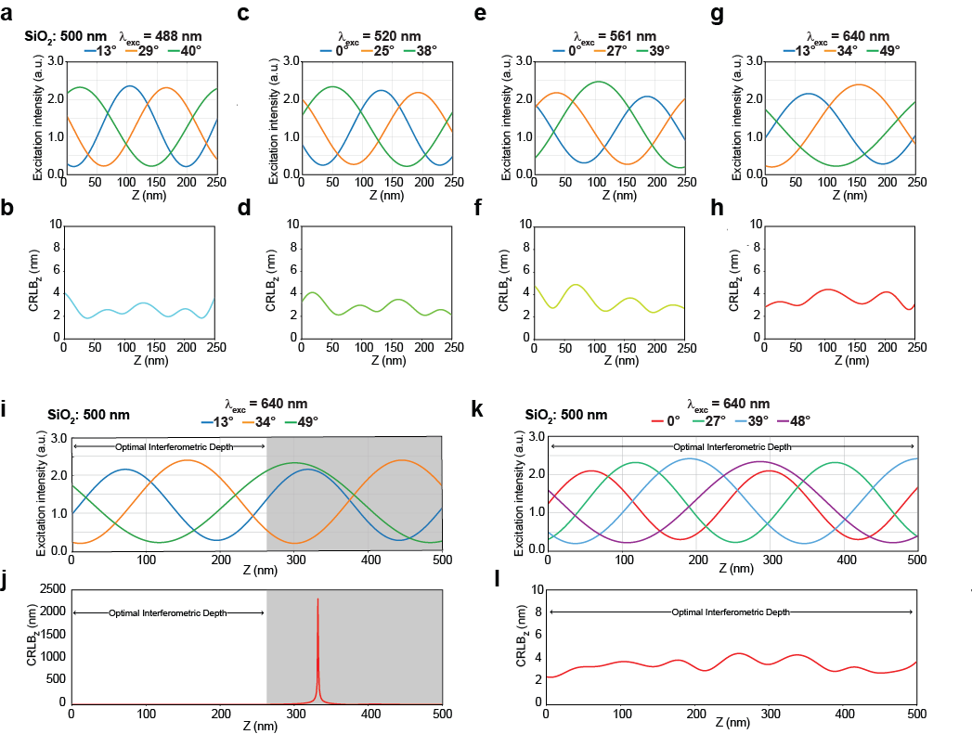
Figure S2 Optimal incidence angles for SiLM imaging (a-h) Optimal triplets of incidence angle for 488 nm, 520 nm, 561 nm, and 640 nm, calculated for SiO₂ thickness of 500 nm (a,c,e,g), and theoretical axial precision (CRLB_{z}) calculated for 500 photons over the range of z = (0,250 nm). (see also Supplementary Note I). (i-l) Axial precision over an extended depth range. Phase-wrapping artefacts arise for 3-angle SiLM for z > 250 nm, whereby the intensity curve for 13° illumination becomes similar to that of 48°, leading to ambiguity and poor axial precision in 300-350 nm range (j). Phase-wrapping can be resolved using additional illumination angles (k-l). For example, a quartet of optimal angles (0°, 27°, 38°, 48°) can be used to resolve ambiguity over a depth range of ~ 500 nm, enabling good axial precision over an extended depth range (l).

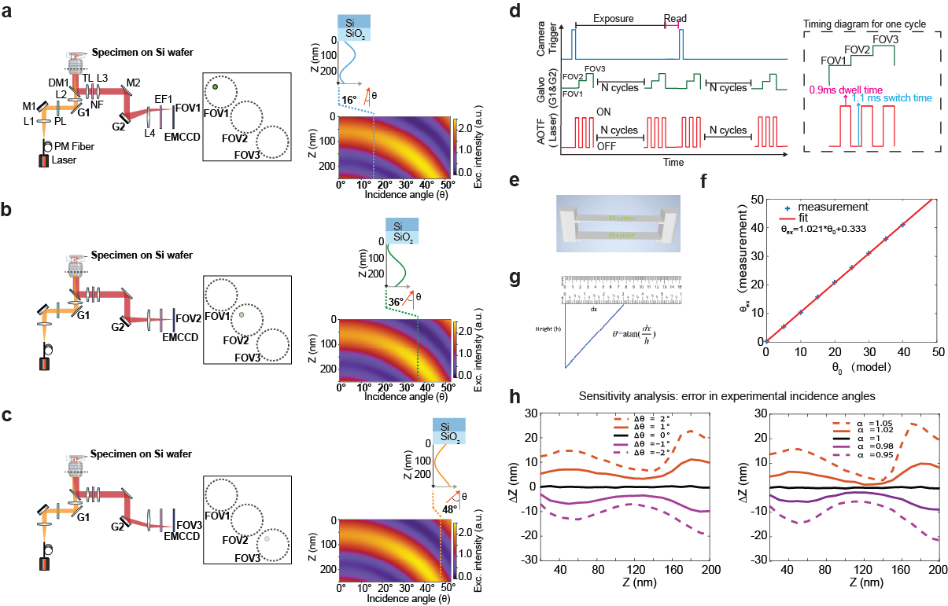
Figure S3 Operational principles of SiLM (a-c) Spatial multiplexing of different excitation incidence angles in SiLM (3-angle acquisition mode). For each camera frame, the scanning galvo mirrors G1 and G2 were synchronized to three different positions, corresponding to three incidence angles and three fields of view (FOVs), respectively, according to timing diagram in (d). Components depicted: L1-L4: lenses, M1-M2: mirrors, G1-G2: Scanning Galvo mirrors, PM Fiber: Polarization-maintaining optical fiber, PL: Linear polarizer, DM1: Dichroic mirror, TL: Tube lens, NF: Notch filter, EF1: Emission filter. Optimal angles for SiO₂ thickness of 481.4 nm and excitation wavelength of 639 nm are depicted (a: 16°, b: 36°, c: 48°) with the left insets indicate the standing wave pattern generated at each incidence angle. (d) Timing diagram depicting synchronization of camera read-out, galvo mirrors G1 and G2, and the AOTF controlling the laser illumination. (e) 3D-printed tool for angle calibration. During calibration, this is placed above the objective lens, whereby the laser beam positions on each crossbar are recorded and used to calculate the angle from trigonometric relationship (g). (f) Correspondence between angle measurement (blue) and fit (red). The fit parameters are used as correction factors during z-coordinate fitting. (h) Sensitivity analysis of the extracted z-position accuracy as a function of error in incidence angle determination. The error is modeled by 𝜃=𝛼𝜃₀+𝛿𝜃, with 𝜃₀ being the ground-truth value, 𝛼 the angle amplitude, and 𝛿𝜃 the angle shift.

Figure S4 SiLM image processing flowchart.
I: Calibration: image transformation matrices are calculated using the raw images acquired during the calibration step during which the illumination angles are kept constant (Supplementary Notes IV). II: Data Acquisition & Pre-processing. Raw images are cropped and registered using the transformation matrices from I. III: XY-Coordinate and Amplitude Fitting: Summed images of all channels are fitted to a Gaussian point spread function (PSF) to determine the xy-position and width (σ). These are then used to fit each channel individually, thus extracting the intensity. IV: Z-extraction: The intensities from all channels are fitted to theoretical intensity vs z curves to determine the axial position. V: 3D Coordinate post-processing: lateral drift correction is applied, followed by 3D image reconstruction and rendering of the 3D point clouds.

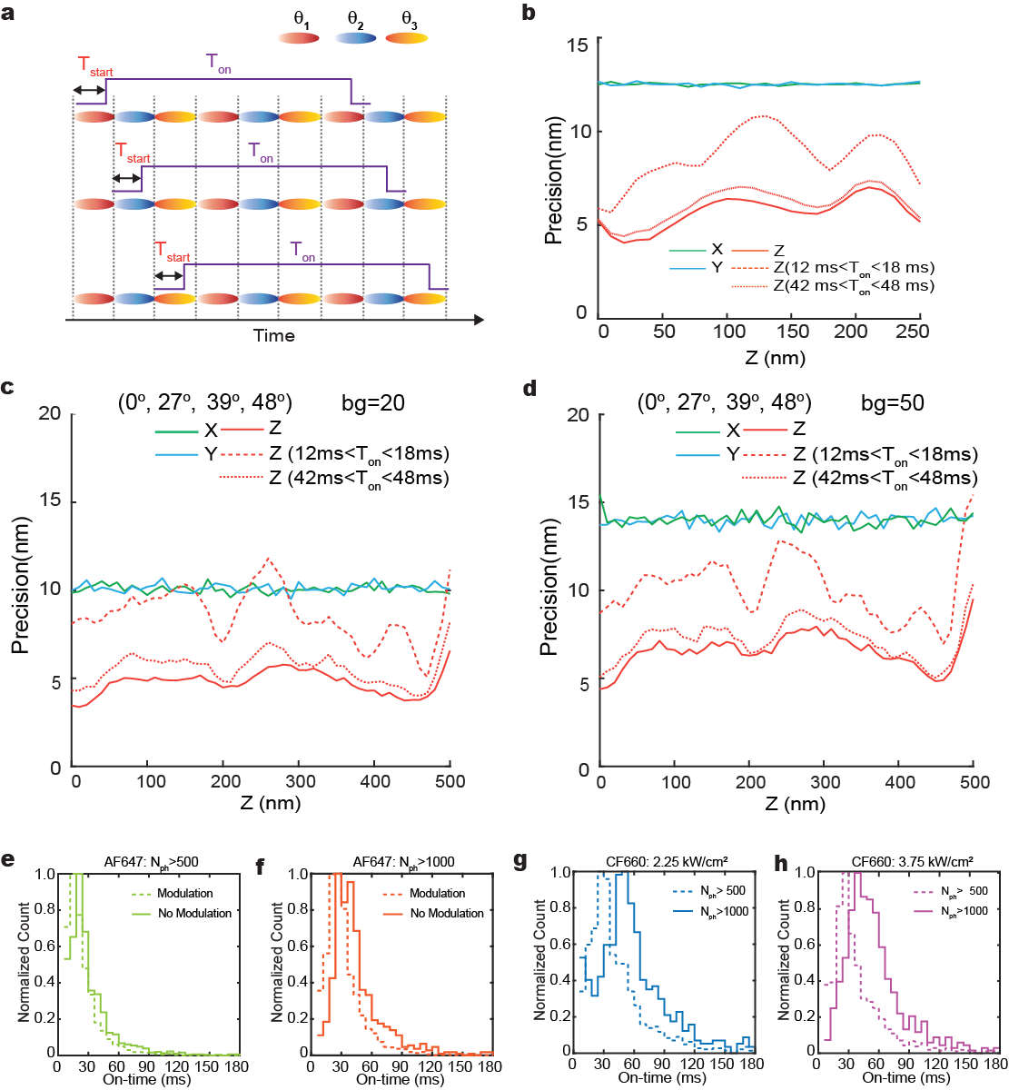
Figure S5 Influence of ‘on’ time on localization precision. (a) Schematic of 3-angle acquisition with blinking fluorophores having various start times, 𝑇_{start}, and "on" times, T_{on}. 𝑇_{start} is the lag between fluorescence onset and the nearest sub-cycle. For our analysis 𝑇_{start} is randomly distributed between 0 and the galvo dwell time, as the fluorophores emit only when laser is on. 𝑇_{on} denotes the duration for which each fluorophore remains fluorescent. (b) SiLM localization precision, calculated for typical experimental parameters used for AlexaFluor 647. Lateral precision (blue and green) is unaffected. Solid red lines depict theoretical CRLB_{z} for Q = 1 (perfect synchronicity). For longer T_{on} between 42-48 ms (dashed), the axial precision remains close to the theoretical value. For a shorter T_{on} in the 12-18 ms range, the axial precision is somewhat attenuated but still remains better than the lateral precision by approximately 1.2 to 1.6 times. (c-d) Localization precision for 4-angle acquisition for extended depth under different background photon levels. bg corresponds to the background photon count per pixel per channel. The axial range is increased to 500 nm, compared to 250 nm for 3-angle. The theoretical axial precision is consistent across the entire axial range. Axial precision is 1.8 to 2.3 times better than lateral for long “on” time, becoming close to isotropic for reduced “on” time. (e-f) Comparison of "on" time for Alexa Fluor 647 under modulated and constant laser illumination. Imaging was performed using regular coverslip instead of Si wafer to eliminate the influence of axial structured illumination field. (g-h) Characterization of "on" time for CF660 under different laser intensity and photon-number threshold.

Figure S6 Fourier ring correlation analysis of SiLM (a) Axial color-coded SiLM image of AlexaFluor 647-immunolabelled microtubules in COS7 cells. (b) 2D Fourier Ring Correlation (FRC) curves for the dataset in (a). The resolution is determined from 20 FRC calculations. (c-d) Orthogonal slices of the Fourier Plane Correlation (FPC): (c) q_{x}q_{z} plane, (d) q_{y}q_{z} plane, and with threshold contours for FPC = 1/7 (white lines). The FPC illustrates the anisotropy in localization precision, with axial precision approximately 1.36 to 1.75 times better than the lateral. Note that for filaments, anisotropy in the q_{x} and q_{y} planes results from the filament linear structure, and that FPC resolution is typically larger than the value indicated by 2D FRC results.

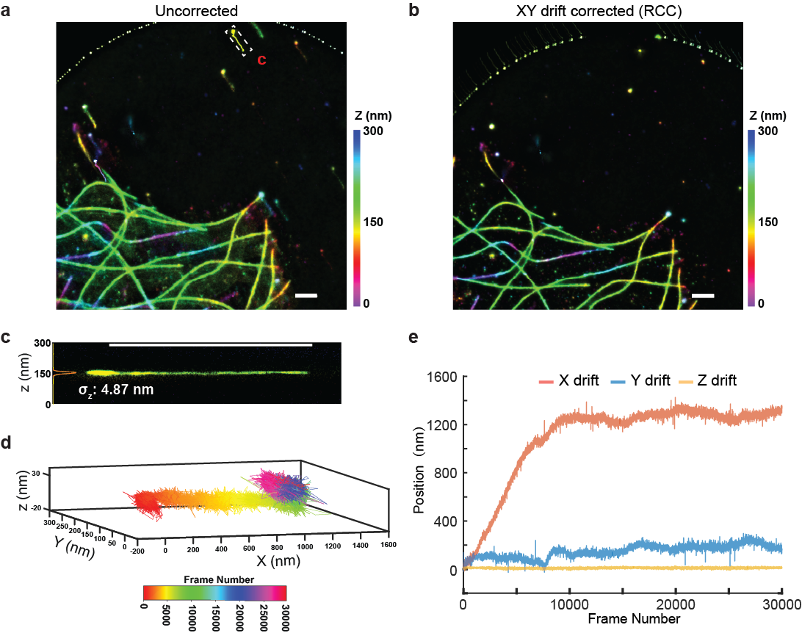
Figure S7 Influence of system drift on extracted 3D position in SiLM. (a-b) Comparison of uncorrected and xy-drift-corrected SiLM dataset of AlexaFluor 647-immunolabelled microtubules in COS-7 cells. Gold nanoparticle fiducials were introduced to monitor drift. Drift correction was performed using iterative redundant cross-correlation method. (c) Uncorrected side-view projection of a fiducial from (a), projected along the long-axis of white box in (a), with z-position histogram and fit. The standard deviation of z-position histogram over 30,000 frames is 4.87 nm, indicating that focal maintenance at the level of hundreds of nanometers by the commercial Perfect Focus System in Nikon Ti microscope is adequate to preserve the ultra-high precision of the reconstructed axial position derived from intensity measurements, as SiLM analysis yield the absolute z-position relative to the substrate surface in the specimen reference frame. (d) 3D temporal color-coded trajectory of the fiducial in (c). (e) Comparisons of drift along x, y, and z dimension over 30,000 frame acquisition time. Despite a lateral drift of over 1 μm, the axial drift remains negligible. Thus, in general, no axial drift correction is necessary in SiLM when used with commercial autofocusing system.

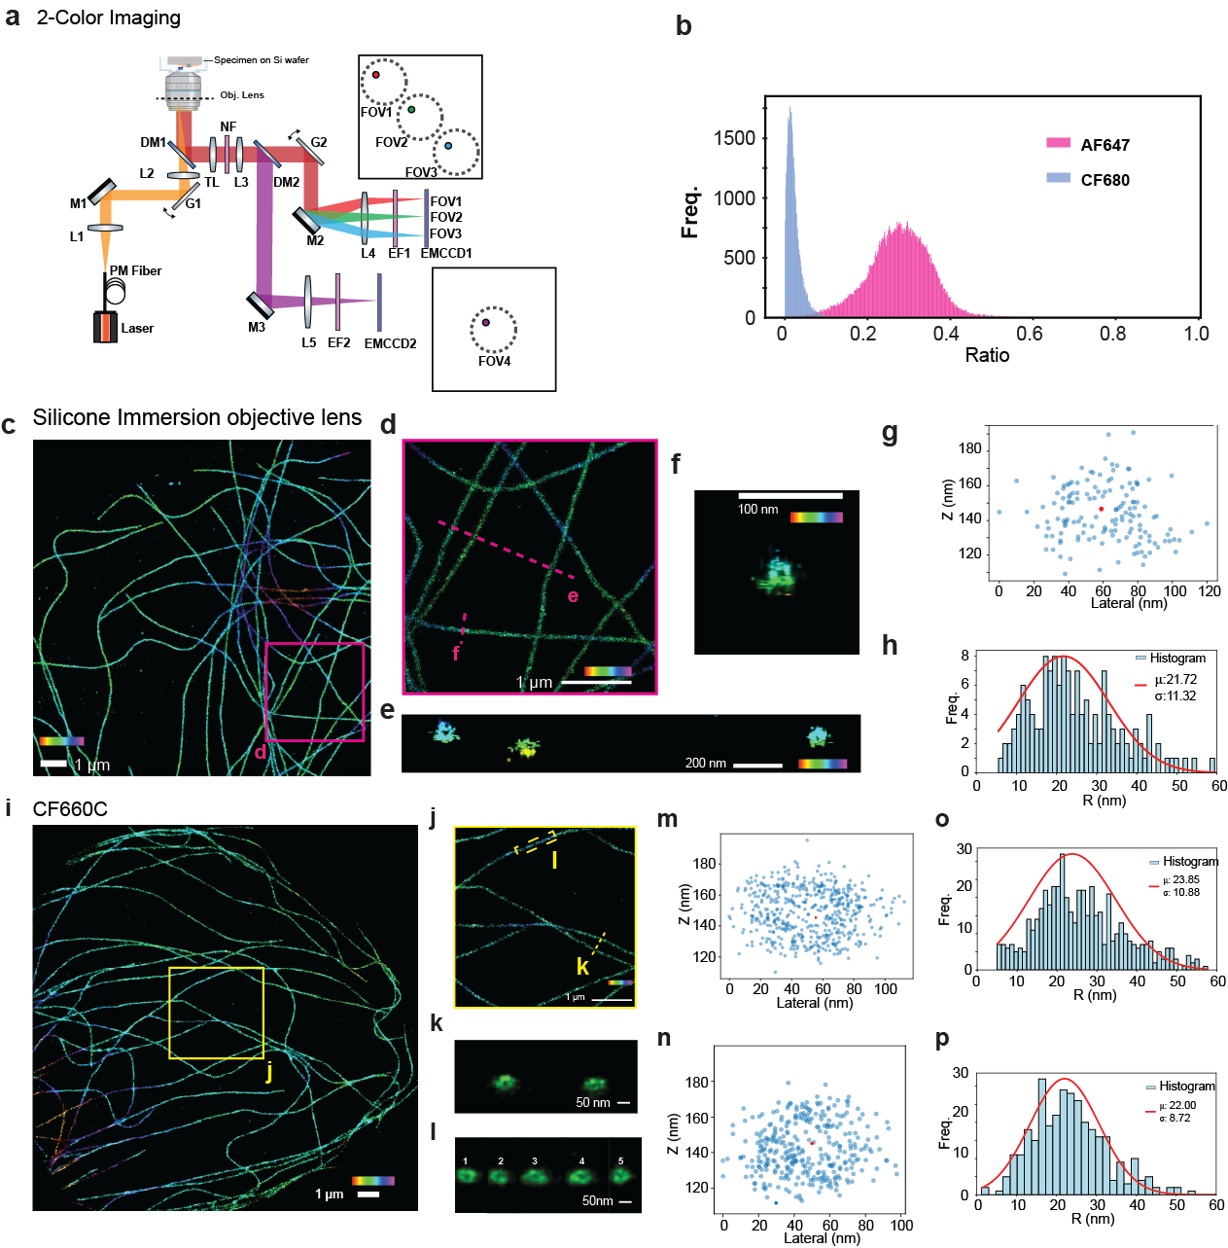
Figure S8 Versatility of SiLM (a) Diagram of the experimental setup for 2-Color SiLM via ratiometric demixing method for simultaneous 2-color imaging. An additional dichroic mirror (DM2) and a 4f-system were added to detect fluorescence emissions above 670 nm using a second EMCCD camera. An emission filter (EFT2) was placed in front of the second camera, while the emission filter (EFT1) was replaced with a multiband emission filter. (b) Demixing ratios for AlexaFluor 647 and CF680, two distinct peaks observed. The demixing ratio is defined as the ratio of photon counts from the second camera (FOV4) to the total photon counts. was used to assign labels to each localization coordinate. (c) Axial color-coded image of AlexaFluor 647 immunolabelled microtubule filaments in COS-7 cells, imaged using a Silicone immersion objective lens. (d) Enlarged view of magenta boxed region in (c). (e) Isometric side-view of 3 microtubules corresponding to line denoted (e) in (d). (f) Isometric side-view of a microtubule corresponding to the line denoted (f) in (d). (g) Scatter plot of localizations from (f). (h) Histograms of radial distribution relative to the centroid (red-dot) for (g). Gaussian fit parameters are shown. (i) Axial color-coded 3D image of CF660C immunolabelled microtubule filaments in COS-7 cells. (j) Enlarged view of yellow boxed region in (i). (k) Isometric side-view of 2 microtubules corresponding to line denoted (k) in (j). (l) Isometric side-view of 5 contiguous slices corresponding to box region denoted (l) in (j) (section width: 200 nm). (m-p) Scatter plots of localizations from selected sections (m:l-1, n: l-4), and corresponding radial distribution histograms and gaussian fit parameters.

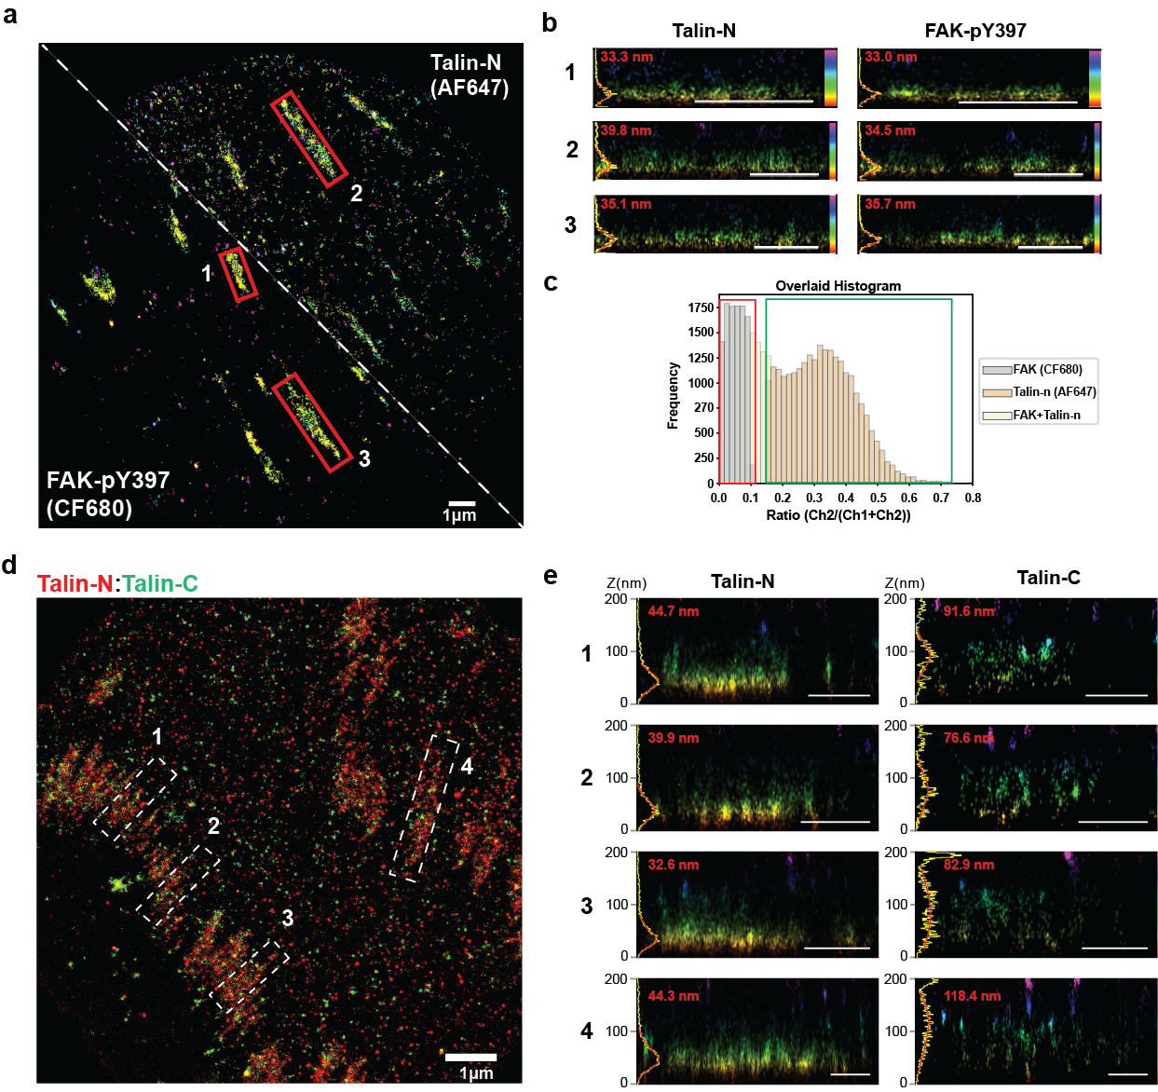
Figure S9 Dual-Color SiLM imaging of focal adhesions (a) Axial color-coded images of focal adhesions in U2OS with N-terminal epitope of talin immunolabeled with AlexaFluor 647 (Talin-N, upper) and phosphorylated FAK (pY397) immunolabeled with CF680 (lower). (b) Sideview projections of Talin-N and FAK-pY397 for boxed regions in (a), z-position histogram (yellow), and fits (red), showing similar localization in ISL compartment of FAs. (c) Histogram of demixing ratios for localizations in (a). Red and green boxes indicate the thresholds used for channel classification. (d) Dual-color image of focal adhesions in U2OS with N-terminal epitope of talin immunolabeled with AlexaFluor 647 (red) and C-terminal epitope of talin immunolabeled with CF680 (green), showing an enlarged area compared to Fig. 5b. (e) Sideview projections of Talin-N and Talin-C for boxed regions in (d), z-position histogram (yellow), and 1-gaussian fits (red), showing various extent of vertical polarized orientation of talin. Scale bars: 1 µm (b, e).

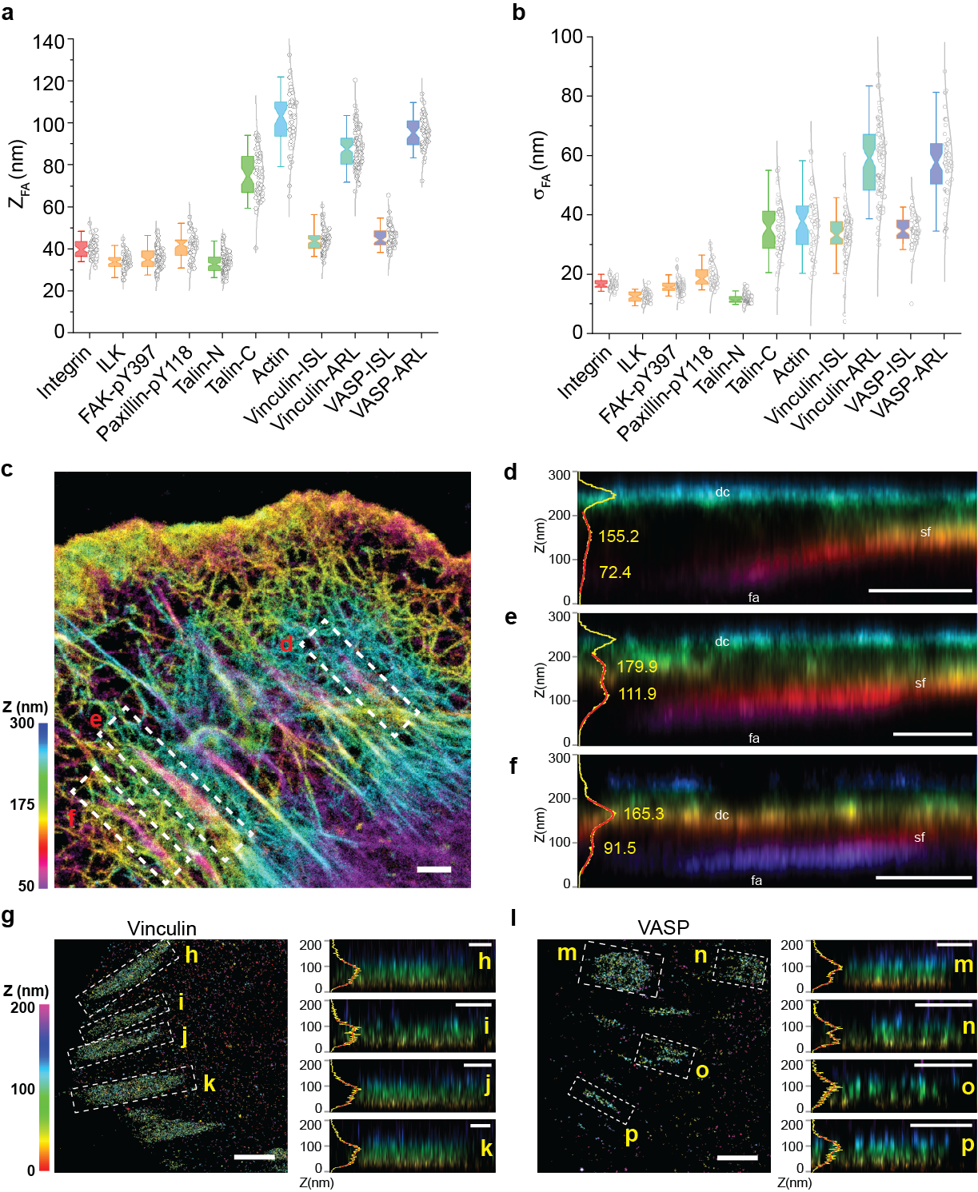
Figure S10 Mapping focal adhesions nanoscale architecture by SiLM (a-b) Notched box-and-whisker plot (5th and 95th percentile) for the median axial positions of major proteins in focal adhesion (z_{FA}, a) or the standard deviation of the distribution (σ_{FA}, b) determined from fitting. Individual data points indicated by circles. Z-position histograms for vinculin and VASP are analyzed using bi-gaussian fitting due to bimodal distribution (g-p), with lower distributions denoted ISL and upper distribution denoted ARL. (c) Axial color-coded images of F-actin labelled by AlexaFluor 647 phalloidin in a U2OS cell. (d-f). Side-view of boxed regions in (c), axial position histogram, and fits to two lower-most peaks. Resolution of distinct actin compartments can be seen with regions corresponding to focal adhesions (fa), stress fibers (sf), and dorsal cortex (dc) respectively denoted. (g,l) Axial color-coded images of vinculin (g) or VASP (l) from Fig. 5a, with additional focal adhesions regions indicated. (h-k, m-p) Side-view projections with axial histogram and bi-gaussian fits, revealing the broadly bi-modal axial distributions. Scale bars: 1 µm (c-p).
Supplementary Tables
Table S1 Optimal incidence angle for 3-FOV acquisition. Set of 3 excitation incidence angles that generate the optimal axial localization precision over the z = 0-250 nm range for SiO₂ thickness from 300-600 nm. Angle values (degree) are rounded to the nearest integer.
Wavelength (nm)  d:SiO₂ (nm) | 488 |  |  | 520 |  |  | 561 |  |  | 640
300 | 0 | 29 | 45 | 0 | 30 | 46 | 0 | 31 | 46 | 20 | 43 | 63
310 | 0 | 30 | 45 | 0 | 29 | 45 | 0 | 31 | 46 | 23 | 44 | 64
320 | 5 | 31 | 45 | 0 | 29 | 45 | 0 | 31 | 46 | 26 | 45 | 65
330 | 12 | 33 | 46 | 0 | 29 | 45 | 0 | 31 | 46 | 28 | 46 | 66
340 | 17 | 35 | 48 | 0 | 30 | 45 | 0 | 30 | 45 | 0 | 29 | 46
350 | 20 | 49 | 37 | 0 | 31 | 45 | 0 | 30 | 45 | 0 | 30 | 46
360 | 24 | 39 | 51 | 10 | 33 | 46 | 0 | 30 | 45 | 0 | 30 | 46
370 | 27 | 41 | 52 | 16 | 35 | 48 | 0 | 30 | 45 | 0 | 31 | 46
380 | 28 | 42 | 53 | 19 | 37 | 49 | 0 | 31 | 46 | 0 | 31 | 46
390 | 31 | 44 | 55 | 23 | 39 | 51 | 0 | 31 | 46 | 0 | 31 | 46
400 | 33 | 45 | 56 | 25 | 40 | 52 | 9 | 33 | 47 | 0 | 31 | 45
410 | 34 | 46 | 57 | 27 | 41 | 53 | 14 | 35 | 48 | 0 | 32 | 45
420 | 0 | 27 | 39 | 29 | 43 | 54 | 17 | 36 | 49 | 0 | 32 | 45
430 | 0 | 26 | 39 | 31 | 44 | 55 | 21 | 38 | 51 | 0 | 33 | 46
440 | 0 | 26 | 39 | 32 | 45 | 56 | 23 | 39 | 52 | 0 | 32 | 46
450 | 0 | 25 | 39 | 0 | 27 | 39 | 25 | 40 | 53 | 0 | 32 | 46
460 | 0 | 25 | 39 | 0 | 27 | 39 | 27 | 41 | 54 | 0 | 32 | 46
470 | 0 | 26 | 39 | 0 | 26 | 39 | 28 | 42 | 54 | 0 | 32 | 47
480 | 0 | 26 | 38 | 0 | 26 | 39 | 30 | 43 | 55 | 0 | 32 | 47
490 | 6 | 27 | 38 | 0 | 26 | 39 | 41 | 54 | 61 | 9 | 33 | 48
500 | 13 | 29 | 40 | 0 | 25 | 38 | 0 | 27 | 39 | 13 | 34 | 49
510 | 16 | 31 | 41 | 0 | 25 | 38 | 0 | 27 | 39 | 31 | 47 | 55
520 | 20 | 33 | 43 | 0 | 26 | 38 | 0 | 26 | 39 | 33 | 48 | 56
530 | 22 | 35 | 44 | 0 | 27 | 38 | 0 | 26 | 39 | 34 | 49 | 57
540 | 36 | 24 | 45 | 11 | 29 | 40 | 0 | 26 | 39 | 36 | 51 | 58
550 | 26 | 37 | 46 | 15 | 31 | 41 | 0 | 26 | 38 | 38 | 52 | 59
560 | 28 | 39 | 47 | 19 | 33 | 43 | 0 | 26 | 38 | 39 | 53 | 60
570 | 30 | 40 | 48 | 21 | 34 | 44 | 0 | 27 | 39 | 40 | 54 | 61
580 | 31 | 41 | 49 | 23 | 36 | 45 | 0 | 27 | 39 | 41 | 55 | 61
590 | 0 | 24 | 35 | 25 | 37 | 46 | 9 | 29 | 40 | 0 | 26 | 39
600 | 0 | 23 | 34 | 27 | 38 | 47 | 13 | 30 | 41 | 0 | 27 | 39

Table S2 Imaging parameters
Datasets | Frames | Excitation Wavelength | Angles | Thickness of Silicon Wafer
Fig. 1g: Fluorescent bead | 1,000 | 639 nm | $${16}^{°},{36}^{°},{48}^{°}$$ | 481.4 nm
Fig. 3a: Microtubule | 30,000 | 639 nm | $${16}^{°},{36}^{°},{48}^{°}$$ | 481.4 nm
Fig. 3i: Actin | 40,000 | 639 nm | $${16}^{°},{36}^{°},{48}^{°}$$ | 481.4 nm
Fig. 4b: Microtubules | 30,000 | 639 nm | $$0^{°},{27}^{°},{39}^{°},{48}^{°}$$ | 481.4 nm
Fig. 4f: 2 Color SiLM (Microtubule and Clathrin- Coated Pits) | 20,000 | 639 nm | $${16}^{°},{36}^{°},{48}^{°}$$ | 481.4 nm
Fig. 4j: Live 3D SPT | 200 | 488 nm | $$0^{°},{26}^{°},{38}^{°}$$ | 481.4 nm
Fig. 5a: Focal adhesion proteins | 10,000-20,000 | 639 nm | $${16}^{°},{36}^{°},{48}^{°}$$ | 481.4 nm
Fig. 5b: 2 Color SiLM (Talin-C and Talin-N) | 20,000 | 639 nm | $${16}^{°},{36}^{°},{48}^{°}$$ | 481.4 nm
Fig. S7a, b: Microtubule and Gold nanoparticle | 30,000 | 639 nm | $${16}^{°},{36}^{°},{48}^{°}$$ | 481.3 nm
Fig. S8c: Microtubule (Silicone immersion lens) | 20,000 | 639 nm | $${16}^{°},{36}^{°},{48}^{°}$$ | 481.2 nm
Fig. S8i: Microtubule (CF660C) | 30,000 | 639 nm | $${16}^{°},{36}^{°},{48}^{°}$$ | 481.2 nm
Fig. S9a: 2 Color SiLM (Talin-N and FAK-pY397) | 10,000 | 639 nm | $${16}^{°},{36}^{°},{48}^{°}$$ | 481.4 nm
Fig. S9b: 2 Color SiLM (Talin-N and Talin-C) | 20,000 | 639 nm | $${16}^{°},{36}^{°},{48}^{°}$$ | 481.4 nm
Fig. S10c: Actin | 30,000 | 639 nm | $${16}^{°},{36}^{°},{48}^{°}$$ | 481.3 nm

Table S3 Statistics of FAs protein vertical distribution
Z-position of histogram of protein in individual FAs were calculated (1-nm bin size) and characterized by gaussian fit to determine the peak position, Z_{FA}, and the standard deviation, $σ_{FA}$. Number of adhesion regions (N_{FA}) and Number of cells (N_{cell}) are also indicated.
FA proteins | Average $z_{FA}±st. dev. \left(nm\right)$ | Average $σ_{FA}±st. dev. \left(nm\right)$ | $$N_{FA}$$ | $$N_{cell}$$
Integrin | $$40.07±4.58$$ | $$16.85±1.74$$ | 53 | 5
ILK | $$33.67±4.02$$ | $$12.68±1.79$$ | 57 | 4
FAK-pY397 | $$35.55±5.35$$ | $$16.02±2.38$$ | 92 | 5
Paxillin-pY118 | $$41.04±6.47$$ | $$19.59±3.91$$ | 47 | 5
Talin-N | $$33.20±4.90$$ | $$11.79±1.46$$ | 117 | 7
Talin-C | $$75.45±11.49$$ | $$35.93±9.08$$ | 58 | 5
Vinculin | $$67.70±7.86$$ | $$37.47±5.97$$ | 73 | 5
VASP | $$80.69±8.42$$ | $$37.60±7.35$$ | 55 | 6
Actin | $$101.79±14.35$$ | $$37.52±10.72$$ | 45 | 5

Supplementary Movies
Supplementary Movies 1 Raw SiLM dataset
Selection of 100 frames from a raw SiLM acquisition in 3-FOV modes. The specimen is fixed COS-7 cells with microtubules immunolabeled with AlexaFluor 647.

