Table 1: Optimization the reaction conditions for synthesis of oxindole (4a)ª
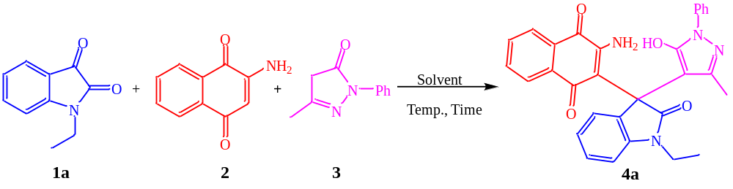
Entry | Solvent | Temperature | Time (h) | Yield %^{b}
1 | CH₃CN | reflux | 12 | 79
2 | EtOH | reflux | 4 | 94
3 | CH₃OH | reflux | 12 | 81
4 | THF | reflux | 12 | 77
5 | H₂O | reflux | 12 | 72
6 | EtOH | r.t | 12 | 49
7 | EtOH | 50 | 12 | 69
8 | EtOH | 60 | 12 | 74
ªReaction conditions: N-ethylisatin (1a) (1 mmol), 2-Amino-1,4-naphthoquinone (2) (1 mmol), 5-methyl-2-phenylpyrazolone (3) (1 mmol), solvent (3 mL). ^{b}The yields refer to the isolated pure products.
Table 2: The structure of the synthesized 2-amino-3-(3-(5-hydroxy-1H-pyrazol-4-yl)-2-oxoindolin-3-yl)naphthalene-1,4-diones (4a‒k)ª
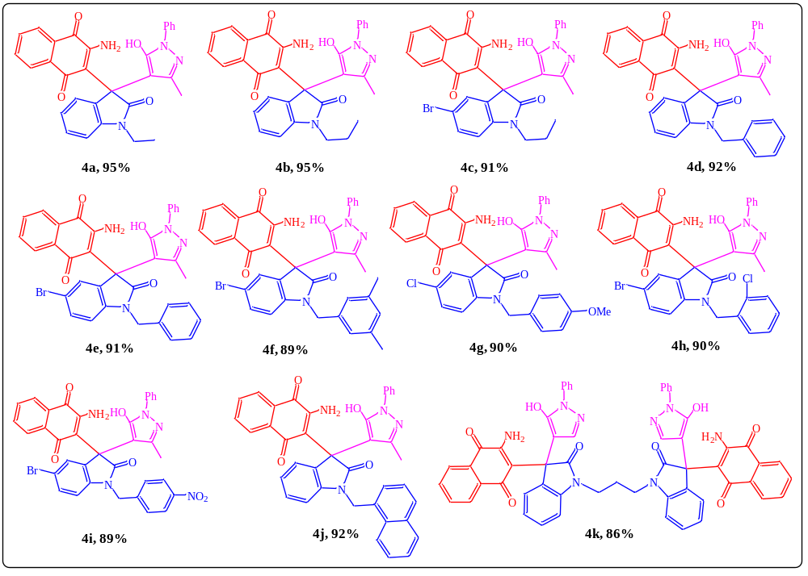
Reaction conditions: ªisatin (1) (1 mmol), 2-Amino-1,4-naphthoquinone (2) (1 mmol), 5-methyl-2-phenylpyrazolone (3) (1 mmol), EtOH (3 mL), reflux, 4 h. The yields refer to the isolated pure products.
Table 3: The structure of the synthesized 1H-spiro[benzo[6,7]chromeno[2,3-c]pyrazole-4,3'-indoline]-2',5,10-trione (5a-h)
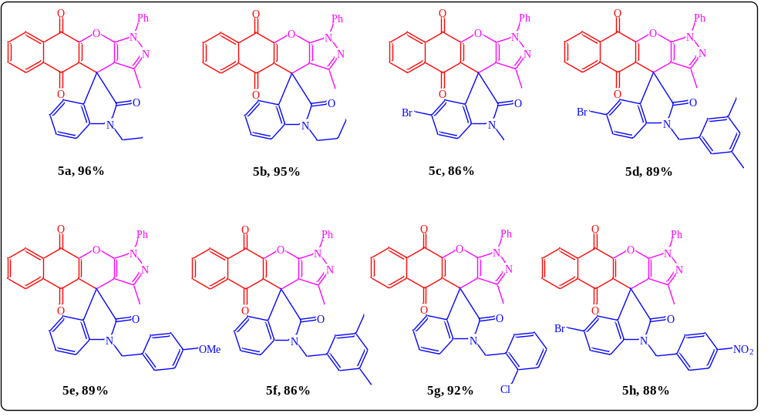
Reaction conditions: ªisatin (1) (1 mmol), 2-Amino-1,4-naphthoquinone (2) (1 mmol), 5-methyl-2-phenylpyrazolone (3) (1 mmol), AcOH (3 mL), reflux, 4 h. The yields refer to the isolated pure products.

