Supporting information

Solvent-controlled chemo-selective synthesis of 2-amino-3-(3-(5-hydroxy-1H-pyrazol-4-yl)-2-oxoindolin-3-yl)naphthalene-1,4-diones and 1H-spiro[benzo[6,7]chromeno[2,3-c]pyrazole-4,3'-indoline]-2',5,10-trione

Hamzeh Pezhman, Mohammad Reza Mohammadizadeh*,
‡ Department of Chemistry, Faculty of Nano and Bio Sciences and Technology, Persian Gulf University, Bushehr 75169, Iran. E-mail: Mrmohamadizadeh@pgu.ac.ir; Fax: +98-771-4541494

Table of Contents
Page
General information | 2
General procedure for one-pot synthesis of 2-amino-3-(3-(5-hydroxy-1H-pyrazol-4-yl)-2-oxoindolin-3-yl)naphthalene-1,4-diones (4a-k) | 2
General procedure for one-pot synthesis of 1H-spiro[benzo[6,7]chromeno[2,3-c]pyrazole-4,3'-indoline]-2',5,10-trione (5a-h ) | 2
Spectrum information of the synthesized compounds | 3
¹H‒NMR and ¹³C‒NMR spectrum of the synthesized compounds | 14

1. Experimental
1.1. General informations: All reagents were purchased from commercial suppliers and used without further purification. All experiments were carried out under air atmosphere. Column chromatography was carried out with Merck silica gel 60 (63-200 mesh). Analytical TLC was performed with Merck silica gel 60 F254 plates, and the products were visualized by 1H-NMR and 13C-NMR (400 MHz and 100 MHz, respectively) spectra were recorded in CDCl3. Chemical shifts (δ) are reported in ppm using TMS as internal standard, and spin-spin coupling constants (J) are given in Hz. IR spectra were recorded on a Perkin-Elmer FT/IR 1760 as KBr pellets. MSESI spectra were obtained on Agilent 6450 spectrometer. Melting points were determined in open-end capillary tubes on a Büchi B-540 melting point apparatus and are uncorrected.
1.2. General procedure for one-pot synthesis of 2-amino-3-(3-(5-hydroxy-1H-pyrazol-4-yl)-2-oxoindolin-3-yl)naphthalene-1,4-diones (4a-k): 2-Amino-1,4-naphthoquinone (2) (1 mmol) was added to a round bottom flask containing EtOH (3 mL), isatin (1) (1 mmol) and 5-methyl-2-phenylpyrazolone (3) (1 mmol) and the resulting mixture stirred for 4 hours at 80 ℃. Reaction progress was monitored by TLC. After completion, the resulting mixture was filtered and the precipitate obtained washed with warm EtOH (2 mL) and dried at 50 °C until the products (4a-k) obtained in pure form. No additional operations were required for further purification.
1.3. General procedure for one-pot synthesis of 1H-spiro[benzo[6,7]chromeno[2,3-c]pyrazole-4,3'-indoline]-2',5,10-trione (5a-h): 2-amino-1,4-naphthoquinone (2) (1 mmol) was added to a round bottom flask containing AcOH (3 mL), isatin (1) (1 mmol) and and 5-methyl-2-phenylpyrazolone (3) (1 mmol) and the resulting mixture stirred for 4 hours at 80 ℃. The progress of the reaction was followed by TLC. After completion, the resulting mixture was filtered and the precipitate obtained washed with warm EtOH (2 mL) and dried at 50 °C until the products (5a-h) obtained in pure form. No additional operations were required for further purification.

2-amino-3-(1-ethyl-3-(5-hydroxy-3-methyl-1-phenyl-1H-pyrazol-4-yl)-2-oxoindolin-3-yl)naphthalene-1,4-dione (4a)
Orange powder; 95% yield; m.p. = 212 ℃; ¹H-NMR (400 MHz, DMSO-d₆) 𝛿 (ppm): 1.28 (t, J = 4 Hz, 3H, CH₃), 1.41 (s, 2H, CH₃ of enol/keto), 2.22 (s, 1H, CH₃ of enol/keto), 3.66-3.82 (m, 2H, CH₂), 5.48-6.82 (broad peak, 2H, NH₂ and OH of enol/CH of keto), 6.82-7.52 (m, 7H, arom), 7.52-7.9 (m, 5H, arom), 7.98 (d, J = 8 Hz, 1H, arom), 10.2-11.8 (broad peak, 1H, NH₂); ¹³C-NMR (100 MHz, DMSO-d₆) 𝛿 (ppm): 12.3, 15.1, 34.8, 47, 99.8, 108.2, 109.1, 114.5, 121.6, 122.2, 126.1, 126.2, 129.2, 129.3, 130, 130.2, 132.8, 132.9, 133.3, 135.2, 135.4, 143.4, 145.2, 148.2, 177.2, 180, 181.7, 181.8.

2-amino-3-(3-(5-hydroxy-3-methyl-1-phenyl-1H-pyrazol-4-yl)-2-oxo-1-propylindolin-3-yl)naphthalene-1,4-dione (4b)
Orange Powder; 95% yield; m.p. =214-216 ℃; ¹H-NMR (400 MHz, DMSO-d₆) 𝛿 (ppm): 0.93 (t, J = 8 Hz, 3H, CH₃), 1.41 (s, 2H, CH₃ of enol/keto), 1.68-1.8 (m, 2H, CH₂), 2.22 (s, 1H, CH₃ of enol/keto), 3.63-3.77 (m, 2H, CH₂), 5.02-8.42 (m, 15H, arom and NH₂ and OH of enol/CH of keto), 9.7-11.5 (broad peak, 1H, NH₂,); ¹³C-NMR (100 MHz, DMSO-d₆) 𝛿 (ppm): 11.7, 15.2, 19, 20.6, 41.7, 100, 108.3, 109.2, 114.4, 121.6, 122.2, 125.6, 126.1, 129.2, 129.3, 130, 130.2, 131.4, 132.8, 132.9, 133.3, 135.2, 135.4, 143.8, 145.2, 148.2, 177.5, 180, 181.7, 181.8.

2-amino-3-(5-bromo-3-(5-hydroxy-3-methyl-1-phenyl-1H-pyrazol-4-yl)-2-oxo-1-propylindolin-3-yl)naphthalene-1,4-dione (4c)
Chartreuse green Powder; 91% yield; m.p. = 216-219 ℃; ¹H-NMR (400 MHz, DMSO-d₆) 𝛿 (ppm): 0.9 (q, J = 8 Hz, 3H, CH₃), 1.42-1.56 (broad peak, 1H, CH₃ of enol/keto), 1.6-1.81 (m, 1H, CH₂), 1.83-1.86 (m, 1H, CH₂), 2.23 (s, 2H, CH₃ of enol/keto), 3.92-4.01 (m, 2H, CH₂), 6.76-7.03 (broad peak, 2H, NH₂ and OH of enol/CH of keto), 7.1-7.3 (m, 1H, arom), 7.34-7.48 (m, 3H, arom), 7.57-7.86 (m, 6H, arom), 7.94-8.03 (m, 1H, arom), 10.5-12.56 (broad peak, 2H, NH₂,); ¹³C-NMR (100 MHz, DMSO-d₆) 𝛿 (ppm): 11, 19, 22.5, 42.8, 50.7, 56.5, 101.4, 112.7, 113.7, ,126.1, 126.3, 126.3, 129.1, 129.3, 130.1, 132.8, 133, 133, 133.4, 134.8, 135.2, 135.4, 140.3, 140.6, 148.3, 148.7, 177.9, 180.2, 181.4, 181.7.

2-amino-3-(1-benzyl-3-(5-hydroxy-3-methyl-1-phenyl-1H-pyrazol-4-yl)-2-oxoindolin-3-yl)naphthalene-1,4-dione (4d)
Amber Powder; 92% yield; m.p. =220 ℃; ¹H-NMR (400 MHz, DMSO-d₆) 𝛿 (ppm): 1.38 (s, 1H, CH₃ of enol/keto), 2.23 (s, 2H, CH₃ of enol/keto), 4.62-5.22 (m, 2H, CH₂), 6.38-8.6 (m, 19H, NH₂ and arom), 9.86-11.94 (m, 2H, NH₂ and OH of enol/ CH of keto).
2-amino-3-(1-benzyl-5-bromo-3-(5-hydroxy-3-methyl-1-phenyl-1H-pyrazol-4-yl)-2-oxoindolin-3-yl)naphthalene-1,4-dione (4e)
Chartreuse green Powder; 91 % yield; m.p. = 228-230 ℃; ¹H-NMR (400 MHz, DMSO-d₆) 𝛿 (ppm): 1.38 (s, 1H, CH₃ of enol/keto), 2.23 (s, 2H, CH₃ of enol/keto), 4.65-5.2 (m, 2H, CH₂), 5.8-8.82 (m, 19H, NH₂ and arom), 8.76-12.08 (broad peak, 1H, NH₂ and OH); ¹³C-NMR (100 MHz, DMSO-d₆) 𝛿 (ppm): 43.4, 51, 113.7, 126.1, 126.3, 127.3, 127.7, 128.8, 128.9, 129.2, 129.3, 132.7, 133, 133.5, 135.4, 136.9, 142.9, 180, 181.5.

2-amino-3-(5-bromo-1-(3,5-dimethylbenzyl)-3-(5-hydroxy-3-methyl-1-phenyl-1H-pyrazol-4-yl)-2-oxoindolin-3-yl)naphthalene-1,4-dione (4f)
Orange powder; 89% yield; m.p. >230 ℃; ¹H-NMR (400 MHz, DMSO-d₆) 𝛿 (ppm): 1.14-2.35 (m, 9H, CH₃), 4.55-5.18 (m, 2H, CH₂), 5.9-8.35 (m, 16H, NH₂ and arom), 8.98-12.54 (m, 2H, NH₂ and OH of enol/ CH of keto); ¹³C-NMR (100 MHz, DMSO-d₆) 𝛿 (ppm): 21.2, 21.3, 43.1, 48.3, 51, 110.3, 111.3, 113.6, 118.9, 121.8, 124.8, 125.1, 126, 126.2, 126.3, 128.8, 129.1, 129.3, 130.2, 130.4, 132.7, 133, 133.2, 133.4, 135.2, 135.4, 136.6, 137.8, 137.9, 142.8, 148.6, 177.4, 180, 181.5, 181.8.
2-amino-3-(5-chloro-3-(5-hydroxy-3-methyl-1-phenyl-1H-pyrazol-4-yl)-1-(4-methoxybenzyl)-2-oxoindolin-3-yl)naphthalene-1,4-dione (4g)
Orange powder; 90% yield; m.p. >230 ℃; ¹H-NMR (400 MHz, DMSO-d₆) 𝛿 (ppm): 1.31 (s, 2H, CH₃ of enol/keto), 2.23 (s, 1H, CH₃ of enol/keto), 3.72 (d, J = 16 Hz 3H, OCH₃), 4.7-5.4 (m, 2H, CH₂), 6.32-8.3 (m, 18H, NH₂ and OH of enol/CH of keto and arom), 10.18-10.92 (broad peak, 1H, NH₂). ¹³C-NMR (100 MHz, DMSO-d₆) 𝛿 (ppm): 13.1, 15, 42.9, 55.5, 109.7, 114.1, 114.3, 121.8, 122.4, 126.2, , 128.9, 129.3, 130, 132.8, 133, 133.3, 135.2, 135.5, 143.1, 143.5, 158.7, 158.9, 177.7, 180, 181.7, 181.8.
2-amino-3-(5-bromo-1-(2-chlorobenzyl)-3-(5-hydroxy-3-methyl-1-phenyl-1H-pyrazol-4-yl)-2-oxoindolin-3-yl)naphthalene-1,4-dione (4h)
Orange Powder; 90% yield; m.p. = 218-223 ℃; ¹H NMR (400 MHz, DMSO-d₆) 𝛿 (ppm): 1.41 (s, 2H, CH₃ of enol/keto), 2.24 (s, 1H, CH₃ of enol/keto), 4.7-5.4 (m, 2H, CH₂), 5.7-9.6 (m, 18H, NH₂ and OH of enol/CH of keto and arom), 10.1-11.8 (broad peak, 1H, NH₂); ¹³C NMR (100 MHz, DMSO-d₆) 𝛿 (ppm): 41.5, 41.7, 50.9, 108.4, 109.2, 114.1, 121.8, 122.2, 122.7, 126.1, 126.3, 127.5, 127.7, 128.1, 128.4, 128.7, 129.2, 129.3, 129.5, 129.7, 129.9, 130, 130.3, 132.2, 132.4, 132.8, 133.133.1, 133.4, 134.2, 135.2, 135.5, 143.1, 143.3, 147.9, 148.3, 177.9, 180, 180.5, 181.6, 181.8.
2-amino-3-(5-bromo-3-(5-hydroxy-3-methyl-1-phenyl-1H-pyrazol-4-yl)-1-(4-nitrobenzyl)-2-oxoindolin-3-yl)naphthalene-1,4-dione (4i)
Chartreuse green Powder; 89% yield; m.p. = 220 - 222 ℃; ¹H NMR (400 MHz, DMSO- d₆) 𝛿 (ppm): 1.43 (s, 1H, CH₃ of enol/keto), 2.26 (s, 2H, CH₃ of enol/keto), 5.12 (s, 2H, CH₂), 6.24-9.43 (m, 18H, NH₂ and OH and arom), 10.18-12.08 (broad peak, 1H, NH₂); ¹³C NMR (100 MHz, DMSO-d₆) 𝛿 (ppm): 43.1, 53, 113, 114, 119.3, 123.8, 124.1, 126.1, 126.3, 128.7, 129, 129.2, 129.3, 129.4, 130.1, 130.5, 131.6, 132.8, 133, 133.1, 133.4, 135.2, 135.4, 142.5, 145.1, 147.1, 147.3, 177.5, 180.1, 181.5, 181.8.
2-amino-3-(3-(5-hydroxy-3-methyl-1-phenyl-1H-pyrazol-4-yl)-1-(naphthalen-1-ylmethyl)-2-oxoindolin-3-yl)naphthalene-1,4-dione (4j)
Chartreuse green Powder; 92% yield; m.p. = 225-227 ℃; ¹H NMR (400 MHz, DMS0-d₆) 𝛿 (ppm): 1.21 (s, 2H, CH₃ of enol/keto), 2.29 (s, 1H, CH₃ of enol/keto), 5.28 (t, , J = 16 Hz, 1H, CH₂), 5.60 (t, J = 16 Hz, 1H, CH₂), 6.11- 8.78 (m, 22H, NH₂ and OH and NH₂ and arom), 9.94-11.82 (broad peak, 1H, NH₂); ¹³C NMR (100 MHz, DMSO-d₆) 𝛿 (ppm): 41.8, 42.3, 51, 108.8, 109.8, 114.2, 121.9, 122.4, 123.7, 124.4, 125.4, 125.7, 126.1, 126.2, 126.4, 126.6, 127.9, 130.1, 130.3, 131, 131.1, 132.1, 132.8, 133, 133.2, 133.4, 133.7, 133.8, 135.2, 135.5, 143.4, 143.7, 177.9, 180, 181.6, 181.8.
3,3'-(butane-1,4-diylbis(3-(5-hydroxy-3-methyl-1-phenyl-1H-pyrazol-4-yl)-2-oxoindoline-1,3-diyl))bis(2-aminonaphthalene-1,4-dione) (4k)
Brown Powder; 86% yield; m.p. >230 ℃; ¹H NMR (400 MHz, DMS0-d₆) 𝛿 (ppm): 1.37 (s, 2H, CH₃ of enol/keto), 1.66-2.02 (broad peak, 2H, CH₂), 2.22 (s, 1H, CH₃ of enol/keto), 3.64-4.02(m, 2H, CH₂), 6.14-8.43 (m, 15, NH₂ and OH and arom), 10.23-11.6 (broad peak, 1H, NH₂).
1'-ethyl-3-methyl-1-phenyl-1H-spiro[benzo[6,7]chromeno[2,3-c]pyrazole-4,3'-indoline]-2',5,10-trione (5a)
Light brown Powder; 96% yield; m.p. >230 ℃; ¹H NMR (400 MHz, CDCl₃) 𝛿 (ppm): 1.51 (t, J=7.2 Hz ,3H, CH₃), 1.76 (s, 3H, CH₃), 4.02 (q, J = 7.2 Hz, 2H, CH₂), 6.94-7.17 (m, 3H, arom), 7.32-7.44 (m, 2H, arom), 7.49-7.60 (m, 2H, arom), 7.65-7.82 (m, 2H, arom), 7.84-8.08 (m, 3H, arom), 8.11-8.27(m, 1H, arom); ¹³C NMR (100 MHz, CDCl₃) 𝛿 (ppm): 12.3, 12.4, 35.4, 48.4, 97.4, 108.4, 120.4, 121.8, 123, 124.1, 126.6, 126.6, 127, 129.2, 129.4, 130.3, 131.5, 133.9, 134, 134.7, 137.6, 142.5, 144.8, 145.1, 152., 175.8, 177.2, 182.4.

3-methyl-1-phenyl-1'-propyl-1H-spiro[benzo[6,7]chromeno[2,3-c]pyrazole-4,3'-indoline]-2',5,10-trione (5b)
Light brown powder; 95% yield; m.p. >230 ℃; ¹H-NMR (400 MHz, CDCl₃) 𝛿 (ppm): 1.16 (t, J=7.4 Hz ,3H, CH₃), 1.75 (s, 3H, CH₃), 1.87-2.05 (m, 2H, CH₂), 3.81-3.97 (m, 2H, CH₂), 6.96-7.11 (m, 3H, arom), 7.32-7.44 (m, 2H, arom), 7.50-7.59 (m, 2H, arom), 7.68-7.80 (m, 2H, arom), 7.87-8.0 (m, 3H, arom), 8.14-8.22 (m, 1H, arom); ¹³C-NMR (100 MHz, CDCl₃) 𝛿 (ppm): 11.7, 12.3, 42.6, 48.4, 97.5, 108.5, 120.4, 121.8, 123, 124, 126.6, 127, 129.1, 129.4, 130.3, 131.5, 133.9, 133.9, 134.7, 137.6, 143, 144.8, 145.1, 152, 176.1, 177.3, 182.4.

5'-bromo-1',3-dimethyl-1-phenyl-1H-spiro[benzo[6,7]chromeno[2,3-c]pyrazole-4,3'-indoline]-2',5,10-trione (5c)
Yellow powder; 86% yield; m.p. >230 ℃; ¹H-NMR (400 MHz, CDCl₃) 𝛿 (ppm): 0.84 (s,3H, CH₃), 1.23 (s, 3H, CH₃), 7.69-7.92 (m, 3H, arom), 7.98-8.13 (broad peak, 1H, arom), 8.18-8.30 (broad peak, 1H, arom) 8.40 (s, 1H, arom), 8.75-9.05 (m, 3H, arom), 9.17-9.37 (broad peak, 1H, arom), 10.25 (s, 1H, arom), 11.32-11.53 (broad peak, 1H, arom).
5'-bromo-1'-(3,5-dimethylbenzyl)-3-methyl-1-phenyl-1H-spiro[benzo[6,7]chromeno[2,3-c]pyrazole-4,3'-indoline]-2',5,10-trione (5d)

Yellow powder; 89% yield; m.p. >230 ℃; ¹H-NMR (400 MHz, CDCl₃) 𝛿 (ppm): 1.71 (s, 3H, CH₃), 2.38 (two overlapped singlet, 6H, CH₃), 4.96 (d, J =16, 1H, CH₂), 5.13 (d, J =16, 1H, CH₂), 6.84 (d, J =8, 1H, arom), 7.00 (s, 1H, arom), 7.14-7.24 (m, 3H, arom), 7.32-7.44 (m, 2H, arom), 7.51-7.60 (m, 2H, arom), 7.73-7.84 (m, 2H, arom), 7.92 (ddd, J =8, 2H, arom), 7.96-8.01 (m, 1H, arom), 8.17-8.26 (m, 1H, arom); ¹³C-NMR (100 MHz, CDCl₃) 𝛿 (ppm): 12.4, 20.6, 21.3, 44.9, 48.4, 96.9, 110.9, 115.8, 120.5, 121.1, 125.7, 126.7, 126.8, 126.9, 127.1, 129.4, 129.6, 130.4, 131.5, 132, 134.2, 134.9, 135, 135.5, 137.5, 138.4, 141.9, 144.8, 145, 152.1, 175.9, 177, 182.3.

1'-(4-methoxybenzyl)-3-methyl-1-phenyl-1H-spiro[benzo[6,7]chromeno[2,3-c]pyrazole-4,3'-indoline]-2',5,10-trione (5e)
Yellow powder; 89% yield; m.p. >230 ℃; ¹H-NMR (400 MHz, CDCl₃) 𝛿 (ppm): 1.61 (s, 3H, CH₃), 3.84 (s, 3H, OCH₃), 5.00 (d, J =15.2, 1H, CH₂), 5.17 (d, J =15.2, 1H, CH₂), 6.93-7.09 (m, 5H, arom), 7.23-7.31 (m, 1H, arom), 7.32-7.39 (t, J =7.3, 1H, arom), 7.49-7.61 (m, 4H, arom), 7.70-7.83 (m, 2H, arom), 7.88-7.95 (dd, J =8.9, 2H, arom), 7.97-8.02 (m, 1H, arom), 8.15-8.25 (m, 1H, arom); ¹³C-NMR (100 MHz, CDCl₃) 𝛿 (ppm): 12.3, 44.4, 48.5, 55.3, 97.5, 109.3, 114.2, 120.4, 121.6, 123.2, 124, 126.6, 126.7, 127, 127.7, 129.1, 129.4, 129.4, 130.4, 131.5, 133.7, 134, 134.8, 137.6, 142.7, 144.8, 145.2, 152.1, 159.2, 176.3, 177.2, 182.4.

1'-(3,5-dimethylbenzyl)-3-methyl-1-phenyl-1H-spiro[benzo[6,7]chromeno[2,3-c]pyrazole-4,3'-indoline]-2',5,10-trione (5f)
Yellow powder; 92% yield; m.p. >230 ℃; ¹H-NMR (400 MHz, CDCl₃) 𝛿 (ppm): 1.71 (s, 3H, CH₃), 2.36 (two overlapped singlet, 6H, CH₃), 4.94 (d, J =16, 1H, CH₂), 5.16 (d, J =16, 1H, CH₂), 6.82 (d, J =8, 1H, arom), 7.10 (s, 1H, arom), 7.12-7.23 (m, 3H, arom), 7.35-7.48 (m, 2H, arom), 7.49-7.58 (m, 2H, arom), 7.68-7.77 (m, 2H, arom), 7.95 (ddd, J =8, 2H, arom), 7.92-8.05 (m, 1H, arom), 8.18-8.25 (m, 1H, arom); ¹³C-NMR (100 MHz, CDCl₃) 𝛿 (ppm): 12.4, 20.6, 21.3, 44.9, 48.4, 96.9, 110.9, 115.8, 120.5, 121.1, 125.7, 126.7, 126.8, 126.9, 127.1, 129.4, 129.6, 130.4, 131.5, 132, 134.2, 134.9, 135, 135.5, 137.5, 138.4, 141.9, 144.8, 145, 152.1, 175.9, 177, 182.3.

1'-(2-chlorobenzyl)-3-methyl-1-phenyl-1H-spiro[benzo[6,7]chromeno[2,3-c]pyrazole-4,3'-indoline]-2',5,10-trione (5g)
Yellow powder; 92% yield; m.p. >230 ℃; ¹H-NMR (400 MHz, CDCl₃) 𝛿 (ppm): 1.76 (s, 3H, CH₃), 5.11 (d, J =16, 1H, CH₂), 5.44 (d, J =16.5, 1H, CH₂), 6.91 (d, J =8, 1H, arom), 7.02-7.10 (m, 2H, arom), 7.23-7.29 (m, 2H, arom), 7.29-7.43 (m, 2H, arom), 7.48-7.61 (m, 3H, arom), 7.73-7.84 (m, 2H, arom), 7.84-7.95 (m, 3H, arom), 7.97-8.05 (m, 1H, arom), 8.17-8.25 (m, 1H, arom); ¹³C-NMR (100 MHz, CDCl₃) 𝛿 (ppm): 12.5, 42.2, 48.6, 97.5, 109.4, 120.5, 121.5, 123.6, 123.9, 126.7, 126.8, 127.1, 127.4, 129, 129.1, 129.3, 129.4, 129.5, 130.4, 131.5, 132.8, 132.9, 133.6, 134.1, 134.8, 137.5, 142.4, 144.8, 145.1, 152.2, 176.6, 177.2, 182.5.

5'-bromo-3-methyl-1'-(4-nitrobenzyl)-1-phenyl-1H-spiro[benzo[6,7]chromeno[2,3-c]pyrazole-4,3'-indoline]-2',5,10-trione (5h)

Yellow powder; 92% yield; m.p. >230 ℃; ¹H-NMR (400 MHz, CDCl₃) 𝛿 (ppm): 1.75 (s, 3H, CH₃), 4.91 (d, J =16.2, 1H, CH₂), 5.54 (d, J =16.2, 1H, CH₂), 6.69 (d, J =8.8, 1H, arom), 7.21 (d, J =2, 1H, arom), 7.33-7.43 (m, 2H, arom), 7.51-7.61 (m, 2H, arom), 7.75-7.88 (m, 4H, arom), 7.89-7.95 (m, 2H, arom), 7.97-8.07 (m, 1H, arom), 8.18-8.27 (m, 1H, arom), 8.29-8.37 (m, 2H, arom); ¹³C-NMR (100 MHz, CDCl₃) 𝛿 (ppm): 12.5, 44.1, 48.3, 96.7, 110.3, 116.4, 120.5, 120.7, 124.2, 126.9, 127, 127.1, 127.5, 128.6, 129.5, 130.3, 131.3, 132.1, 134.4, 135, 135.4, 137.4, 140.9, 142.4, 144.6, 144.7, 147.7, 152.2, 175.9, 176.9, 182.6.

¹H-NMR and ¹³C-NMR spectrum of the synthesized compounds

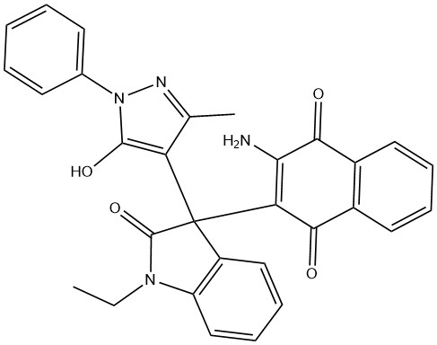
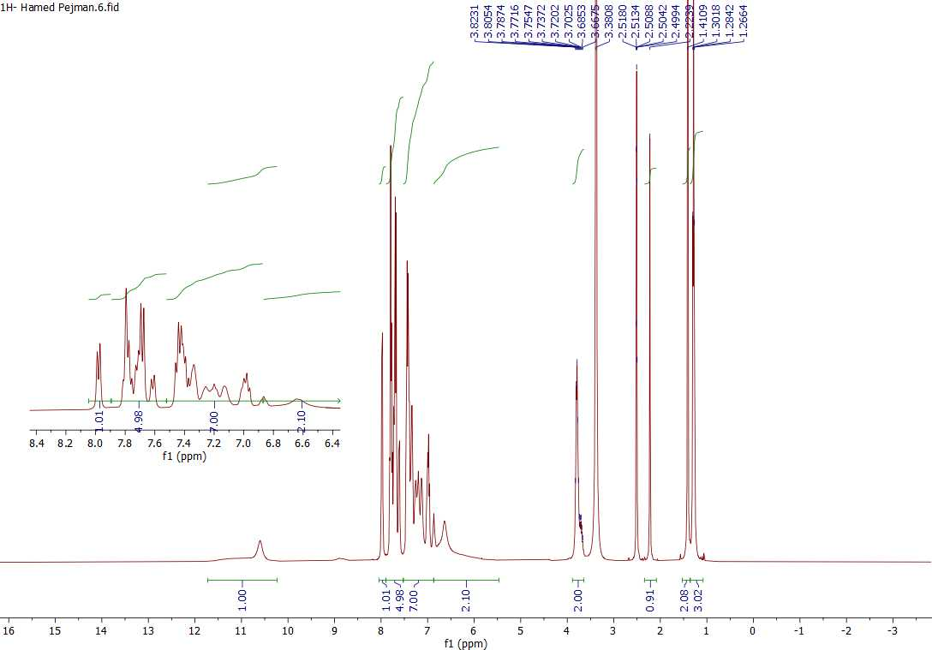

Figure 1: ¹H-NMR spectrum of compound 4a

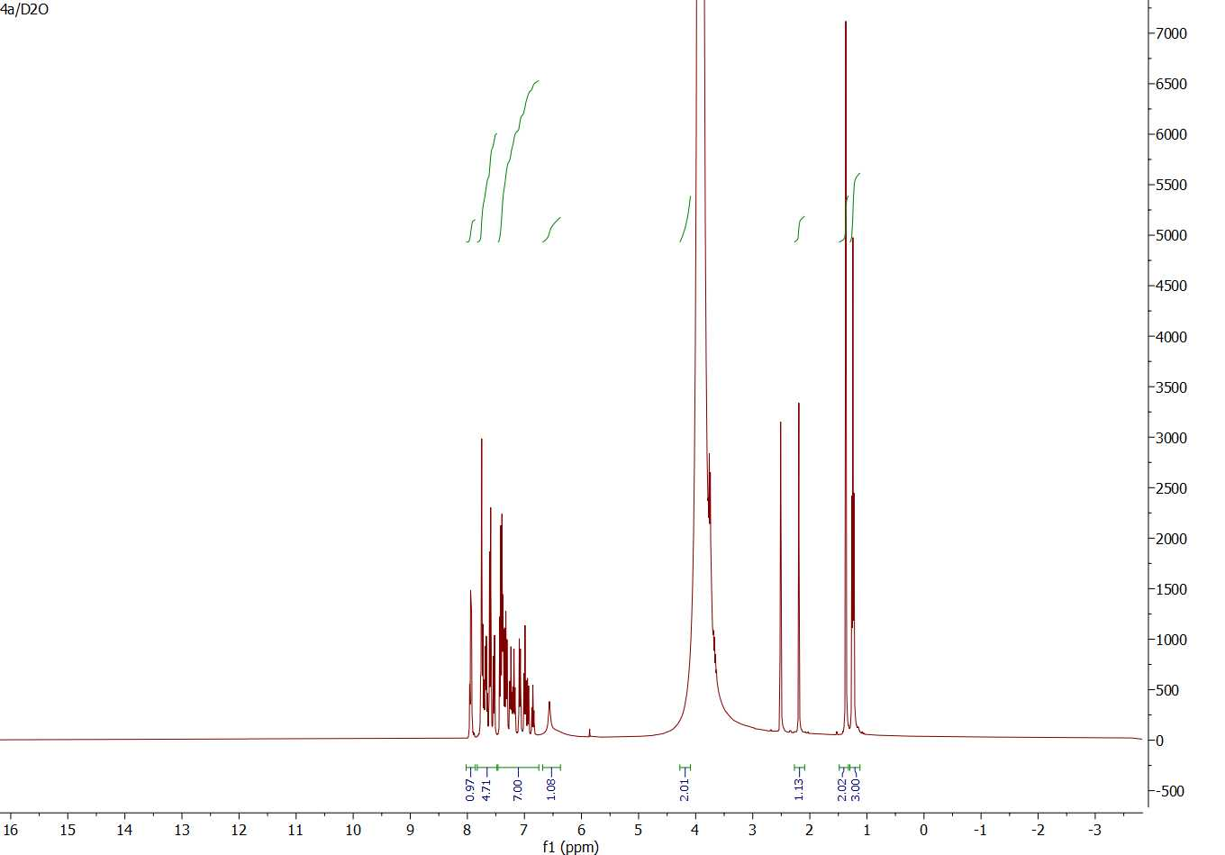
Figure 2: D₂O spectrum of compound 4a

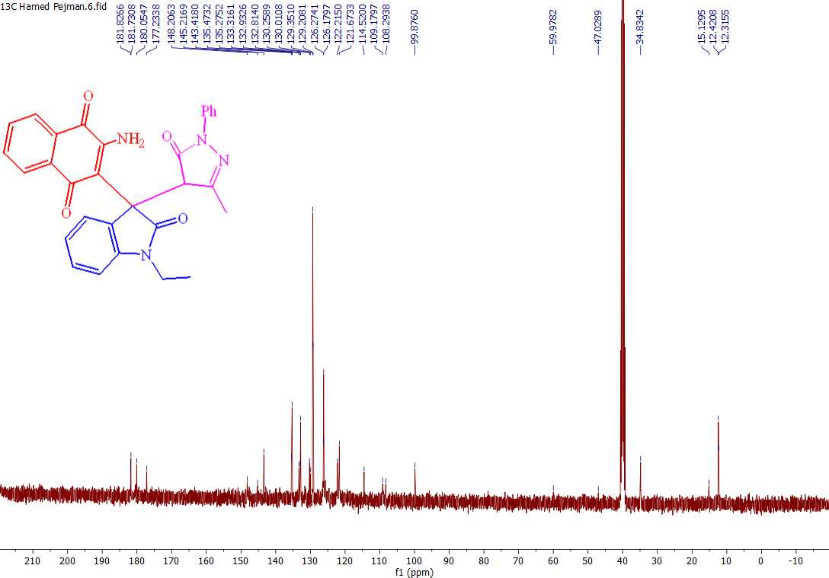

Figure 3: ¹³C-NMR spectrum of compound 4a

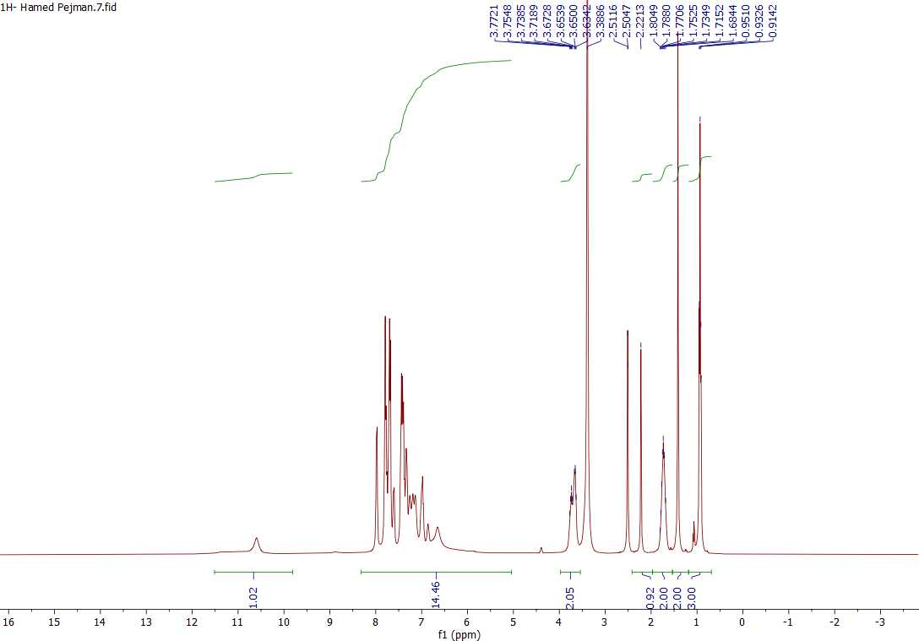

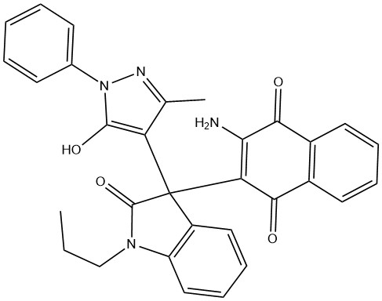

Figure 4: ¹H-NMR spectrum of compound 4b

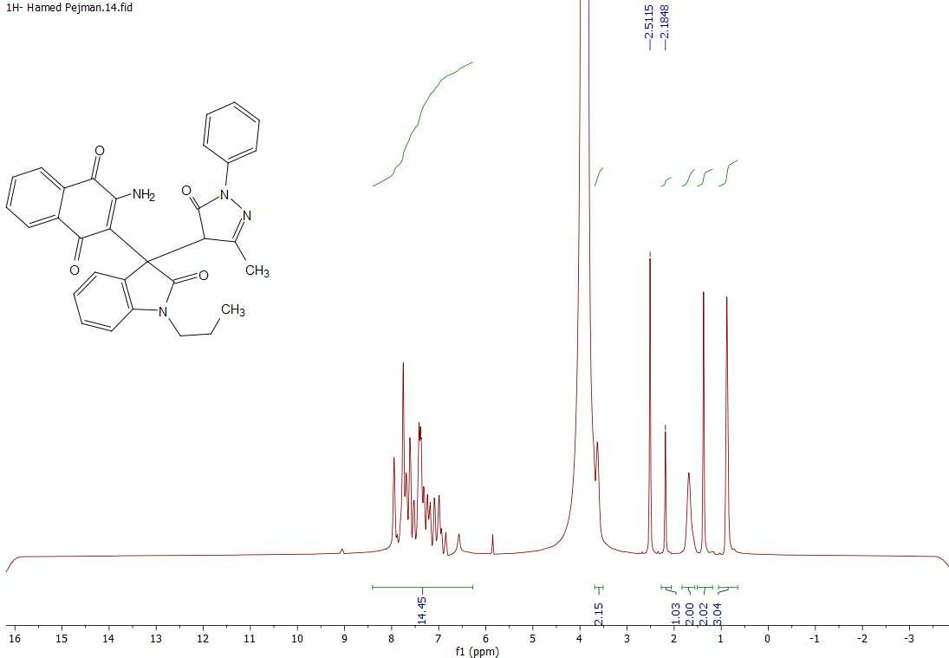
Figure 5: D₂O spectrum of compound 4b

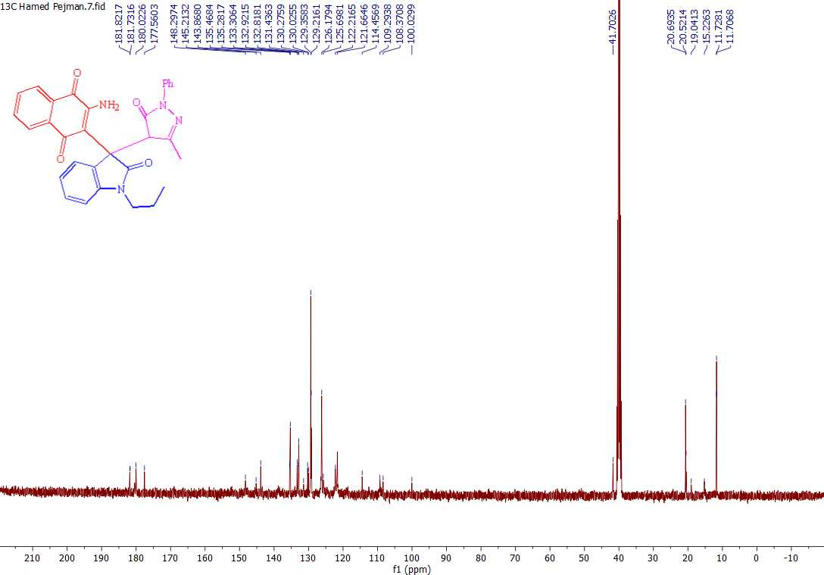

Figure 6: ¹³C-NMR spectrum of compound 4b

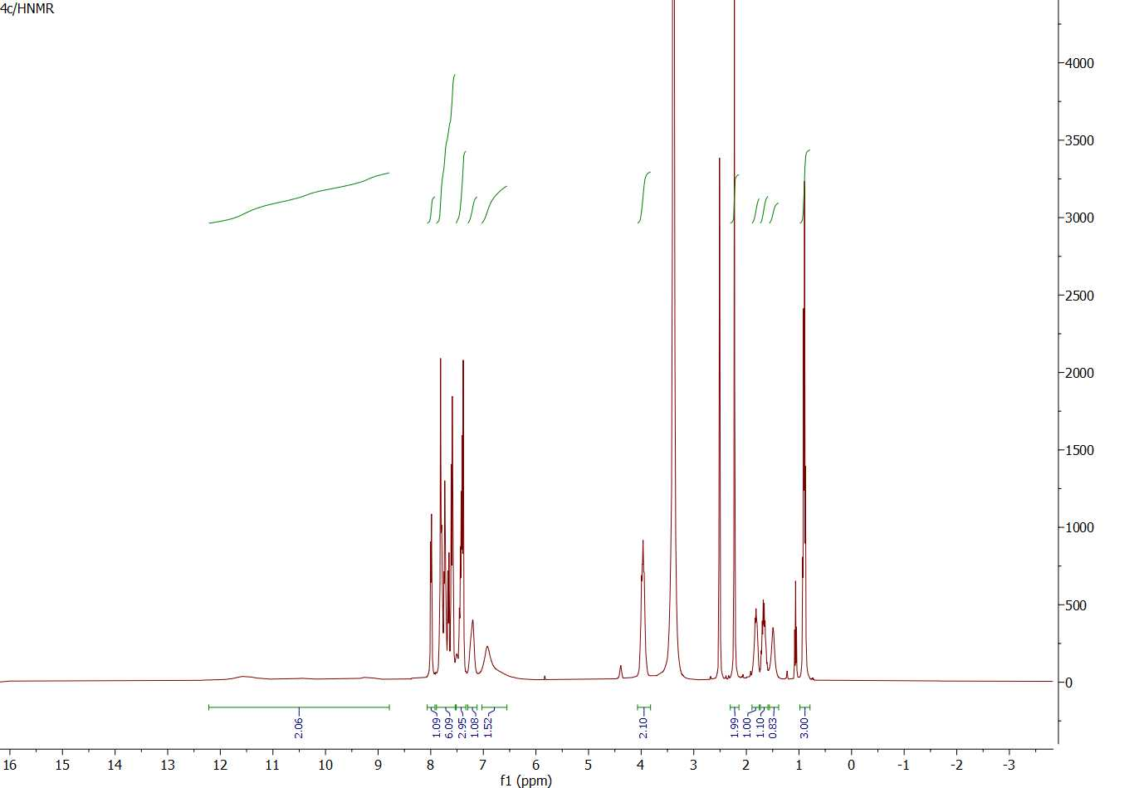
Figure 7: ¹H-NMR spectrum of compound 4c

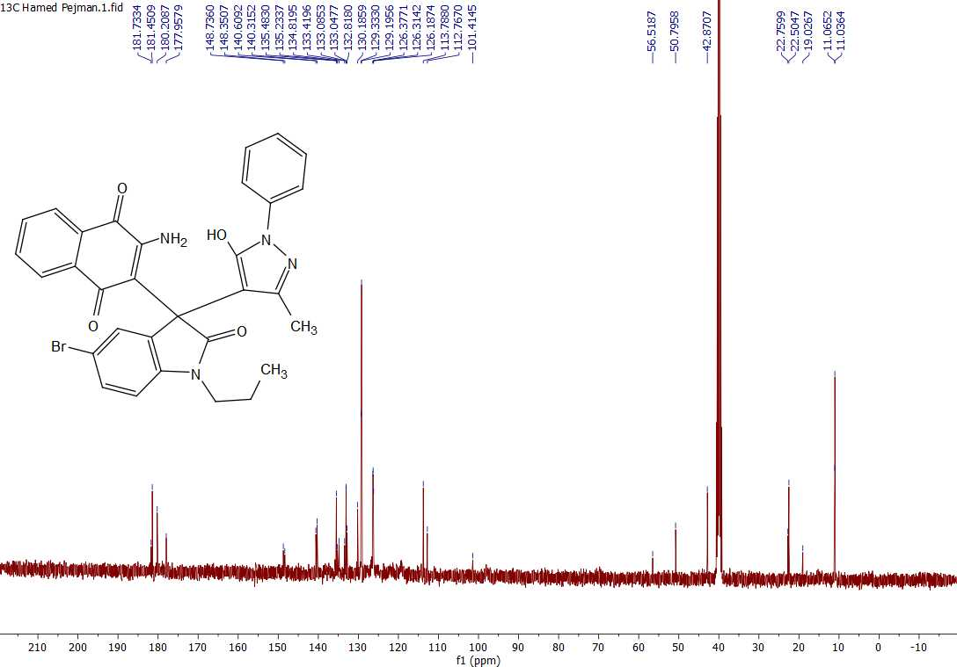

Figure 8: ¹³C-NMR spectrum of compound 4c

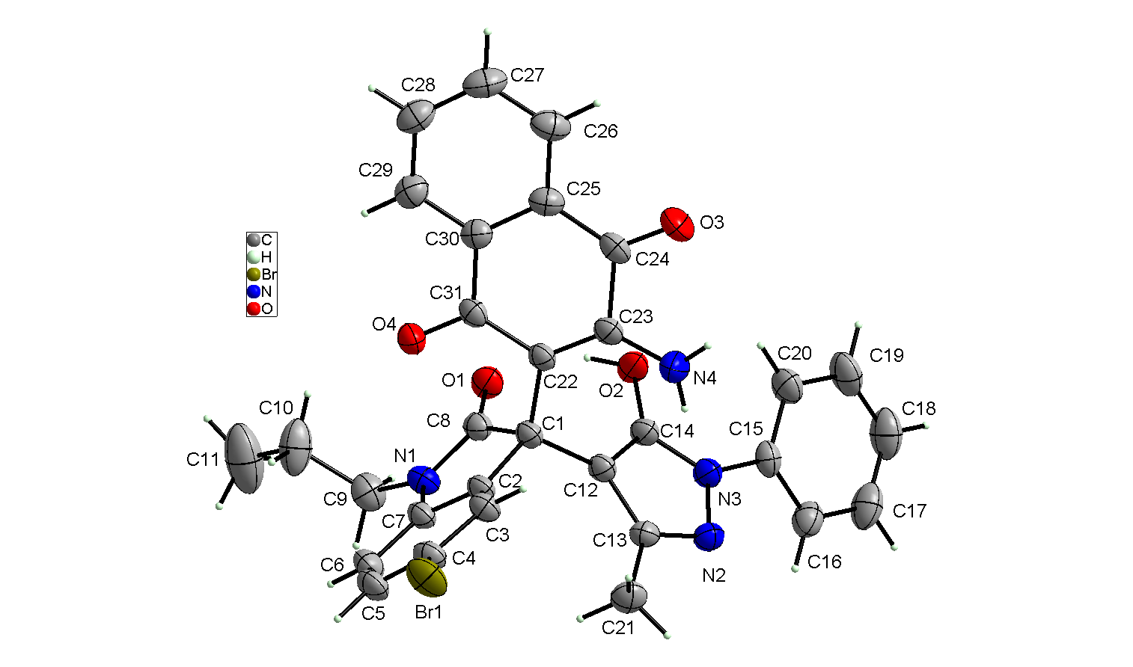
Figure 9: X-Ray spectrum of compound 4c

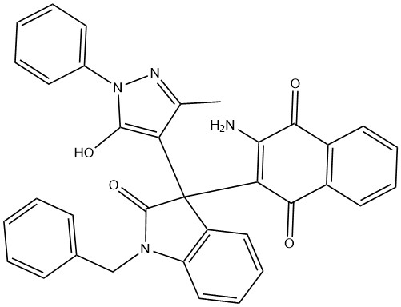
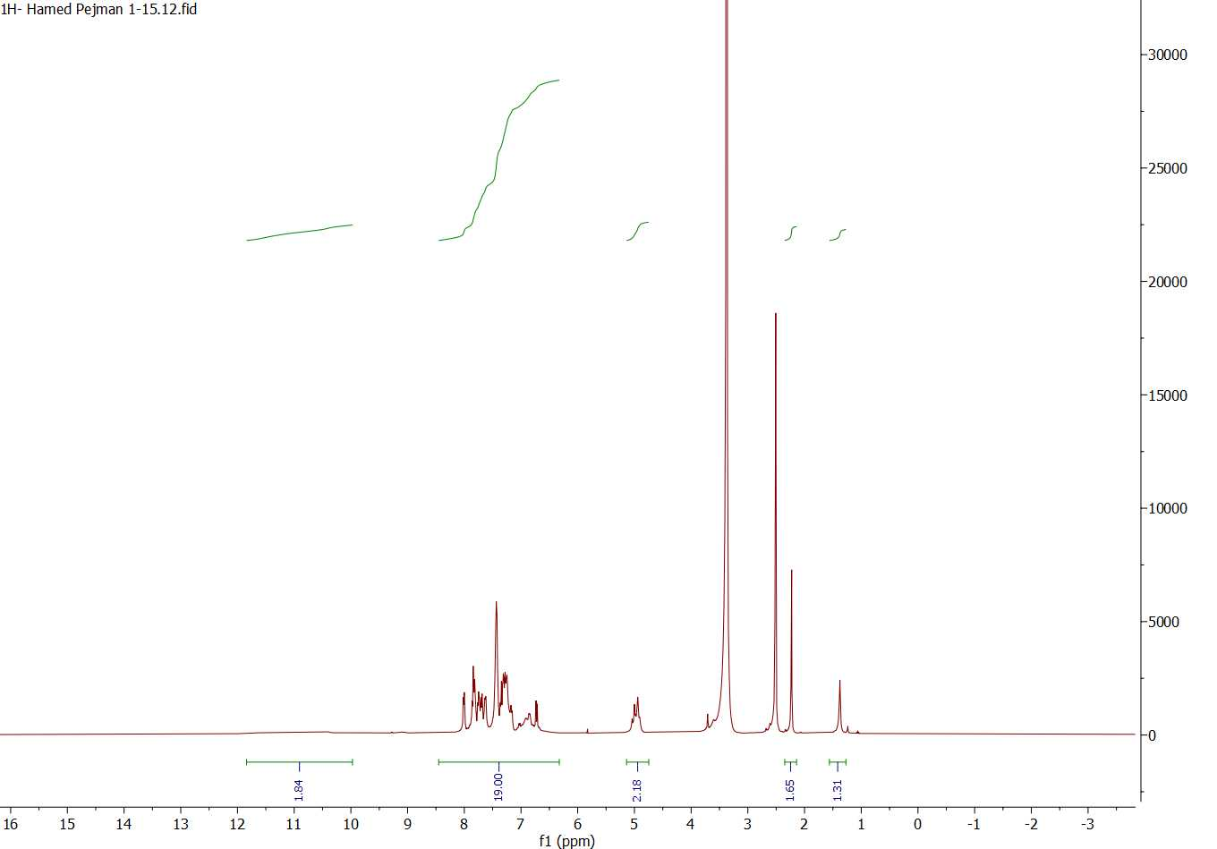

Figure 10: ¹H-NMR spectrum of compound 4d

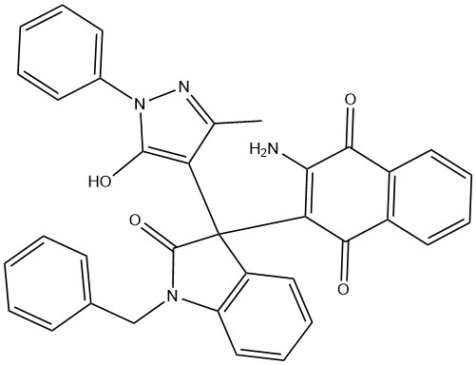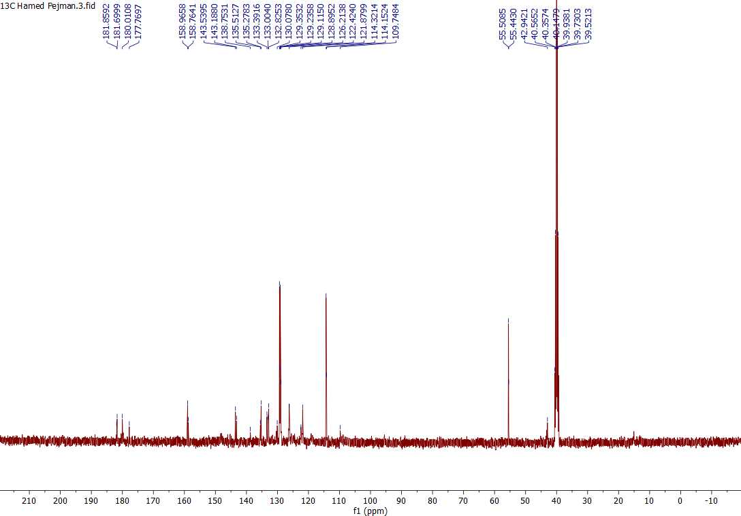

Figure 11: ¹³C-NMR spectrum of compound 4d

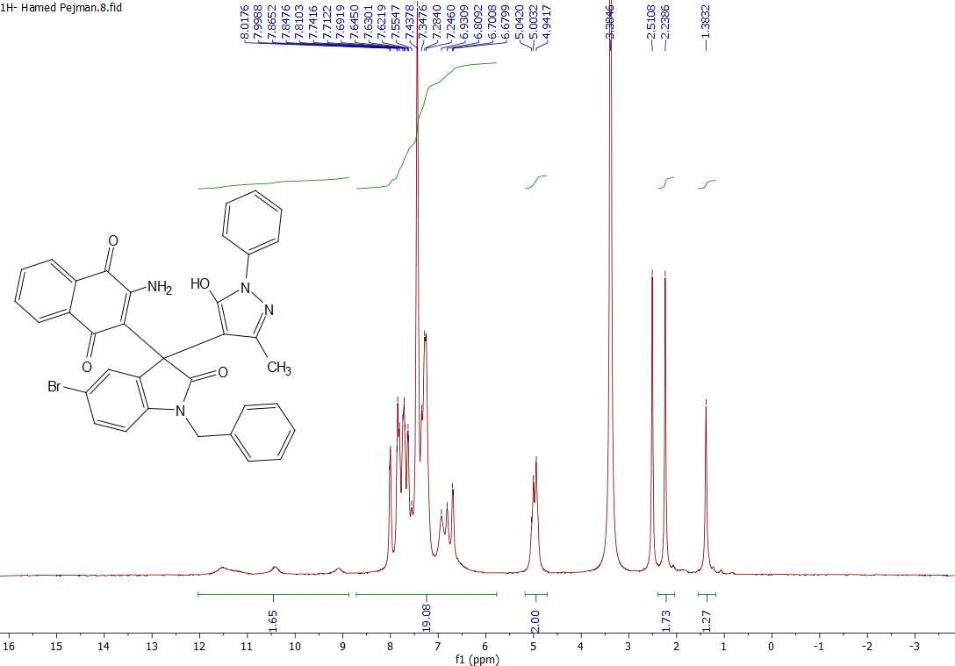

Figure 12: ¹H-NMR spectrum of compound 4e

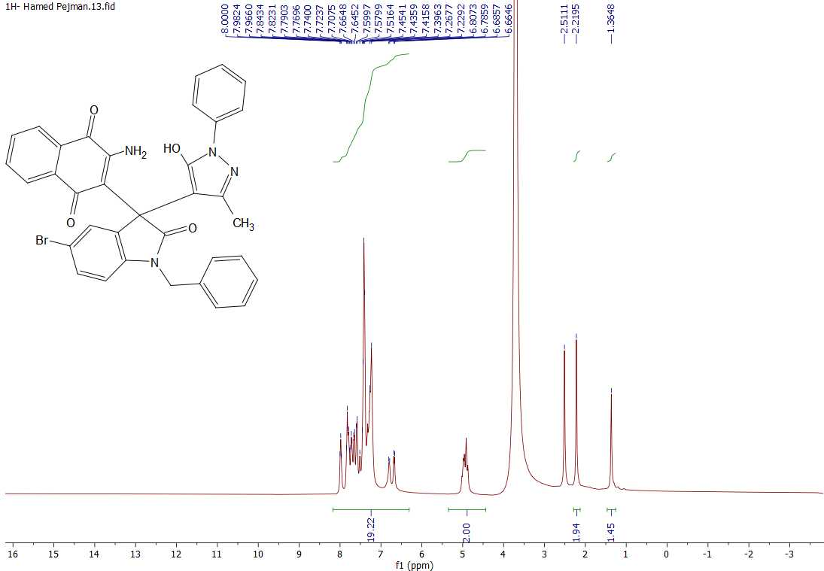
Figure 13: D₂O spectrum of compound 4e

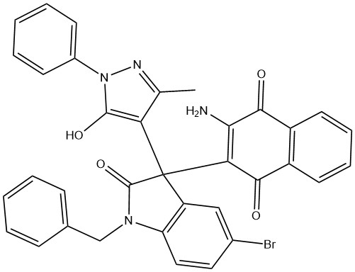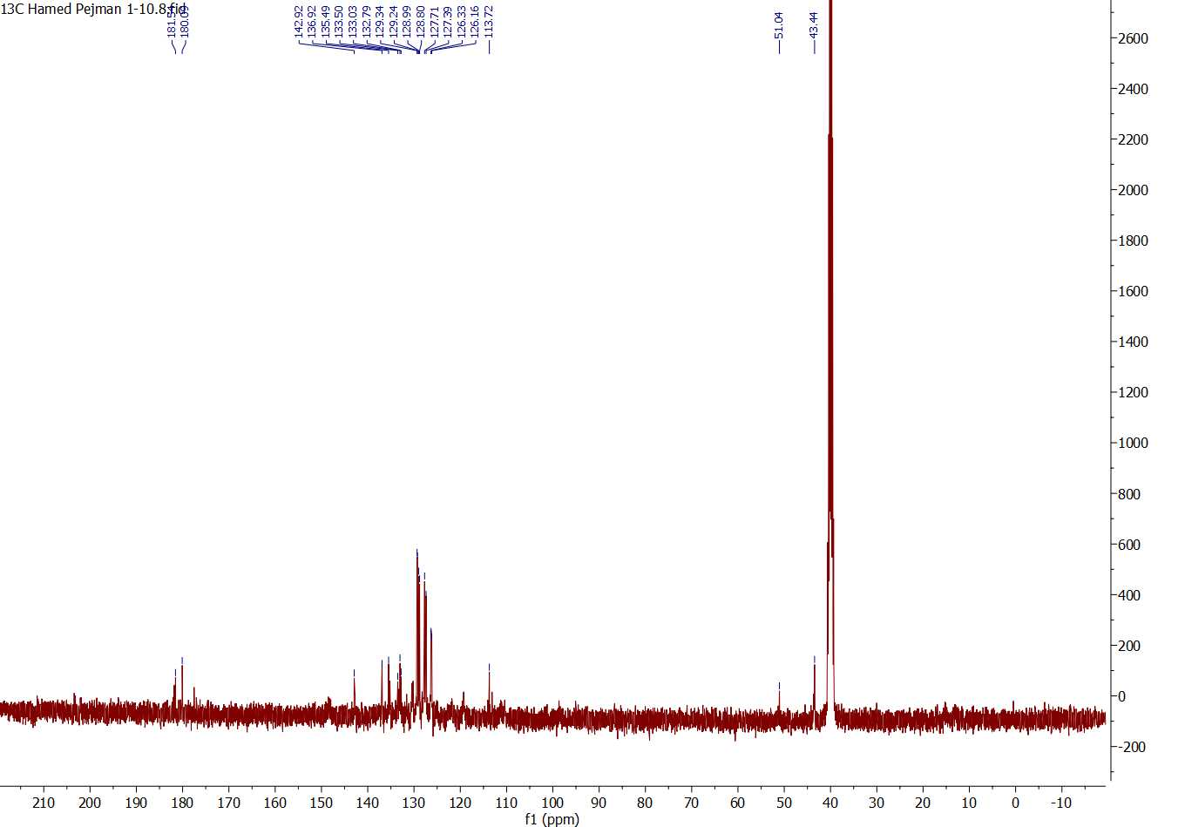

Figure 14: ¹³C-NMR spectrum of compound 4e

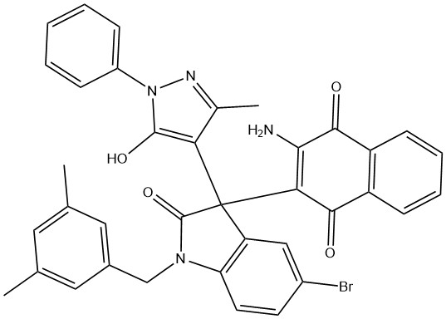
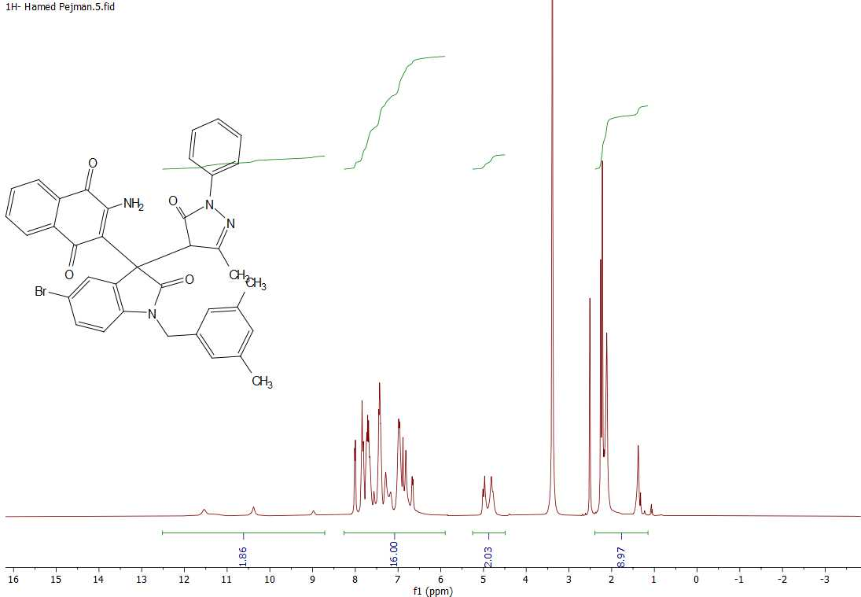

Figure 15: ¹H-NMR spectrum of compound 4f

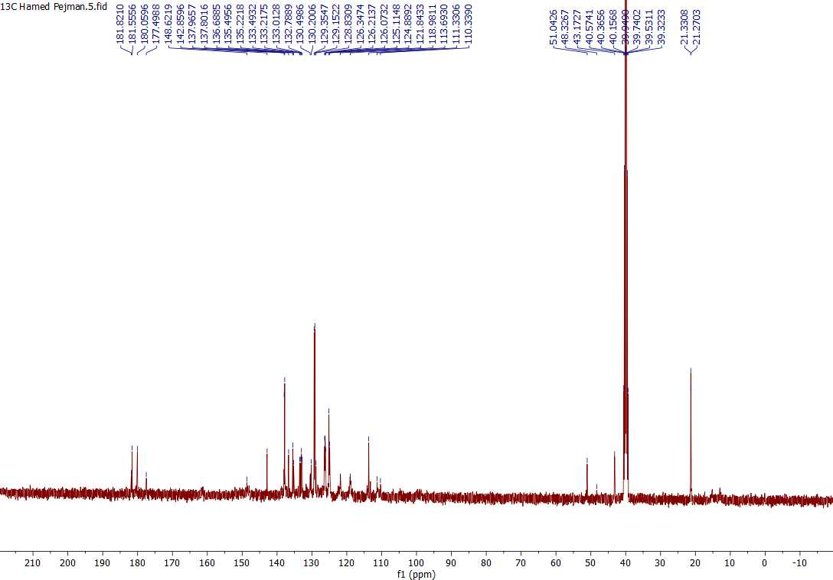

Figure 16: ¹³C-NMR spectrum of compound 4f

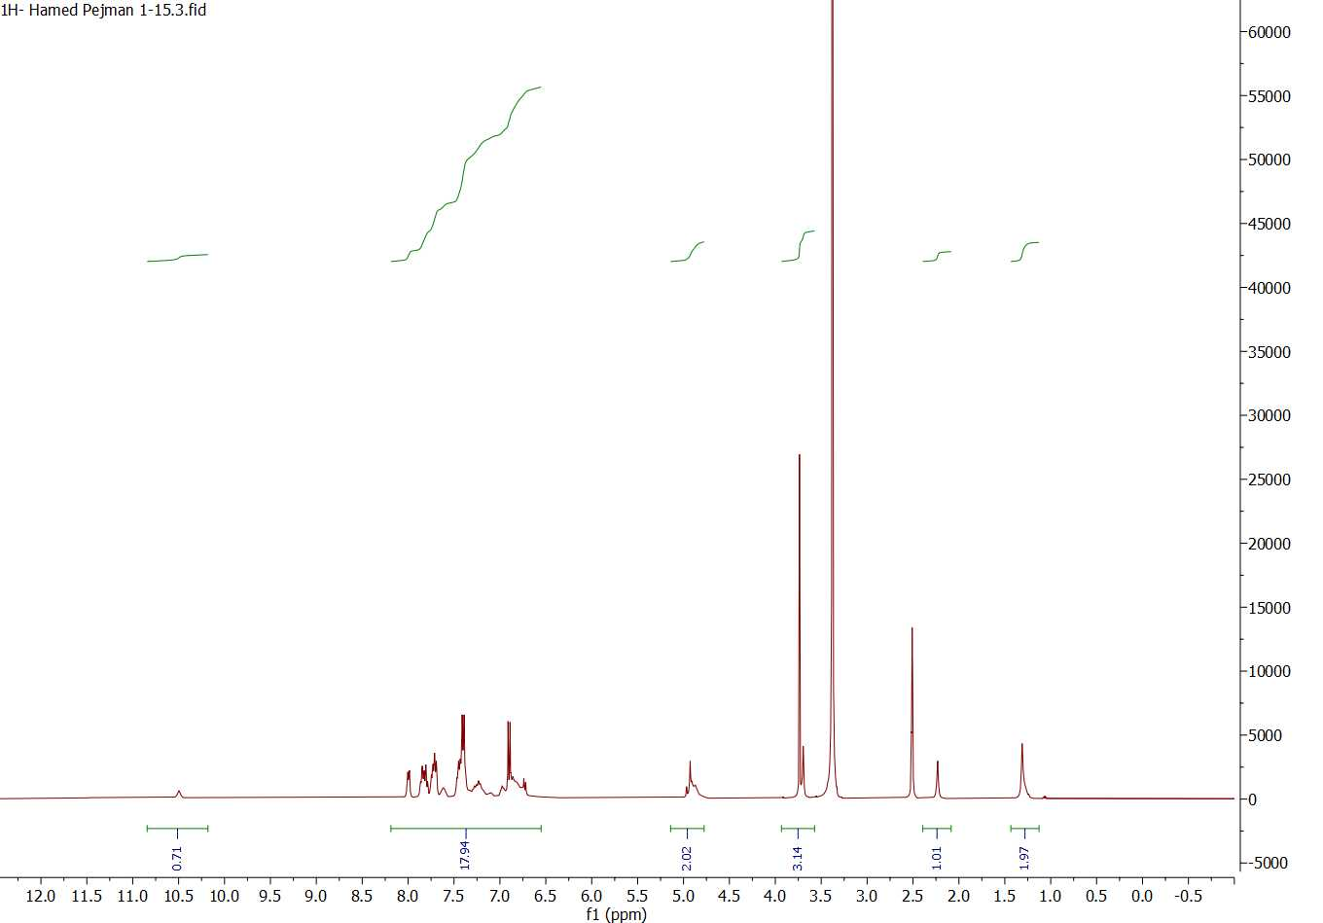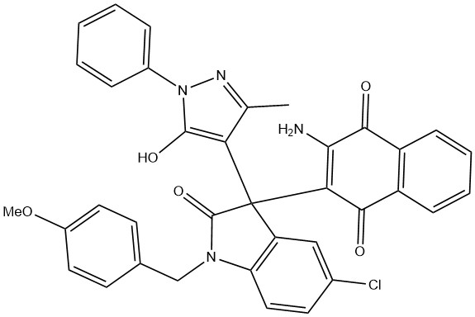

Figure 17: ¹H-NMR spectrum of compound 4g

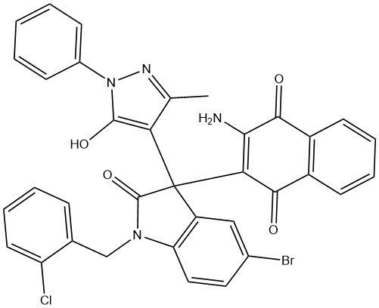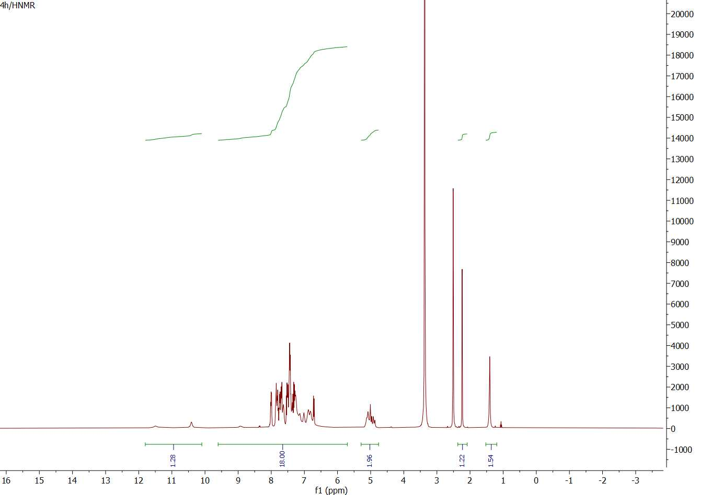

Figure 18: ¹H-NMR spectrum of compound 4h

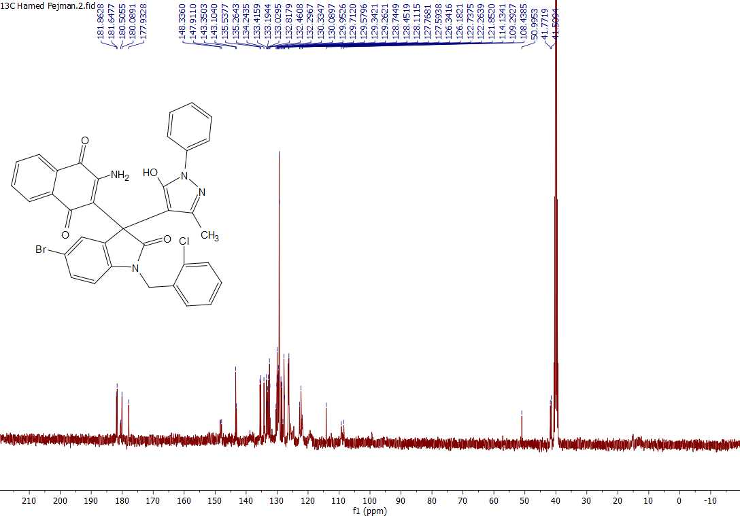
Figure 19: ¹³C-NMR spectrum of compound 4h

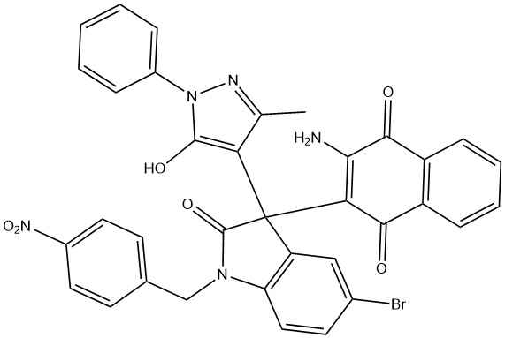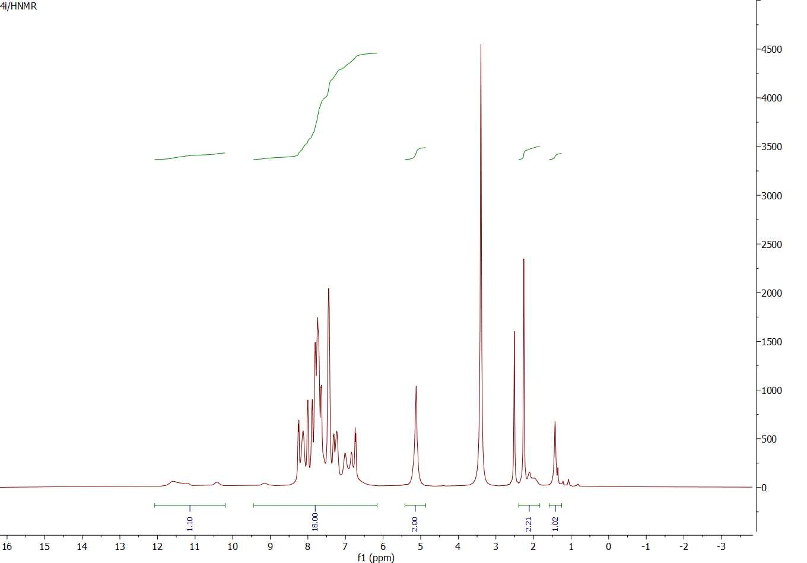

Figure 20: ¹H-NMR spectrum of compound 4i

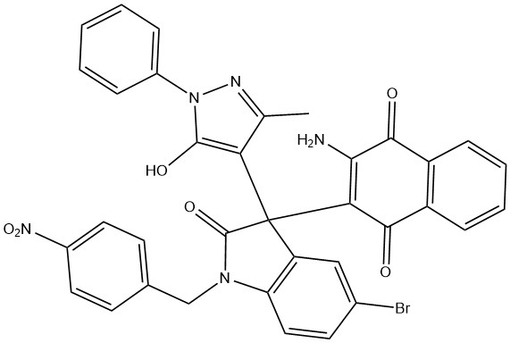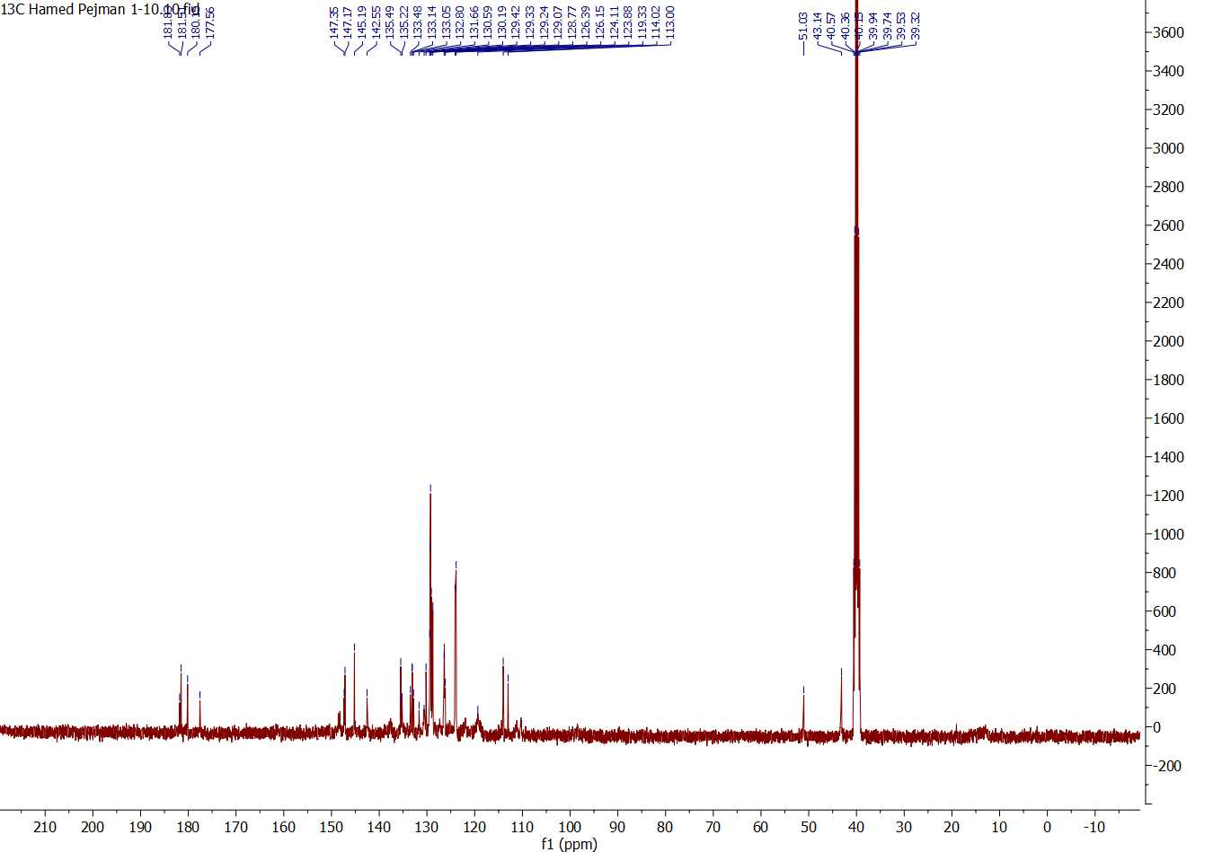
Figure 21: ¹³C-NMR spectrum of compound 4i

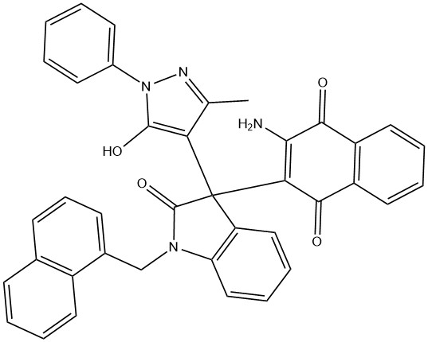
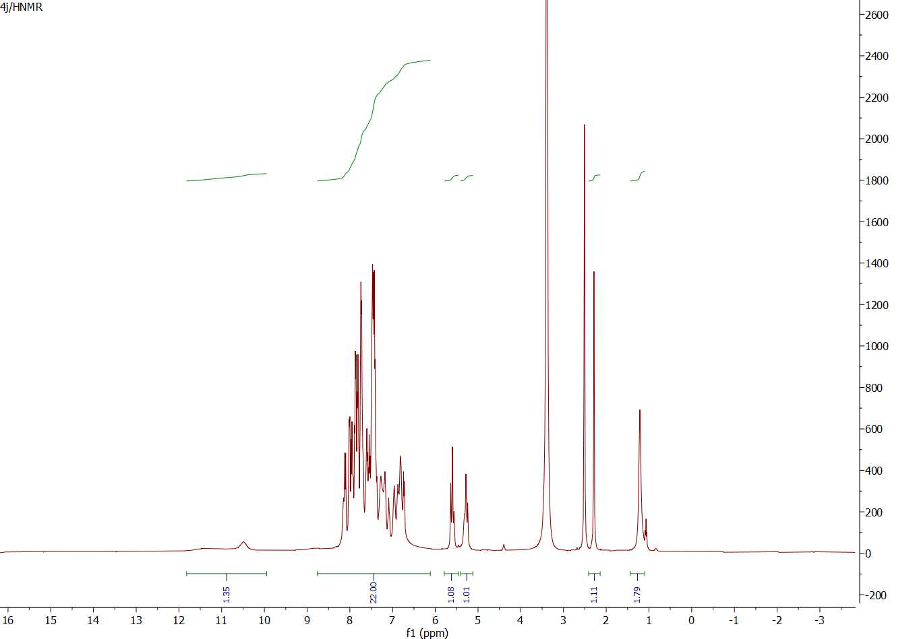
Figure 22: ¹H-NMR spectrum of compound 4j

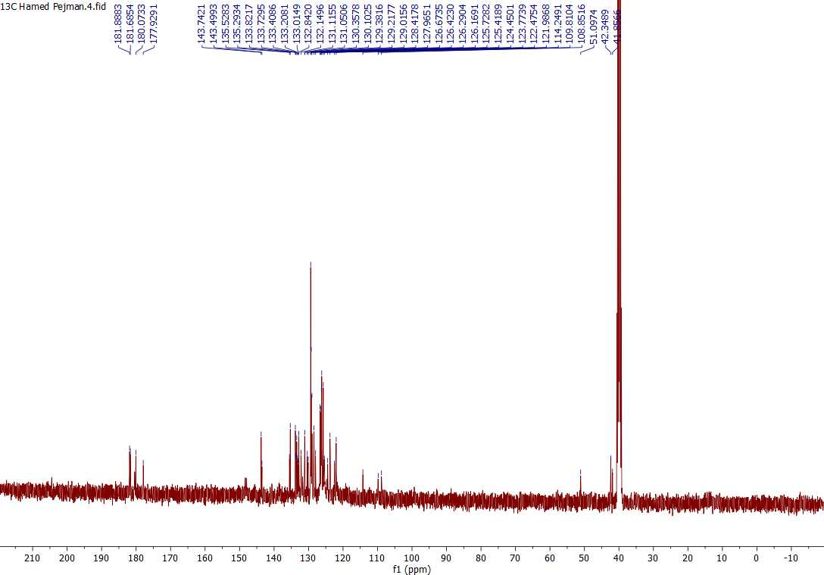
Figure 23: ¹³C-NMR spectrum of compound 4j

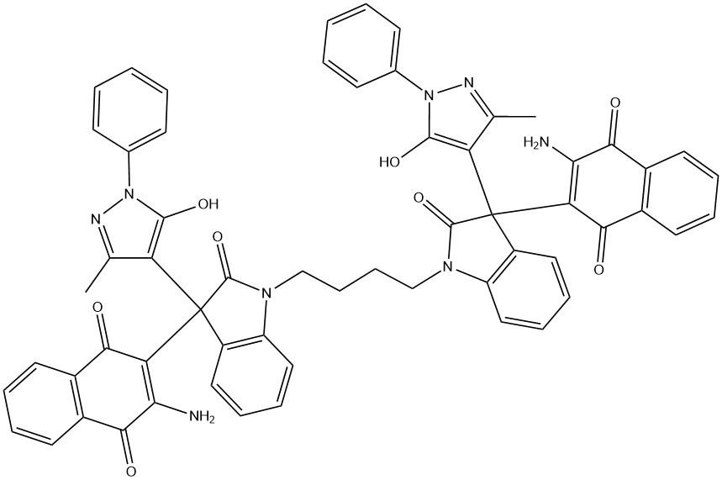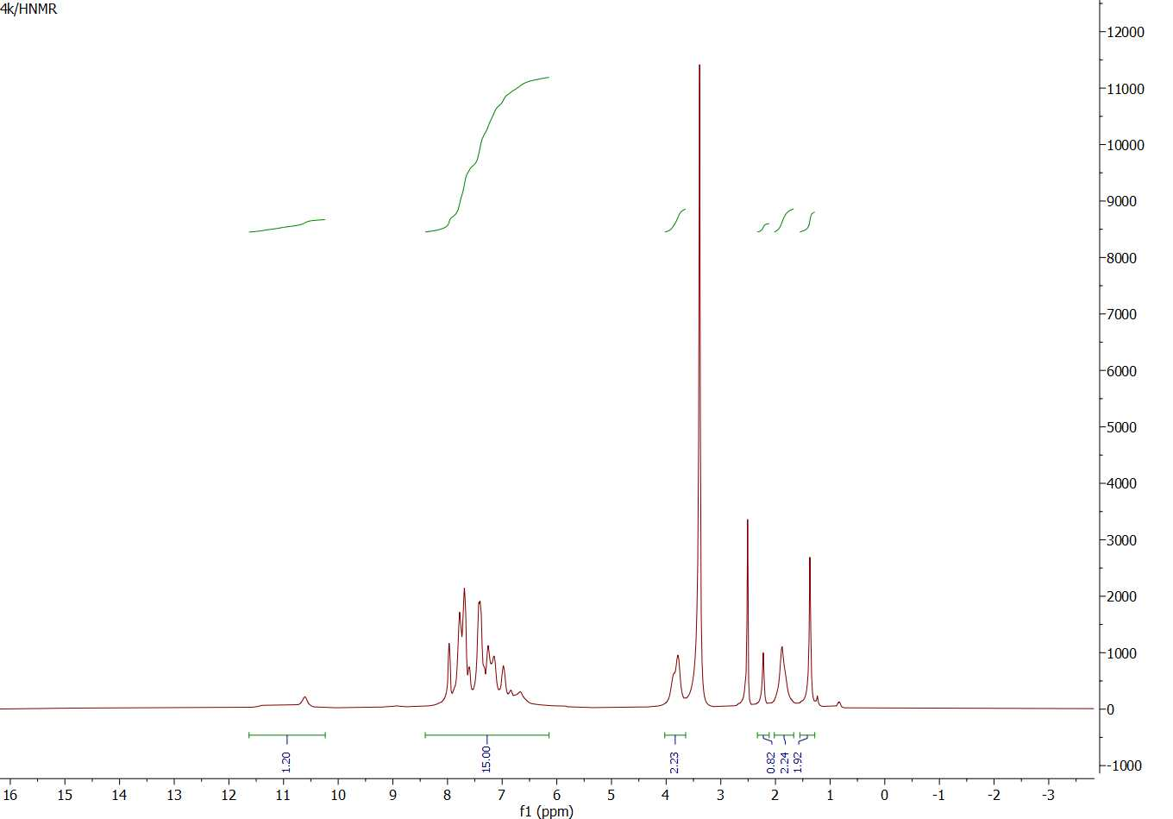
Figure 24: ¹H-NMR spectrum of compound 4k

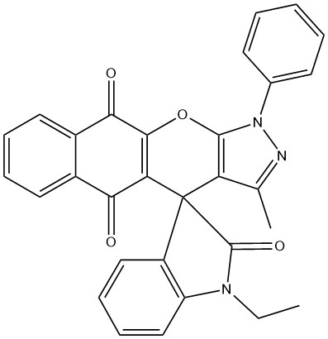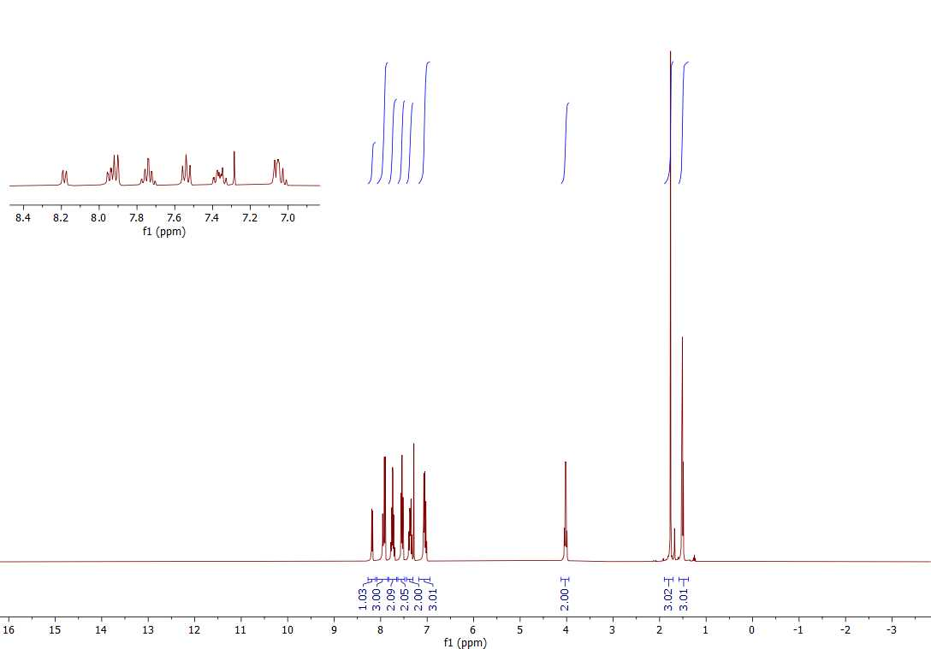
Figure 25: ¹H-NMR spectrum of compound 5a

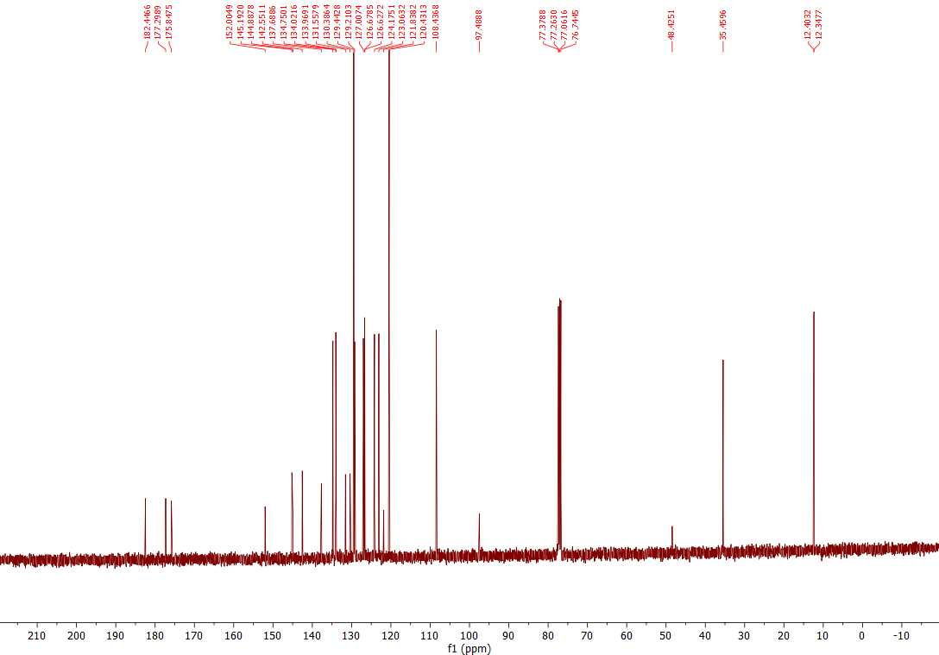
Figure 26: ¹³C-NMR spectrum of compound 5a

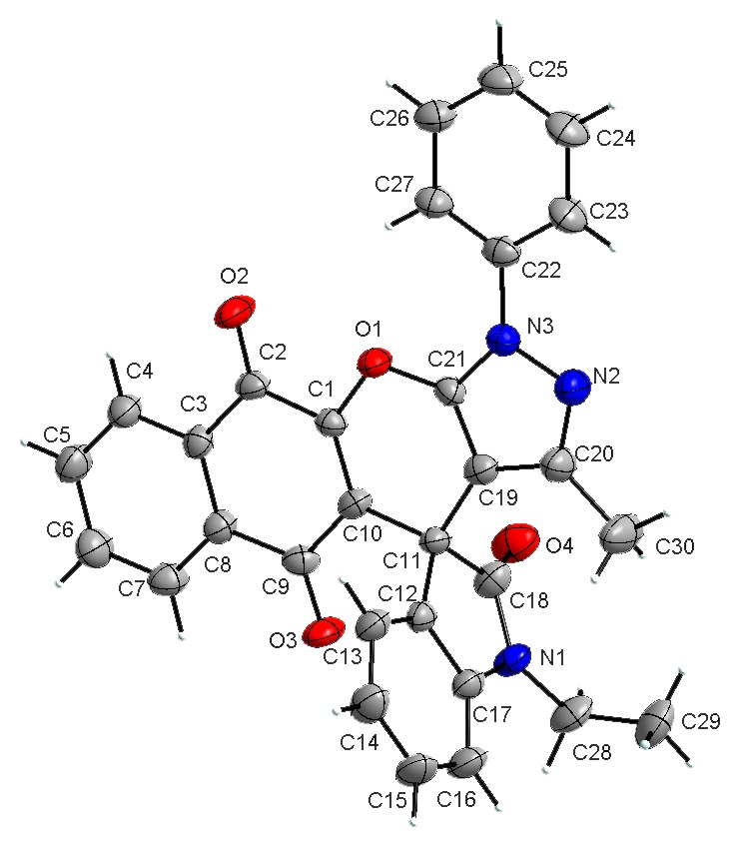
Figure 27: X-Ray spectrum of compound 5a

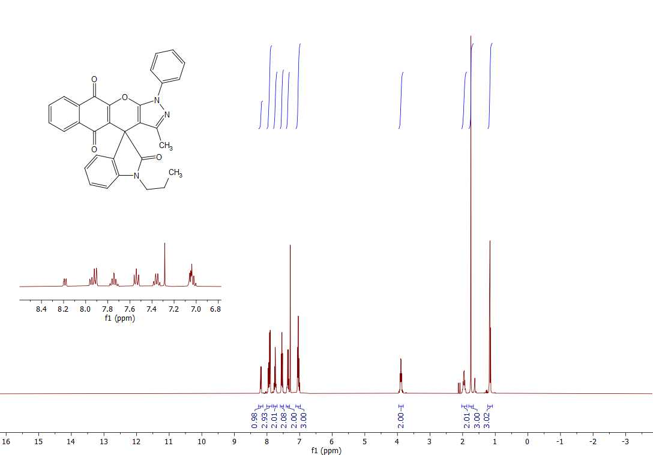
Figure 28: ¹H-NMR spectrum of compound 5b

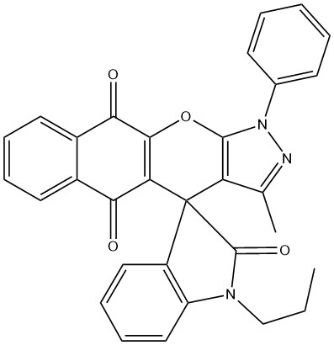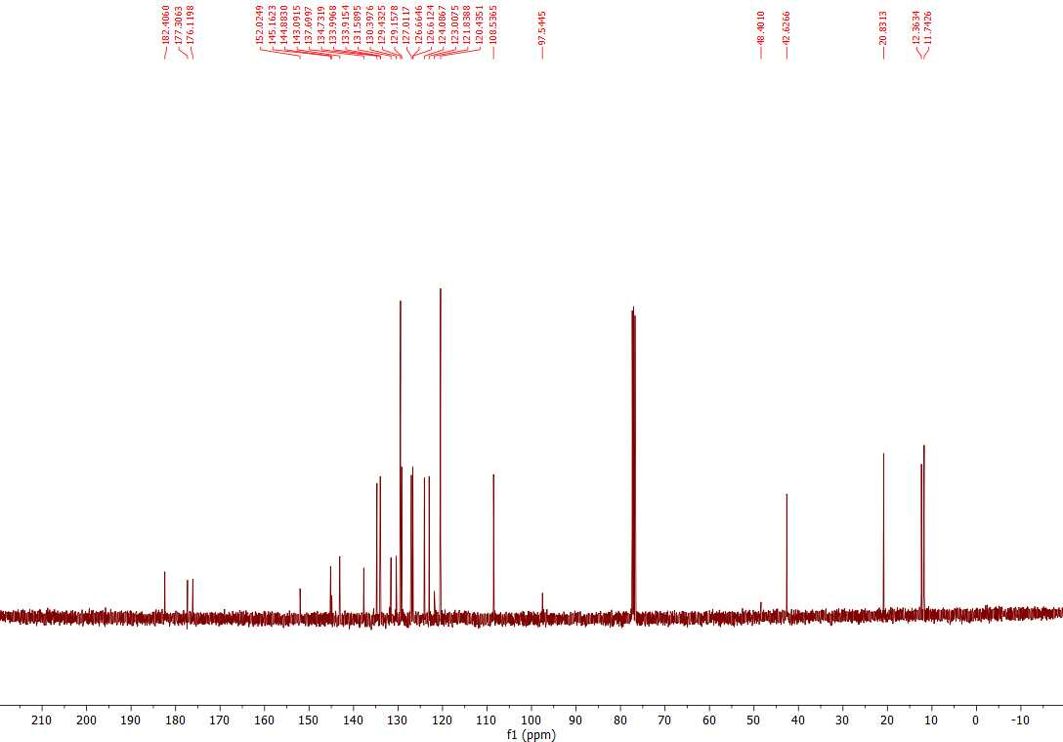

Figure 29: ¹³C-NMR spectrum of compound 5b

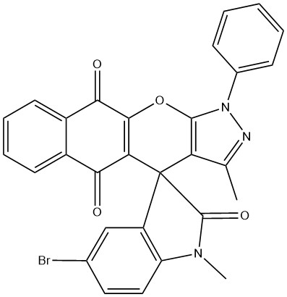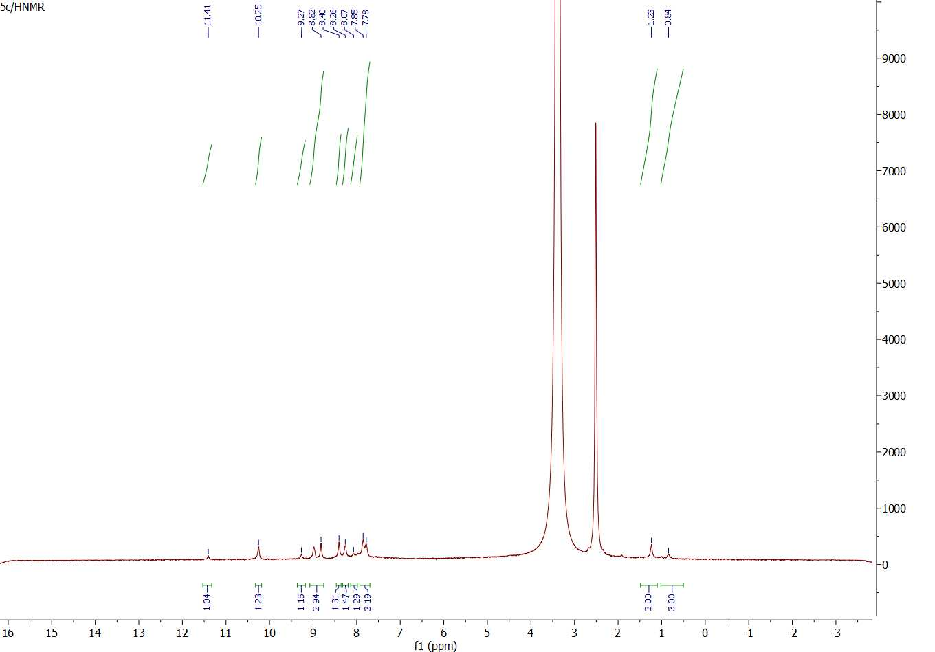
Figure 30: ¹H-NMR spectrum of compound 5c

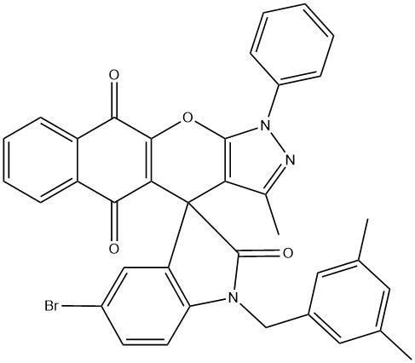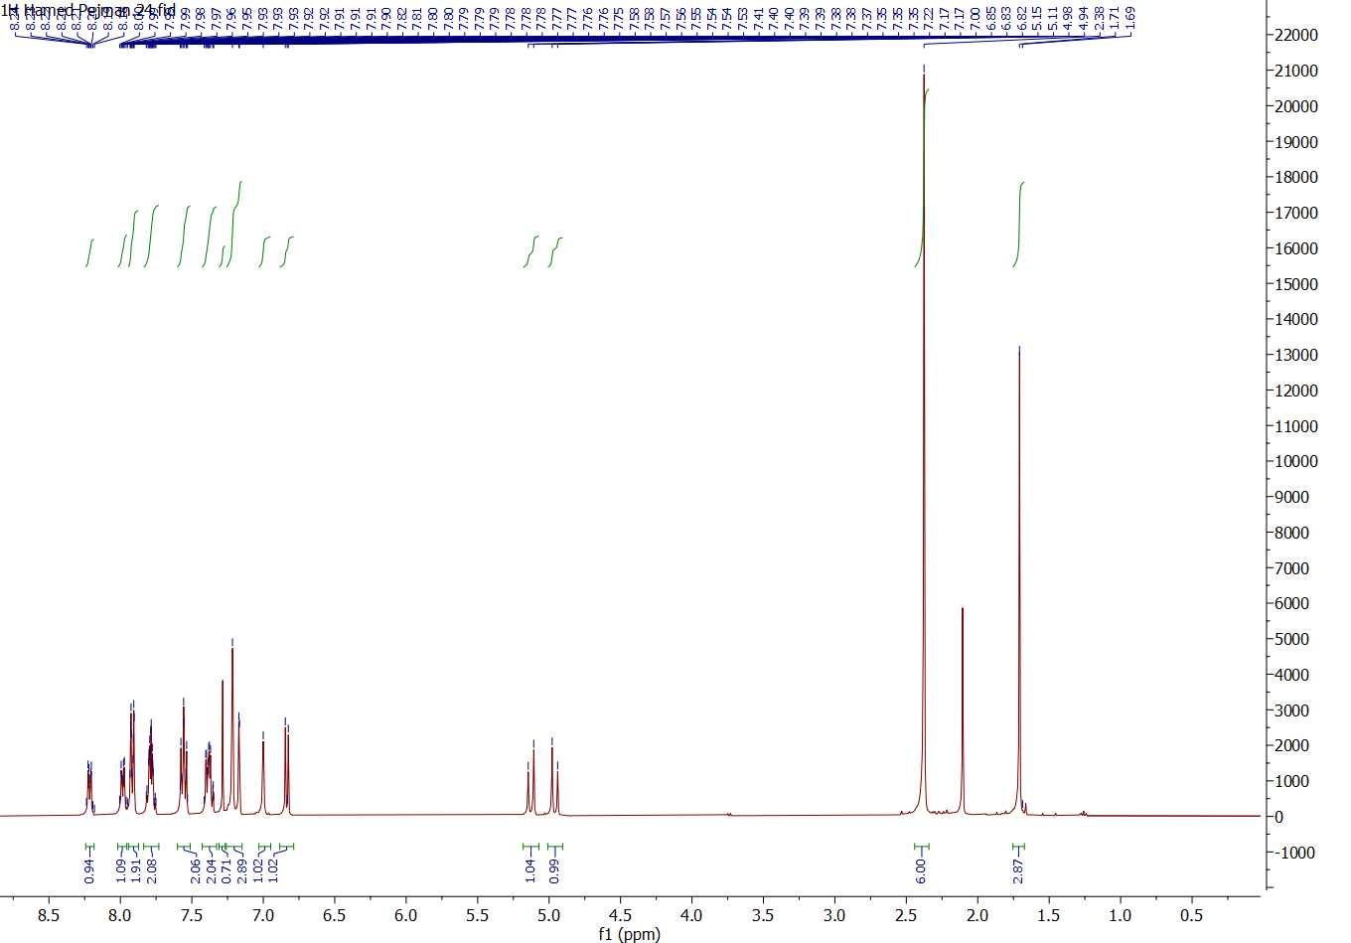

Figure 31: ¹H-NMR spectrum of compound 5d

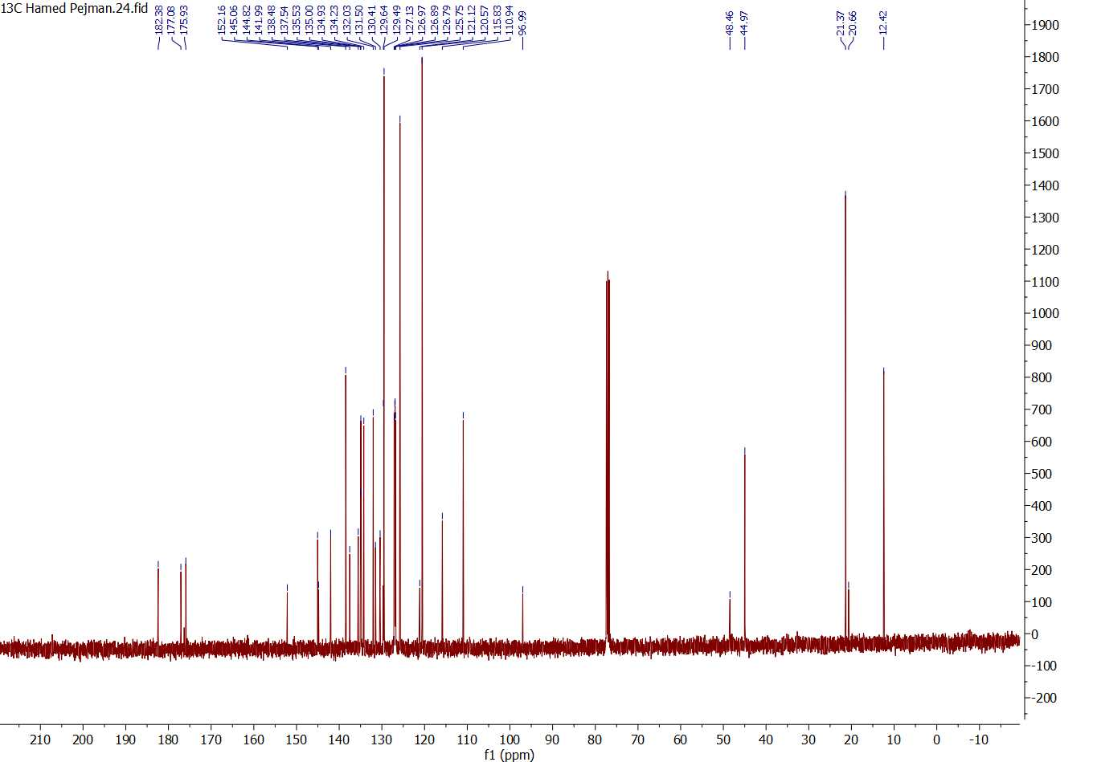
Figure 32: ¹³C-NMR spectrum of compound 5d

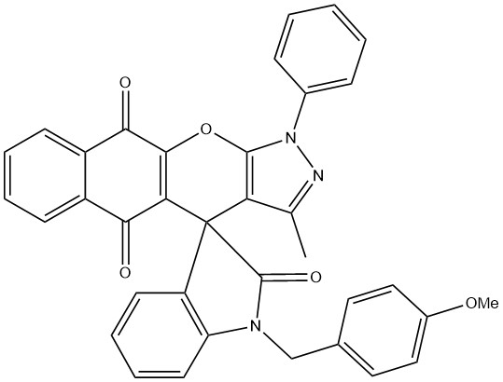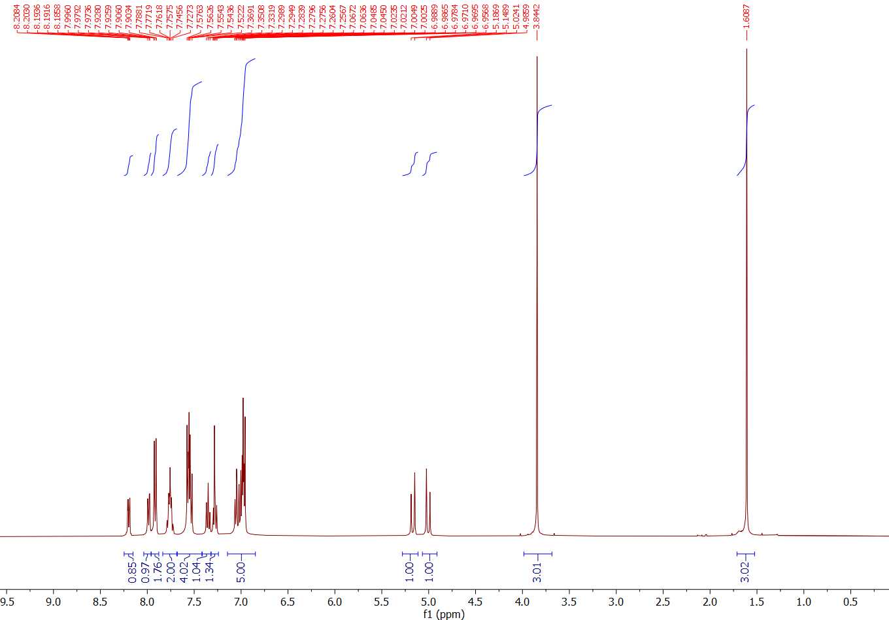

Figure 33: ¹H-NMR spectrum of compound 5e

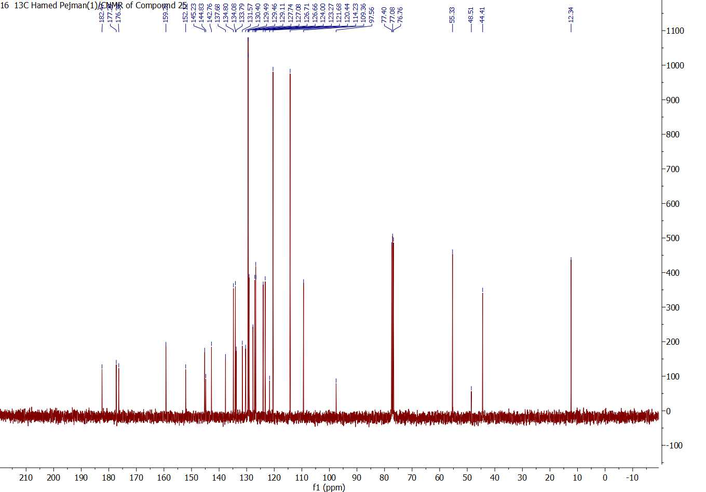
Figure 34: ¹³C-NMR spectrum of compound 5e

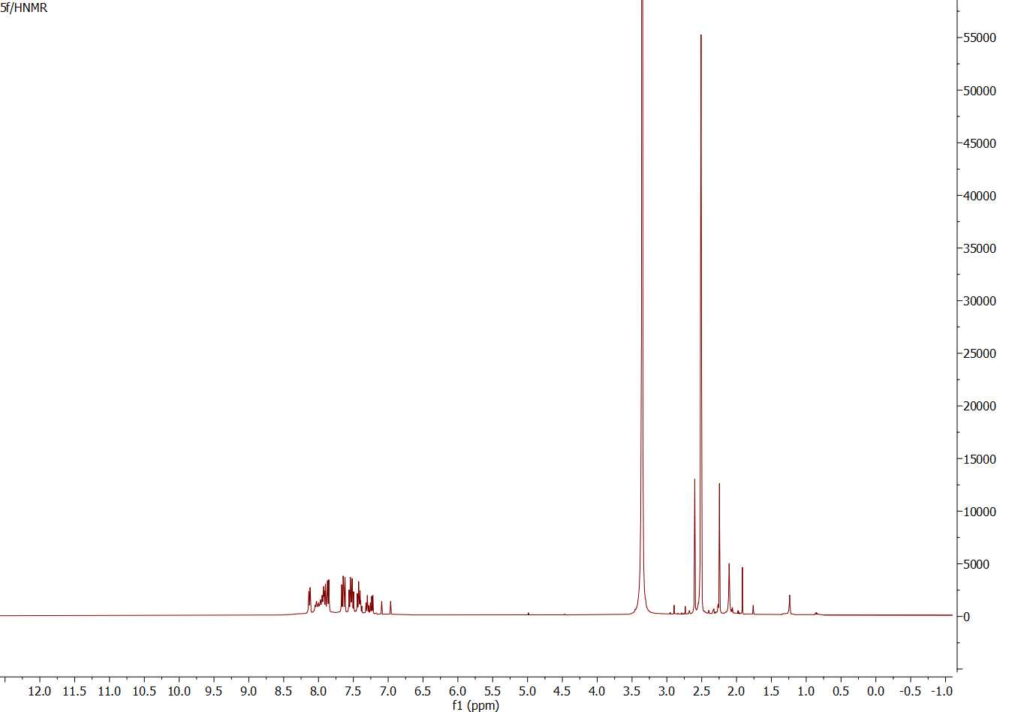
Figure 35: ¹H-NMR spectrum of compound 5f

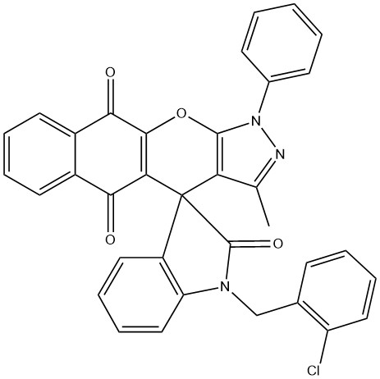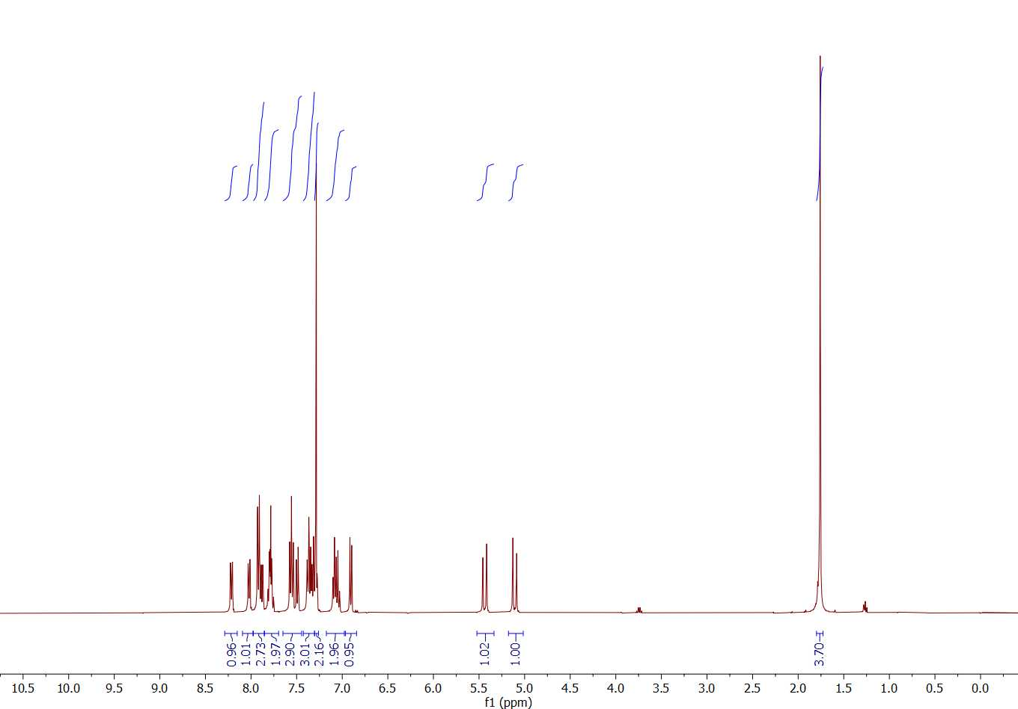
Figure 36: ¹H-NMR spectrum of compound 5g

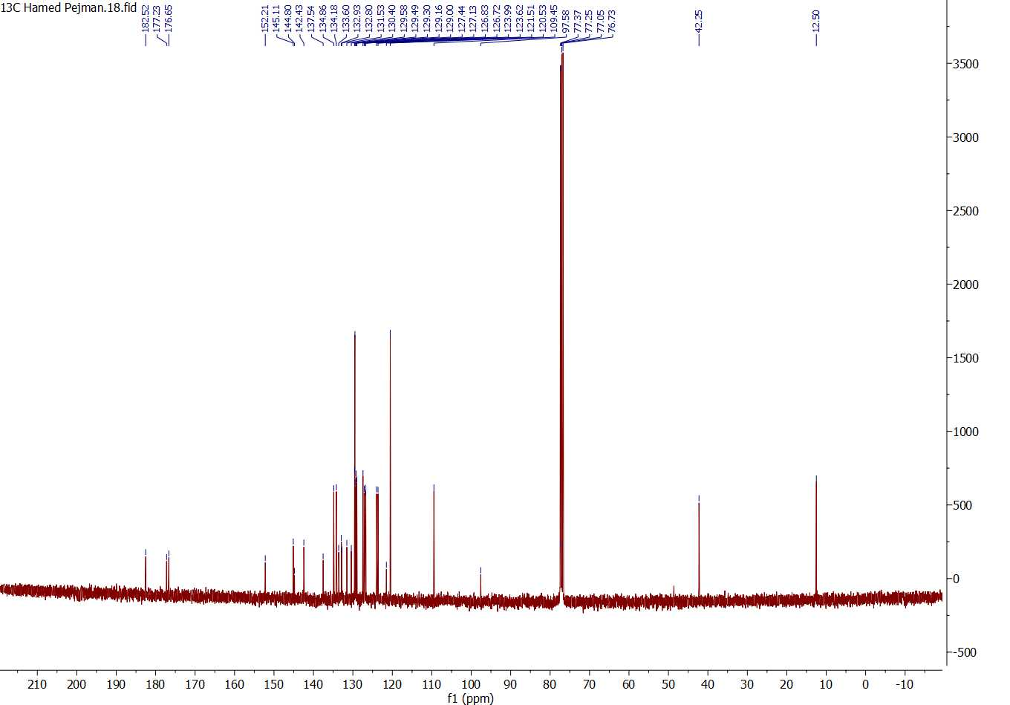
Figure 37: ¹³C-NMR spectrum of compound 5g

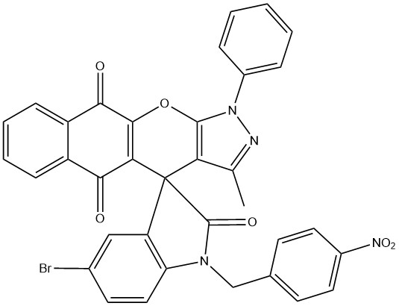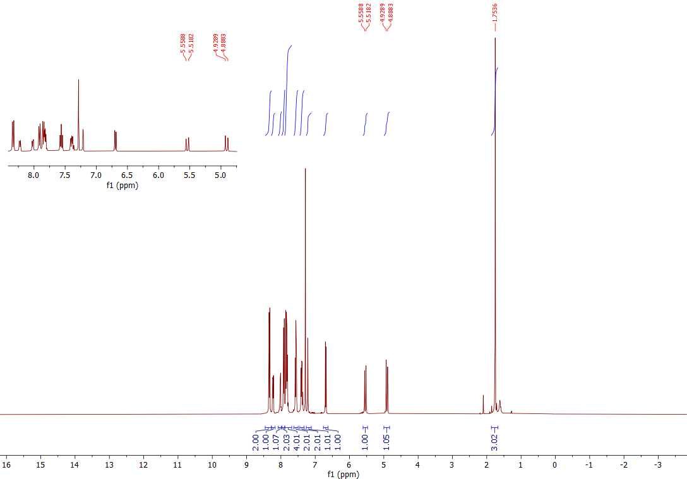
Figure 38: ¹H-NMR spectrum of compound 5h

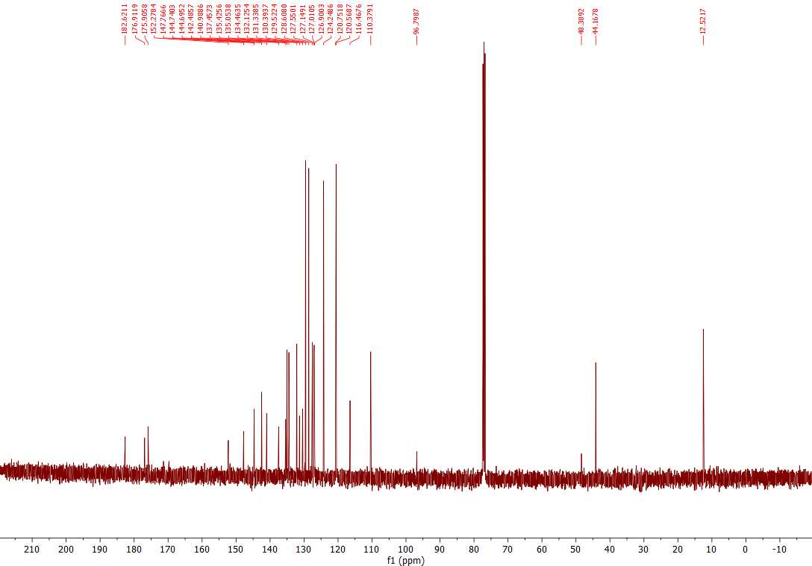
Figure 39: ¹³C-NMR spectrum of compound 5h

