Supplementary Methods

Explanation of Data Domain and Domain Generalization
In machine learning, particularly in the context of domain generalization, the term "domain" refers to the source of data or the environment from which the data is drawn, which includes a specific distribution of features, patterns, and possibly labels. Each domain has its own characteristics and statistical properties. The multi-source training data and biased joint distribution of data categories and sources in this study are relevant to the domain generalization problem. Domain generalization is a scenario where a model is trained on data from one or more source domains to perform well on a target domain that it has not seen during training. The goal is to learn a model that can generalize well to any new domain. The challenge is that the model must learn features that are invariant across the various domains, ignoring domain-specific noise and capturing only the essence of the data that is consistent and predictive across all domains.

Introduction of the CLAM Model
Considering recent progress in computer-aided diagnosis and deep learning algorithms, some recent works have already tried to accomplish histopathological image classification tasks with deep learning methods. The key challenge comes from the gigapixels of the histopathological images, which is unaffordable for any off-the-shelf deep learning method designed for natural images. Therefore, the Multi-Instance Learning (MIL) framework has been widely adopted, and previous works were mainly based on simple local-level predicting and global-level averaging diagrams in MIL. However, as for the differentiation of the MSS, MSI-H, and POLE mutations, it is hard to make decisions for every single patch. Moreover, simply aggregating patch-level classification results by numerical averaging is not enough to capture contextual information, which is critical for molecular classification. Furthermore, the training data is limited because of the rarity of MSI-H and pathogenic POLE mutations. Therefore, in this paper, our model is developed based on the attention-based dual-level MIL classification model CLAM which performs well on different WSI classification tasks and remains robust in the scarcity of training data.
The CLAM model accordingly conducts one global slide classification task and another local-level patch diagnostic relevance prediction task on the given input pre-extracted patch feature vectors for each slide. The CLAM model contains two variants, CLAM-SB and CLAM-MB, whose differences lie in the aggregation of patch features and the final classification strategy.
In the global-level slide classification task, for each class that the slide could be classified as the model employs an attention sub-network to learn how to assign attention weights to each feature vector. It subsequently aggregates the patch features through a weighted sum to form a comprehensive representation feature vector for the entire slide (CLAM-SB) or each target class (CLAM-MB) for the global classification of the entire slide. Therefore, only one global-level feature is obtained in CLAM-SB representing the entire slide with the patch-wise attention mechanism, and the final classification is conducted with a multi-class classifier implemented by a Multi-Layer Perceptron (MLP); and multiple global-level feature vectors are obtained in CLAM-MB, with one feature for each class, and the final results are obtained by several binary classifiers. For example, in the ternary classification task, CLAM-MB will produce three global-level features, and three binary classifiers are used to classify the slide into each class. As CLAM-MB can focus on different image characteristics for different classes, it fits the multi-category classification tasks better. As illustrated in the visualization results in the main paper, different classes have different attention distributions in the ternary classification, which indicates that the model focuses on different image characteristics for different classes.
Besides the global-level task, an additional local-level prediction task is further designed to improve the model performance based on the attention mechanism. For the entire slide (CLAM-SB) or each class (CLAM-MB), patches with the highest attention scores can be regarded as strong positive or strong negative evidence for the final classification result. Therefore, a local patch diagnostic significance prediction task can be conducted based on the patch-wise attention scores, in which patches with the highest attention scores can be seen as “diagnostic”, and a "diagnostic" pseudo label can be assigned to top-$B$ patches with the highest attention scores, while patches with the lowest attention scores can be seen as “non-diagnostic”, and a “non-diagnostic” pseudo label can be assigned to the top-$B$ patches with the lowest attention scores. A local-level predictor is trained to classify these $2B$ patches into “diagnostic” or “non-diagnostic”.

Cross-Domain Feature Alignment and Adversarial Training
To thoroughly eliminate domain-specific characteristics in the multi-source training WSIs, in this paper, we propose the multi-level cross-domain feature alignment method. The multi-level cross-domain feature alignment techniques consist of the local-level patch-wise alignment to ensure detailed patch feature consistency across different data sources, the feature-level prototypical alignment to aggregate patches with attention mechanism and construct prototypes to adaptively extract holistic features representing domain-specific general characteristics, and the global-level slide-wise alignment to directly calibrate the final slide feature for final classification, and are developed based on the domain discriminator and adversarial training method. The optimization objective of the domain discriminator is to distinguish from which data domain its input features are collected and refine the input features to be domain-specific. This objective contrasts with the cross-domain generalizable model, which aims to acquire domain-invariant features. Therefore, the adversarial training method is proposed to reconcile this contradiction, in which gradient reversal layers (GRLs) are integrated before the domain discriminators and reverse the gradients back-propagated from the discriminators, thus tuning the model to learn robust domain-invariant features (opposite to the domain discriminators optimizing goal). In cross-domain adversarial training, components placed after the GRL are trained to become more domain-specific, while components before the GRL are trained to be domain-invariant.

As introduced below, cross-domain feature alignment is conducted at different levels. By aligning the multi-level features and patches from the WSIs, the model ensures that cross-domain variabilities can be thoughtfully removed and generalization performance can be improved.
- Local-Level Patch-wise Alignment: This technique focuses on the consistency of localized image features in small patches from the WSIs across different data sources. It ensures that patches containing similar contents from different domains are aligned in feature space, which helps the model learn to recognize these patches regardless of their domain. This level of alignment is crucial for maintaining the integrity of the localized and subtle diagnostic features. The local-level patch-wise alignment is performed by applying a domain discriminator to each patch feature accordingly. The domain discriminator is implemented by an MLP, and a GRL is inserted before the domain discriminator. With the gradient-reversed domain discriminator, the patch features are trained to confuse the domain discriminator and to be domain-agnostic, and with the following parts of the pathologic classification network, the features are trained to be diagnostic at the same time.
- Feature-level Prototypical Alignment: At a higher level, this technique involves aggregating patches based on patch-wise attention to form “prototypes”. These prototypes represent the general characteristics of a domain and are used to extract holistic features that are domain-specific. Therefore, the entire domain discriminator, comprising an attention-based aggregation module to adaptively extract a feature vector rich in domain-specific information from all patch features, and an MLP for classification, together with a GRL, is applied to all patch features. By such means, domain-specific characteristics can be removed from features before the GRL. The adaptive nature of this alignment allows the model to dynamically adjust feature extraction concerning different inputs, thereby enhancing the model's ability to generalize.
- Global-Level Slide-wise Alignment: The final technique operates at the highest level by aligning the overall slide features for molecular classification. This global alignment ensures that the final, comprehensive features used for classifying an entire slide are diagnostic and consistent across different domains, which is crucial for the model’s performance on the final task. Besides the POLEmut/MSI-H/MSS&TMB-L classifier, a gradient-reversed domain discriminator is additionally applied to the final slide feature in a multi-task manner.
The model is trained in a multi-task manner with the POLEmut/MSI-H/MSS&TMB-L classification and the data source identification tasks, and both pathologic labels and data source labels are required. The model performs five tasks in total: molecular classification for the entire slide, diagnostic relevance prediction for each patch, and the three alignment techniques, each with a loss value to compute. The loss values are added and optimized simultaneously.
By integrating these comprehensive alignment methods conducted at different levels with cross-domain adversarial training, the CDA-CLAM model is trained to identify and emphasize the most informative features for the POLE mutation prediction, irrespective of their domain of origin, and address the challenges posed by dataset biases and data source variability in gene mutation classifications.

Dataset Description of Camelyon17
The publicly available training set of the Camelyon17 dataset is included in our study to validate the deep learning model's performance in distinguishing data sources for various datasets. Camelyon17 is a publicly available dataset for the automated detection and classification of breast cancer metastases in H&E-stained WSIs of histological lymph node sections. The dataset is collected from 5 medical centers in the Netherlands. The training set is composed of 500 slides, 100 slides from each institution. The negative/positive labels and data-source labels are only provided for the training set. In this study, we focus on the data-source label to evaluate the model's performance in distinguishing data sources, and therefore, only the training set with data-source label available is used. For more detailed descriptions of the Camelyon17 dataset, please refer to the official website of the Camelyon17 challenge (https://camelyon17.grand-challenge.org/Data/).

Supplementary Results

POLE mutants and TMB of internal POLE dataset
Supplementary Table 1 POLE mutants and TMB of the internal POLE dataset
Sample ID | Exon rank | Mutation | TMB  (muts/MB) | MSI status(by NGS methods)
RS1707149FFP | 9 | p.P286R | N/A | MSS
RS19022465FFP | 9 | p.P286R | 719 | MSS
RS19032639FFP | 9 | p.P286R | N/A | MSS
RS19045942FFP | 9 | p.P286R | 446 | MSS
RS20023172FFP | 9 | p.P286R | 305·08 | MSS
RS20027535TIS | 9 | p.P286R | 245·26 | MSS
RS21000404FFP | 9 | p.P286R | 266·2 | MSS
RS21000408FFP | 9 | p.p436R | 409·77 | MSS
RS21002804FFP | 9 | p.P286R | 171·49 | MSS
RS21010980FFP | 9 | p.P286R | 388·83 | MSS
RS21026294FFP | 9 | p.P286R | 276·17 | MSS
RS210626296 | 9 | p.P286R | 354·94 | MSS
RS20126297FFP | 9 | p.P286R | 296·11 | MSS
RS21026298 | 9 | p.P286R | 534·4 | MSS
RS21029405FFP | 9 | p.P286R | 199·4 | MSS
RS21031385FFP | 9 | p.P286R | 462·61 | MSS
RS21041493FFP | 9 | p.P286R | 385·84 | MSS
RS21041494FFP | 9 | p.P286R | 195·41 | MSS
RS21041496FFP | 9 | p.P286R | 339·98 | MSS
RS21041498FFP | 9 | p.P286R | 204·39 | MSS
S2039973 | 9 | p.P286R | 221·79 | MSS
CP60003446 | 9 | p.P286R | N/A | MSS
CP60006791 | 9 | p.P286R | N/A | MSS
CP60007027 | 9 | p.P286R | N/A | MSS
CP60016342 | 9 | p.P286R | 200 | MSS
CP60016879 | 9 | p.P286R | N/A | MSS
CP60019570 | 9 | p.P286R | N/A | MSS
CP60023126 | 9 | p.P286R | N/A | MSS
CP70003785 | 9 | p.P286R | 243·548 | MSS
CP70005186 | 9 | p.P286R | N/A | MSS
CP70005417 | 9 | p.P286R | 391·935 | MSS
CP70007268 | 9 | p.P286R | N/A | MSS
CP70007815 | 9 | p.P286R | N/A | MSS
CP70021990 | 9 | p.P286R | N/A | MSS
CP70024538 | 9 | p.P286R | N/A | MSS
CP70029937 | 9 | p.P286R | 218·548 | MSS
CP70030117 | 9 | p.P286R | N/A | MSS
CP70030172 | 9 | p.P286R | N/A | MSS
CP70030990 | 9 | p.P286R | 400 | MSS
CP70035731 | 9 | p.P286R | N/A | MSS
CP70036555 | 9 | p.P286R | N/A | MSS
CP70036625 | 9 | p.P286R | N/A | MSS
CP70037667 | 9 | p.P286R | 313·966 | MSS
CP70040967 | 9 | p.P286R | N/A | MSS
CP70041500 | 9 | p.P286R | N/A | MSS
CP70044571 | 9 | p.P286R | N/A | MSS
CP70046332 | 9 | p.P286R | N/A | MSS
CP70046439 | 9 | p.P286R | 324·581 | MSS
CP70047930 | 9 | p.P286R | 235·196 | MSS
CP70048207 | 9 | p.P286R | N/A | MSS
CP70050242 | 9 | p.P286R | 168·715 | MSS
CP70054434 | 9 | p.P286R | 332·402 | MSS
CP70054990 | 9 | p.P286R | N/A | MSS
P193927 | 9 | p.P286R | 183·11 | MSS
P195200 | 9 | p.P286R | 272·92 | MSS
P197188 | 9 | p.P286R | 195·65 | MSS
P207020 | 9 | p.P286R | 115·8 | MSS
P219716 | 9 | p.P286R | 107·03 | MSS
P227158 | 9 | p.P286R | 335·24 | MSS
RS22013897FFP | 9 | p.P286R | 44·87 | MSS
RS22013911FFP | 9 | p.P286R | 341·97 | MSS
255765 | 9 | p.P286R | N/A | MSS
260216 | 9 | p.P286R | N/A | MSS
RS1724507FFP | 9 | p.S297F | N/A | MSS
RS21026267FFP | 9 | p.S297F | 273·18 | MSS
CP60012061 | 9 | p.S297Y | N/A | MSS
CP70030435 | 9 | p.S297Y | 384·916 | MSS
CP70031381 | 9 | p.S297F | N/A | MSS
CP70034548 | 9 | p.S297F | N/A | MSS
RS21010978FFP | 11 | p.p367V | 383·83 | MSS
RS1819517FFP | 13 | p.V411L | 251·59 | MSS
RS1831592FFP | 13 | p.V411L | N/A | MSS
RS20019503FFP | 13 | p.V411L | N/A | MSS
RS20039725TIS | 13 | p.V411L | 245·26 | MSS
RS20054564TIS | 13 | p.V411L | 184·45 | MSS
RS20058381FFP | 13 | p.V411L | 232·3 | MSS
RS20058382FFP | 13 | p.V411L | 368·67 | MSS
RS21026283FFP | 13 | p.V411L | N/A | MSS
RS2106286FFP | 13 | p.V411L | 227·32 | MSS
RS21026303FFP | 13 | p.V411L | 252·24 | MSS
RS21029409FFP | 13 | p.V411L | 151·55 | MSS
2020-06835-1 | 13 | p.V411L | 315·05 | MSS
22848 | 13 | p.V411L | 423·73 | MSS
CP10003817 | 13 | p.V411L | 197·331 | MSS
CP50005938 | 13 | p.V411L | N/A | MSS
CP60010076 | 13 | p.V411L | N/A | MSS
CP70005653 | 13 | p.V411L | N/A | MSS
CP70008593 | 13 | p.V411L | N/A | MSS
CP70020681 | 13 | p.V411L | N/A | MSS
CP70024351 | 13 | p.V411L | 278·771 | MSS
CP70027380 | 13 | p.V411L | N/A | MSS
CP70042177 | 13 | p.V411L | 256·425 | MSS
CP70044365 | 13 | p.V411L | N/A | MSS
CP70047002 | 13 | p.V411L | 259·218 | MSS
P207325 | 13 | p.V411L | 181·38 | MSS
P224738 | 13 | p.V411L | 267·88 | MSS
T0014682 | 13 | p.V411L | 163·04 | MSS
255765 | 13 | p.V411L | 290·4 | MSS
236859 | 13 | p.V411L | N/A | MSS
CP70024427 | 13 | p.V411L | 378·226 | MSS
84374 | 13 | p.L424I | 91·6 | MSS
CP50004918 | 13 | p.P436R | 187·378 | MSS
CP70010543 | 13 | p.P436R | N/A | MSS
P189820 | 13 | p.P436S | 71·2 | MSS
RS21026290FFP | 13 | p.M444K | 218·34 | MSS
579421A5 | 13 | p.M444K | 191·53 | MSS
RS22013912FFP | 13 | p.M444K | 179·46 | MSS
9728-8 | 13 | p.M444K | N/A | MSS
RS21026291FFP | 14 | p.A456P | 329·01 | MSS
RS21026295FFP | 14 | p.A456P | 314·06 | MSS
CP60022091 | 14 | p.A456P | N/A | MSS
CP70003730 | 14 | p.A456P | N/A | MSS
CP70006042 | 14 | p.A456P | N/A | MSS
CP70024754 | 14 | p.A456P | N/A | MSS
CP70035349 | 14 | p.A456P | N/A | MSS
CP70036641 | 14 | p.A456P | 283·799 | MSS
CP70055075 | 14 | p.A456P | 168·715 | MSS
47021 | 14 | p.A456P | 507·26 | MSS
RS1806307FFP | 14 | p.S459Y | 442 | MSS
RS21000403FFP | 14 | p.S459F | 235·29 | MSS
RS21003154FFP | 14 | p.S459F | 91·27 | MSS
RS21017731FFP | 14 | p.S459F | 294.12 | MSS
RS21026300FFP | 14 | p.S459F | 82·75 | MSS
RS21041495FFP | 14 | p.S459F | 161·52 | MSS
238749-9 | 14 | p.S459F | 136·59 | MSS
CP70034940 | 14 | p.S459F | N/A | MSS
CP70035001 | 14 | p.S459F | 195·531 | MSS
CP70046280 | 14 | p.S459F | N/A | MSS
164705 | 14 | p.S459F | 250·25 | MSS
TMB, tumor mutation burden; MSS, microsatellite stable, MSI, microsatellite instable; N/A, not available

Clinical characteristics of the POLEex dataset
Supplementary Table 2 Clinicopathological characteristics of patients in the POLEex dataset
 | MSS/TMB-L  (n=27) | MSI-H  (n = 19) | POLEmut  (n=14) | p value
Age | 60·9 (55·9 – 65·9) | 56·1 (49·0 – 63·1) | 48·1 (43·3 – 52·9) | 0·0007
Gender  Male  Female | 14 (51·9%)  13 (48·1%) | 7 (36·8%)  12 (63·1%) | 9 (64.3%)  5 (35·7%) | 0·2871
Primary tumor location  Right-side  Left-side | 8 (29·6%)  19 (70·4%) | 13 (68·4%)  6 (31·6%) | 9 (64.3%)  5 (35·7%) | 0·0165
Histology  Adenocarcinoma  Mucinous/ signet-ring cell carcinoma | 24 (88·9%)  3 (11·1%) | 15 (78·9%)  4 (21·1%) | 11 (78·6%)  3 (11·4%) | 0·5793
Tumor differentiation  Well/Mediate  Poor | 24 (88·9%)  3 (11·1%) | 13 (68·4%)  6 (31·6%) | 8 (57·1%)  6 (42·9%) | 0·0609
Stage  Ⅰ/Ⅱ  Ⅲ  Ⅳ | 7 (25·9%)  16 (59·3%)  4 (14.8%) | 13 (68·4%)  5 (26·3%)  1 (5·3%) | 8 (57·1%)  3 (21·4%)  3 (21·4%) | 0·0295
T stage  1/2  3  4 | 2 (7·4%)  14 (51·9%)  11 (40·7%) | 5 (26·3%)  13 (68·4%)  1 (5·3%) | 3 (21·4%)  9 (64.3%)  2 (14.3%) | 0·0428

Detailed Performance of the proposed CDA-CLAM
As introduced in Section 3.4 of the main manuscript, the proposed CDA-CLAM model demonstrates good performance in both internal cross-validation and external prospective evaluation and in both the binary and ternary classification tasks. The detailed ROC curves and AUC values for each fold in cross-validation, and the performance of each fold’s model on the external evaluation dataset are shown in Supplementary Table 3 and Supplementary Figure 1 for the binary classification task, and Supplementary Table 4 and Supplementary Figure 2. for the ternary classification task.
Supplementary Table 3 Detailed cross-validation and external validation performance for CDA-CLAM in the binary classification task
 | Internal |  | External
 | AUC | Accuracy | AUC | Accuracy
Avg | 0·9543  (0·9376 - 0·9710) | 0·8775  (0·8489 - 0·9060) | 0·8676  (0·7687 - 0·9665) | 0·8333  (0·7390 - 0·9276)
Fold 0 | 0·9882  (0·9715 - 1·0000) | 0·9510  (0·9091 - 0·9929) | 0·8631  (0·7626 - 0·9636) | 0·8000  (0·6988 - 0·9012)
Fold 1 | 0·9412  (0·8970 - 0·9853) | 0·8431  (0·7726 - 0·9137) | 0·8676  (0·7674 - 0·9678) | 0·8000  (0·6988 - 0·9012)
Fold 2 | 0·9520  (0·9172 - 0·9868) | 0·8515  (0·7821 - 0·9208) | 0·8721  (0·7756 - 0·9686) | 0·8333  (0·7390 - 0·9276)
Fold 3 | 0·9144  (0·8614 - 0·9675) | 0·8200  (0·7447 - 0·8953) | 0·8698  (0·7706 - 0·9690) | 0·8000  (0·6988 - 0·9012)
Fold 4 | 0·9629  (0·9283 - 0·9974) | 0·9208  (0·8681 - 0·9735) | 0·8608  (0·7590 - 0·9627) | 0·7833  (0·6791 - 0·8876)

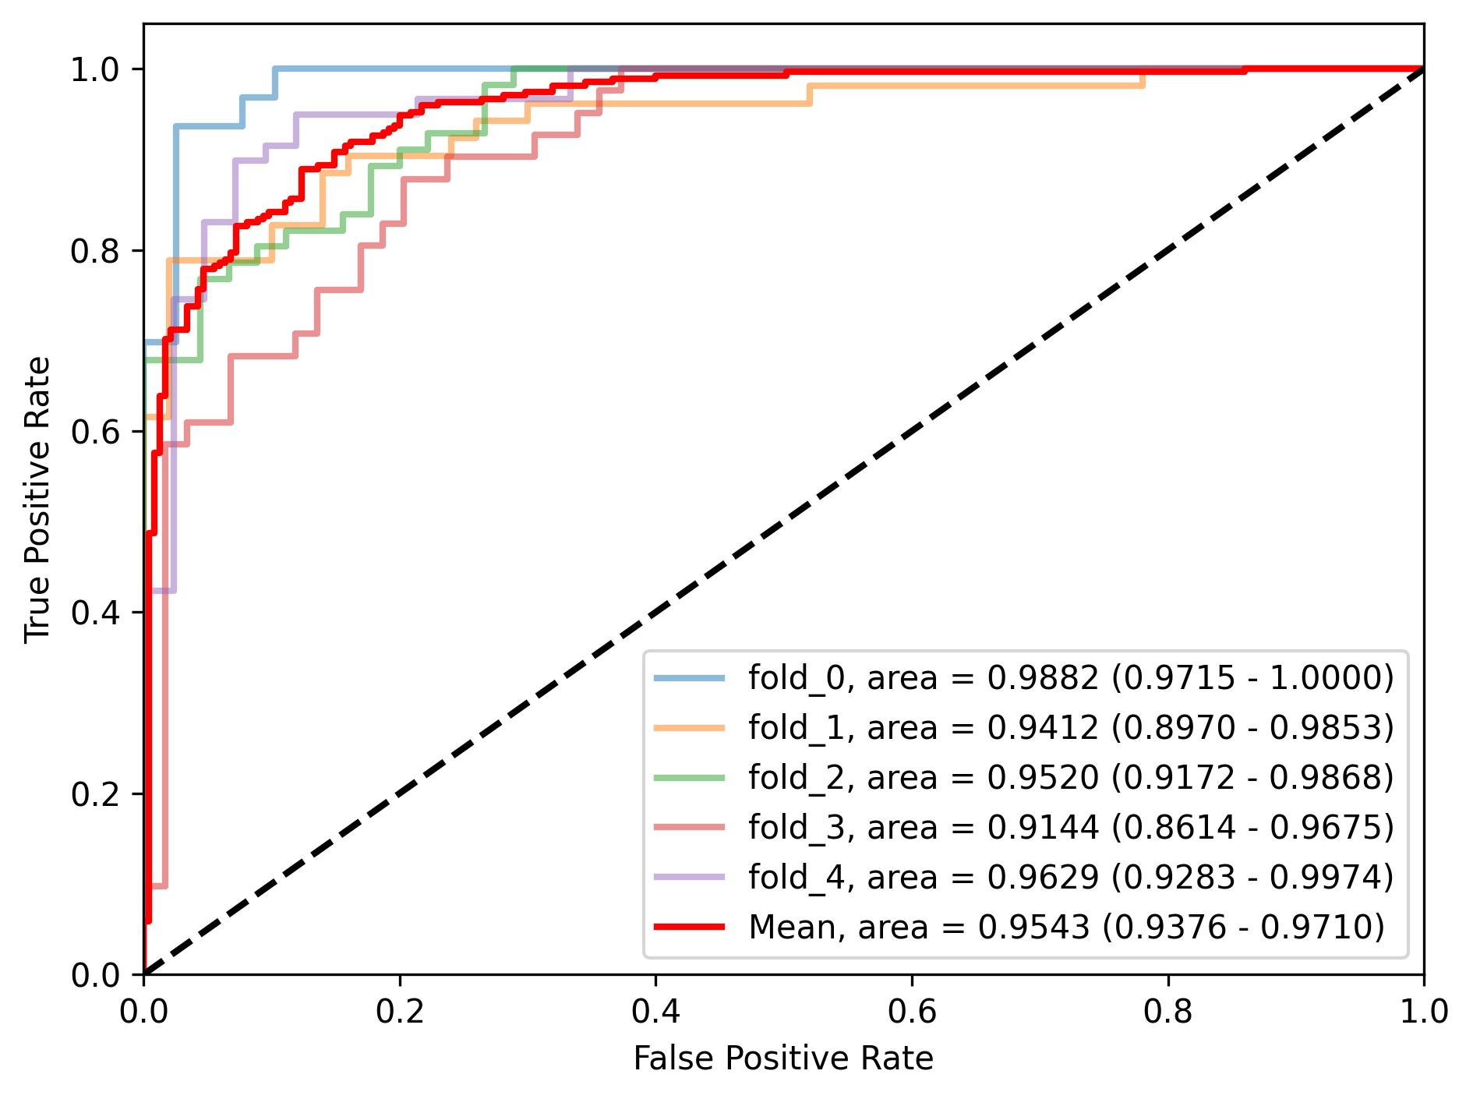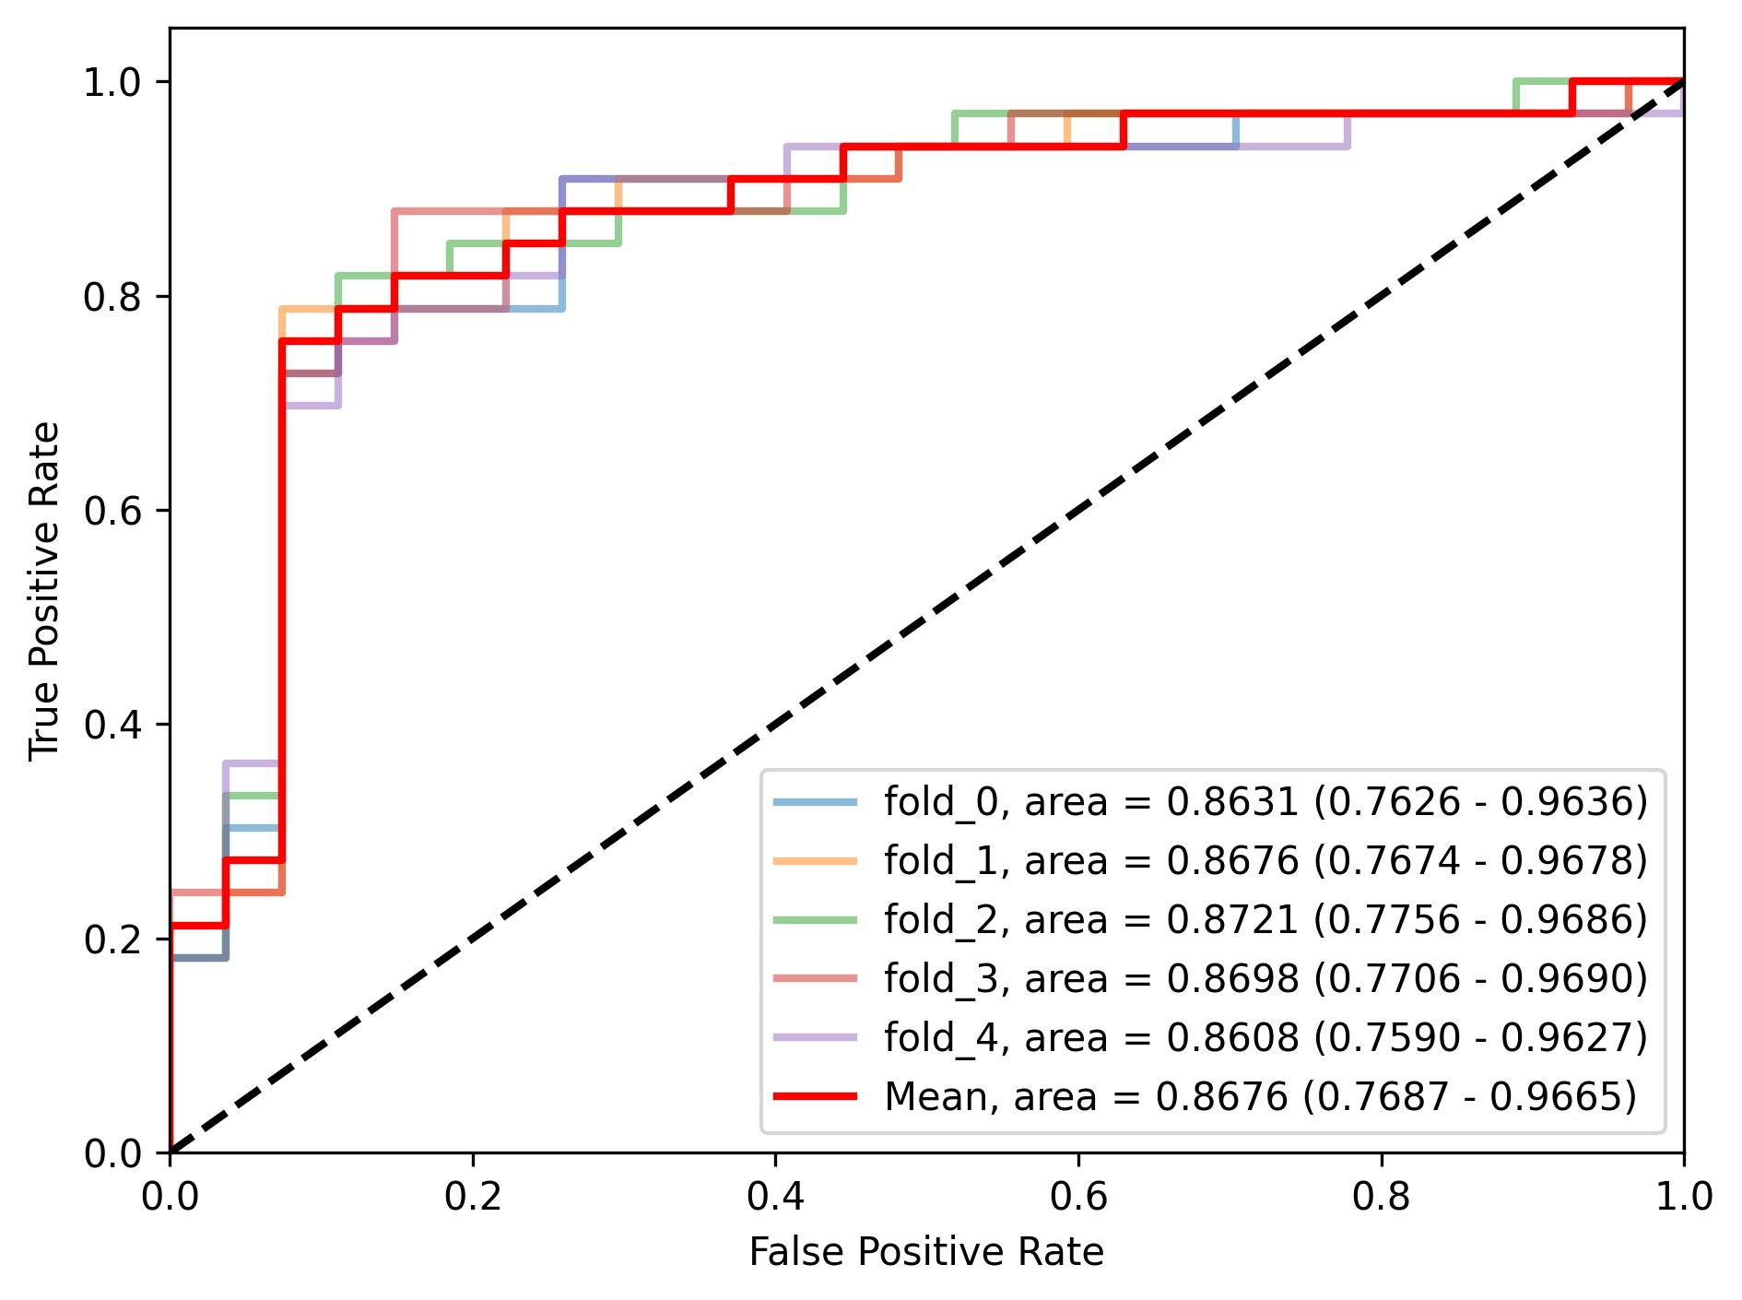
(a) Internal cross-validation (b) External evaluation
Supplementary Figure 1 The ROC curves and the AUC values for CDA-CLAM in the binary classification task

Supplementary Table 4 Detailed cross-validation and external validation performance for CDA-CLAM in the ternary classification task
 | Internal |  | External
 | AUC | Accuracy | AUC | Accuracy
Avg | 0·9638  (0·9453-0·9823) | 0·8880  (0·8614-0·9147) | 0·9323  (0·8693-0·9932) | 0·8778  (0·7965-0·9590)
Fold 0 | 0·9890  (0·9699-1·0000) | 0·9281  (0·8796-0·9766) | 0·9056  (0·8290-0·9798) | 0·8333  (0·7428-0·9239)
Fold 1 | 0·9661  (0·9261-0·9992) | 0·9085  (0·8536-0·9634) | 0·8981  (0·8181-0·9778) | 0·8111  (0·7130-0·9092)
Fold 2 | 0·9662  (0·9408-0·9909) | 0·8944  (0·8391-0·9496) | 0·8790  (0·7804-0·9775) | 0·8444  (0·7539-0·9350)
Fold 3 | 0·9409  (0·8890-0·9928) | 0·8533  (0·7854-0·9212) | 0·9257  (0·8611-0·9876) | 0·8889  (0·8120-0·9658)
Fold 4 | 0·9580  (0·9152-0·9990) | 0·8548  (0·7880-0·9216) | 0·9396  (0·8806-0·9963) | 0·8889  (0·8094-0·9683)
Class 0  (MSS) | 0·9663  (0·9520-0·9806) | 0·8597  (0·8294-0·8899) | 0·9091  (0·8338-0·9844) | 0·8500  (0·7597-0·9403)
Class 1  (MSI-H) | 0·9524  (0·9303-0·9746) | 0·8538  (0·8230-0·8845) | 0·9204  (0·8458-0·9951) | 0·8500  (0·7597-0·9403)
Class 2  (POLE) | 0·9727  (0·9536-0·9918) | 0·9506  (0·9317-0·9695) | 0·9674  (0·9283-1·0000) | 0·9333  (0·8702-0·9965)

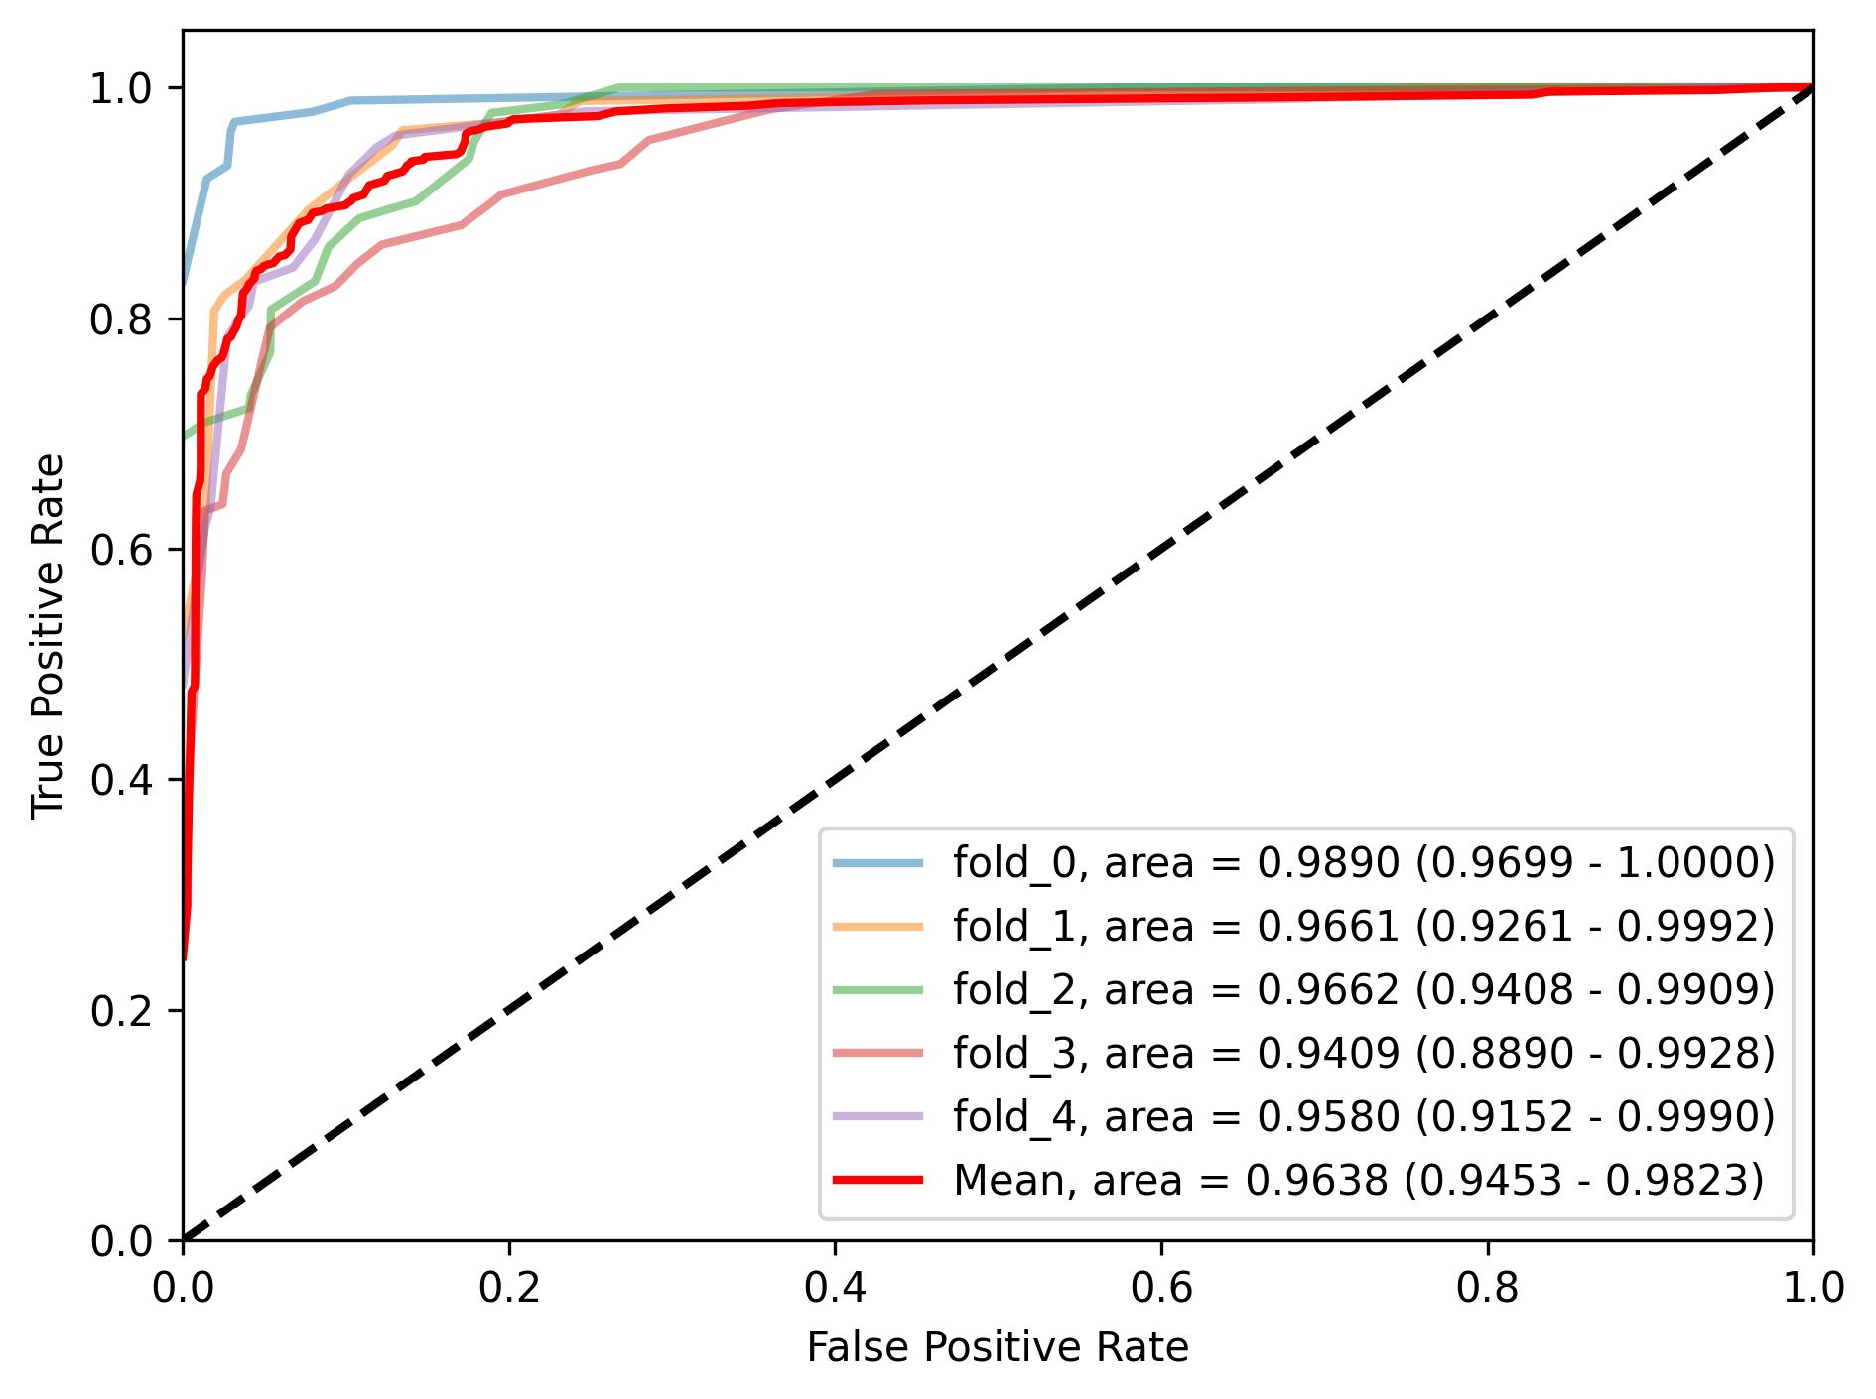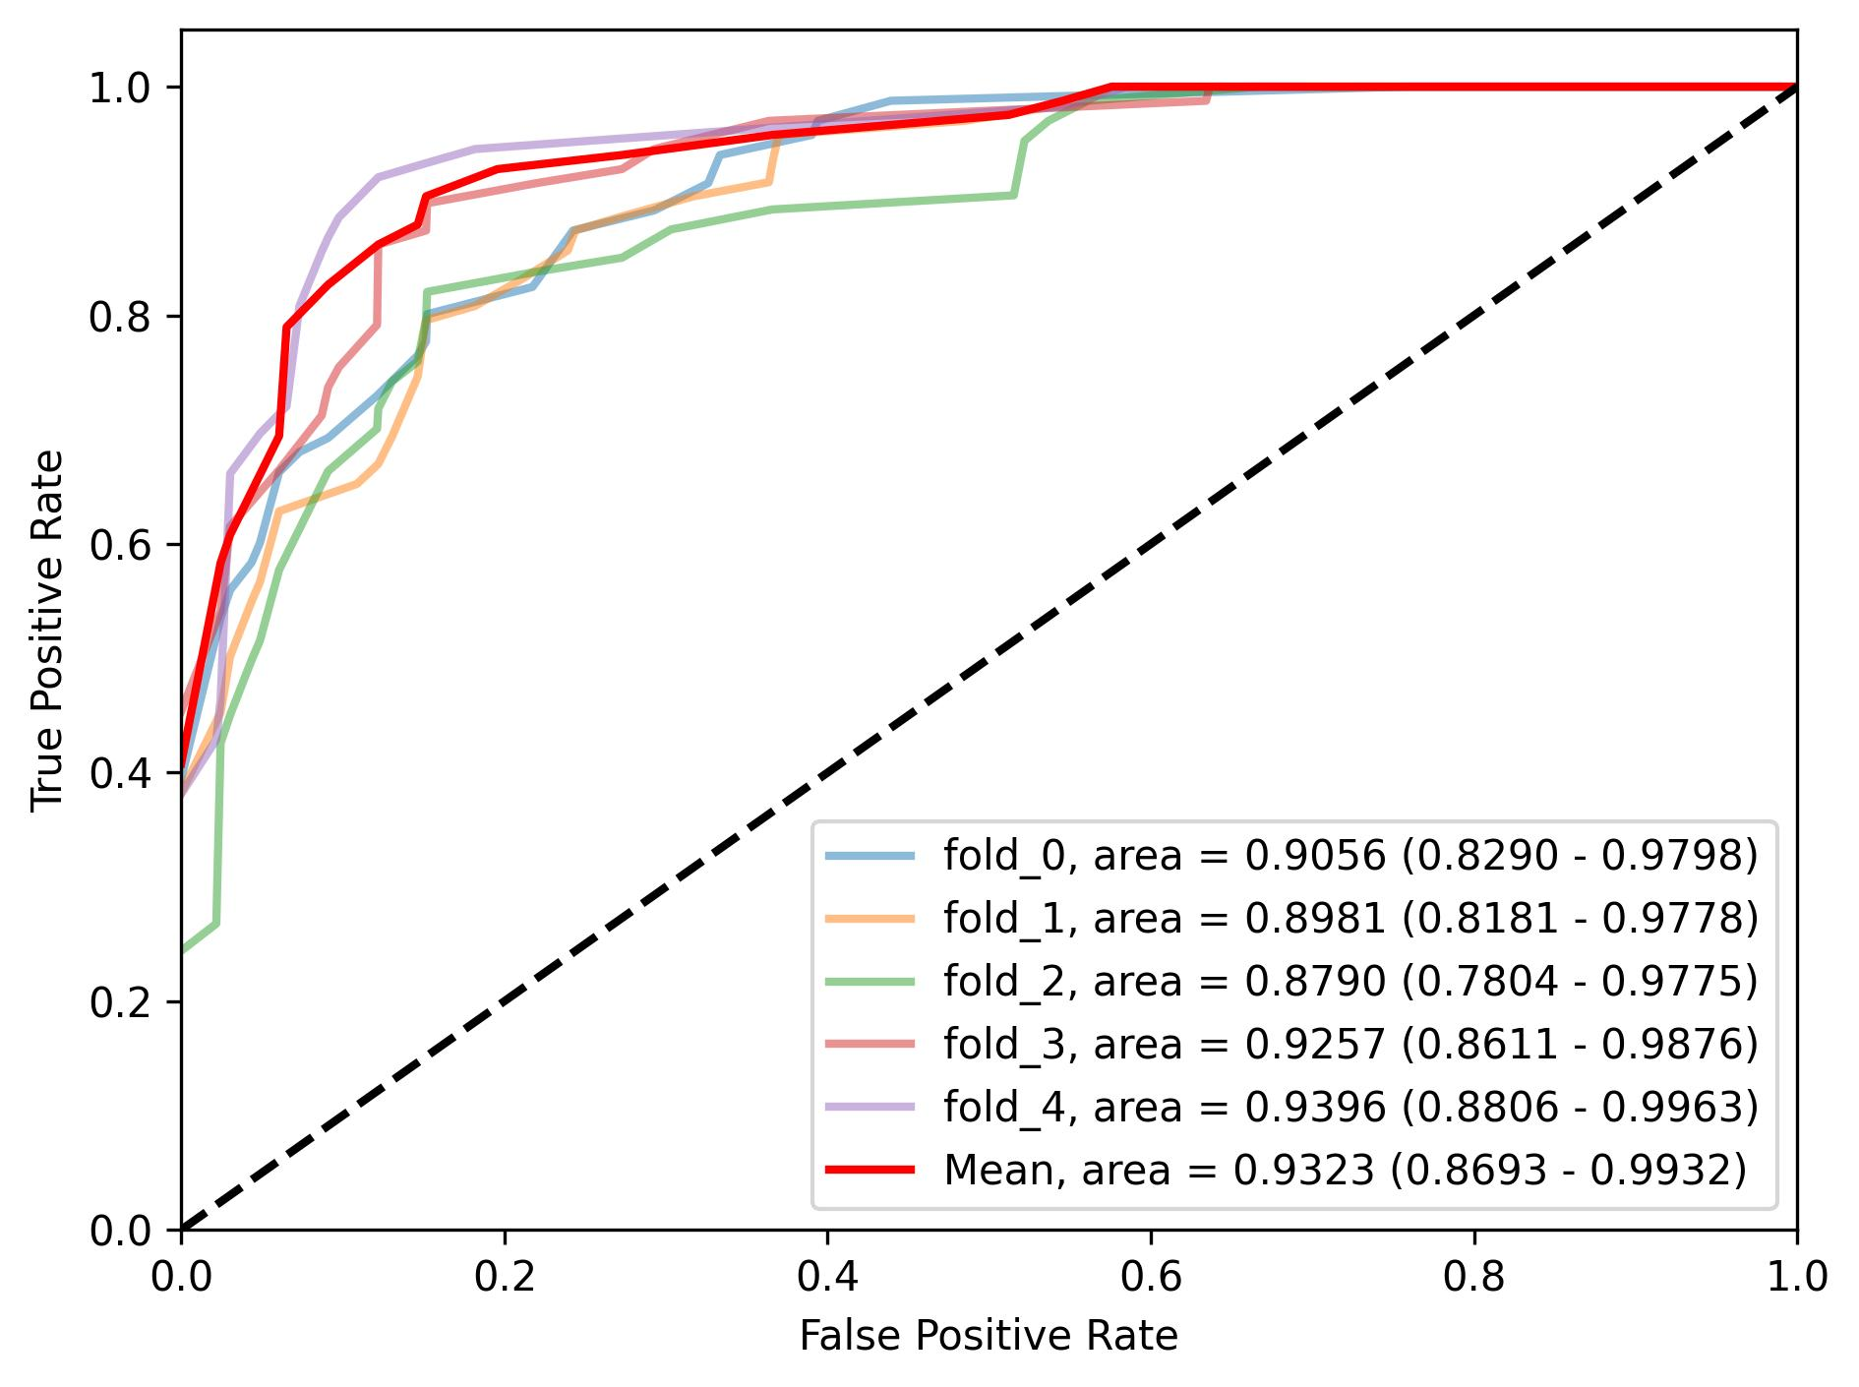
(a) Internal cross-validation,
per-fold results
(b) External evaluation,
per-fold results
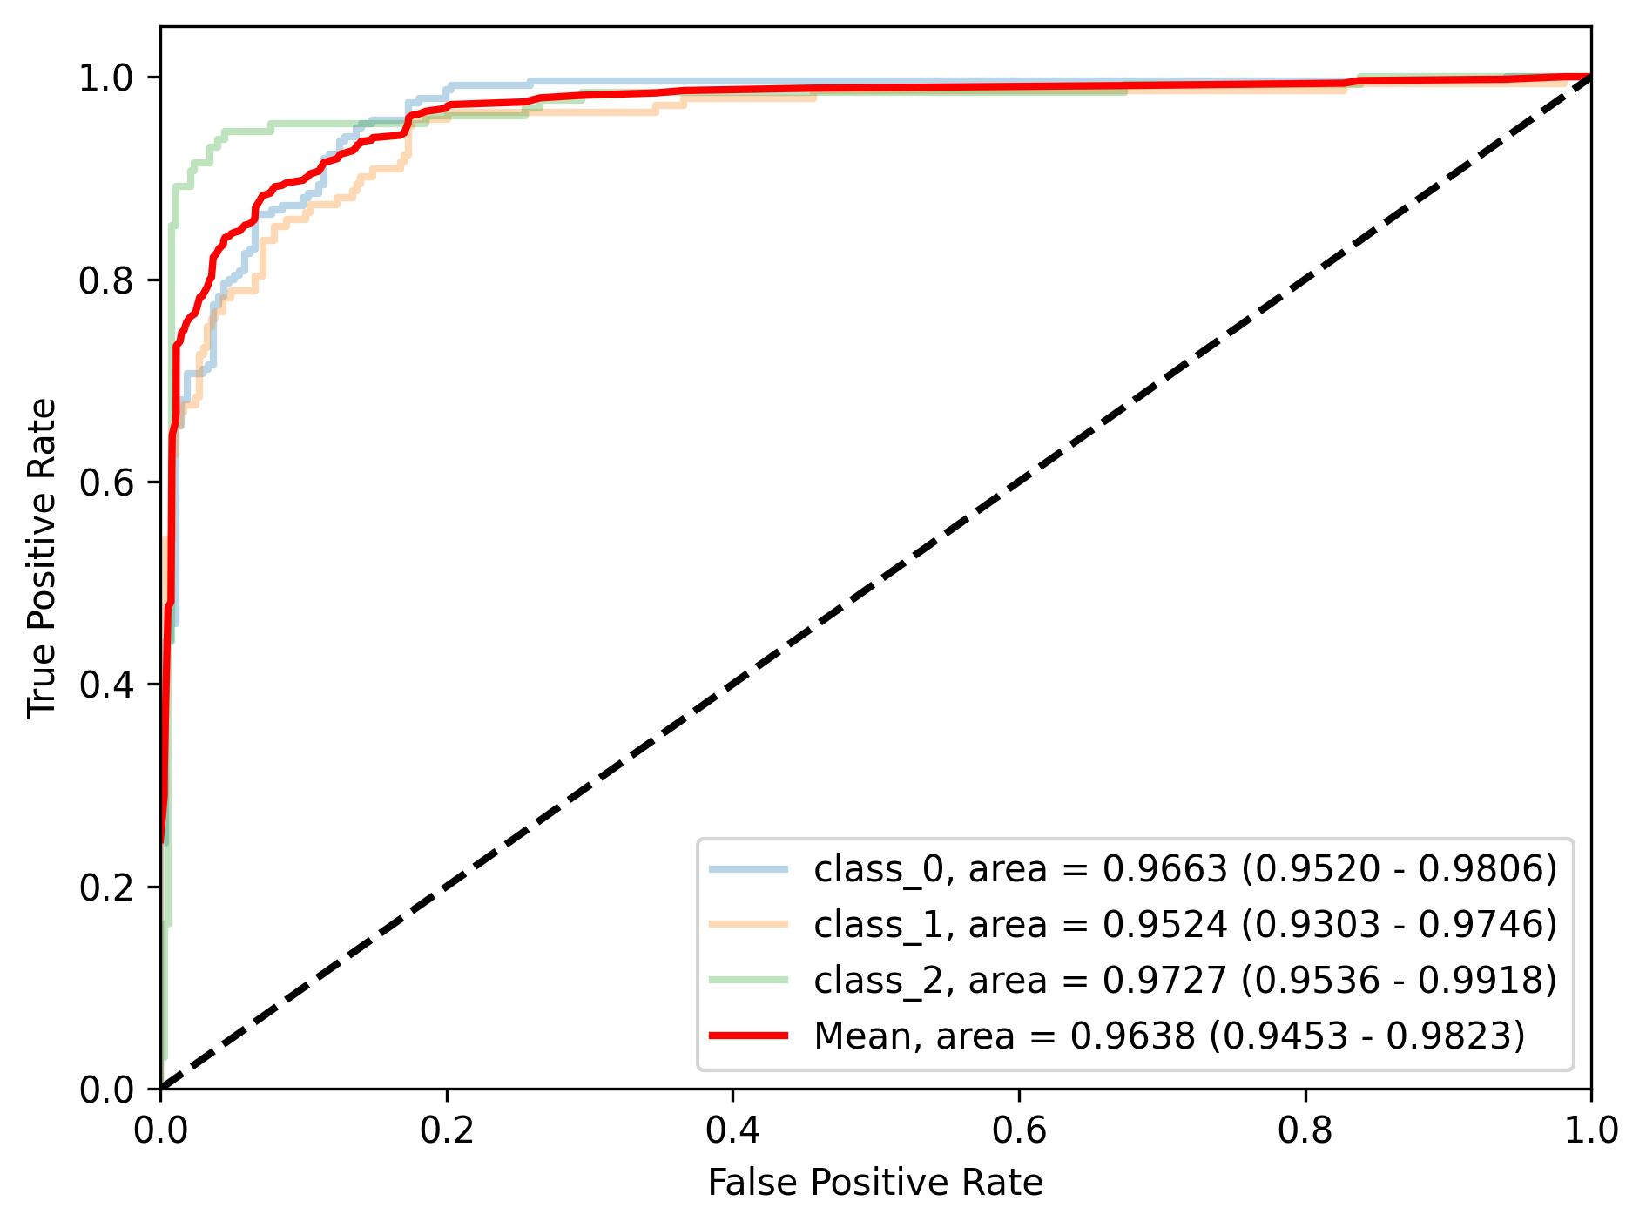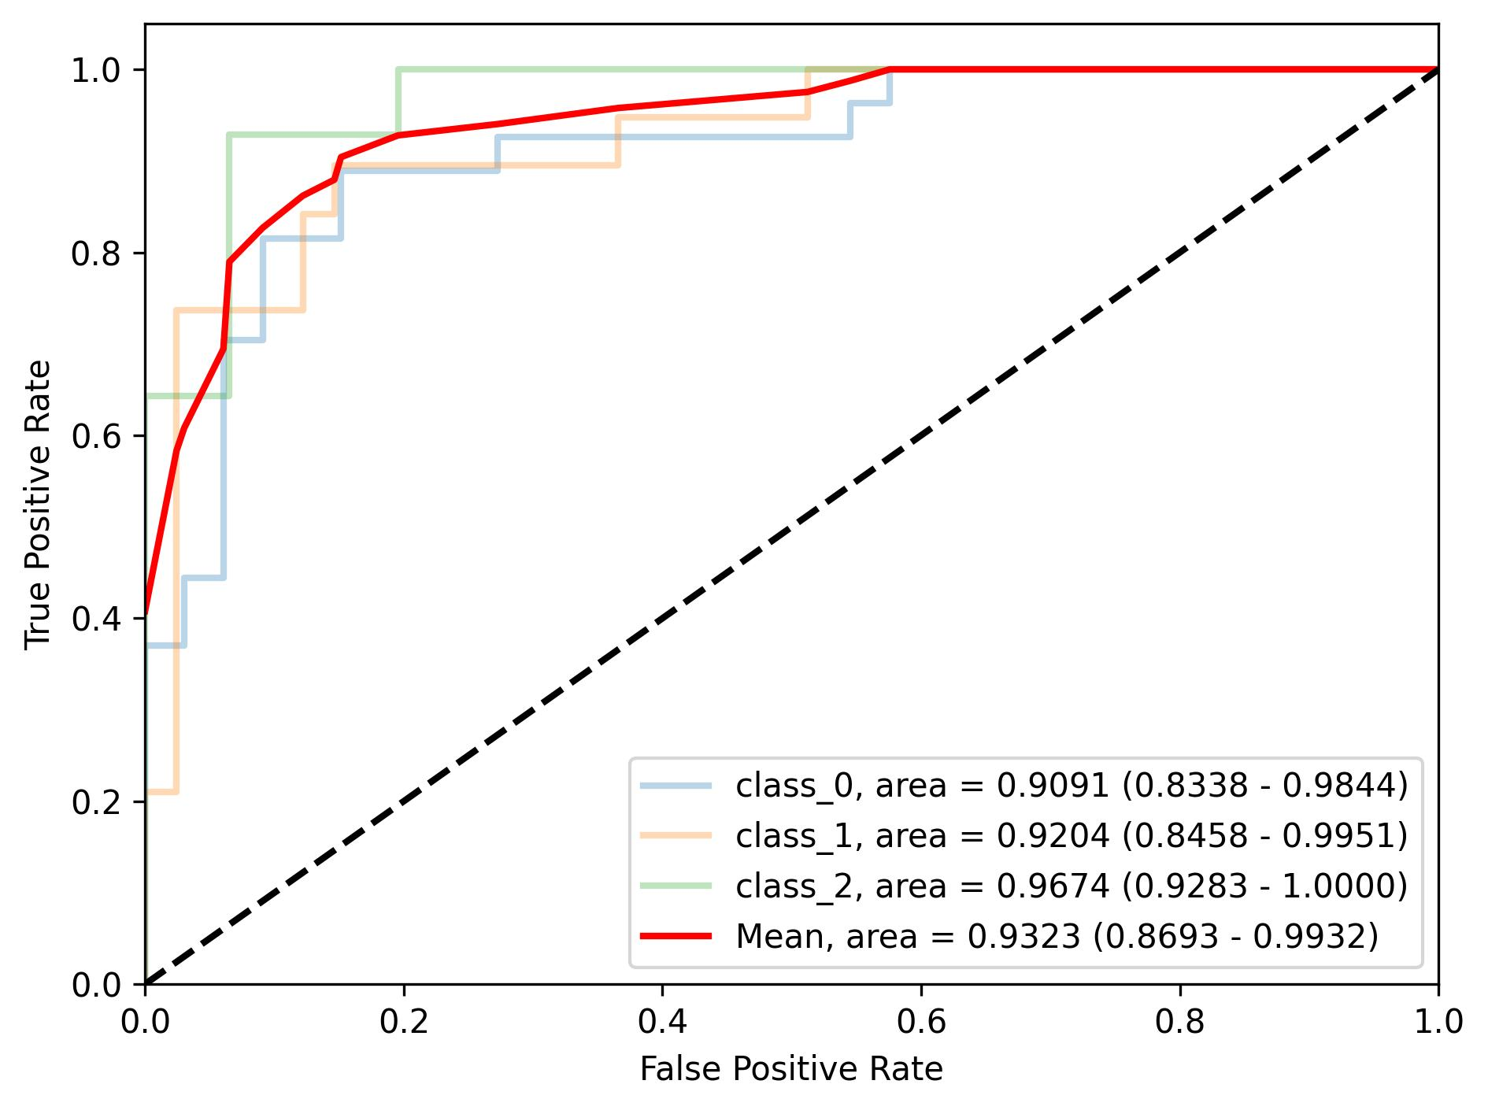
(c) Internal cross-validation,
per-class results
(d) External evaluation,
per-class results
Supplementary Figure 2 The ROC curves and the AUC values for CDA-CLAM in the ternary classification task

Subgroup analysis of CDA-CLAM model
Colorectal cancer is a highly heterogeneous disease. Subgroup analysis was performed to validate the robustness of the CDA-CLAM classifier. Performance of the ternary and binary CDA-CLAM models remained unaffected by patient gender, primary tumor site, tumor differentiation, clinical stage, or pathological subtype. Notably, the subgroup with T4-stage tumors exhibits a higher AUC, which can be attributed to the model's ability to capture more extensive imaging information from T4-stage tumors compared to those at T1-3 stages.
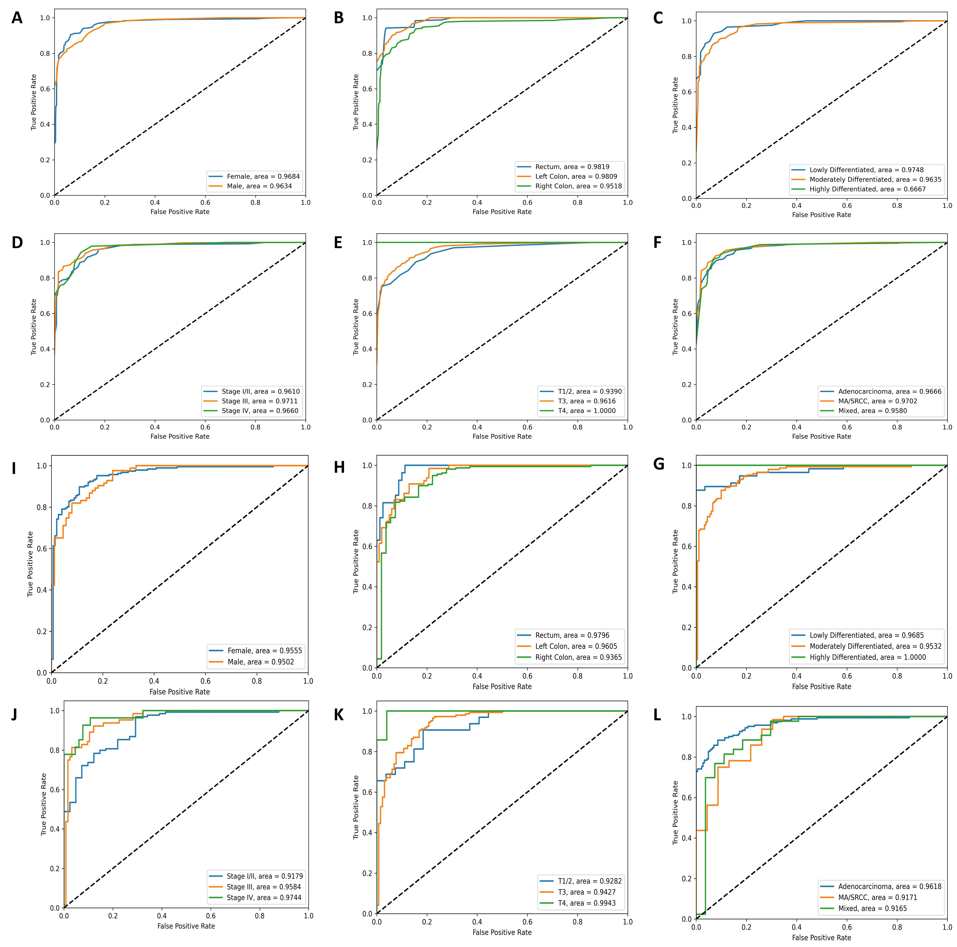

Supplementary Figure 3 Subgroup AUC of the ternary CDA-CLAM models (A to F) and the binary CDA-CLAM model (G to L)

