Construction of Lightweight Multi-Dimensional Composites Based on MOF@RGO Derivatives for High-Efficiency Electromagnetic Wave Absorption
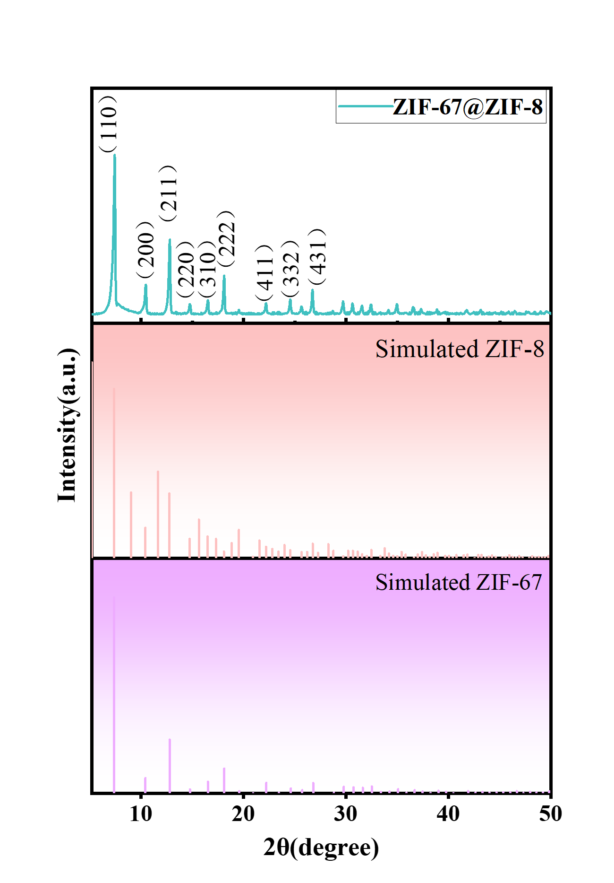
Fig. S1 The XRD of ZIF-67@ZIF-8
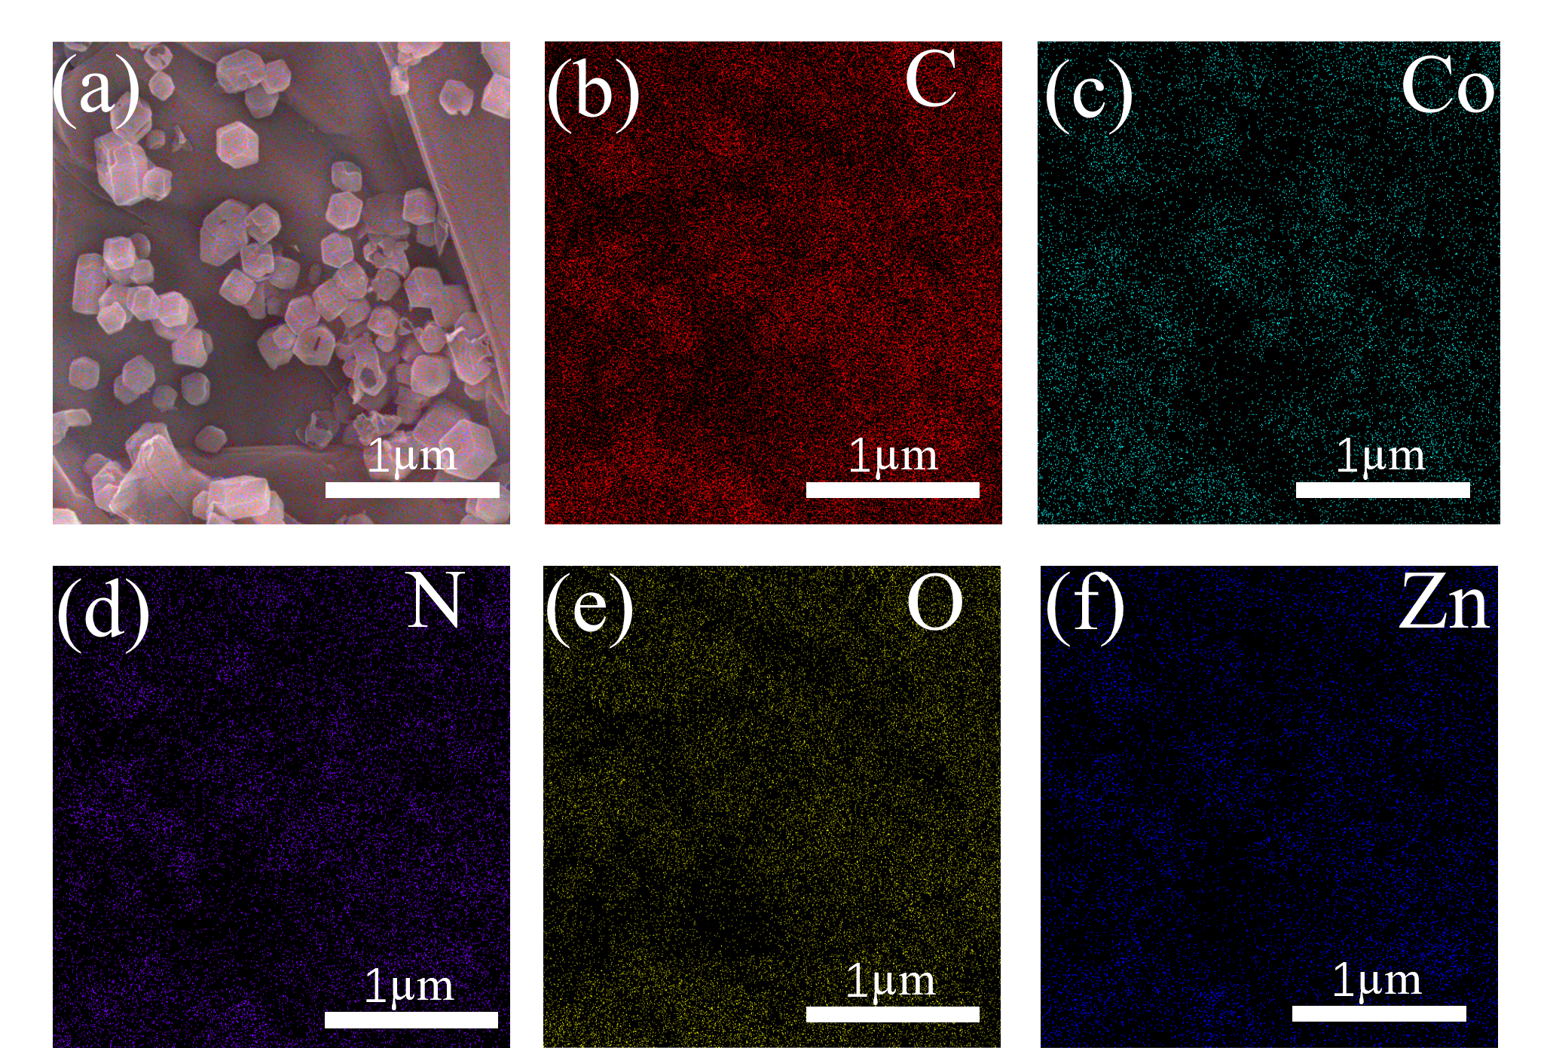
Fig. S2 (a-f) EDS element mapping images of ZIF-67@ZIF-8/RGO
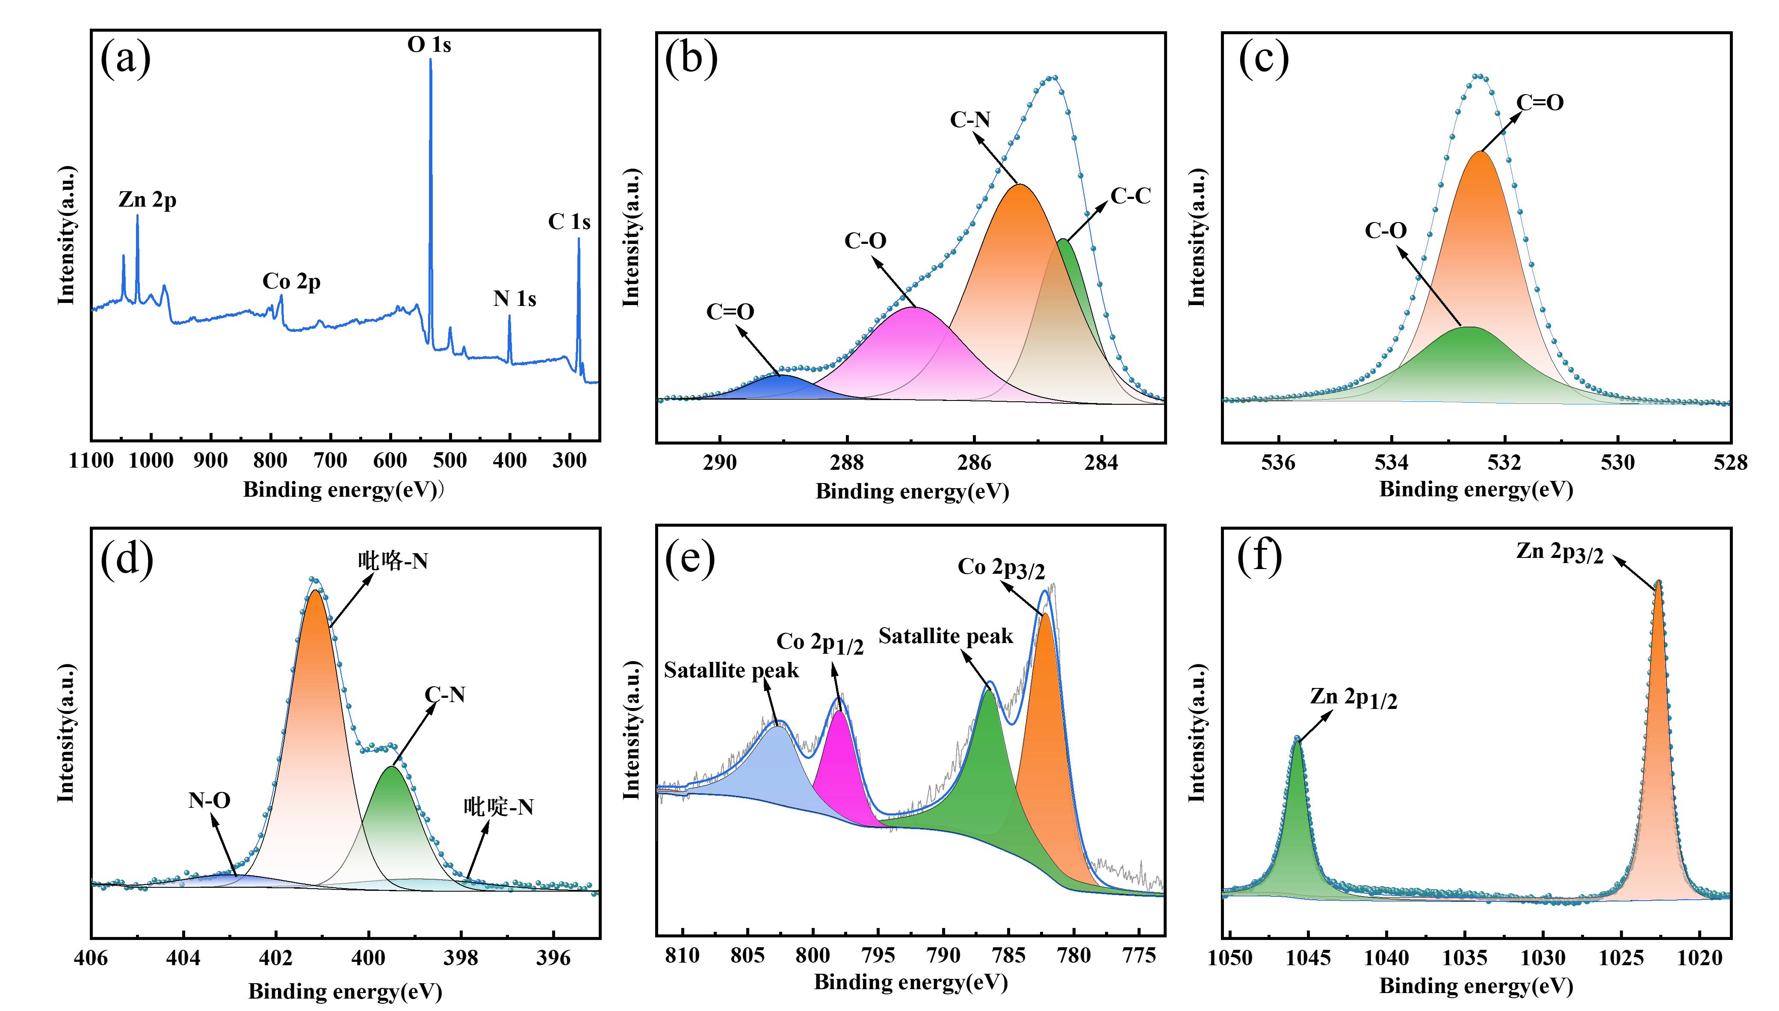
Fig. S3 XPS profiles of ZIF-67@ZIF-8@GO: (a) total spectrum, (b) O 1s, (c) N 1s, (d) C 1s, (e) Co 2p, (f) Zn 2p
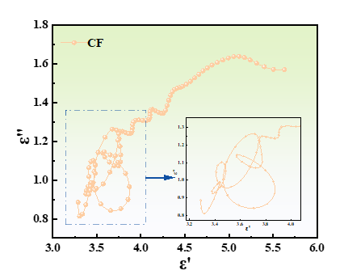
Fig. S4 Cole-Cole semicircular curve of CF

