No colonies grew after one week of incubation of the control plates for all plant samples, indicating that the sample surface was completely sterilized. DNA cleaved by proteinase K combined with phenol chloroform was detected by 1.2% agarose gel electrophoresis. The electrophoretic test showed that the ITS1 band was single, and the PCR amplification product bands of all samples were between 500 and 250 bp, with good specificity and brightness, and there were no side bands and drag bands, indicating that the PCR amplification conditions were suitable, and the purity of each sample was high, which could be used for subsequent high-throughput sequencing analysis
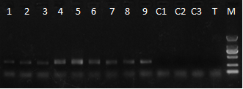
1~3 is FG1, FG2, FG3; 4~6 is FY1, FY2, FY3; 7~8 is FJ1, FJ2, FJ3; C1-3 is the blank control of the extraction reagent; The Marker is DL2000, and the band from top to bottom is 2000bp, 1000bp, 750bp, 500bp, 250bp, 100bp.
Fig.1 Electrophoresis map of PCR amplification products

