Table 1│Results of ATRP of MA using Phen-CHCP photocatalyst in presence of oxygen or inhibitor under green light irradiation.
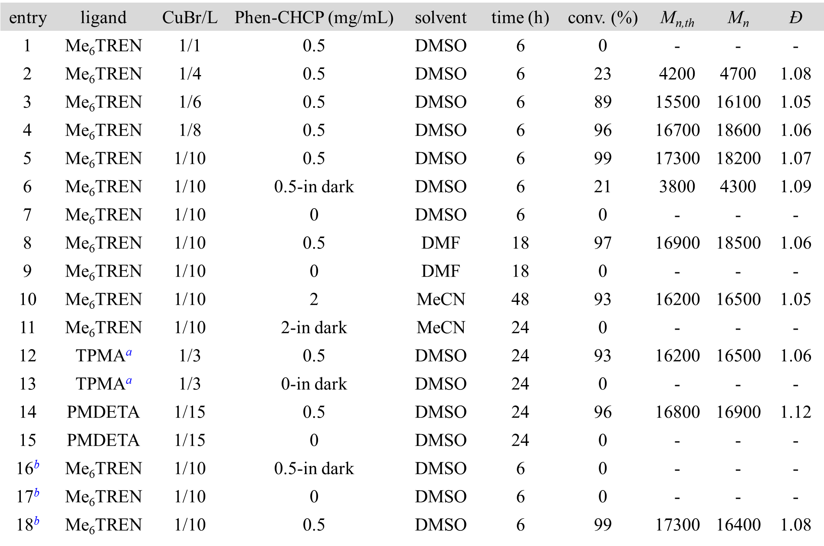
Reaction conditions: [MA]/[EBiB]/[CuBr]/[L] = 200/1/0.02/x (L = Me₆TREN, TPMA, or PMDETA; x = 0.04, 0.08, 0.12, 0.16, 0.2 or 0.3 respectively) in 50 vol% different solvents, V_{air}/V_{bottle} = 0.5, irradiated under green light (0.9 mW/cm²). ªTriethanolamine (1.0 equiv relative to EBiB) was used as the electron donor in presence of TPMA. ^{b}Monomer with inhibitor in presence of oxygen (50% air, v/v).

