Table 1. Characteristics of the graphic model, nutrient profile model and related regulatory measures of the front-of-pack nutrition warning labelling in Uruguay, Mexico and Argentina.
 | 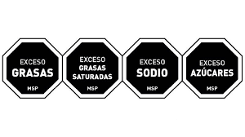  Uruguay  [29, 30] | Mexico  [31-33] | Argentina  [34, 35]
Graphic model | EXCESS FATS, EXCESS SATURATED FATS, EXCESS SODIUM, EXCESS SUGARS | 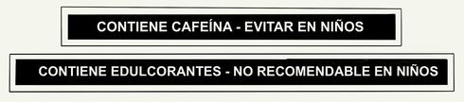  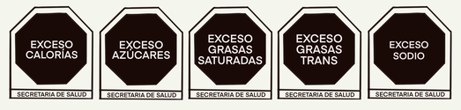  EXCESS CALORIES, EXCESS SUGARS, EXCESS SATURATED FATS, EXCESS TRANS FATS, EXCESS SODIUM  CONTAINS CAFFEINE – AVOID IN CHILDREN  CONTAINS SWEETENERS – NOT RECOMMENDED FOR CHILDREN | 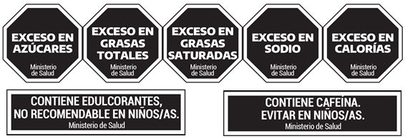  EXCESS SUGARS, EXCESS TOTAL FATS, EXCESS  SATURATED FATS, EXCESS SODIUM, EXCESS CALORIES  CONTAINS SWEETENERS, NOT RECOMMENDED FOR CHILDREN, CONTAINS CAFFEINE, AVOID IN CHILDREN
Nutrient profile model* | Solids  Sugars: > 13 g/100 g  Total fats: > 13 g/100 g  Saturated fats: > 6 g/100 g  Sodium: > 500 mg/100 g | Energy: ≥ 275 kcal/100 g for solids; ≥ 70 kcal/100 ml or ≥ 8 kcal free sugars/100 ml for soft drinks.  Sugars: ≥ 10% of total energy  Saturated fats: ≥ 10% of total energy  Trans fats: ≥ 1% of total energy  Sodium: ≥ 1 mg/kcal or ≥ 300 mg/100 g; ≥ 45 mg/100 ml for calorie-free beverages.  Caffeine: any amount  Sweeteners: any amount | Calories: ≥ 275 kcal/100 g or ≥ 25 kcal/100 ml for non-alcoholic drinks  Added sugars: ≥ 10% of total energy  Total fats: ≥ 30% of total energy  Saturated fats: ≥ 10% of total energy  Sodium: ≥ 1 mg/kcal or ≥ 300 mg/100 g or ≥ 40 mg/100 ml for alcohol-free and calorie-free beverages  Caffeine: any amount  Sweeteners: any amount
Nutrient profile model* | Liquids  Sugars: > 3 g/100 ml or > 5 g/100 ml for products with sweeteners or > 7 g/100 g for products with sweeteners and sugar energy < 80 % of total calories  Total fats: > 4 g/100 g
Related regulatory measures |  | Prohibition of the use of nutritional or health claims, as well as the use of characters and other advertising elements aimed at children in products with octagons. | Prohibition of all forms of advertising, promotion and sponsorship directed at children and adolescents; offering, marketing, advertising, promotion and sponsorship in educational establishments; and claims of nutritional or health properties, and logos or messages of endorsement by health institutions.
*For Mexico and Argentina, which have two and three phases of implementation of the nutrient profile model, respectively, the last phases, which represent the most rigid thresholds of each profile, were used.

