Supplementary information (SI)

Self-explaining Artificial Intelligence for the Classification of B cell Non-Hodgkin Lymphoma
Michael C. Thrun¹*, Jörg Hoffmann², Stefan W. Krause³, Peter Krawitz⁴, Quirin Stier¹, Andreas Neubauer², Cornelia Brendel^{2#} and Alfred Ultsch^{1#}

¹Mathematics and Computer Science, Philipps University Marburg, Hans-Meerwein-Strasse 6, 35032 Marburg, Germany
²Department of Hematology, Oncology and Immunology, Philipps University Marburg, University Hospital Giessen and Marburg, Baldingerstrasse, 35043 Marburg, Germany
³Department of Medicine 5, Universitätsklinikum Erlangen, Ulmenweg 18, 91054 Erlangen, Germany
⁴Institute for Genomic Statistics and Bioinformatics, University Bonn, Venusberg-Campus 1, 53127 Bonn, Germany

*Corresponding author
Michael C. Thrun
E-mail: mthrun@informatik.uni-marburg.de

#AU and CB contributed equally and share the last author title.

Table 1 Confusion matrix between clusters and lymphoma identities of Figure 1A and 1B.

 | CLL | FL | HCL | LPL | MBL | ML | MZL | NC | PL
Cluster1 | 2990 | 116 | 114 | 217 | 946 | 307 | 597 | 3 | 548
Cluster2 | 9 | 62 | 10 | 8 | 41 | 57 | 32 | 2995 | 10
OutlierGroup | 0 | 8 | 0 | 5 | 4 | 5 | 2 | 0 | 3
OutlierGroup | 0 | 0 | 0 | 0 | 10 | 1 | 3 | 0 | 2
VariousOutlier | 1 | 0 | 4 | 6 | 5 | 2 | 3 | 2 | 0

Table 2 Confusion matrix between clusters and lymphoma identities of Figure 1C and 1D.
 | CLL | FL | HCL | LPL | MBL | MCL | MZL | PL
Cluster1 | 9 | 166 | 64 | 490 | 132 | 140 | 747 | 159
Cluster2 | 491 | 1 | 0 | 21 | 365 | 75 | 23 | 264
Cluster3 | 0 | 1 | 82 | 2 | 0 | 1 | 25 | 1
Outliers1 | 0 | 1 | 0 | 0 | 1 | 1 | 0 | 0
Outliers2 | 0 | 0 | 0 | 0 | 2 | 0 | 0 | 0
Outliers3 | 0 | 0 | 0 | 0 | 0 | 2 | 0 | 0
Outliers4 | 0 | 0 | 0 | 0 | 0 | 2 | 0 | 0

Table 3 Designation of classes and lymphoma categories
Class No | Entity | MLL9F Typical No. | MLL9F Atypical No. | PUM2  Typical No. | PUM2  Atypical No.
1 | NC | 8,692 | 1,967 | 193 | 32
2 | CLL | 3,325 | 949 | 223 | 45
3 | MCL | 237 | 60 | 20 | 16
4 | FL | 195 | 38 | 10 | 5
5 | MZL | 867 | 170 | 14 | 5
6 | LPL | 555 | 120 | 10 | 3
7 | HCL | 171 | 31 | 15 | 7
(2*) | DLBCL | 0 | 0 | 3 | 4
(2*) | BL | 0 | 0 | 2 | 0
2 | MBL | 1,267 | 247 | 13 | 3
2 | PL | 432 | 121 | 0 | 0
(2*) | HCLv | 50 | 10 | 0 | 0
(2*) | NOS | 0 | 0 | 15 | 1

PUM2 = Philipps-University Marburg data, MLL9F = Munich Leukemia Laboratory data. CLL, MBL, and PL are classified as CLL-like. In the first column, the table shows the diagnoses that were combined with the class numbers used for the learning task for the MLL9F data. Because of the small number of patients, only the NC and B-cell lymphoma patient data were trained for the PUM2 dataset, and the HCLV entity was disregarded[1]. NOS = not otherwise specifiable, NC = normal controls. *: these diagnoses were considered for distinguishing NC and B-NHL samples in L1 but not in L2 or L3.

Table 4 Average contingency table in L3 for the probable and confident classes.
Diagnosis  \Flow XAI | NC | CLL-like | MCL | FL | MZL | LPL | HCL | No | Percent
NC | 55.7 | 1 | 0.1 | 0.5 | 1.1 | 1.1 | 0.1 | 2081 | 59.6
CLL-like | 0.2 | 31.4 | 0.6 | 0 | 0.4 | 0.3 | 0 | 1149 | 32.9
MCL | 0 | 0.3 | 0.4 | 0 | 0.1 | 0 | 0 | 28 | 0.8
FL | 0 | 0 | 0 | 0.2 | 0 | 0 | 0 | 7 | 0.2
MZL | 0.2 | 0.3 | 0.1 | 0.1 | 2.3 | 0.7 | 0 | 129 | 3.7
LPL | 0.3 | 0.1 | 0 | 0.1 | 0.4 | 0.6 | 0 | 52 | 1.5
HCL | 0.1 | 0 | 0 | 0 | 0.1 | 0 | 1 | 42 | 1.2
No | 1973 | 1156 | 42 | 31 | 154 | 94 | 38 | 3488 | 99.9
Percent | 56.2 | 33.1 | 1.2 | 0.9 | 4.4 | 2.7 | 1.1 | 99.9 | 85.1%

The average FlowXAI performance for all test cases with either a confident or probable degree of trustworthiness reached an MCC of 85.1%. The columns depict the diagnoses according to the MLL9 dataset, and the rows present the predictions given by FlowXAI. The sum of the cross-validation trials was taken per table entry and then normalized to the sum of all entries. For the case numbers, the percentages per entry were multiplied by the average number of cases. (Corresponding to the red dot in Fig. 3e).

Table 5 Average contingency table in L3 for the confident class.
Diagnosis  \Flow XAI | NC | CLL-like | MCL | FL | MZL | LPL | HCL | No | Percent
NC | 56.4 | 0.7 | 0.1 | 0.3 | 0.8 | 0.8 | 0 | 1362 | 59.1
CLL-like | 0.1 | 35.1 | 0.5 | 0 | 0.4 | 0.2 | 0 | 836 | 36.3
MCL | 0 | 0.2 | 0.3 | 0 | 0 | 0 | 0 | 12 | 0.5
FL | 0 | 0 | 0 | 0.1 | 0 | 0 | 0 | 2 | 0.1
MZL | 0.1 | 0.3 | 0.1 | 0.1 | 1.7 | 0.5 | 0 | 65 | 2.8
LPL | 0.1 | 0.1 | 0 | 0.1 | 0.2 | 0.3 | 0 | 18 | 0.8
HCL | 0 | 0 | 0 | 0 | 0 | 0 | 0.3 | 7 | 0.3
No | 1307 | 839 | 23 | 14 | 71 | 41 | 7 | 2302 | 99.9
Percent | 56.7 | 36.4 | 1 | 0.6 | 3.1 | 1.8 | 0.3 | 99.9 | 89.3%

The average FlowXAI performance in percent for all test cases with a confident degree of trustworthiness is shown in Fig. 3d, with an average MCC of 89.3%. The columns depict the diagnoses according to the MLL9 dataset, and the rows present the predictions given by FlowXAI. For percentages, the sum of the cross-validation trials was taken per table entry and then normalized to the sum of all entries.

Table 6 Average contingency table in L3 for the probable class.
Diagnosis  \Flow XAI | NC | CLL-like | MCL | FL | MZL | LPL | HCL | No | Percent
NC | 54.2 | 1.5 | 0.2 | 0.8 | 1.7 | 1.7 | 0.1 | 715 | 60.2
CLL-like | 0.4 | 24.2 | 0.8 | 0.1 | 0.5 | 0.4 | 0 | 313 | 26.4
MCL | 0 | 0.4 | 0.6 | 0 | 0.1 | 0.1 | 0 | 14 | 1.2
FL | 0 | 0 | 0 | 0.3 | 0 | 0 | 0 | 4 | 0.3
MZL | 0.5 | 0.4 | 0.1 | 0.2 | 3.5 | 1.1 | 0 | 69 | 5.8
LPL | 0.5 | 0.2 | 0.1 | 0.2 | 0.8 | 1.3 | 0 | 37 | 3.1
HCL | 0.3 | 0.1 | 0 | 0 | 0.3 | 0.1 | 2.2 | 36 | 3
No | 664 | 318 | 21 | 19 | 82 | 56 | 27 | 1186 | 100
Percent | 55.9 | 26.8 | 1.8 | 1.6 | 6.9 | 4.7 | 2.3 | 100 | 76.9%

The average FlowXAI performance in percent for all test cases with a probable degree of trustworthiness using an 80/20 split is shown in Fig. 3d, with an average MCC of 76.9%. The columns depict the diagnoses according to the MLL9 dataset, and the rows present the predictions given by FlowXAI. For percentages, the sum of the cross-validation trials was taken per table entry and then normalized to the sum of all entries.

Table 7 Average contingency table in percent in L3 for the challenging class.
Diagnosis  \Flow XAI | NC | CLL-like | MCL | FL | MZL | LPL | HCL | No | Percent
NC | 33.1 | 1.9 | 0.5 | 1.1 | 2.7 | 2.3 | 0.1 | 165 | 41.7
CLL-like | 2.2 | 25.3 | 1.6 | 0.2 | 0.9 | 0.9 | 0 | 123 | 31.1
MCL | 0.3 | 0.8 | 1.3 | 0 | 0.1 | 0.2 | 0 | 11 | 2.7
FL | 0.3 | 0.1 | 0 | 0.7 | 0.1 | 0.2 | 0 | 6 | 1.4
MZL | 2.6 | 0.7 | 0.3 | 0.5 | 7.4 | 2.6 | 0.1 | 56 | 14.2
LPL | 1.8 | 0.5 | 0.3 | 0.7 | 2 | 3.9 | 0 | 36 | 9.2
HCL | 0 | 0 | 0 | 0 | 0 | 0 | 0 | 0 | 0
No | 160 | 116 | 16 | 13 | 52 | 40 | 1 | 395 | 100.3
Percent | 40.3 | 29.3 | 4 | 3.2 | 13.2 | 10.1 | 0.2 | 100.3 | 60.1%

The average FlowXAI performance in percent for all test cases with challenging degrees of trustworthiness using an 80/20 split is shown in Fig. 3d, with an average MCC of 60.1%. The columns depict the diagnoses according to the MLL9 dataset, and the rows present the predictions given by FlowXAI. For percentages, the sum of the cross-validation trials was taken per table entry and then normalized to the sum of all entries.

Table 8 Contingency table for 512 training cases in L3 for the confident class.
Diagnosis  \Flow XAI | NC | CLL-like | MCL | FL | MZL | LPL | HCL | No | Percent
NC | 49.64 | 0.61 | 0.03 | 0.14 | 0.56 | 0.31 | 0.08 | 3818 | 49.69
CLL-like | 0 | 39.76 | 0.29 | 0.04 | 0.55 | 0.18 | 0.03 | 3262 | 42.45
MCL | 0 | 1.11 | 0.52 | 0.01 | 0.21 | 0.05 | 0 | 82 | 1.07
FL | 0.01 | 0.52 | 0.16 | 0.3 | 0.85 | 0.42 | 0.01 | 48 | 0.62
MZL | 0.01 | 0.34 | 0.03 | 0.08 | 1.08 | 0.38 | 0.04 | 281 | 3.66
LPL | 0.03 | 0.1 | 0.05 | 0.05 | 0.35 | 0.16 | 0 | 115 | 1.5
HCL | 0 | 0.01 | 0 | 0 | 0.07 | 0 | 0.86 | 78 | 1.02
No | 3947 | 3138 | 146 | 174 | 150 | 57 | 72 | 7684 | 100.0
Percent | 51.37 | 40.84 | 1.90 | 2.26 | 1.95 | 0.74 | 0.94 | 100.0 | 86.6%

The FlowXAI performance in percent trained with 512 cases, and for all test cases judged as probable by Flow XAI; the MCC was 86.6%. The columns depict the diagnosis, and the rows present the predictions made by FlowXAI. It covers 49% (N=7684) of the whole test data. The third level of diagnosis (consisting of additional B-NHL diagnoses 3, 4, 5, and 6) has to diagnosed by human experts based on additional data (morphology, molecular biology).

Table 9 Contingency table for 512 training cases in L3 for the probable class.
Diagnosis  \Flow XAI | NC | CLL-like | MCL | FL | MZL | LPL | HCL | No | Percent
NC | 53.36 | 1.47 | 0.17 | 0.33 | 1.65 | 1.14 | 0.21 | 3099 | 63.65
CLL-like | 0.06 | 31.44 | 0.26 | 0.03 | 0.43 | 0.15 | 0.02 | 1111 | 22.82
MCL | 0.18 | 1.02 | 0.43 | 0.02 | 0.17 | 0.05 | 0 | 60 | 1.23
FL | 0.56 | 0.45 | 0.16 | 0.31 | 0.79 | 0.46 | 0.01 | 52 | 1.07
MZL | 0.46 | 0.34 | 0.04 | 0.06 | 0.97 | 0.35 | 0.02 | 283 | 5.81
LPL | 0.34 | 0.11 | 0.07 | 0.06 | 0.4 | 0.38 | 0 | 205 | 4.21
HCL | 0.14 | 0.01 | 0 | 0 | 0.09 | 0.02 | 0.84 | 59 | 1.21
No | 3373 | 929 | 87 | 169 | 132 | 114 | 65 | 4869 | 100.0
Percent | 63.65 | 22.82 | 1.23 | 1.07 | 5.81 | 4.21 | 1.21 | 100.0 | 62.4%

The FlowXAI performance in percent, trained with 512 samples, for all test samples was judged as probable by FlowXAI, resulting in an MCC of 62.4%. It covers 30% (N=4869) of the test data. The columns depict the physician’s manual diagnosis according to [1], and the rows show the predictions made by FlowXAI. The percentages of correct diagnoses of the L3 lymphoma entities are highlighted in green, and the MCC is marked in blue.

Table 10 Contingency table for 512 training cases in L3 for the challenging class.
Diagnosis  \Flow XAI | NC | CLL-like | MCL | FL | MZL | LPL | HCL | No | Percent
NC | 45.43 | 12.14 | 1.43 | 1.47 | 7.96 | 5.24 | 0.59 | 2025 | 74.26
CLL-like | 0.59 | 7 | 0.07 | 0 | 0.11 | 0.15 | 0 | 216 | 7.92
MCL | 0.92 | 0.48 | 0.51 | 0.07 | 0.26 | 0.22 | 0 | 67 | 2.46
FL | 3.37 | 0.18 | 0.18 | 0.55 | 0.4 | 0.44 | 0 | 140 | 5.12
MZL | 2.31 | 0.33 | 0.07 | 0 | 0.84 | 0.51 | 0 | 111 | 4.06
LPL | 2.27 | 0.22 | 0.07 | 0.22 | 0.33 | 0.88 | 0 | 109 | 3.99
HCL | 0.84 | 0.04 | 0 | 0.04 | 0.15 | 0.04 | 1.06 | 59 | 2.17
No | 1520 | 556 | 64 | 64 | 274 | 204 | 45 | 2727 | 100.0
Percent | 55.73 | 20.39 | 2.33 | 2.35 | 10.05 | 7.48 | 1.65 | 100.0 | 23.6%

The FlowXAI performance in percent, trained with 512 samples, for all test samples was judged as challenging by FlowXAI, resulting in an MCC of 23.6%. It covers 21% (N=2727) of the test data. The columns depict the physician’s manual diagnosis according to[1], and the rows show the predictions made by FlowXAI. The percentages of correct diagnoses of the L3 lymphoma entities are highlighted in green, and the MCC is marked in blue.

SI Figure 1 Flow chart for the ALPODS committee assembly
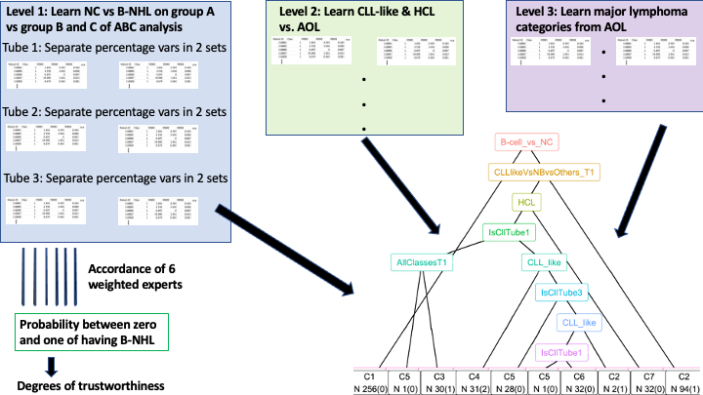

Process flow of the ALPODS populations used within the committee of experts to judge the degree of trustworthiness for self-assessment and yield of the final diagnosis. Weighing for learning classification defined by various levels based on ALPODS populations per patient sample and learning the final diagnosis of the case.

TM identifies typical cases, from which 32 cases per diagnosis (512) serve to define representatives per diagnosis. In the first step, ALPODS experts learn the relevant populations for the specific task described below and store the frequencies within tables. This means that each ALPODS model is an expert that answers a specific question for a particular tube of a patient sample. All ALPODS experts learn populations for each tube separately for a specific task. The L1 task distinguishes whether the sample is an NC or B-cell lymphoma.
After the populations are identified, they are divided into two groups per tube using computed ABC analysis [7]. The ABC curve of the computed ABC analysis can be used to visualize the data by graphically representing the cumulative distribution function closely related to the Lorenz curve. Using the ABC curve, the algorithm calculates optimal limits by exploiting mathematical properties pertaining to the distribution of the analyzed populations. The first group of populations has large frequencies (set A in the computed ABC analysis) and is analyzed by the first ALPODS expert. The second group of populations is identified as sets B and C within the algorithm. Populations in the second group have smaller frequencies and are used by the second ALPODS expert. Both ALPODS experts learn to distinguish the NC from B-cell lymphoma. In sum, six (four) experts are employed for the L1 task since the MLL9F dataset (PUM2 dataset) consists of three (two) tubes. Here, expert opinions on samples from tube two are weighted more than those from tube one, and those from tube one are weighted more than those from tube three by the ALPODS experts for the L1 task. Four experts are used for the PUM2 dataset, which incorporates only two tubes.
In case of L2 and L3, more ALPODS experts are trained on the populations extracted for specific tasks. Three experts investigated the three tubes for CLL-like lymphoma, while three other ALPODS experts investigated the tubes for other types of lymphoma. One ALPODS expert determines whether a patient has HCL, using samples from tube two, the samples from other tubes not being useful to human expert when diagnosing HCL. In summary, ALPODS experts at specific levels (L1, L2 and L3) diagnose the samples context-specific and separately. Their opinions are combined to an AI committee to form a mixture of experts. The opinion of the full committee that provides the final diagnosis is generated by a decision tree using an impurity function that is applicable to categorical data [8].

SI Figure 2 Illustration of outliner samples with dot plots
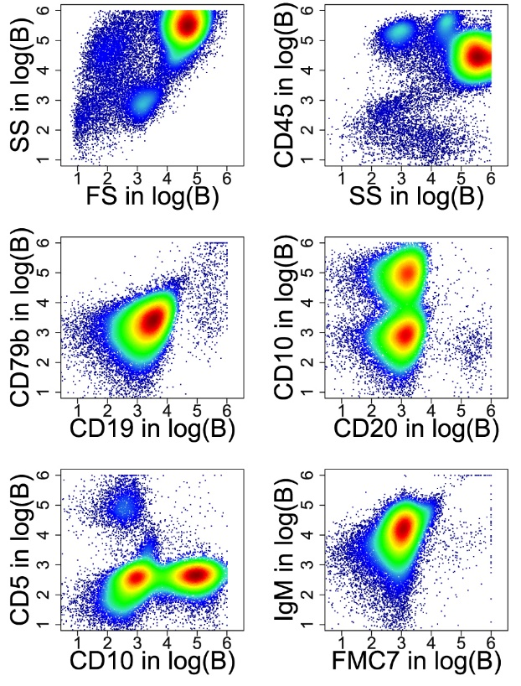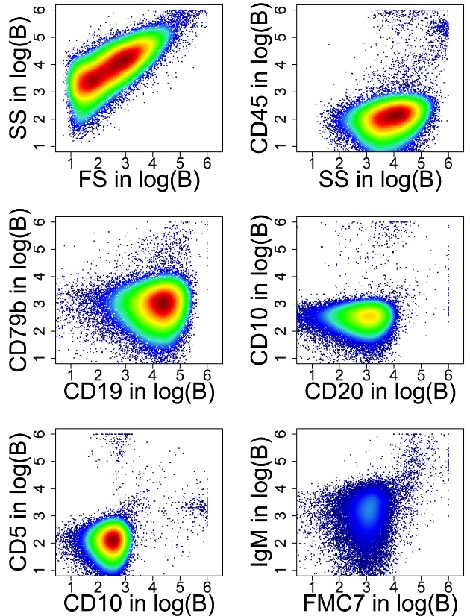

Quality control of sample files identified with TM revealed that 19% of the samples within the MLL9F sample files were atypical. Manual validation was performed on 100 samples hereby confirming that TM reliably distinguished typical samples from atypical ones. All 100 evaluated samples are available as fcs files at 10.5281/zenodo.7744104. Tube 1 of a typical three-tube panel for a typical patient (A; left) and an atypical patient (B; right) are presented here in log scale. Human experts assume that red blood cells are predominant in atypical samples for the reason that most recorded events do not stain positive for CD45 or other leukocyte antigens. Other presumed reasons for the strong alterations were incomplete erythrocyte lysis, irregular antibody staining patterns or other aberrations, most likely acquisition artifacts.

SI Figure 3 Explaining Flow XAI diagnoses decisions
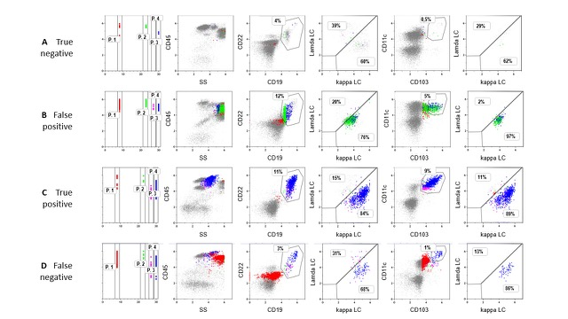
Four HCL samples (rows A-D) were analyzed manually via Flow XAI-extracted FCS files using commercial (Kaluza™) software (version 2.1) in log scale. The classification of the samples is as follows: a: true negative, b: false positive, c: true positive, d: false negative. The populations selected by Flow XAI as relevant for its decisions are highlighted in the first column (P1-P4) and colored in all diagrams. The conventional manual gating procedure involved lymphocyte versus monocyte and granulocyte imaging (second column), B-cell imaging (third column), light chain distribution on B cells (fourth column), depiction of hairy cells (fifth column) and assessment of light chain distributions on hairy cells (sixth column). For simplification, not all typical hairy cell epitopes are depicted.

Flow XAI justifies its diagnostic decisions by providing individual explanations specifically tailored to physicians [9]. For example, the diagnosis of HCL is considered positive if human experts find “hairy cells”, which exist in a tiny but distinct B-cell population with a unique antigen expression pattern characterized as CD103+++, CD25+++, CD19++, CD25++, or SS++. For the confident trustworthiness degree, on average, all HCL cases were classified correctly. The false-positive (N=4) and false-negative HCL (N=4) cases were, on average, assigned to the probable degree of trustworthiness. Flow XAI learned and subsequently used four particular cell populations to classify the cases as HCL. The decision depended solely on tube 2, containing the relevant HCL antibodies. These four populations, considered to be highly relevant to Flow XAI’s diagnostic decision-making, are highlighted in the left column (SI Fig. 3). In the first row, an NC case (named a true negative) is depicted; the B-cells show a typical light chain distribution pattern for kappa and lambda, and the “hairy cell gate” (CD103 vs. CD11c) is almost empty (Fig. 3a). In the second row, HCL was incorrectly suspected because ALPODS revealed populations in the B-cell or hairy cell regions (Fig. 3b). A human expert can recognize that CD19+ cells do not appear as lymphocytes in CD45+ vs. SS images and “understands” that Flow XAI’s reasoning is incorrect. Sample degradation could be a biological reason for granulocytes' presumably unselective antibody capture. A real HCL case is depicted as a “true positive” in the third row (Fig. 3c), which illustrates that the hairy cells correspond to “highly scattered lymphocytes” in the CD45 vs. SS image and are indeed CD103++CD11c+++, i.e., they highly express these epitopes. Additionally, as depicted in the right column, the correctly classified hairy cells exhibited light chain restrictions, i.e., a significant predominance of kappa vs. lambda light chains. CD25 and other B-cell epitope expression patterns are not shown to simplify the graphic. Finally, a false negative sample was chosen for further illustration (Fig. 3d). Although the algorithm correctly recognized that the events in the hairy cell region were not B cells, the subtle population masked by the irregular staining pattern of a dominant granulocytic fraction was not detected. Of note, there were fewer than 700 relevant events in each population. Dot plot images for the remaining six incorrectly classified HCL cases are provided in SI Figure 4 and 5.

SI Figure 4 Explanations for HCL misdiagnosis using bivariate dot plots in log scale: Three false positive results for distinguishing HCL patients from NCs.

SI Figure 5 Explanations for HCL misdiagnosis using bivariate dot plots in log scale: Three false negative results for distinguishing HCL patients from NCs.

SI Figure 6 AI based lymphoma classification with the PUM2 dataset (atypical cases)
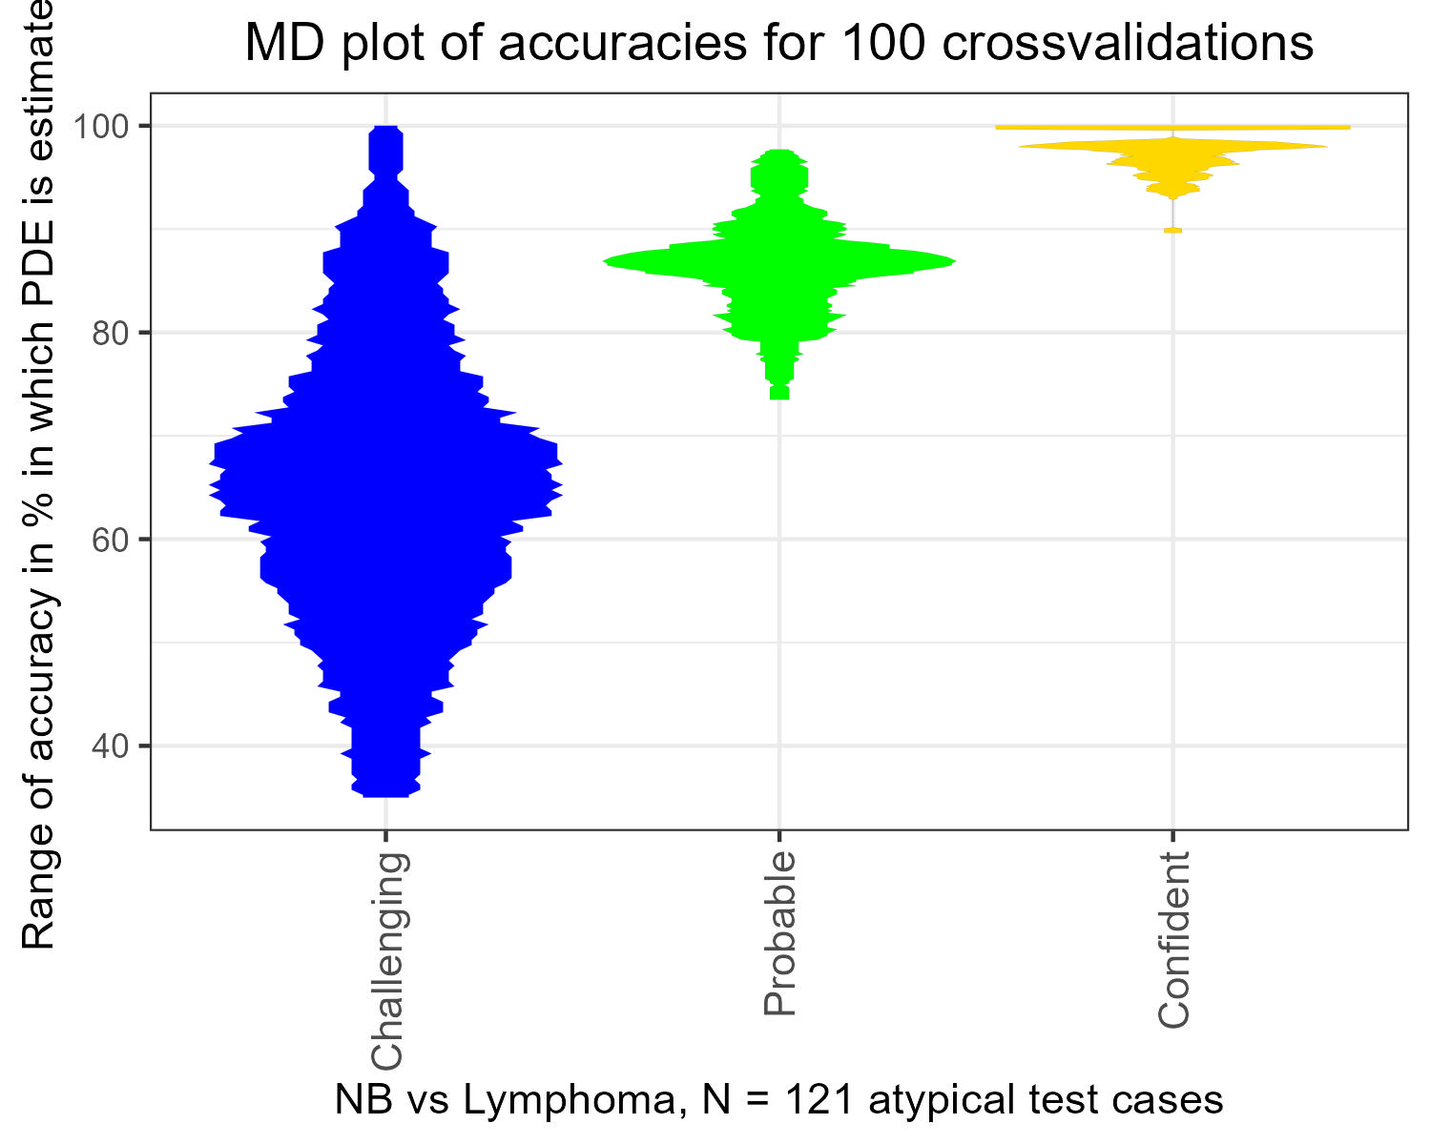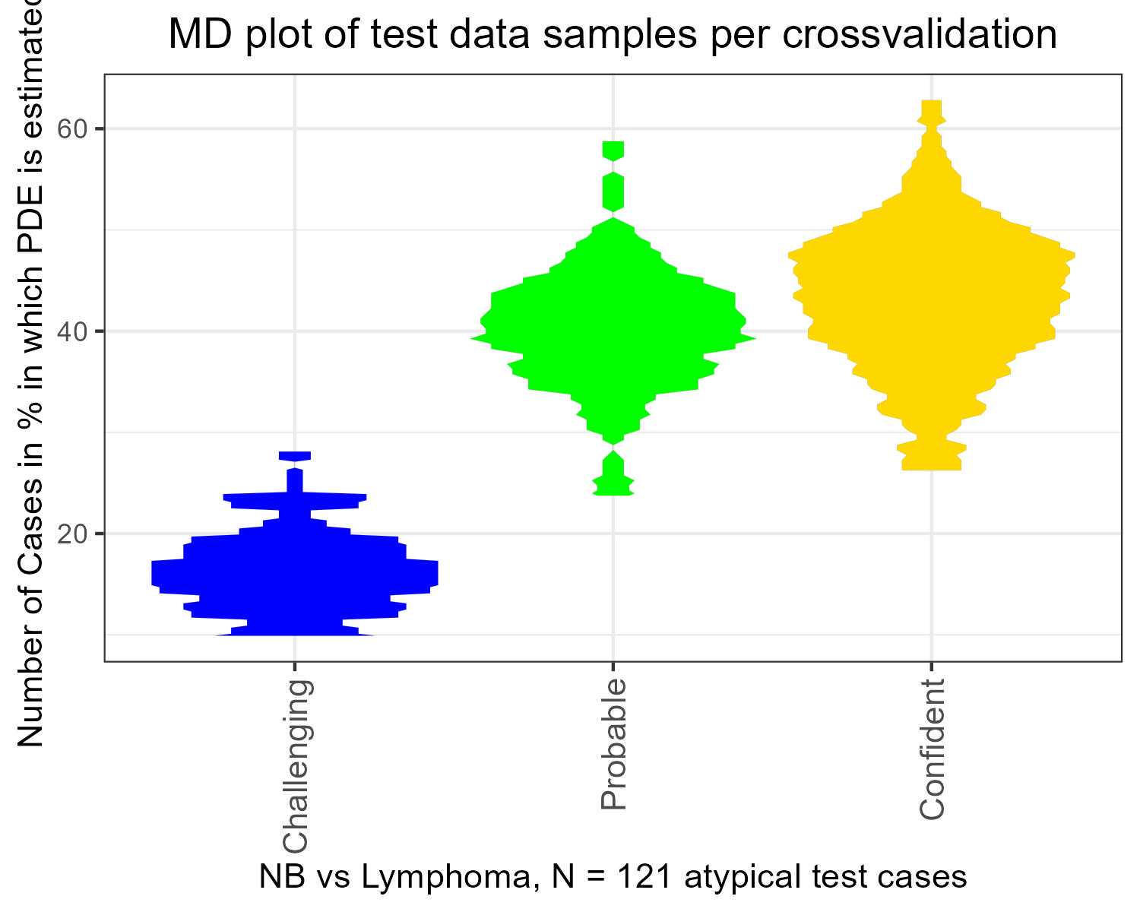
One hundred cross-validation steps were visualized with an MD-plot for the three degrees of trustworthiness. MD-plots were used to estimate and visualize the probability density function

To validate the applicability of FlowXAI to diverse B-NHL immunophenotyping datasets, we utilized a second dataset comprising 638 samples obtained from the diagnostic center Marburg (PUM2). This diagnostic laboratory employs a panel targeting distinct B-cell epitopes, measured across two tubes samples per case/patient, as previously described[11].
Initially, the TM algorithm was used to distinguish typical from atypical cases. Subsequently, 100 cross-validation trials were conducted on L1 cases. All training cases were selected exclusively from the typical category. For each trial, the training dataset consisted of 100 normal controls (NC) and 100 B-NHL cases, distributed as follows: 30 CLL, 15 MCL, 10 FL, 10 MZL, 5 LPL, 10 HCL, 10 MBL, and 10 NS.
The evaluation results for the typical cases in the test sets are detailed in the main text. A total of 121 test cases were considered as atypical in Figure 6. In Figure 6a, the Accuracy metric was selected to account for balanced group sizes. The accuracy was 99% when FlowXAI was confident, 89% when XAI estimated that the appropriate diagnosis was probable, and 69% when XAI judged a case as challenging (SI, Fig. 6, left). The variance in the confident degree of trustworthiness is very low, while the challenging degree exhibits a high variance, as shown in the MD plot.
Despite the relatively small training set size, FlowXAI classified 57% of cases as confident, 31% as probable, and 12% as challenging (SI, Fig. 6 left). Interestingly, none of the estimated PDFs exhibited a Gaussian distribution (magenta frame). This observation suggests that learning structural patterns in the data could be improved with a larger dataset.

SI Methods
Literature evaluation for seeking benchmark algorithms

A comprehensive literature screening was conducted to identify relevant sources about cell population gating in flow cytometry. Special attention was given to seminal studies, recent advancements, and established gating methodologies. While the primary focus of the selection of gating algorithms, widely utilized gating software, including FlowJo, FCS Express, WinMDI, CytoPaint, Leukobyte, VenturiOne, CellQuest Pro, and Cytospec, was acknowledged. However, the primary investigation did not extend to these proprietary gating software programs. To select a subset of algorithms, a systematic search was performed on Google Scholar using the keywords "gating" and "flow cytometry" to identify relevant publications and research in the field. Citations from the identified publications were meticulously followed to ensure a comprehensive understanding of the current landscape and recent advancements in gating methodologies.
In addition, algorithms used in the FlowCap challenges were thoroughly examined. These challenges provided valuable insights into the evaluation of gating algorithms and their performance across various datasets, contributing to a robust assessment of the efficacy and applicability of the proposed gating algorithm. A relevance assessment was conducted to ascertain the significance and impact of the identified literature by normalizing citations through the number of years until 2023. This approach facilitated a comprehensive evaluation of each publication's enduring contributions and relevance within the context of cell population gating in contemporary flow cytometry research. In the next step, only publications referencing open-source code in R or Python were considered.
On the remaining publications, a recursive ABC analysis [7] using the R package “ABCanalysis” available on CRAN (http://cran.r-project.org/web/packages/ABCanalysis/index.html) was applied to prioritize key publications and gating methodologies. The ABC curve can visualize the data by graphically representing the cumulative distribution function closely related to the Lorenz curve. Using the ABC curve, the algorithm calculates the optimal limits by exploiting the mathematical properties of the distribution of analyzed items. This method allows for systematical identification of the most effective and innovative gating techniques based on their normalizing citations, which then can be identified in group A. In analogy to [10], ABC analysis was applied recursively for group A until the eight most influential publications could be identified.
The investigation revealed that a significant proportion, approximately 70% of 95 algorithms in 68 publications of the identified algorithms, employed unsupervised techniques. The analysis of auto-gating publications delineated distinct "waves" of prominent research activity, notably in the years 2001, 2009/2010, and 2019. These pivotal periods marked heightened interest in developing and applying automated gating methodologies within the field of flow cytometry. Next, recursive ABCanalysis on normalized citations was employed. Consequently, among the identified algorithms, eight were deemed highly relevant by recursive ABCanalysis, with the added advantage of being open-source software. Notable algorithms included PhenoGraph, Citrus, FlowSOM, CellCNN, diffCyt, FLAME, FlowPeak, and FlowClust, each presenting unique features and approaches to streamline and enhance the accuracy of automated gating procedures. Diffcyt does not provide the necessary functionality. Citrus and CellCNN mention the required capabilities, but in their open-source code, they need a class per sample file and return a class per sample file, which did not fit the problem structure we defined. FlowSOM, PhenoGraph, FlowClust, and FlowPeak were tried out, but we could not generate a sufficient B-cell gate on the two given datasets.

Benchmarking the FlowXAI Algorithm with CITRUS

For Benchmarking with CITRUS 512 samples were randomly selected for training, with 256 NC samples and 256 B-NHL samples equally distributed for diagnoses (see SI Table 3) were randomly drawn 100 times. The samples were either drawn randomly or restricted to the category of typical samples as defined by TM. For simplicity, both AI systems CITRUS and FlowXAI, as the committee of ALPODS experts, were restricted in this experiment to a single tube. Figure 6 shows the accuracies of the pdfs based on 96.7% (n=15,271) of the test cases in the MD plots. The L1 performance of TM-CITRUS was computed to test whether TM selection of typical training cases improves the CITRUS algorithms' usage. The median accuracies for the CITRUS, TM-FlowXAI, and TM-CITRUS models were, on average, 82%, 90%, and 89%, respectively, although it should be noted that all three distributions were skewed and not normally distributed. The differences of accuracies were tested with an unpaired two-sided Wilcoxon rank sum tests with continuity $p(BasicCitrus,TM$ correction with the alternative hypothesis being that the true location shift is not equal to zero, $-Citrus)<2e-16, W=1240, N=100$, and p$(FlowXAI,TM-Citrus)<2e-16, W=8414, N=100$.

SI References
1. Rawstron AC, Kreuzer KA, Soosapilla A, Spacek M, Stehlikova O, Gambell P, et al. Reproducible diagnosis of chronic lymphocytic leukemia by flow cytometry: an European Research Initiative on CLL (ERIC) & European Society for Clinical Cell Analysis (ESCCA) Harmonisation project. Cytometry Part B: Clinical Cytometry. 2018;94(1):121–8.
2. Ultsch A, Hoffman J, Röhnert M, Von Bonin M, Oelschlägel U, Brendel C, et al. An Explainable AI System for the Diagnosis of High Dimensional Biomedical Data. BioMedInformatics. 2024;4:197-218. doi: 10.3390/biomedinformatics4010013.
3. Hurulbert S. The nonconcept of species diversity: a critique and alternatives parameters. Ecology. 1971;52:577-86.
4. Ruck DW, Rogers SK, Kabrisky M, Oxley ME, Suter BW. The multilayer perceptron as an approximation to a Bayes optimal discriminant function. IEEE Transactions on Neural Networks. 1990;1(4):296-8.
5. Luan S, Schooler LJ, Gigerenzer G. A signal-detection analysis of fast-and-frugal trees. Psychological review. 2011;118(2):316.
6. Cohen J. Statistical power analysis for the behavioral sciences. New York: Academic Press; 2013.
7. Ultsch A, Lötsch J. Computed ABC Analysis for Rational Selection of Most Informative Variables in Multivariate Data. PloS one. 2015;10(6):e0129767. doi: 10.1371/journal.pone.0129767.
8. Breiman L, Friedman J, Stone CJ, Olshen RA. Classification and regression trees. CRC press; 1984.
9. Miller T, Howe P, Sonenberg L, AI E. Explainable AI: Beware of inmates running the asylum. International Joint Conference on Artificial Intelligence, Workshop on Explainable AI (XAI)2017. p. 36-42.
10. Thrun MC, Mack E, Neubauer A, Haferlach T, Frech M, Ultsch A, et al. A Bioinformatics View on Acute Myeloid Leukemia Surface Molecules by Combined Bayesian and ABC Analysis. Bioengineering. 2022;9(11):642. doi: bioengineering9110642.
11. Hoffmann J, Rother M, Kaiser U, Thrun MC, Wilhelm C, Gruen A, et al. Determination of CD43 and CD200 surface expression improves accuracy of B-cell lymphoma immunophenotyping. Cytometry B Clin Cytom. 2020;98(6):476–82. doi: 10.1002/cyto.b.21936.
12. Zhao M, Mallesh N, Höllein A, Schabath R, Haferlach C, Haferlach T, et al. Hematologist‐Level Classification of Mature B‐Cell Neoplasm Using Deep Learning on Multiparameter Flow Cytometry Data. Cytometry Part A. 2020;97:1073-80. doi: 10.1002/cyto.a.24159.
13. Thrun MC, Hoffman J, Röhnert M, Von Bonin M, Oelschlägel U, Brendel C, et al. Flow Cytometry datasets consisting of peripheral blood and bone marrow samples for the evaluation of explainable artificial intelligence methods. Data In Brief. 2022;43:108382. doi: 10.1016/j.dib.2022.108382.

