Appendix I Ethics Approval declaration/ Ethical Approval
from Human Research Ethics Committee (HREC)
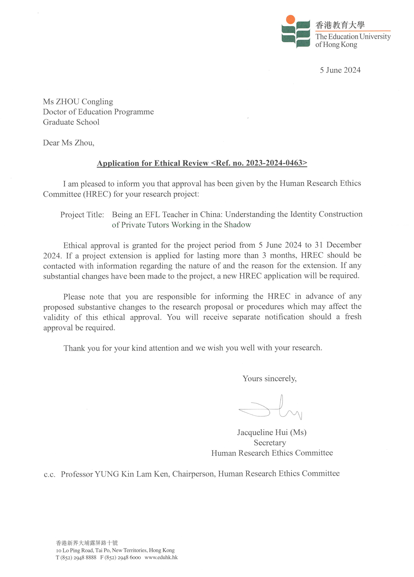

Appendix II Consent to Participate declaration

Participant 1
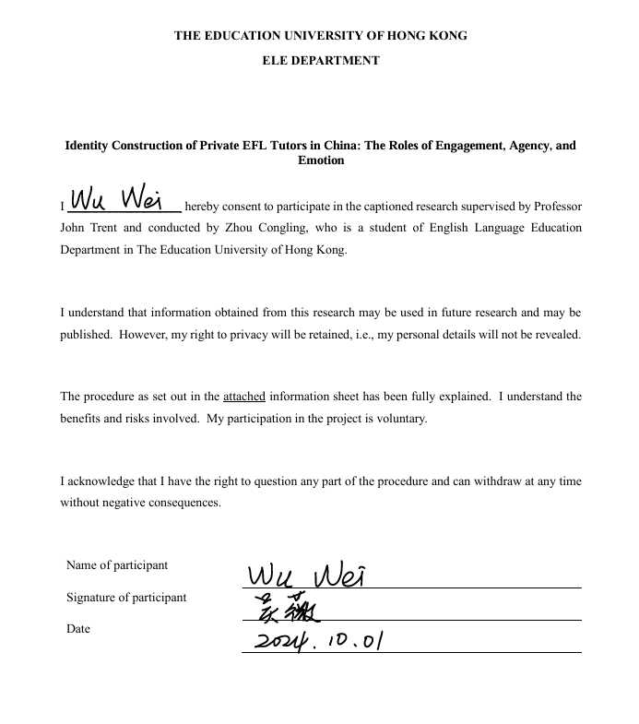

Participant 2
