Electronic Supplementary Material
Ultrafast and long-range self-transport of droplets on multi-bioinspired surface with dual-gradient structure
Supplementary Figure
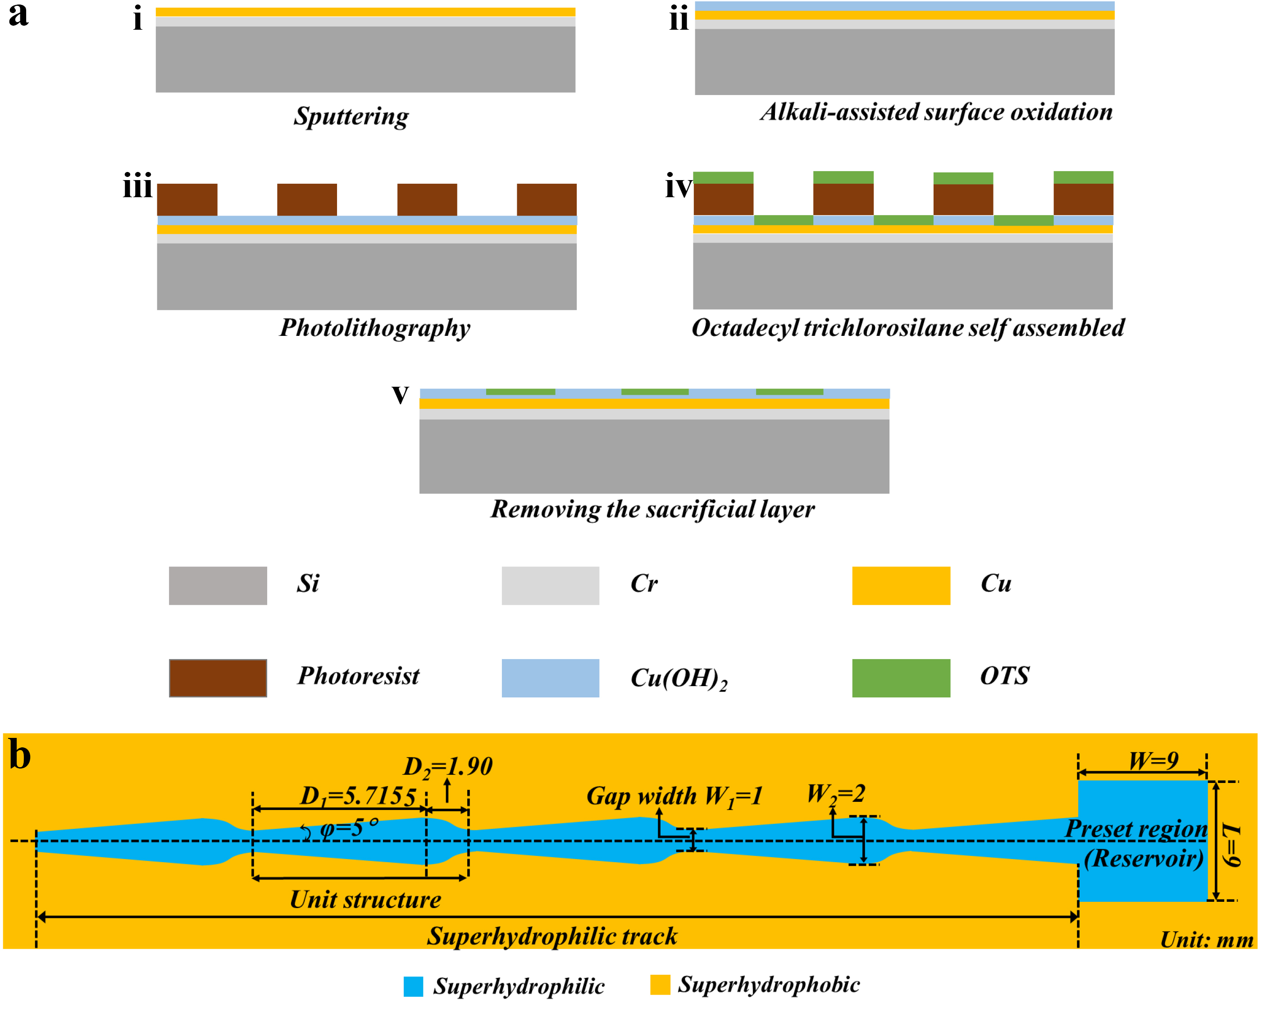
Supplementary Figure 1. Detailed manufacturing of the multi-bioinspired surface and its structural parameters. a The manufacturing process of multi-bioinspired surface. i Chromium (~50 nm) and copper film (~600 nm) grown on silicon wafer using magnetron sputtering at power of 300 W for 2 min and 20 min, respectively. ii Immersing the sample in the growth solution (0.625 M sodium hydroxide and 0.025 M ammonium persulfate aqueous solution) for 10 min at room temperature. iii Obtaining the designed bio-inspired pattern using photolithography technology. iv Immersing the sample in n-hexane solution with octadecyltrichlorosilane (OTS, concentration of 5 mM) for 15 min to obtain the superhydrophobic surface. v Using lift-off technology to remove the sacrificial layer and obtaining the multi-bioinspired surface. b The schematic and detailed parameters of a typical fabricated surface.
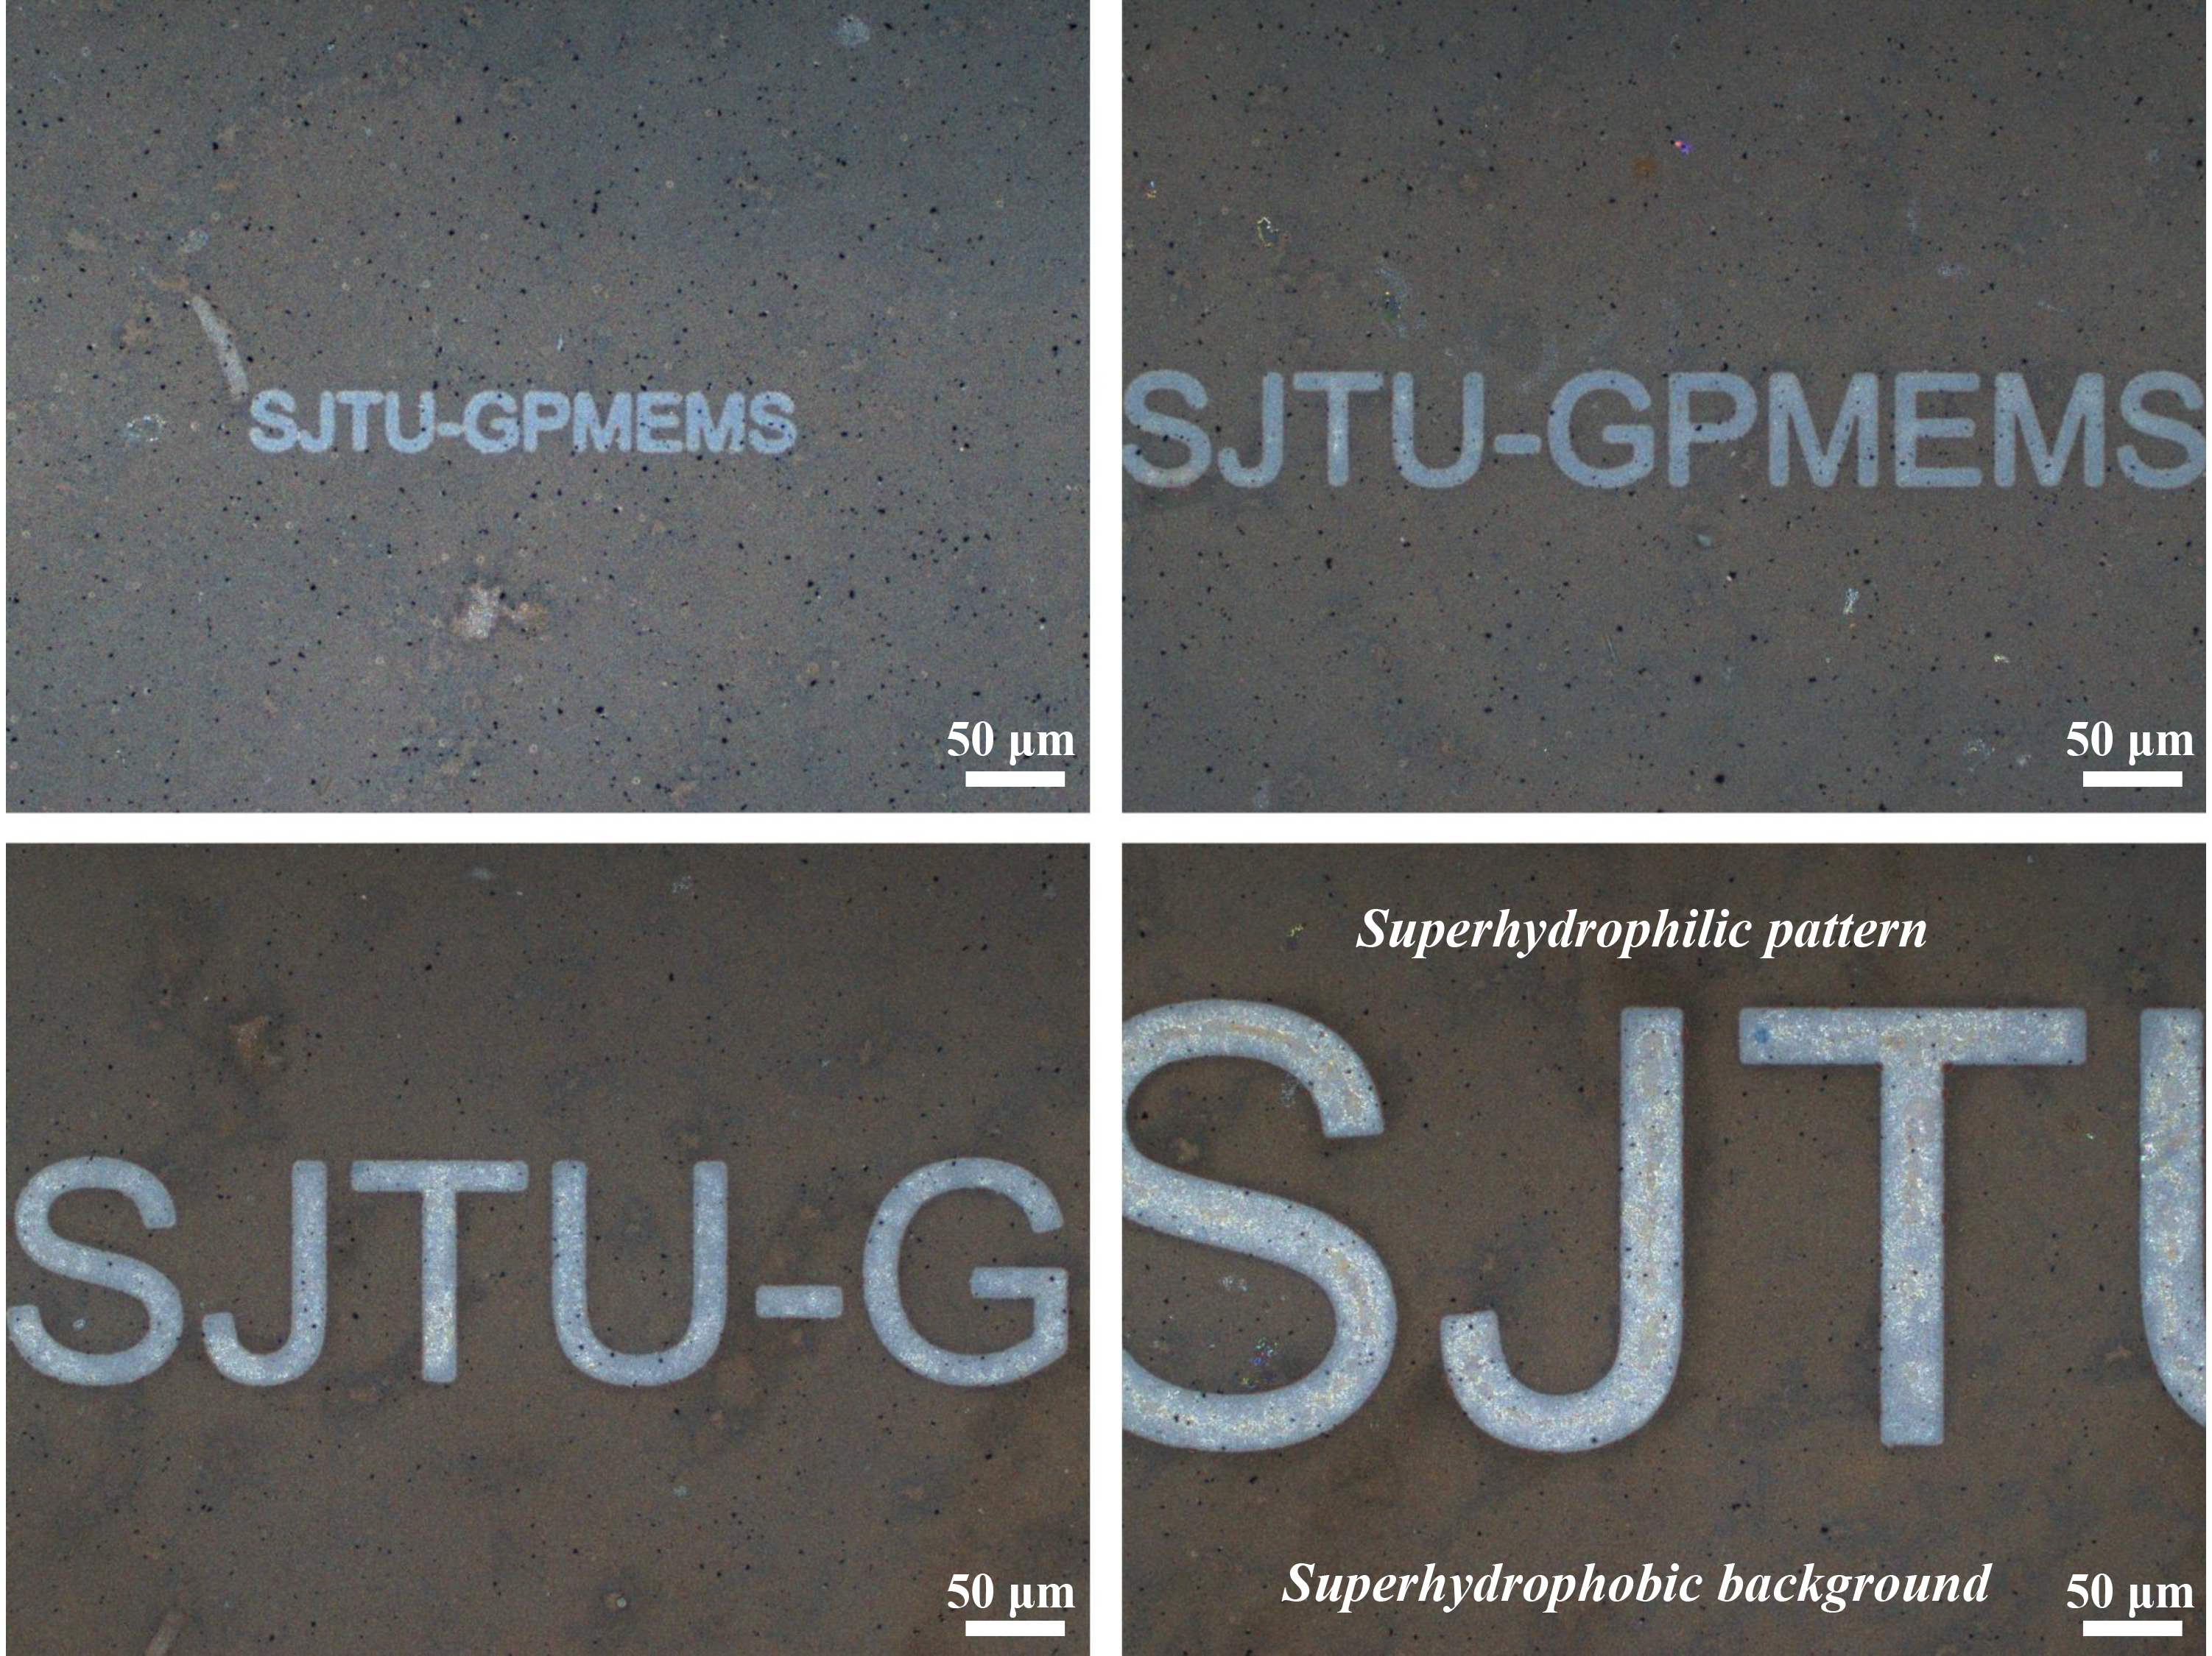
Supplementary Figure 2. Janus structure with various multi-scale complex patterns fabricated by advanced manufacturing technology, in which superhydrophilic patterns (SJTU-GPMEMS) are surrounded by superhydrophobic background.
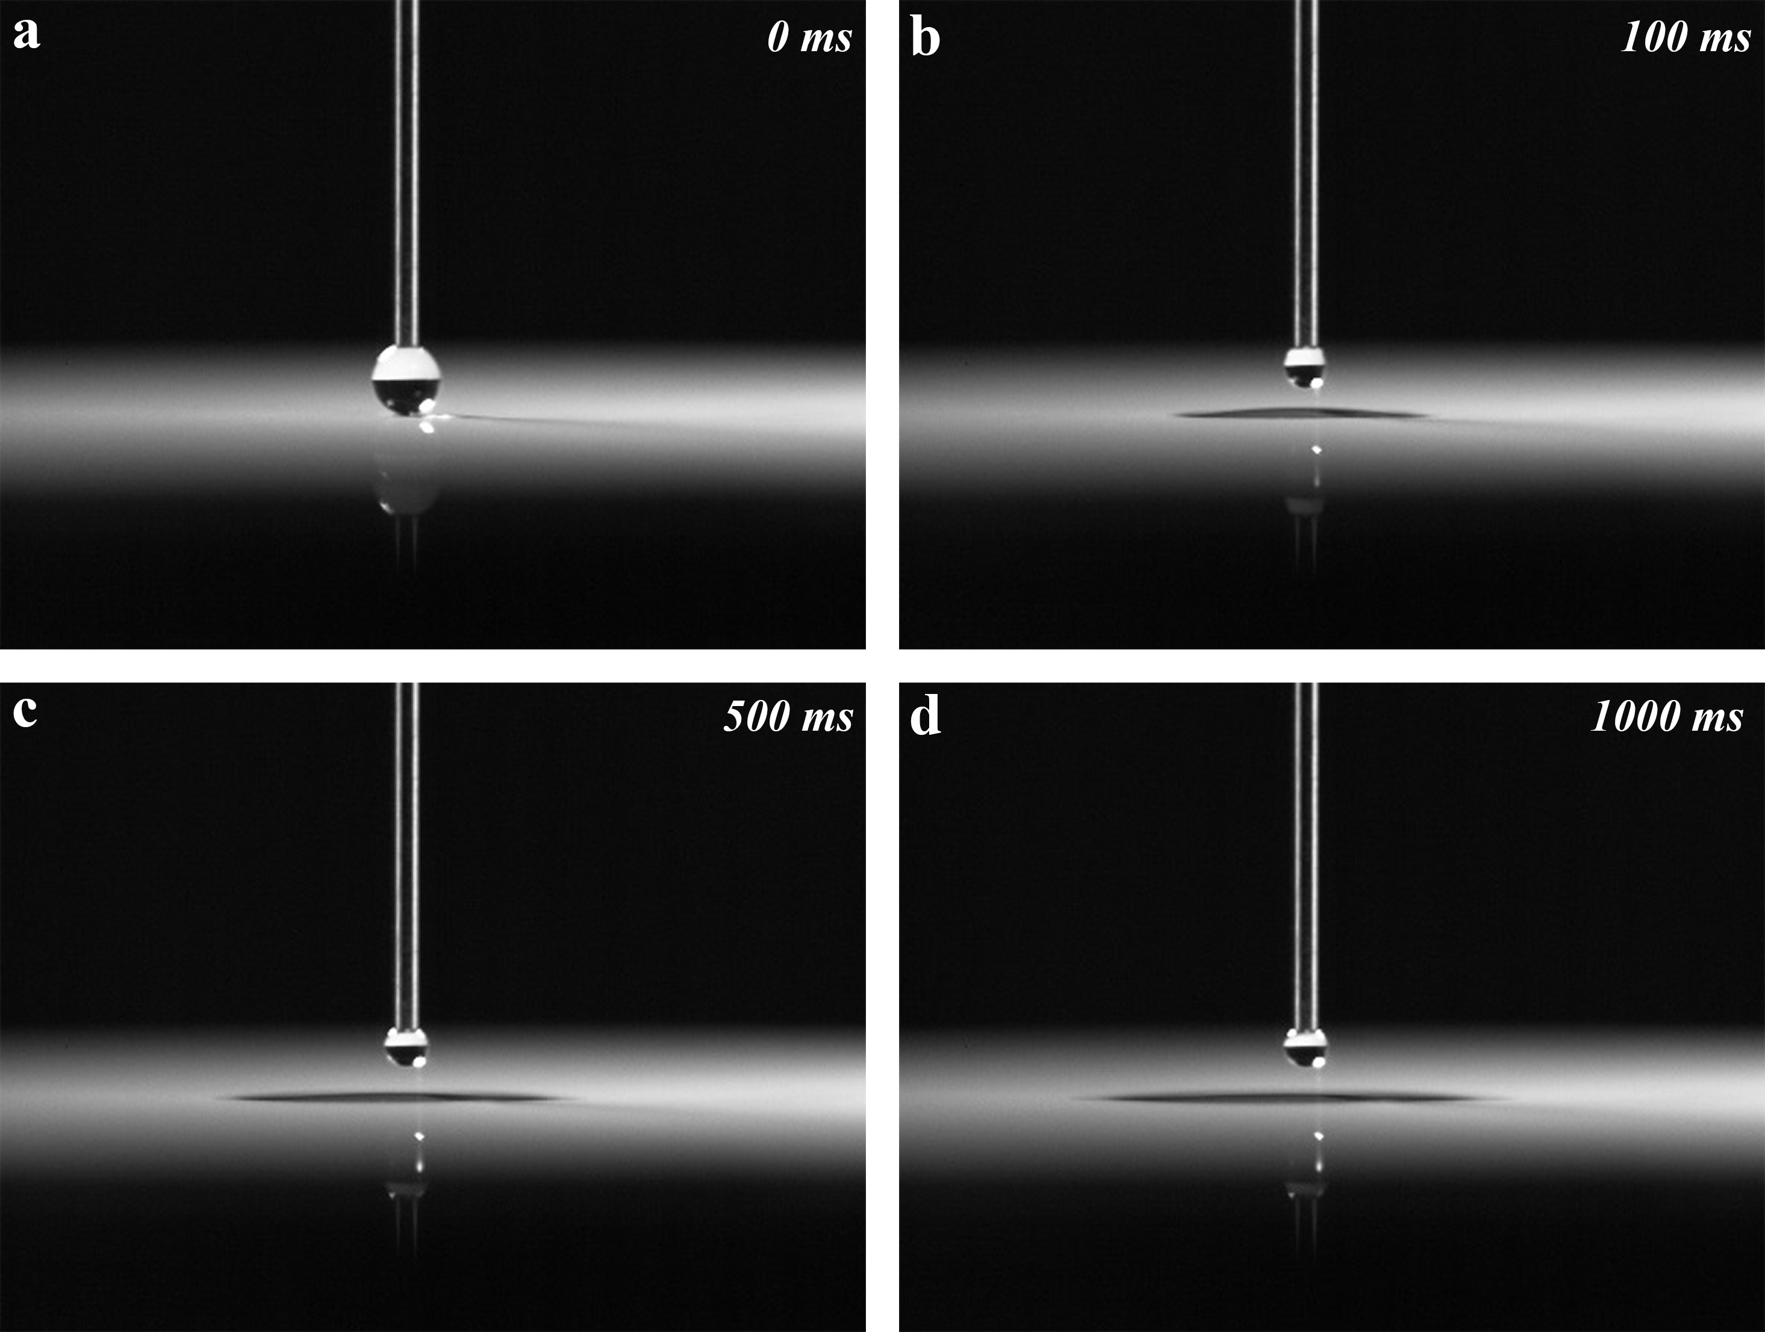
Supplementary Figure 3. Rapid droplet (~3 μL) spreading on a superhydrophilic Cu(OH)₂ surface. a 0 ms. b 100 ms. c 500 ms d 1000 ms.

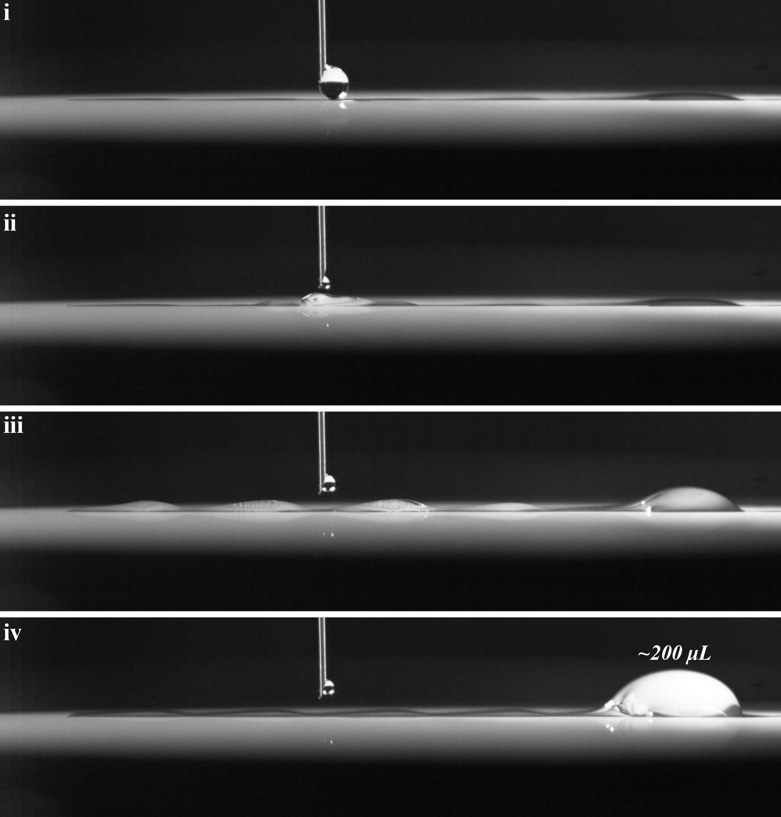
Supplementary Figure 4. Time-lapse images illustrating the ultrafast long-range self-transport of droplets (~200 μL) when the depositing site is in the middle of track.

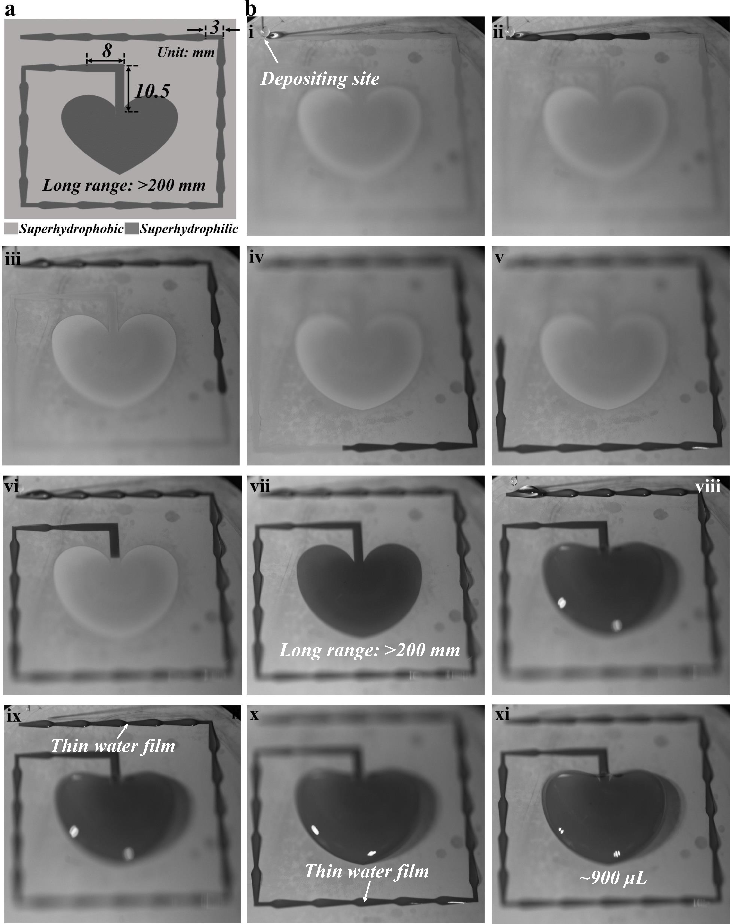
Supplementary Figure 5. Time-lapse images illustrating the advantages of proposed structure in long-range self-transport of droplets. a Schematic and structural parameter of the designed surface. b Time-lapse images illustrating (i-vii) the long-range self-transport of droplets on the dry track, and (vii-xi) the successful long-range self-transport of numerous droplets (~900 μL) on the designed structure with ultralow loss.

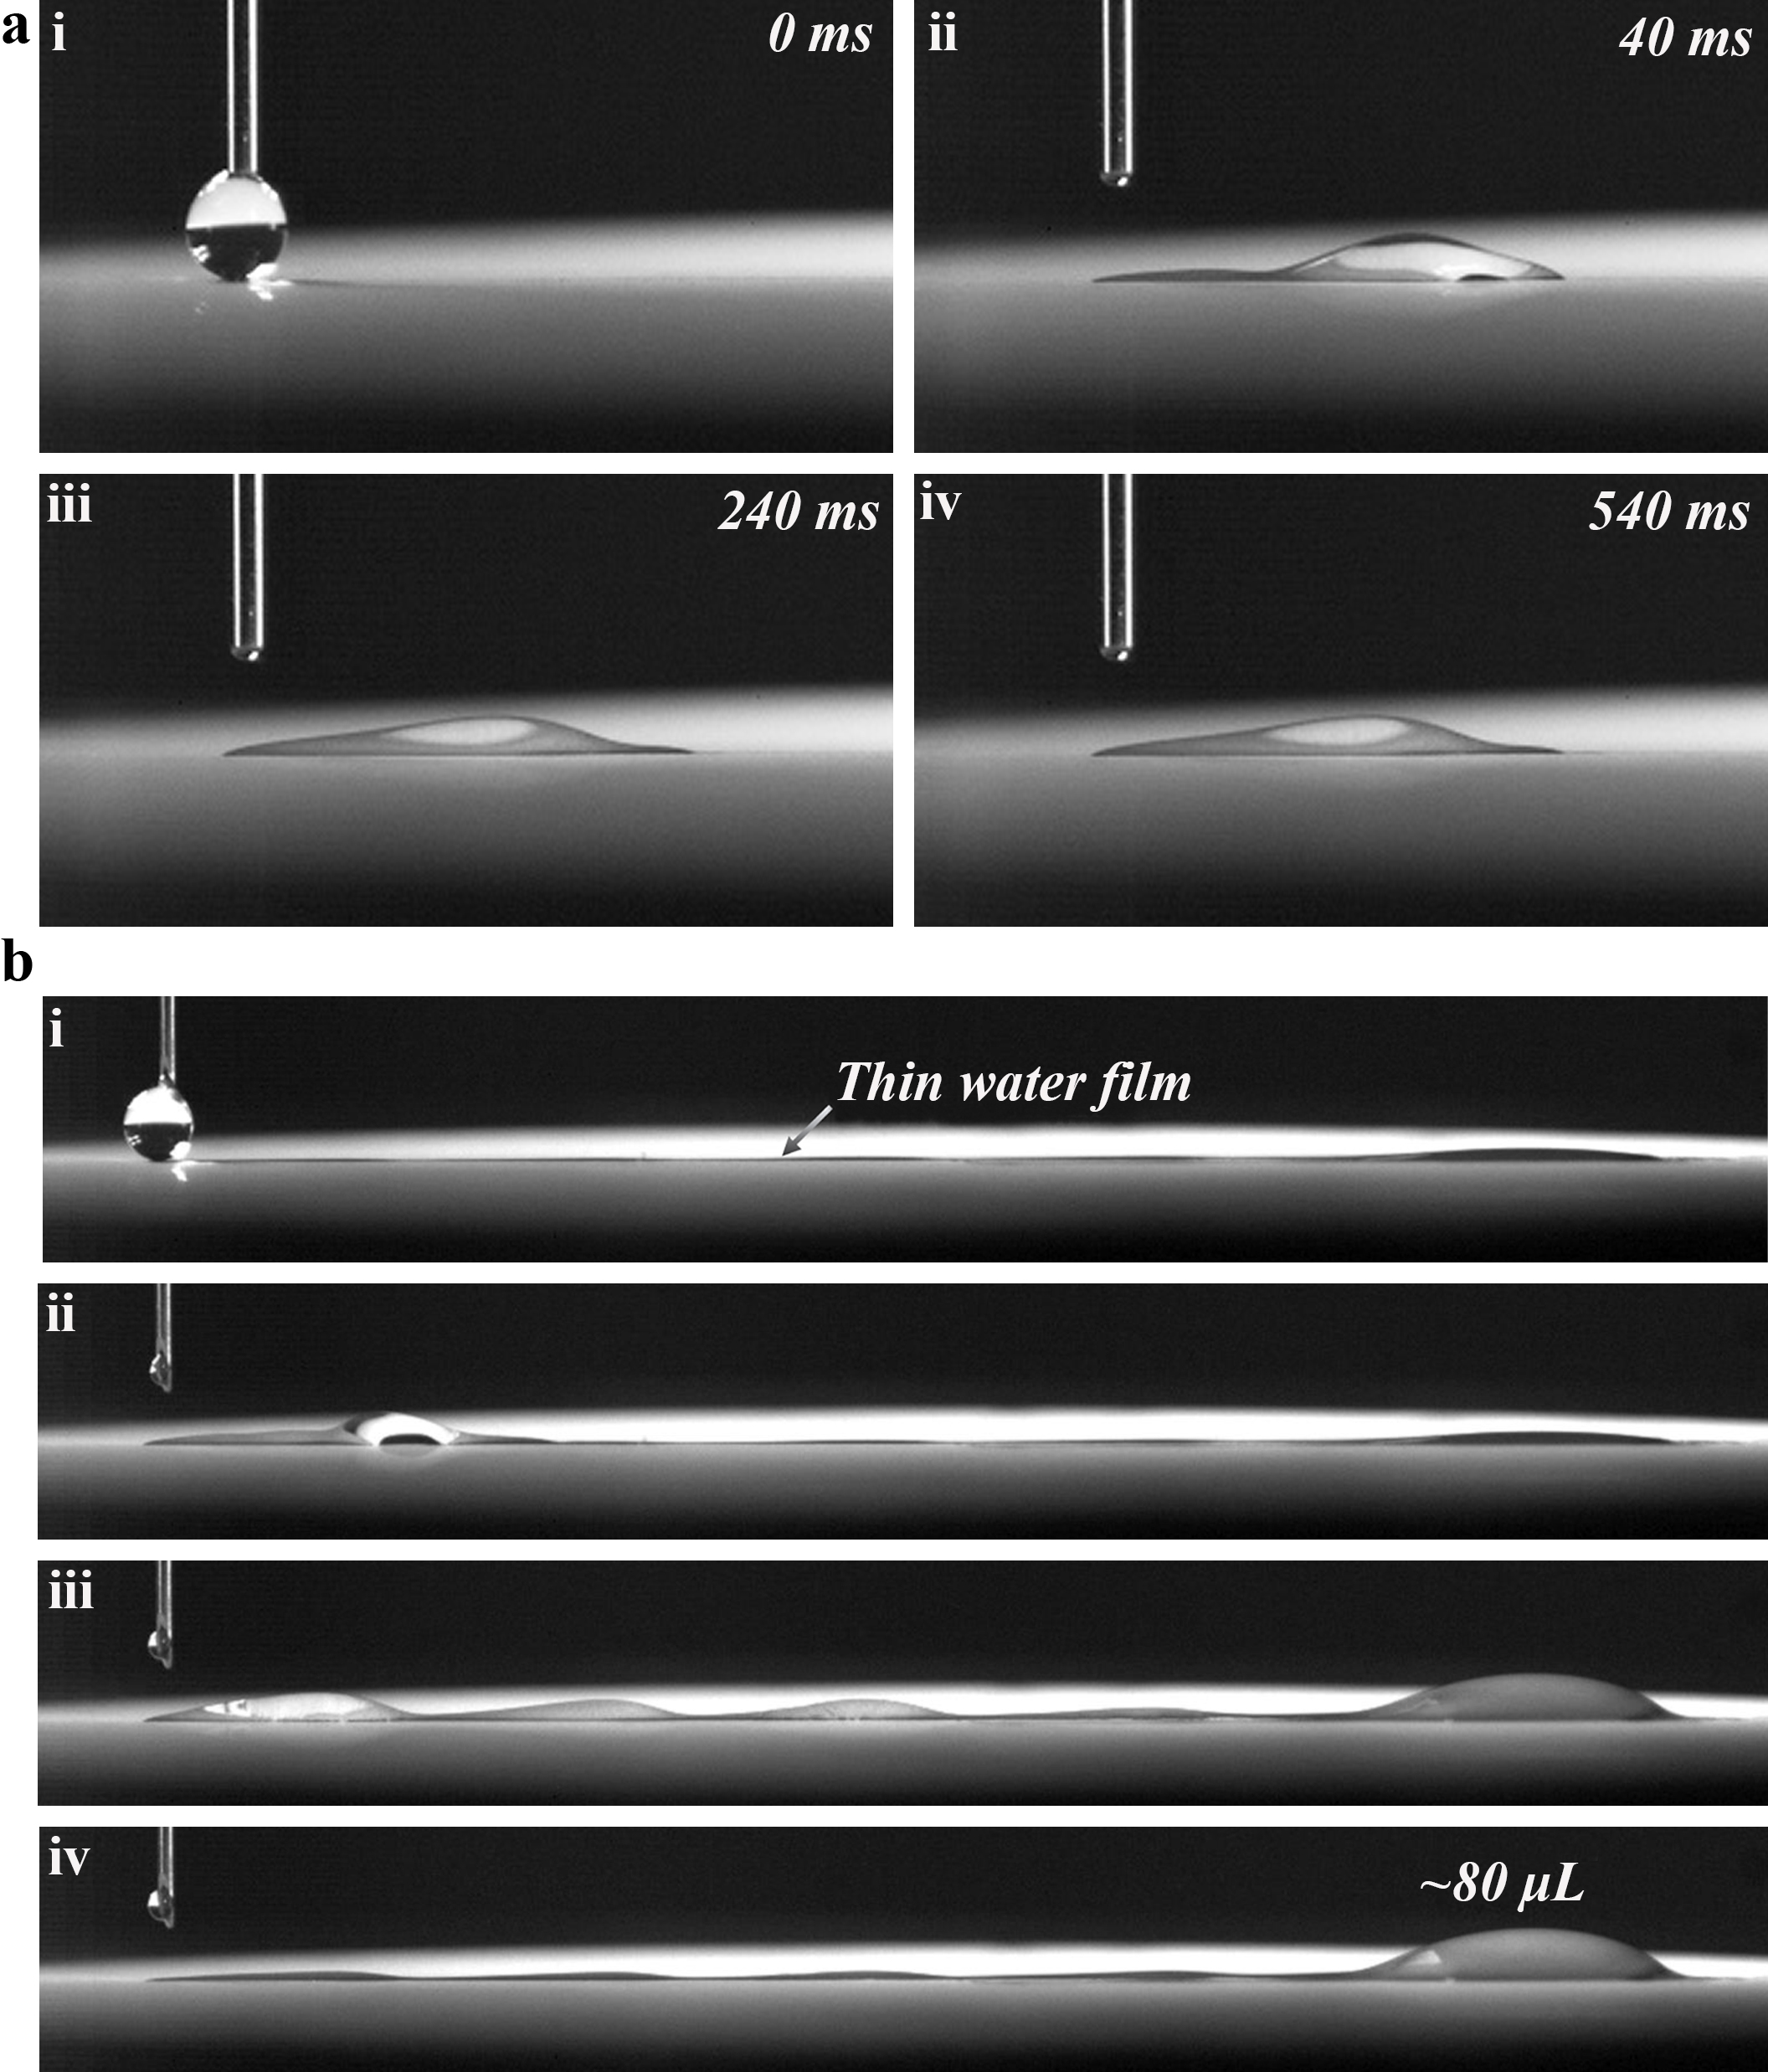
Supplementary Figure 6. Droplet transport behaviors on the bioinspired surface comprising hydrophilic-superhydrophobic wettability. a Failing to achieve the effective continuous transport of droplets on the dry surface. b Achieving the effective continuous transport of droplets after artificial pre-wetting.
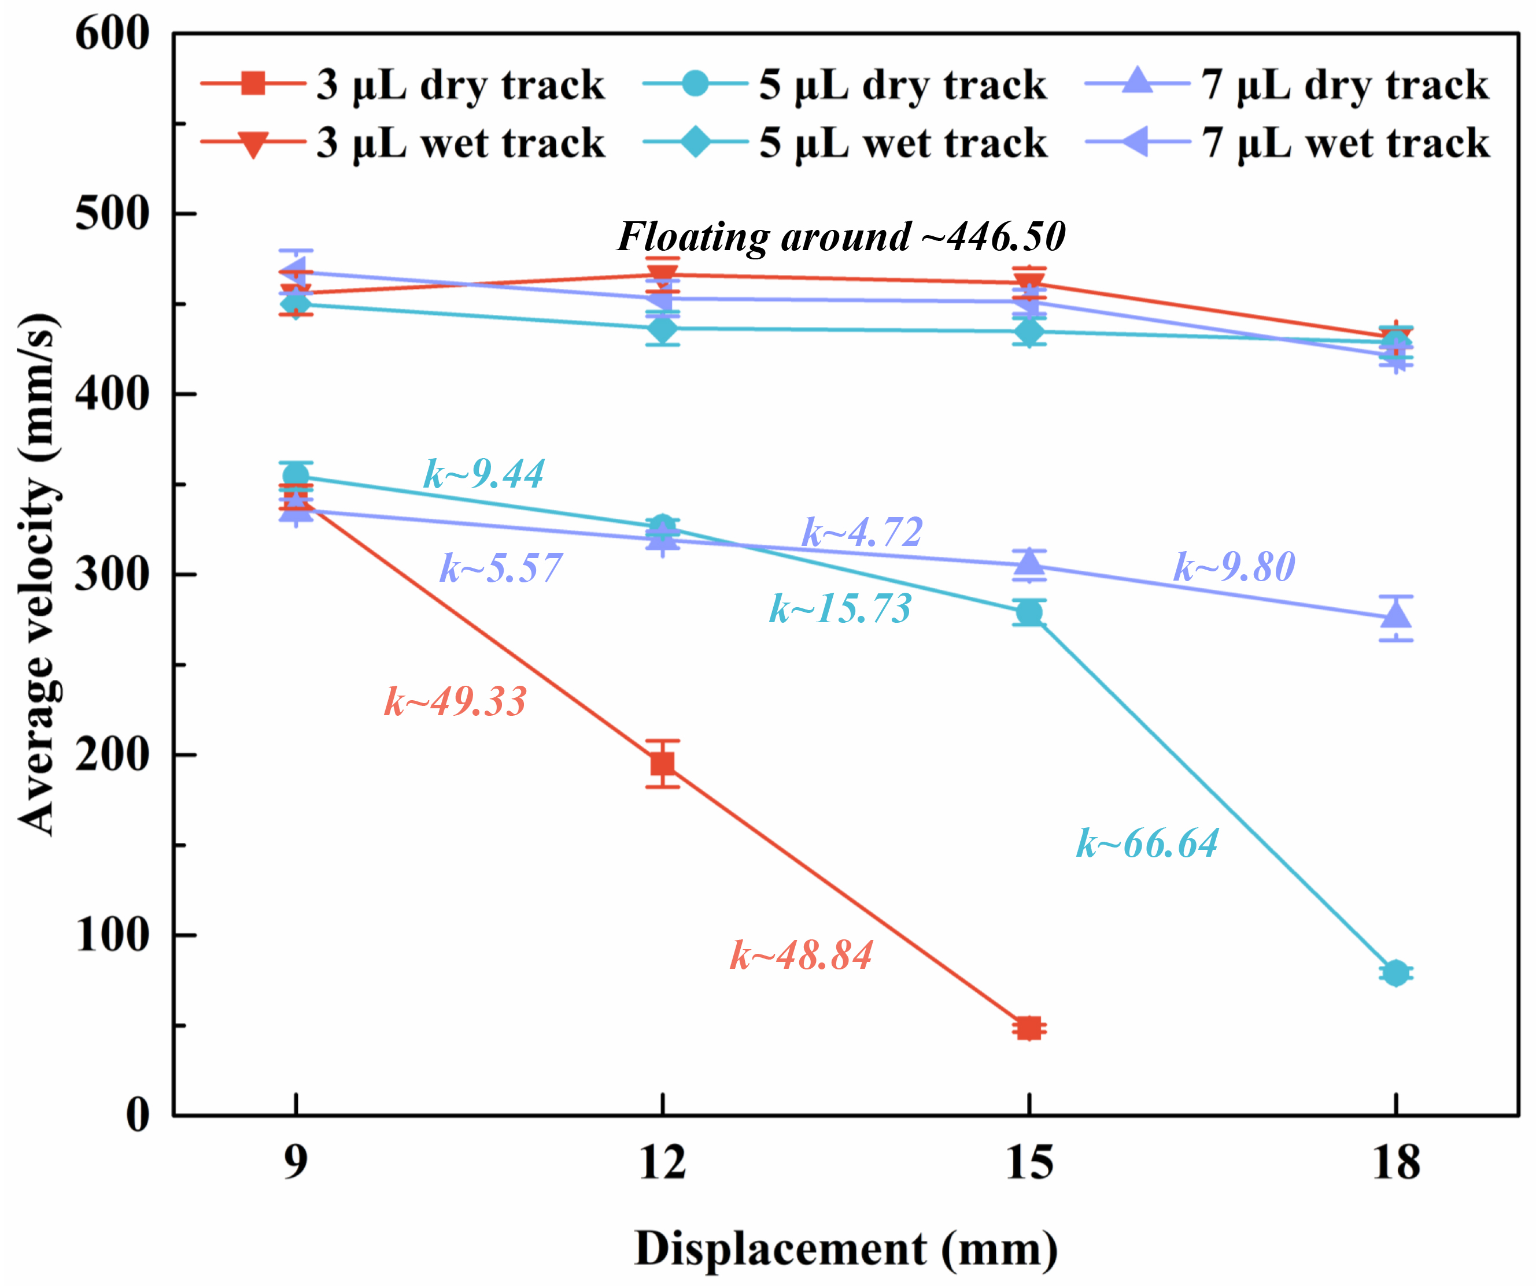
Supplementary Figure 7. Average velocity of droplet transport on the superhydrophilic track with different volumes (3, 5, and 7 μL) in different displacements (~9, ~12, ~15, and ~18 mm).
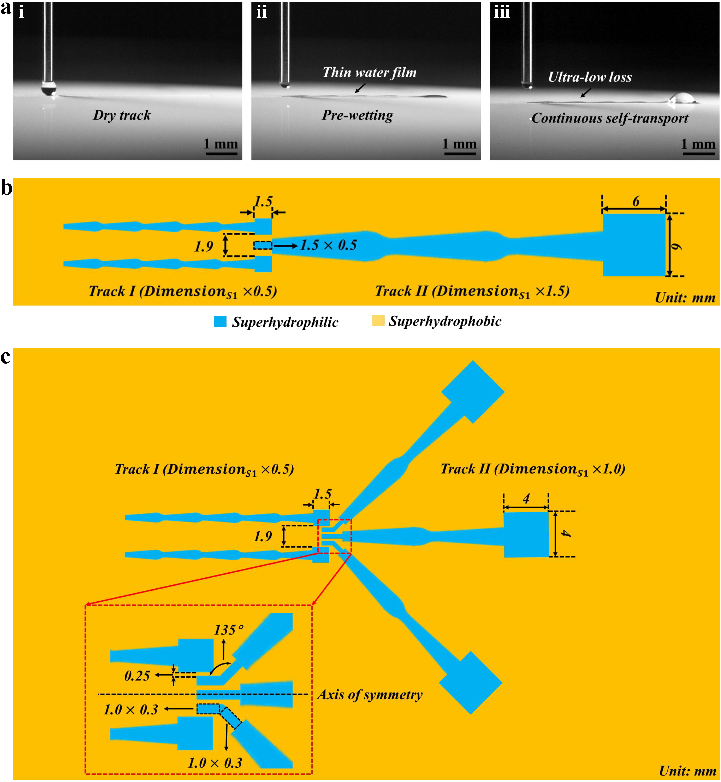
Supplementary Fig. 8 The scalability of the bioinspired structure and schematic diagram of the two systems based on it. a Time-lapse images illustrating the scaleable property of the proposed multi-bioinspired structure. The dimension of the test sample (Sample 7) is 1/8 of Sample 1. b,c Schematic diagram and structural parameters of the designed systems.

Supplementary Table 1

Table 1 Detailed structural parameter of the bioinspired surface of different samples | Reservoir area  (A, mm$×$mm) | 9×9 | 9×9 | 9×9 | 9×9 | 9$×$9 | 9$×$9 | 0.75$×$0.75
 | Maximum width  (W₂, μm) | 2 | 2 | 2 | 2 | 2 | 2 | 2
 | Half apex angle  $$φ$$ | $$5^{°}$$ | $$5^{°}$$ | $$5^{°}$$ | $$5^{°}$$ | $$5^{°}$$ | $$5^{°}$$ | $$5^{°}$$
 | Joint length  (D₂, μm) | 1.905 | 2.095 | 2.286 | 2.476 | 2.667 | 2.858 | 0.238
 | Wedge length  (D₁, μm) | 5.715 | 6.286 | 6.858 | 7.430 | 8.001 | 8.573 | 0.714
 | Gap width  (W₁, μm) | 1000 | 900 | 800 | 700 | 600 | 500 | 125
 |  | Sample 1 (S1) | Sample 2 (S2) | Sample 3 (S3) | Sample 4 (S4) | Sample 5 (S5) | Sample 6 (S6) | Sample 7 (S7)
Supplementary Movie
Supplementary Movie 1:
A droplet (~7 μL) transports on the dry/wet superhydrophilic track of the Janus surface.
Supplementary Movie 2:
Considerable droplets (~200 μL) are continuously pumped from one site to the preset region with ultra-low loss along the track.
Supplementary Movie 3:
Successful long-range (over ~200 μm) self-transport of numerous droplets (~900 μL in total) on the designed structure with ultralow loss.
Supplementary Movie 4:
Dry bioinspired surface comprising hydrophilic-superhydrophobic wettability fails to achieve the effective continuous transport of droplets. After artificial pre-wetting, droplets (~80 μL) can successfully transport to the preset region.
Supplementary Movie 5:
Droplets transport on the dry/wet superhydrophilic track of miniaturized structure, which proves the scalability of the bioinspired structure.
Supplementary Movie 6:
Metering, merging and ultrafast long-range self-transport of droplets on the designed system.
Supplementary Movie 7:
Metering, merging, splitting and ultrafast long-range self-transport of droplets on the designed system.
Supplementary Note 1
The full mathematic derivation of surface energy
The calculation of surface energy focuses on the water/track interface. The surface energy E of a droplet can be expressed as follows:
$E=Aγ_{LG}+Bγ_{SG}+Cγ_{SL}$ (1)
where γ is the interfacial tension between the gas (G), liquid (L) and solid (S); A, B and C denote the corresponding contact areas. The infinitely close to the superhydrophilic track is defined as the initial state of droplet, and the corresponding surface energy is $E_{0}$ which is set as 0 to conveniently clarify the droplet movement. The surface energy of a droplet ($E_{i}$) transport on the track can be expressed:
$$E_{i}=E_{i}-E_{0}={(A}_{i}γ_{LG}+B_{i}γ_{SG}+C_{i}γ_{SL})-{(A}_{0}γ_{LG}+B_{0}γ_{SG}+C_{0}γ_{SL})$$$=\left(A_{i}-A_{0}\right)γ_{LG}+\left(B_{i}-B_{0}\right)γ_{SG}+\left(C_{i}-C_{0}\right)γ_{SL}$ (2)
During the droplet transport, the increase in the liquid-solid contact area is accompanied by a decrease in the gas-solid area, thus
$C_{i}-C_{0}=-(B_{i}-B_{0})$ (3)
Then $E_{i}$ is
$E_{i}=\left(A_{i}-A_{0}\right)γ_{LG}++\left(C_{i}-C_{0}\right)(γ_{SL}-γ_{SG})$ (4)
Considering that the liquid-solid contact area is 0 in the initial state ($C_{0}=0$), $E_{i}$ can be simplified as
$E_{i}=\left(A_{i}-A_{0}\right)γ_{LG}+C_{i}(γ_{SL}-γ_{SG})$ (5)
According to the Young’s equation, the relationship among the $γ_{LG}$, $γ_{SG}$ and $γ_{SL}$ can be obtained as follows:
$γ_{SG}-γ_{SL}=γ_{LG}cos θ$ (6)
where $θ$ denotes the water contact angle. Thus $E_{i}$ is
$E_{i}=\left(A_{i}-A_{0}-C_{i}cos θ_{i}\right)γ_{LG}$ (7)
For the droplet on the horizontal solid plane, its shape is mainly determined by surface tension and gravity. In this situation, the surface tension is dominant due to the small liquid volume, so the model of the droplet surface can be simplified as a spherical crown. According to the spherical crown model of the droplet, we obtain that
$A_{i}=2πR_{i}(1-cos θ_{i})$ (8)
$C_{i}=π{R_{i}}^{2}{(sinθ_{i})}^{2}$ (9)
where $R_{i}$ is the equivalent radius of the droplet. Thus
$C_{i}=A_{i}\frac{1+cosθ_{i}}{2}$ (10)
Then $E_{i}$ can be expressed as
$E_{i}=\frac{1}{2}A_{i}\left(2+cosθ_{i}\right)\left(1-cosθ_{i}\right)γ_{LG}-A_{0}γ_{LG}$ (11)
According to spherical crown model, the volume of a droplet$(V_{i})$ can be expressed
$V_{i}=\frac{π}{3}{R_{i}}^{3}(2+cosθ_{i}){(1-cosθ_{i})}^{2}$ (12)
Thus $A_{i}$ can be substituted as
${A_{i}}^{3}=\frac{72π{V_{i}}^{2}}{(1-cos θ_{i}){(2+cos θ_{i})}^{2}}$ (13)
Substitute Equation (13) into Equation (11), the relation between $E_{i}$ and $θ_{i}$ can be obtained that
$E_{i}=[9π{V_{i}}^{2}{(cos {θ_{i}}^{3}-3cos θ_{i}+2 )]}^{\frac{1}{3}}γ_{LG}-A_{0}γ_{LG}$ (14)
To conveniently clarify the factor affecting the surface energy of droplet, $E_{i}$ is simplified as
$E_{i}=λ{(cos {θ_{i}}^{3}-3cos θ_{i}+2 )}^{\frac{1}{3}}-η$ (15)
where $λ=γ_{LG}{(9π{V_{i}}^{2})}^{\frac{1}{3}}$ and $η=A_{0}γ_{LG}$.
Supplementary Note 2
Detailed information on the modification of droplet equivalent radius in the initial state
For a given volume of droplet, the equivalent radius of droplet ($R_{0}$) can be obtained according to Equation (12) in Supplementary Note 1 as follows:
$R_{0}={(\frac{3V_{0}}{π\left(2+\cos{θ_{0}}\right){\left(1-\cos{θ_{0}}\right)}^{2}})}^{\frac{1}{3}}$ (16)
where $θ_{0}$ can be regarded as $\sim 180^{°}$ in the initial state. Thus $R_{0}$ can be simplified as
$R_{0}={(\frac{3V_{0}}{4π})}^{\frac{1}{3}}$ (17)
For the droplet of 3, 5 and 7 μL, the theoretical ${R_{0}}^{th}$ are 0.8947, 1.0608 and 1.1867 mm, respectively. Considering the influence of gravity on the shape of droplet, we measured the radius of a given volume experimentally. The longitudinal and transverse length of the droplet are measured, and half of the arithmetic mean of the two is taken as the radius of the droplet. Each data represents the average reading of at least six independent runs. For the droplet of 3, 5 and 7 μL, the experimental ${R_{0}}^{ex}$ are 0.9115, 1.0984 and 1.2533 mm, respectively. Thus, the modified ${R_{0}}^{mo}$ can be obtained as follows
$R_{0}=\frac{{R_{0}}^{th}+{R_{0}}^{ex}}{2}$ (18)
For the droplet of 3, 5 and 7 μL, the corresponding modified ${R_{0}}^{mo}$ are 0.9031, 1.0796 and 1.2200 mm, respectively. The corresponding released surface energy are about $7.4613 ×{10}^{2}$, $1.0663 ×{10}^{3}$ an$1.3616 ×{10}^{3}$nJ, respectively. Additionally, the gravitational potential energy (${∆E}_{G}$) of droplets also drives droplet transport. For a droplet of 3, 5 and 7 μL, ${∆E}_{G}$ are about $2.6551 ×{10}^{1}$, $5.2900 ×{10}^{1}$ and $8.3692 ×{10}^{1}$ nJ, respectively.

