Supplementary Information for:

Weaker Nordic Seas convection and bottom water warming during Greenland stadials

Christine Lockwood-Ireland^{(1, 2)*}, Tine L. Rasmussen⁽¹⁾, Mohamed M. Ezat^{(1,3)}, James W. B. Rae⁽⁴⁾, John A. Howe⁽⁵⁾, Riko Noormets⁽²⁾
¹Department of Geosciences, UiT The Arctic University of Norway, 9037 Tromsø, Norway.
²The University Centre in Svalbard, P.O. Box 156, 9171 Longyearbyen, Svalbard, Norway.
³iC3: Centre for ice, Cryosphere, Carbon and Climate, Department of Geosciences, UiT The Arctic University of Norway, 9037 Tromsø, Norway
⁴School of Earth and Environmental Sciences, University of St Andrews, Bute Building, Queen´s Terrace, St Andrews, United Kingdom, KY16 9TS
⁵The Scottish Association for Marine Science, Dunbeg, Oban, Argyll, United Kingdom, PA37 1QA
*Correspondence to: christine.lockwood.ireland@uit.no
Content
The supplementary information provides additional figures, tables and supporting text and interpretations.
- Supplementary Figures S1−S7
- Supplementary Tables S1−S4 (see Supplementary Dataset 1 for Tables S5−S9).
- Interpretation of palaeoenvironment from key benthic and planktic foraminiferal faunas (see below Figure S2)
- $\overline{SS}$ palaeo-flow proxy validation (see below Figure S3)
- Components of benthic foraminiferal δ¹⁸O_{calcite} (see below Table S3)
- Determination of corresponding Greenland interstadial−stadial palaeo-flow and bottom water temperature (BWT) variations (see below Table S4)

Supplementry Figures
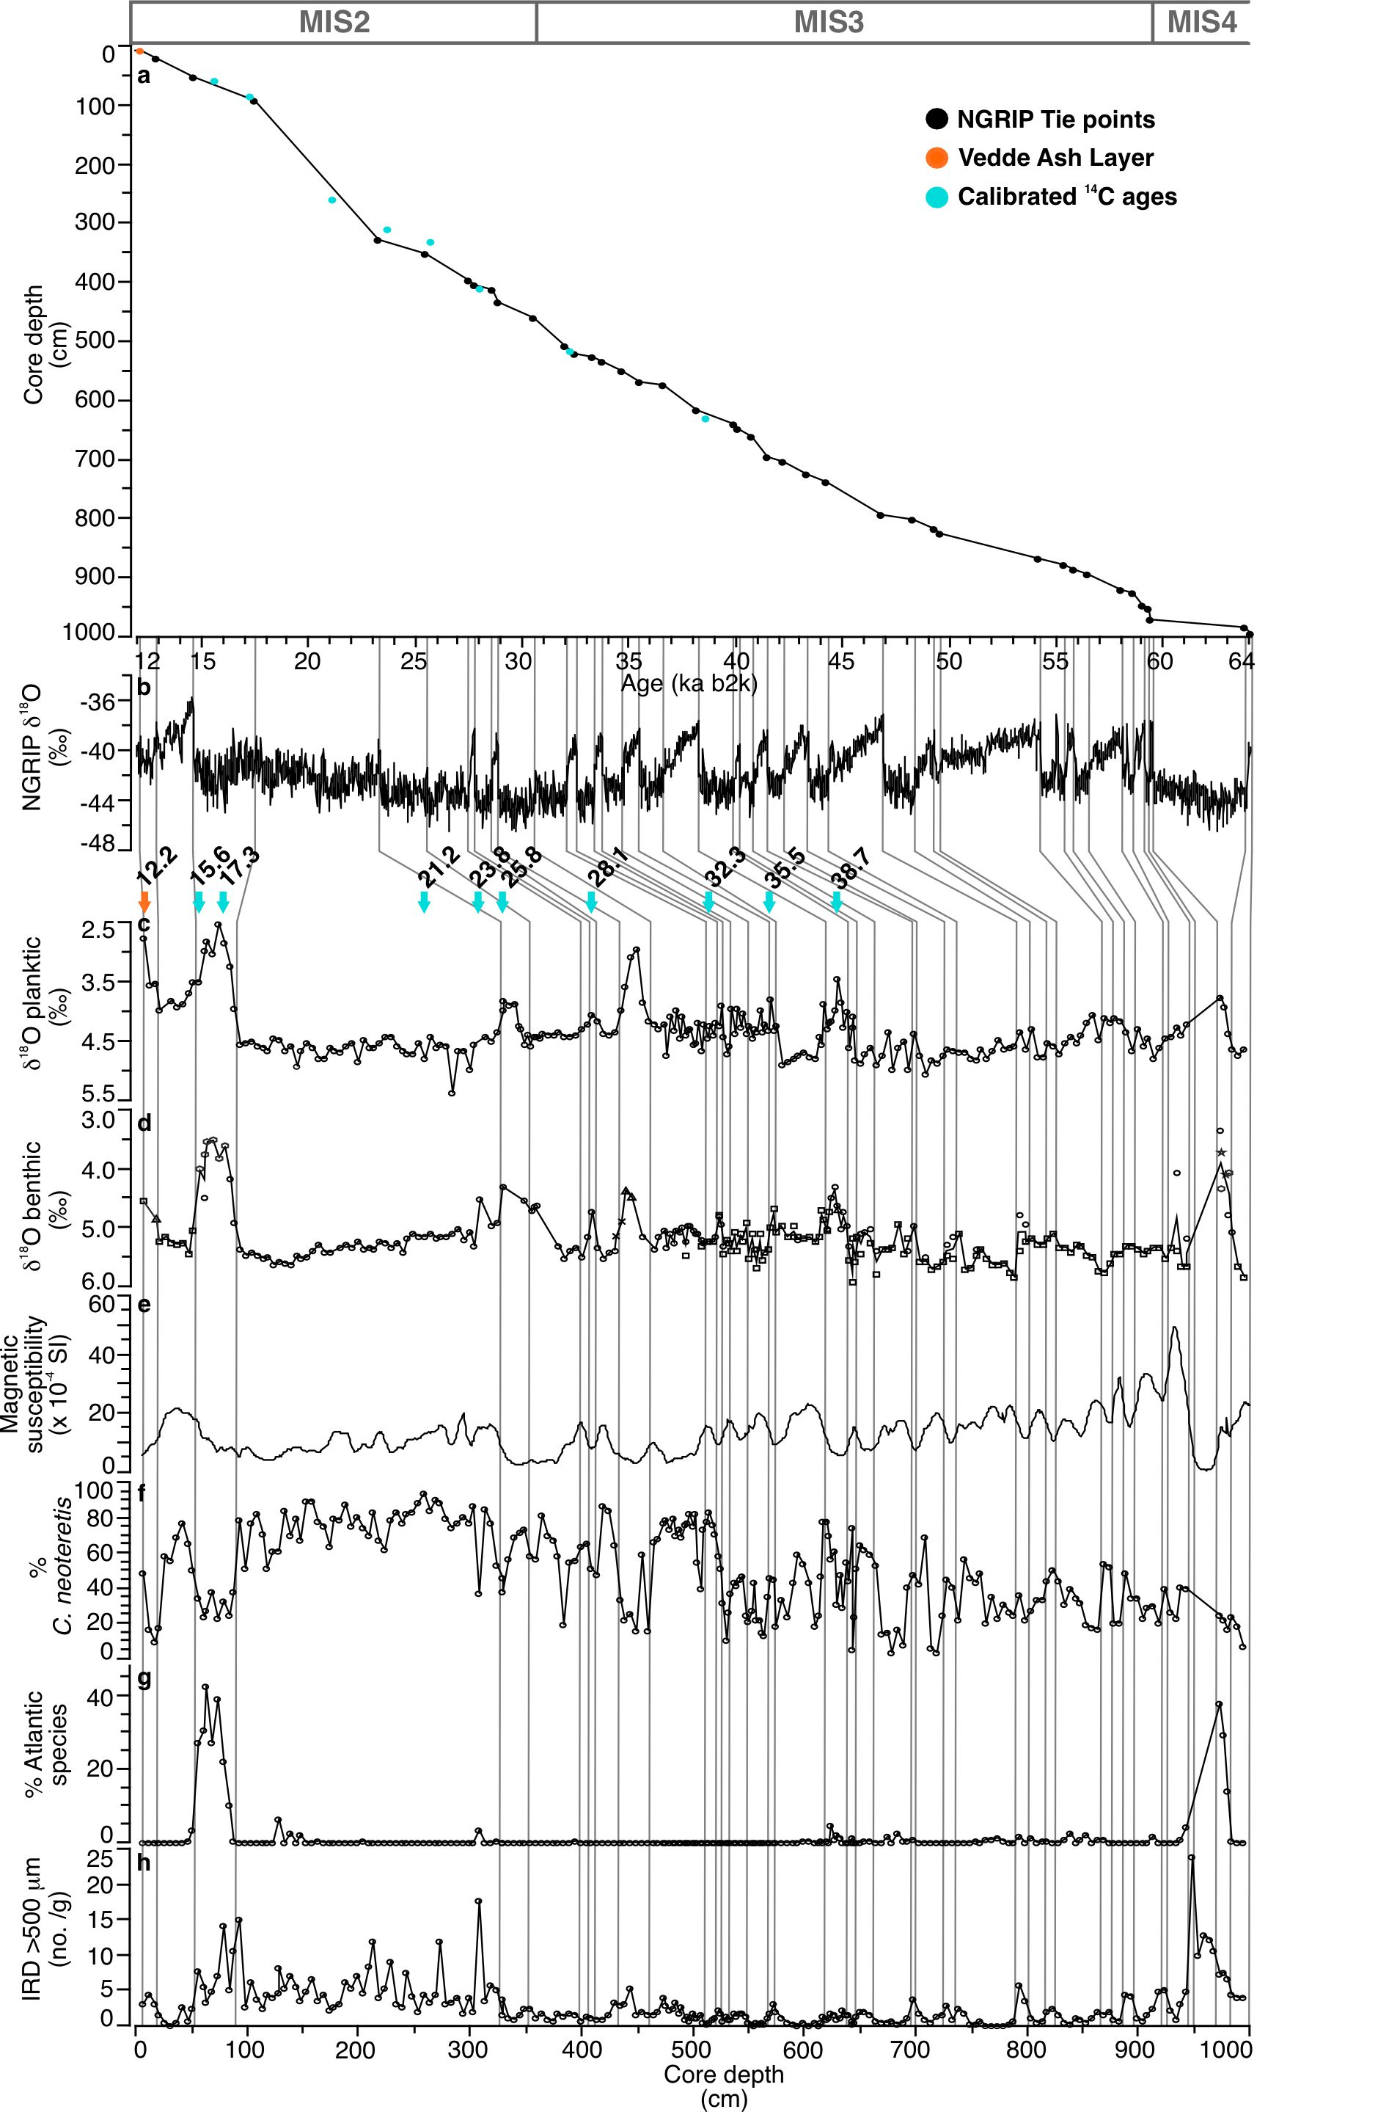

Figure S1. Age model construction of HH13-071GC/070PC (hereafter, 71GC/70PC) by correlation to the North Greenland Ice Core Project (NGRIP) ice-core chronology. (a) Age-depth model with tie points to the NGRIP onset of the Greenland interstadials (GIS) and Greenland stadials (GS) (Table S5). (b) NGRIP ice-core δ¹⁸O record with the GICC05 timescale (ka b2k)^{58,59,60}. (c) Planktic foraminiferal δ¹⁸O values measured on Neogloboquadrina pachyderma. (d) Benthic foraminiferal δ¹⁸O values measured on dominant species Cassidulina neoteretis ( ) and Melonis barleeanus ( ). Measurements from Bulimina costata ( ); Cibicidoides floridanus ( ); Cibicidoides wuellerstorfi ( ); Oridorsalis umbonatus ( ) were taken for some intervals. (e) Magnetic susceptibility. (f) Relative abundance of C.neoteretis. (g) Relative abundance of the Atlantic species group (Table S2). (h) Ice-rafted debris concentration. Vedde Ash layer and calibrated AMS-¹⁴C dates that were used to confirm our tuning with NGRIP are shown (Table S6).
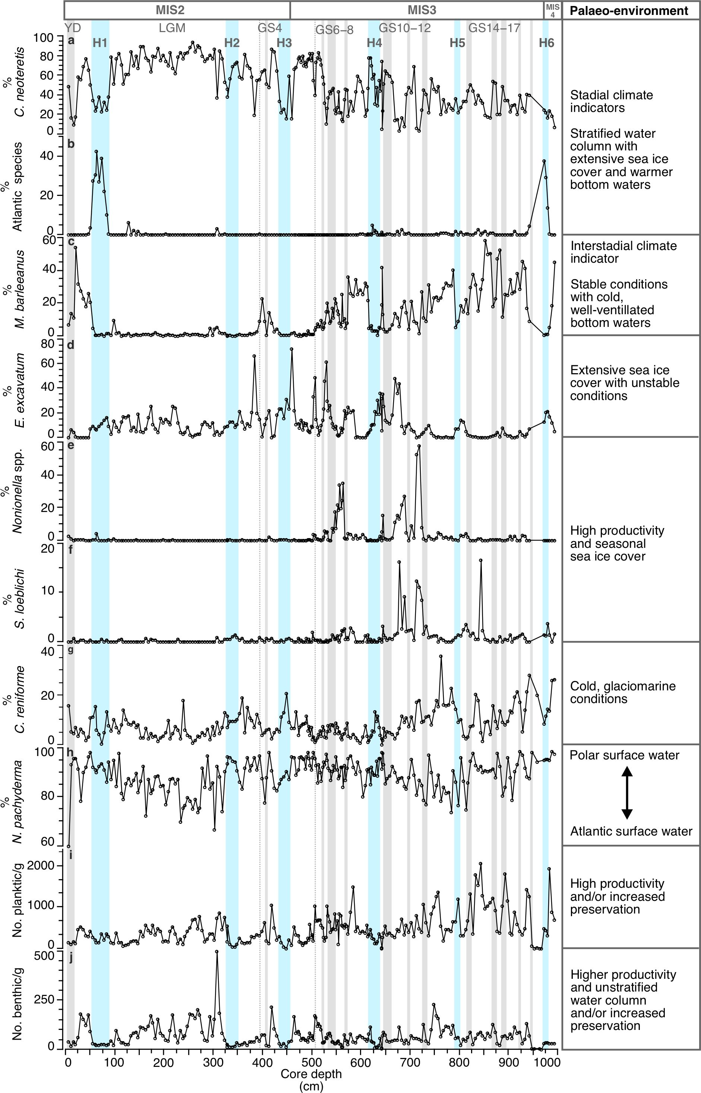
Figure S2. Relative abundance of key foraminiferal species and foraminifera concentration. (a) % Cassidulina neoteretis. (b) % Atlantic species. (c) % Melonis barleeanus. (d) % Elphidium excavatum. (e) % Nonionella spp.. (f) % Stainforthia loeblichi. (g) Cassidulina reniforme. (h) Neogloboquadrina pachyderma. (i) No. planktic specimens/g (j) No. benthic specimens/g. Main associated palaeo-environmental conditions are indicated. Blue bars mark the Heinrich stadials (HS) and grey bars mark the Greenland stadials (GS). Dashed lines mark the onset of Faroe-Shetland Interstadial 5b (FS-IS5b) and 3b (FS-IS3b)⁶¹. MIS, YD and LGM stand for Marine Isotope Stage, Younger Dryas and Last Glacial Maximum, respectively.
Interpretation of palaeoenvironment from key benthic and planktic foraminiferal faunas.
The benthic foraminiferal assemblages during MIS3 and MIS2 are dominated by Cassidulina neoteretis, Melonis barleeanus, Elphidium excavatum, Stainforthia loeblichi, Nonionella spp., and Cassidulina reniforme (Fig. S2; Table S2). Interstadials are characterised by the presence-dominance of M. barleeanus, C. reniforme, S. loeblichi and Nonionella spp.. Melonis barleeanus is an indicator of stable conditions with higher food production and a well-ventilated water column (e.g., ref.¹). Cassidulina reniforme occurs throughout the interstadials and likely indicates cold, salty bottom waters and stronger bottom currents under a glaciomarine setting². Stainforthia loeblichi and Nonionella spp. (comprising N. iridea, N. stella and N. turgida) occur briefly in some of the longer-lasting interstadials (GIS14, 11−10 and 7). Together, they suggest a highly productive marginal ice zone from seasonal sea ice cover (e.g., refs.^{3,4}). The benthic faunas of the peak interstadials correlate with colder BWT and higher δ¹⁸O values (Fig. 2; Fig. S2) that indicates active convection with conditions that are similar to modern that have been observed in previous studies from the northern North Atlantic and Nordic Seas (e.g., refs.^{5,6,7,8}). The interstadial cooling periods tend to be dominated by an increased relative abundance of C. neoteretis and E. excavatum. These faunas probably represent deteriorating conditions with an expansion of sea ice and likely a gradual decrease in convection strength (e.g., refs.^{9,10}).
The Heinrich stadials and Greenland stadials generally have a low concentration of benthic foraminifera (no. benthic/g) that are dominated by C. neoteretis, and a diverse group of warm water species termed the ´Atlantic species group´ (see Table S2) that are most abundant in H6 and H1. The benthic faunas correlate with low benthic and planktic δ¹⁸O values, and higher BWT (Fig. 2; Fig. S2) indicating the water column was stratified with extensive sea ice cover and Atlantic water circulated as an intermediate water mass. These stadial conditions are typical at mid-depth in the northern North Atlantic and Nordic Seas (e.g., refs.^{5,6,8}).
The dominance of planktic species Neogloboquadrina pachyderma throughout the record suggests polar surface conditions even in the interstadials¹¹. Interestingly, higher abundances of subpolar species (mainly Globigerinita glutinata, Turborotalita quinqueloba and Neogloboquadrina incompta) indicated by a decline in N. pachyderma occur during parts of the Last Glacial Maximum (LGM). This probably indicates a westward expansion of Atlantic surface water that has been documented previously to flow periodically into the Nordic Seas during the LGM. (e.g., ref.¹²). This is likely coupled with a higher preservation of specimens due to high productivity of planktic and benthic foraminifera, high abundance of detrital carbonate and high sedimentation rates associated with the LGM^{12,13,14}.
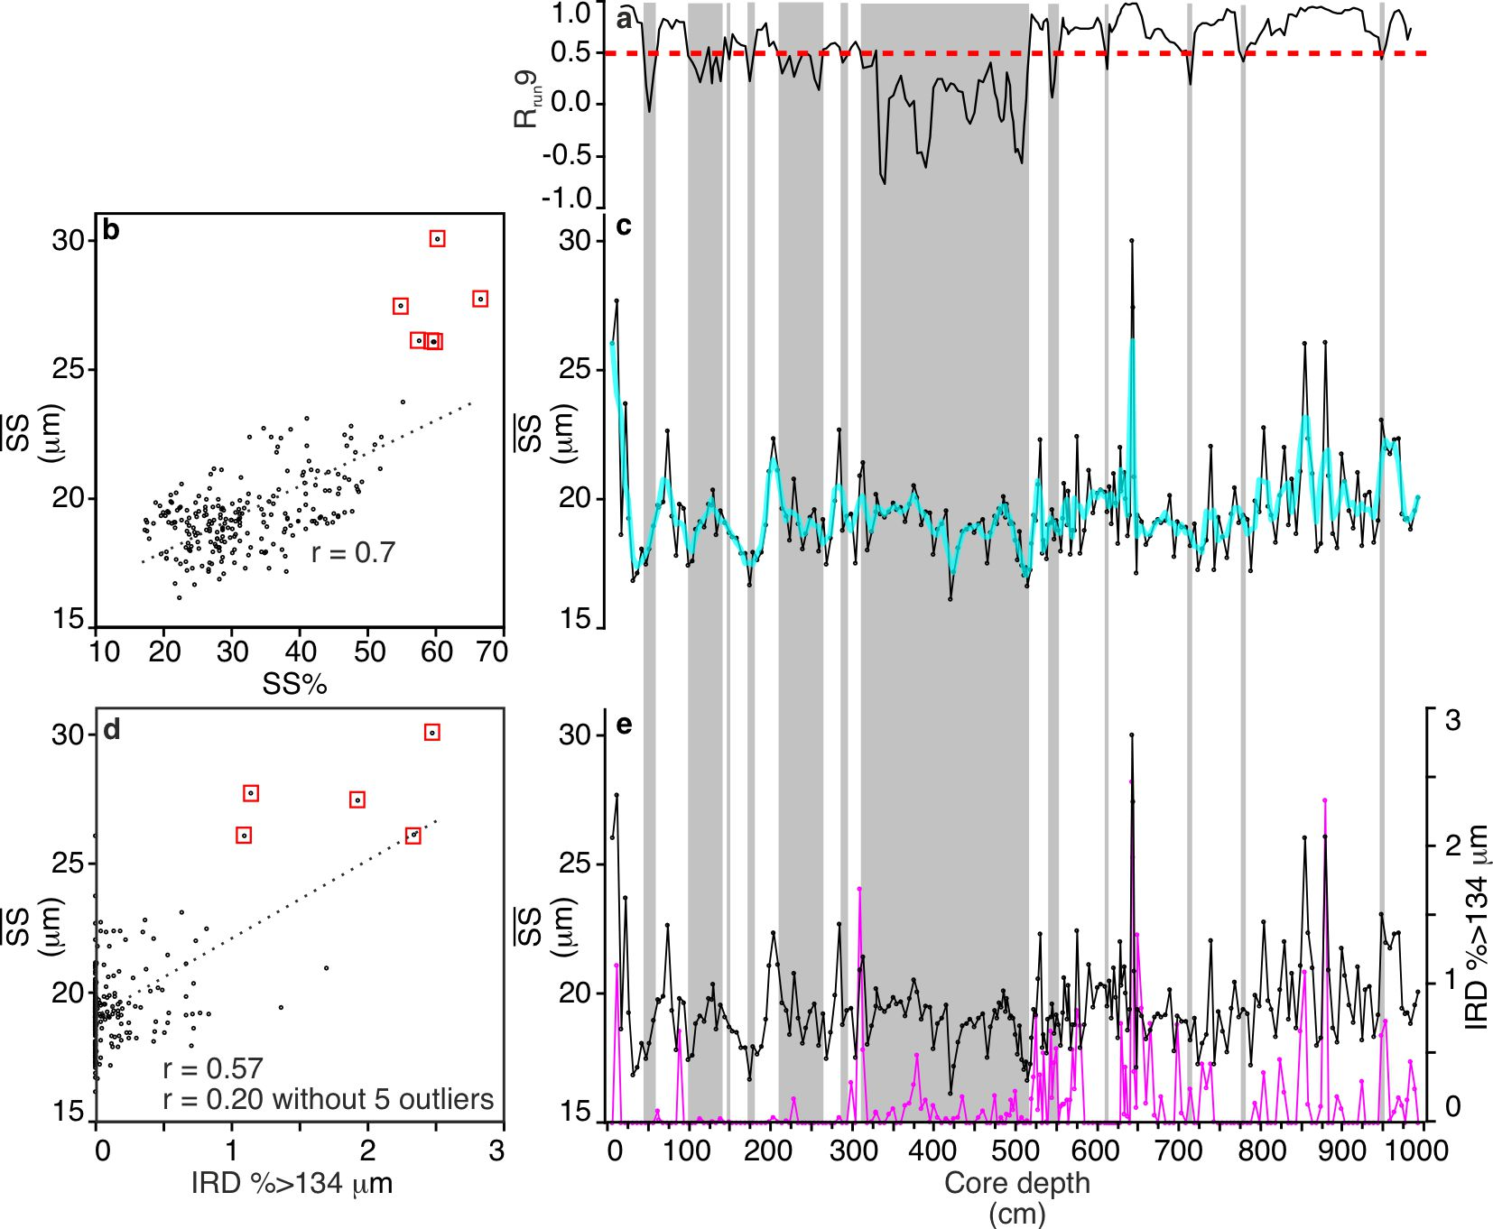
Figure S3. $\overline{SS}$palaeo-flow proxy (a) Sortable silt mean size $\overline{SS}$−SS% running 9-point correlation (R_{run}9) with the red line indicating the current sorting threshold value of 0.5. (b) Cross plot of $\overline{SS}$ versus SS% (all data points). (c) $\overline{SS}$ plotted against core depth. Turqoise line is the 3-point running mean. (d) Cross plot of $\overline{SS}$ versus IRD%>134 μm. (e) $\overline{SS}$ ( ) and IRD%>134 μm ( ) plotted against core depth. Poorly sorted sediments that are unreliable for accurate palaeo-flow interpretation are highlighted by the grey bars. Potential outliers are bound by .
-

$\overline{SS}$ palaeo-flow proxy validation
The $\overline{SS}$ palaeo-flow proxy is only validated for current-sorted sediments and where ice-rafted debris (IRD) does not significantly impact the $\overline{SS}$. IRD is particularly important to consider on formerly glaciated margins such as those in the Nordic Seas where 71GC/70PC was recovered. The relationship between three parameters ($\overline{SS}$, SS% and IRD) following McCave and Andrews (ref.¹⁵) is used to assess if the sediments were current-sorted through selective deposition (i.e., finer grains deposited under slower bottom current velocities), or poorly sorted, potentially deposited by ice-rafting and/or downslope processes. The $\overline{SS}$−SS% parameters of well current-sorted sediments are highly correlated (R >0.9)¹⁵. The correlation coefficient of R = 0.5 is set as the threshold value for adequate current-sorting of the sediments for reliable interpretation in terms of palaeo-flow¹⁵. 71GC/70PC has a whole-record $\overline{SS}$−SS% correlation coefficient of 0.7, therefore most of the dataset is sufficiently current-sorted (Fig. S3b). Six samples stand out as having a coarser $\overline{SS}$ that correlates with a higher SS% compared with the other samples in the dataset (Fig. S3b). A running 9-data point correlation (R_{run}9) between $\overline{SS}$ and SS% was performed following the processing scheme of McCave and Andrews (ref.¹⁵). Samples with R_{run}9 values >0.5 are included in our palaeo-flow interpretations (Fig. S3a, c). R_{run}9 is >0.5 in 65 % of the samples (i.e. 150 out of 231 samples) and >0.7 in 49 % of the samples (i.e. 113 out of 231 samples). R_{run}9 is <0.5 in 45 % of the samples (i.e. 81 out of 231 samples). These sediments are speculated to be deposited under a slower bottom current strength and possibly a high sediment supply from the continental margin that impacted the sorting action of the currents (e.g., refs.^{15,16}).
Coarser grains (e.g., sand-size >500 μm) are too large to be transported by contour (along-slope) currents and are deposited by ice-rafting and/or downslope processes^{15,17}. Correlation between $\overline{SS}$ and the percentage of coarser grains could mean that ice-rafting processes impact the $\overline{SS}$ (i.e. high percentage coarse IRD >500 μm and coarser $\overline{SS}$). A correlation between $\overline{SS}$ and the coarse IRD fraction could occur under four scenarios; 1. sorting of sediment grains by stronger bottom currents that reduces deposition of the finer grains (i.e. no impact of IRD on $\overline{SS}$), 2. rapid input of IRD, 3. weaker bottom current strength with insufficient sorting of the fine fraction, or 4. 2. and 3. combined, commonly during glacial periods (under scenario 2. and/or 3. IRD will potentially influence the $\overline{SS}$). High coarse IRD content of >50% are suggested to be required to influence the $\overline{SS}$¹⁵. The grain size that is recommended to use from high latitude records to assess the relationship between coarse IRD and $\overline{SS}$ is medium-grade sand >250 μm. 71GC/70PC contains very little coarse IRD, therefore fine sand-size %>134 μm (hereafter, IRD134) was the next available grain size to use. IRD does not appear to have an impact on the current-sorting of the sediments, with R=>0.5 in intervals with higher IRD134 input (Fig. S3a, e). The correlation between $\overline{SS}$ and coarse IRD134 is weak (r = 0.57) (Fig. S3d). Five samples with coarser $\overline{SS}$ are potential outliers that correlate with higher coarse IRD134 (r = 0.20 without outliers). This could be related to stronger bottom currents that have winnowed and subdued the deposition of finer (clay-silt size) grains.

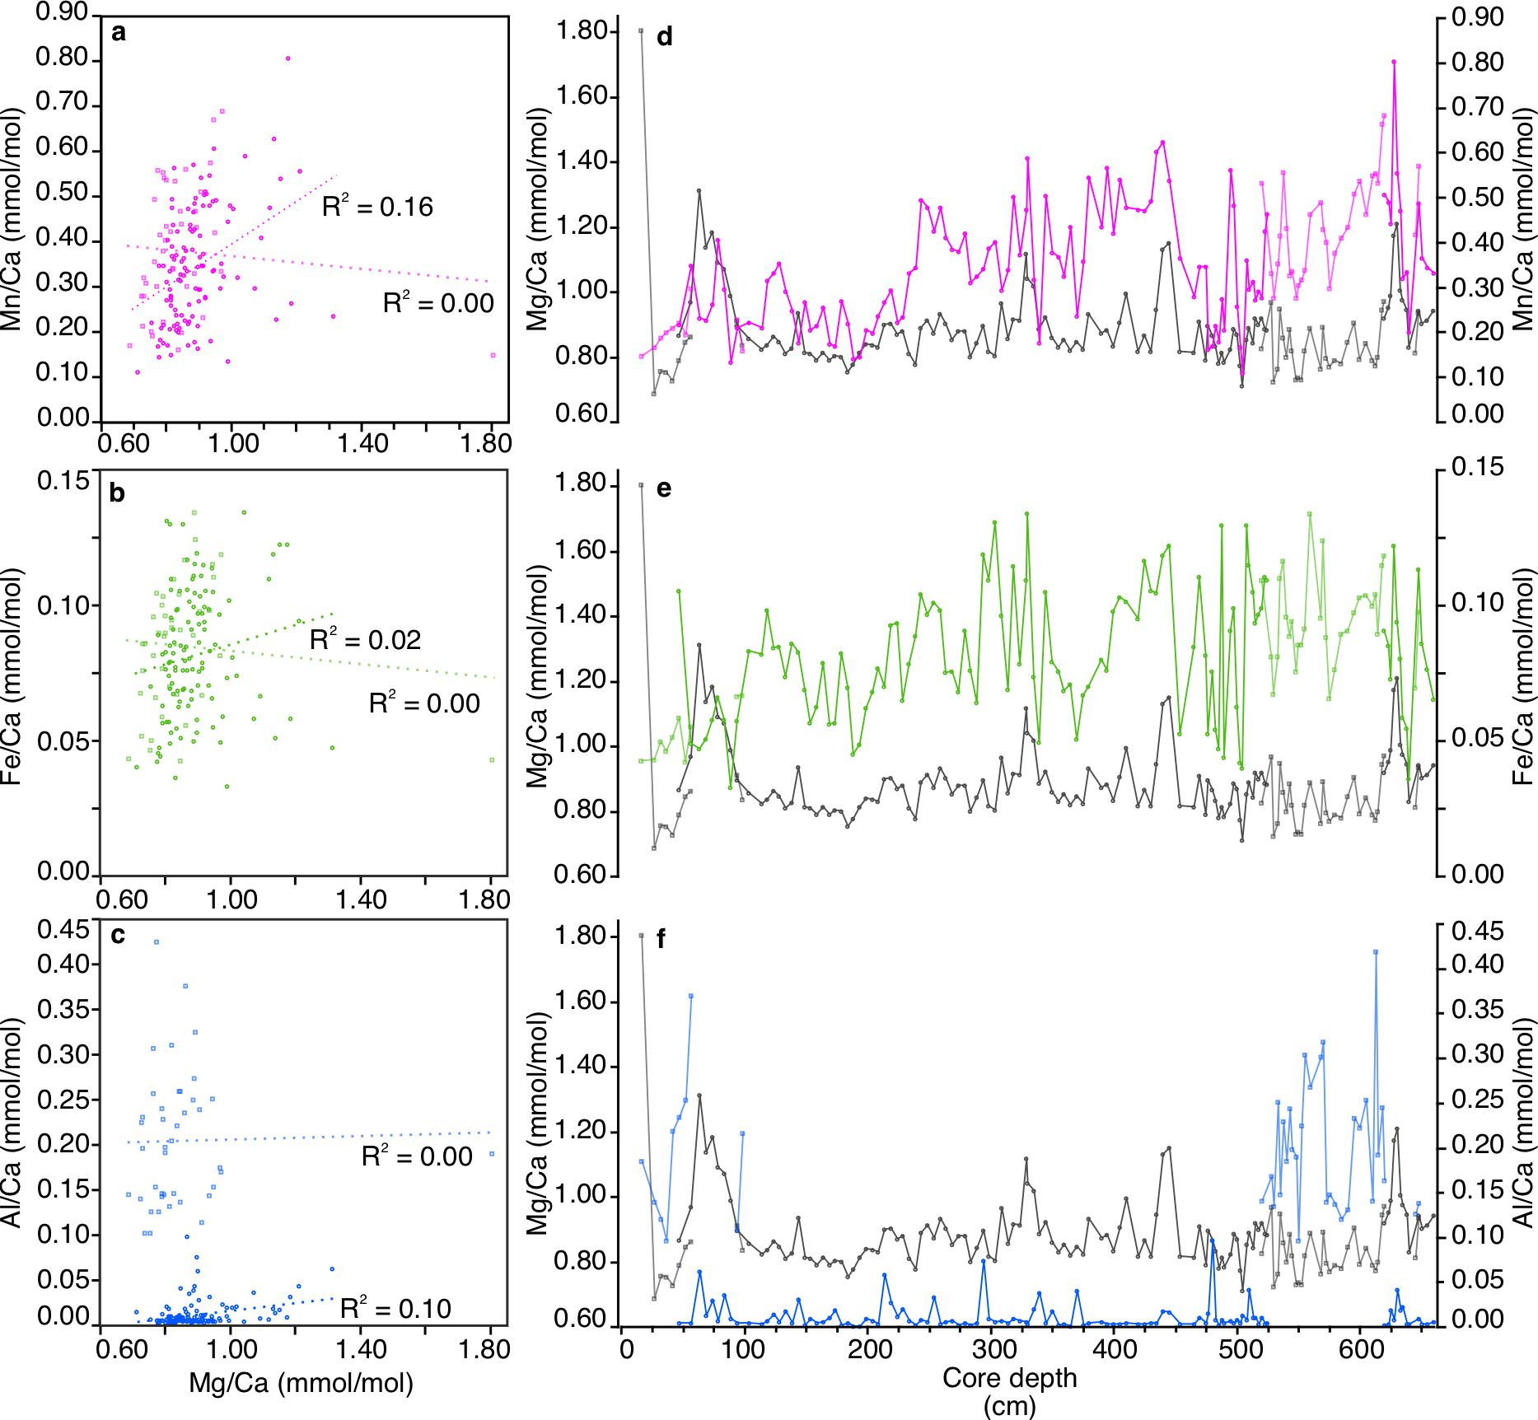
Figure S4. Mg/Ca contaminant check. (a−c) Scatter plots show no significant correlation between Mg/Ca and the contaminant indicators (Mn/Ca, Fe/Ca and Al/Ca). (d−f). Trace element ratios plotted against depth. Cassidulina neoteretis ( ) and Melonis barleeanus ( ). Mg/Ca (grey), Mn/Ca (magenta), Fe/Ca (green), Al/Ca (blue). An outlier check was performed in addition (see Methods).

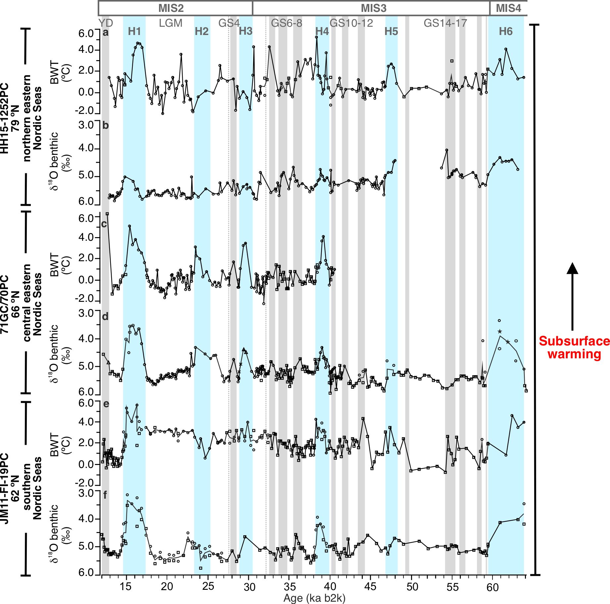
Figure S5. Greenland stadial and Heinrich stadial subsurface warming in the Nordic Seas. Correlation of sedimentary records from 79 °N – 62 °N recovered from intermediate water depth. Plotted versus age with the GICC05 timescale (ka b2k)^{58,59,60}. (a−f) BWT proxies (Mg-Ca-based BWT estimates and benthic foraminiferal δ¹⁸O): (a−b) HH15-1252PC (ref.⁸), 79 °N western Svalbard slope, eastern northern Nordic Seas, 1273 m water depth; (c−d) 71GC/70PC (this study), 66°N Vøring Plateau, central eastern Nordic Seas, 1223 m water depth; (e−f) JM11-FI-19PC (ref.⁷), 62 °N Faroe-Shetland margin, southern Nordic Seas, 1179 m water depth. Stable isotope and trace elemental measurements were taken from dominant benthic foraminiferal species Cassidulina neoteretis ( ) and Melonis barleeanus ( ). Stable isotopes were measured in Bulimina costata ( ); Cibicidoides floridanus ( ); Cibicidoides wuellerstorfi ( ) and Oridorsalis umbonatus ( ) for some intervals in 71GC/70PC. Blue bars mark the Heinrich stadials (HS) and grey bars mark the Greenland stadials (GS). Dashed lines mark the onset of Faroe-Shetland Interstadial 5b (FS-IS5b) and 3b (FS-IS3b)⁶¹. MIS, YD and LGM stand for Marine Isotope Stage, Younger Dryas and Last Glacial Maximum, respectively.

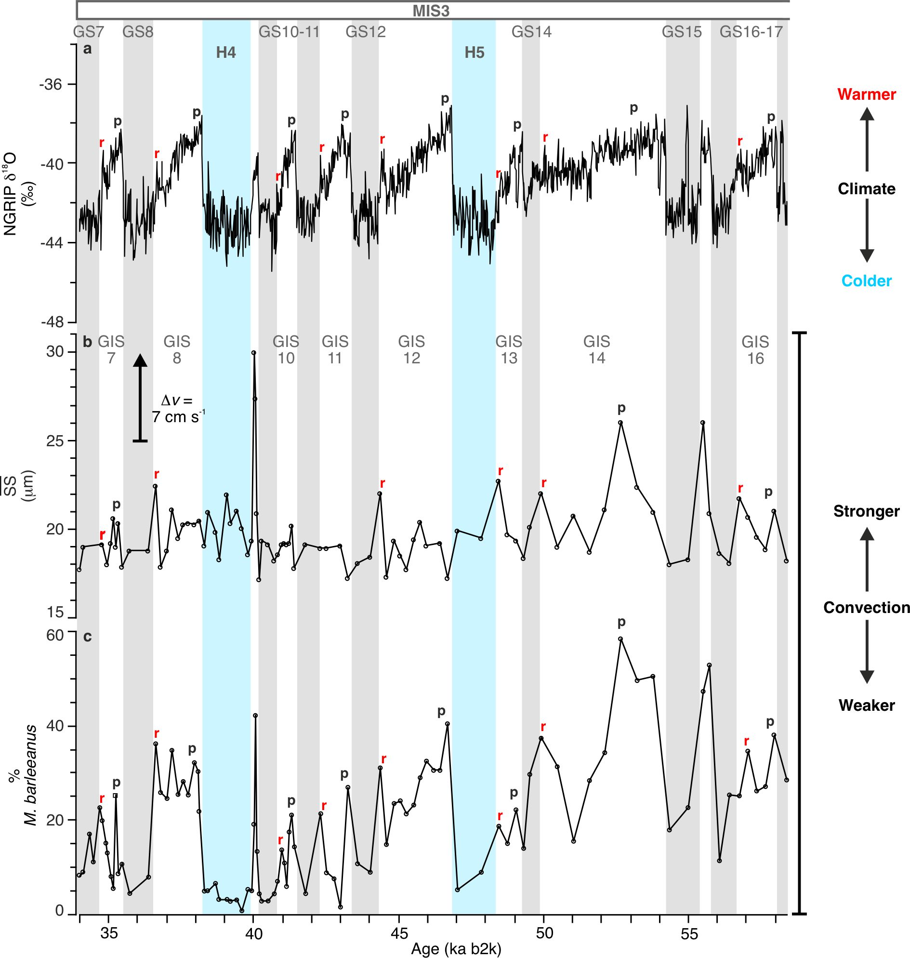
Figure S6. Convection revivals at the end of the Greenland interstadials in 71GC/70PC. (a) NGRIP ice-core with GICC05 timescale (ka b2k)^{58,59,60}. (b) $\overline{SS}$ palaeo-flow proxy. (c) % M. barleeanus (relative abundance). Peak Greenland interstadial (GIS) conditions (p). Atmospheric warmings and stronger convection signals at the end of the GIS (r). Blue bars mark the Heinrich stadials (HS) and grey bars mark the Greenland stadials (GS).

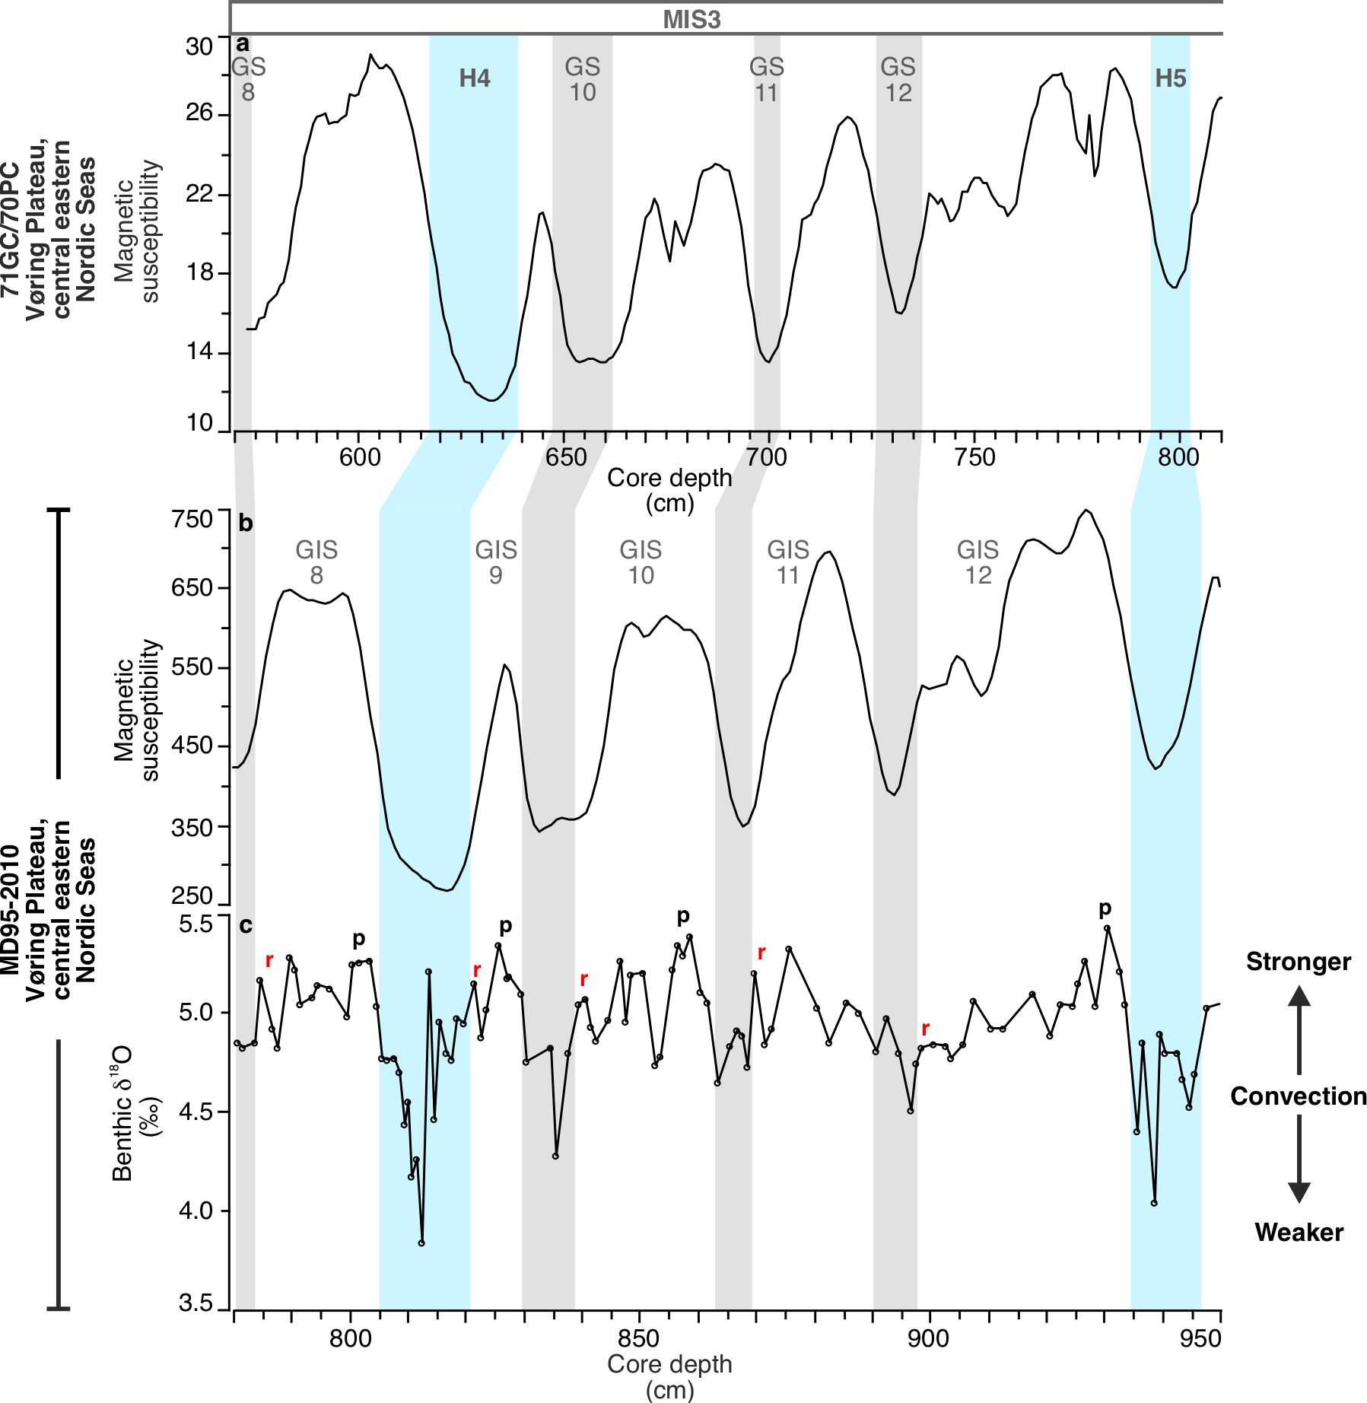
Figure S7. End of the Greenland interstadial convection revivals in a proximal core on the Vøring Plateau, central eastern Nordic Seas. 71GC/70PC (this study); 66° N, 04° E; 1222 m water depth: (a) Magnetic susceptibility stratigraphically correlated with sediment core MD95-2010 (ref. ²¹); 66° N, 04° E; 1226 m water depth: (b) Magnetic susceptibility. (c) Benthic foraminiferal δ¹⁸O (C. neoteretis). Peak Greenland interstadial (GIS) conditions (p). Stronger convection signals at the end of the GIS (r). Blue bars mark the Heinrich stadials (HS) and grey bars mark the Greenland stadials (GS).
Supplementary tables and supporting text
Table S1. Sediment core details used in this study.

Core name | Ship | Location | Latitude (N) Longitude (E) | Water depth (m)
HH13-071GC | RV Helmer Hanssen | Vøring Plateau, Norwegian margin, central eastern Nordic Seas | 66°40  04°33 | 1222
HH13-070PC | RV Helmer Hanssen | Vøring Plateau, Norwegian margin, central eastern Nordic Seas | 66°40  04°33 | 1223

Table S2. Ecological preference of key benthic and planktic foraminiferal species.
Species | Ecological preference
Benthic species
Cassidulina neoteretis | Cooled Atlantic-origin waters (preferably >0 °C) with a stratified water column under extensive sea ice cover. Can tolerate a poor food supply^{9,41,42}.
Melonis barleeanus | Stable conditions with higher organic food supply. Well-ventilated water mass and less sea ice. Known to migrate in the sediment column during times of starvation^{1,43,44,45}.
Atlantic species group:  Sigmoilopsis schlumbergeri, Eggerella bradyi/Tosaia hanzawaia, Bulimina costata,  Sagrina subspinescens, Epistominella decorata/nipponica, Anomalinoides minimus, Gavelinopsis praegeri, Nummoloculina  irregularis and other miliolid species (e.g. Discospirina italica, Spirophtalmidium acutimargo,  Sigmoilina tenuis, Pyrgoella sphaera), Cibicides aff. C. floridanus (synonym C. pachyderma), and various species of Gyroidina/  Gyroidinoides (G. umbonata and G. neosoldanii) | Diverse group of warm water (BWT >2 °C) species presently found at mid-latitudes in the boreal to subtropical Atlantic^{5,46,47}.
Elphidium excavatum (forma clavatum) | Opportunistic species related to sea-ice-edge and glacier proximal environments. Variable and unstable conditions with a tolerance for cold, low salinity and turbid waters^{16,48,49}.
Stainforthia loeblichi | Seasonal sea ice cover indicator species³.
Nonionella spp.  (includes N. iridea, N. stella and N. turgida) | High seasonal productivity indicator species^{50,51}.
Cassidulina reniforme | Indicator species of cold Arctic conditions in an ice-distal glaciomarine environment. Can be associated with a high food supply and stronger bottom currents^{2,52,53}.
Planktic species
Neogloboquadrina pachyderma | Polar water indicator species. Subsurface water masses <5 °C. Tolerates low salinities^{11,12}.
Subpolar species  (includes Globigerinita glutinata, Turborotalita quinqueloba and Neogloboquadrina incompta) | Subpolar conditions associated with warm, Atlantic surface water^{5,54,55,56,57}.

Table S3. Calculation of benthic foraminiferal δ¹⁸O_{calcite} components (example from 71GC/70PC).

Age (ka b2k)  /D-O event¹ | Mg/Ca-based BWT (°C) | δ¹⁸O_{calcite}  (PDB ‰) | Temperature component  (PDB ‰) | Global  δ¹⁸O_{seawater}  (SMOW ‰) | Global average seawater  δ¹⁸O_{ice volume}  (SMOW ‰) | Local  δ¹⁸O_{seawater}  (SMOW ‰) | Estimated  salinity  (‰)
19.8 (T1)² | -1.6 | 5.34 | 4.63  (4.43)⁴ | 0.916 | 1.055 | -0.139 | 34.28
16.8  (H1)³ | 2.6 | 4.17 | 3.57  (3.37)⁴ | 0.802 | 0.952 | -0.149 | 34.27
Difference (T1 – H1) | 4.2 | -1.17 | -1.06 | -0.113 | -0.103 | -0.01 | -0.01
¹Dansgaard-Oeschger event
² Termination 1 (GIS2 LGM - early deglaciation)
³ Heinrich 1 (GS2)
⁴Conversion to SMOW
Components of benthic foraminiferal δ¹⁸O_{calcite.}
Benthic foraminiferal δ¹⁸O_{calcite} is dependent on two components; 1. temperature through the thermodynamic fractionation of oxygen isotopes and 2. δ¹⁸O_{seawater} with a global signal related to ice volume changes and a local signal with processes related to salinity¹⁸. Speculation remains over what is the dominant driver of the low benthic δ¹⁸O signals recorded in the Nordic Seas during stadial periods. Enhanced brine formation (linked to high salinity) continues to be suggested to be responsible for the low δ¹⁸O signal sinking to depth within dense brines, as occurs around Antarctica today (e.g., refs.^{19,20,21,22,23,24,25,26,27}). Meltwater dispersal preconditions the surface water for the formation of brines in cold, saline waters that can reach sufficient density to penetrate the halocline to intermediate depths in the Nordic Seas and Arctic Ocean (e.g., refs.^{28,29}). Brines formed under these conditions would record higher benthic foraminiferal δ¹⁸O values³⁰. Brines in the Nordic Seas during stadials would form from cold, less saline meltwater on the surface that stratified the ocean as indicated by low planktic δ¹⁸O values^{5,6,21} and would not be dense enough to penetrate the halocline to intermediate depths (e.g., refs.^{29,30,31}).
Our results suggest that bottom water temperature changes have the largest impact on the benthic foraminiferal δ¹⁸O_{calcite} during stadials in the Nordic Seas in agreement with several studies from the region (e.g., refs.^{5,6,7,8,30,31,32,33}). To resolve this, we calculate the local sea water δ¹⁸O (salinity-related) based on samples of Cassidulina neoteretis δ¹⁸O and Mg/Ca-based bottom water temperature (BWT). Firstly, we rearranged the equation from Lubinski et al. (ref.⁹; equation 1) to calculate the seawater δ¹⁸O (equation 2). The equations are based on the palaeotemperature equation of Shackleton (ref.³⁴) that is based on the equation of O´Neil et al. (ref.³⁵). The conversion factor from the original calibrations of -0.20 ‰ is used from Standard Mean Ocean Water (SMOW) to Pee Dee Belemnite (PDB).
(1) δ¹⁸O_{calcite(PDB)} = δ¹⁸O_{seawater(SMOW)} − 0.20 + ((−16.9+BWT(°C))/ −4)
(2) δ¹⁸O_{seawater(SMOW)} = δ¹⁸O_{calcite(PDB)} + 0.20 − ((−16.9+BWT(°C))/ −4)
The calculated seawater δ¹⁸O was corrected for global ice volume δ¹⁸O changes to obtain the local seawater δ¹⁸O values. We used the global sea level curve of Spratt and Lisiecki (ref.³⁶) with a conversion factor of 0.009 ‰ per metre of sea level to deduct the ice volume δ¹⁸O. We have converted the local seawater δ¹⁸O to estimate salinity using the GEOSECS regional Greenland-Iceland-Norwegian Seas mixing line formula of LeGrande and Schmidt (ref.³⁷; equation 3).
- δ¹⁸O_{seawater} = 0.6 x salinity − 20.71
We show an example from the early Termination 1 (T1) during the LGM at 19.8 ka and H1 at 16.8 ka with a 4.2 °C BWT increase and corresponding δ¹⁸O_{calcite} decrease of 1.17 ‰ within 3 ka (Table S3). BWT increase is clearly the largest contributor to δ¹⁸O_{calcite} change (-1.06 ‰) with only minor contributions from global δ¹⁸O_{seawater} (-0.11 ‰). There are no significant changes in the calculated salinities (34.27 and 34.28 ‰) with a local δ¹⁸O_{seawater} difference of -0.01 ‰. A δ¹⁸O_{calcite} decrease of -1.06 ‰ is a change of -0.25 ‰ per 1.05 °C BWT increase in our example. This is in close agreement with the reference value of 0.25 ‰ change δ¹⁸O_{calcite} that corresponds to a temperature change of 1 °C^{34,38,39}. The minor difference could be due to vital effects and/or errors (±1 °C) from the BWT estimates. The possibility of brine formation during Dansgaard-Oeschger (D-O) events should not be excluded, however our results indicate that benthic δ¹⁸O variability are related to bottom water temperature changes rather than large-scale brine formation driving convection during the cold stadial phases of the Last Glacial Period in the Nordic Seas.
Table S4. Corresponding Greenland interstadial-stadial palaeo-flow and BWT variations.

D-O event | GIS/  GS no. | $$\overline{SS}$$  (μm) | Palaeo-flow depletion (cm s⁻¹)  (GIS-GS) | BWT (°C) | BWT increase (°C) (GIS-GS) | Benthic δ¹⁸O (‰) | δ¹⁸O depletion  (‰)  (GIS-GS)
D-O 1 | GS1 | 18.6 | 1 | 6.4 | 7.7 | 4.87 | 0.29
D-O 1 | GIS1 | 19.3 |  | -1.3 |  | 5.16
D-O 2 | GS2 (H1) | 17.8 | 7 | 2.6 | 3.5 | 4.17 | 0.92
D-O 2 | GIS2 LGM | 22.7 |  | -0.9 |  | 5.09
DO-3 | GS3 (H2) | Poorly  sorted | − | 3.2 | 3.6 | 4.29 | 1.21
DO-3 | GIS3/  FS-IS3b | Poorly  sorted |  | -0.4 |  | 5.50
D-O 4 | GS4 | Poorly  sorted | − | 1.8 | 2.5 | 4.72 | 0.81
D-O 4 | GIS4 | Poorly  sorted |  | -0.7 |  | 5.53
D-O 5 | GS5 (H3) | Poorly  sorted | − | 3.5 | 4.8 | 4.49 | 0.61
D-O 5 | GIS5/  FS-IS5b | Poorly  sorted |  | -1.3 |  | 5.10
D-O 6 | GS6 | 19.4 | 4 | 0.3 | 1.2 | 4.80 | 0.4
D-O 6 | GIS6 | 22.3 |  | -0.9 |  | 5.20
D-O 7 | GS7 | 17.7 | 4 | 0.5 | -0.3 | 5.07 | 0.03
D-O 7 | GIS7 | 20.6 |  | 0.8 |  | 5.10
D-O 8 | GS8 | 18.8 | 5 | 0.8 | 1.2 | 5.01 | 0.07
D-O 8 | GIS8 | 22.4 |  | -0.4 |  | 5.08
D-O 9 | GS9 (H4) | 18.3 | 4 | 1.7 | 1.7 | 4.50 | 1.09
D-O 9 | GIS9 | 20.9 |  | 0.0 |  | 5.59
D-O 10 | GS10 | 17.2 | 4 | No data >D-O10 | − | 5.16 | 0.28
D-O 10 | GIS10 | 20.2 |  | − |  | 5.44
D-O 11 | GS11 | 19.2 | 0 | − | − | 4.95 | 0.70
D-O 11 | GIS11 | 19.1 |  | − |  | 5.65
D-O 12 | GS12 | 18.4 | 3 | − | − | 5.14 | 0.50
D-O 12 | GIS12 | 20.4 |  | − |  | 5.64
D-O 13 | GS13 (H5) | 19.9 | 4 | − | − | 4.79 | 0.38
D-O 13 | GIS13 | 22.8 |  | − |  | 5.17
D-O 14 | GS14 | 18.4 | 10 | − | − | 5.18 | 0.29
D-O 14 | GIS14 | 26.0 |  | − |  | 5.47
D-O 15 | GS15 | 18.0 | 4 | − | − | 5.76 | -0.3
D-O 15 | GIS15 | 21.0 |  | − |  | 5.46
D-O 16 | GS16 | 18.1 | 5 | − | − | 5.31 | 0.05
D-O 16 | GIS16 | 21.8 |  | − |  | 5.36
D-O 17 | GS17 | 18.2 | 3 | − | − | 5.54 | -0.15
D-O 17 | GIS17 | 20.3 |  | − |  | 5.39
D-O 18 | GS18 (H6) | 19.3 | 1 | − | − | 4.08 | 1.77
D-O 18 | GIS18 | 20.1 |  | − |  | 5.85

Determination of corresponding Greenland interstadial−stadial palaeo-flow and BWT variations.
The values used for the three parameters ($\overline{SS}$, BWT(Mg/Ca-based), and benthic δ¹⁸O) are from the same sample depth (age) for each corresponding GIS/GS number (Table S4). BWT and palaeo-flow changes are described separately in the results and discussion sections as maximum GIS-GS variations of each parameter and are not necessarily the same age. $\overline{SS}$ decreases in Table S4 are calculated by subtracting the maximum GIS value from the minimum value of the subsequent GS of current-sorted sediments (R_{run}9 >0.5). Palaeo-flow bottom current speed depletions are estimated by calibrating the $\overline{SS}$ using the conversion of 1.33 cm s⁻¹/μm⁴⁰. BWT and benthic δ¹⁸O variations are calculated by subtracting maximum GIS values from minimum values of the subsequent GS. BWT and δ¹⁸O values from dominant species Cassidulina neoteretis ( ) and Melonis barleeanus ( ) were used in the calculations. δ¹⁸O values from Cibicidoides floridanus ( ) and Oridorsalis umbonatus ( ) were used in some intervals. Where possible, BWT and benthic δ¹⁸O values were selected from the same species from the same sample depth, and the same species in the same D-O event.
(See Supplementary Dataset 1 for Tables S5−S9).
Supplementary References
- Caralp, M. H. Abundance of Bulimina exilis and Melonis barleeanum: Relationship to the Quality of Marine Organic Matter. Geo-Marine Letters 9, 37-43 (1989). https://doi.org/10.1007/BF02262816
- Steinsund, P. I. Benthic foraminifera in surface sediments of the Barents and Kara seas: Modern and late Quaternary applications. Unpublished PhD thesis, UiT the Arctic University Norway, Tromsø, 1-111 (1994).
- Seidenkrantz, M.-S. Benthic foraminifera as palaeo sea-ice indicators in the subarctic realm – examples from the Labrador Sea–Baffin Bay region. Quaternary Science Reviews 79, 135-144 (2013). https://doi.org/10.1016/j.quascirev.2013.03.014
- Rasmussen, T. L. & Thomsen, E. Pink marine sediments reveal rapid ice melt and Arctic meltwater discharge during Dansgaard-Oeschger warmings. Nature Communications 4, 2849 (2013). https://doi.org/10.1038/ncomms3849
- Rasmussen, T. L., Thomsen, E., Labeyrie, L. & van Weering, T. C. E. Circulation changes in the Faeroe-Shetland Channel correlating with cold events. Geology 24, 937-940 (1996). https://doi.org/10.1130/0091-7613(1996)024<0937:CCITFS>2.3.CO;2
- Rasmussen, T. L. & Thomsen, E. The role of the North Atlantic Drift in the millennial timescale glacial climate fluctuations. Palaeogeography, Palaeoclimatology, Palaeoecology 210, 101-116 (2004). https://doi.org/10.1016/j.palaeo.2004.04.005
- Ezat, M. M., Rasmussen, T. L. & Groeneveld, J. Persistent intermediate water warming during cold stadials in the southeastern Nordic seas during the past 65 k.y. Geology 42, 663-666 (2014). https://doi.org/10.1130/g35579.1
- El bani Altuna, N., Ezat, M. M., Greaves, M. & Rasmussen, T. L. Millennial‐ccale changes in bottom water temperature and water mass exchange through the Fram Strait 79°N, 63‐13 ka. Paleoceanography and Paleoclimatology 36, 1-21 (2021). https://doi.org/10.1029/2020pa004061
- Lubinski, D. J., Polyak, L. & Forman, S. L. Freshwater and Atlantic water inflows to the deep northern Barents and Kara seas since ca 13 14C ka: foraminifera and stable isotopes. Quaternary Science Reviews 20, 1851-1879 (2001). https://doi.org/10.1016/S0277-3791(01)00016-6
- Hald, M. & Korsun, S. Distribution of modern benthic foraminifera from fjords of Svalbard, European Arctic. Journal of Foraminiferal Research 27, 101-122 (1997). https://doi.org/10.2113/gsjfr.27.2.101
- Bé, A. W. & Tolderlund, D. S. Seasonal distribution of planktonic foraminifera in the western North Atlantic. Micropaleontology 17, 297-329 (1971). https://doi.org/10.2307/1485143
- Hebbeln, D., Dokken, T., Andersen, E. et al. Moisture supply for northern ice-sheet growth during the Last Glacial Maximum. Nature 370, 357-360 (1994). https://doi.org/10.1038/370357a0
- Helmke, J. P. & Bauch, H. A. Glacial-interglacial carbonate preservation records in the Nordic Seas. Global and Planetary Change 33, 15-28 (2002). https://doi.org/10.1016/S0921-8181(02)00058-9

- Zamelczyk, K., Rasmussen, T. L., Husum, K. & Hald, M. Marine calcium carbonate preservation vs. climate change over the last two millennia in the Fram Strait: Implications for planktic foraminiferal paleostudies. Marine Micropaleontology 98, 14-27 (2013). https://doi.org/10.1016/j.marmicro.2012.10.001
- McCave, I. N. & Andrews, J. T. Distinguishing current effects in sediments delivered to the ocean by ice. I. Principles, methods and examples. Quaternary Science Reviews 212, 92-107 (2019). https://doi.org/10.1016/j.quascirev.2019.03.031
- Lekens, W. A. H. et al. Laminated sediments preceding Heinrich event 1 in the Northern North Sea and Southern Norwegian Sea: Origin, processes and regional linkage. Marine Geology 216, 27-50 (2005). https://doi.org/10.1016/j.margeo.2004.12.007
- Miller, M. C., McCave, I. N. & Komar, P. D. Threshold of sediment motion under unidirectional currents. Sedimentology 24, 507-527 (1977). https://doi.org/10.1111/j.1365-3091.1977.tb00136.x
- Adkins, J. F., McIntyre, K. & Schrag, D. The salinity, temperature, and δ¹⁸O of the glacial deep ocean. Science 298, 1769-1773 (2002). https://doi.org/10.1126/science.1076252
- Cortijo, E. et al. Changes in sea surface hydrology associated with Heinrich event 4 in the North Atlantic Ocean between 40’ and 60°N. Earth and Planetary Science Letters 146, 29-45 (1997). https://doi.org/10.1016/S0012-821X(96)00217-8

- Vidal, L., Labeyrie, L. & van Weering, T. C. E. Benthic δ¹⁸O records in the North Atlantic over the Last Glacial period (60–10 kyr): Evidence for brine formation. Paleoceanography 13, 245-251 (2010). https://doi.org/10.1029/98pa00315
- Dokken, T. M. & Jansen, E. Rapid changes in the mechanism of ocean convection during the last glacial period. Nature 401, 458-461 (1999). https://doi.org/10.1038/46753
- Labeyrie, L., Waelbroeck, C., Cortijo, E., Michel, E. & Duplessy, J.-C. Changes in deep water hydrology during the Last Deglaciation. Comptes Rendus. Géoscience 337, 919-927 (2005). https://doi.org/10.1016/j.crte.2005.05.010
- Meland, M. Y., Dokken, T. M., Jansen, E. & Hevrøy, K. Water mass properties and exchange between the Nordic seas and the northern North Atlantic during the period 23–6 ka: Benthic oxygen isotopic evidence. Paleoceanography 23, 1-19 (2008). https://doi.org/10.1029/2007pa001416
- Thornalley, D. J. R., Elderfield, H. & McCave, I. N. Intermediate and deep water paleoceanography of the northern North Atlantic over the past 21,000 years. Paleoceanography 25, 1-17 (2010). https://doi.org/10.1029/2009pa001833
- Dokken, T. M., Nisancioglu, K. H., Li, C., Battisti, D. S. & Kissel, C. Dansgaard‐Oeschger cycles: Interactions between ocean and sea ice intrinsic to the Nordic seas. Paleoceanography 28, 491-502 (2013). https://doi.org/10.1002/palo.20042
- Keigwin, L. D. & Swift, S. A. Carbon isotope evidence for a northern source of deep water in the glacial western North Atlantic. Proceedings of the National Academy of Sciences USA 114, 2831-2835 (2017). https://doi.org/10.1073/pnas.1614693114

- Sessford, E. G. et al. Consistent fluctuations in intermediate water temperature off the coast of Greenland and Norway during Dansgaard-Oeschger events. Quaternary Science Reviews 223, 1-16 (2019). https://doi.org/10.1016/j.quascirev.2019.105887
- Shapiro, G. I., Huthnance, J. M. & Ivanov, V. V. Dense water cascading off the continental shelf. Journal of Geophysical Research: Oceans 108, 1-19 (2003). https://doi.org/10.1029/2002jc001610
- Ivanov, V. V., Shapiro, G. I., Huthnance, J. M., Aleynik, D. L. & Golovin, P. N. Cascades of dense water around the world ocean. Progress in Oceanography 60, 47-98 (2004). https://doi.org/10.1016/j.pocean.2003.12.002
- Rasmussen, T. L. & Thomsen, E. Ventilation changes in intermediate water on millennial time scales in the SE Nordic seas, 65‐14 kyr BP. Geophysical Research Letters 36, 1-5 (2009). https://doi.org/10.1029/2008gl036563
- Bauch, D. & Bauch, H. A. Last glacial benthic foraminiferal δ¹⁸O anomalies in the polar North Atlantic: A modern analogue evaluation. Journal of Geophysical Research: Oceans 106, 9135-9143 (2001). https://doi.org/10.1029/1999jc000164
- Marcott, S. A. et al. Ice-shelf collapse from subsurface warming as a trigger for Heinrich events. Proceedings of the National Academy of Sciences USA 108, 13415-13419 (2011). https://doi.org/10.1073/pnas.1104772108
- Mackensen, A. High epibenthic foraminiferal δ¹³C in the Recent deep Arctic Ocean: Implications for ventilation and brine release during stadials. Paleoceanography 28, 574-584 (2013). https://doi.org/10.1002/palo.20058
- Shackleton, N. J. Attainment of isotopic equilibrium between ocean water and the benthonic foraminifera genus Uvigerina: Isotopic changes in the ocean during the last glacial. Colloque international du CNRS 219, 203-210 (1974).

- O’Neil, J.R., Clayton, R.N. & Mayeda,T.K. Oxygen isotope fractionation in divalent metal carbonates. Journal of Chemical Physics 51, 5547 58 (1969). https://doi.org/10.1063/1.1671982
- Spratt, R. M. & Lisiecki, L. E. A Late Pleistocene sea level stack. Climate of the Past 12, 1079-1092 (2016). https://doi.org/10.5194/cp-12-1079-2016
- LeGrande, A. N. & Schmidt, G. A. Global gridded data set of the oxygen isotopic composition in seawater. Geophysical Research Letters 33, 1−5 (2006). https://doi.org/10.1029/2006gl026011
- McCrea, J. M. On the Isotopic Chemistry of Carbonates and a Paleotemperature Scale. The Journal of Chemical Physics 18, 849-857 (1950). https://doi.org/10.1063/1.1747785
- Epstein, S., Buchsbaum, R., Lowenstam, H. A. & Urey, H. C. Revised carbonate-water isotopic temperature scale. Geological Society of America Bulletin 64, 1315-1326. https://doi.org/10.1130/0016-7606(1953)64[1315:RCITS]2.0.CO;2
- McCave, I. N. & Andrews, J. T. Distinguishing current effects in sediments delivered to the ocean by ice. II. Glacial to Holocene changes in high latitude North Atlantic upper ocean flows. Quaternary Science Reviews 223, 1-21 (2019b). https://doi.org/10.1016/j.quascirev.2019.105902
- Kristjánsdóttir, G. B., Lea, D. W., Jennings, A. E., Pak, D. K. & Belanger, C. New spatial Mg/Ca‐temperature calibrations for three Arctic, benthic foraminifera and reconstruction of north Iceland shelf temperature for the past 4000 years. Geochemistry, Geophysics, Geosystems 8, 1-27 (2007). https://doi.org/10.1029/2006gc001425
- Cage, A. G., Pieńkowski, A. J., Jennings, A., Knudsen, K. L. & Seidenkrantz, M.-S. Comparative analysis of six common foraminiferal species of the genera Cassidulina, Paracassidulina and Islandiella from the Arctic–North Atlantic domain. Journal of Micropalaeontology 40, 37-60 (2021). https://doi.org/10.5194/jm-40-37-2021
- Corliss, B. H. Microhabitats of benthic foraminifera within deep-sea sediments. Nature 314, 435-438 (1985). https://doi.org/10.1038/314435a0
- Mackensen, A., Sejrup, H. P. & Jansen, E. The distribution of living benthic foraminifera on the continental slope and rise off south west Norway. Marine Micropaleontology 9, 275-306 (1985). https://doi.org/10.1016/0377-8398(85)90001-5
- Mackensen, A. Bentische Foraminiferen auf dem Island-Schottland Rücken: Umwelt-Anzeiger an der Grenze zweier Ozeansicher Raume. Paläontolgische Zeitschrift 61, 149–179 (1987). https://dx.doi.org/10.1007/BF02985902
- Wollenburg, J. E. & Mackensen, A. Living benthic foraminifers from the central Arctic Ocean: faunal composition, standing stock and diversity. Marine Micropaleontology 34, 153-185 (1998). https://doi.org/10.1016/S0377-8398(98)00007-3
- Wollenburg, J. E., Knies, J. & Mackensen, A. High-resolution paleoproductivity fluctuations during the past 24 kyr as indicated by benthic foraminifera in the marginal Arctic Ocean. Palaeogeography, Palaeoclimatology, Palaeoecology 204, 209-238 (2004). https://doi.org/10.1016/s0031-0182(03)00726-0
- Vilks, G. Late glacial-postglacial foraminiferal boundary in sediments of eastern Canada Denmark and Norway. Geoscience Canada 8, 48-55 (1985).

- Hald M. & Steinsund, P.I. Late Cenozoic Benthic Foraminifera: Taxonomy, Ecology and Stratigraphy Ch. Recent and Late Quaternary Distribution of Elphidium excavatum F. clavatum in Arctic Seas (Cushman Foundation for Foraminiferal Research, 1994).
- Gooday, A. J. & Hughes, A. Foraminifera associated with phytodetritus deposits at a bathayal site in the northern Rockall Trough (NE Atlantic): seasonal contrasts and a comparison of stained and dead assemblages. Marine Micropaleontology 46, 83-110 (2002). https://doi.org/https://doi.org/10.1016/S0377-8398(02)00050-6
- Sejrup, H. P., Birks, H. J. B., Klitgaard Kristensen, D. & Madsen, H. Benthonic foraminiferal distributions and quantitative transfer functions for the northwest European continental margin. Marine Micropaleontology 53, 197–226 (2004). https://doi.org/10.1016/j.marmicro.2004.05.009
- Sejrup, H. P., & Guilbault, J. P. Cassidulina reniforme and C. obtusa (Foraminifera), taxonomy, distribution, and ecology. Sarsia, 65, 79-85 (1980). https://doi.org/10.1080/00364827.1980.10431476
- Sejrup, H. P. et al. Benthonic foraminifera in surface samples from the Norwegian continental margin between 62 degrees N and 65 degrees N. The Journal of Foraminiferal Research 11, 277–295 (1981). https://doi.org/10.2113/gsjfr.11.4.277
- Kellogg, T. B. Investigations of Late Quaternary Paleoceanography and Paleoclimatology Ch. Late Quaternary Climatic Changes: Evidence from Deep-Sea Cores of Norwegian and Greenland Seas (Geological Society of America, Boulder, 1976). https://doi.org/10.1130/MEM145-p77
- Johannessen, T., Jansen, E., Flatøy, A. & Ravelo, A. Carbon Cycling in the Glacial Ocean: Constraints of the Ocean's Role in Global Change Ch. The Relationship Between Surface Water Masses, Oceanographic Fronts and Paleoclimatic Proxies in Surface Sediments of the Greenland, Iceland, Norwegian Seas (Springer, Berlin, 1994). http://dx.doi.org/10.1007/978-3-642-78737-9_4
- Bauch, H. A., Carstens, J. & Wefer, G. Oxygen isotope composition of living Neogloboquadrina pachyderma (sin.) in the Arctic Ocean. Earth and Planetary Science Letters 146, 47-58 (1997). https://doi.org/10.1016/S0012-821X(96)00211-7
- Schiebel, R. et al. Modern planktic foraminifers in the high-latitude ocean. Marine Micropaleontology 136, 1-13 (2017). https://doi.org/10.1016/j.marmicro.2017.08.004
- Andersen, K. K. et al. The Greenland Ice Core Chronology 2005, 15–42ka. Part 1: constructing the time scale. Quaternary Science Reviews 25, 3246-3257 (2006). https://doi.org/10.1016/j.quascirev.2006.08.002
- Svensson, A. et al. A 60,000 year Greenland stratigraphic ice core chronology. Climate of the Past 4, 47-57 (2008). https://doi.org/10.5194/cp-4-47-2008
- Rasmussen, S. O. et al. A stratigraphic framework for abrupt climatic changes during the Last Glacial period based on three synchronized Greenland ice-core records: refining and extending the INTIMATE event stratigraphy. Quaternary Science Reviews 106, 14-28 (2014). https://doi.org/10.1016/j.quascirev.2014.09.007
- Rasmussen, T. L. & Thomsen, E. Warm Atlantic surface water inflow to the Nordic seas 34–10 calibrated ka B.P. Paleoceanography 23, 1-13 (2008). https://doi.org/10.1029/2007pa001453

