Supplementary Information
Loss of ATRX sensitizes HeLa cells in response to ionizing irradiation in a manner dependent on the ATM/Chk2 pathway
Geng Tang, Yanming Yang, Yuxin Liu, Bing Han, Weiqiang Xu, Lijing Qin, Fang Fang, and ZhiCheng Wang
Supplementary Figure Legends
Figure S1 WB demonstrate that the ATRX protein level are downregulated in stable ATRX-depleted cell lines.
Figure S2 PARP1, Cleaved caspase-9 and -3 were detected by WB, GAPDH proteins were used for loading control. M: rotein marker, Lane 1: shCon-HeLa cell and Lane 2: shATRX2-HeLa cell.
Figure S3 Protein expression were detected by WB. (A) The expression of γH2AX protein were measured by WB, GAPDH proteins were used for loading control. (B) ATRX and Rad51 proteins were assessed by WB, GAPDH proteins were used for loading control. Lane 1: shCon-HeLa cell and Lane 2: shATRX2-HeLa cell.
Figure S4 WB analysis of ATM and its downstream proteins is shown. M: rotein marker, Lane 1: shCon-HeLa cell and Lane 2: shATRX2-HeLa cell.
Con shCon shATRX1 shATRX2 shATRX3

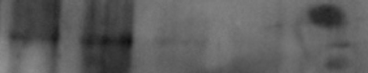
280kDaa
ATRX
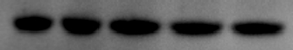
36kDa
GAPDH
Figure S1
8 Gy
2

48 h
24
48
24
M
1 2 1 2 1 2 1 2 1 2

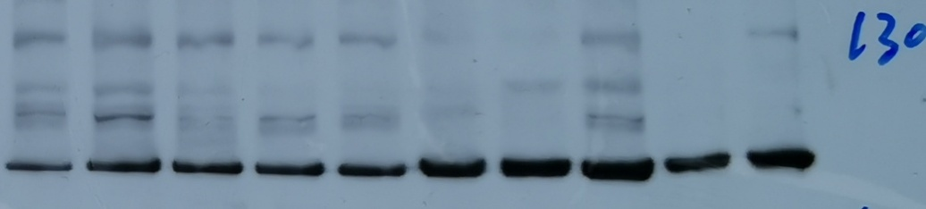
116kDa
PARP1
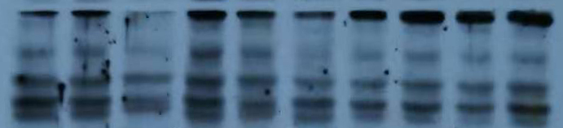
M
45kDa
37kDa
35kDa
Cleaved caspase-9

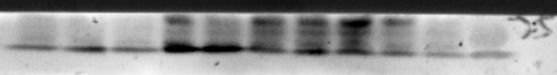
Cleaved caspase-3
19kDa
17kDa
35kDa
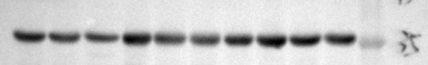
GAPDH
36kDa
Figure S2
shATRX2
shCon
B
A
8 Gy
2
8
2
0 1 6 24 1 6 24 0 1 6 24 1 6 24 h

15kDa
γH2AX
36kDa
GAPDH
8 Gy
2

48 h
24
48
24
1 2 1 2 1 2 1 2 1 2

280kDa
ATRX

XRCC1
37kDa
Rad51
36kDa
GAPDH
Figure S3
8 Gy
2

24
48 h
48
24
1 2 1 2 1 2 1 2 1 2
p-ATM
350 kDa
M
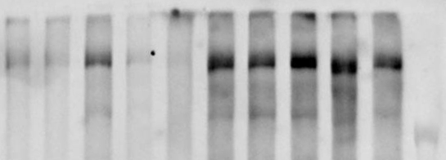
350 kDa
240 kDa
ATM
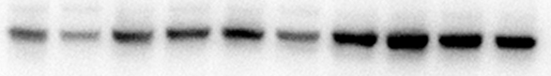
p-Chk2
62 kDa
62 kDa
Chk2
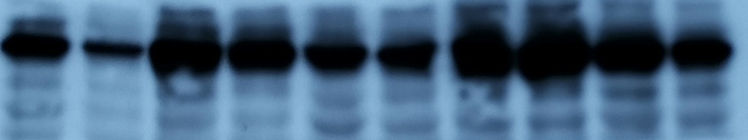
CyclinB1
55 kDa
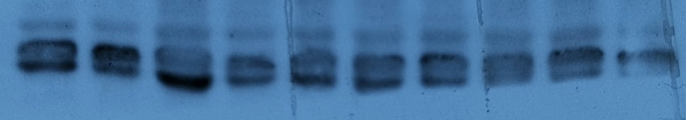
cdc2
34 kDa
70 kDa
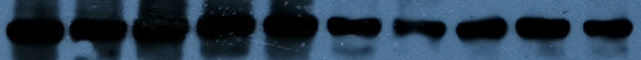
CDC25A
GAPDH
36kDa
Figure S4

