Supplementary Information for Arman BY, et al. Simple and rapid low-cost assays to investigate ethylene glycol and diethylene glycol contamination in raw materials and medicinal syrups (2025).

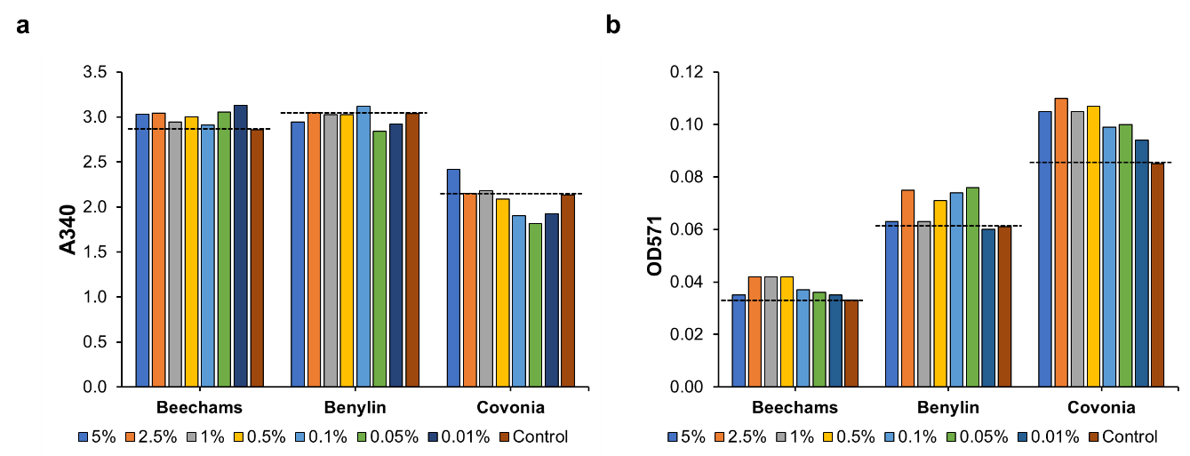
Supplementary Fig. 1. Enzymatic assay results of three ethanol-containing medicinal syrups (Beechams, Benylin Chesty, and Covonia), spiked with different percentages of EG. a End-point 340 nm absorbance readings of NADH after using alcohol dehydrogenase and aldehyde dehydrogenase. b End-point 571 nm absorbance readings after additionally using glycolate oxidase in the glycolic acid assay. The neat syrups without EG spiking (0% EG) were used as controls. Error bars show the standard deviations of two replicates.

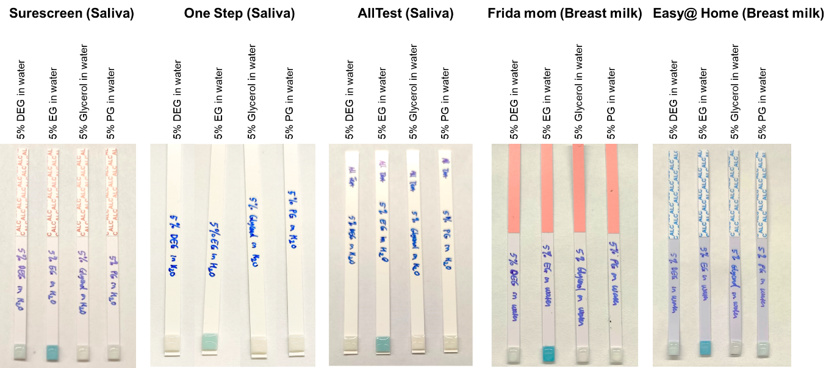
Supplementary Fig. 2. Successful differentiation of EG from glycerol, PG and DEG using five different brands of alcohol saliva and breast milk test strips. The best sensitivity for EG was observed using the Surescreen and Frida mom alcohol test strips although all brands could determine EG from the other alcohols with 100% accuracy. A sixth brand (Wondfo One Step Alcohol Saliva Test, Guangzhou, China) was also tested which showed similar results (data not shown).

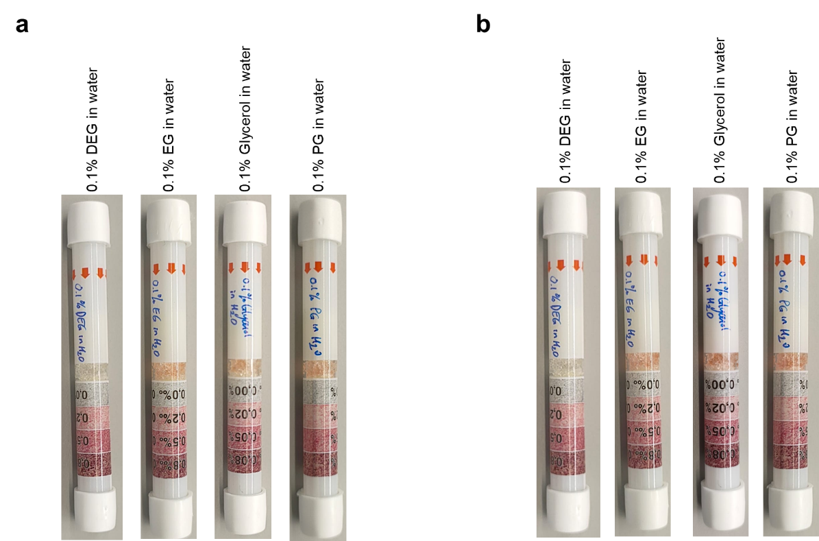
Supplementary Fig. 3. Disposable breathalysers after testing 0.1% v/v alcohols diluted in water. a Photos taken after 10 seconds and b after two minutes.

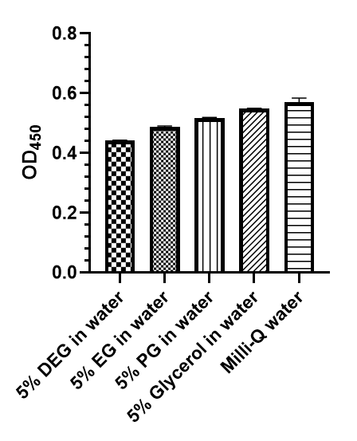
Supplementary Fig. 4. PEG ELISA results of the alcohol solutions show very weak preferential binding to DEG. Lower absorbances show greater binding due to this being a competitive ELISA. Error bars show the standard deviations of two replicates.

