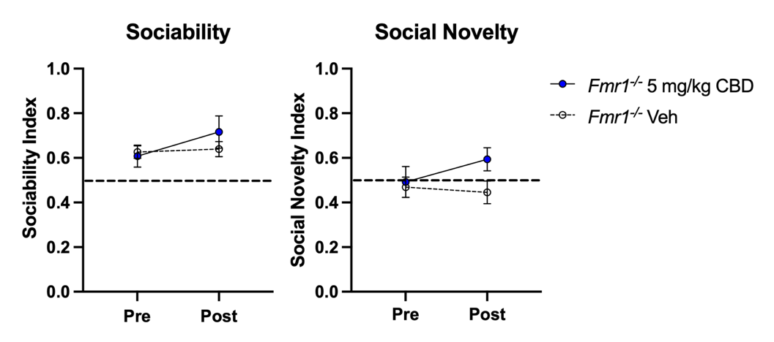
Supplementary Figure 1. No significant recovery of social novelty deficit in females at 5 mg/kg CBD dose. (Left) Average social novelty index score among female Fmr1 KO mice at baseline and one hour after injection with vehicle or CBD (s.c., 5 mg/kg) injection. The vehicle data are the same as those presented in figure 2. Data represent means ± SEM. Dashed lines at 0.5 represent the chance level social novelty index.

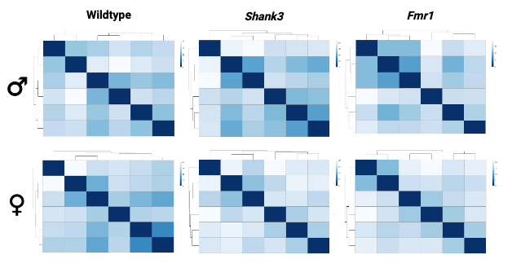
Supplementary Figure 2. Replicate correlation matrix in vehicle and CBD-treated wildtype, Shank3, and Fmr1 KO mice. The matrix represents hierarchical clustering of sequencing similarity (TPM values) between replicates. The darker the hue, the greater the sequencing similarity.

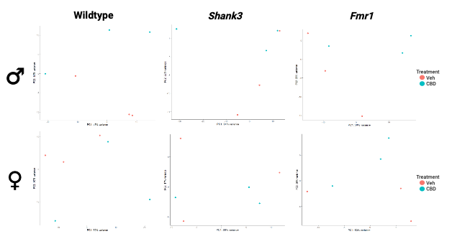
Supplementary Figure 3. Principal component analysis of replicate variation in vehicle and CBD-treated wildtype, Shank3, and Fmr1 KO mice.

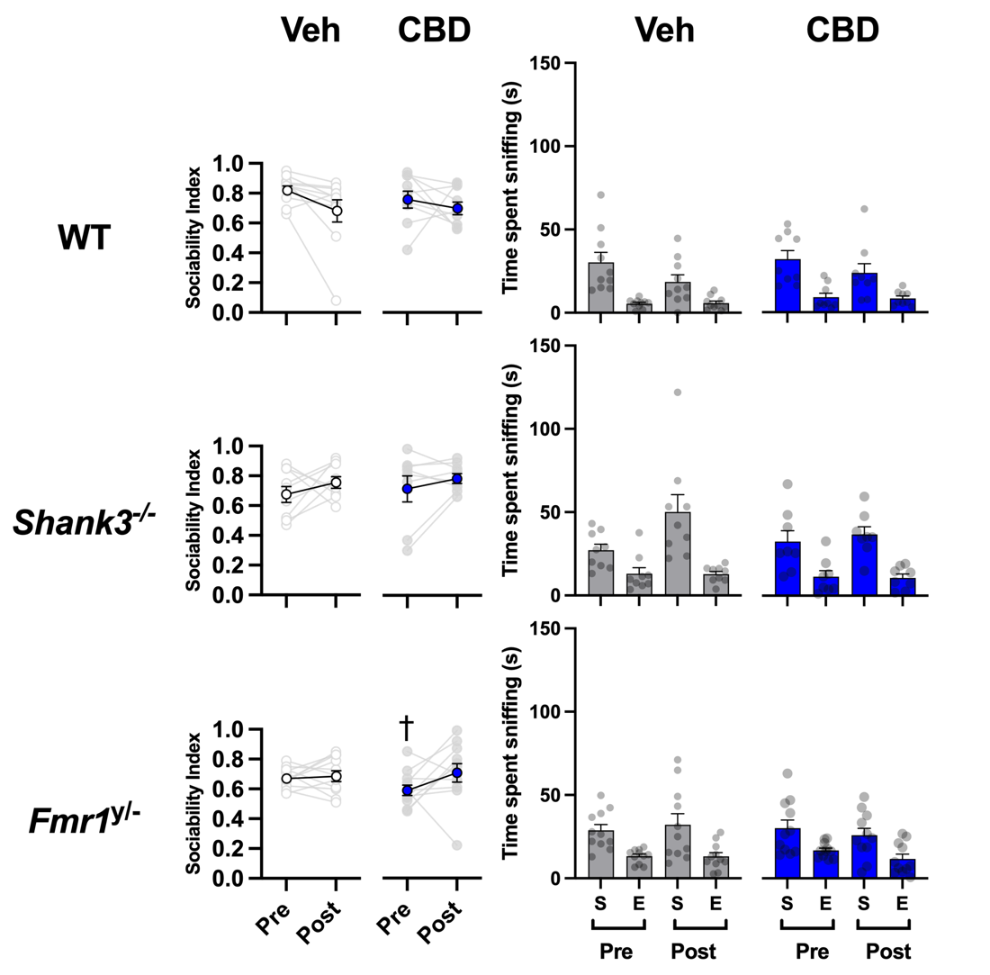
Supplementary Figure 4. No sociability deficits in male mice. (Left) Average sociability index score among male wildtype (CBD: 9, VEH: 10), Shank3 KO (CBD: 8, VEH: 8), and Fmr1 KO (CBD: 11, VEH: 11) mice in the three-chamber social test one hour after injection with vehicle or CBD (s.c., 5 mg/kg) injection. (Right) Average time spent sniffing the stranger (S) or empty (E) cup during the sociability phase of the three-chamber social test, one hour after injection with vehicle or CBD (s.c., 5 mg/kg) injection. Both the index and time spent sniffing indicated that wildtype, Fmr1 KO, and Shank3 KO mice displayed a preference for the cup containing a mouse over the empty cup, indicating comparable sociability. CBD treatment did not lead to a change in the sociability of these mice. Data represent mean ± SEM. †, p < 0.05 vs. pre-treatment wild-type mice. Statistical analysis by 3-way ANOVA with Tukey’s post hoc test.

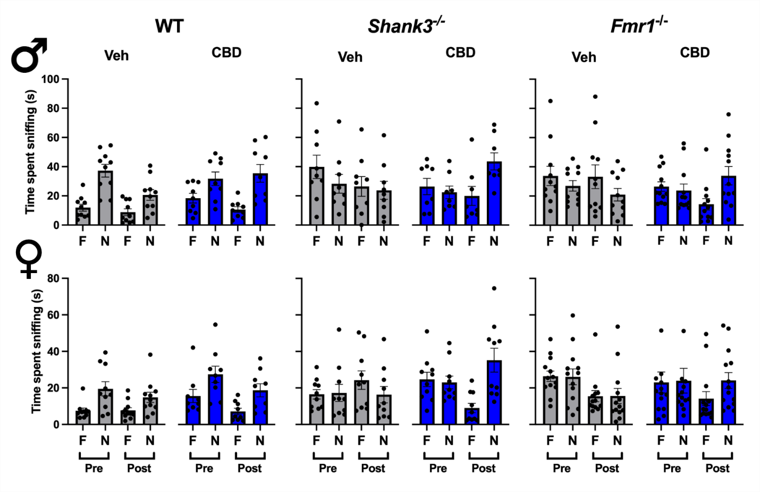
Supplementary Figure 5. CBD increases time spent sniffing novel social stimulus in both male and female Fmr1 and Shank3 KO mice. Time spent interacting with familiar (F) or novel (N) both pre- and post-treatment in wildtype, Fmr1 KO or Shank3 KO males and females treated with either vehicle or CBD (s.c., 5mg/kg in males or 50mg/kg in females). Treatment with CBD lead to a preference for the novel mouse compared to the familiar mouse in both Fmr1 and Shank3 KO mice. Bar graphs represent mean ± SEM.

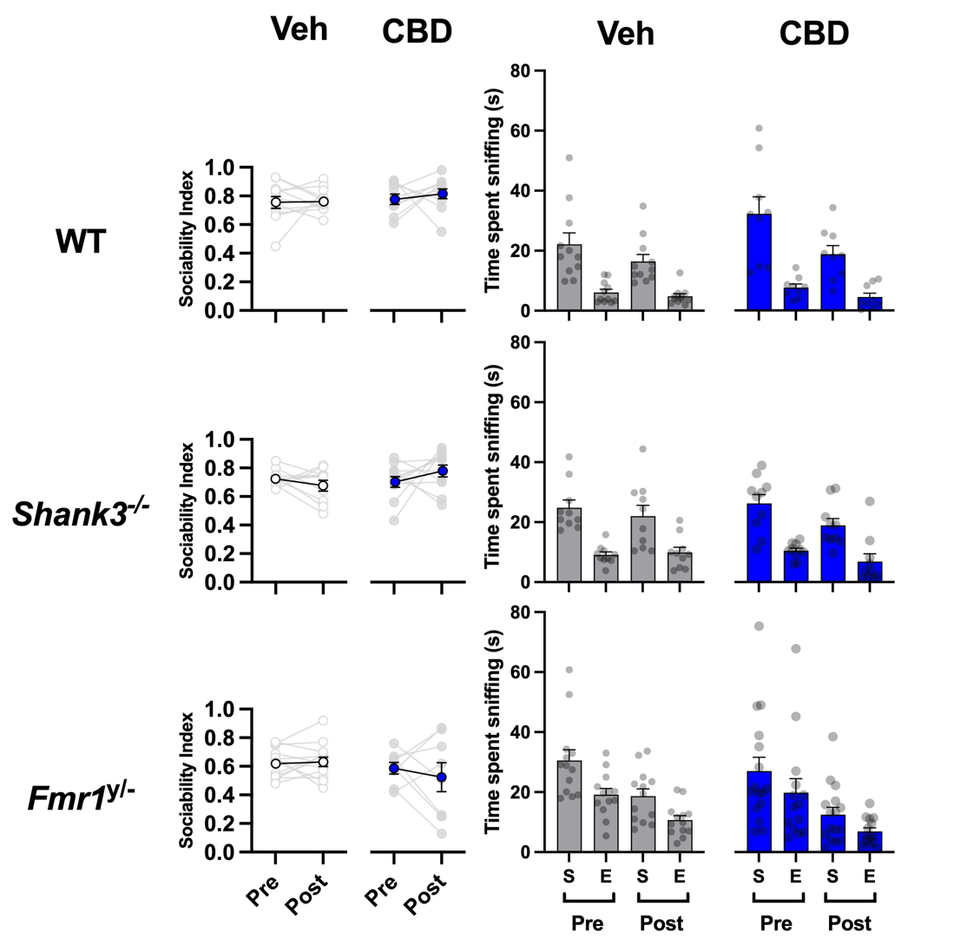

Supplementary Figure 6. Sociability deficit also absent in female Shank3 and Fmr1 KO mice. (Left) Average sociability index score among female wildtype (CBD: 9, VEH: 11), Fmr1 KO (CBD: 8, VEH: 13), Shank3 KO (CBD: 11, VEH: 10) mice in the three-chamber social test one hour after injection with vehicle or CBD (s.c., 50mg/kg). (Right) Average time spent sniffing the stranger (S) or empty (E) cup during the sociability phase of the three-chamber social test one hour after treatments. Both the index and time spent sniffing indicated wildtype, Fmr1 KO, and Shank3 KO mice displayed a preference for the cup containing a mouse over the empty cup, indicating a lack of sociability deficit. CBD treatment did not change this preference. Data represent mean ± SEM. Statistical analysis by 3-way ANOVA with Tukey’s post hoc test.

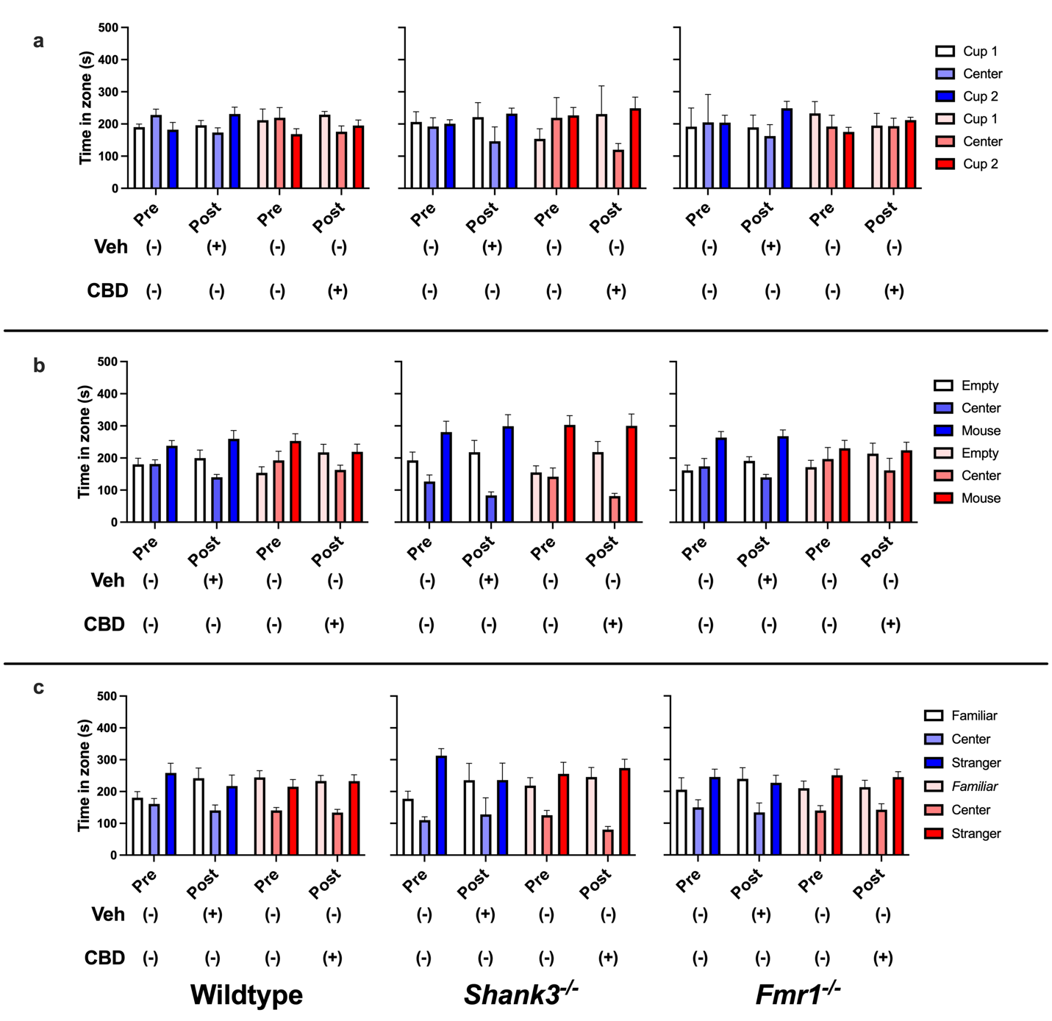
Supplementary Figure 7. Time in zone data trends for each phase of 3-chamber task in males. Average time spent in each chamber by male mice during the acclimation phase (a), sociability phase (b), and social novelty phase (c) of the 3-chamber social task in wildtype, Shank3 and Fmr1 KO mice (also represented in Fig.2, and supplementary Figs. 4-5). Data represent mean ± SEM.

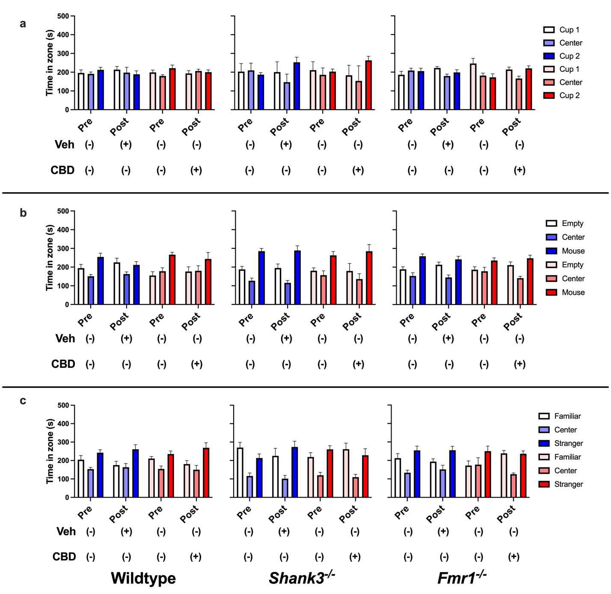

Supplementary Fig 8. Time in zone data trends for each phase of 3-chamebr task in females. Average time spent in each chamber by female mice during the acclimation phase (a), sociability phase (b), and social novelty phase (c) of the 3-chamber social task in wildtype, Shank3 and Fmr1 KO mice (also represented in Fig.2, and supplementary Figs. 5-6). Data represent mean ± SEM..

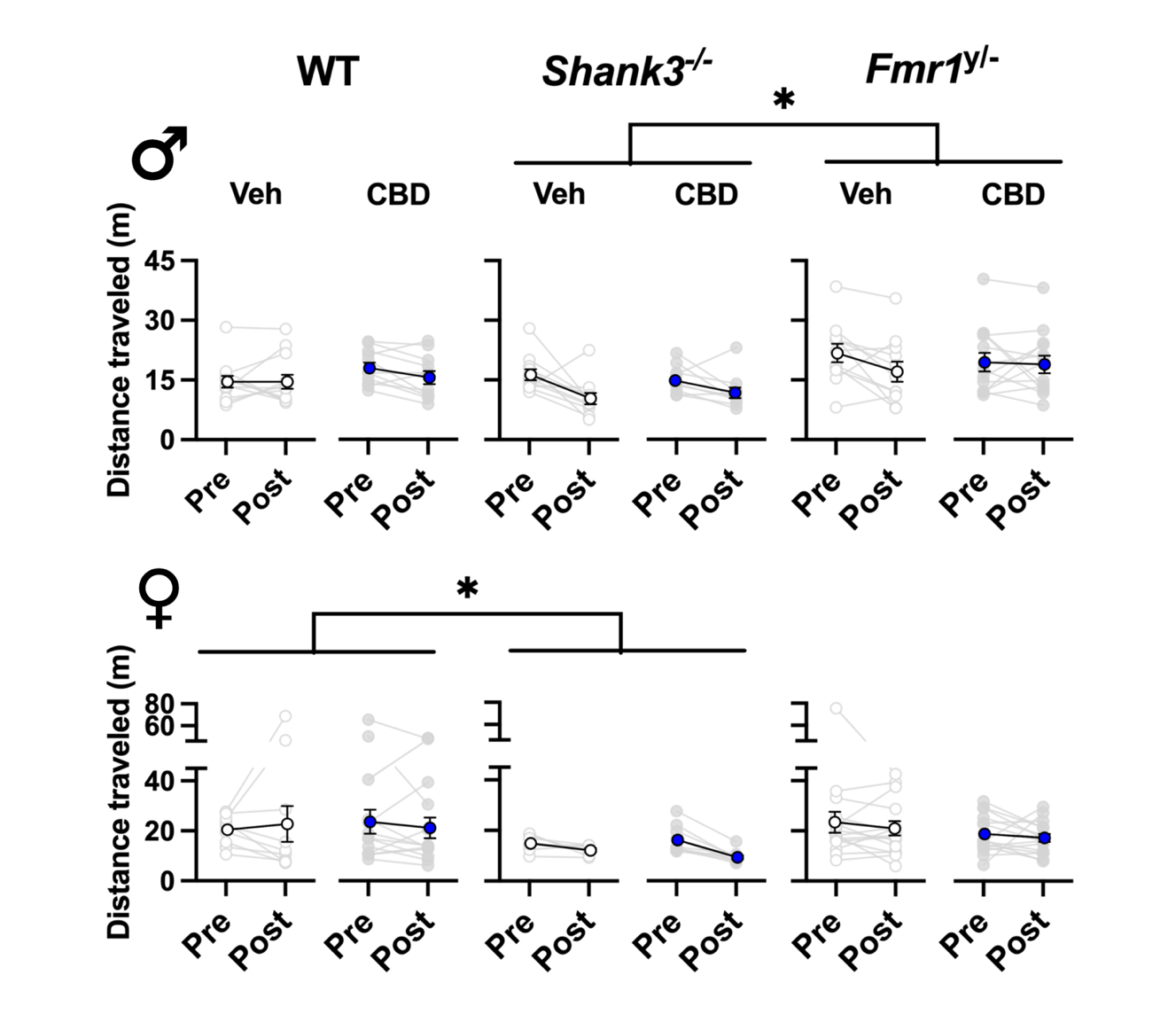

Supplementary Figure 9. No CBD-induced changes in locomotion. (Top) Average distance travelled by male wildtype, Fmr1 KO, and Shank3 KO mice treated with vehicle or CBD (s.c., 5 mg/kg) during the open field test. (Bottom) Average distance travelled by female wildtpye, Fmr1 KO, and Shank3 KO mice treated with vehicle or CBD (s.c., 50 mg/kg) during the open field test. Data represent means ± SEM. * p < 0.05 Statistical analysis by 3-way ANOVA with Tukey’s multiple comparison test.

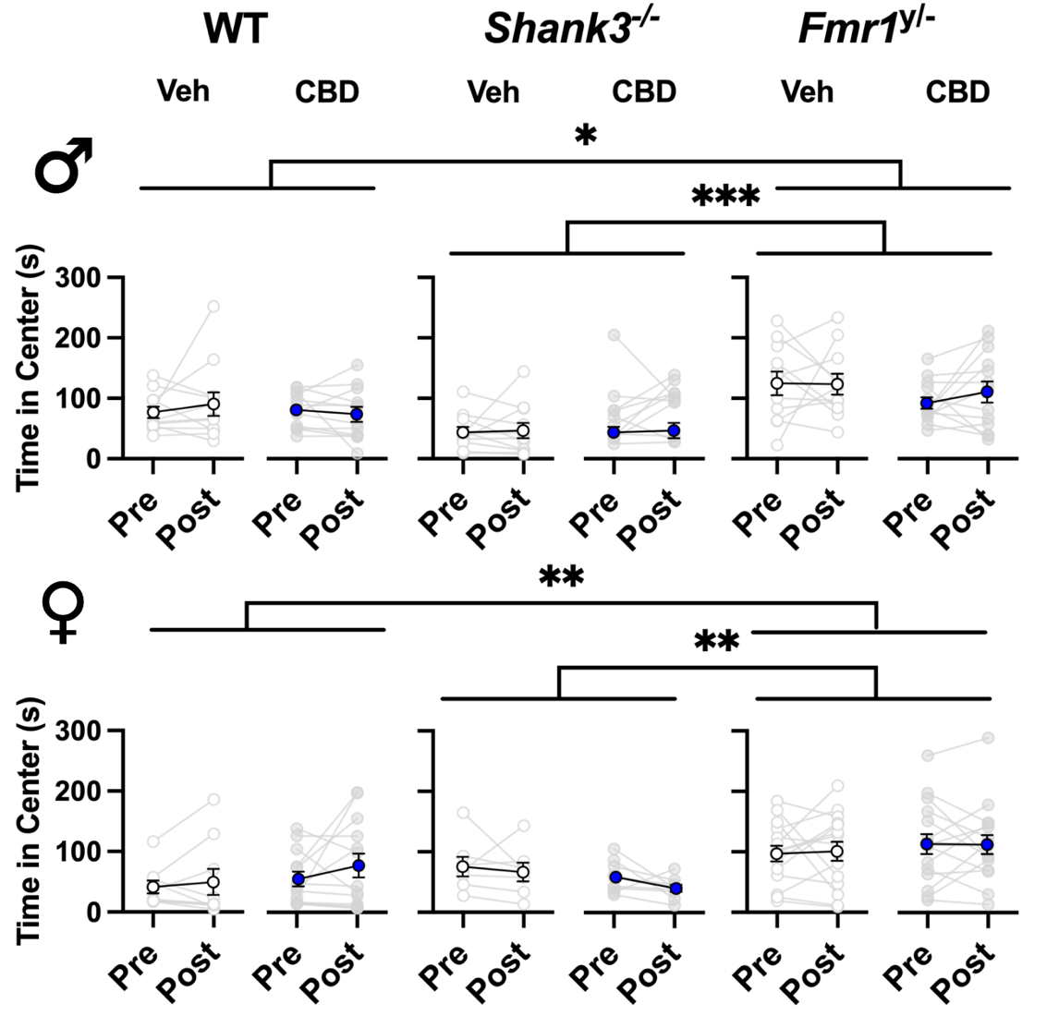
Supplementary Fig 10. CBD-induced changes in time in center during open field test. (Top) Average time spent in the center of the open field box by male mice treated with vehicle or CBD (s.c., 5 mg/kg). (Bottom) Average time spent in the center of the open field box by female mice treated with vehicle or CBD (s.c, 50 mg/kg). Data represent means ± SEM. * p<0.05, ** p ≤ 0.01, *** p ≤ 0.001. Statistical analysis by 3-way ANOVA with Tukey’s multiple comparison test.

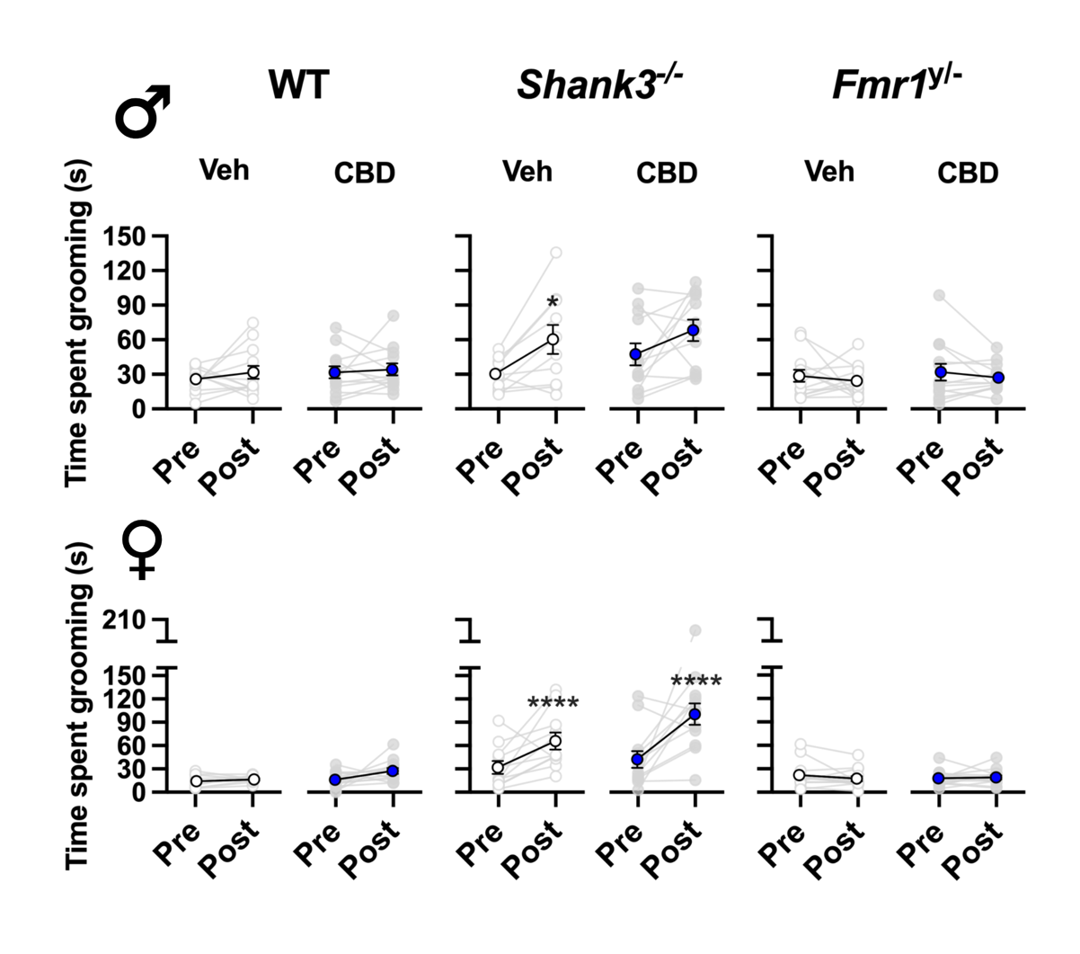
Supplementary Fig 11. Elevated levels of grooming among Shank3 KO mice following injections. (Top) Average time spent grooming among male mice treated with vehicle or 5mg/kg of CBD. (Bottom) Average time spent grooming among female mice treated with vehicle or 50mg/kg of CBD. Data represent means ± SEM. * p < 0.05, **** p < 0.0001 vs. pre-treatment score. Statistical analysis by 3-way ANOVA with Tukey’s multiple comparison test.

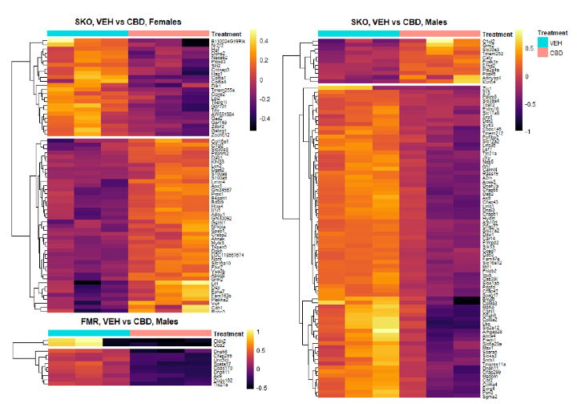
Supplementary Figure 12. K-means clustered heatmap of all differentially expressed genes in Shank3 and Fmr1 knock-out mice treated with CBD. Cell color represents log2-fold change, columns represent sample replicates. Clustering not possible for Fmr1 females due to low gene number.

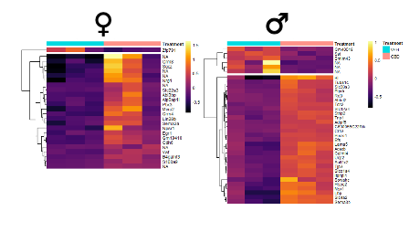
Supplementary Figure 13. K-means clustered heatmap of all differentially expressed genes in wild-type mice treated with CBD. Cell color represents log2-fold change, columns represent sample replicates.

