Appendix A: MP4 Architecture

This appendix provides a high-level overview of the MP4 model architecture and its training regime. Due to proprietary considerations, specific implementation details—including internal layer configurations, precise hyperparameters, and optimization strategies—are not disclosed. The following sections outline the key design choices that enable MP4 to translate natural language prompts into functional, de novo protein sequences.

A.1 HIGH-LEVEL OVERVIEW

MP4 is a transformer-based model specifically designed for de novo protein design. It accepts natural language prompts that encode comprehensive protein information—such as fitness criteria, physical properties, source organism, and sequence-related properties—and generates protein sequences that meet the desired functional and structural constraints. The model emphasizes molecule programmability by integrating data from diverse sources and synchronizing multiple design objectives during training. This capability enables MP4 to deliver state-of-the-art performance in generating novel proteins that are both experimentally feasible and functionally robust.

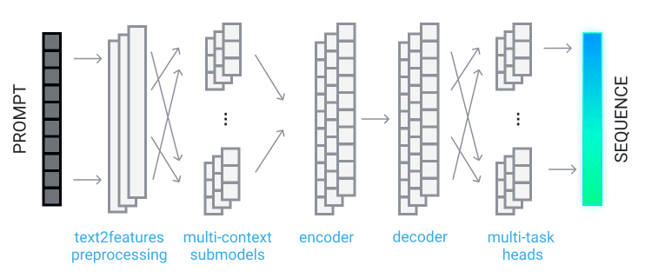
Figure S1: An overview of the MP4 architecture.

A.2 INPUT AND OUTPUT REPRESENTATIONS

Input Representation: The input to MP4 is a detailed textual prompt. These prompts include
various descriptors such as:
- Fitness: Desired functional and performance metrics.
- Organism: Source organism or related biological context.
- Sequence Properties: Attributes that might include partial sequences, motifs, or structural hints.
Before being processed by the core model, these textual inputs pass through a text2feature preprocessing unit, which tokenizes the prompt and converts it into a structured feature representation. This conversion ensures that all pertinent information is captured and made accessible to subsequent layers.
Output Representation: The final output of MP4 is a protein sequence composed of amino acids. The sequence is generated in a way that reflects the functional and structural requirements encoded in the input prompt. By balancing multiple design tasks, MP4 ensures that the generated sequence is consistent with both the raw input and the underlying biochemical principles.

A.3 TRANSFORMER BACKBONE AND CONDITIONAL GENERATION

At the core of MP4 lies a multi-layer transformer architecture that has been adapted for the com-
plexities of protein design. The architecture comprises several key components:
Multi-Context Sub Models: These sub-models are designed to process different aspects
of the input features. Each sub-model focuses on distinct information—derived from the
prompt—ensuring that the model can attend to diverse functional, structural, and contextual
cues.
- Encoder: After the multi-context sub models process the input, an encoder aggregates the information. It captures long-range dependencies and builds a rich, context-aware representation that summarizes the key aspects of the protein prompt.
- Decoder: The decoder translates the encoder’s latent representation into a form that is directly amenable to sequence generation. In this phase, the model transforms abstract feature representations into sequential data.
- Multi-Task Head: The output from the decoder is routed through a set of task-specific heads. MP4 is trained to perform 70 synchronized tasks, where each head is responsible for interpreting the decoder vector with respect to a particular design objective. These tasks include aspects such as structural fold determination, functional site prediction, and sequence novelty assessment. The collaborative output from these heads is then integrated to construct the final protein sequence.
Figure S1 schematically illustrates the end-to-end architecture of MP4, highlighting the sequential processing from prompt to final protein sequence.

A.4 TRAINING AND INFERENCE OVERVIEW

Training Data and Regime: MP4 has been trained on a highly diverse and extensive dataset,
comprising over 1.8 billion datapoints which were collected from various repositories, including
UniProt. The training process involved processing 138K tokens and was carried out across 70 synchronized tasks, with each task emphasizing a distinct aspect of protein design—from structural features to functional specificity. Overall, the training was carried out with approximately 3,800 AMD-Instinct GPU-days.

A.5 PROPRIETARY CONSIDERATIONS AND FUTURE DIRECTIONS
While this appendix outlines the overarching design and training strategy of MP4, many technical details remain confidential. In particular, specific modifications to the standard transformer framework, internal layer configurations, and fine-tuning strategies are proprietary. Future research will focus on:
- Refining the multi-context sub models to enhance the model’s sensitivity to nuanced protein features.
- Expanding the range of synchronized tasks to capture an even broader spectrum of protein functionalities.
- Exploring alternative decoding strategies to further improve sequence fidelity and novelty.
- Integrating all-atom protein structure generation to enable the direct production of detailed, three-dimensional protein models.
This continued evolution aims to push the boundaries of molecule programmability in protein design.

APPENDIX B: EXPERIMENTAL METHODS

B.1 CONSTRUCT DESIGN

Constructs were designed with C-terminal tags (GFP11 for split-GFP solubility and Twin-Strep for purification) and sourced from Twist Bioscience. The DNA constructs were subsequently assembled into the appropriate expression vector using the NEBuilder HiFi DNA Assembly Kit (New England Biolabs) according to the manufacturer’s protocol, with assembly reactions performed in 3μL volumes.

B.2 PROTEIN EXPRESSION AND PURIFICATION

Protein expression was carried out in a prokaryotic cell-free system at Adaptyv Bio. Briefly, expression reactions were prepared in a total volume of 60μL and incubated at 37°C for 12 hours to ensure robust protein synthesis. Expression was detected by the fluorescent coexpression of the GFP11 tag and GFP1-10 marker as determined by a split-GFP solubility assay (Cabantous & Waldo (2006)). For protein purification, an affinity capture approach was employed using magnetic beads. Protein samples were mixed with the beads and incubated for 10 minutes at room temperature with gentle agitation to allow binding. Following binding, the beads were washed three times with a washing buffer composed of 1M Tris-Cl, 1.5M NaCl, and 10mM EDTA (pH 8) to remove unbound proteins. The concentration and yield of the purified proteins were quantified using an affinity-based assay, with normalization performed via a Qubit fluorometer assay.

B.3 THERMOSTABILITY
Protein thermostability was assessed using nano differential scanning fluorimetry (NanoDSF). Protein samples were diluted to a concentration of 100μg/mL in assay buffer (20mM sodium phosphate, 150mM NaCl, pH 7.0), and 10μL aliquots were pipetted into NanoDSF capillaries. The assay was performed with a temperature ramp of 1°C per minute while monitoring intrinsic fluorescence, specifically by tracking the ratio of fluorescence intensities at 350nm and 330nm. Fluorescence changes were recorded continuously during the temperature increase, and the melting temperature (Tm) was determined as the inflection point on the fluorescence change curve. Tm values obtained for different constructs were compared to evaluate relative thermostability. Measurements reported were single measurements from a given sample.

B.3 DYNAMIC LIGHT SCATTERING

Dynamic light scattering (DLS) was used to evaluate the hydrodynamic radius and aggregation state of the expressed proteins. Prior to measurement, purified protein samples were allowed to equilibrate to room temperature. Approximately 20μL of each sample was loaded into a disposable cuvette, and measurements were performed at 25°C using the Unchained Labs Uncle instrument. A series of at least 10 runs per sample was acquired to ensure statistical reliability. The size distribution data were analyzed to determine the hydrodynamic radius and to assess the presence of protein aggregates. Measurements reported were single measurements from a given sample.

APPENDIX C: SUPPLEMENTAL DATA
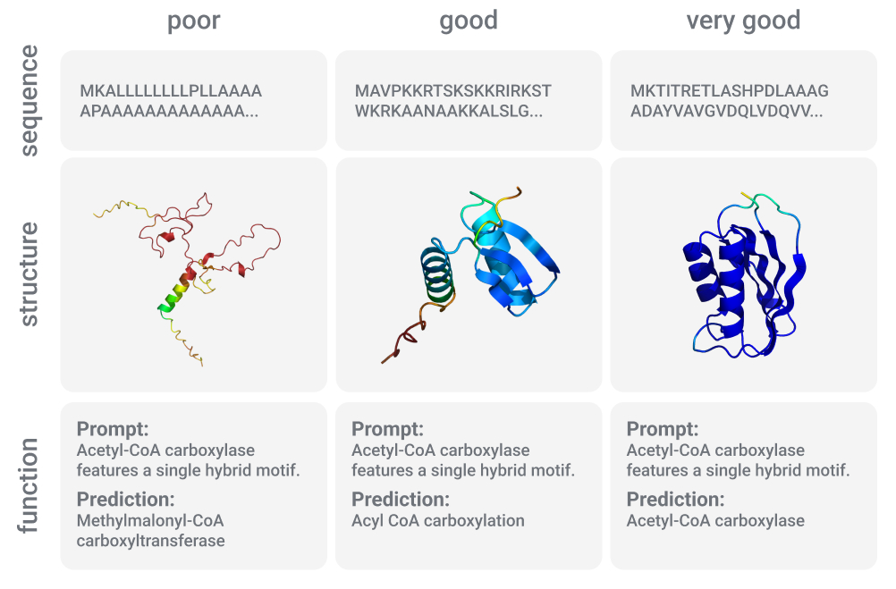
Figure S2: Examples of poor, good, or very good quality sequences, structures, and functions.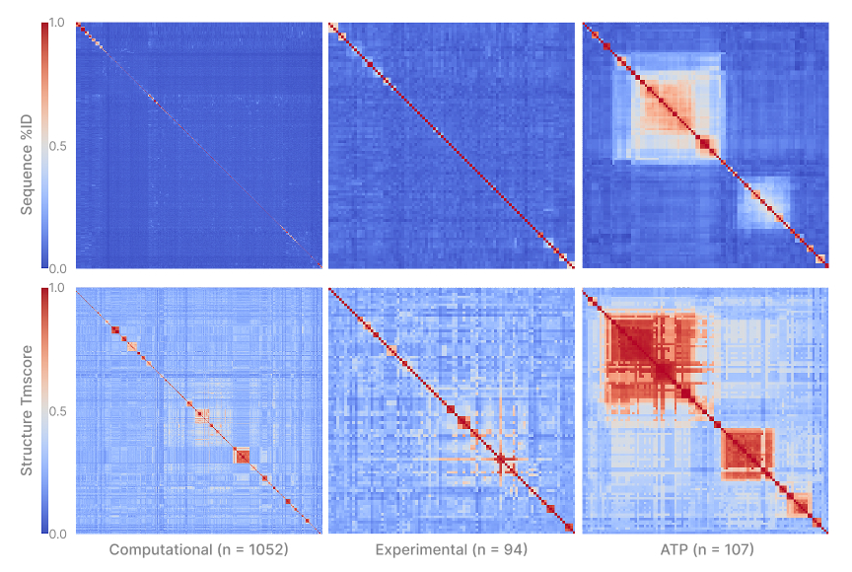
Figure S3: Heatmaps showing sequence (top) and structural (bottom) similarity of MP4 designed proteins compared to others in the full computational set (left), experimental validated diversity set (middle), and experimentally validated ATP activity focused set (right).
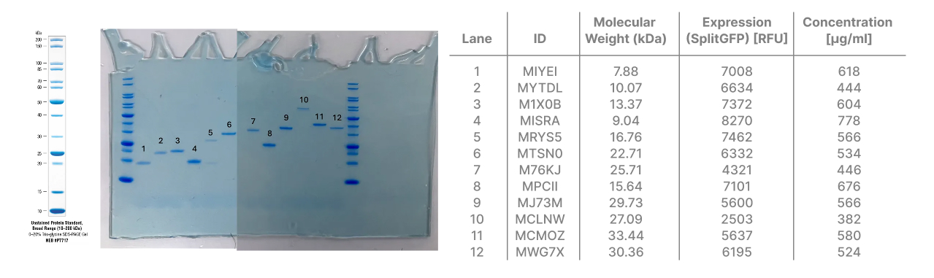Figure S4: SDS-PAGE gel characterization of select proteins of the diversity set.
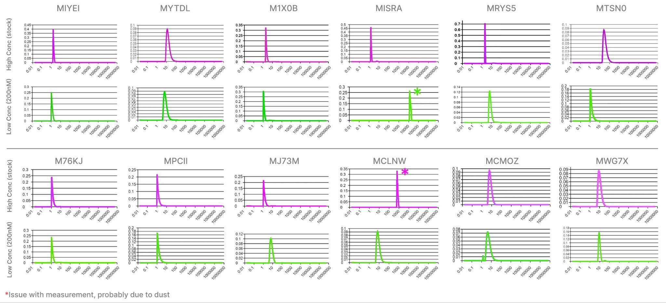
Figure S5: Dynamic light scattering (DLS) characterization of select proteins of the diversity set.
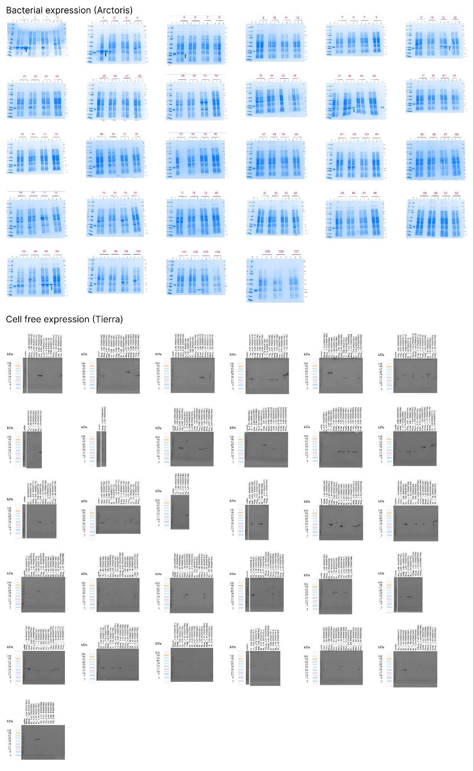
Figure S6: SDS-PAGE gel characterization of bacterial expression of the ATP activity set.
Figure S7: SDS-PAGE gel characterization of cell-free expression of the ATP activity set.

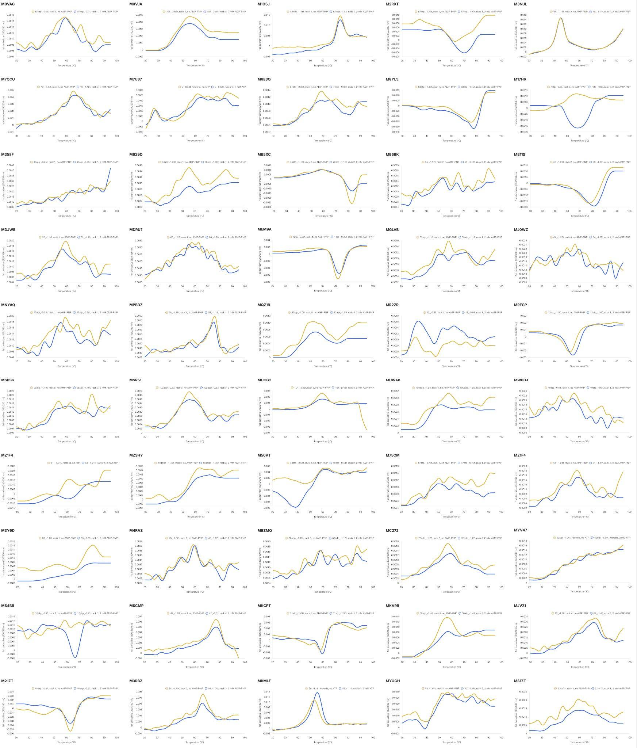
Figure S8: Melting temperature by nanoDSF with 0 mM or 2 mM ATP or AMP-PNP of proteins in the ATP activity set.

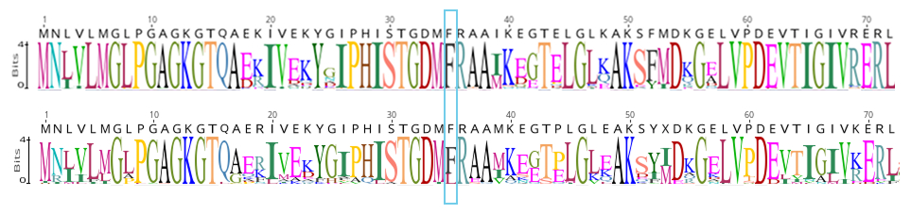
Figure S9: Top: Sequence logo from blastp search of MBMLF against nr/nt (n = 1000). Position 35 is highlighted by the blue box. Bottom: Sequence logo from Foldseek search of MBMLF against PDB100 with TM-score > 0.9 (n = 37).

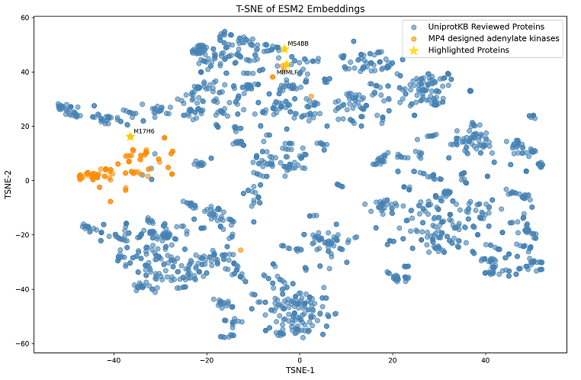
Figure S10: T-SNE plot of ESM2 embeddings of natural adenylate kinases (from SwissProt) in blue, MP4 designed in orange, and 3 highlighted proteins in yellow stars.

Table S1: Sample naming conversion table
Repo ID | Sample Name | Sample # | Repo ID | Sample Name | Sample # | Repo ID | Sample Name | Sample #
M0VAG | 52atp_-0.91 | 35 | MAOYP | 72atp_-1.17t | 63 | MOFBD | 88_-1.57t | 82
M0VJA | 105_-2.66t | 107 | MB11S | 63_-1.23t | 64 | MPBDZ | 58_-1.18t | 70
M17H6 | 7atp_-0.65 | 7 | MB5XC | 76atp_-1.13t | 62 | MQU7R | 85_-1.50t | 59
M17PF | 78_-1.40t | 79 | MB6BK | 55_-1.17t | 49 | MQZ1R | 42atp_-1.09 | 93
M1CE2 | 61atp_-0.84t | 25 | MBGJG | 8atp_-0.97t | 9 | MR2ZR | 13_-0.99 | 36
M1O5J | 83adp_-1.03 | 31 | MBMLF | 59_-1.18 | 95 | MR5BT | 89adp_-1.29t | 87
M1OEB | 96_-1.78t | 96 | MBZMQ | 86adp_-1.17t | 32 | MREGP | 12atp_-1.00 | 15
M21ZT | 44atp_-0.87 | 13 | MC272 | 75adp_-1.22 | 99 | MRQ0O | 60_-1.19t | 34
M2RXT | 57atp_-1.29t | 21 | MC3D0 | 41_-1.00t | 66 | MS1ZT | 5_-0.74 | 27
M2TAA | 91_-1.67t | 91 | MC6BG | 5atp_-0.92 | 81 | MS4BB | 10atp_-0.93 | 40
M2VPY | 92atp_-1.33t | 69 | MCPRP | 105atp_-1.11t | 54 | MSB6I | 92_-1.67t | 94
M2VZK | 84atp_-1.26 | 20 | MCWDA | 8_-0.81 | 18 | MSCMP | 42_-1.01 | 46
M30TD | 56atp_-1.01t | 90 | MDJWB | 52_-1.16 | 42 | MSPS6 | 58atp_-1.19t | 89
M358F | 43atp_-0.65t | 41 | MDRU7 | 66_-1.28 | 77 | MSR51 | 102adp_-0.83 | 83
M3DNA | 106atp_-1.20 | 55 | ME7LO | 78atp_-0.81t | 52 | MT56P | 2atp_-0.89t | 11
M3NUL | 48_-1.11t | 58 | MEM9A | 1atp_-0.90t | 3 | MTQKH | 103_-2.41t | 105
M3QQV | 87atp_-1.29 | 39 | MESSJ | 51atp_-1.00 | 6 | MTUAM | 85atp_-1.17t | 78
M3RBZ | 94_-1.70t | 104 | MG4ML | 0atp_-1.16t | 88 | MTZB5 | 47atp_-0.87 | 28
M3Y6D | 33_-1.00 | 33 | MGLVB | 53atp_-1.18 | 47 | MU4X7 | 77atp_-1.37t | 74
M4GK5 | 54atp_-1.37 | 22 | MGRG1 | 97adp_-1.40t | 100 | MUCG2 | 104_-2.42t | 106
M4RAZ | 45_-1.07t | 60 | MH9IN | 4atp_-0.95t | 51 | MUWA8 | 100adp_-1.25 | 43
M4WKJ | 65_-1.27t | 97 | MHV6S | 99atp_-1.25 | 23 | MV1NF | 46atp_-1.13t | 37
M50VT | 48atp_-0.64t | 61 | MIB32 | 38_-1.00t | 12 | MW0XQ | 9atp_-0.83t | 57
M644A | 60atp_-0.89t | 14 | MIY6R | 20_-1.00t | 71 | MW80J | 49atp_-0.64 | 8
M75CM | 67atp_-0.79t | 16 | MJ0WZ | 64_-1.27t | 50 | MWJWM | 3_-0.71t | 4
M77O8 | 98adp_-1.40 | 68 | MJVZ1 | 82_-1.48 | 75 | MX2F5 | 96atp_-1.40t | 92
M7QCU | 49_-1.12t | 53 | MKA7J | 14atp_-0.82 | 2 | MX31H | 74atp_-1.22 | 45
M7U37 | 0_-0.58t | 5 | MKCPT | 11atp_-1.07t | 24 | MY02U | 89_-1.57t | 76
M7ZLJ | 17_-1.00t | 19 | MKE6W | 73atp_-1.42t | 86 | MYCYM | 82atp_-1.03 | 65
M839Z | 6atp_-0.73 | 30 | MKUGO | 93atp_-1.43t | 72 | MYLZR | 32_-1.00t | 73
M8E3Q | 34atp_-0.86t | 26 | MKV9B | 50atp_-1.48 | 101 | MYOGH | 43_-1.04t | 80
M8SCR | 80_-1.42 | 103 | ML01H | 91atp_-1.11t | 44 | MYV47 | 62atp_-1.36t | 1
M8XF8 | 72_-1.35t | 48 | MMI5D | 56_-1.18t | 85 | MZ1F4 | 61_-1.21t | 38
M8YL5 | 63atp_-1.10t | 56 | MN3VY | 88adp_-1.29t | 102 | MZH7E | 18_-1.00t | 10
M929Q | 68atp_-1.03t | 29 | MNXBV | 93_-1.69t | 84 | MZSHY | 104adp_-1.49t | 98
MAKA5 | 101atp_-0.83t | 67 | MNYAQ | 45atp_-0.55t | 17

Table S2: Thermostability

Repo ID | ProtNLM | Length | Tm | Tm (2mM ATP/AMP-PNP)
M1X0B | Response regulator | 119 | 86.2 | n/a
MQLYM | Dihydroxyacetone kinase subunit L | 207 | 83.36 | n/a
MJFIU | Protein kinase domain-containing protein | 202 | 81.94 | n/a
MW51C | PAS domain S-box protein | 490 | 79.89 | n/a
M54FQ | LacI family transcriptional regulator | 296 | 76.8 | n/a
MV2G8 | Potassium transporter TrkA | 214 | 75.64 | n/a
M7PN6 | Ferritin | 159 | 71.05 | n/a
MTXPM | Trigger factor | 260 | 68.51 | n/a
MT47E | Toxin VapC | 127 | 67.05 | n/a
MLFIT | Ferritin | 157 | 65.18 | n/a
MWG7X | Prephenate dehydrogenase | 277 | 62.22 | n/a
MPCII | Hemerythrin domain-containing protein | 133 | 55.97 | n/a
MR1UH | 3-isopropylmalate dehydratase large subunit | 234 | 47.97 | n/a
M5CZB | 3.1.3.25 | 252 | 45.43 | n/a
MMUJG | Importin N-terminal domain-containing protein | 245 | 41.2 | n/a
MJY78 | DNA polymerase beta | 258 | 36.48 | n/a
M7S72 | Glycosyltransferase family 1 protein | 296 | 31.32 | n/a
M17H6 | AK | 189 | - | 58.4
MS4BB | AK | 188 | - | 66.4
MBMLF | AK | 214 | 53.1 | 55.5
M21ZT | Sn-glycerol-3-phosphate ABC transporter ATP-bi | 357 | 62.9 | 63
MEM9A | ABC transporter ATP-binding protein | 222 | 72.4 | 72.9
MB5XC | ABC transporter ATP-binding protein | 234 | 83 | 83
MREGP | Amino acid ABC transporter ATP-binding protein | 241 | 52.4 | 54.9
MB11S | Amino acid ABC transporter ATP-binding protein | 233 | 67.6 | 71.4
MSCMP | DEAD/DEAH box helicase | 296 | 77.2 | 76.9
M3Y6D | DEAD/DEAH box helicase | 369 | 80.8 | -
MQZ1R | DEAD/DEAH box helicase | 296 | 52.5 | 53.8
MKV9B | DEAD/DEAH box helicase | 299 | 56.4 | 57.1
MUCG2 | DEAD/DEAH box helicase | 372 | 59.2 | 59.5
M3RBZ | DEAD/DEAH box helicase | 372 | 66.5 | 66.1
M1O5J | DEAD/DEAH box helicase | 295 | 73.8 | 73.8
MPBDZ | ATP-dependent RNA helicase DbpA | 292 | 75.7 | 75
M50VT | APS kinase | 197 | - | 38
M3NUL | Adenylyl-sulfate kinase | 185 | 45.5 | 45.5
MB6BK | AAA family ATPase | 280 | - | 66.4
MSR51 | AAA domain-containing protein | 199 | 55.2 | 55.9
M0VJA | Chromosome segregation protein SMC | 132 | 55.3 | 55.2
M7QCU | Arsenical pump-driving ATPase | 240 | 65 | 67

APPENDIX D: SOFTWARE

D.1 DATA COLLECTION

Software provided with commercial instruments was used for data collection.

D.2 DATA ANALYSIS

Microsoft Excel (2025) and GraphPad (2025) were used to graph and analyze experimental data. PyMOL (Schrodinger, LLC) Version 3.1.4.1 was used for structural analysis. Geneious Prime (www.geneious.com) 2023.2.1 was used for sequence analysis. Foldseek Search Server (https://search.foldseek.com/search; 2025) was used to find structure-based matches. BLAST webserver (https://blast.ncbi.nlm.nih.gov/; 2025) was used to find sequence-based matches.

