Supplementary Information

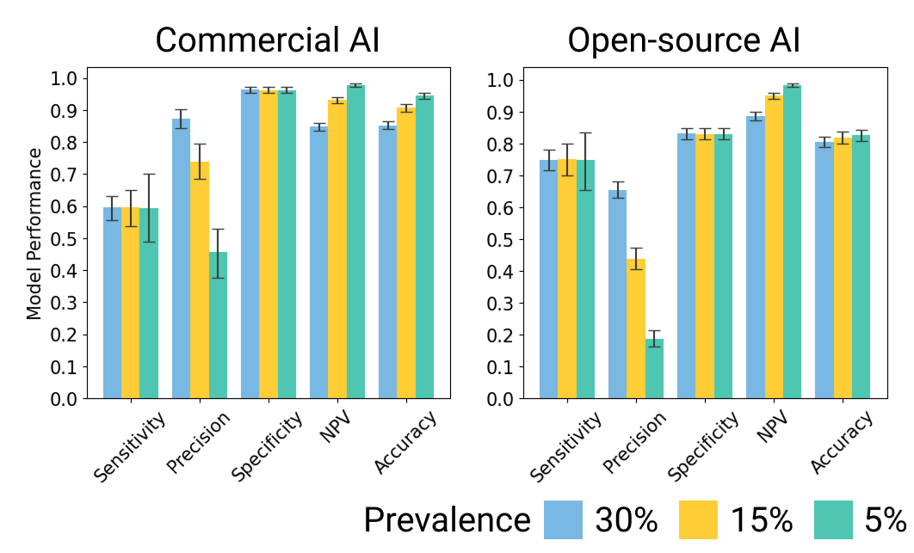
Supplementary Figure 1. Primary ICH detection AI performance at different ICH prevalences. Two primary ICH detection models were evaluated in this study: an FDA-cleared model and an open-source model. The FDA-cleared model demonstrated relatively lower sensitivity and NPV, but higher precision, specificity, and overall accuracy compared to the open-source model. As prevalence decreased from 30% to 5%, both models exhibited decreased precision with increased NPV and accuracy, while sensitivity and specificity remained unchanged.

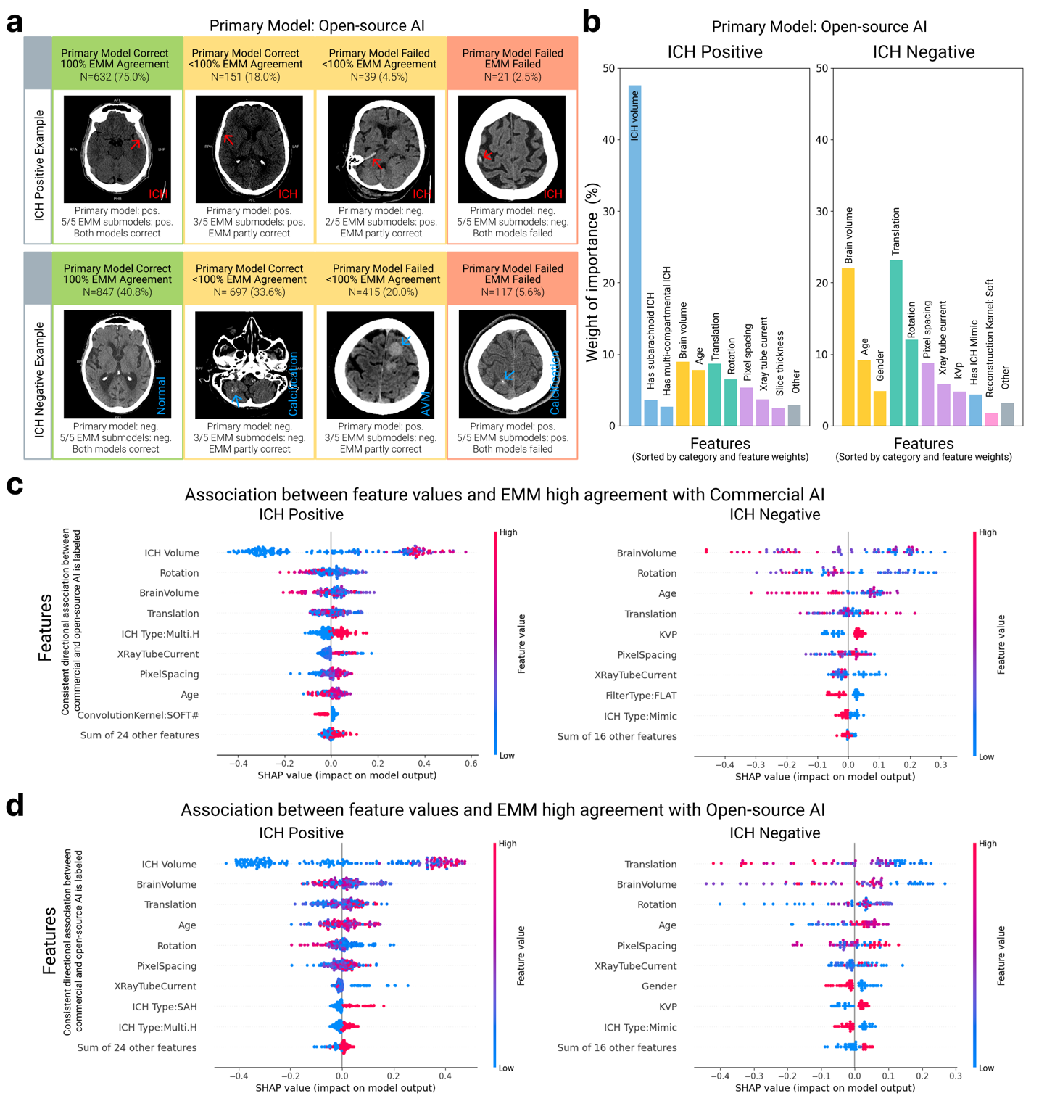
Supplementary Figure 2. a. Example cases for which EMM showed different levels of agreement with the Open-Source primary ICH detection model. b. Quantitative analysis on the importance of features affecting EMM agreement with the commercial primary model in ICH-positive and ICH-negative cases. c. Shapley analysis on feature values’ association with 100% EMM agreements for the commercial AI. d. Shapley analysis on feature values’ association with 100% EMM agreements for the open-source AI.

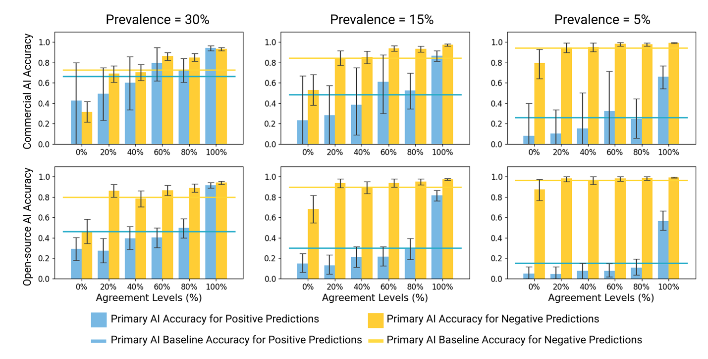
Supplementary Figure 3. EMM level of agreement stratified primary AI predictions into categories of different accuracies. The primary model’s accuracy for both positive (blue) and negative (yellow) predictions is shown across different EMM agreement and prevalence levels.

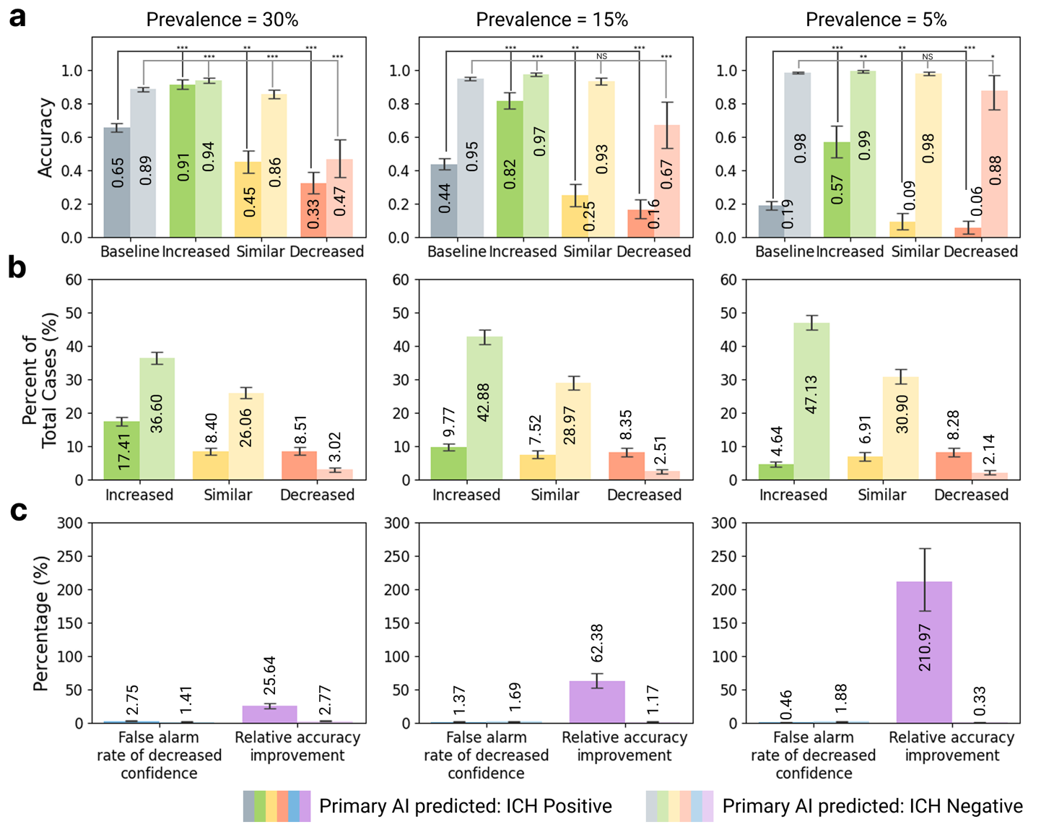
Supplementary Figure 4. EMM stratified cases into increased, similar, and decreased confidence groups for open-source primary AI and enables customized clinical decision making. a. Accuracy of each subgroups. b. Percent of cases of each subgroups. c. Tradeoff between the unnecessary false alarm review and the relative accuracy improvement. Same EMM agreement thresholds were used as in Figure 1b.

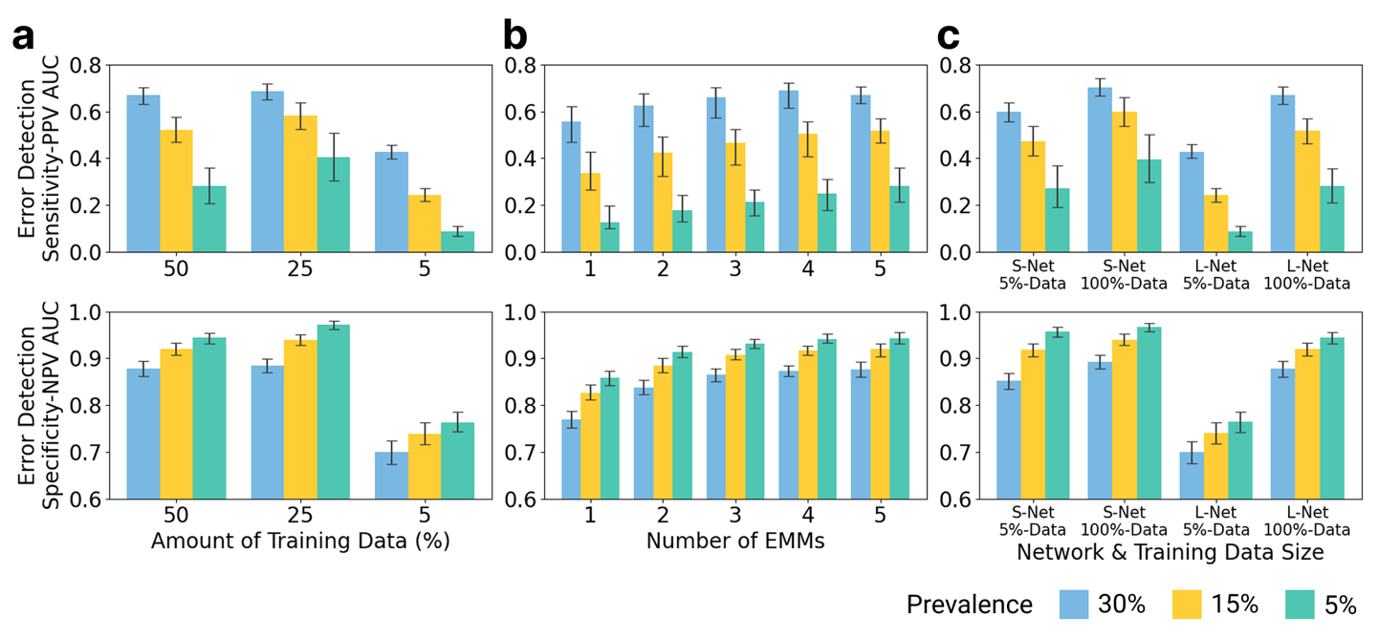
Supplementary Figure 5. EMM performance on catching open-source ICH AI errors generally improves with increasing training data volume (a), number of sub-models (b), and sub-model sizes.

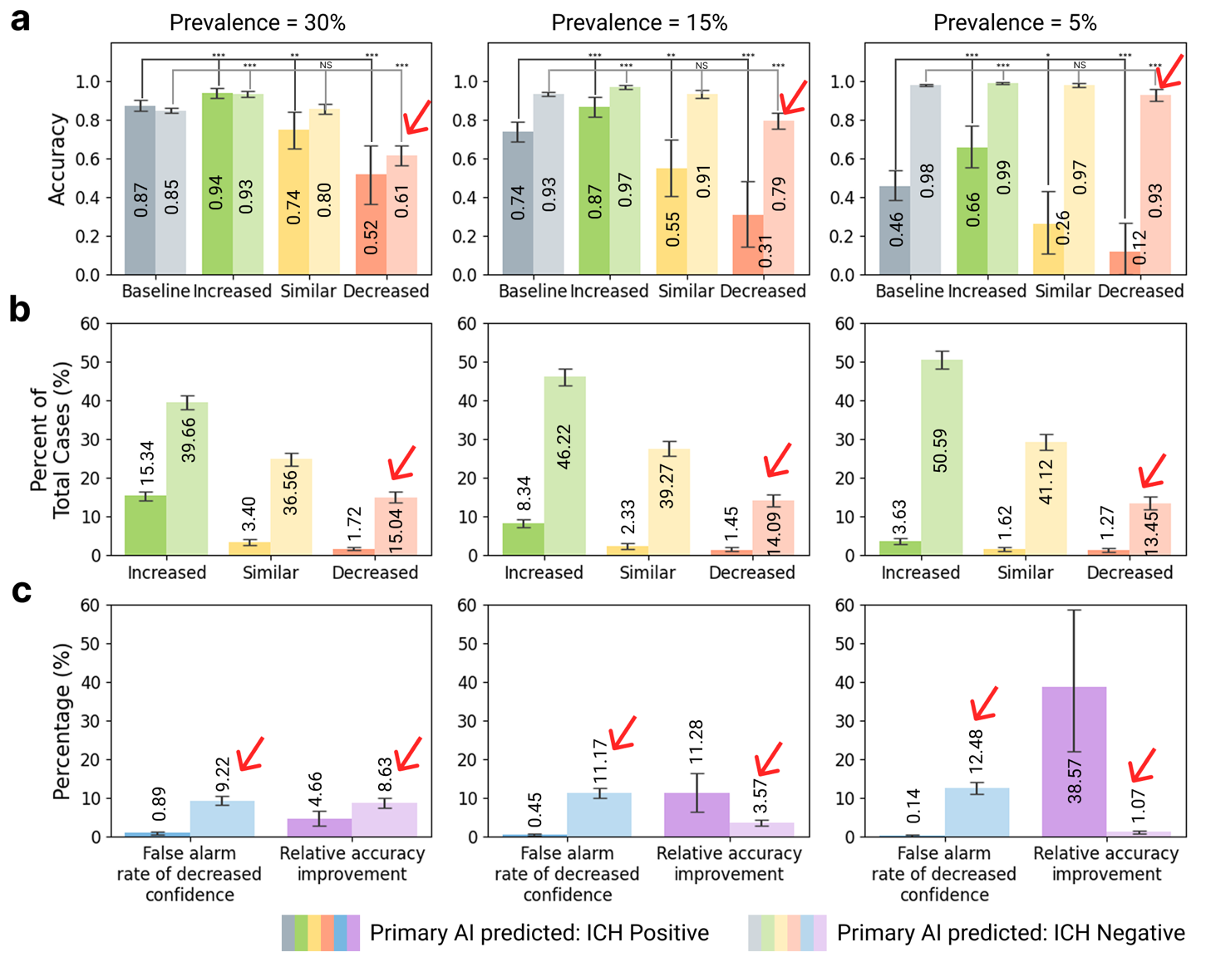
Supplementary Figure 6. Suboptimal EMM stratification threshold increased unnecessary reviews for false alarm cases while reduced the relative accuracy gain. Red arrows indicate the changes compared to Figure 3. In this example, the negative yellow thresholds changed from [80%, 60%, 40%, and 20%] to [80% and 60%], and negative red thresholds changed from [0%] to [40%, 20%, and 0%] compared to Figure 3a.

