Additional file 1:
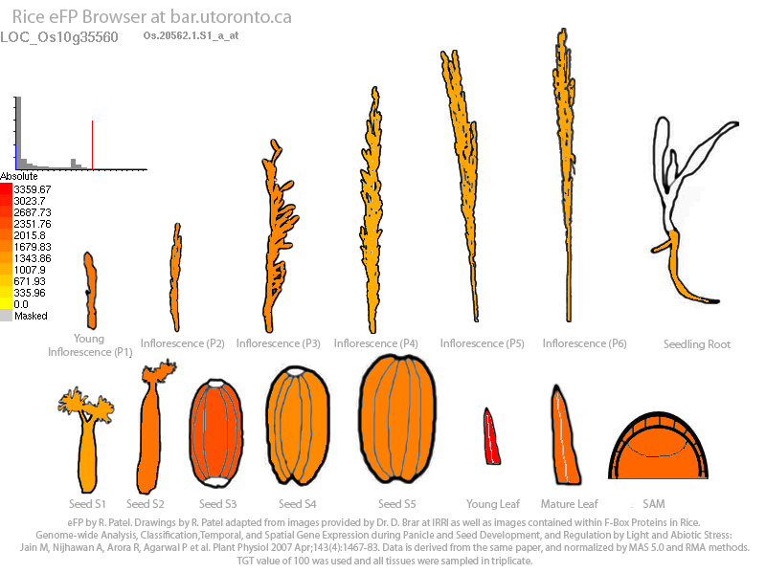

Fig. S1 Transcript level of OsMed16 in the developing inflorescence and seed. The result was extracted from the eFP browser database (Winter et al. 2007)

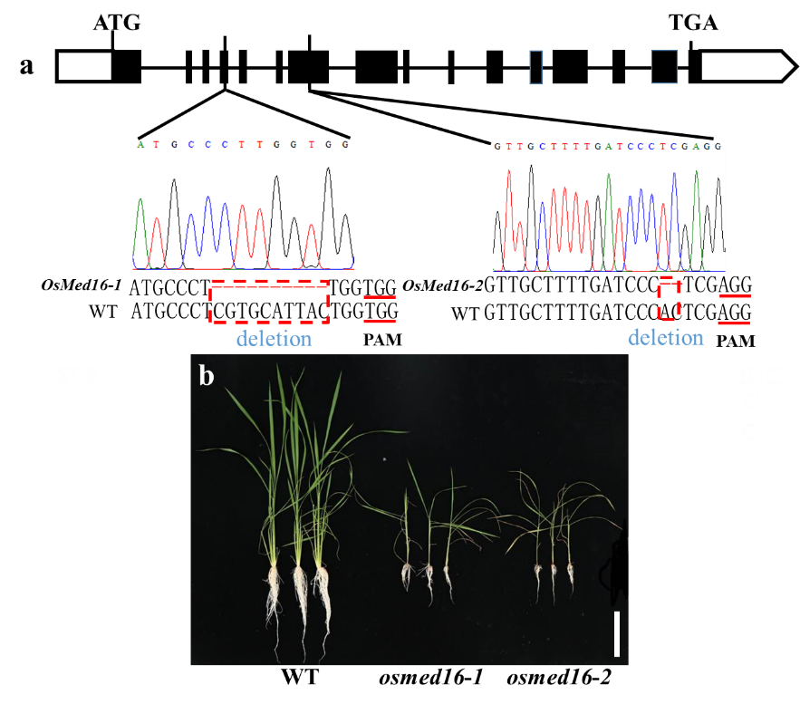
Fig S2 Knockout of OsMed16 using CRISPR technology causes rice seedling lethality. a The two target site mutations of OsMed16 gene. The black inverted triangle indicates the positions of the two targets; The red dashed box is positioned at the mutation site of the mutants. b The phenotype of the wild-type and two OsMed16 knockout lines of 48-d old. Scale bars = 10 cm.

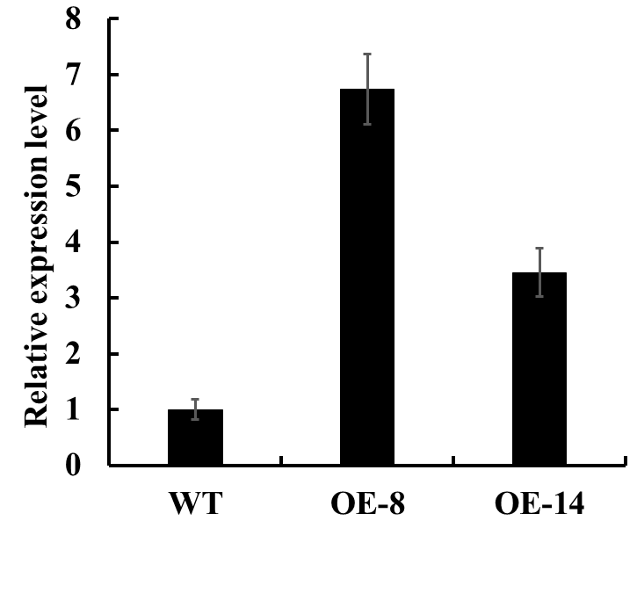
Fig. S3 Detection of the expression level of OsMed16 in WT and transgenic plants by qRT-PCR. RNA was extracted from the roots of the seedlings. The expression of rice ACTIN was used as the internal control.

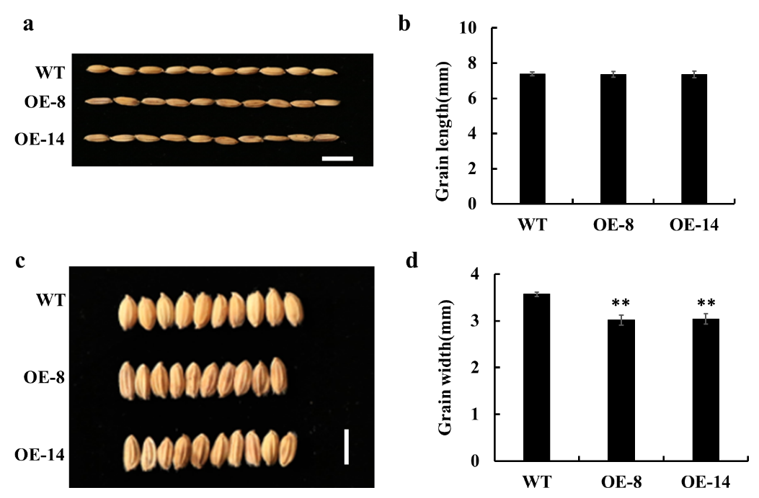
Fig. S4 Grain shape of OsMed16 overexpression plants. Comparisons of grain length (a and b) and grain width (c and d) between the wild-type and OsMed16-OE plants. Scale bars = 5 mm. Data (c and d) are means ±SD of three biological replicates. * represents P < 0.05, * * represents P < 0.01.

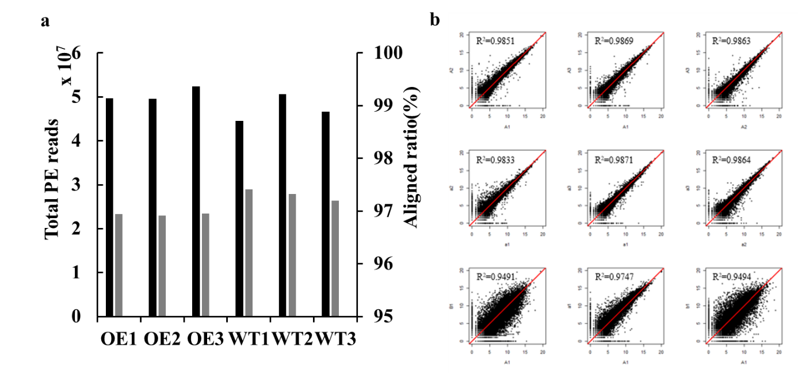
Fig. S5 Basic statistics of RNA-seq data. a Statistics of total paired-end reads (black bar) and aligned ratio (gray bar) for each replicate. b Consistency of samples and replicates.

Table S1 Primers used for defense-related genes.
Gene name | Forward primer (5'-3') | Reverse primer (5'-3')
OsPR1a | CGTGTCGGCGTGGGTGT | GGCGAGTAGTTGCAGGTGATG
OsPR1b | TACGCCAGCCAGAGAAGC | GCCGAACCCCAGAAGAGG
OsPR10a | GTCCGGGCACCATCTACACC | CAAGCTTCGTCTCCGTCGAGT
OsNLS | GAAGACCACCCTTGCCAATCA | GCTTGTTGATGATGGCTTGC
OsMPK3 | CACCTCGACCACGAGAACATCA | GGCAGTGCTCTTCTGACAGTTC
OsWRKY45 | GCCGACGACCAGCACGATCACC | AGGCTGCTCAGCACCTCCTCCT
PDI | CGTCGAGTTCTACGCCCCGT | CCTGAATGTTCTTGCCCTGGTTCC
OsPAL1 | TTCGACGCCAACATCCTCG | GCTTCAGCTTGTGGGTCAGGT

