Supplemental Materials
As a first step to determining how light exposure differs with disease burden in youth with migraine, we conducted analyses to determine sample sizes needed to adequately power such comparisons. We compared light metrics across the following groups: (1) those with at least 15 headache days per month and 8 migraine days per month based on ICHD-3 criteria for chronic migraine compared to those who did not meet this criteria, (2) those with no-to-mild versus moderate-to-severe headache-related disability as defined by PedMIDAS, (3) those with low visual sensitivity (VLSQ-8 $≤$ 24) versus high visual sensitivity (VLSQ-8 > 24), (4) those with no or mild versus moderate-to-severe sleep disturbance defined by PROMIS, (5) those with no or mild versus moderate-to-severe sleep impairment defined by PROMIS.
Light metrics included total photopic illuminance, time spent in bright light, percent time within recommended daytime and pre-bedtime light levels across these groups. Percent time spent within recommended nighttime light levels was removed because all, but 2 participants were within the recommended range >99% of the time indicating very little variability in this metric. Based on the pattern of mEDI exposure throughout the day, mean mEDI was also calculated during periods of transition, including 6 am – 8 am (“lights on” or the time frame of the start of morning light exposure), 3 pm – 6 pm (afternoon), and 9 pm – 12 am (“lights out” or time frame of the onset of nighttime light levels). Here we provide the mean and standard deviations of each tested variable to support additional power analysis calculations (Table S1).
Characteristic (n) | PHOTOPIC |  | MELANOPIC
Characteristic (n) | Luminous  Exposure  [klux*hr] | Time in bright light  [minutes] | % within recommended light |  | mEDI [log lux]
Characteristic (n) | Luminous  Exposure  [klux*hr] | Time in bright light  [minutes] | Daytime | Pre-bed | ‘Lights on’  (6 – 8a) | Afternoon  (3 – 6p) | ‘Lights out’ (9p – 11p)
Not chr. migraine (12)  Chr. migraine (8) | 5.5 +/- 5.0  7.3 +/- 3.8 | 32 +/- 33  56 +/- 33 | 12.4 +/- 6.8  17.8 +/- 7.4 | 81.1 +/- 19.1  72.2 +/- 25.2 | -2.8 +/- 1.6  -4.3 +/- 0.5 | 2.2 +/- 1.4  3.5 +/- 1.2 | -2.7 +/- 1.9  -1.4 +/- 2.2
Low HA disability (6)  High HA disability (14) | 9.0 +/- 6.3  5.0 +/- 3.2 | 55 +/- 35  36 +/- 33 | 15.6 +/- 9.8  14.1 +/- 6.4 | 81.3 +/- 19.9  75..9 +/- 22.8 | -3.4 +/- 1.7  -3.4 +/- 1.4 | 1.7 +/- 0.7  2.5 +/- 2.4 | -2.8 +/- 1.7  -1.9 +/- 2.2
Low fear-of-pain (4)  High fear-of-pain (16) | 7.6 +/- 3.7  5.9 +/- 4.8 | 40 +/- 31  42 +/- 36 | 15.1 +/- 4.7  14.4 +/- 8.0 | 72.9 +/- 23.1  78.7 +/- 21.8 | -3.5 +/- 2.1  -3.4 +/- 1.3 | 2.6 +/- 1.5  2.2 +/- 2.2 | -1.8 +/- 2.3  -2.7 +/- 2.1
Low visual sens. (13)  High visual sens. (7) | 6.6 +/- 5.0  5.5 +/- 3.9 | 41 +/- 32  44 +/- 40 | 14.2 +/- 7.1  15.0 +/- 8.3 | 79.5 +/- 20.0  73.8 +/- 25.6 | -3.2 +/- 1.7  -3.8 +/- 0.7 | 2.1 +/- 2.3  2.5 +/- 1.7 | -2.9 +/- 1.5  -0.9 +/- 2.5
Low sleep impair. (10)  High sleep impair. (10) | 7.5 +/- 5.3  4.9 +/- 3.5 | 50 +/- 30  34 +/- 37 | 15.7 +/- 6.3  13.3 +/- 8.5 | 75.1 +/- 22.0  79.9 +/- 22.1 | -4.0 +/- 0.9  -2.8 +/- 1.6 | 2.0 +/- 2.6  2.4 +/- 1.6 | -2.3 +/- 2.0  -2.1 +/- 2.2
Low sleep disturb. (11)  High sleep disturb. (9) | 6.0 +/- 4.4  6.5 +/- 5.0 | 40 +/- 34  44 +/- 37 | 13.5 +/- 8.5  15.8 +/- 5.9 | 84.2 +/- 17.9  69.3 +/- 23.9 | -3.7 +/- 1.0  -3.1 +/- 1.8 | 2.0 +/- 2.6  2.5 +/- 1.4 | -2.3 +/- 2.0  -2.0 +/- 2.3
Table S 1: Comparison of light metrics based on clinical characteristics of migraine and sleep. Chr. = chronic, HA = headache, sens. = sensitivity, impair. = impairment, disturb. = disturbance. Values indicate Mean +/- SD.
Power analysis was conducted by simulating data for sample sizes ranging from 5 to 75 participants per group by resampling from the original 20 participants 1,000 with replacement. Clinical group characteristics were compared using a two-sample two-tailed t-test. The sample size needed to achieve 80% power with an alpha of 0.05 was determined.
Group comparison of youth with and without chronic migraine, with low versus high headache-related disability, low versus high visual sensitivity, and low versus high sleep impairment had at least two differences light metrics that reached 80% power with 75 participants or less (Figure S1). Percent time spent within recommended light for 3 hours prior to bedtime had sufficient power to identify differences between youth with low versus high sleep disturbance (n = 30 to achieve 80% power). No light metrics had sufficient power to identify differences between youth with low compared to high fear-of-pain scores with 75 participants per group or less, though overall fear of pain scores were high.
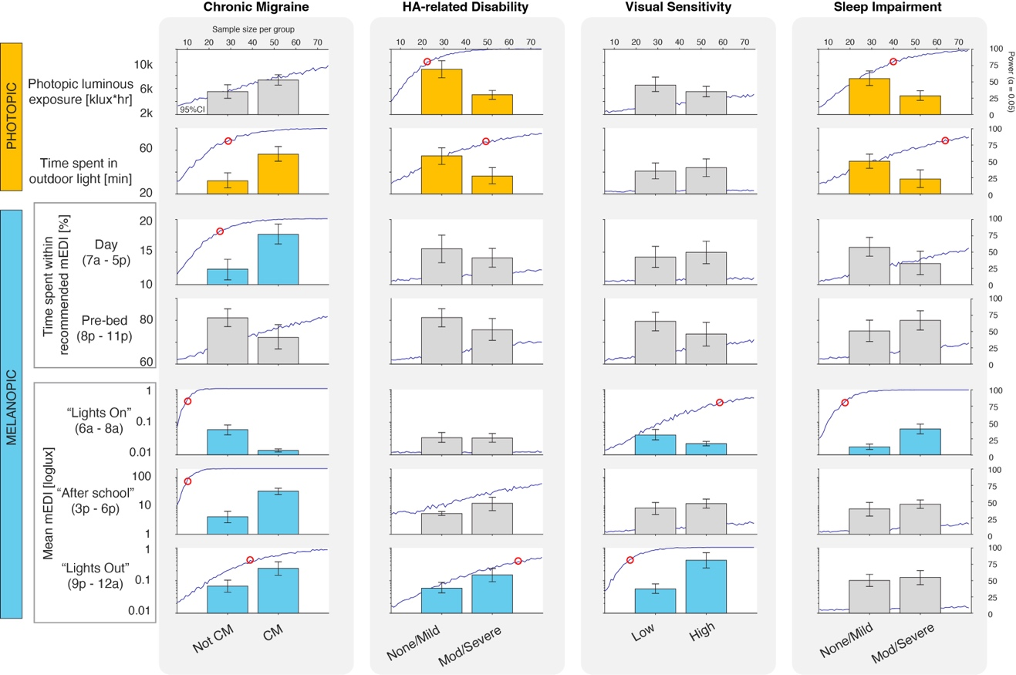
Figure S1: Power analysis of group comparison of clinical characteristics across light exposure metrics. Bar graphs represent mean and 95% CI for simulated light metric data with 75 participants per group. Dark blue line represents the power for an alpha of 0.05 for sample sizes ranging from 5 to 75 per group. Red circles represent the sample size where 80% power is achieved. Metrics that reached 80% power within 75 participants per group are shown in orange (photopic metrics) and light blue (melanopic metrics) and the minimum sample size that achieves this power threshold is reported on the figure. Metrics that did not achieve this within 75 participants are shown in gray. CM = chronic migraine; Mod = moderate. mEDI = melanopic equivalent daylight illuminance.

