Supporting Information
The microecological mechanism of Cordyceps chanhua promoting soil nitrogen cycling

Gongping Hu^{1,2,#}, Youcui Yang^{1,#}, Tao Wang^{2,}, Jiaojiao Qu³, Zhongshun Xu¹, Yanling Ren², Yeming Zhou¹, Gangxiang Fei¹, Yanfeng Han¹, Jian Zhang¹, Chunbo Dong¹, Tengxia He¹, Ye Deng¹, Xiao Zou^{1,}.

¹Institute of Fungus Resources, Guizhou Key Laboratory of Agricultural Microbiology, College of life Sciences, Guizhou University, Guiyang, Guizhou, 550025, PR China;
²Guizhou Light Industry Vocational and Technical College, Guiyang, Guizhou, 550025, PR China;
³Tea College, Guizhou University, Guiyang, Guizhou, 550025, PR China.

Corresponding author: Xiao Zou, Tao Wang
Xiao Zou (xzou@gzu.edu.cn)
Tao Wang (wangtaotougao@126.com)

Number of pages: 37; Number of Texts: 8; Number of Tables: 4; Number of Fig.s: 15

Contents
Text S1. Derivation of the formula of exocrine nitrogen content of C. chanhua 4
Text S2. High throughput sequencing and data analysis methods. 6
Text S3. Methods for determination of ammonium nitrogen (NH₄⁺-N). 9
Text S4. Methods for determination of nitrite nitrogen (NO₂⁻-N). 11
Text S5. Detailed method of extracting bacterial DNA by the Chelex-100 method. 12
Text S6. Data analysis. 13
Text S7. Prediction of KEGG function and COG functions of bacteria in each sample. 14
Text S8. Prediction of KEGG function and COG functions of bacteria in SNN and SNck. 17
Table S1. Sample names derived from formulas 19
Table S2. The colour and shape of various strain’s colony. 20
Table S3. Test results of strain 16S rRNA. 21
Table S4. Taxonomic status of strains L4, B1, and B5. 22
Fig. S1. The structure of C. chanhua. 23
Fig. S2. Artificial cultivation of C. chanhua. 24
Fig. S3. The experimental method and sample sampling diagram. 25
Fig. S4. Schematic diagram of preparation of C. chanhua exocrine nitrogen aqueous solution and its effect on soil bacterial community 26
Fig. S5. The process of isolating bacteria in soils. 27
Fig. S6. The schematic diagram of plate streak. 28
Fig. S7. The standard of ammonia nitrogen concentration line 29
Fig. S8. The standard of nitrite nitrogen concentration line. 30
Fig. S9. Schematic diagram of extracting bacterial DNA using the chelex 100 method. 31
Fig. S10. Rarefaction curve. 32
Fig. S11 Change of bacterial community co-occurrence network of different samples at the OTU level. 33
Fig. S12. SNN and SNck rarefaction curve. 34
Fig. S13. Analysis of significant differences in KEGG and COG functions of bacterial communities in SNN and SNck samples. 35
Fig. S14. Colony morphology of B1, B5 and L4 on plate medium. 36
Fig. S15. Identification gel map of PCR amplification results. 37
References 38

Text S1. Derivation of the formula of exocrine nitrogen content of C. chanhua
In Table S1, where S represents the content of a certain nitrogen in the inner sclerotium (IS), Sm represents the content of a certain nitrogen in bacteriospheric soil (BS: soil tightly wrapped about 0.2 cm of the insect body), and Sck represents the content of a certain nitrogen in control soil (CS: soil without C. chanhua in the same conditions), JC indicates the IS of the C. chanhua during the rigor stage. The growth process of C. chanhua is divided into three stages: the rigor stage (P1), the membrane formation stage (P2), and the maturation stage (P3), and ω represents the content of exonitrogen of this form of nitrogen. The form of the table is as follows:
The derivation process is as follows (taking P2 as an example):
(1) At P2 stage, the nitrogen content ω₂ of excreted by C. chanhua is equal to the difference between JC and the nitrogen content originally transferred to IS (S_{2O}).
ω₂= JC-S_{2O} ①
(2) The experimental results of Hu et al. [1] proved that the C. chanhua cultivated under ecological soil cover exchanged soil nitrogen with the environmental soil, so the content of certain nitrogen forms in the IS measured S2 was equal to the sum of the S_{2O} transferred to the IS and the content transferred from the cultivated soil to the IS ΔS₂, namely
S₂=S_{2O} +ΔS₂
That is
S_{2O} = S₂ - ΔS₂ ②
(3) The reduced nitrogen content in soil Δk due to other unknown factors is equal to the content of this nitrogen form in P1 stage minus the content of this nitrogen form in the CS in P2 stage, that is
Δk = (Sck₁ - Sck₂) ③
(4) Because the CS and the BS had the same conditions except for the presence or absence of C. chanhua, the nitrogen content decreased due to other unknown factors was the same. The whereabouts of certain nitrogen forms in BS at P1 period mainly included the content measured at P2 period, the nitrogen content reduced by other unknown factors, and the content transferred to IS, that is
Sm₁=Sm₂+Δk+ΔS₂
That is
ΔS₂=Sm₁-Sm₂-Δk ④
(5) Since the soil used before C. chanhua cultivation is the same as the CS, then
Sm₁=Sck₁ ⑤
The exocrine nitrogen content of this nitrogen was calculated from ①, ②, ③, ④ and ⑤
ω₂= (JC - S₂) - (Sm₂ - Sck₂)
Similarly, the content of certain nitrogen form in C. chanhua at P3 stage
ω₃= (JC - S₃) - (Sm₃ - Sck₃)
In summary, the formula for the content of exocrine nitrogen or some exocrine nitrogen form absorbed by C. chanhua is
ω_{n}= (JC - S_{n}) – (Sm_{n} - Sck_{n})
In the formula, n represents a particular period of growth for C. chanhua. If ω > 0, it means that the form of this nitrogen is the form of C. chanhua exserted into the soil environment, and the value of ω is the content of exserted nitrogen. On the contrary, if ω < 0, it means that this form of nitrogen is the form absorbed by C. chanhua exudates from the soil environment into the IS, and the value of ω is the absorbed nitrogen content.

Text S2. High throughput sequencing and data analysis methods.
Amplification of 16S rRNA Genes. The total bacterial DNA was extracted according to the instructions of E.Z.N.A.®SoiL DNA Kit. Using the extracted DNA as a template, primers 338 F (ACTCCTACGGGAGGCAGCAG) and 806 R (GGACTACNNGGGTATCTAAT) were used to amplify the V3-V4 region of the bacterial 16S rRNA gene [2], and PCR amplification was performed using 25 µL Taq enzyme and 5 µL dNTPs (2.5 mmol/L). 2.5 µL upstream primer 338 F (10 µM), 2.5 µL downstream primer 806 R (10 µM), 50 mg DNA sample, supplemented with ddH₂O to 50 µL. The reaction system was placed in a PCR instrument (ABI Gene Amp®9700) for amplification. The parameters of PCR amplification were set at 94 ℃ for 5 min. 94 ℃ 30 s, 53 ℃ 30 s, 72 ℃ 30 s, 32 cycles; The reaction was prolonged at 72 ℃ for 8 min and at 12 ℃ until the reaction stopped [1]. Positive and negative controls were designed during both DNA extraction and PCR amplification. Among them, each 96-well extraction plate contained a positive control (50 ng of template DNA in 100 microliters of matrix) and a negative extraction control (containing matrix only) during the DNA extraction step. In the PCR amplification step: Each PCR run contained a positive control (5 × LOD) and a template-free negative control (PCR-grade pure water). According to NEBNext Ultra DNA Library Prep Kit for Illumina standard process for building operation, is completed by high-throughput sequencing platform Hiseq or Miseq sequence on the computer. The original image data files obtained by sequencing were converted into Raw Reads by Base Calling analysis, and the results were stored in FASTQ (fq) file format.
OTU notes. Bacterial diversity sequencing library was constructed using PCR products, and PE reads of sample bacteria were obtained by Illumina Miseq high-throughput sequencing platform in Guangdong Megg Gene Technology Co., LTD. And use the Uparse software (http://www.drive5.com/uparse/) according to the similarity of 97% of repeat sequences OTU clustering, use RDP database (http://rdp.cme.msu.edu/) to remove the chimeric after OTU annotation to species.
Bacterial community diversity analysis. The sclerotium and soil samples were first physically homogenized by grinding in sterile PBS with a bead-beater (30 Hz, 2 min) to ensure even distribution of microbial cells. After DNA extraction, PCR amplification (16S rRNA V3–V4 region) and Illumina MiSeq sequencing, raw reads were quality-filtered, denoised, and chimeras were removed using DADA2 (q-score ≥ 30, expected errors ≤ 2). Sequences were then clustered into operational taxonomic units (OTUs) at a 97 % similarity threshold using the UPARSE-OTU algorithm implemented in USEARCH v11. To characterize the microbial diversity within sclerotium and soil samples of C. chanhua, we calculated alpha diversity indices (Shannon, Simpson, Chao1 and Ace) using the “summary.single” command in Mothur. Prior to calculation, the OTU table was rarefied (subsampled) to an even depth of 12,000 sequences per sample to standardize sequencing effort and enable robust comparisons. Based on this rarefied OTU table, we calculated the following indices: Ace index, Chao1 richness estimator, Shannon diversity index, and Inverse Simpson index. Additionally, Good's coverage estimator was calculated based on the non-rarefied OTU data to assess the sequencing depth adequacy. These indices provide measures of species richness (Ace, Chao1), diversity incorporating richness and evenness (Shannon, Inverse Simpson), and sampling completeness (Good's coverage). A total of 21 samples were taken from 7 groups with 3 replicates in each group, and the significant differences among the groups were compared by SPSS software. In order to clarify the distance matrix between different groups, the unweighted group average method was used to cluster the Beta diversity index of different samples, and then the principal coordinate analysis was carried out.
Bacterial community structure analysis. The "ggplot2" package in R-4.2.0 was used to create a histogram of the percentage of bacterial groups whose relative abundance was greater than 1% (3 replicates) in each group of samples, while the bacterial groups whose relative abundance was less than 1% were divided into others. Two packages of "venneuler" and "VennDiagram" in R-studio were used to create Venn diagrams of common OTU and unique OTU in internal sclerotium samples or soil samples of C. chanhua at different growth stages, and the similarity and overlap of bacterial community composition in internal sclerotium samples and soil samples were analyzed. Bacterial-community petal maps were generated with the ggplot2 package to visualise genus-level composition across all samples and to identify shared and habitat-restricted genera between C. chanhua sclerotia and soil. In addition, a One-way ANOVA analysis was used to analyze the significant differences between the top 20 genera in the bacterial community abundance (the average of three repeats) among the inner sclerotium, bacteriosoil and control soil samples of C. chanhua at different development stages, and the significant differences in the relative abundance of bacterial communities among different samples were obtained.
Prediction and analysis of bacterial community function in different samples. Functional predictions of microbial metabolism were inferred from 16S rRNA gene data using PICRUSt2 (https://github.com/picrust/picrust2) [3]. The OTU abundance table was normalized by dividing each OTU’s read count by its predicted 16S rRNA gene copy number per genome to correct for between-genome differences in 16S copy number, and then through each OTU corresponding greengene id. Then, according to the COG database (http://eggnog.embl.de/) and KEGG database (http://www.genome.jp/kegg/) information, draw the function of each functional prediction information abundance spectrum and the sample room OTU abundances in KEGG primary and secondary channel classification level heat maps.
Bacterial cooccurrence network analysis. The bacterial network co-occurrence analysis diagram based on the correlation of bacterial communities in the bacterial nuclei in C. chanhua, the bacteriosphere soil and the control soil samples was constructed by using the igraph kit in R-studio software based on the data obtained by high-throughput sequencing [4]. After transforming OTU counts with the centred-log-ratio (CLR) method, co-occurrence networks were inferred with FastSpar [5]. Only robust correlations (|ρ| ≥ 0.6, FDR-adjusted p ≤ 0.05) were retained; network topology was calculated with igraph v1.3.0 in R. The matrix of correlation coefficient is transformed into adjacency matrix by using "igraph" package, and network co-occurrence graphs of different sample bacteria are constructed.
All images were processed using Adobe Illustrator 2021 software.

Text S3. Methods for determination of ammonium nitrogen (NH₄⁺-N).
Absorb 0.00 mL, 2.00 mL, 4.00 mL, 6.00 mL, 8.00 mL and 10.00 mL ammonium ammonia standard liquid (weigh 0.4717 g ammonium sulfate dried at 105 ℃ for 2 h and dissolve in 1 L of water, dilute it 40 times with water before use) into 50 mL volume bottle. Add 10 mL potassium chloride solution (weigh 149.0 g potassium chloride dissolved in 1 L water), then add 5.0 mL phenol solution (weigh 10.0 g phenol and 100 mg sodium nitroprusside dissolved in 1 L pure water) and 5.0 mL sodium hyponitine basic solution (preparation of sodium hyponitine basic solution: Dissolve 10.00 g sodium hydroxide, 7.06 g sodium hydrogen phosphate, 31.80g sodium phosphate in a small amount of pure water. Add 10.0 mL sodium hypochlorite solution (weigh the solution obtained by 5.25 g sodium hypochlorite dissolved in 100 mL water) to dilute to 1 L), shake well. After being placed at room temperature of about 20 ℃ for 1 h, 1.0 mL of the mask was added (40.0 g potassium sodium tartrate and 10.0 g EDTA disodium salt were added to 100 mL pure water, and the two solutions were mixed in equal volume after full stirring and dissolution, and then 1 mL 10 mol/L sodium hydroxide solution was added). The content of ammonium nitrogen in bacterial solution was determined by ultraviolet spectrophotometer with the wavelength of 625 nm and the reference solution was 0.00 mg/L standard solution. The absorbance value OD of the solution to be measured in the standard series was determined, and the standard curve with the concentration of ammonium nitrogen (mg/mL) to correct the absorbance was drawn (FIGURE S11, the equation of the standard curve was as follows: y =0.1748x+0.0436, R² = 0.9937.
The content of ammonium nitrogen in bacterial solution was determined by indophenol blue colorimetry, as calculated in equation (1) :
ω_{N}= (c-c₀) × V...... (1)
In this formula, ω_{N} represents the content of ammonium nitrogen (NH₄⁺-N) in bacterial solution, the unit is mg/L; The units of c, c₀ and V are mg/L, mg/L and mL, respectively, indicating the concentration of ammonium nitrogen in the bacterial solution to be tested, the concentration of ammonium nitrogen in the blank solution and the volume of the color developing solution.

Text S4. Methods for determination of nitrite nitrogen (NO₂⁻-N).
7 25 mL clean colorimetric tubes were added into the standard sodium nitrite solution (ρ (NO₂⁻-N)=10 mg/mL: 4.926 g sodium nitrite, dissolved in appropriate amount of water, fixed volume to 1 L, and then diluted 100 times the resulting aqueous solution): 0,0.1, 0.3, 0.5, 0.7, 0.9, 1.1 mL (equivalent to containing NO₂⁻-N respectively: 0, 0.1, 0.3, 0.5, 0.7, 0.9, 1.1 mg), add 20 mL pure water, add 0.2 mL color developing agent (20 mL sulfonamide, 20 mL hydrochloric naphthyl solution, 20 mL concentrated phosphoric acid and 100 mL deionized water), set the volume to 25 mL and mix well. After standing at room temperature for 60 minutes, the color was compared at 540 nm wavelength, and a standard curve was drawn from the measured absorbance (Fig. S12). The equation of the standard curve was y = 0.017x + 0.061, and the correlation coefficient R² = 0.9965.
The content of ammonium nitrogen was determined by indophenol blue colorimetry. The formula is as follows:
Nitrite nitrogen (mg/L) =(C×Vt)/Vc
In this formula, C represents the NO₂⁻-N content (mg/L) in the measurement solution of the sample checked from the standard curve; Vt and Vc respectively extracted the total volume of liquid (mL) and measured the volume of liquid (mL).

Text S5. Detailed method of extracting bacterial DNA by the Chelex-100 method.
The pipette scale was adjusted to 50 µL, and chelex100 solution (1 g chelex100, 20 mL TE buffer) was sucked from the bottom of the reagent using the cut gun tip into the sterilized PCR tubules; The inoculation needle was sterilized by burning the alcohol lamp, a small number of colonies were picked from the plate and added into the PCR tube, and then mixed well; The PCR tube was placed in the PCR instrument, and the program was set as heat shock at 56 ℃ for 30 min and boiling at 99 ℃ for 10 min; Centrifuge for 10 min (to obtain the stock solution), adjust the pipette scale to 3 µL, and absorb the supernatant 3 µL as the PCR template; Preparation of PCR system: Easy Taq super mix (12.5 µL), upstream primer (1 µL; 27 F: AGAGTTTGATCCTGGCTCAG) [6], downstream primer (1 µL; 1492 R: TACGGCTACCTTGTTACGACTT) [7], enzyme-free ultrapure water: 7.7 µL, template DNA: 3 µL. The system was added into the pre-destroyed PCR tubules according to the system, and the system was mixed evenly. The prepared PCR system was amplified in a PCR instrument, and the PCR parameters were as follows: 94 ℃ for 3 min. 94 ℃ 30 s, 53 ℃ 30 s, 72℃ 30 s, 30 cycles; The reaction was extended at 72 ℃ for 10 min and stopped at 10 ℃.
Mix 1 g agarose, 100 mL 1×TAE, microwave to boil; Place until the liquid cools at about 50 ℃; Absorb a small amount of GoldView nucleic acid dye, add, mix, upside down, cool for 30 min until agarose gel solidified.
Add 1 × TAE buffer until submerged agarose gel. The PCR product was absorbed and slowly added to the sample hole. Absorb 5 µL 2 K maker and add the sample hole; After sampling all samples, set the electrophoresis voltage to 120 v and time to 30 min.
The leading indicator was transferred to the middle stream, and the clear bands and single peaks could be seen on the computer.

Text S6. Data analysis.
The nitrogen content of C. chanhua exocrine was calculated by Excel and the equation of standard curve was fitted. Pairwise comparison of nitrogen content in different samples, nitrogen conversion rate and α diversity of SNN and SNck samples was performed by Bonferroni method in Prism 9.5.1 software and histogram was drawn. The difference of nitrogen content in different samples was analyzed by one-way ANOVA using SPSS 26.0. The results of bacterial diversity were mapped using Rstudio. Draw other graphs using Origin 2021.

Text S7. Prediction of KEGG function and COG functions of bacteria in each sample.
Prediction of KEGG function of bacteria in each sample. The functions of the bacterial communities in all samples at the level of KEGG primary pathway were mainly related to metabolism, genetic information processing, and cellular transformation information related to processes, environmental information processing, human diseases and some organic systems organismal systems. The functional heat maps of the top 30 abundant bacterial communities in all samples at the KEGG secondary pathway level in the three growth stages of P1, P2 and P3 were drawn (Fig. 4a). The redder the color of the functional heat map squares, the higher the abundance of this function between samples. The enrichment levels of KEGG pathway were similar in IS, BS and CS samples of C. chanhua at different development stages. Among them, the metabolism related pathway was as follows: carbohydrate metabolism (12.84%~14.85%), amino acid metabolism (11.89%~14.30%), coenzyme and vitamin metabolism of cofactors and vitamins (10.06%-11.36%), the metabolism of terpenoids and polyketones metabolic information such as polyketides (7.50%-9.74%), xenobiotics biodegradation and metabolism (7.43%-10.35%); Secondly, the abundance of translation, replication and repair information related to genetic information processing was greater in S2, while the information related to the processing of genetic information processing showed little difference in relative abundance between the P2 and P3 stage CS samples. However, the abundance in CS was higher than that in BS. Cell motility, cell growth and death related to cell transformation had significant effects on JC sample, while their effects on sclerotium samples became less and less with the growth of C. chanhua. With the growth of C. chanhua, the effect of C. chanhua in soil samples was less and less, and the abundance of this information in CS samples was greater than that in BS. In the sclerotium samples, membrane transport and signal transduction related to environmental information processing played a significant role in JC and S2. In soil samples, information related to environmental information processing had little effect in all samples, possibly because C. chanhua were adapting to the complex soil environment. In addition, some information related to human diseases was also found in various samples from different developmental stages of C. chanhua and peanuts. Such as neurodegenerative disease, Infectious disease bacterial and infectious disease parasitic. In addition, there are also some information related to organic systems, such as the endocrine system, the immune system, and the digestive system.
COG function prediction analysis of bacteria in each sample. In this study, PICRUSt software was used to predict COG function of all the sample bacterial communities (Fig. 4c). The COG functions in the samples mainly include amino acid transport and metabolism (9.18%~11.11%), Translation, ribosome structure and biogenetic translation. ribosomal structure and biogenesis (7.11%-8.61%), general function prediction only (6.99%-7.98%), cell wall/membrane/envelope biosynthetic cell major functional gene families such as wall/membrane/envelope biogenesis (6.30%-7.36%). Function unknown accounts for 3.40% to 4.85%. In addition, the relative abundances of COG functions such as amino acid transport and metabolism, major function prediction, energy generation and conversion in the sclerotium of C. chanhua decreased first and then increased with the growth and development of C. chanhua, and the abundances were the least at P2 stage. The abundances of ribosome structure and biosynthesis, cell wall/membrane/envelope biosynthesis, carbohydrate transport metabolism and transcriptional function increased first and then decreased, and the relative abundances of carbohydrate transport metabolism were the largest in P2 stage, in which carbohydrate transport metabolism was significantly higher in P2 stage than in P1 stage and P3 stage. In the soil samples, intersoil translation, ribosome structure and biosynthesis, cell wall/membrane/envelope biosynthesis and post-translational modification, protein folding and partner protein abundance were higher in P2 stage than in P3 stage, and amino acid transport metabolism, major function prediction, carbohydrate transport metabolism, transcription and inorganic ion transport metabolism were lower than in P3 stage. However, the functions of energy generation and conversion, coenzyme transport and metabolism and fat transport metabolism were almost unchanged in the two stages of microbial soil. In addition to cell wall/membrane/envelope biosynthesis, carbohydrate transport metabolism, transcription, other functions were almost unchanged in the control soil samples at the membrane formation stage and the maturation stage of C. chanhua. At P2 stage, the functions of carbohydrate transport metabolism, transcription and inorganic ion transport metabolism were higher in BS than in CS, the translation, ribosome structure and biosynthesis were lower in BS than in CS, and other functions were almost no difference between BS and CS. At P3 stage, the function of amino acid transport metabolism and inorganic ion transport metabolism in BS samples was higher than that of CS, the function of translation, ribosome structure and biosynthesis was lower than that of CS, and other functions were basically no difference.

Text S8. Prediction of KEGG function and COG functions of bacteria in SNN and SNck.
KEGG function prediction. The KEGG functions of the bacterial communities in SNN (Soil dripped with an aqueous solution of nitrogen secreted by C. chanhua) and SNck (Soil without dropping an aqueous solution of nitrogen secreted by C. chanhua was used as a control against SNN) samples mainly included metabolism (78.60%~81.32%), genetic information processing and genetic information at the level of Pathway 1 processing (10.49% to 11.98%), cellular processes (4.70% to 5.81%), etc. According to the analysis of KEGG functions of the top 50 bacterial communities in the SNN and SNck samples at the level of Pathway secondary pathway in relative abundance (Fig. 8b), KEGG functions related to metabolism include carbohydrate metabolism (12.97%~13.14%) and amino acid metabolism metabolism (12.78%-13.86%), metabolism of cofactors and vitamins (10.93%-12.07%), metabolism of other amino acids acids (7.97%-8.744%), lipid metabolism (7.60%-8.33%), metabolism of terpenoids and polyketones polyketides (6.58%~8.87%), xenobiotics biodegradation and metabolism (5.74%~8.30%) and other metabolic information; Secondly, replication and repair related to genetic information processing (4.60%~4.94%), folding, folding sorting and degradation (2.83%~3.33%) were more abundant in SNN soil samples than in SNck samples. It is possible that C. chanhua exonitrogen can affect genetic information processing in soil. Cell motility, cell growth and death, prokaryotic cell community -- cell growth and death in SNN soil samples. The relative abundance of KEGG functions related to cell transformation, such as prokaryotes, is greater than that of SNck, so it is hypothesized that exocrine nitrogen of C. chanhua can promote the movement of soil bacterial groups.
However, the significance analysis of inter-group differences (Fig. 8c) showed that KEGG functional abundance of all the bacteria genera with the top 50 abundances in SNN and SNck soil samples showed no difference (p ≥ 0.05), indicating that KEGG function of bacterial communities in SNN supplemented with C. chanhua exonitrogen aqueous solution was similar to that in SNck. That is, exonitrogen had little effect on KEGG function of bacterial community in soil environment.
COG function prediction. In the SNN and SNck samples, there were 23 COG family information with relative abundance greater than 0.01% (Fig. 8d). The main functional gene families include amino acid transport and metabolism (9.18%-11.11%), translation, ribosome structure and biogenesis (7.97%-8.98%), the most important function prediction (7.78%-7.95%), and transcription (6.24%-7.21%). The functional information of COG in SNN samples was higher than that of SNck. However, the significance analysis of inter-group differences found (Fig. 8e) that there was no difference in functional abundance of COG in all the bacteria genera with the top 10 abundances in SNN and SNck soil samples (p = 0.05), indicating that the COG functions of the bacterial communities in soil (SNN) supplemented with C. chanhua exonitrogen aqueous solution were similar to those in SNck. That is, the exonitrogen of C. chanhua had little effect on the COG function of bacterial community in soil environment.

Table S1. Sample names derived from formulas
 | P1(rigor stage) | P2(Membrane formation Stage) | P3(Mature period)
IS, S | JC | S₂ | S₃
BS, Sm | Sm₁ | Sm₂ | Sm₃
CS, Sck | Sck₁ | Sck₂ | Sck₃

Table S2. The colour and shape of various strain’s colony.
No.of strains | Colour | Colony Shape
No.of strains | Colour | Shape | Surface | Edges | Texture | Transparency | Ridge
L4 | pale yellow | Round | smooth | orderliness | oily | translucence | hump
B1 | pale yellow | Round | smooth | orderliness | oily | translucence | micro-convex
B5 | white | Round | smooth | orderliness | oily | translucence | micro-convex

Table S3. Test results of strain 16S rRNA.
No.of strains | Name | Accession | Nucleotide sequence identity
B1 | Delftia sp. | MK414965.1 | 99.92%
B5 | Delftia acidovorans | MK414884.1 | 99.85%
L4 | Pseudomonas protegens | MK235212.1 | 100.00%

Table S4. Taxonomic status of strains L4, B1, and B5.
Strain | Kingdom | Phylum | Class | Order | Family | Genus | Species
L4 | Bacteria | Pseudomonadota | Gammaproteobacteria | Pseudomonadales | Pseudomonadaceae | Pseudomonas | Pseudomonas chlororaphis
B1 | Bacteria | Pseudomonadota | Betaproteobacteria | Burkholderiales | Comamonadaceae | Delftia | Delftia sp.
B5 | Bacteria | Pseudomonadota | Betaproteobacteria | Burkholderiales | Comamonadaceae | Delftia | Delftia acidovorans

Fig. S1. Structure diagram of C. chanhua. (a) Comic diagram of C. chanhua structure. (b) Cross section of C. chanhua cultivated under soil cover.

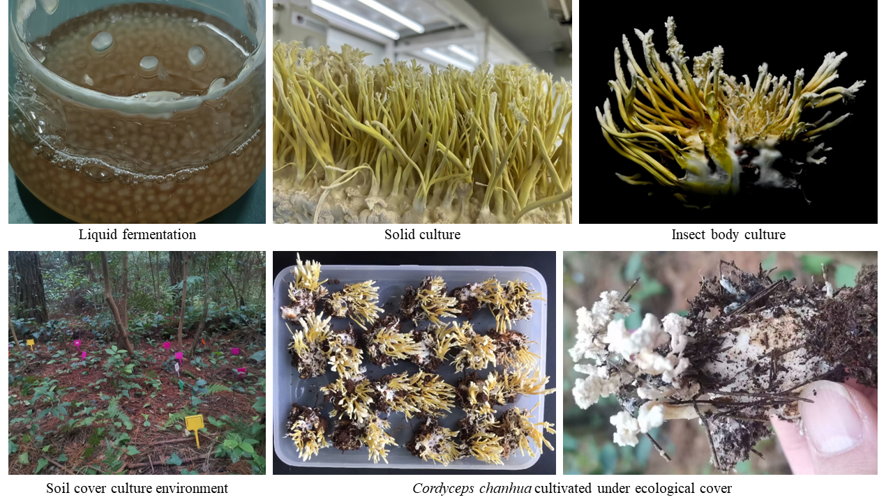

Fig. S2. Artificial cultivation of C. chanhua.

Fig. S3. The experimental method and sample sampling diagram. The red font in the figure represents the sample taken, JC is expressed as the sclerotium in the rigor stage, S2 is expressed as the sclerotium at cortices formation stage, and S3 is expressed as the sclerotium in the mature stage. Sm2 is expressed as the bacteriospheric soil at the stage of membrane formation and Sm3 is expressed as the bacteriospheric soil at the stage of Cordyceps chanhua maturation. Sck2 is expressed as the control soil of membrane formation stage. Sck3 is expressed as control soil at maturity, the same below.

Fig. S4. Schematic diagram of preparation of C. chanhua exocrine nitrogen aqueous solution and its effect on soil bacterial community

Fig. S5. The process of isolating bacteria in soils.

Fig. S6. The schematic diagram of plate streak.

Fig. S7. The standard of ammonia nitrogen concentration line

Fig. S8. The standard of nitrite nitrogen concentration line.

Fig. S9. Schematic diagram of extracting bacterial DNA using the chelex 100 method.

Fig. S10. Rarefaction curve.

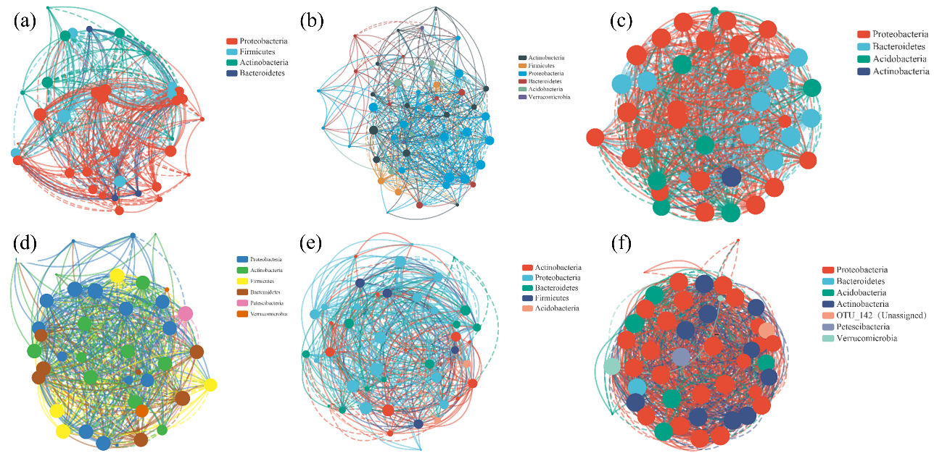

Fig. S11 Change of bacterial community co-occurrence network of different samples at the OTU level. (a) IS from three growth stages of C. chanhua. (b) BS and CS at P2 and P3 stages. (c) BS and CS at P2 stage of C. chanhua. (d) BS and CS at P3 stages. (e) Soil samples at P2 and P3 stages. (f) CS samples at P2 and P3 stages of the C. chanhua.

Fig. S12. SNN and SNck rarefaction curve.

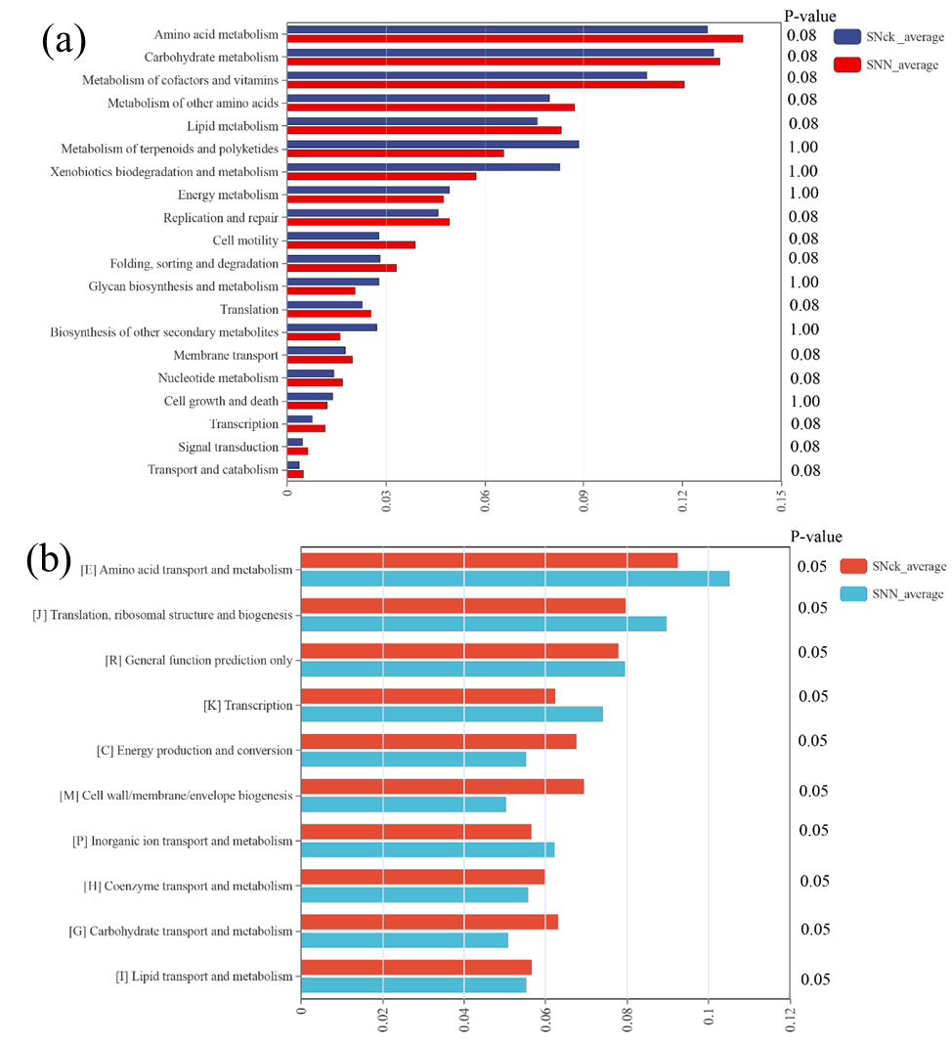

Fig. S13. Analysis of significant differences in KEGG and COG functions of bacterial communities in SNN and SNck samples. (a) Analysis of significant differences in KEGG function of bacterial communities in SNN and SNck soil samples. (b) Analysis of significant difference in prediction of COG function of bacterial communities in SNN and SNck soil samples.

Fig. S14. Colony morphology of B1, B5 and L4 on plate medium.

Fig. S15. Identification gel map of PCR amplification results.

References
- Hu G, Zhou Y, Mou D, Qu J, Luo L, Duan L, Xu Z, Zou X. Filtration effect of Cordyceps chanhua mycoderm on bacteria and its transport function on nitrogen. Microbiology Spectrum. 2024; 12(1): e01179-23. https://doi.org/10.1128/spectrum.01179-23.
- Yang X, Liang Q, Chen Y, Wang B. Alteration of methanogenic archaeon by ethanol contribute to the enhancement of biogenic methane production of lignite. Frontiers in Microbiology. 2019; 10: 2323. https://doi.org/10.3389/fmicb.2019.02323.
- Douglas GM, Maffei VJ, Zaneveld JR, Yurgel SN, Brown JR, Taylor CM, Huttenhower C, Langille MGI. PICRUSt2 for prediction of metagenome functions. Nature Biotechnology. 2020; 38: 685-688. https://doi.org/10.1038/s41587-020-0548-6.
- Gustavsen JA, Pai S, Isserlin R, Demchak B, Pico AR. RCy3: Network biology using Cytoscape from within R. F1000Research. 2019; 8: 1774. https://doi.org/10.12688/f1000research.20887.2.
- Watts SC, Ritchie SC, Inouye M, Holt KE. FastSpar: rapid and scalable correlation estimation for compositional data. Bioinformatics. 2019; 35: 1064-1066. https://doi.org/10.1093/bioinformatics/bty734.
- Weisburg WG, Barns SM, Pelletier DA, Lane DJ. 16S ribosomal DNA amplification for phylogenetic study. Journal of Bacteriology. 1991; 173: 697-703. https://doi.org/10.1128/jb.173.2.697-703.1991.
- Turner S, Pryer KM, Miao VPW, Palmer JD. Investigating deep phylogenetic relationships among cyanobacteria and plastids by small subunit rRNA sequence analysis. Journal of Eukaryotic Microbiology. 1999; 46: 327-338. https://doi.org/10.1111/j.1550-7408.1999.tb04612.x.

