Extended Data
Extended Data 1. RT-PCR detection of influenza A virus reported as Ct values of the pooled raw milk from intramammary inoculated cows fed to calves.
Pooled Milk without Antibodies |  | Pooled Milk with Antibodies
Day | Ct Value | Day | Ct Value
0 | 37.0 | 0 | 21.14
1 | 18.5 | 1 | 26.7
2 | 24.7 | 2 | 21.1
3 | 29.0 | 3 | 28.1

Extended Data 2. Clinical scores used to assess dairy calves.
Score | Behavior | Respiratory signs/Rate | Cough | Nasal discharge | Ocular Discharge | Feces
0 | Normal | Normal | Normal | Normal, serous discharge | Normal | Normal
1 | Mild lethargy with decrease in ambulation and attitude compared to pen mates | Slightly increased respiratory effort/slight dyspnea | Induce single cough | Small amount of unilateral, cloudy discharge | Mild ocular discharge (predominately in canthi) | Semi-formed, pasty
2 | Moderate lethargy with stimulation needed to provoke ambulation | Notable increase in respiratory effort/dyspnea | Induce repeated coughs or occasional spontaneous cough | Cloudy or excessive mucus | Moderate bilateral ocular discharge | Loose, but stays on top of bedding or dry and tacky
3 | Marked lethargy with ambulation not provoked by stimulation | Severe dyspnea with respiratory distress and tachypnea | Repeated spontaneous coughing | Copious, mucopurulent nasal discharge | Heavy ocular discharge (lashes coated) swelling/erythema of the eyelid | Watery, sifts through bedding
*Adapted from https://www.vetmed.wisc.edu/fapm/svm-dairy-apps/calf-health-scorer-chs/ Calf Health Scorer (CHS) – Food Animal Production Medicine – UW–Madison (wisc.edu)
Extended Data 3. Tissues and samples collected at necropsy and tested by RT-qPCR for Group One calves fed milk from inoculated cows.

Tissue | DPI 6 |  | DPI 13
 | 2410 | 2414 | 2411 | 2417
Tracheal swab
Olfactory bulb
Cerebrum
Cerebellum
Brainstem
Pharyngeal tonsil
Palatine tonsil
Lingual tonsil
Cranial part right cranial lung lobe
Caudal part right cranial lung lobe
Cranial part left cranial lung lobe
Caudal part left cranial lung lobe
Middle lung lobe
Accessory lung lobe
Caudal right lung lobe
Caudal left lung lobe
Retropharyngeal lymph node
Mandibular lymph node
Parotid lymph node
Tracheobronchial lymph node
Supramammary lymph node
Inguinal lymph node
Mesenteric lymph node
Heart
Thymus
Spleen
Pancreas
Liver
Kidney
Rumen
Reticulum
Omasum
Abomasum
Jejunum
Spiral colon
Descending colon
Urinare
Diaphragm
Pectoral muscle (Brisket)

Each column represents an individual animal. Green = Ct>38, orange = Ct 35-38, red = Ct <35, black = not collected.

Extended Data 4. Tissues and samples collected at necropsy and tested by RT-qPCR for Group Two calves fed milk from inoculated cows shedding virus and neutralizing antibodies.

Tissue | DPI 6 |  | DPI 13
 | 2950 | 2958 | 2947 | 2957
Olfactory bulb
Cerebrum
Pharyngeal Tonsil
Palatine Tonsil
Lingual Tonsil
Cranial part right cranial lung lobe
Caudal part right cranial lung lobe
Cranial part left cranial lung lobe
Caudal part left cranial lung lobe
Middle lung lobe
Accessory lung lobe
Caudal right lung lobe
Caudal right lung lobe
Retropharyngeal lymph node
Mandibular lymph node
Parotid lymph node
Tracheobronchial lymph node
Rumen
Reticulum
Omasum
Abomasum

Each column represents an individual animal. Green = Ct>38, orange = Ct 35-38, red = Ct <35, black = not collected.

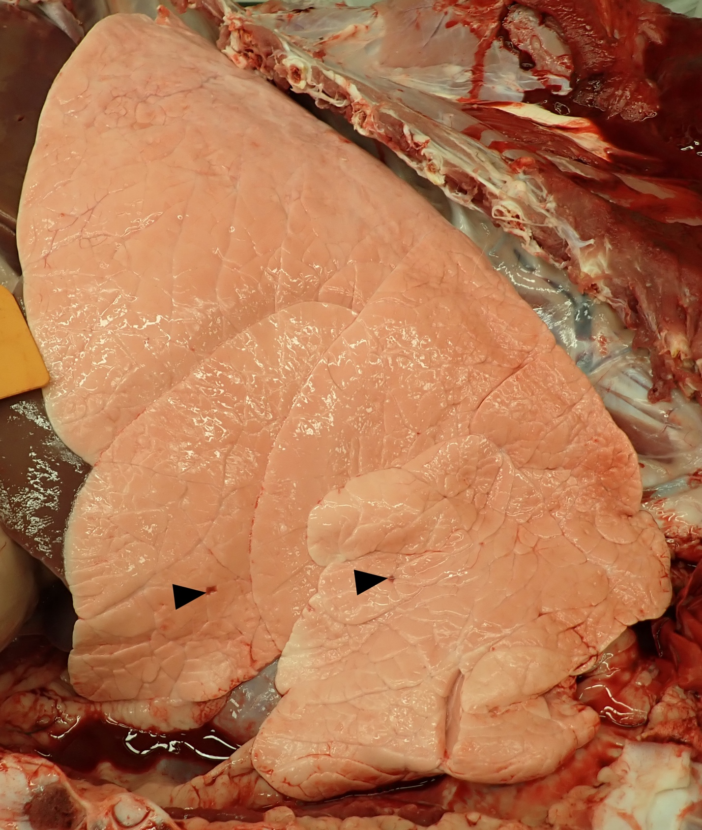
Extended Data Figure 1.Minimal multifocal obstructive atelectasis (arrowheads) consistent with influenza A virus at 6 dpi in calf 2411.
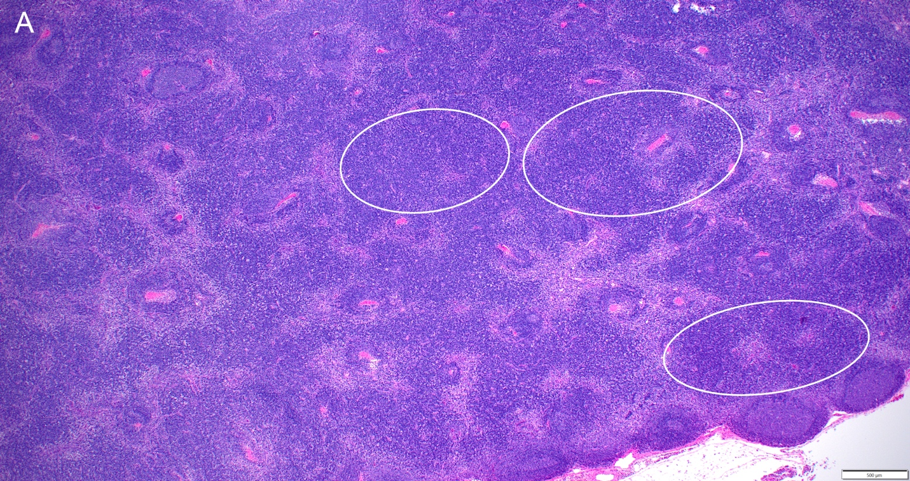
Extended Data Figure 2. Parafollicular hyperplasia (white circles) of the tracheobronchial lymph node in Calf 2414.
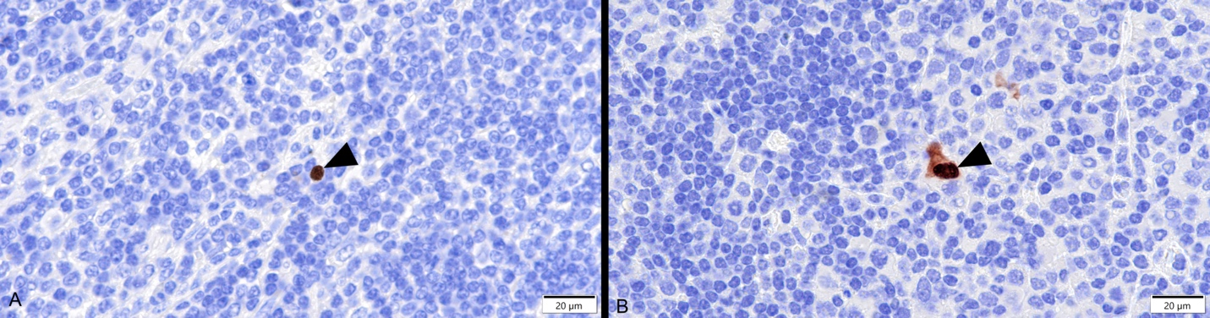

Extended Data Figure 3. Influenza A virus nucleoprotein antigen detection (brown) by immunohistochemistry in the nuclei (arrowhead) of leukocytes with different morphologies consistent with different cell types in the retropharyngeal lymph node of 2410 (A) and 2414 (B) necropsied on DPI 6.
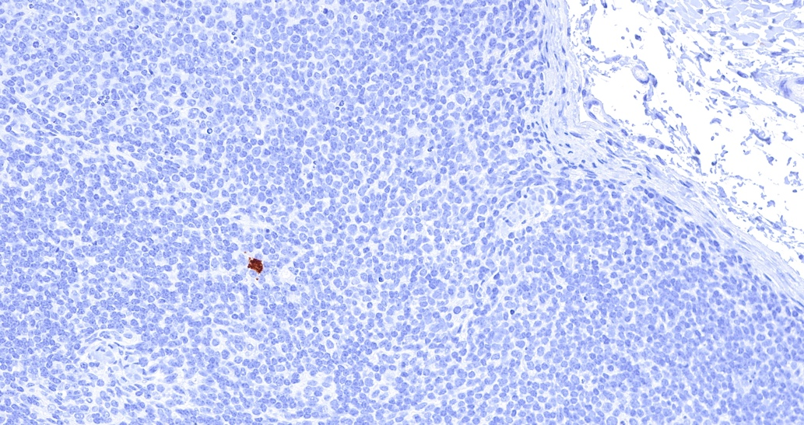
Extended Data Figure 4. Influenza A virus nucleoprotein antigen detection (brown) by immunohistochemistry in the nucleus (arrowhead) of a leukocyte in the retropharyngeal lymph node of 2950 necropsied on DPI 6.

