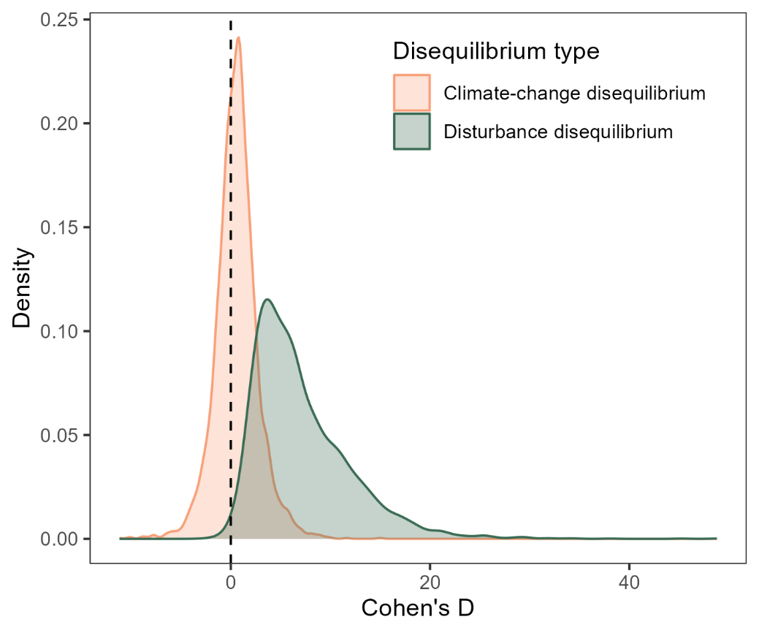
Extended Data Figure 1. Distribution density of Cohen’s D across all 3,047 European plant species, summarizing the severity of climate-change and disturbance disequilibrium. Cohen’s D was calculated from species-level comparisons of model performance using a pairwise t-test, between standard SDMs and models incorporating either dynamic climate variables (climate-change disequilibrium) or community derived disturbance indicators (disturbance disequilibrium). Positive values indicate improved model performance when including dynamic or disturbance-related predictors, reflecting strong disequilibrium. The density distribution shows the broad prevalence and contrasting severity of each disequilibrium type across species.

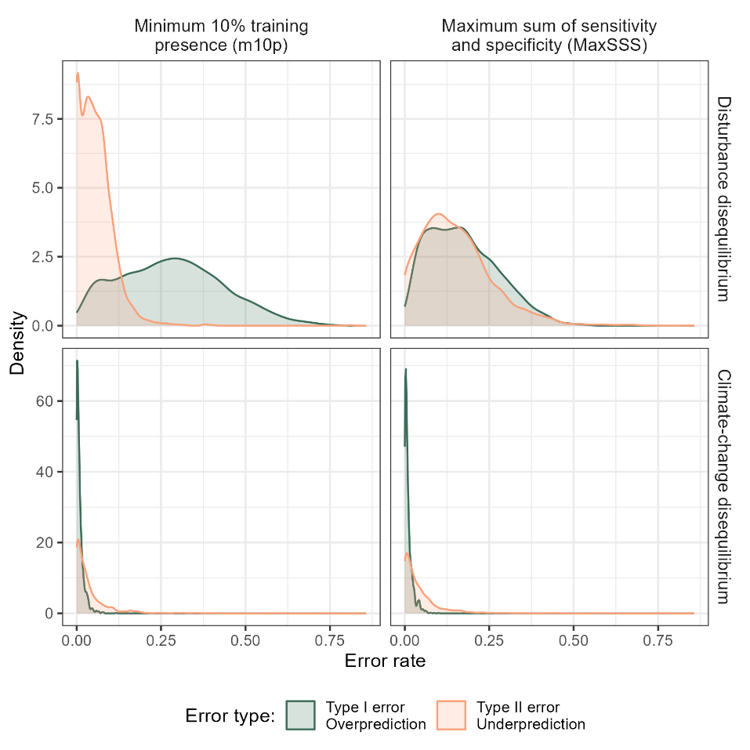
Extended Data Figure 2. Distribution of over- and underpredictions (Type I and II errors, respectively) across 3,047 European plant species. Distributions are shown separately for climate-change and disturbance disequilibrium and under two commonly used binary classification thresholds: the minimum 10th percentile training presence (m10p) and the maximum sum of sensitivity and specificity (MaxSSS) thresholds. Overpredictions represent plots where standard SDMs predicted presences, but where models incorporating either dynamic climate variables (climate-change disequilibrium) or community derived disturbance indicators (disturbance disequilibrium) correctly predicted absences, and vice versa for underpredictions. The m10p threshold, used in our main analyses, excludes marginally suitable sites (10th percentile of training presences) when predicting presences, and is a threshold insensitive to the predictions of suitability across absences. In contrast, the MaxSSS threshold minimizes total classification error but somewhat assumes equal error costs. This is problematic for disturbance disequilibrium, where absences often reflect omitted habitat conditions (e.g., light or disturbance regimes) not included in standard models, and likely have predicted suitability near-equal to those predicted for true presences⁵³. Consequently, by maximising sensitivity and specificity, MaxSSS balances false positives and negatives, masking the true extent and dominant error type pertaining to disturbance disequilibrium. As shown here, overpredictions dominate under the m10p threshold for disturbance disequilibrium, whereas error types were more balanced under MaxSSS. This issue is specific to disturbance disequilibrium, where key filtering variables are not included as model predictors⁵³. This is emphasized by the similar distribution of error types when examining climate-change disequilibrium, regardless of threshold; because climate-change disequilibrium is a temporal mismatch in the association between climate conditions and species’ presences, rather than an inability to distinguish suitable and unsuitable plots because of a missing predictor.
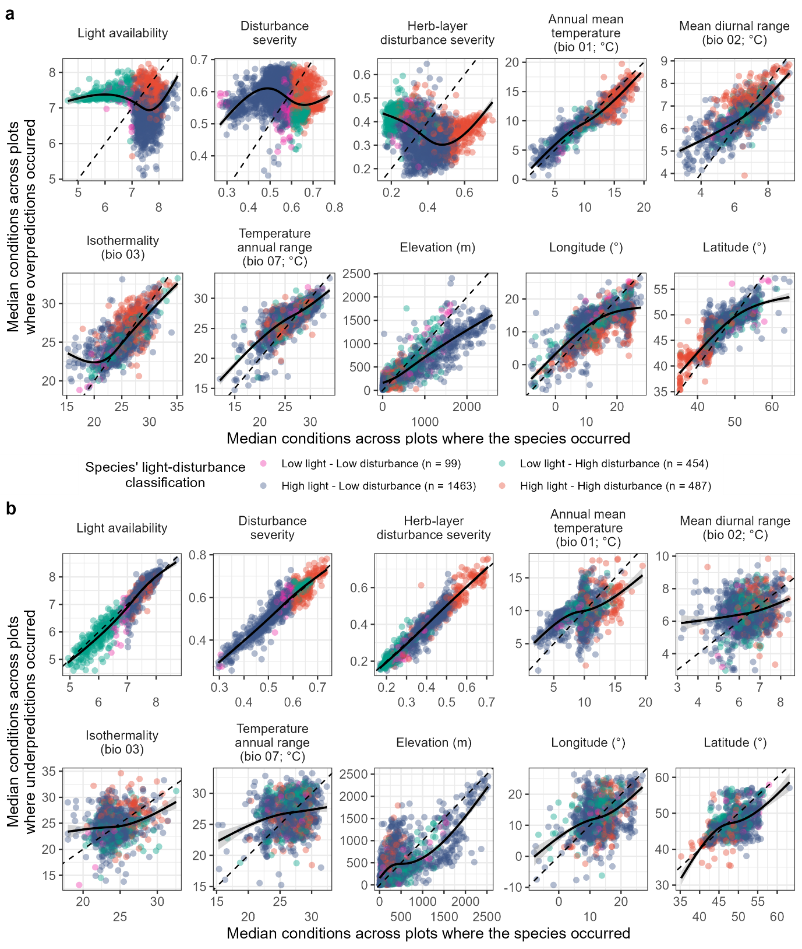
Extended Data Figure 3. Distribution of species-specific disturbance disequilibrium across 10 environmental gradients for (a) overpredictions and (b) underpredictions. (a) Overpredictions are plots where standard SDMs predicted presences but disturbance-informed SDMs correctly predicted absences—indicating likely exclusion due to unsuitable disturbance conditions despite climatic suitability. (b) Underpredictions are plots where standard SDMs predicted absences but disturbance-informed SDMs correctly predicted presences—suggesting truncated climatic niches that became detectable when disturbance conditions were included. For each species, the median value of a given environmental variable across over-/underpredicted plots (y-axis) is plotted against the median across occupied plots (x-axis). The dashed 1:1 line indicates no difference in conditions; points above or below show whether over-/underpredictions occurrence in environments with higher or lower values, respectively. Generalized additive model (GAM) curves show across-species trends. Species were heuristically classified based on thresholds in light availability (7) and disturbance severity (0.6), determined where GAM lines crossed the 1:1 dashed line for analyses of overpredictions (a). Analyses included species with significant disturbance disequilibrium and at least five overpredicted (n = 2,502) or underpredicted (n = 1465) plots.
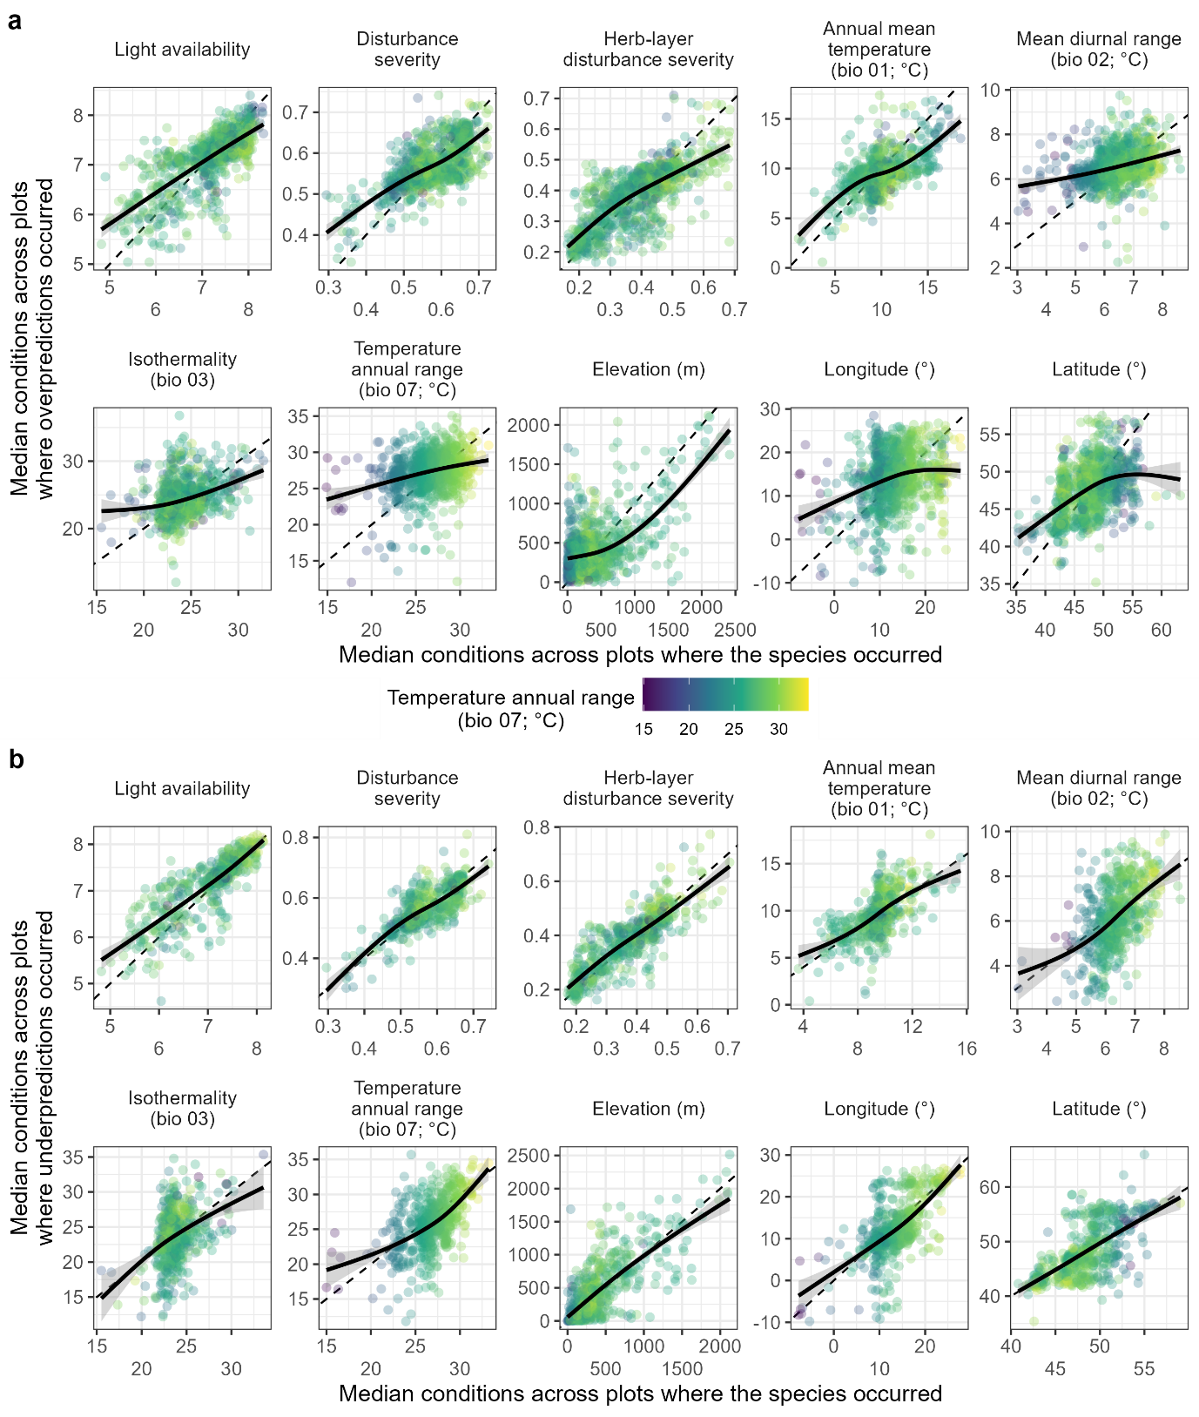
Extended Data Figure 4. Distribution of species-specific climate-change disequilibrium across 10 environmental gradients for (a) overpredictions and (b) underpredictions. (a) Overpredictions are plots where standard SDMs predicted presences but dynamic SDMs correctly predicted absences—indicating where static variables lead to overestimations of suitability. (b) Underpredictions are plots where standard SDMs predicted absences but dynamic SDMs correctly predicted presences—indicating where excluding climate dynamics led to a truncation of the estimated climate niche. For each species, the median value of a given environmental variable across over-/underpredicted plots (y-axis) is plotted against the median across occupied plots (x-axis). The dashed 1:1 line indicates no difference in conditions; points above or below show whether over-/underpredictions occurrence in environments with higher or lower values, respectively. Generalized additive model (GAM) curves show across-species trends. Species were coloured based on the most important predictor of climate-change disequilibrium when analysing severity-attribute associations: temperature annual range. Analyses included species with significant climate-change disequilibrium and at least five overpredicted (n = 987) or underpredicted (n = 575) plots.
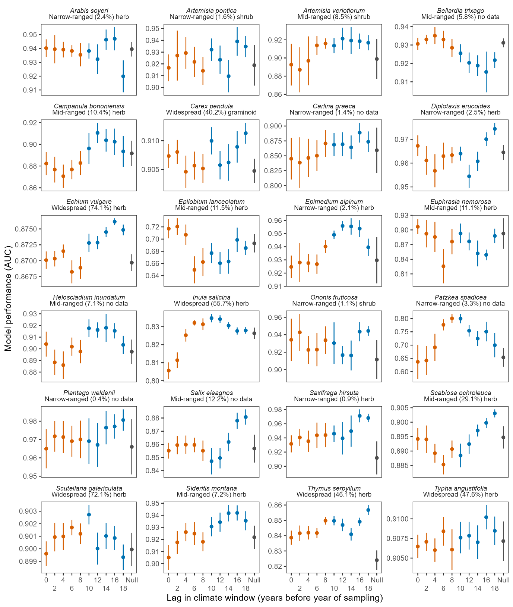
Extended Data Figure 5. Climate window performance across 24 randomly selected species with significant climate-change disequilibrium. Each panel title contains the species’ name, range size label, range size’s percentile, and its growth form (labelled “no data” when unavailable). Models tested 5-year moving-window climate averages spanning 0 to 18 years before the sampling year (in 2-year increments); points show mean performance (AUC) across 10 replicates, with error bars indicating standard deviation. Colors indicate the window’s binning as recent (orange), older (blue), or null (grey). “Null” indicates the performance of standard static-climate-only SDMs.

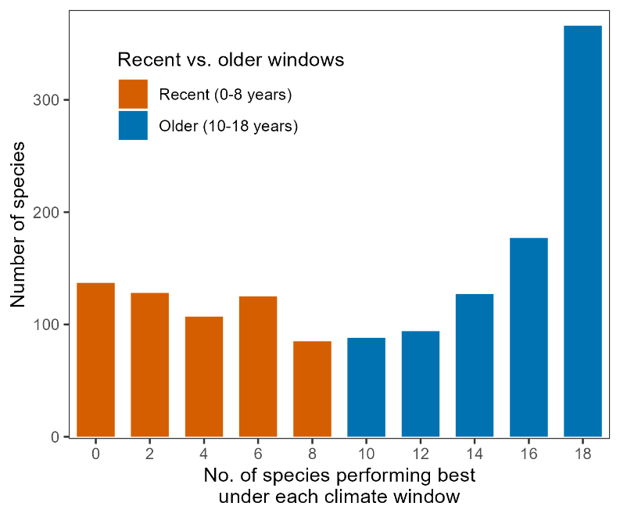
Extended Data Figure 6. Distribution of the best-performing climate windows across species. Windows are coloured as recent (0 – 8 years; orange) and older (10 – 18 years; blue). Plot shows a total of 1,434 species. Species without significant climate-change disequilibrium were excluded.

