Plant range disequilibrium in Europe is shaped more by disturbance than climate change
Supplementary Information 1 of 1
Table of Contents
Extended results 2
Supplementary Figure 1. Distribution of model performance assessed using TSS across four model types. 2
Supplementary Figure 2. As the single predictor in univariate models, the relationship between disturbance and climate-change disequilibrium severity and various species attributes. 3
Supplementary Figure 3. In a variant model set-up without light availability and disturbance severity as predictors, the relationship between disturbance and climate-change disequilibrium severity and various species attributes as single predictors. 4
Supplementary Figure 4. In a variant model set-up with longitude replacing latitude as a predictor, the relationship between disturbance and climate-change disequilibrium severity and various species attributes as single predictors. 5
Extended methods 6
Supplementary Section 1. Data preparation 6
Supplementary Figure 5. Distribution of the final, “usable”, post-thinning plot data across our study area of Europe (n = 525,638). 6
Supplementary Table 1. List of climate variables considered as predictors for the SDMs. 7
Supplementary Section 2. Species distribution models 8
Supplementary Section 3. Severity and attributes 8
Supplementary Table 2. Full list of species attributes considered and those selected after excluding for highly correlated variables. 9
Supplementary Table 3. Full list of post-filtered predictors and their variance inflation factor (VIF) for various model variants. 11
References 13

Extended results
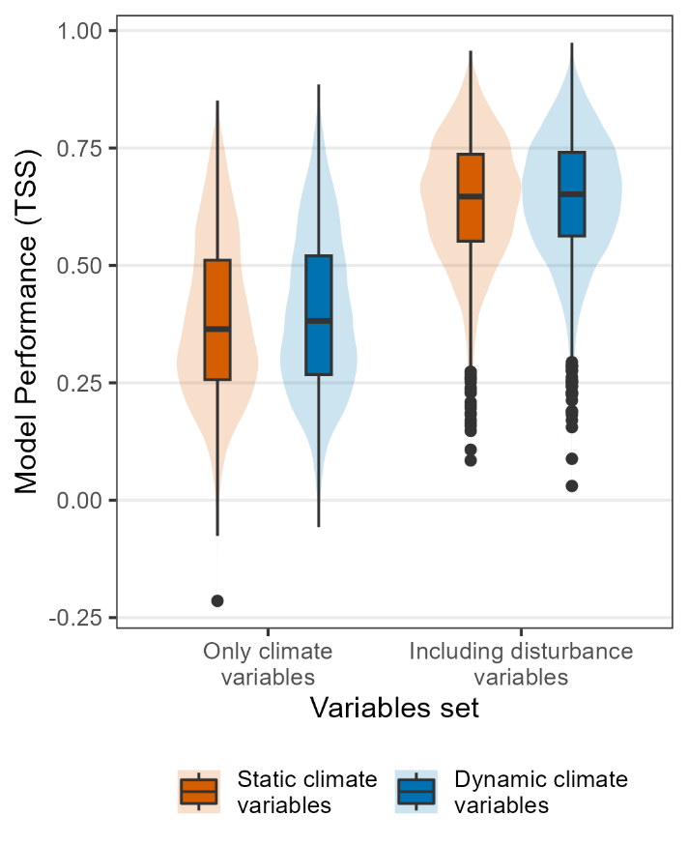
Supplementary Figure 1. Distribution of model performance assessed using TSS across the four model types. True skill statistic (TSS) is a discriminatory test of binary predictive performance, quantified as 1 minus the sum of sensitivity and specificity, and is another popular metric of SDM performance. Model performance, assessed using TSS, are shown for 3,047 European plant species across models differing in their use of climate variables (static vs. dynamic; colors) and the inclusion of disturbance variables (only climate vs. including disturbances; x-axis). Box-and-whisker plots show the median, spread, and variation in TSS across species. Static models used long-term climate averages, while dynamic models incorporated 5-year moving windows to capture lagged responses. Models including habitat predictors used community-derived indicators of light availability, disturbance severity, and herb-layer disturbance severity. All models were significantly different from each other, showing similar performance rankings as in the main text for AUC.
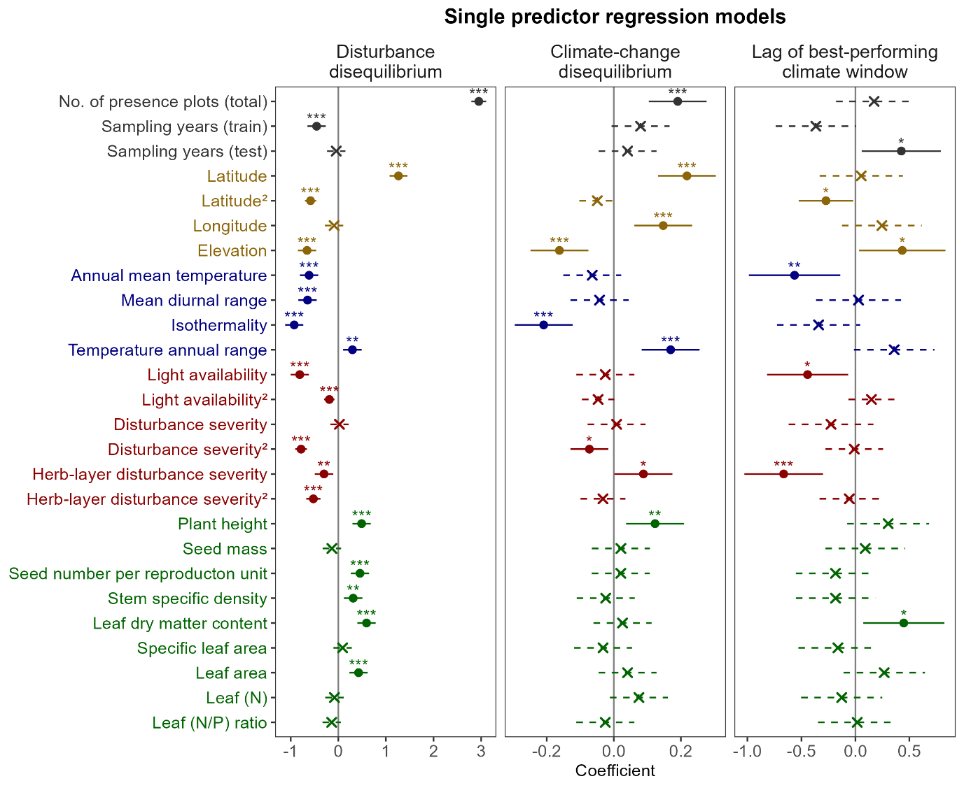
Supplementary Figure 2. As the single predictor in univariate models, the relationship between disturbance and climate-change disequilibrium severity and various species attributes. Generalized linear models (GLMs) were used to assess how various species attributes relate to disturbance (left) and climate-change (center) disequilibrium, measured using Cohen’s D, for 2,529 European plant species with complete trait data, and to lag length (right) as defined by the best-performing window for 1,204 species with significant climate-change disequilibrium and complete trait data. Species attributes included data characteristics (black), geographic variables (gold), bioclimatic conditions (blue), disturbance indicators (red), and plant functional traits (green). For all non-trait attributes, species-level median across presence plots was used. Points indicate model coefficients (solid for significant, cross for non-significant), 95% confidence intervals shown (solid lines for significant effects, dashed for non-significant). Significance levels are denoted by asterisks (* < 0.05, ** < 0.01, *** < 0.001).
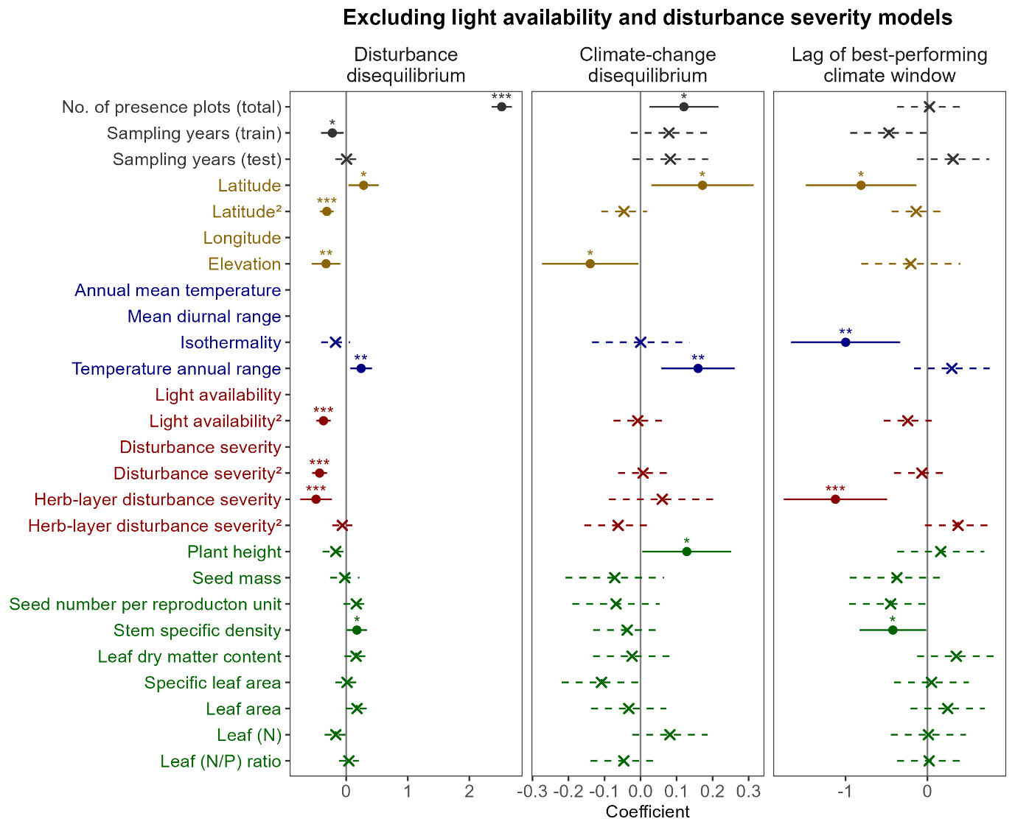
Supplementary Figure 3. In a variant model set-up without light availability and disturbance severity as predictors, the relationship between disturbance and climate-change disequilibrium severity and various species attributes as single predictors. Generalized linear models (GLMs) were used to assess how various species attributes relate to disturbance (left) and climate-change (center) disequilibrium, measured using Cohen’s D, for 2,529 European plant species with complete trait data, and to lag length (right) as defined by the best-performing window for 1,204 species with significant climate-change disequilibrium and complete trait data. Species attributes included data characteristics (black), geographic variables (gold), bioclimatic conditions (blue), disturbance indicators (red), and plant functional traits (green). For all non-trait attributes, species-level median across presence plots was used. Points indicate model coefficients (solid for significant, cross for non-significant), 95% confidence intervals shown (solid lines for significant effects, dashed for non-significant). Significance levels are denoted by asterisks (* < 0.05, ** < 0.01, *** < 0.001).
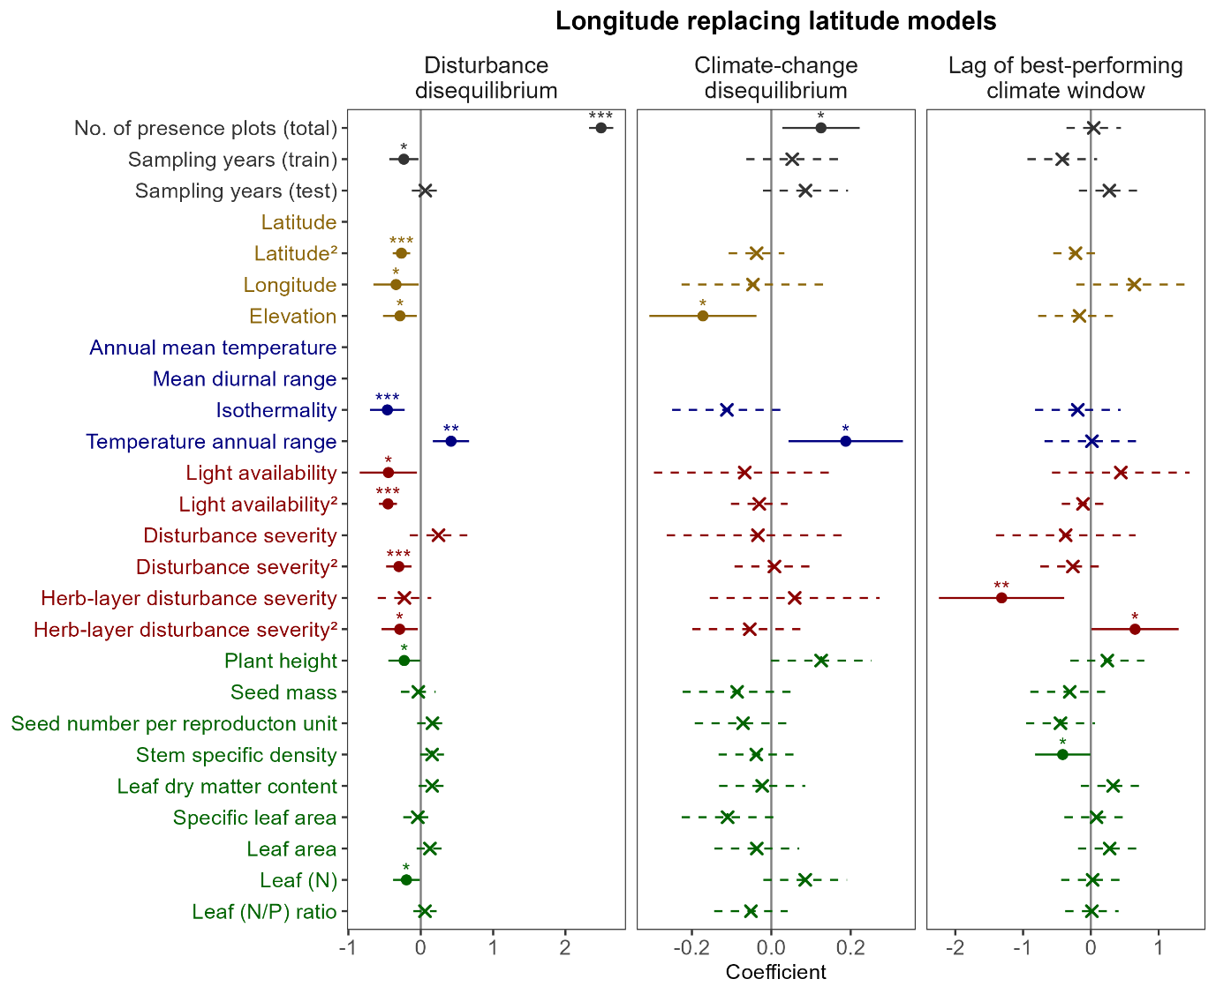
Supplementary Figure 4. In a variant model set-up with longitude replacing latitude as a predictor, the relationship between disturbance and climate-change disequilibrium severity and various species attributes as single predictors. Generalized linear models (GLMs) were used to assess how various species attributes relate to disturbance (left) and climate-change (center) disequilibrium, measured using Cohen’s D, for 2,529 European plant species with complete trait data, and to lag length (right) as defined by the best-performing window for 1,204 species with significant climate-change disequilibrium and complete trait data. Species attributes included data characteristics (black), geographic variables (gold), bioclimatic conditions (blue), disturbance indicators (red), and plant functional traits (green). For all non-trait attributes, species-level median across presence plots was used. Points indicate model coefficients (solid for significant, cross for non-significant), 95% confidence intervals shown (solid lines for significant effects, dashed for non-significant). Significance levels are denoted by asterisks (* < 0.05, ** < 0.01, *** < 0.001).

Extended methods

Supplementary Section 1. Data preparation
After our filtering process of vegetation plots, 1,138,587 remain. Plot density was highest in Denmark, Netherlands, Czechia, the Alps including parts of Switzerland and eastern France, the Apennines in Italy, and the Pyrenees including northern Spain and southern France (Supplementary Fig. 5).
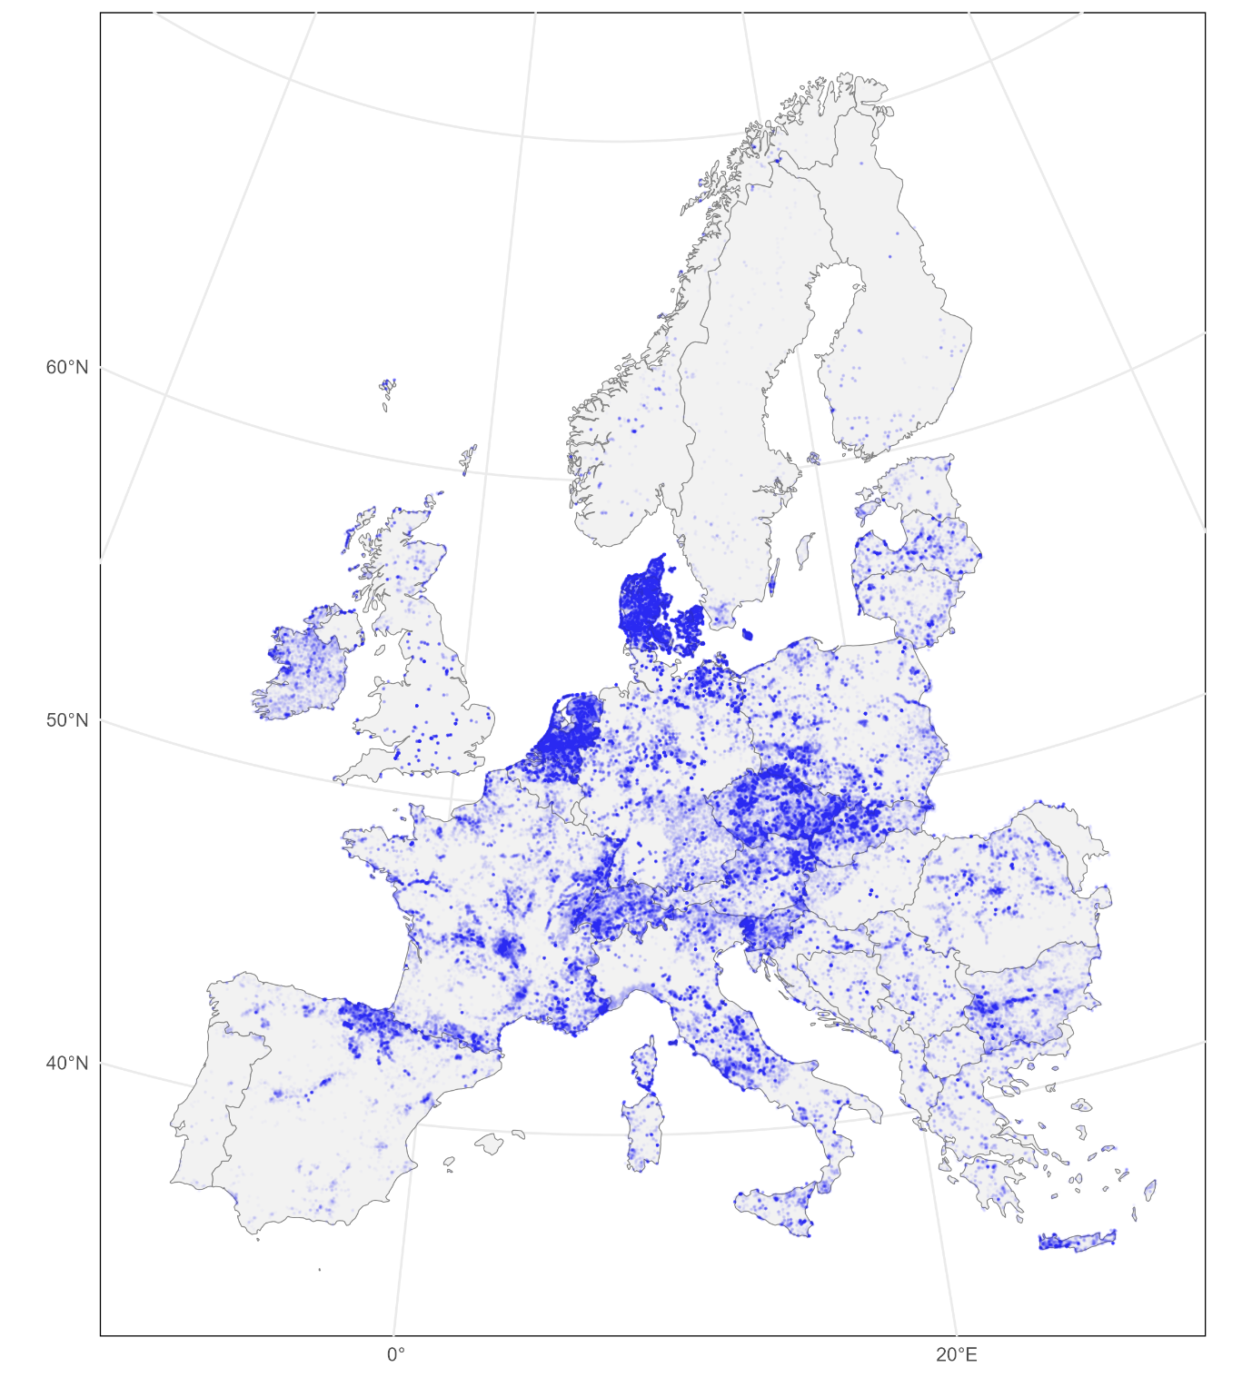
Supplementary Figure 5. Distribution of the final, “usable”, post-thinning plot data across our study area of Europe (n = 525,638). Points were plotted with an opacity value of 0.01, where darker blue areas indicate a higher density of plots and light blue areas indicate a lower density of plots. Darker grey lines indicate country borders.
All climate data were sourced from the UERRA regional reanalysis for Europe dataset (retrieved 18th October 2023; Copernicus Climate Change Service 2019). Daily near-surface temperature and precipitation records from 1961 to 2018 were obtained from the MESCAN-SURFEX system (5.5 km by 5.5 km). Daily temperature data contained four measurements, at 00, 06, 12, and 18 UTC, which was used to first calculate daily mean, min, and max temperature. Daily measurements of mean, min, and max were then averaged to calculate monthly mean, min, and max temperatures. Meaning the average of those moments was calculated for the month, e.g., minimum monthly temperature was the minimum temperature observed for each day, averaged across days for a given month. Precipitation values only contained one measurement per day, which was then summed across days within each month. These monthly variables were needed to calculate the bioclimatic variables considered. While several calculations allowed input data using daily climate variable to potentially calculate variables with greater accuracy (e.g., for calculating growing degree days), the temporal and spatial extent of our study limited our capacity to do so due to space and computational limitations.
A large selection of annual climate variables was considered. Namely, the commonly used 19 bioclimatic variables, and additional variables related to growth, snow, and frost. All variables were handled in R (R Core Team 2013) using the ‘terra’ package (Hijmans et al. 2022). We accessed SAGA GIS (9.1.2) using the ‘Rsagacmd’ package (Pawley 2019). The Climate and Weather Tools in SAGA GIS was used to calculate all bioclimatic variables (Conrad et al. 2015), namely: the bioclimatic variables based off the WorldClim – Global Climate Data project (Hijmans et al. 2005), growing degree days (Karger et al. 2017), tree growth season (Paulsen and Körner 2014, Karger et al. 2019), frost change frequency (Conrad et al. 2015), and snow cover (Paulsen and Körner 2014).
Precipitation variables based on temperature-defined periods, and vice versa, were excluded from the original 19 bioclimatic variables (four of these type of variables in total) due to spatial artifacts that typically arise from sudden changes in classification periods (months or quarters) resulting in jumps in values owing primarily to that change in classification period, not the actual climate conditions itself. Day specific growth-related variables were excluded as they were considered uninformative and non-applicable at continental scale development of SDMs, e.g., first growing degree day or first tree growing day; partly also because values are NA when all days of the year are growing days. The same applied to multiple snow- and frost-related variables, e.g., standard deviation of daily temperature span of frost change days. Hence, we pre-selected 21 annual climate variables, covering a wide range of climatic processes that are expected to drive plant distribution dynamics across Europe (Supplementary Table 2).
Supplementary Table 1. List of climate variables considered as predictors for the SDMs. Final predictors column indicates the final seven variable used as predictors for the SDMs after excluding highly correlated variables (r ≥ 0.7).
Predictors | Notes | Final predictors (SDM)
Annual mean temperature (bio 01) |  | ✓
Mean diurnal range (bio 02) | Mean of monthly (max temp - min temp) | ✓
Isothermality (bio 03) | (bio 02 / bio 07) x 100 | ✓
Temperature seasonality (bio 04) | Standard deviation x 100 | ✓
Max temperature of warmest month (bio 05)
Min temperature of coldest month (bio 06)
Temperature annual range (bio 07) | bio 05 - bio 06
Mean temperature of warmest quarter (bio 10)
Mean temperature of coldest quarter (bio 11)
Annual precipitation (bio 12) |  | ✓
Precipitation of wettest month (bio 13)
Precipitation of driest month (bio 14)
Precipitation seasonality (bio 15) | Coefficient of variation | ✓
Precipitation of wettest quarter (bio 16)
Precipitation of driest quarter (bio 17)
Growing degree days (>0°C)
Growing degree days (>5°C)
Growing degree days (>10°C)
Tree growth season length | Soil water capacity was not included in calculations
Snow cover days
Frost change frequency |  | ✓

Supplementary Section 2. Species distribution models
We developed SDMs that accounted for disequilibrium dynamics to measure disequilibrium severity. The greater the increase in model performance, the greater the severity of disequilibrium is present. Because our study partly focused on climate change effects, we temporally split our training and testing data to test model performance by forcing models to project forward across a period of known climate change. A rough 20-year period was chosen for each temporal bin of data, which roughly translates to the common time period used for averaging climate values in other popular climate dataset, such as WorldClim (Fick and Hijmans 2017) or CHELSA climate data (Karger et al. 2017). In this way, the static-climate-only SDMs being trained on an early dataset (1981-2003) and validated on a later dataset (2004-2018) also represents how SDMs are typically used to predict future climate change impacts. Although the velocity of future, post-2030 climate change is likely to be much larger than what is tested here, our temporal splitting of the data offers some insights into how ignoring species ongoing responses and lags in those responses to recent climate change affects the predictive accuracy of SDMs.
Species presence data were spatially thinned with a 10 km buffer to reduce autocorrelation, i.e., presences occurring within 10 km of another were removed, using the ‘spThin’ package in R (Aiello-Lammens et al. 2015). Thinning was applied 10 times (replicates), where the replicate with the greatest number of remaining presences, and then the most recent average year of sampling, was chosen. In this way, presence data was maximized while more recent sampling records were prioritized. The same was applied to each temporal bin. Absences were binned and thinned identically to presence plots.

Supplementary Section 3. Severity and attributes
To quantify the severity of distributional disequilibrium for each species, we used Cohen’s D as a standardized effect size metric, derived from the t-value obtained through species-specific pairwise t-tests. These t-tests compared model performance (as measured by AUC) between models that incorporated disequilibrium-related predictors (i.e., dynamic climate or disturbance variables) and the baseline static-climate-only models.
For each species, we ran 10 replicate models under each modelling protocol (same subset of training data was used across models for each replicate) and calculated the t-value from a paired t-test comparing the AUCs of the two models.
Cohen’s D provides a standardized, directionally aware estimate of the magnitude of model performance improvement—positive values indicate the disequilibrium-informed model outperformed the static baseline, while negative values would indicate poorer performance.
We chose Cohen’s D because it (1) naturally incorporates variance across model replicates, providing a measure of the consistency of model improvement, (2) allows comparison of disequilibrium severity across species, regardless of differences in raw AUC values, and (3) avoids the pitfalls of directly calculated proportion-based metrics (i.e., ratio of incorrect predictions against total sample size, presences, or absences), which can be unstable and difficult to compare across species with unequal prevalence or sample sizes (e.g., overpredictions in rare vs. common species).
Ecologically, higher Cohen’s D values indicate species for which ignoring disturbance or climate-change dynamics results in systematic model failure—a signature of stronger disequilibrium between predicted and realized distributions. Conversely, near-zero or negative values suggest either equilibrium or no consistent improvement from accounting for dynamic processes. While cases of negative values were rare for disturbance-informed SDMs, negative values were more common for dynamic SDMs. Negative values, however, do not indicate “negative disequilibrium”, but that static climate conditions averaged over about two decades better predict species distributions than our tested form of dynamic climate variables. A negative value also does not necessarily mean that climate-change disequilibrium was not present, just that our tested form of dynamic SDMs did not detect it.
To explore potential species-level drivers of disequilibrium severity (Cohen’s D), we considered several species attributes, including those described in the main text. Several were excluded a prior to the pre-modelling correlation test because (a) they were not relevant to our hypothesis of where disequilibrium severity is likely greatest (e.g., stem conduit density and salinity indicator values) or (b) were found to exhibit high correlation with another variable early on (e.g., the number of presence plots, in total, within the training data bin, and within the testing data bin). Of relevance to the main text was estimated range size, which was highly correlated with the total number of presence plots (r = 0.86). Range size was estimated for each species using an alpha-hull approach applied to all unique geographic coordinates of vegetation plot occurrences (post data thinning but for both training and testing data). We implemented the getDynamicAlphaHull function from the ‘rangeBuilder’ package (v2.1) (Davis Rabosky et al. 2016) in R to construct species ranges, using a 90% inclusion fraction, a 10 km buffer, and a dynamic alpha parameter capped at 10. Hulls were clipped to terrestrial coastlines. Estimated range size was used when randomly selecting for narrow-ranged and widespread species for illustrating their climate-window performance (main text Fig. 4).
In total, five types of species attributes were considered.
- Data characteristics—describe attributes of the available occurrence data for each species. These included the total number of presence plots and the median year of sampling for both training and testing data. Relationships with these attributes may indicate data-related biases, such as changes in sampling effort or representation over time.
- Geographical variables—characterize the general distributional centroid of each species in geographic space, including median latitude, longitude, and elevation across all presence plots. These variables help capture broad-scale spatial tendencies that may relate to macroecological gradients or regional habitat types.
- Climate variables—describe the median macroclimatic conditions where each species was observed. These were derived from the UERRA climate dataset and included annual mean temperature, mean diurnal range, isothermality, and temperature annual range—capturing different dimensions of temperature variability and climatic regime. Note, precipitation variables were highly correlated with several geographical variables and excluded during the pre-modelling filtering step.
- Disturbance-related indicators—reflect the median habitat conditions in which species occurred, based on community-derived indicator values of light availability, disturbance severity, and herb-layer disturbance severity. These values represent the realized vegetation structure and composition shaped by disturbance regimes (e.g., grazing, fire, clear-cutting), rather than direct measurements of disturbance events themselves. They serve as proxies for the ecological filtering effects of disturbance on species distributions.
- Plant functional traits—include a suite of ecologically meaningful traits related to plant size, growth rate, tissue structure, and nutrient economy. These traits were obtained from a gap-filled version of the TRY database and they provide insight into species’ life-history strategies and potential ecological tolerances.
Supplementary Table 2. Full list of species attributes considered and those selected after excluding for highly correlated variables. Five types of species attributes were considered. (1) Data characteristics that quantified attributes related to the data available for the species, where significant relationships with these attributes may indicate potential data-related biases. However, the total number of presence plots was highly correlated to estimated range size (r = 0.86), making it difficult to separate the effects of these two attributes. (2) Geographical type variables that describe the general distribution pattern of the species across geographic space. (3) Climate variables that describe the median climate conditions for which the species were found in. (4) Disturbance-related indicators reflect the general habitat conditions in which species were found, specific to indicators related to disturbance. Note, indicators here reflect the resulting vegetation structure and composition rather than direct measurements of disturbance processes. (5) Plant functional traits are a collection of ecologically relevant traits relating species’ life-history strategies and potential ecological tolerances.
Predictors | Attribute type | Post-filtering remaining predictors (severity ~ attribute GLM)
No. of presence plots (total) | Data characteristic | ✓
Sampling years (train) | Data characteristic | ✓
Sampling years (test) | Data characteristic | ✓
Latitude | Geographical | ✓
Latitude² | Geographical | ✓
Longitude | Geographical | ✓
Elevation | Geographical | ✓
Annual mean temperature (bio 01) | Climatic | ✓
Mean diurnal range (bio 02) | Climatic | ✓
Isothermality (bio 03) | Climatic | ✓
Temperature seasonality (bio 04) | Climatic
Max temperature of warmest month (bio 05) | Climatic
Min temperature of coldest month (bio 06) | Climatic
Temperature annual range (bio 07) | Climatic | ✓
Mean temperature of warmest quarter (bio 10) | Climatic
Mean temperature of coldest quarter (bio 11) | Climatic
Annual precipitation (bio 12) | Climatic
Precipitation of wettest month (bio 13) | Climatic
Precipitation of driest month (bio 14) | Climatic
Precipitation seasonality (bio 15) | Climatic
Precipitation of wettest quarter (bio 16) | Climatic
Precipitation of driest quarter (bio 17) | Climatic
Growing degree days (>0°C) | Climatic
Growing degree days (>5°C) | Climatic
Growing degree days (>10°C) | Climatic
Tree growth season length | Climatic
Snow cover days | Climatic
Frost change frequency | Climatic
Light availability | Disturbance-related indicator | ✓
Light availability² | Disturbance-related indicator | ✓
Disturbance severity | Disturbance-related indicator | ✓
Disturbance severity² | Disturbance-related indicator | ✓
Disturbance frequency | Disturbance-related indicator
Herb-layer disturbance severity | Disturbance-related indicator | ✓
Herb-layer disturbance severity² | Disturbance-related indicator | ✓
Herb-layer disturbance frequency | Disturbance-related indicator
Plant height | Plant functional trait | ✓
Seed mass | Plant functional trait | ✓
Seed length | Plant functional trait
Seed number per reproduction unit | Plant functional trait | ✓
Dispersal unit length | Plant functional trait
Stem specific density | Plant functional trait | ✓
Leaf dry matter content | Plant functional trait | ✓
Specific leaf area | Plant functional trait | ✓
Leaf area | Plant functional trait | ✓
Leaf fresh mass | Plant functional trait
Leaf (N) | Plant functional trait | ✓
Leaf (N/P) ratio | Plant functional trait | ✓

After excluding highly correlated species attributes (r ≥ 0.7), 26 attributes remained, including the quadratic terms for latitude, light availability, disturbance severity, and herb-layer disturbance severity. All 26 attributes were initially used as predictors in the generalized linear regression model, with disequilibrium severity (Cohen’s D) as the response variable. However, even after pre-filtering for highly correlated predictors, model variance inflation factors (VIFs) were high. We therefore excluded the predictor with the highest VIF sequentially. However, for the main model, we decided to retain disturbance severity (VIF = 9.7) and light availability (VIF = 8.9). Despite their VIFs exceed the strict threshold of 5, those variables were retained as they were necessary for interpreting their quadratic terms. Additionally, VIFs for those two variables had not exceeded 10 and were thus within acceptable boundaries. However, as a precaution, we explored models for which light availability and disturbance severity were excluded. Latitude was another high VIF predictor (VIF = 7.3), but was important to our hypothesis on where disturbance disequilibrium might be greatest following (Vera 2000). Hence, we excluded the next predictor, which was interestingly longitude (VIF = 7.2). Excluding longitude brought down the VIF of latitude (7.3 to 4.5) and also notably isothermality (5.7 to 2.5) and temperature annual range (3.9 to 1.4), indicating some level of multicollinearity between them; changes in VIF among other predictors were comparatively small.
Supplementary Table 3. Full list of post-filtered predictors and their variance inflation factor (VIF) for various model variants. Values were rounded to one decimal place. Missing values indicate that the predictor was not included in this model variant (grey box). The column detailing the final set of predictors presented in the main text is bolded.
Predictor | Full model | Removing high VIF predictors | Removing high VIF predictors | Final model | Variant model (longitude for latitude) | Variant model (excl. disturbance severity) | Variant model (excl. disturbance severity and light)
No. of presence plots (total) | 1.3 | 1.3 | 1.3 | 1.3 | 1.3 | 1.3 | 1.3
Sampling years (train) | 1.8 | 1.8 | 1.8 | 1.6 | 1.8 | 1.6 | 1.5
Sampling years (test) | 1.6 | 1.6 | 1.6 | 1.6 | 1.6 | 1.5 | 1.5
Latitude | 16.0 | 7.3 | 7.3 | 4.5 |  | 3.0 | 2.8
Latitude² | 2.2 | 2.1 | 2.1 | 1.7 | 1.7 | 1.5 | 1.4
Longitude | 7.3 | 7.2 | 7.2 |  | 4.4
Elevation | 20.1 | 2.8 | 2.8 | 2.7 | 2.5 | 2.5 | 2.5
Annual mean temperature | 33.8
Mean diurnal range | 31.8 | 31.4
Isothermality | 24.4 | 24.4 | 5.7 | 2.5 | 2.6 | 2.5 | 2.5
Temperature annual range | 20.0 | 18.2 | 3.9 | 1.4 | 2.8 | 1.4 | 1.4
Light availability | 11.0 | 9.1 | 8.9 | 8.7 | 7.2 | 7.3
Light availability² | 2.7 | 2.5 | 2.5 | 2.4 | 2.2 | 2.4 | 2.0
Disturbance severity | 11.0 | 9.7 | 9.7 | 9.6 | 7.2
Disturbance severity² | 3.8 | 3.5 | 3.5 | 3.5 | 3.3 | 1.7 | 1.6
Herb-layer disturbance severity | 6.4 | 6.3 | 6.3 | 6.3 | 6.2 | 6.1 | 3.0
Herb-layer disturbance severity² | 5.4 | 5.2 | 5.2 | 5.2 | 4.8 | 3.0 | 2.0
Plant height | 2.2 | 2.2 | 2.2 | 2.2 | 2.2 | 2.1 | 2.1
Seed mass | 2.6 | 2.6 | 2.6 | 2.6 | 2.6 | 2.6 | 2.6
Seed number per reproduction unit | 2.0 | 2.0 | 2.0 | 2.0 | 2.0 | 2.0 | 2.0
Stem specific density | 1.2 | 1.2 | 1.2 | 1.2 | 1.2 | 1.2 | 1.2
Leaf dry matter content | 1.6 | 1.6 | 1.6 | 1.6 | 1.6 | 1.6 | 1.6
Specific leaf area | 1.8 | 1.8 | 1.8 | 1.8 | 1.8 | 1.8 | 1.7
Leaf area | 1.6 | 1.6 | 1.6 | 1.6 | 1.6 | 1.6 | 1.5
Leaf (N) | 1.5 | 1.5 | 1.5 | 1.5 | 1.5 | 1.5 | 1.5
Leaf (N/P) ratio | 1.2 | 1.2 | 1.2 | 1.2 | 1.2 | 1.2 | 1.2

When calculating disequilibrium severity (Cohen’s D) or identifying the spatial and environmental patterns where disequilibrium occurred (i.e., where predictions failed), we explicitly accounted for potential overlap between disturbance and climate-change disequilibrium. This step was critical to avoid confounding effects, ensuring that each type of disequilibrium was isolated and measured in a context where the other had already been addressed.
Specifically, when estimating the severity of climate-change disequilibrium, we did not always compare dynamic SDMs directly to standard static-climate-only SDMs. Instead, for species where disturbance disequilibrium was significant (n = 3,010 of 3,047), we used the disturbance-informed SDM as the baseline model. The comparison then tested the added benefit of incorporating dynamic climate variables on top of disturbance predictors—i.e., between disturbance-informed and dynamic-disturbance-informed SDMs. This isolates the effect of temporal climatic mismatch (lagged responses), controlling for any model performance improvement attributable to habitat filtering from disturbance effects.
A reciprocal procedure was applied when assessing disturbance disequilibrium. For the subset of species with significant climate-change disequilibrium (n = 1,437 of 3,047), we compared the dynamic-disturbance-informed SDM (which included both climate lags and disturbance predictors) against the dynamic SDM (accounting for lagged climate responses). For species without significant climate-change disequilibrium, comparisons defaulted to the standard SDM.
This model-nesting approach (e.g., disturbance → disturbance + climate change; or climate → climate + disturbance) ensures that each form of disequilibrium was evaluated incrementally, using the most appropriate baseline for each species where appropriate. We did this for two reasons: (1) it avoided overestimating disequilibrium severity due to model misspecification or omission of a dominant filtering process, and (2) it allowed for a cleaner ecological interpretation—i.e., that the quantified disequilibrium truly reflects the respective process (lagged climate response or habitat filtering from disturbance), not a composite effect of both (i.e., one disequilibrium being attributed to another). We considered this approach mainly because early results suggested a marked decrease in effect size when including dynamic climate variables for models that had already incorporated disturbance-related predictors—which we demonstrate in the main text. This design therefore strengthened inference by ensuring that (a) Cohen’s D captures the marginal contribution of either climate or disturbance, (b) analyses of over- and underpredictions reflect process-specific mismatches in predicted vs. realized distributions, and (c) spatial and environmental patterns in disequilibrium are not misattributed to the wrong underlying driver.

References
Aiello-Lammens, M. E., Boria, R. A., Radosavljevic, A., Vilela, B. and Anderson, R. P. 2015. spThin: an R package for spatial thinning of species occurrence records for use in ecological niche models. - Ecography 38: 541–545.
Conrad, O., Bechtel, B., Bock, M., Dietrich, H., Fischer, E., Gerlitz, L., Wehberg, J., Wichmann, V. and Böhner, J. 2015. System for Automated Geoscientific Analyses (SAGA) v. 2.1.4. - Geosci. Model Dev. 8: 1991–2007.
Copernicus Climate Change Service 2019. UERRA regional reanalysis for Europe on single levels from 1961 to 2019.
Davis Rabosky, A. R., Cox, C. L., Rabosky, D. L., Title, P. O., Holmes, I. A., Feldman, A. and McGuire, J. A. 2016. Coral snakes predict the evolution of mimicry across New World snakes. - Nat Commun 7: 11484.
Fick, S. E. and Hijmans, R. J. 2017. WorldClim 2: new 1-km spatial resolution climate surfaces for global land areas. - International Journal of Climatology 37: 4302–4315.
Hijmans, R. J., Cameron, S. E., Parra, J. L., Jones, P. G. and Jarvis, A. 2005. Very high resolution interpolated climate surfaces for global land areas. - Int. J. Climatol. 25: 1965–1978.
Hijmans, R. J., Bivand, R., van Etten, J., Forner, K., Ooms, J. and Pebesma, E. 2022. Package ‘terra.’ in press.
Karger, D. N., Conrad, O., Böhner, J., Kawohl, T., Kreft, H., Soria-Auza, R. W., Zimmermann, N. E., Linder, H. P. and Kessler, M. 2017. Climatologies at high resolution for the earth’s land surface areas. - Sci Data 4: 170122.
Karger, D. N., Kessler, M., Conrad, O., Weigelt, P., Kreft, H., König, C. and Zimmermann, N. E. 2019. Why tree lines are lower on islands—Climatic and biogeographic effects hold the answer. - Global Ecology and Biogeography 28: 839–850.
Paulsen, J. and Körner, C. 2014. A climate-based model to predict potential treeline position around the globe. - Alp Botany 124: 1–12.
Pawley, S. 2019. Rsagacmd: Linking R with the Open-Source “SAGA-GIS” Software.: 0.4.3.
R Core Team 2013. R: A language and environment for statistical computing. - R Foundation for Statistical Computing, Vienna, Austria 55: 275–286.
Vera, F. W. M. 2000. Grazing ecology and forest history. - CABI.

