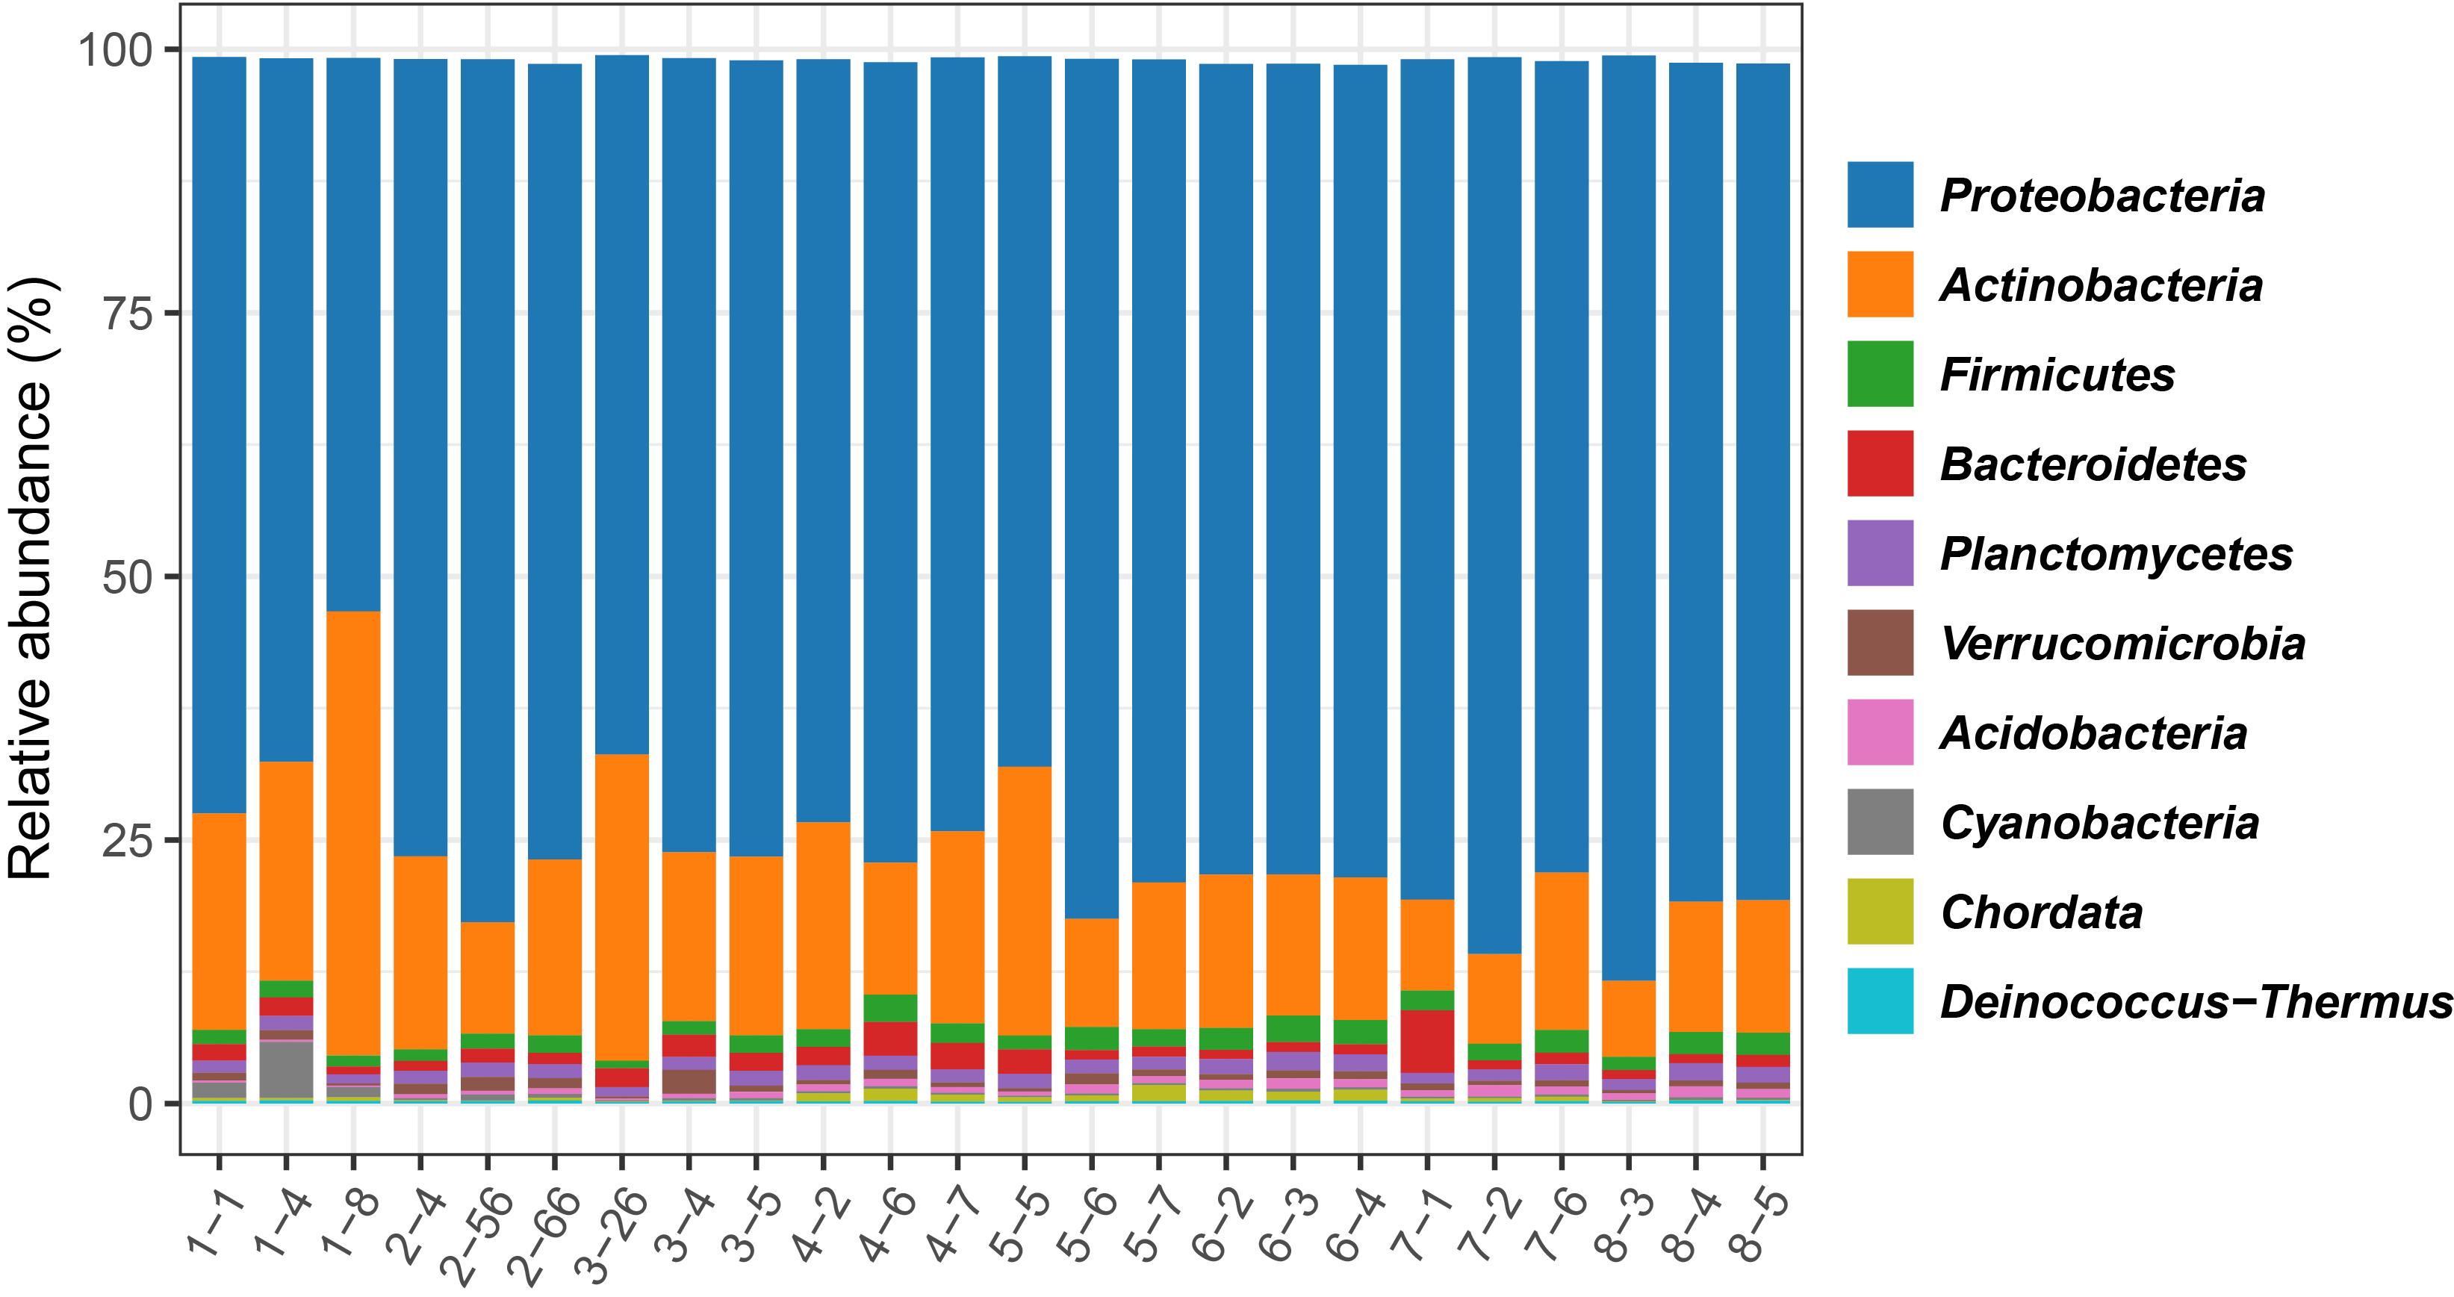
Figure S1 The bar plot indicated that the profiles of microbial communities in different samples of the Gongga mountain glacial foreland based on the metagenomic Kraken2 analysis.

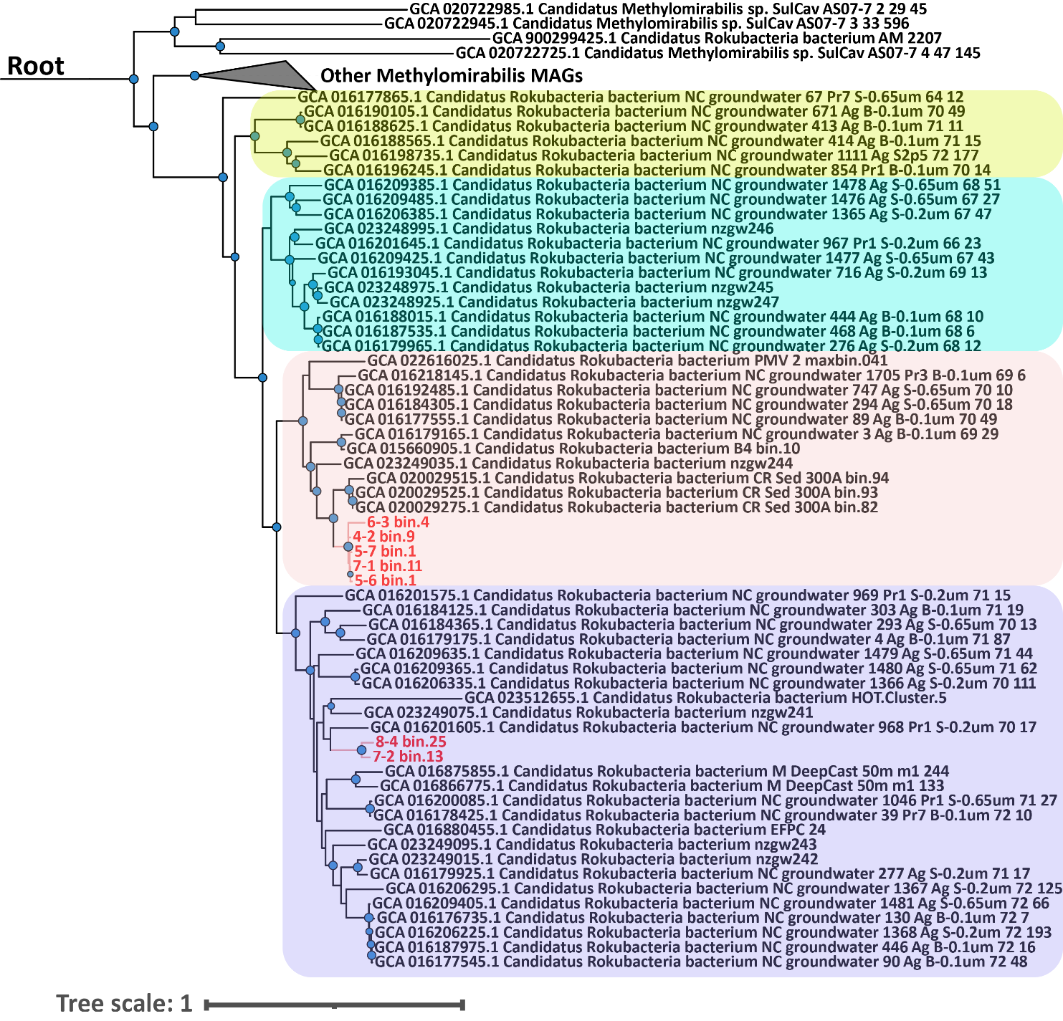
Figure S2. The phylogenomic tree were constructed based on the concatenated bac120 marker genes of “Candidatus Methylomirabilota” genomes, and the Nitrospirota MAGs from this study were selected as the outgroup.

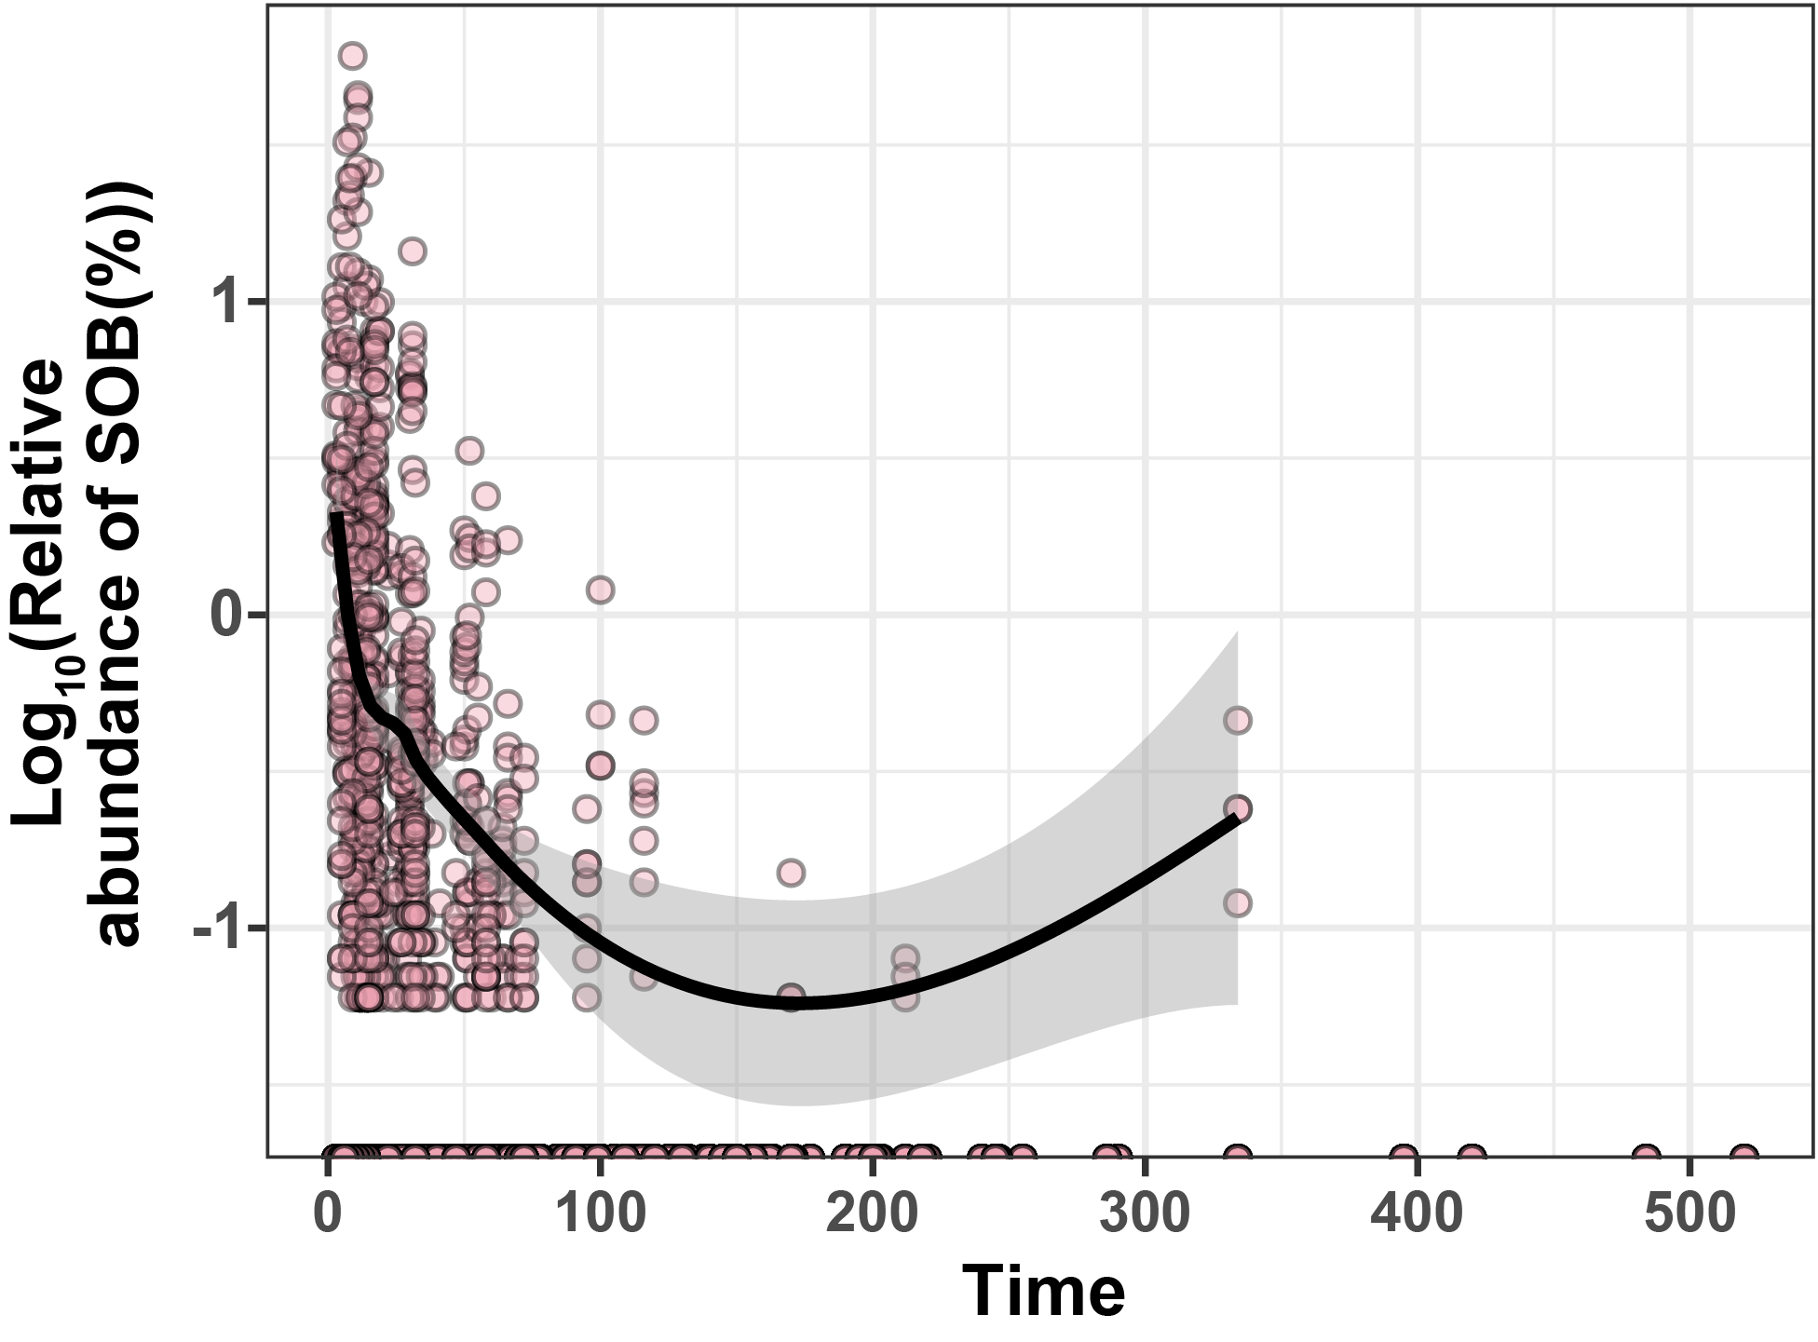
Figure S3 The scatterplot showed the relative abundance of SOB in global mountain glacial foreland¹.

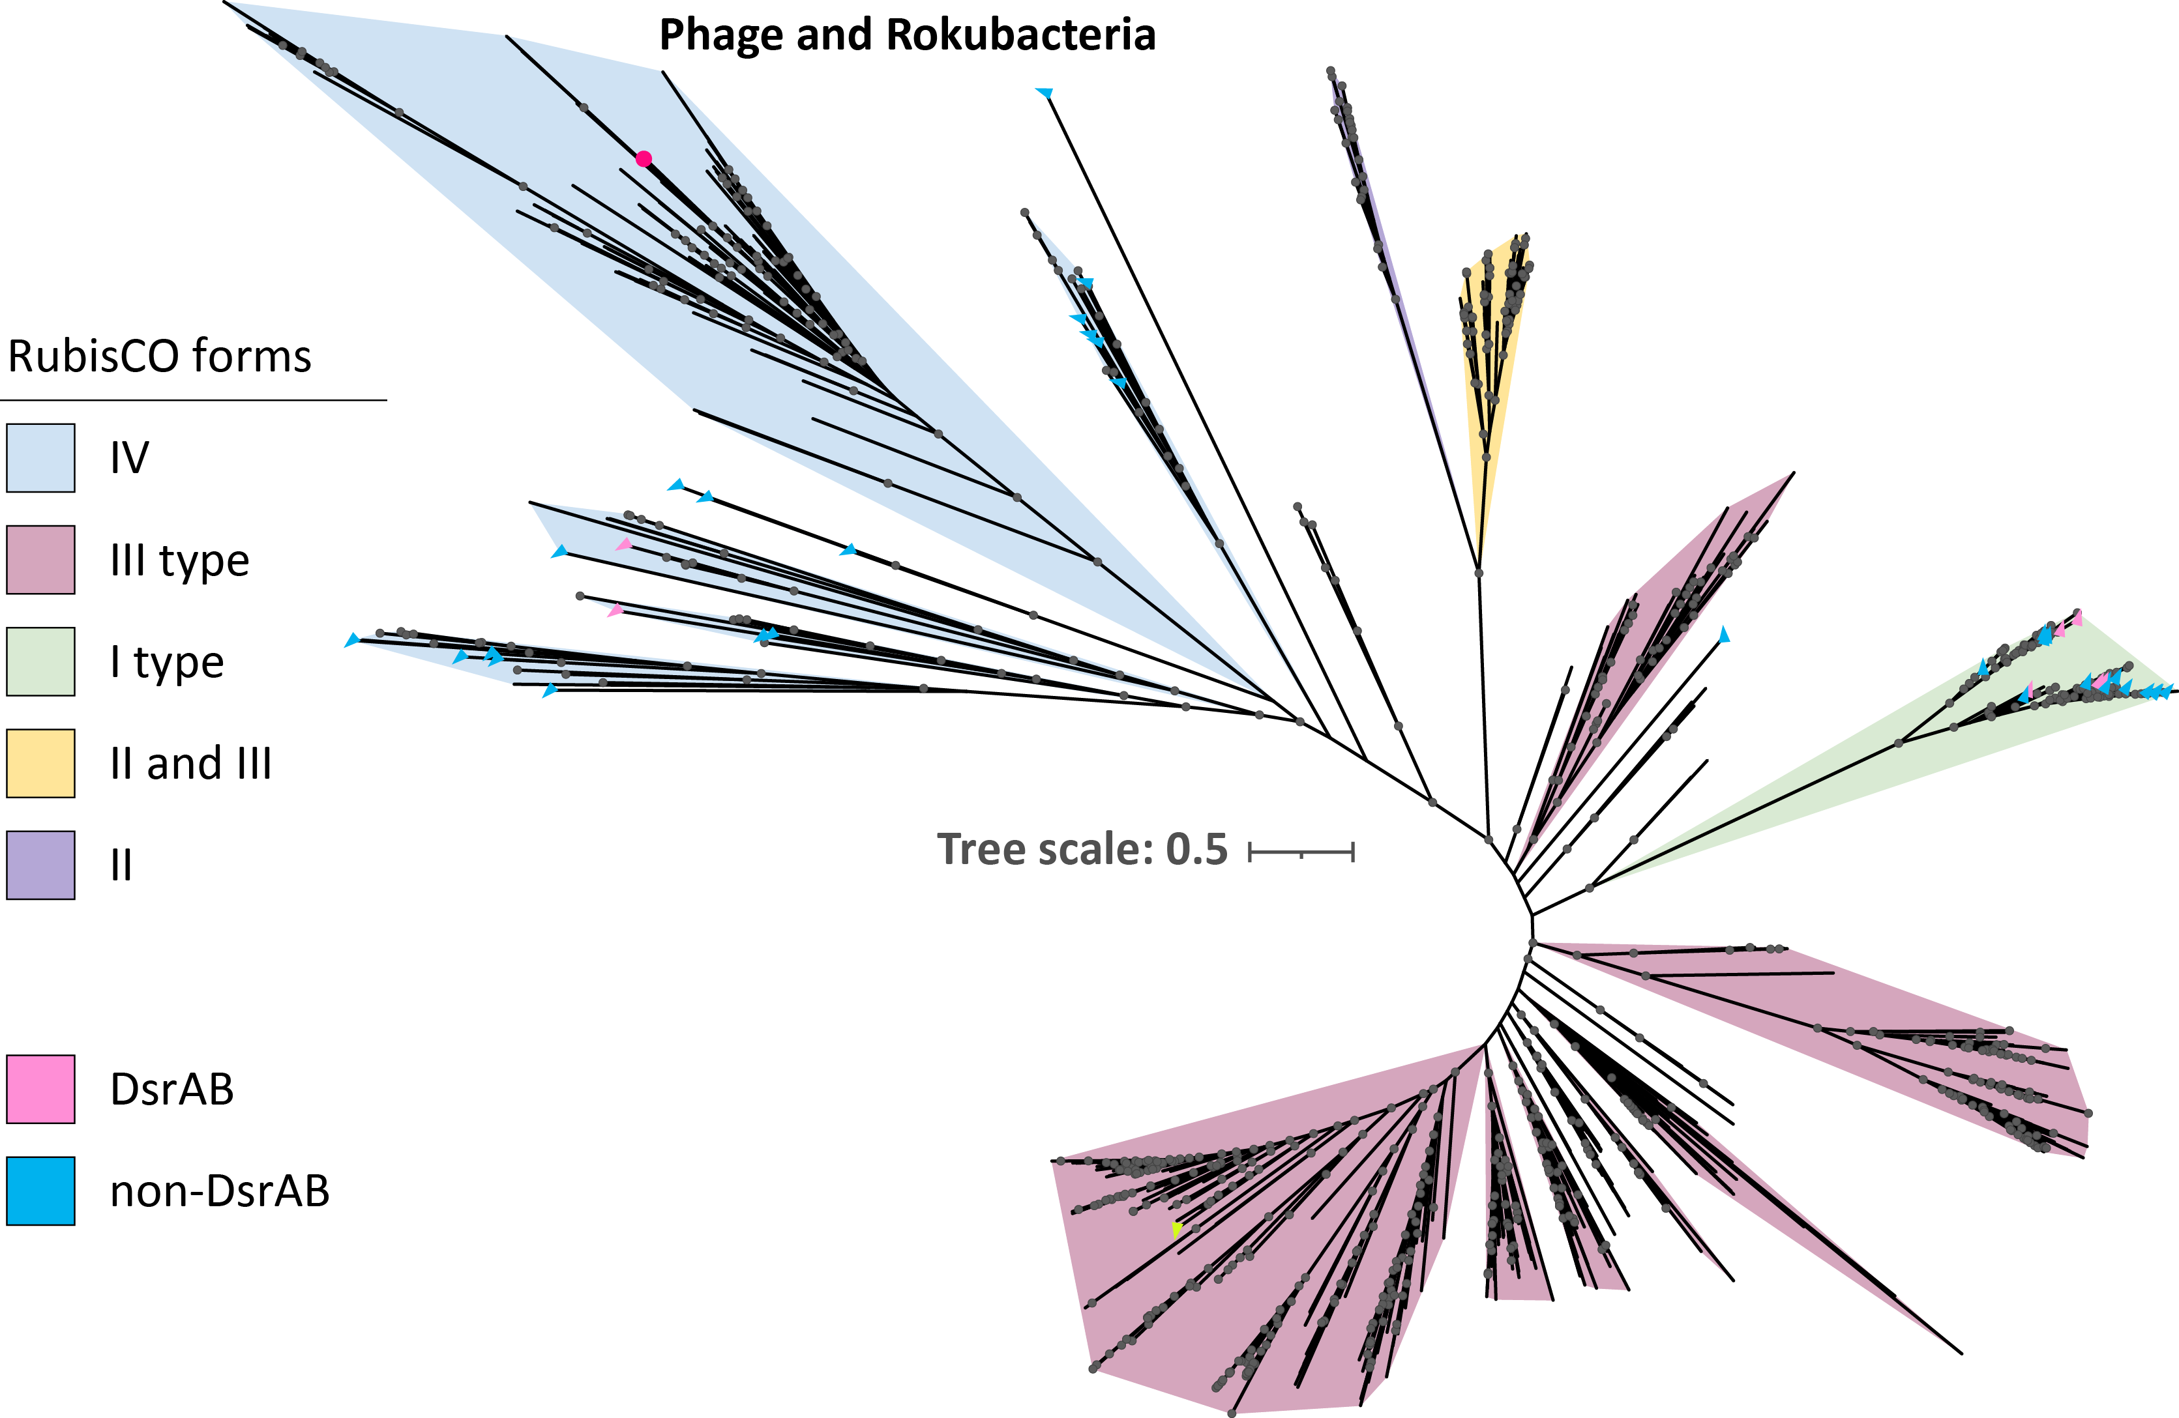
Figure S4 The maximum-likelihood phylogenetic tree of RubisCO. constructed based on package IQtree with parameters: -MPF -bb 1000. The filled circle in the branch represented the bootstrap value greater than 90.

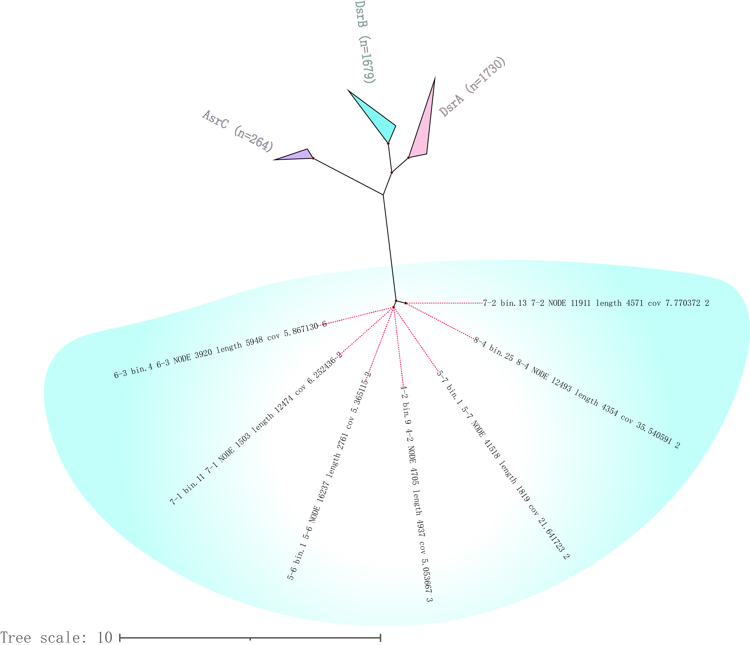
Figure S5 The maximum-likelihood phylogenetic tree of AsrC, DsrA, DsrB and our remote dsr proteins was constructed based on package IQtree with parameters: -MPF -bb 1000.
Figure S6 The upper of the picture indicated that the three-dimensional structure of protein 4-2_bin.9~4-2_NODE_4705_length_4937_cov_5.053667_3, it was predicated by the tool RoseTTaFold. The siroheme-binding residues were highlighted by yellow and orange atoms. The bottom of the figure indicated the sequences of seven putative Dsr genes encoded by Rokubacterial MAGs, the siroheme-binding residues were highlighted by the red word.

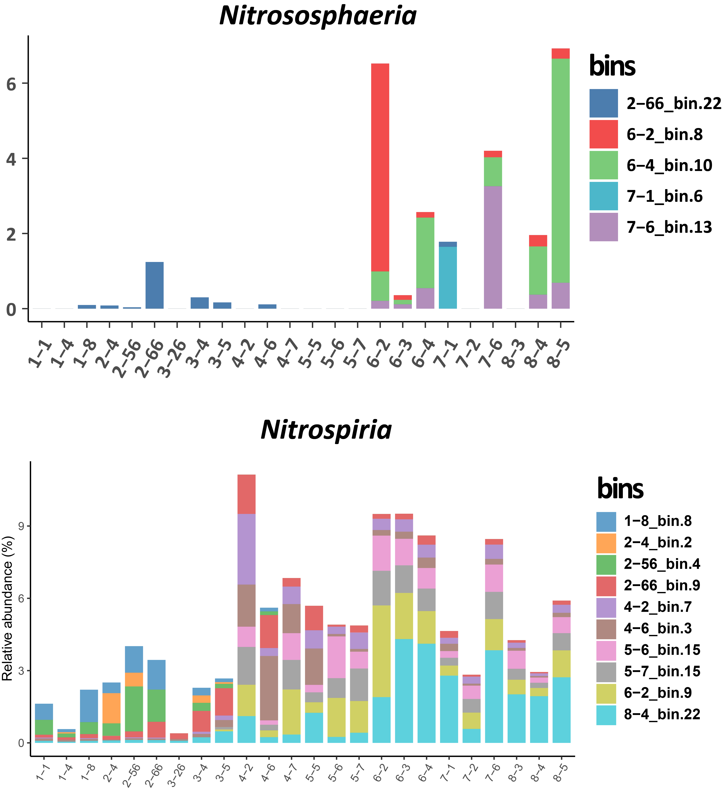
Figure S7 The relative abundance distribution of Nitrososphaeria (top) and Nitrospiria (bottom) across different samples.
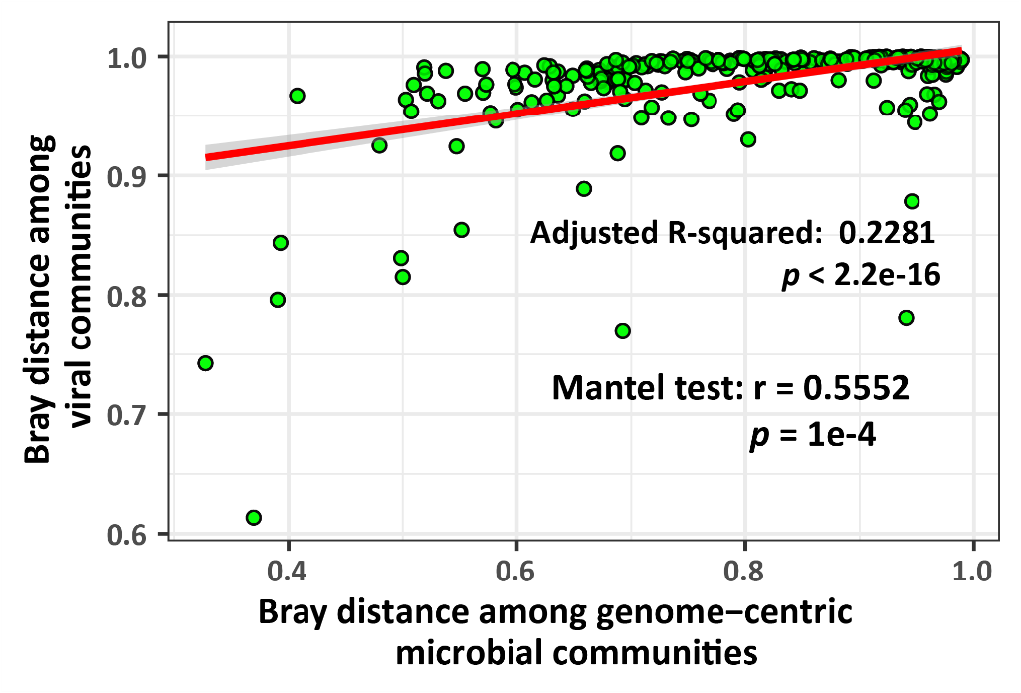
Figure S8. The linear model and Mantel test showing the relationship between the Bray-Curtis distance among different viral communities and corresponded microbial communities. The fitted line is provided for 95% confidence intervals. Inset values display the R2 and p value of F-statistic. The statistical test used was two-tailed. Source data are provided in the Source Data file.

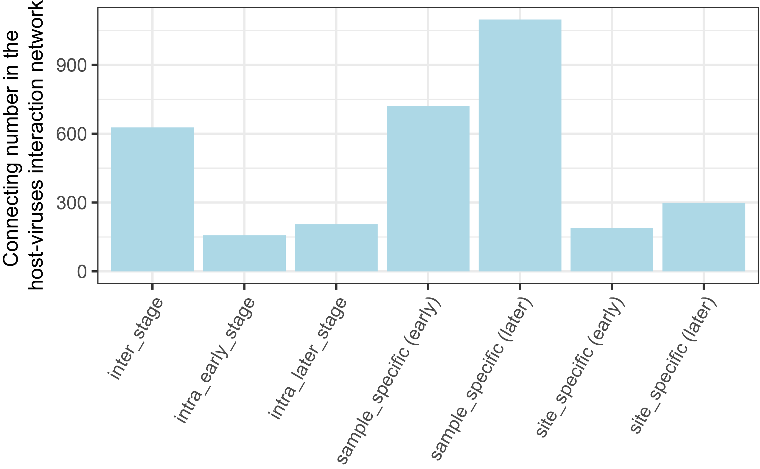
Figure S9 The figure indicated that the connecting number of vOTUs with different geographic distribution range in the glacial foreland in the host-viruses interaction network.
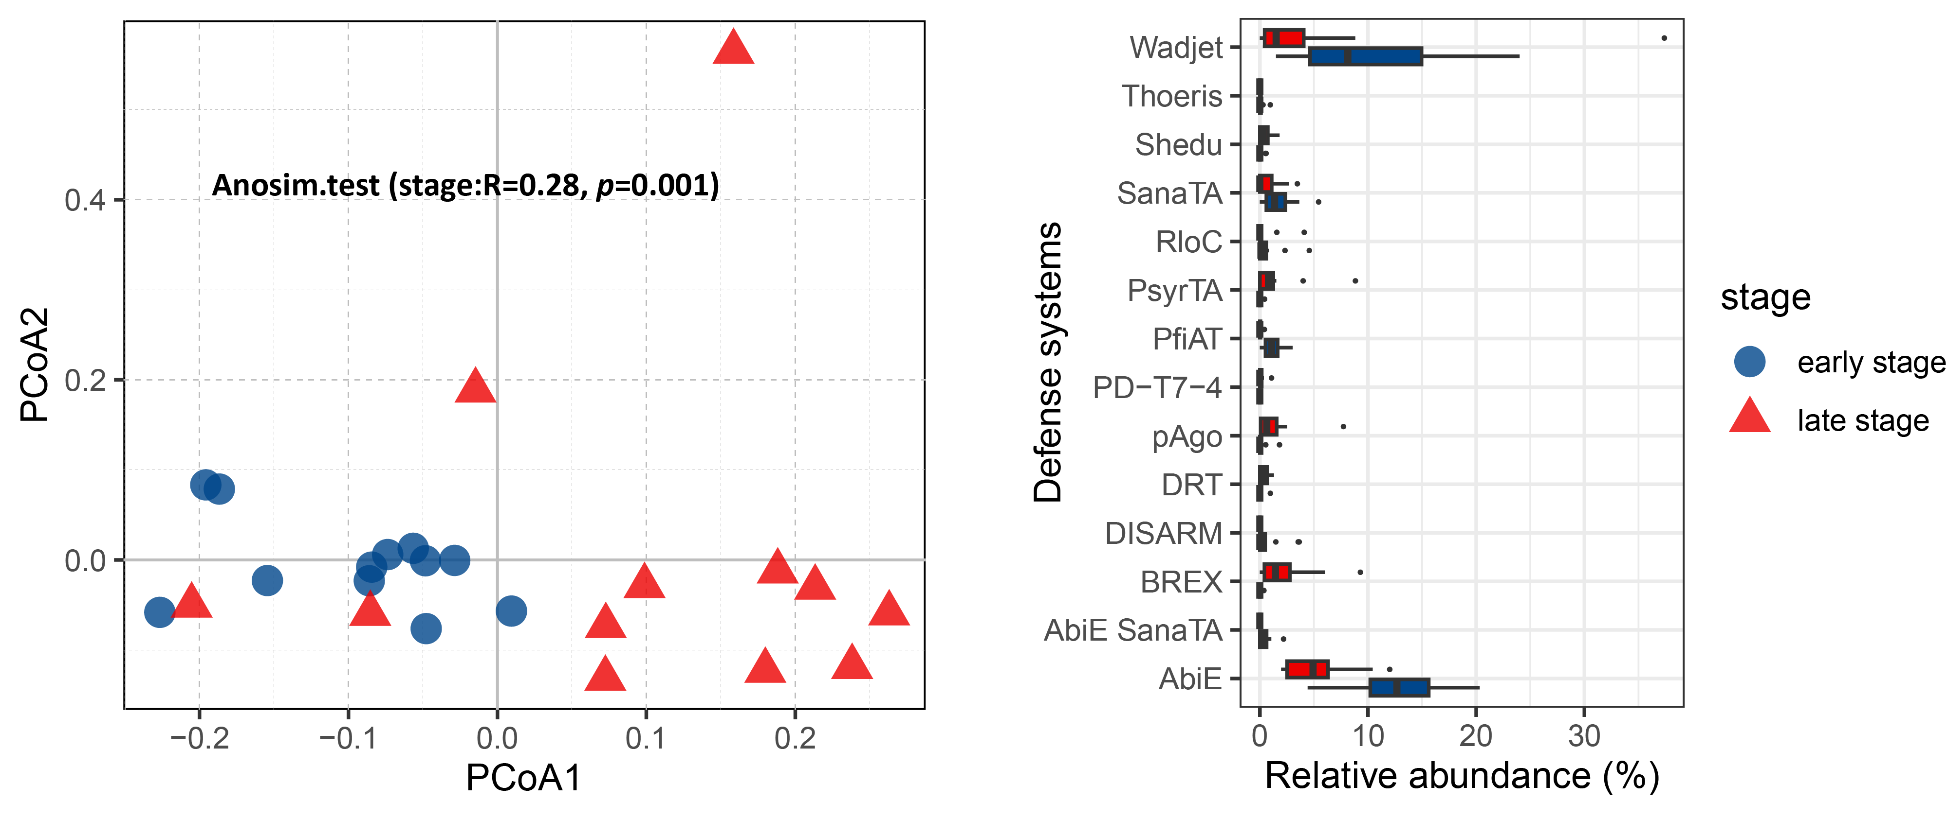
Figure S10 The PCoA plot (left) indicated the significant difference of bacterial defense systems compositions among early and late stage. The boxplot (right) showed the relative abundance of defense systems which are significant different (wilcox.test: p<0.01) between early and late stage of glacial retreat.

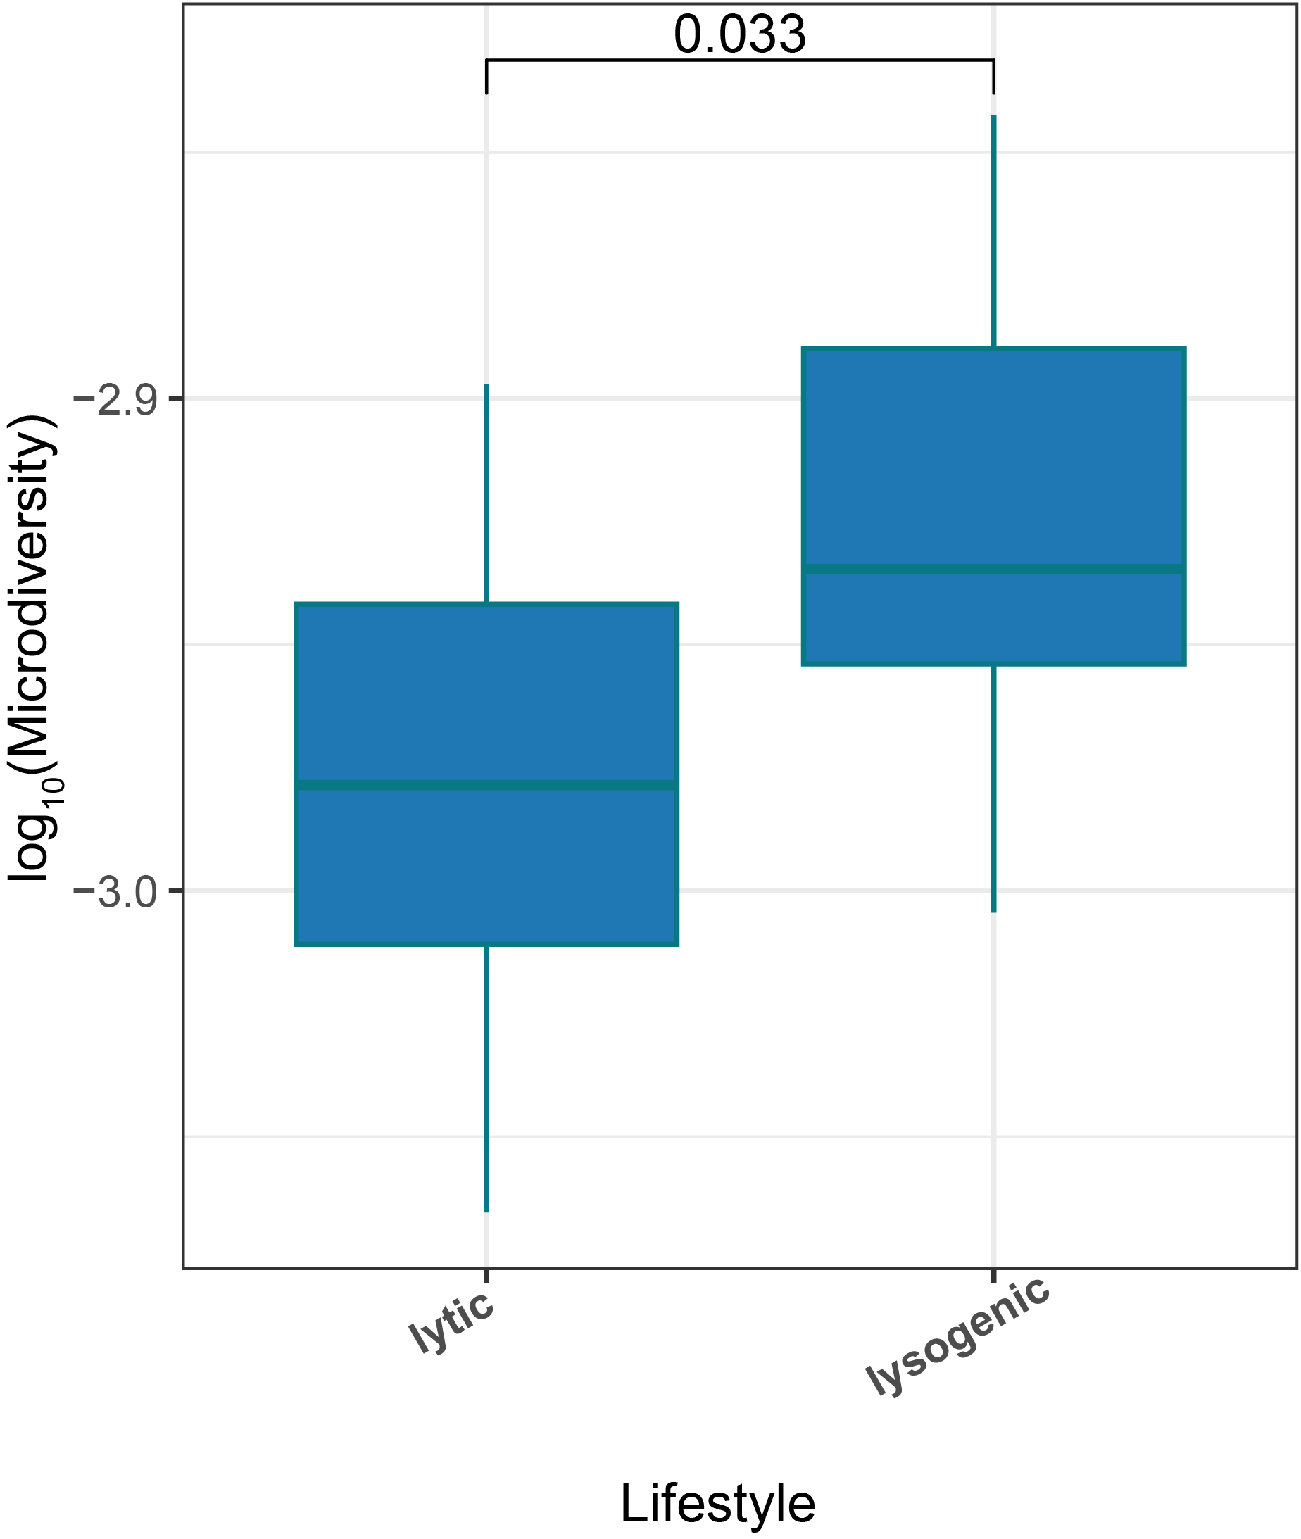
Figure S11 The boxplot illustrated the variance of microdiversity among “20-60kbp” viruses with different lifestyle in the early stage of glacial foreland. The difference was tested using the two-sided wilcox.test (alternative=greater), exact P-value is presented in the figure. The minima, maxima, centre, bounds of box and whiskers in boxplots from bottom to top represented percentile 0, 10, 25, 50, 75, 90 and 100, respectively.

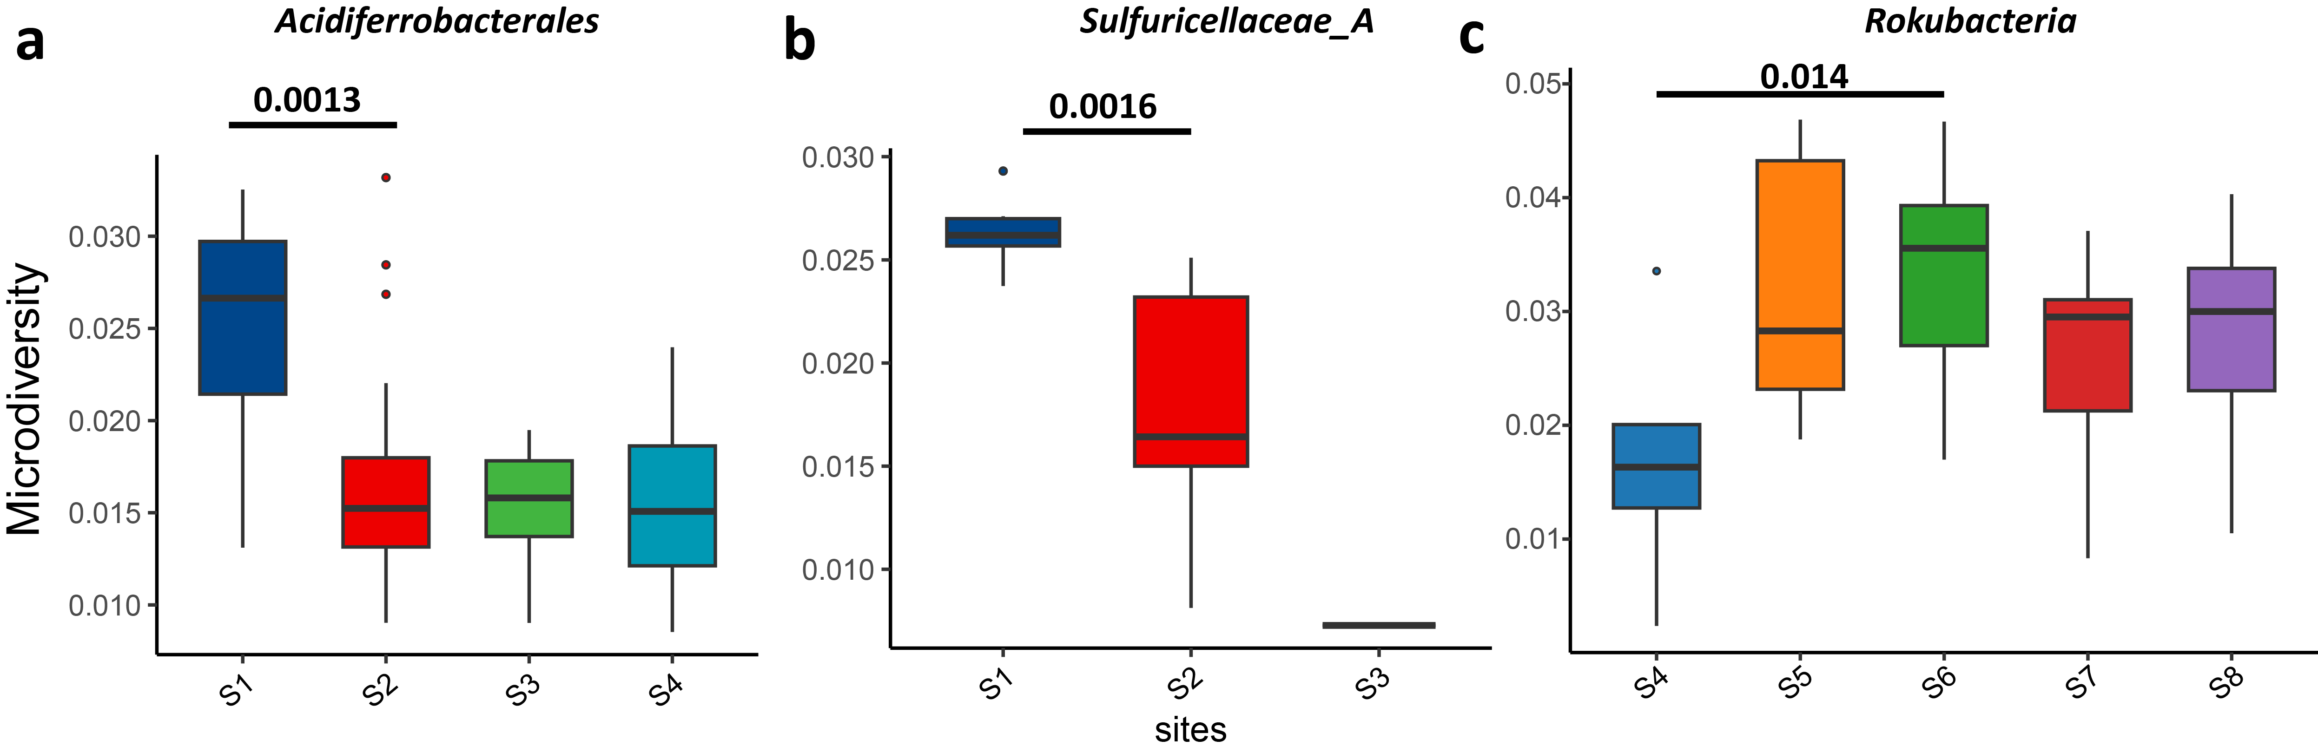
Figure S12. The boxplots indicated that the microdiversity of MAGs in order Acidiferrobacterales (a), and family Sulfuricellaceae_A (b), and phylum Rokubacteria, respectively. The difference was tested using the two-sided wilcox.test (alternative=greater), exact P-value is presented in the figure. The minima, maxima, centre, bounds of box and whiskers in boxplots from bottom to top represented percentile 0, 10, 25, 50, 75, 90 and 100, respectively.

1 Ficetola, G. F. et al. The development of terrestrial ecosystems emerging after glacier retreat. Nature 632, 336-342, doi:10.1038/s41586-024-07778-2 (2024).

