Infaunal polychaete communities from the Antarctic Peninsula and the Filchner Trough region (Weddell Sea)

Friederike Weith ^{1,2,3*} https://orcid.org/0000-0002-7306-8263
Andreas Bick⁴ https://orcid.org/0000-0003-2356-6106
Kerstin Jerosch³ https://orcid.org/0000-0003-0728-2154
Hendrik Pehlke³ https://orcid.org/0000-0003-1916-7831
Ben Behrend²
Gritta Veit-Köhler⁵ https://orcid.org/0000-0002-3453-898X
Heike Link^{1,2} https://orcid.org/0000-0002-8484-845X

* friederike.weith@awi.de

¹ University of Rostock, Department Maritime Systems, Faculty of Interdisciplinary Research, 18059 Rostock, Germany
² University of Rostock, Institute of Biological Science, Faculty of Mathematics and Natural Science, 18059 Rostock, Germany
³ Alfred Wegener Institute, Benthic Ecology, 27570 Bremerhaven, Germany
⁴ University of Rostock, Institute of Biological Science, General and Systematic Zoology, 18055 Rostock, Germany
⁵ Senckenberg am Meer, German Centre for Marine Biodiversity Research (DZMB), 26382 Wilhelmshaven, Germany

Table SI1 Assignment of the recorded polychaete families to functional groups (feeding type: F = filter/ suspension feeder, O = omnivore, P = predator, S = surface deposit feeder, Sb = subsurface deposit feeder; motility: M = motile, D = discretely motile, N = no motility; movement: C = crawling, B = burrowing, Se = sessile; feeding) and the corresponding reference. In cases of uncertainties or ambiguous assignments, comments have been added to underline the classification/assignment
Family | Feeding type | Reference | Comment | Motility | Reference | Comment | Movement | Comment | Reference
Acrocirridae | Sb | Jumars et al. (2015) |  | D | Jumars et al. (2015) |  | C |  | Jumars et al. (2015)
Ampharetidae | S | Jumars et al. (2015) | personal observation: short feeding tentacles | D | Jumars et al. (2015) | Jumars et al. (2015): can extent tubes and build new ones; personal observation: only few individuals with tubes were found | Se |  | Polytraits Team (2025); Jumars et al. (2015)
Amphinomidae | O | Jumars et al. (2015), personal visual identification | Jumars et al. (2015): mostly scavengers, some detritus and algae; personal observation: small and fragile individuals without any visible jaw structure, | M | Jumars et al. (2015) |  | C |  | Jumars et al. (2015)
Capitellidae | Sb | Jumars et al. (2015); personal visual identification |  | M | Jumars et al. (2015) | Jumars et al. (2015): mostly tube builder | B |  | Jumars et al. (2015)
Chaetopteridae | F | Jumars et al. (2015) |  | N | Jumars et al. (2015) | Jumars et al. (2015): tube dwelling | Se |  | Jumars et al. (2015)
Cirratulidae | S | Polytraits Team (2025); Jumars et al. (2015); Rouse & Pleijel (2001) | personal observation: small individuals, usually in the first cm sediment layer, | M | Jumars et al. (2015) | Jumars et al. (2015): can be tube dwelling, but here no tube dwellings forms were observed | B |  | Polytraits Team (2025); Jumars et al. (2015)
Dorvilleidae | O | Jumars et al. (2015) | Jumars et al. (2015): carnivore/scavenger, feed on diatoms, macroalgae, bacterial mats, detritus material | M | Jumars et al. (2015) | Jumars et al. (2015): mostly crawling | C | personal observation: all individuals found in first cm sediment layer | Jumars et al. (2015)
Flabelligeridae | S | Polytraits Team (2025); Jumars et al. (2015) |  | D | Jumars et al. (2015) | Jumars et al. (2015): slow burrowing, many burrow in sand or mud | B |  | Jumars et al. (2015)
Glyceridae | P | Polytraits Team (2025); Jumars et al. (2015), personal visual identification | personal observation: all individuals with muscular pharynx and jaw structure | D | Jumars et al. (2015) | Jumars et al. (2015): burrowing, sitting and waiting predator | B |  | Jumars et al. (2015); Böggemann (2002)
Hesionidae | P | Polytraits Team (2025); Jumars et al. (2015); personal visual identification | Jumars et al. (2015): many carnivores; personal observation: all individuals similar habitus with a visible jaw and muscular pharynx structre | M | Jumars et al. (2015) | Jumars et al. (2015): some crawl or construct burrow galleries, mostly unknown, personal observation: bodies formed like crawling and motile organisms | C |  | Jumars et al. (2015); Queirós (2013)
Lumbrineridae | P | Polytraits Team (2025); Jumars et al. (2015); Pettibone (1982); personal visual identification | personal observation: individuals had visible jaw | M | Jumars et al. (2015) |  | B |  | Jumars et al. (2015); Carson & Hentschel (2006)
Maldanidae | Sb | Polytraits Team (2025); Jumars et al. (2015); Rouse & Pleijel (2002) |  | D | Jumars et al. (2015) | Jumars et al. (2015): more active, tube dwelling, can extent tubes, tube builder; burrowing in sand and mud | B | personal observation: individuals also found in deeper sediment layers | Jumars et al. (2015); personal visual identification
Nephtyidae | P | Polytraits Team (2025); Jumars et al. (2015); personal visual identification | personal observation: strong and muscular pharynx and jaws | M | Jumars et al. (2015) | Jumars et al. (2015): burrowing and crawling, but personal observation: body form preferred for crawling movement | C | personal observation: individuals found in first sediment layer | Jumars et al. (2015); personal visual identification
Nereididae | O | Polytraits Team (2025); Jumars et al. (2015) |  | M | Jumars et al. (2015) | Jumars et al. (2015): burrowing and crawling, but personal observation: body form preferred for crawling movement | C |  | Jumars et al. (2015a); Rouse and Pleijel (2001)
Nerillidae | S | Jumars et al. (2015a); Rouse and Pleijel (2001) |  | M | Jumars et al. (2015) |  | C |  | Jumars et al. (2015)
Oenonidae | P | Polytraits Team (2025), Jumars et al. (2015) |  | M | Jumars et al. (2015) | Jumars et al. (2015): burrowing and crawling, but personal observation: body form preferred for crawling movement | B | personal observation: found in deeper sediment layer | Jumars et al. (2015); personal visual identification
Onuphidae | O | Jumars et al. (2015); personal visual identification | personal observation: strong and muscular jaw apparatus | D | Jumars et al. (2015); personal visual identification | Jumars et al. (2015): mostly tubicolous, often in soft sediments, but are motile, carry their tubes with them in clearly discrete motility; personal observation: all individuals were in tubes | C | personal observation: almost all individuals in first sediment layer | Jumars et al. (2015); personal visual identification
Opheliidae | Sb | Jumars et al. (2015); Rouse & Pleijel (2001) |  | M | Jumars et al. (2015) |  | B | personal obervation: found in different sediment layers | Polytraits Team (2025); Jumars et al. (2015); Rouse & Pleijel (2001)
Orbiniidae | Sb | Polytraits Team (2025); Jumars et al. (2015); Rouse & Pleijel (2001) |  | M | Jumars et al. (2015) |  | B | personal obervation: found in different sediment layers | Polytraits Team (2025), Jumars et al. (2015); Rouse & Pleijel (2001)
Oweniidae | S | Polytraits Team (2025); Jumars et al. (2015); personal visual identification | personal observation: no tentacular crown, lips or grooved palps, indicator for surface deposit feeder | D | Jumars et al. (2015) | Jumars et al. (2015): tubicolous, but can move tubes, burrowing in muddy sediment | B |  | Polytraits Team (2025), Jumars et al. (2015)
Paraonidae | Sb | Polytraits Team (2025); Jumars et al. (2015); personal visual identification | personal obervation: found in different sediment layers | M | Jumars et al. (2015) |  | B | personal obervation: found in different sediment layers | Polytraits Team (2025); Jumars et al. (2015); personal visual identification
Pectinariidae | Sb | Polytraits Team (2025); Jumars et al. (2015) |  | D | Jumars et al. (2015) | Jumars et al. (2015): infauna (burrowing) in heterogenous and nutrient-poor sediments | B |  | Jumars et al. (2015)
Phyllodocidae | P | Polytraits Team (2025); Jumars et al. (2015); Lee et al. (2004) |  | M | Jumars et al. (2015) | Jumars et al. (2015): actively burrowing and crawling | C | personal observation: individuals found in first sediment layer | Polytraits Team (2025); Jumars et al. (2015); personal visual identification
Pilargiidae | P | Jumars et al. (2015) |  | M | Jumars et al. (2015) |  | B |  | Jumars et al. (2015)
 |  | Jumars et al. (2015) |  |  | Jumars et al. (2015) | Jumars et al. (2015) |  |  | Jumars et al. (2015)
Polynoidae | P | Polytraits Team (2025); Jumars et al. (2015) |  | M | Jumars et al. (2015) |  | C | personal observation: most individuals were found in first cm sediment layers | Polytraits Team (2025); Jumars et al. (2015)
Sabellidae | F | Polytraits Team (2025); Jumars et al. (2015); personal visual identification | personal observation: all individuals with tentacle crown | N | Polytraits et al. (2025); Jumars et al. (2015) |  | Se | personal observation: usually found in first cm sediment layers | Polytraits Team (2025); Jumars et al. (2015); personal visual identification
Scalibregmatidae | Sb | Jumars et al. (2015) |  | M | Jumars et al. (2015) |  | B | personal observation: individuals found in deeper sediment layers | Polytraits Team (2025); Jumars et al. (2015)
Sigalionidae | P | Jumars et al. (2015) |  | M | Jumars et al. (2015) |  | B | Jumars et al. (2015): larger morphotype is well suited to burrowing in mud, crawls interstitially | Jumars et al. (2015)
Sphaerodoridae | S | Jumars et al. (2015) | personal oberservation: no jaw was observed, really small individuals | M | Jumars et al. (2015) | but poorly understood, body shape not build for fast crawling | B | personal observation: found across different sediment layers | Polytraits Team (2025); Jumars et al. (2015)
Spionidae | S | Polytraits Team (2023); Jumars et al. (2015) | personal observation: no tentacle crown, mostly on the first cm sediment layer | D | Jumars et al. (2015) | Jumars et al. (2015): most discretely motile in tubes; a few are more  motile; boring species are unlikely to create new tube | B |  | Jumars et al. (2015a,b)
Sternaspidae | Sb | Jumars et al. (2015) |  | M | Jumars et al. (2015) |  | B |  | Jumars et al. (2015)
Syllidae | O | Jumars et al. (2015) | personal observation: visible pharynx but now jaws | M | Jumars et al. (2015) |  | C |  | Polytraits Team (2025); Jumars et al. (2015); Carson & Hentschel (2006)
Terebellidae | S | Polytraits Team (2025); Jumars et al. (2015); Rouse & Pleijel (2001) |  | D | Jumars et al. (2015) | Jumars et al. (2015): mostly tube-dwelling, personal observation: body form was looked like a sessile movement type mostly with tubes | Se | personal observation: found in first cm sediment layers | Jumars et al. (2015); personal visual identification
Trichobranchidae | Sb | Jumars et al. (2015) |  | D | Jumars et al. (2015) | Jumars et al. (2015): widely tubiculous; personal observation: found with tubes | B |  | Jumars et al. (2015)

Table SI2 Biodiversity indices for the taxonomic composition of polychaete communities. St. = Station; Taxon = Family level; Average ind. number per st. calculated as total number per station/ number of cores
Region | Subregion | St. | Total number of taxa  S | Average ind. number per st.  N | Evenness (Pielou)  J' | Shannon-Wiener  H' | Simpson  λ
Antarctic Peninsula (AP) | Drake Passage (DP) | 235 | 16 | 29.78 | 0.92 | 2.54 | 0.09
Antarctic Peninsula (AP) | Drake Passage (DP) | 241 | 18 | 36.44 | 0.85 | 2.46 | 0.11
Antarctic Peninsula (AP) | Bransfield Strait (BS) | 217 | 11 | 16.81 | 0.87 | 2.08 | 0.16
Antarctic Peninsula (AP) | Bransfield Strait (BS) | 225 | 13 | 25.94 | 0.88 | 2.26 | 0.12
Antarctic Peninsula (AP) | Northwestern Weddell Sea (NW-WS) | 6 | 9 | 38.04 | 0.69 | 1.52 | 0.27
Antarctic Peninsula (AP) | Northwestern Weddell Sea (NW-WS) | 8 | 15 | 160.55 | 0.78 | 2.11 | 0.16
Antarctic Peninsula (AP) | Northwestern Weddell Sea (NW-WS) | 38 | 14 | 125.43 | 0.75 | 1.97 | 0.18
Antarctic Peninsula (AP) | Northwestern Weddell Sea (NW-WS) | 120 | 7 | 46.59 | 0.80 | 1.55 | 0.26
Antarctic Peninsula (AP) | Northwestern Weddell Sea (NW-WS) | 163 | 15 | 61.48 | 0.73 | 1.96 | 0.22
Antarctic Peninsula (AP) | Northwestern Weddell Sea (NW-WS) | 190 | 14 | 86.46 | 0.61 | 1.61 | 0.28
Filchner  Trough  (FT) |  | 17 | 11 | 11.52 | 0.90 | 2.16 | 0.14
 |  | 26 | 13 | 14.13 | 0.89 | 2.27 | 0.12
 |  | 37 | 20 | 31.45 | 0.80 | 2.39 | 0.13
 |  | 48 | 14 | 17.06 | 0.81 | 2.13 | 0.16
 |  | 61 | 13 | 21.59 | 0.87 | 2.24 | 0.14
 |  | 72 | 12 | 11.52 | 0.94 | 2.35 | 0.11

Table SI3 Taxonomic polychaete community: Results of the SIMPER analysis representing within-group (type) similarities, between-group (type) dissimilarities (bold), and taxonomic unit contribution (%, cut off for low contribution: 90%) of the community clusters (A–F)
 | A (st. 6, 120) | B (st. 163) | C (st. 8, 38, 190) | D (st. 17, 72) | E (st. 26, 37, 48, 61) | F (st. 217, 225, 235, 241)
within-group similarity (%) | 50.15%;  Paraonidae (35.8%), Opheliidae (35.8%), Hesionidae (21.6%) |  | 63.3%;  Paraonidae (36%), Cirratulidae (24.9%), Opheliidae (11%), Hesionidae (9.7%), Maldanidae (6.3%), Spionidae (4%), | 54.55%;  Ampharetidae (16.7%), Cirratulidae (16.7%), Paraonidae (16.7%), Spionidae (16.7%), Hesionidae (8.3%), Maldanidae (8.3%), Oweniidae (8.3%) | 57.5%;  Paraonidae (23%), Cirratulidae (19.5%), Syllidae (17.3%), Glyceridae (16.6%), Spionidae (3.8%), Ampharetidae (3.3%), Phyllodocidae (3.2%), Lumbrineridae (3.1%), Maldanidae (2.9%) | 55.7%;  Onuphidae (21.2%), Cirratulidae (15.8%), Paraonidae (15.4%), Ampharetidae (10.4%), Sternaspidae (8.3%), Maldanidae (7.4%), Syllidae (6%)
Between-group dissimilarity (%)
A
B | 55.7%;  Hesionidae (32%), Cirratulidae (12.7%), Opheliidae (12.2%), Maldanidae (12.2%), Paraonidae (9%), Lumbrineridae (5%), Scalibregmidae (4.85), Polynoidae (2.4%)
C | 54.5%;  Cirratulidae (23.3%), Paraonidae (22.3%), Hesionidae (16.7%), Opheliidae (9.5%), Maldanidae (6.2%), Dorvilleidae (5.3%), Lumbrineridae (4%), Spionidae (3.8%) | 53.2%;  Cirratulidae (27.3%), Paraonidae (24.3%), Hesionidae (13%), Opheliidae (11.8%), Dorvilleidae (4.3%), Spionidae (3.2%), Scalibregmidae (2.3%), Maldanidae (2.2%), Lumbrineridae (2.2%)
D | 81.9%;  Paraonidae (24.9%), Opheliidae (20.8%), Cirratulidae (18.3%), Hesionidae (11%), Ampharetidae (4.8%), Maldanidae (4.2%), Lumbrineridae (4.1%), Spionidae (3.1%) | 81%;  Hesionidae (40.6%), Maldanidae (14.1%), Paraonidae (12.3%), Lumbrineridae (7.2%), Scalibregmidae (4.9%), Opheliidae (3.2%), Polynoidae (2.4%), Cirratulidae (2.3%), Ampharetidae (1.9%), Spionidae (1.8%) | 87.8%;  Paraonidae (27.2%), Cirratulidae (24.3%), Hesionidae (13.8%), Opheliidae (11.3%), Maldanidae (5.6%), Dorvilleidae (4%), Lumbrineridae (3.7%), Ampharetidae (1.9%)
E | 72.2%;  Opheliidae (20.5%), Paraonidae (20.4%), Cirratulidae (17.2%), Hesionidae (10.9%), Syllidae (5.5%), Lumbrineridae (5.1%), Glyceridae (4.5%), Maldanidae (4%), Nephtyidae (1.6%), Spionidae (1.5%) | 73.9%;  Hesionidae (39.7%), Maldanidae (14%), Paraonidae (9.2%), Lumbrineridae (5.8%), Cirratulidae (4.3%), Scalibregmidae (4.1%), Syllidae (4%), Glyceridae (3.7%), Opheliidae (3.3%), Polynoidae (2.2%) | 81.6%;  Paraonidae (25.7%), Cirratulidae (21.5%), Hesionidae (14%), Opheliidae (11.5%), Maldanidae (5.6%), Dorvilleidae (4%), Lumbrineridae (3.3%), Spionidae (2.4%), Gylceridae (1.8%), Syllidae (1.8%) | 62%;  Cirratulidae (15.2%), Syllidae (13%), Glyceridae (10.2%), Paraonidae (9.3%), Ampharetidae (8%), Lumbrineridae (7.6%), Spionidae (4.4%), Nephtyidae (3.7%), Opheliidae (3.9%), Flabelligeridae (2.7%), Sphaerodoridae (2.7%), Phyllodocidae (2.6%), Maldanidae (2.5%), Oweniidae (2.4%), Sabellidae (2.3%), Amphinomidae (2.2%)
F | 76.6%;  Paraonidae (18.2%), Opheliidae (17.3%), Cirratulidae (14.5%), Hesionidae (9.7%), Onuphidae (5.8%), Ampharetidae (5.3%), Sternaspidae (5.1%), Maldanidae (3.6%), Lumbrineridae (3.5%), Sabellidae (3.4%), Syllidae (3.2%), Spionidae (2.3%) | 77.1%;  Hesionidae (35.7%), Maldanidae (11.4%), Paraonidae (8.6%), Lumbrineridae (6.8%), Onuphidae (5.1%), Scalibregmidae (4.1%), Sternaspidae (4%), Cirratulidae (2.8%), Ampharetidae (2.7%), Opheliidae (2.6%), Sabellidae (2.6%), Syllidae (2.5%), Spionidae (2%) | 82.5%;  Paraonidae (24.5%), Cirratulidae (20.7%), Hesionidae (13.5%), Opheliidae (10.7%), Maldanidae (4.7%), Dorvilleidae (3.9%), Lumbrineridae (3.8%), Spionidae (2.6%), Onuphidae (2.3%), Ampharetidae (2.2%), Sternaspidae (2%) | 65.3%;  Onuphidae (14.2%), Sternaspidae (10.5%), Cirratulidae (10.3%), Spionidae (8%), Ampharetidae (7%), Paraonidae (6.9%), Syllidae (6.8%), Sabellidae (5.8%), Terebellidae (4.7%), Maldanidae (2.4%), Polynoidae (2.3%), Hesionidae (2.2%), Flabelligeridae (2.2%), Opheliidae (2.2%), Lumbrineridae (2.2%), Sphaerodoridae (2.2%) | 59.4%;  Onuphidae (12.6%), Sternaspidae (9.5%), Cirratulidae (9.3%), Ampharetidae (8.4%), Glyceridae (7.7%), Lumbrineridae (5.8%), Spionidae (5.5%), Paraonidae (5.4%), Sabellidae (5.2%), Syllidae (4.6%), Terebellidae (4.2%), Maldanidae (2.6%), Nephtyidae (2.6%), Opheliidae (1.9%), Polynoidae (1.9%), Hesionidae (1.9%), Amphinomidae (1.7%)

Table SI4 Biodiversity indices for the functional polychaete community composition. St. = Station, Average in. number per st. calculated as total number per station/ number of cores
Region | Subregion | St. | Total number of functional groups  S | Average ind. number per st.  N | Evenness (Pielou)  J' | Shannon-Wiener  H' | Simpson  λ
Antarctic Peninsula (AP) | Drake Passage (DP) | 235 | 12 | 29.78 | 0.85 | 2.10 | 0.16
Antarctic Peninsula (AP) | Drake Passage (DP) | 241 | 11 | 36.44 | 0.90 | 2.15 | 0.13
Antarctic Peninsula (AP) | Bransfield Strait (BS) | 217 | 8 | 16.81 | 0.89 | 1.85 | 0.19
Antarctic Peninsula (AP) | Bransfield Strait (BS) | 225 | 9 | 25.94 | 0.81 | 1.78 | 0.22
Antarctic Peninsula (AP) | Northwestern Weddell Sea (NW-WS) | 6 | 7 | 38.04 | 0.62 | 1.21 | 0.35
Antarctic Peninsula (AP) | Northwestern Weddell Sea (NW-WS) | 8 | 8 | 160.55 | 0.78 | 1.62 | 0.24
Antarctic Peninsula (AP) | Northwestern Weddell Sea (NW-WS) | 38 | 7 | 125.43 | 0.76 | 1.49 | 0.31
Antarctic Peninsula (AP) | Northwestern Weddell Sea (NW-WS) | 120 | 6 | 46.59 | 0.62 | 1.11 | 0.47
Antarctic Peninsula (AP) | Northwestern Weddell Sea (NW-WS) | 163 | 8 | 61.48 | 0.73 | 1.52 | 0.28
Antarctic Peninsula (AP) | Northwestern Weddell Sea (NW-WS) | 190 | 8 | 86.46 | 0.65 | 1.35 | 0.33
Filchner  Trough  (FT) |  | 17 | 8 | 21.59 | 0.84 | 1.74 | 0.21
 |  | 26 | 10 | 17.06 | 0.84 | 1.94 | 0.18
 |  | 37 | 8 | 11.52 | 0.93 | 1.93 | 0.16
 |  | 48 | 11 | 31.45 | 0.87 | 2.09 | 0.15
 |  | 61 | 8 | 21.59 | 0.84 | 1.74 | 0.21
 |  | 72 | 7 | 11.52 | 0.88 | 1.72 | 0.20

Table SI5 Functional polychaete communities: Results of the SIMPER analysis representing within-group (type) similarities, between-group (type) dissimilarities (bold), and functional unit contribution (%, cut off for low contribution: 90%) of the community clusters (A–E)
 | A (st. 6) | B (st. 8, 38, 120, 163, 190) | C (st. 17, 72) | D (st. 217, 225, 235) | E (st. 26, 37, 48, 61, 241)
within-group similarity % |  | 57.10%;  SbMB (51.1%), PMC (17.5%), SMB (11.5%), SbDB (9.7%), PMB (6.8%) | 77.30%;  SbMB (29.4%), SDB (29.4%), SMB (17.7%), SDSe, (11.8%), PMC (5.9%) | 69.20%;  SbMB (24.1%), SDSe (23.3%), ODC (21.2%), SMB (12%), SbDB (6.6%), FNSe (5.8%) | 60.20%;  SbMB (25.5%), SMB (20.3%), OMC (17.5%), PMC (11.4%), PDB (9.5%), SDB (5.5%), SDSe (3.1%)
between-group dissimilarity
A
B | 52.70%;  SbMB (31.6%), SMB (22.4%), PMC (19.4%), SbDB (10.5%), PMB (6.5%)
C | 78%;  SMB (37.4%), SbMB (32.6%), PMC (11.5%), SDB (5.8%), SDSe (5.4%) | 83%;  SbMB (41.7%), PMC (20.1%), SMB (16.3%), SbDB (7.4%), PMB (5.2%)
D | 63%;  SMB (34%), SbMB (21.8%), SDSe (11.6%), PMC (10.8%), ODC (7.5%), SbDB (3.6%), OMC (3.5%) | 75.40%;  SbMB (35.2%), PMC (19.2%), SMB (16.1%), SbDB (6.6%), PMB (5.5%), SDSe (5.3%), ODC (4.2%) | 53.90%;  SbMB (23.6%), ODC (19.4%), SDSe (13.1%), SDB (12.5%), OMC (7.5%), SMB (6.7%), FNSe (5.2%), SbDB (3.4%)
E | 59%;  SMB (31.7%), SbMB (28.6%), OMC (8.7%), PMC (8.5%), PDB (4.5%), SDB (3.8%), PMB (3.6%), ODC (2.7%) | 72.70%;  SbMB (39.1%), PMC (18.5%), SMB (17.1%), SbDB (7.7%), PMB (4.8%), OMC (4.2%) | 54.70%;  SMB (17%), OMC (16.9%), SbMB (12%), SDB (9.7%), PDB (9.4%), SDSe (8%), PMB (7.3%), PMC (7.4%), FNSe (4.8%) | 52.30%;  SbMB (16.7%), SDSe (15.7%), ODC (13.4%), SMB (11%), OMC (7.5%), PDB (7.5%), SDB (6.3%), PMB (5.8%), FNSe (5%), PMC (4.8%)

Figure SI1: Dendrogram and shade plot of taxonomic polychaete communities based on cluster (group average) and SIMPROF analyses with similarity at 50% as cut off (dashed line). Colored icons represent taxonomic cluster (A–F) to which stations were assigned. SIMPROF differentiated groups with a = 0.05 (permutations = 9999). Shades indicate the abundance of polychaetes per family per 100 cm² for each station
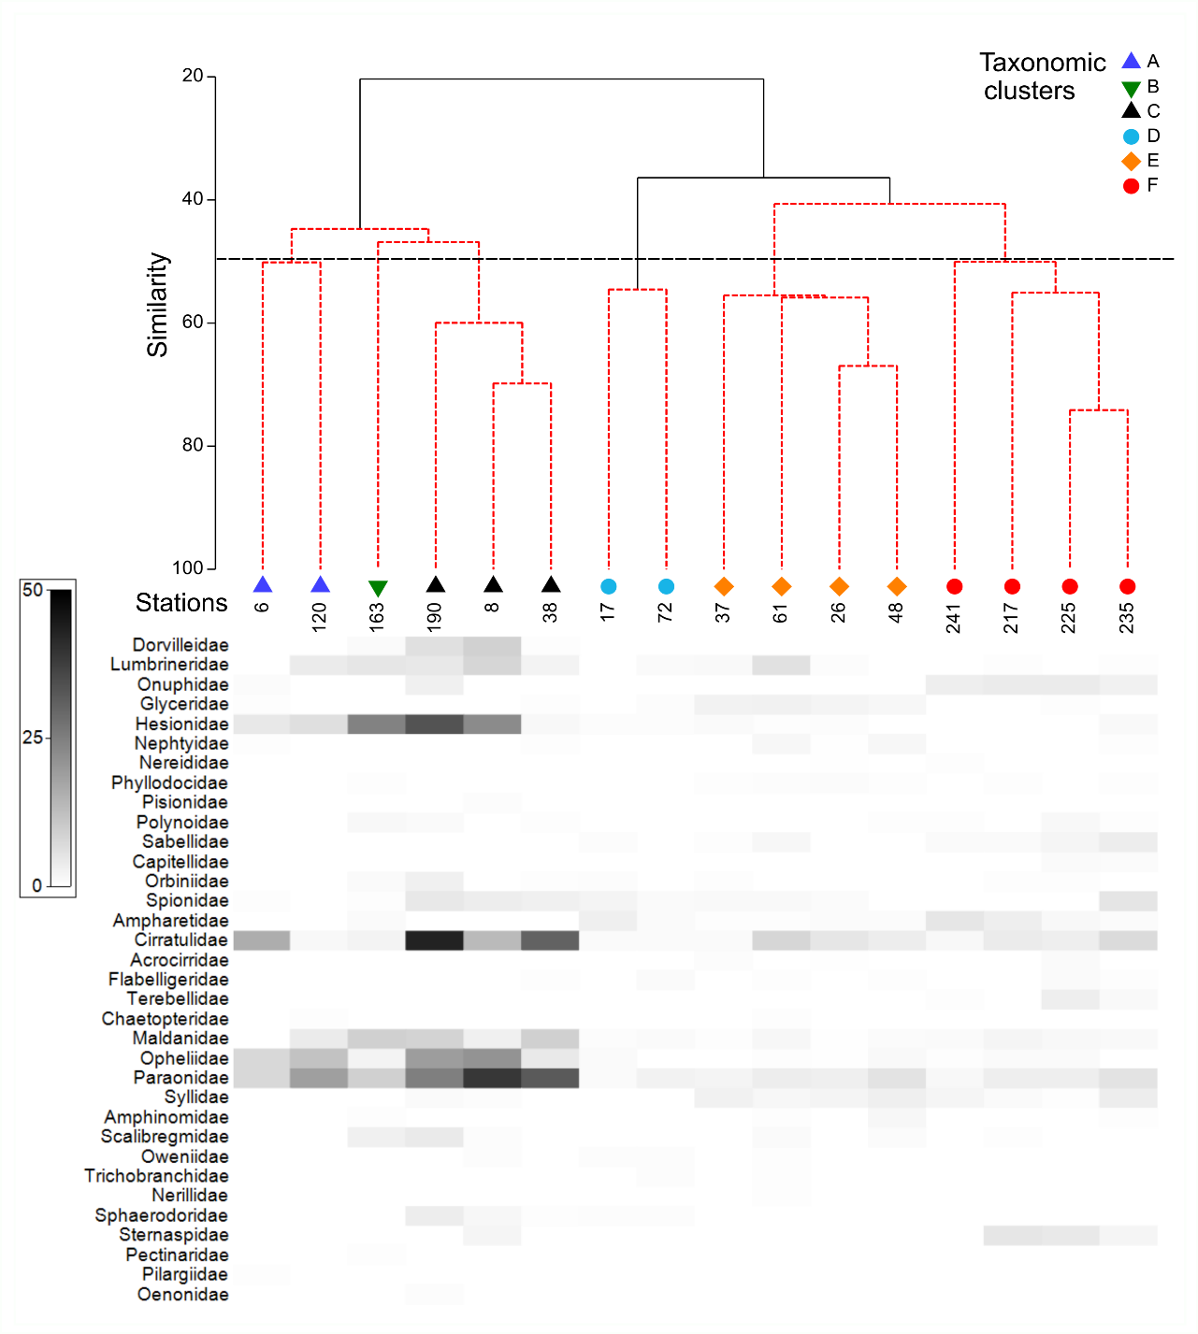
Figure SI2 Dendrogram and shade plot of functional polychaete communities based on cluster (group average) and SIMPROF analyses with similarity at 50% as cut off (dashed line). Colored icons represent functional clusters (A–E) to which stations were assigned. SIMPROF differentiated groups with a = 0.05 (permutations = 9999). Shades indicate the abundance of polychaetes per functional group per 100 cm² for each station
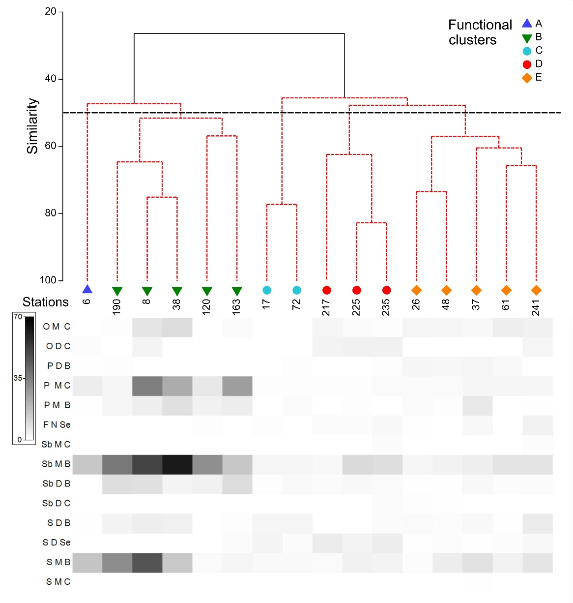

References
Böggemann M (2002) Revision of the Glyceridae Grube 1850 (Annelida: Polychaeta). Abhandlungen Der Senckenbergischen Naturforschenden Gesellschaft, Frankfurt am Main. 249
Carson HS, Hentschel BT (2006) Estimating the dispersal potential of polychaete species in the Southern California Bight: implications for designing marine reserves. Mar. Eco. Prog. Ser. 316: 105–113.
Jumars PA, Dorgan KM, Lindsay SM (2015) Diet of Worms Emended: An Update of Polychaete Feeding Guilds. Annual Review of Marine Science 7: 497-520 doi: 10.1146/annurev-marine-010814-020007
Lee C, Huettel M, Hong J, Reise K (2004) Carrion-Feeding on the Sediment Surface at Nocturnal Low Tides by the Polychaete Phyllodoce Mucosa. Mar. Biol. 145: 575-583
Pettibone MH (1982) Polychaeta. In: Parker, S. P. (Eds.): Synopsis and Classification of living organisms. 3-50
PolytraitsTeam (2025) Polytraits: A database on biological traits of polychaetes. LifewatchGreece, Hellenic Centre for Marine Research
Queirós AM, Birchenough SNR, Bremner J, Godbold JA, Parker RE, Romero-Ramirez A, Reiss H, Solan M, Somerfield PJ, Van Colen C, Van Hoey G. Widdicombe S (2013) A bioturbation classification of European marine infaunal invertebrates. Ecol Evol. 3: 3958–3985
Rouse GW, Pleijel F (2001) Polychaetes. Oxford University. Press, Oxford, UK

