Notoginsenoside R1 Mitigates UVB-induced Skin Sunburn Injury through Modulation of N4-acetylcytidine and Macroautophagy

Shuyun Liang^{a,b}, Xiaokang Liu^{a,b,c}, Yuting Yangª, Fangyuan Zhangª, Xiaobo Sun^{d}, Tong Zhang^{b}, Dean Guo^{c,e}, Jiyu Gong^{a*}, Zizhao Yang^{b, f*}

a. School of Pharmaceutical Sciences, Changchun University of Chinese Medicine, Changchun,130117 China.
b. School of Pharmacy, Shanghai University of Traditional Chinese Medicine, Shanghai, 201203, China.
c. Zhongshan Institute for Drug Discovery, Shanghai Institute of Materia Medica, Chinese Academy of Sciences, Zhongshan 528400, China.
d. Beijing Key Laboratory of Innovative Drug Discovery of Traditional Nature herbs (Natural Medicine) and Translational Medicine, Institute of Medicinal Plant Development, Peking Union Medical College, and Chinese Academy of Medical Sciences, 100193 China.
e. National Engineering Research Center of Traditional Chinese Medicine Standardization Technology, Shanghai Institute of Materia Medica, Chinese Academy of Sciences, Shanghai 201203, China.
f. Department of General Surgery, Shanghai Seventh People's Hospital, Shanghai,200137, China.

*These authors contributed equally.
Corresponding Authors: Prof. Zizhao Yang Ph.D. School of Pharmacy, Shanghai University of Traditional Chinese Medicine, Shanghai, 201203, China. Email: zzyang@shutcm.edu.cn and Prof. Jiyu Gong Ph.D. School of Pharmaceutical Sciences, Changchun University of Chinese Medicine, Changchun,130117 China. Email: gjy0431@126.com

Supplemental information:
• Supplementary figure legends
• Methods
• Supplementary tables

Supplementary figure legends

Supplementary Figure 1. TIC (Total Ion Chromatogram) of the qualitative analysis of total saponins from PNS.

Methods

High-Performance Liquid Chromatography Analysis

Preparation of PNS Sample Solution: Accurately weigh 3 mg of PNS at room temperature, followed by ultrasonic extraction using 1 mL of a 70% (v/v) methanol/water solution for a duration of 15 minutes. Subsequently, the resulting mixture must be filtered through a 0.22 μm membrane filter post- ultrasonic treatment to obtain a pure PNS sample solution.

Preparation of Standard Solution: Weigh appropriate amounts of Notoginsenoside R1, Ginsenoside Rg1, Ginsenoside Rb1, Ginsenoside Re, Ginseno side Rd , Notoginseno side C , Pseudoginseno side RT5 , Rf, Momordicoside A, Ginsenoside F2, Ginsenoside Rb2, Ginsenoside Rg3, Gypenoside XVII, Notoginsenoside Fe, and Ginsenoside Rh4, a total of fifteen saponins. Under the same ambient temperature conditions, employ 1 mL of a 70% (v/v) methanol/water solution for ultrasonic extraction over a duration of 15 minutes, and subsequently prepare a mixed solution with a concentration of 800 mg/ml. Similarly, this composite solution also necessitates filtration through a 0.22 μm membrane filter. The filtrate will be transferred to a specialized sample vial for subsequent analysis using high- performance liquid chromatography (HPLC).

.The mobile phases A and C consist of water and acetonitrile, respectively,
with a flow rate of 0.35 mL/min and a temperature maintained at 35 C. For the multi-component quantification of PNS, the following gradient separation scheme is employed: from 0 to 3.0 minutes, phase C constitutes 81%; from 3.0 to 9.0 minutes, phase C constitutes 79%; at 16.0 minutes, 74% C; 30.0 minutes , 72% C; 33 .0 minutes , 65 .0% C; 38 .0 minutes , 62 .0% C; 45 .0 minutes, 59.0% C; 50 minutes, 55% B; 57.0 minutes, 5.0% C; 62.0 minutes, 81.0% C.

Supplementary figure legends
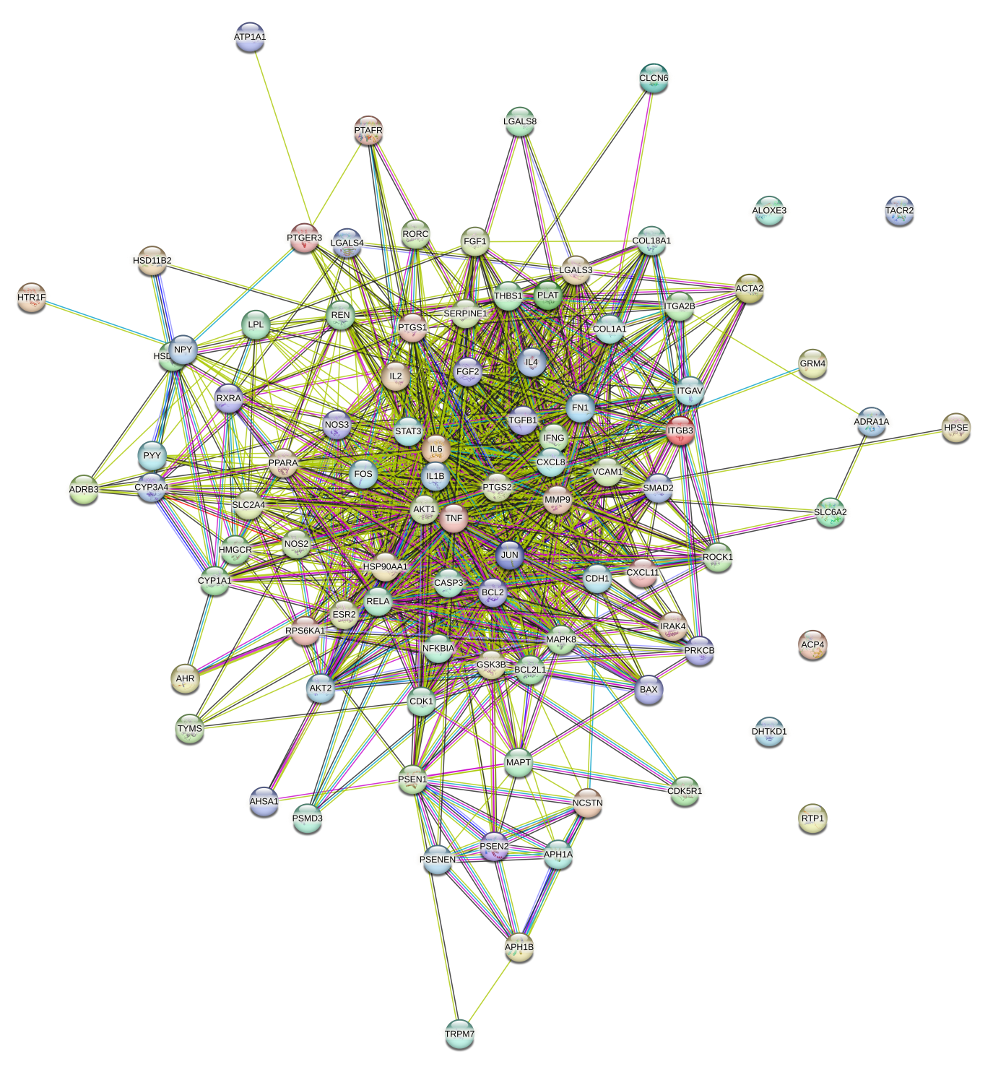

Supplementary Figure 2.Protein-protein interaction network of shared targets between PNS and UVB-induced skin photoaging.

Supplementary figure legends
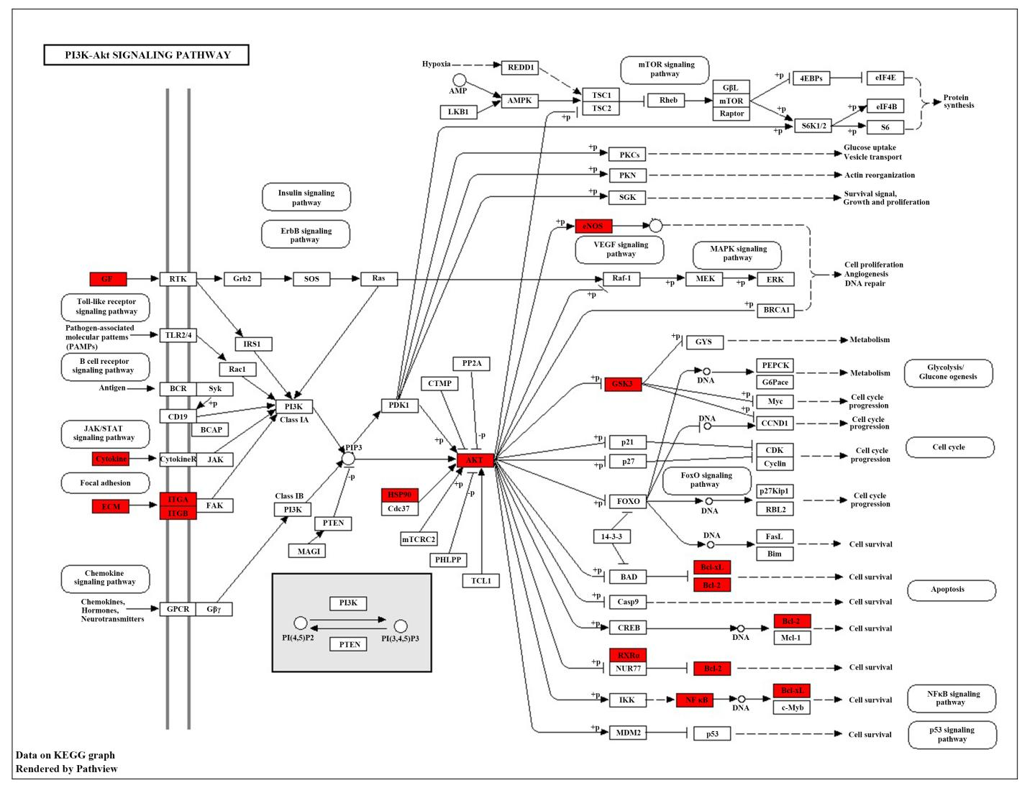
Supplementary Figure 3.The distribution of key targets in the most relevant pathways. Distribution of key targets in the PI3K/AKT signaling pathway.

Supplementary figure legends
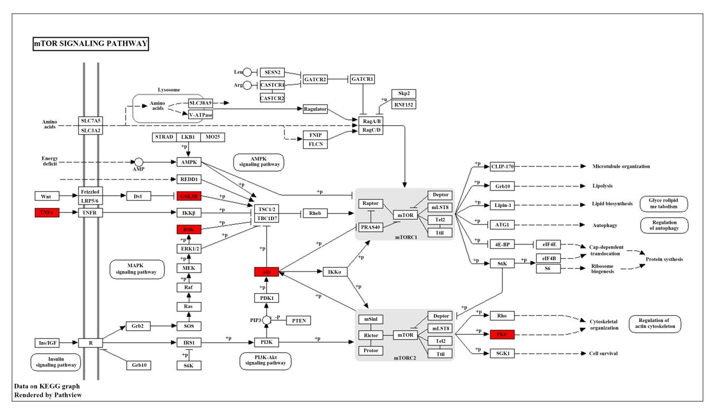
Supplementary Figure 4. Distribution of key targets in the mTOR signaling pathway. Red rectangles represent key targets. Hypothetical targets and genes are shown in red.

Supplementary figure legends
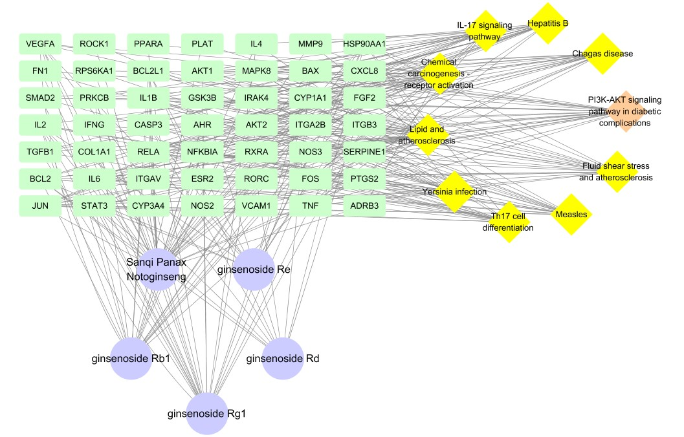
Supplementary Figure 5.Main pathways and target network of PNS in treating UVB-induced skin photoaging.

Supplementary figure legends
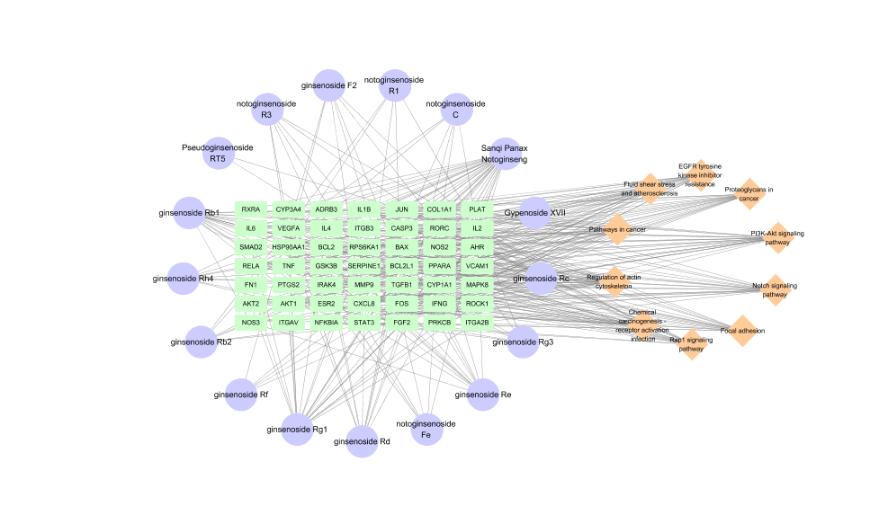

Supplementary Figure 6. A network diagram of 15saponins in PNS and their component targets in UVB-induced skin damage.

Animal Ethics Review Forms
