Table
Table 1: Compounds Identified from PNS by UHPLC-Q-Orbitrap-MS/MS.
NO | RT  (min) | Identity | Formula | Detected m/z | Adducts | Error  (ppm) | Fragment ion
1 | 3.35 | Notoginsenoside C | C₅₄H₉₂O₂₅ | 1139.5873 | [M-H]⁻ | 2.54 | 635.256, 475.3792
2 | 4.99 | Pseudoginsenoside RT5 | C₃₆H₆₂O₁₀ | 653.4262 | [M-H]⁻ | 0.46 | 503.8903, 411.8715
 |  |  |  | 699.433 | [M+HCOO]⁻ | 2.29 | 586.8031, 508.8143, 482.8184, 370.8670
3 | 5.91 | Notoginsenoside R1 | C₄₇H₈₀O₁₈ | 931.5276 | [M-H]⁻ | -1.40 | 931.52759,799.48425, 637.43207,475.37946,
4 | 6.41 | Ginsenoside Rg1 | C₄₂H₇₂O₁₄ | 845.4914 | [M-H]⁻ | 2.48 | 637.43359,475.37976, 391.28748
5 | 6.6 | Ginsenoside Re | C₄₈H₈₂O₁₈ | 945.5383 | [M-H]⁻ | -3.60 | 799.48511,637.43237, 475.37958
6 | 7.05 | Ginsenoside Rf | C₄₂H₇₂O₁₄ | 799.4823 | [M-H]⁻ | -1.88 | 637.4326, 475.3799
 |  |  |  | 845.4915 | [M+HCOO]⁻ | 2.60 | 799.4844, 637.4336, 619.4188, 475.3798
7 | 8.86 | Ginsenoside Rb1 | C₅₄H₉₂O₂₃ | 1107.5936 | [M-H]⁻ | -0.81 | 945.5448, 783.4869, 621.4371, 475.3785
 |  |  |  | 1153.6018 | [M+HCOO]⁻ | 1.56 | 945.5453, 783.4898, 621.4379, 475.3799, 370.8699
8 | 9.03 | Momordicoside A | C₄₂H₇₂O₁₅ | 815.481 | [M-H]⁻ | 2.82 | 637.4345, 475.3802, 370.8673
9 | 9.14 | Ginsenoside F2 | C₄₂H₇₂O₁₃ | 783.4868 | [M-H]⁻ | -2.68 | 637.4344, 475.3811, 370.8683
 |  |  |  | 829.4968 | [M+HCOO]⁻ | 3.01 | 783.4952, 637.4962, 475.3809 370.8665
10 | 9.4 | Ginsenoside Rc | C₅₃H₉₀O₂₂ | 1077.5814 | [M-H]- | -2.41 | 783.4381, 621.4378, 459.3825
11 | 9.56 | Ginsenoside Rb2 | C₅₃H₉₀O₂₂ | 1123.5912 | [M+HCOO]⁻ | 1.60 | 783.4877, 621.4352, 459.3839
12 | 9.81 | Ginsenoside Rd | C₄₈H₈₂O₁₈ | 945.5413 | [M-H]⁻ | -0.42 | 784.49609,621.43695, 459.38132
13 | 9.99 | Ginsenoside Rg3 | C₄₂H₇₂O₁₃ | 783.4861 | [M-H]⁻ | -4.34 | 621.4341, 475.3776, 370.8673
14 | 10.18 | Gypenoside XVII | C₄₈H₈₂O₁₈ | 945.5452 | [M-H]⁻ | 3.70 | 783.4889, 621.4365, 459.3865
15 | 10.62 | Notoginsenoside Fe | C₄₇H₈₀O₁₇ | 915.5277 | [M-H]⁻ | -3.82 | 799.4844, 637.4367, 475.3766
16 | 11.4 | Ginsenoside Rh4 | C₃₆H₆₀O₈ | 619.4208 | [M-H]⁻ | 0.65 | 532.2057, 403.4331, 370.8644
 |  |  |  | 665.4281 | [M+HCOO]⁻ | 3.31 | 508.8144, 370.8675

Table 2: The chemical structural formulas of 16 compounds were identified.
Identity | Chemical structure formula
Notoginsenoside C | 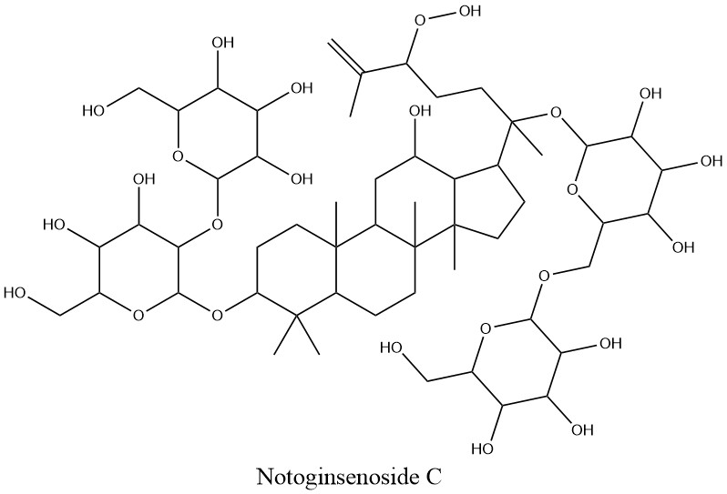
Pseudoginsenoside RT5 | 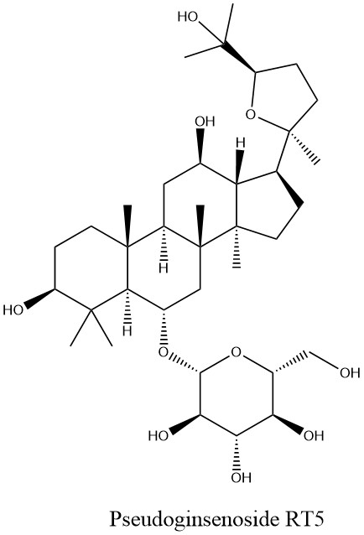
Notoginsenoside R1 | 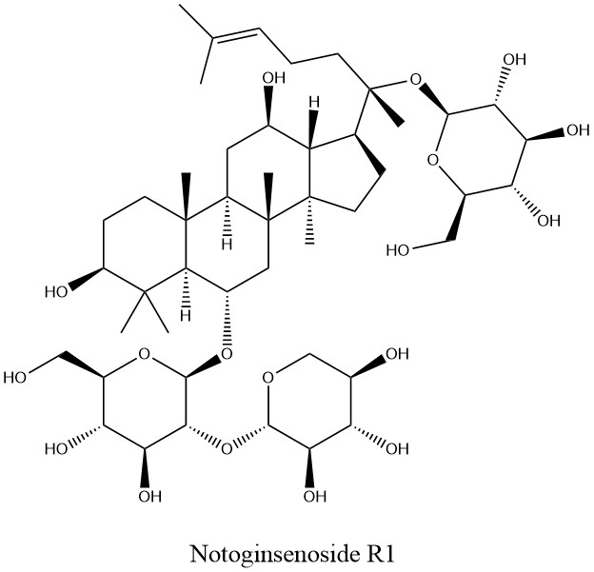
Ginsenoside Rg1 | 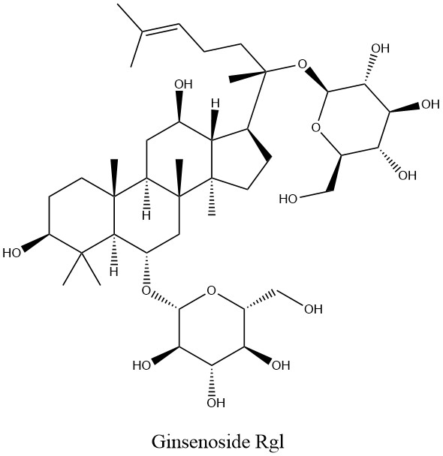
Ginsenoside Re | 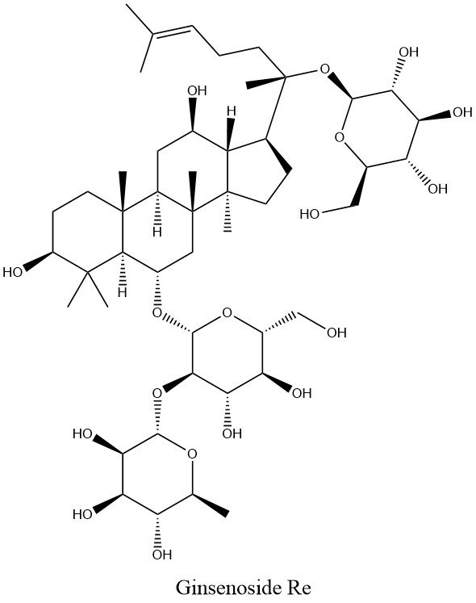
Ginsenoside Rf | 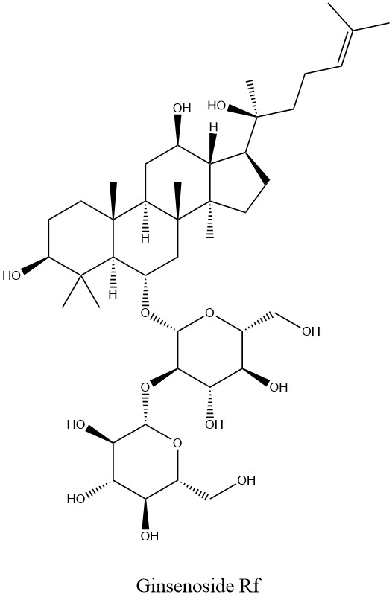
Ginsenoside Rb1 | 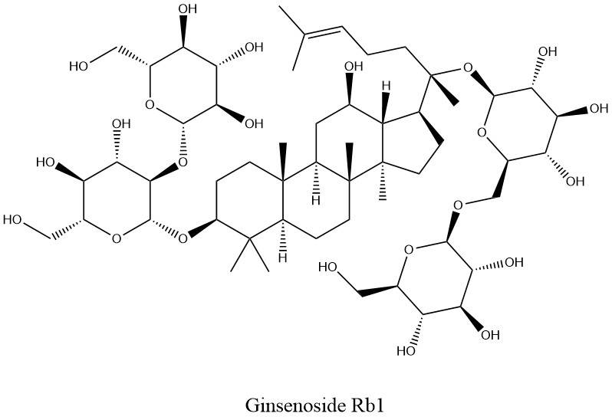
Momordicoside A | 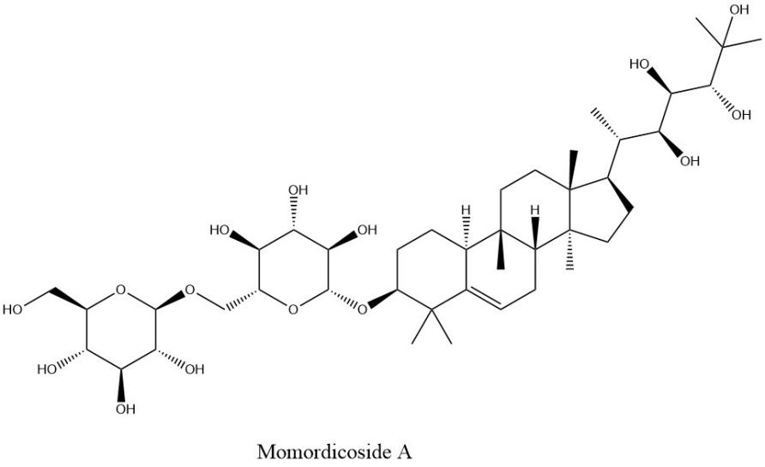
Ginsenoside F2 | 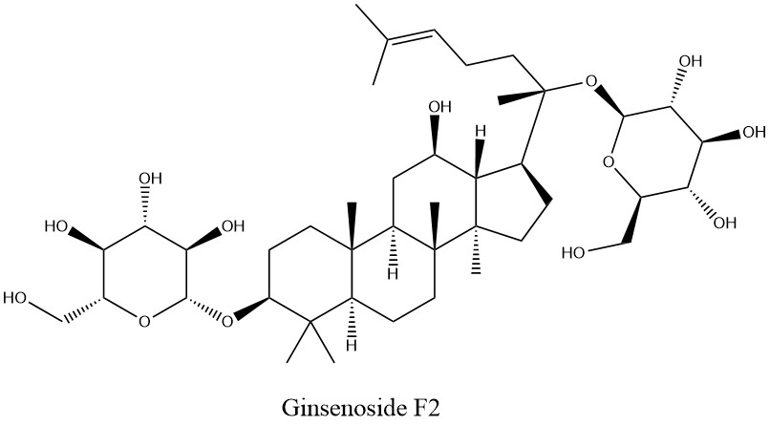
Ginsenoside Rc | 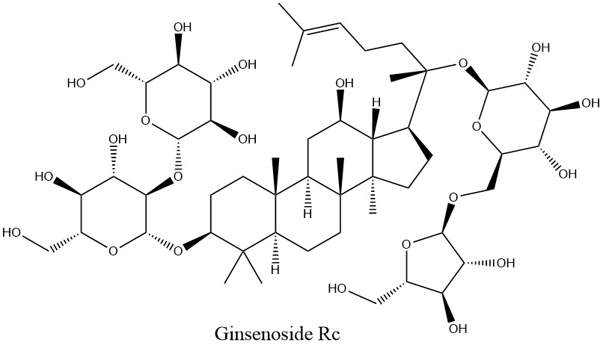
Ginsenoside Rb2 | 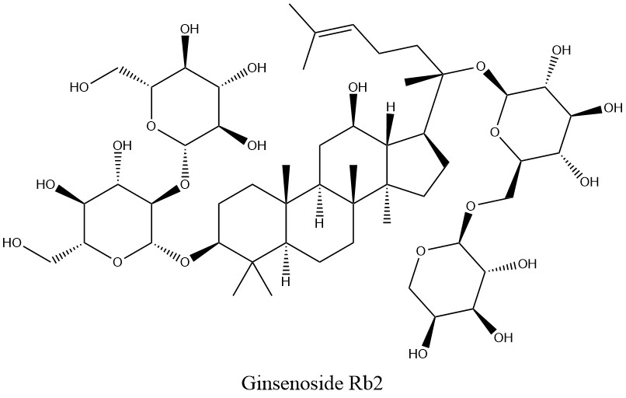
Ginsenoside Rd | 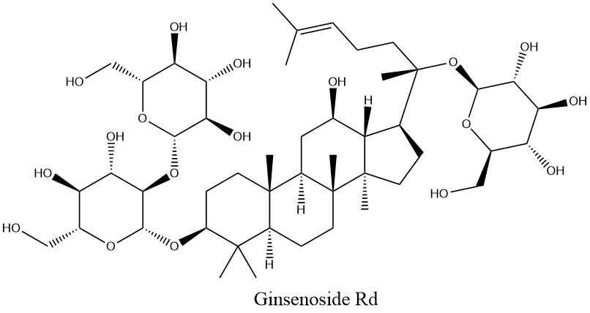
Ginsenoside Rg3 | 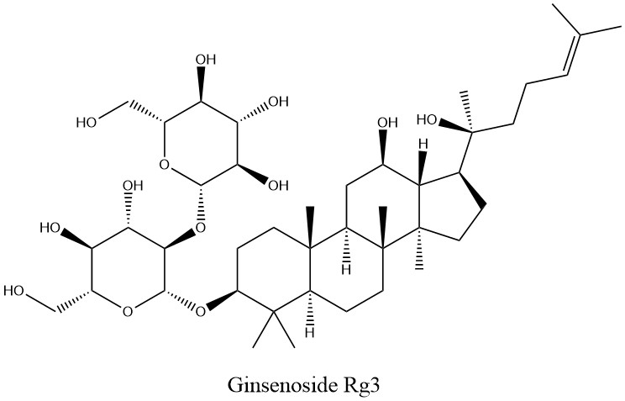
Gypenoside XVII | 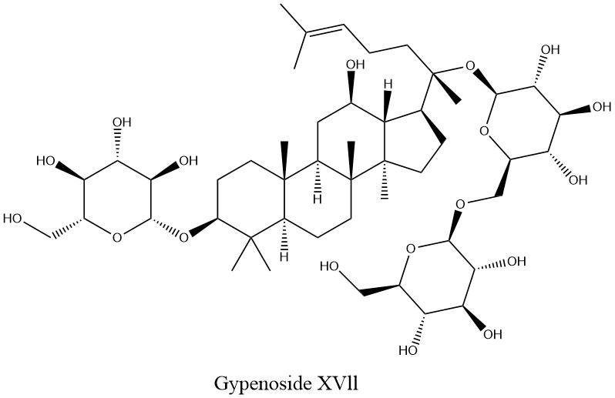
Notoginsenoside Fe | 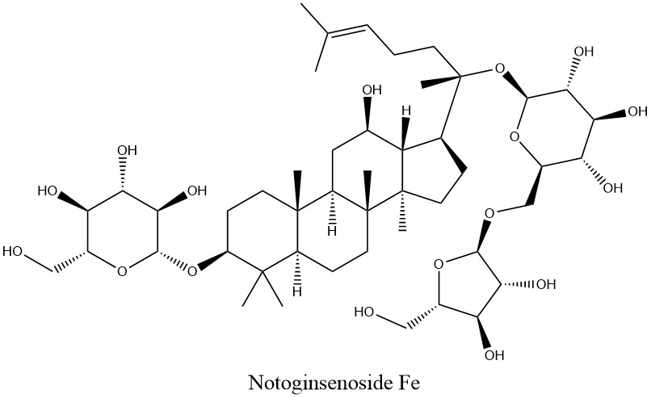
Ginsenoside Rh4 | 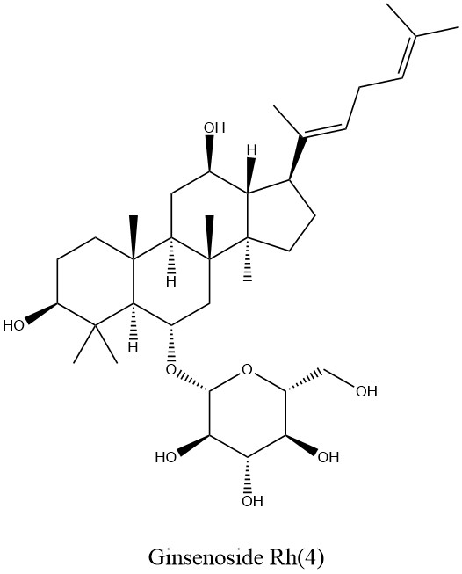

Table 3: The Markers in the Interaction Network between PNS and UVB-induced Damage Proteins (Top 5).
Target name | Degree | Closeness | Betweenness
TNF | 68 | 0.0094 | 974.51
IL6 | 61 | 0.0089 | 377.22
AKT1 | 60 | 0.0088 | 452.96
IL1B | 55 | 0.0084 | 310.35
CASP3 | 52 | 0.0081 | 209.97

Table 4: The Information of the Gene Number and Ratio of KEGG Pathway.
KEGG Pathway | Gene number | Gene Ratio
hsa04151: PI3K-AKT signaling pathway | 11 | 33.33
hsa05205: Proteoglycans in cancer | 9 | 27.27
hsa05200: Pathways in cancer | 12 | 36.36
hsa04330: Notch signaling pathway | 6 | 18.18
hsa05418: Fluid shear stress and atherosclerosis | 7 | 21.21
hsa01521: EGFR tyrosine kinase inhibitor resistance | 6 | 18.18
hsa04810: Regulation of actin cytoskeleton | 8 | 24.24
hsa04510: Focal adhesion | 7 | 21.21
hsa04015: Rap1 signaling pathway | 7 | 21.21
hsa05207: Chemical carcinogenesis - receptor activation | 7 | 21.21

Table 5: Analysis of Pathways Related to Damage Proteins Induced by 15 Saponins in PNS and UVB.
MOL | GENE | PATH
Ginsenoside Rb1 | STAT3 PTAFR IL2 VEGFA FGF1 FGF2 HPSE RORC PSEN2 HSP90AA1 LGALS4 LGALS3 LGALS8 BCL2L1 CDK1 HSD11B2 HSD11B1 ATP1A1 AHR BCL2 CYP1A1 ESR2 IL1B MAPT NFKBIA NOS3 SERPINE1 PLAT PRKCB MAPK8 VCAM1 VEGFA CDK5R1 AHSA1 | PI3K-Akt signaling pathway Proteoglycans in cancer Pathways in cancer Notch signaling pathway Fluid shear stress and atherosclerosis EGFR tyrosine kinase inhibitor resistance Regulation of actin cytoskeleton Focal adhesion Rap1 signaling pathway Chemical carcinogenesis - receptor activation
Ginsenoside Rd | STAT3 PTAFR IL2 VEGFA FGF1 FGF2 HPSE RORC ATP1A1 PSEN2 HSP90AA1 LGALS4 LGALS3 LGALS8 BCL2L1 CDK1 HSD11B2 HSD11B1 PSENEN NCSTN APH1A PSEN1 APH1B TRPM7 GSK3B BAX BCL2 CASP3 PSMD3 | PI3K-Akt signaling pathway Proteoglycans in cancer Pathways in cancer Notch signaling pathway Fluid shear stress and atherosclerosis EGFR tyrosine kinase inhibitor resistance Regulation of actin cytoskeleton Focal adhesion Rap1 signaling pathway Chemical carcinogenesis - receptor activation
Ginsenoside Re | STAT3 PTAFR IL2 VEGFA FGF1 FGF2 HPSE ATP1A1 PSEN2 HSP90AA1 LGALS4 LGALS3 LGALS8 BCL2L1 CDK1 HSD11B2 HSD11B1 SLC2A4 BAX BCL2 CASP3 FOS NOS2 NOS3 | PI3K-Akt signaling pathway Proteoglycans in cancer Pathways in cancer Notch signaling pathway Fluid shear stress and atherosclerosis EGFR tyrosine kinase inhibitor resistance Regulation of actin cytoskeleton Focal adhesion Rap1 signaling pathway Chemical carcinogenesis - receptor activation
Ginsenoside Rg1 | STAT3 PTAFR IL2 BCL2L1 VEGFA FGF1 FGF2 HPSE ATP1A1 HSP90AA1 TYMS ITGAV ITGA2B REN TACR2 AKT2 RPS6KA1 ROCK1 AKT1 LGALS4 LGALS3 LGALS8 ITGB3 ACTA2 AHR CDH1 COL1A1 CYP1A1 FN1 IL2 IL4 SMAD2 PRKCB TGFB1 THBS1 | PI3K-Akt signaling pathway Proteoglycans in cancer Pathways in cancer Notch signaling pathway Fluid shear stress and atherosclerosis EGFR tyrosine kinase inhibitor resistance Regulation of actin cytoskeleton Focal adhesion Rap1 signaling pathway Chemical carcinogenesis - receptor activation
Sanqi Panax Notoginseng | STAT3 PTAFR IL2 VEGFA FGF1 FGF2 HPSE RORC ATP1A1 PSEN2 HSP90AA1 LGALS4 LGALS3 LGALS8 BCL2L1 CDK1 HSD11B2 HSD11B1 PSENEN NCSTN APH1A PSEN1 APH1B PTGS1 PTGS2 ADRA1A ADRB3 NOS2 SLC6A2 ACP4 PM20D2 RTP1 DHTKD1 ALOXE3 RXRA COL1A1 BCL2 CYP1A1 NOS3 NPY IL6 Ccpg1os BAX CASPS JUN CYP3A4 TNF CXCL8 PPARA AHR CLCN6 HTR1E HTR1F MMP9 NFKBIA PYY RELA SLC2A4 PRKCB GRM4 PTGER3 CXCL11 HMGCR LPL Lprq3 IL1B IFNG IL4 IRAK4 Ptges3-ps TP53COR1 Tstap198-15 Cox20b Coaaq1 | PI3K-Akt signaling pathway Proteoglycans in cancer Pathways in cancer Notch signaling pathway Fluid shear stress and atherosclerosis EGFR tyrosine kinase inhibitor resistance Regulation of actin cytoskeleton Focal adhesion Rap1 signaling pathway Chemical carcinogenesis - receptor activation
Pseudoginsenoside RT5 | BCL2L1 GLI1 GLRA1 GLRA2 JUN PTAFR HSD11B1 F2 HSD11B2 PSEN2 PSENEN NCSTN APH1A PSEN1 APH1B PPM1A PTPA PRKCA PTPN1 | Proteoglycans in cancer Pathways in cancer Notch signaling pathway Fluid shear stress and atherosclerosis EGFR tyrosine kinase inhibitor resistance Regulation of actin cytoskeleton Focal adhesion Rap1 signaling pathway Chemical carcinogenesis - receptor activation
ginsenoside Rg3 | STAT3 PTAFR IL2 VEGFA FGF1 FGF2 HPSE PSEN2 PSENEN NCSTN APH1A PSEN1 APH1B HSP90AA1 ATP1A1 LGALS4 LGALS3 LGALS8 BCL2L1 CDK1 HSD11B2 HSD11B1 RORC | PI3K-Akt signaling pathway Proteoglycans in cancer Pathways in cancer Notch signaling pathway Fluid shear stress and atherosclerosis EGFR tyrosine kinase inhibitor resistance Regulation of actin cytoskeleton Focal adhesion Rap1 signaling pathway Chemical carcinogenesis - receptor activation
Ginsenoside Rh4 | STAT3 IL2 PSEN2 PSENEN NCSTN APH1A PSEN1 APH1B BCL2L1 NR3C1 MTOR HSP90AA1 PIK3CA PTAFR EGFR AR PPARG GRB2 MAPK14 PFKFB3 JAK2 MKNK2 BCL2A1 MAPK8 MAPK9 ATP1A1 CSF1R AURKB AURKA ADORA1 ADK CFD PGK1 CHEK1 MAPK1 PTGER1 MAOA SYK S1PR2 SLC5A2 PRF1 MAP3K14 PIM1 MET PIM2 RORC VEGFA FGF1 FGF2 ADORA3 PDPK1 LIMK1 SIRT2 RPS6KB1 LRRK2 TBXAS1 AKR1B1 MAOB CYP2C9 CTSL CTSB LIMK2 ABCB11 | PI3K-Akt signaling pathway Proteoglycans in cancer Pathways in cancer Notch signaling pathway Fluid shear stress and atherosclerosis EGFR tyrosine kinase inhibitor resistance Regulation of actin cytoskeleton Focal adhesion Rap1 signaling pathway Chemical carcinogenesis - receptor activation
Ginsenoside Rc | STAT3 PTAFR IL2 VEGFA FGF1 FGF2 HPSE RORC ATP1A1 HSP90AA1 PSEN2 PSENEN NCSTN APH1A PSEN1 APH1B CDK1 LGALS4 LGALS3 LGALS8 BCL2L1 HSD11B2 HSD11B1 | PI3K-Akt signaling pathway Proteoglycans in cancer Pathways in cancer Notch signaling pathway Fluid shear stress and atherosclerosis EGFR tyrosine kinase inhibitor resistance Regulation of actin cytoskeleton Focal adhesion Rap1 signaling pathway Chemical carcinogenesis - receptor activation
Ginsenoside Rb2 | STAT3 PTAFR IL2 VEGFA FGF1 FGF2 HPSE RORC ATP1A1 HSP90AA1 PSEN2 PSENEN NCSTN APH1A PSEN1 APH1B CDK1 LGALS4 LGALS3 LGALS8 BCL2L1 HSD11B2 HSD11B1 | PI3K-Akt signaling pathway Proteoglycans in cancer Pathways in cancer Notch signaling pathway Fluid shear stress and atherosclerosis EGFR tyrosine kinase inhibitor resistance Regulation of actin cytoskeleton Focal adhesion Rap1 signaling pathway Chemical carcinogenesis - receptor activation
Ginsenoside F2 | STAT3 PTAFR IL2 VEGFA FGF1 FGF2 HPSE RORC ATP1A1 HSP90AA1 PSEN2 PSENEN NCSTN APH1A PSEN1 APH1B LGALS4 LGALS3 LGALS8 BCL2L1 | PI3K-Akt signaling pathway Proteoglycans in cancer Pathways in cancer Notch signaling pathway Fluid shear stress and atherosclerosis EGFR tyrosine kinase inhibitor resistance Regulation of actin cytoskeleton Focal adhesion Rap1 signaling pathway Chemical carcinogenesis - receptor activation
Ginsenoside Rf | STAT3 PTAFR IL2 VEGFA FGF1 FGF2 HPSE RORC ATP1A1 HSD11B2 PSEN2 PSENEN NCSTN APH1A PSEN1 APH1B ADORA1 ADORA2A TYMS ATP1AI | PI3K-Akt signaling pathway Proteoglycans in cancer Pathways in cancer Notch signaling pathway Fluid shear stress and atherosclerosis EGFR tyrosine kinase inhibitor resistance Regulation of actin cytoskeleton Focal adhesion Rap1 signaling pathway
Notoginsenoside R3 | STAT3 PTAFR IL2 VEGFA FGF1 FGF2 HPSE RORC ATP1A1 HSD11B2 PSEN2 PSENEN NCSTN APH1A PSEN1 APH1B LGALS4 LGALS3 LGALS8 BCL2L1 HSD11B2 HSD11B1 CDK1 | PI3K-Akt signaling pathway Proteoglycans in cancer Pathways in cancer Notch signaling pathway Fluid shear stress and atherosclerosis EGFR tyrosine kinase inhibitor resistance Regulation of actin cytoskeleton Focal adhesion Rap1 signaling pathway Chemical carcinogenesis - receptor activation
Notoginsenoside Fe | VEGFA FGF1 FGF2 HPSE HSP90AA1 PSEN2 PSENEN NCSTN APH1A PSEN1 APH1B CDK1 LGALS4 LGALS3 LGALS8 RORC HTR2B ADRA2A ADRA2B ADRA2C DRD1 DRD2 ADRA1D HTR2A HTR2C DRD3 CYP2D6 HTR6 ADRA1A HTR1B STAT3 IL2 TRPV1 SLC6A2 | PI3K-Akt signaling pathway Proteoglycans in cancer Pathways in cancer Notch signaling pathway Fluid shear stress and atherosclerosis EGFR tyrosine kinase inhibitor resistance Regulation of actin cytoskeleton Focal adhesion Rap1 signaling pathway Chemical carcinogenesis - receptor activation
Notoginsenoside R1 | STAT3 VEGFA FGF1 FGF2 HPSE IL2 PTAFR LGALS4 LGALS3 LGALS8 CDK1 ATP1A1 HSD11B2 SLC5A2 SLC5A1 PSEN2 PSENEN NCSTN APH1A PSEN1 APH1B S1PR1 HTR2B ADRA1A ADRA1B ADRA1C DRD1 CYP2D6 HTR1B HSP90AA1 ALOX5AP | PI3K-Akt signaling pathway Proteoglycans in cancer Pathways in cancer Notch signaling pathway Fluid shear stress and atherosclerosis EGFR tyrosine kinase inhibitor resistance Regulation of actin cytoskeleton Focal adhesion Rap1 signaling pathway Chemical carcinogenesis - receptor activation
Notoginsenoside C | VEGFA FGF1 FGF2 HPSE PSEN2 PSENEN NCSTN APH1A PSEN1 APH1B HSP90AA1 LGALS4 LGALS3 LGALS8 CDK1 RORC HTR2B ADRA2A ADRA2B ADRA2C DRD1 DRD2 ADRA1D HTR2A HTR2C DRD3 CYP2D6 HTR6 ADRA1A STAT3 HTR1B SLC6A2 IL2 | PI3K-Akt signaling pathway Proteoglycans in cancer Pathways in cancer Notch signaling pathway Fluid shear stress and atherosclerosis EGFR tyrosine kinase inhibitor resistance Regulation of actin cytoskeleton Focal adhesion Rap1 signaling pathway Chemical carcinogenesis - receptor activation
Gypenoside XVII | STAT3 IL2 VEGFA FGF1 FGF2 HPSE ATP1A1 SLC5A1 SLC5A1 MAP2K1 CDK1 HSD11B2 MTOR PI3KCA MAPK14 REN GNRHR TACR2 PI3KCD PI3KCB PI3KCG | PI3K-Akt signaling pathway Proteoglycans in cancer Pathways in cancer Notch signaling pathway Fluid shear stress and atherosclerosis EGFR tyrosine kinase inhibitor resistance Regulation of actin cytoskeleton Focal adhesion Rap1 signaling pathway

Table 6:Molecular Docking Binding Energy
Component | Target | Energy （kJ/mol） | Component | Target | Energy （kJ/mol）
NGR1 | AKT1 | -9.8 | Rd | IL6 | -6.9
NGR1 | CASP3 | -8.3 | Rd | TNF | -5.7
NGR1 | IL1B | -7.9 | Re | AKT1 | -8.6
NGR1 | IL6 | -7.4 | Re | CASP3 | -7.6
NGR1 | TNF | -7.9 | Re | IL1B | -7.1
Rb1 | AKT1 | -8.3 | Re | IL6 | -7.0
Rb1 | CASP3 | -8.1 | Re | TNF | -6.3
Rb1 | IL1B | -7.1 | Rg1 | AKT1 | -7.5
Rb1 | IL6 | -7.1 | Rg1 | CASP3 | -7.7
Rb1 | TNF | -7.1 | Rg1 | IL1B | -7.2
Rd | AKT1 | -8.3 | Rg1 | IL6 | -7.1
Rd | CASP3 | -7.6 | Rg1 | TNF | -7.3
Rd | IL1B | -7.4

Table 7: The Calibration Curves and Quantitative Data for 16 Analytes Utilizing HPLC.
Analytes | Linearity |  |  | Percentage of content
Analytes | Calibration curves | Range (μg/mL) | R² | Percentage of content
Notoginsenoside C | Y=2430X+87000 | 20.00-800.00 | 0.9967 | 1.19%
Pseudoginsenoside RT5 | Y = 3550 X + 136000 | 20.00-800.00 | 0.9976 | 1.27%
Notoginsenoside R1 | Y = 3110 X + 94500 | 2.00-800.00 | 0.9974 | 9.64%
Ginsenoside Rg1 | Y = 3310 X + 116000 | 2.00-800.00 | 0.9969 | 35.43%
Ginsenoside Re | Y = 3350 X + 109000 | 2.00-800.00 | 0.9977 | 4.77%
Ginsenoside Rf | Y = 3920 X + 118000 | 20.00-800.00 | 0.9980 | 1.01%
Ginsenoside Rb1 | Y = 2340 X + 61900 | 2.00-800.00 | 0.9971 | 29.69%
Momordicoside A | Y = 3490 X + 86100 | 20.00-800.00 | 0.9977 | 0.82%
Ginsenoside F2 | Y = 3950 X + 135000 | 20.00-800.00 | 0.9970 | 1.13%
Ginsenoside Rc | Y = 1460 X - 44600 | 20.00-800.00 | 0.9860 | 1.59%
Ginsenoside Rb2 | Y = 2960 X + 102000 | 20.00-800.00 | 0.9959 | 1.15%
Ginsenoside Rd | Y = 3350 X + 123000 | 2.00-800.00 | 0.9966 | 4.60%
Ginsenoside Rg3 | Y = 4160 X + 146000 | 20.00-800.00 | 0.9970 | 1.17%
Gypenoside XVII | Y = 3270 X + 117000 | 20.00-800.00 | 0.9970 | 1.19%
Notoginsenoside Fe | Y = 3300 X + 113000 | 20.00-800.00 | 0.9973 | 2.04%
Ginsenoside Rh4 | Y = 1110 X + 38300 | 2.00-800.00 | 0.9970 | 3.25%

