Scheme1. Synthesis of two heterobifunctional linkers.

Scheme 2. Synthesis of glycidic cluue G1.

GRAPHICAL ABSTRACT
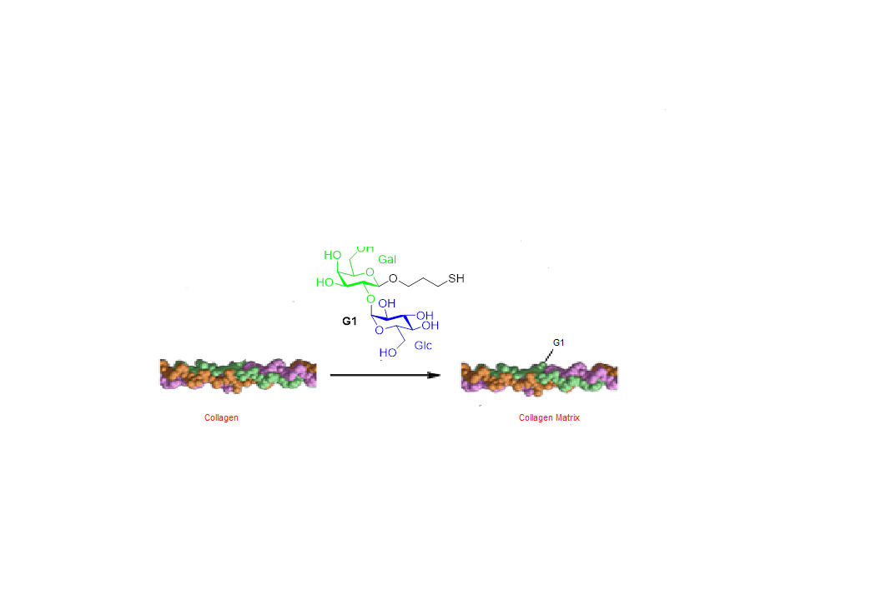
This study seeks to synthesize new glycidic clues that can be used for potential osteoarthritis repair. It is planned to increase the biomaterial bioactivity through collagen glycosylation. This research is strongly motivated by the need for innovative biomaterials in cartilage tissue engineering, especially for repairing osteoarthritis defects.

