Table S1 Incidence of Outcomes During Follow-up
Variable | Overall, N = 22,270 | Control, N = 16,906 | Case, N = 5,364 | p-value
Age | 61 (55 – 65) | 60 (53 – 65) | 63 (59 – 66) | <0.001¹
Sex |  |  |  | 0.002²
Female | 8,895 (40) | 6,849 (41) | 2,046 (38)
Male | 13,375 (60) | 10,057 (59) | 3,318 (62)
Ethnic |  |  |  | 0.002²
Others | 2,782 (12) | 2,178 (13) | 604 (11)
White | 19,488 (88) | 14,728 (87) | 4,760 (89)
Education |  |  |  | <0.001²
Less than high school | 6,267 (28) | 4,408 (26) | 1,859 (35)
High school or equivalent | 10,633 (48) | 8,191 (48) | 2,442 (46)
College or above | 5,370 (24) | 4,307 (25) | 1,063 (20)
BMI |  |  |  | <0.001²
<25 | 2,534 (11) | 2,096 (12) | 438 (8.2)
25-29.9 | 7,724 (35) | 6,014 (36) | 1,710 (32)
≥30 | 12,012 (54) | 8,796 (52) | 3,216 (60)
Smoking |  |  |  | <0.001²
Non-smoking | 10,020 (45) | 7,834 (46) | 2,186 (41)
Smoking | 12,250 (55) | 9,072 (54) | 3,178 (59)
Alcohol |  |  |  | <0.001²
Non-drinking | 14,364 (64) | 10,661 (63) | 3,703 (69)
Drinking | 7,906 (36) | 6,245 (37) | 1,661 (31)
Hypertension | 14,423 (65) | 10,348 (61) | 4,075 (76) | <0.001²
eGFR | 95.4 (85.4 – 102.5) | 96.6 (88.7 – 103.3) | 89.6 (73.1 – 98.8) | <0.001¹
Remnant cholesterol | 0.6 (0.4 – 0.8) | 0.6 (0.4 – 0.8) | 0.6 (0.4 – 0.8) | 0.017¹
Triglycerides | 1.9 (1.3 – 2.7) | 1.9 (1.3 – 2.7) | 2.0 (1.4 – 2.8) | <0.001¹
LDL-C | 2.7 (2.3 – 3.4) | 2.8 (2.3 – 3.4) | 2.6 (2.2 – 3.2) | <0.001¹
HDL-C | 1.2 (1.0 – 1.4) | 1.2 (1.0 – 1.4) | 1.1 (0.9 – 1.3) | <0.001¹
Use of diabetes medication | 11,349 (51) | 7,967 (47) | 3,382 (63) | <0.001²
Use of lipid-lowing medication | 14,602 (66) | 10,534 (62) | 4,068 (76) | <0.001²
¹Wilcoxon rank sum test, ²Pearson's Chi-squared test

Table S2 HRs (95% CIs) of microvascular complications according to the remnant cholesterol among individuals with T2D after excluding the cases that occurred within first 2 years of follow-up
Outcomes | Events/n | Per 1000 person-years | HR (95% CI)
Outcomes | Events/n | Per 1000 person-years | Model1 | Model2 | Model3
Composite microvascular complications
Per 1-SD measure inceases |  |  | 0.97 (0.94-1.00) | 1.11 (1.07-1.15) | 1.11 (1.07-1.15)
Tertile 1 (low) | 1783/7325 | 17.8 | 1.00 | 1.00 | 1.00
Tertile 2 (middle) | 1685/7353 | 16.6 | 0.93 (0.87-1.00) | 1.01 (0.94-1.08) | 0.97 (0.91-1.04)
Tertile 3 (high) | 1645/7341 | 16.1 | 0.90 (0.85-0.97) | 1.21 (1.11-1.32) | 1.15 (1.05-1.25)
Diabetic nephropathy
Per 1-SD measure inceases |  |  | 0.99 (0.96-1.02) | 1.14 (1.10-1.18) | 1.12 (1.07-1.16)
Tertile 1 (low) | 1366/8487 | 11.3 | 1.00 | 1.00 | 1.00
Tertile 2 (middle) | 1409/8494 | 11.6 | 1.03 (0.96-1.11) | 1.12 (1.03-1.21) | 1.07 (0.99-1.16)
Tertile 3 (high) | 1333/8476 | 11.0 | 0.98 (0.91-1.05) | 1.33 (1.21-1.47) | 1.19 (1.08-1.31)
Diabetic retinopathy
Per 1-SD measure inceases |  |  | 0.94 (0.90-0.98) | 1.06 (1.01-1.12) | 1.06 (1.00-1.12)
Tertile 1 (low) | 823/7487 | 7.5 | 1.00 | 1.00 | 1.00
Tertile 2 (middle) | 681/7514 | 6.1 | 0.81 (0.73-0.90) | 0.88 (0.79-0.98) | 0.86 (0.78-0.96)
Tertile 3 (high) | 674/7502 | 6.1 | 0.81 (0.73-0.89) | 1.03 (0.90-1.17) | 1.01 (0.88-1.15)
Diabetic neuropathy
Per 1-SD measure inceases |  |  | 1.05 (1.00-1.11) | 1.15 (1.08-1.23) | 1.15 (1.08-1.22)
Tertile 1 (low) | 428/8432 | 3.4 | 1.00 | 1.00 | 1.00
Tertile 2 (middle) | 414/8455 | 3.3 | 0.96 (0.84-1.10) | 1.02 (0.89-1.18) | 1.00 (0.86-1.15)
Tertile 3 (high) | 464/8458 | 3.7 | 1.08 (0.95-1.23) | 1.33 (1.12-1.58) | 1.29 (1.09-1.53)

Table S3 HRs (95% CIs) of diabetic microvascular complications according to the remnant cholesterol among individuals with T2D with additional adjustment for CRP.
Outcomes | Events/n | Per 1000 person-years | HR (95% CI)
Outcomes | Events/n | Per 1000 person-years | Model1 | Model2 | Model3
Composite microvascular complications
Per 1-SD measure inceases |  |  | 0.97 (0.94-1.00) | 1.11 (1.08-1.15) | 1.11 (1.07-1.15)
Tertile 1 (low) | 1880/7414 | 18.7 | 1.00 | 1.00 | 1.00
Tertile 2 (middle) | 1760/7418 | 17.3 | 0.92 (0.86-0.99) | 1.00 (0.93-1.07) | 0.96 (0.90-1.03)
Tertile 3 (high) | 1711/7379 | 16.8 | 0.90 (0.84-0.96) | 1.20 (1.10-1.31) | 1.13 (1.04-1.23)
Diabetic nephropathy
Per 1-SD measure inceases |  |  | 0.99 (0.96-1.02) | 1.14 (1.10-1.19) | 1.11 (1.07-1.16)
Tertile 1 (low) | 1409/8520 | 11.7 | 1.00 | 1.00 | 1.00
Tertile 2 (middle) | 1453/8525 | 12.0 | 1.03 (0.96-1.11) | 1.12 (1.03-1.21) | 1.08 (1.00-1.16)
Tertile 3 (high) | 1377/8448 | 11.4 | 0.97 (0.90-1.05) | 1.34 (1.22-1.47) | 1.19 (1.08-1.31)
Diabetic retinopathy
Per 1-SD measure inceases |  |  | 0.93 (0.89-0.97) | 1.05 (1.00-1.11) | 1.05 (0.99-1.11)
Tertile 1 (low) | 878/7531 | 8.0 | 1.00 | 1.00 | 1.00
Tertile 2 (middle) | 712/7535 | 6.4 | 0.80 (0.72-0.88) | 0.87 (0.78-0.96) | 0.85 (0.76-0.94)
Tertile 3 (high) | 697/7492 | 6.3 | 0.78 (0.71-0.87) | 1.00 (0.88-1.14) | 0.98 (0.86-1.12)
Diabetic neuropathy
Per 1-SD measure inceases |  |  | 1.03 (0.98-1.08) | 1.15 (1.08-1.22) | 1.14 (1.07-1.21)
Tertile 1 (low) | 485/8477 | 3.9 | 1.00 | 1.00 | 1.00
Tertile 2 (middle) | 457/8484 | 3.6 | 0.94 (0.83-1.07) | 1.00 (0.88-1.15) | 0.97 (0.85-1.11)
Tertile 3 (high) | 493/8447 | 3.9 | 1.02 (0.90-1.15) | 1.27 (1.08-1.49) | 1.22 (1.04-1.43)

Table S4 Information on Remnant cholesterol instrumental variables.
exposure | outcome | SNP | effect_allele.exposure | other_allele.exposure | eaf.exposure | beta.exposure | se.exposure | pval.exposure
Remnant cholesterol | Composite microvascular complications | rs10162642 | A | G | 0.210 | -0.043 | 0.005 | 1.50003E-18
Remnant cholesterol | Composite microvascular complications | rs102275 | C | T | 0.350 | -0.045 | 0.004 | 1.50003E-27
Remnant cholesterol | Composite microvascular complications | rs10260606 | C | G | 0.183 | 0.034 | 0.005 | 8.19974E-11
Remnant cholesterol | Composite microvascular complications | rs1057558 | C | T | 0.220 | -0.025 | 0.005 | 2.99999E-08
Remnant cholesterol | Composite microvascular complications | rs111784051 | G | T | 0.030 | -0.354 | 0.012 | 5.7016E-195
Remnant cholesterol | Composite microvascular complications | rs11206517 | G | T | 0.033 | 0.090 | 0.011 | 7.8001E-15
Remnant cholesterol | Composite microvascular complications | rs115478735 | T | A | 0.183 | 0.059 | 0.005 | 1.80011E-30
Remnant cholesterol | Composite microvascular complications | rs11591147 | T | G | 0.017 | -0.309 | 0.016 | 7.29962E-90
Remnant cholesterol | Composite microvascular complications | rs1169292 | T | C | 0.311 | 0.031 | 0.004 | 4.70002E-12
Remnant cholesterol | Composite microvascular complications | rs117310449 | T | C | 0.012 | 0.178 | 0.019 | 1.29987E-21
Remnant cholesterol | Composite microvascular complications | rs12151108 | A | G | 0.120 | -0.153 | 0.006 | 8.4918E-133
Remnant cholesterol | Composite microvascular complications | rs12740374 | T | G | 0.221 | -0.096 | 0.005 | 1.80011E-85
Remnant cholesterol | Composite microvascular complications | rs12804228 | G | A | 0.085 | 0.053 | 0.007 | 9.8992E-12
Remnant cholesterol | Composite microvascular complications | rs12916 | C | T | 0.400 | 0.058 | 0.004 | 1.39991E-44
Remnant cholesterol | Composite microvascular complications | rs1500188 | G | A | 0.450 | -0.024 | 0.004 | 4.90004E-09
Remnant cholesterol | Composite microvascular complications | rs186021206 | A | G | 0.007 | -0.199 | 0.028 | 1.50003E-12
Remnant cholesterol | Composite microvascular complications | rs187814248 | C | T | 0.006 | 0.152 | 0.029 | 4.90004E-08
Remnant cholesterol | Composite microvascular complications | rs1883711 | C | G | 0.031 | 0.110 | 0.012 | 4.40048E-21
Remnant cholesterol | Composite microvascular complications | rs2326077 | T | C | 0.663 | -0.027 | 0.004 | 7.29962E-11
Remnant cholesterol | Composite microvascular complications | rs247616 | T | C | 0.325 | -0.061 | 0.004 | 1.69981E-43
Remnant cholesterol | Composite microvascular complications | rs2478237 | G | A | 0.404 | -0.021 | 0.004 | 4.09996E-08
Remnant cholesterol | Composite microvascular complications | rs261290 | C | T | 0.655 | -0.076 | 0.004 | 8.80035E-71
Remnant cholesterol | Composite microvascular complications | rs2737245 | T | G | 0.279 | -0.028 | 0.005 | 2.59998E-09
Remnant cholesterol | Composite microvascular complications | rs28550459 | A | T | 0.035 | -0.082 | 0.012 | 2.39994E-12
Remnant cholesterol | Composite microvascular complications | rs35633876 | T | G | 0.482 | -0.024 | 0.004 | 1.2E-08
Remnant cholesterol | Composite microvascular complications | rs3777411 | T | C | 0.151 | -0.049 | 0.006 | 8.49963E-18
Remnant cholesterol | Composite microvascular complications | rs3794695 | T | C | 0.189 | 0.040 | 0.005 | 2.29985E-15
Remnant cholesterol | Composite microvascular complications | rs41289512 | G | C | 0.042 | 0.080 | 0.010 | 4.10015E-16
Remnant cholesterol | Composite microvascular complications | rs41290120 | A | G | 0.049 | -0.371 | 0.010 | 1E-200
Remnant cholesterol | Composite microvascular complications | rs4299376 | T | G | 0.676 | -0.047 | 0.004 | 5.40008E-27
Remnant cholesterol | Composite microvascular complications | rs4665972 | C | T | 0.605 | -0.036 | 0.004 | 8.49963E-18
Remnant cholesterol | Composite microvascular complications | rs472495 | T | G | 0.649 | 0.032 | 0.004 | 3.19963E-14
Remnant cholesterol | Composite microvascular complications | rs488490 | A | C | 0.853 | -0.070 | 0.006 | 1.39991E-32
Remnant cholesterol | Composite microvascular complications | rs553427 | T | C | 0.517 | 0.029 | 0.004 | 2.80027E-13
Remnant cholesterol | Composite microvascular complications | rs56325564 | A | G | 0.483 | 0.030 | 0.004 | 8.00018E-14
Remnant cholesterol | Composite microvascular complications | rs58542926 | T | C | 0.074 | -0.118 | 0.008 | 3.10027E-51
Remnant cholesterol | Composite microvascular complications | rs653178 | T | C | 0.516 | 0.025 | 0.004 | 6.59994E-10
Remnant cholesterol | Composite microvascular complications | rs6601299 | C | T | 0.899 | 0.045 | 0.007 | 9.49948E-12
Remnant cholesterol | Composite microvascular complications | rs6602911 | T | C | 0.360 | 0.024 | 0.004 | 1.89998E-08
Remnant cholesterol | Composite microvascular complications | rs6882345 | A | G | 0.633 | 0.041 | 0.004 | 1.9002E-22
Remnant cholesterol | Composite microvascular complications | rs693 | A | G | 0.521 | 0.077 | 0.004 | 5.40008E-83
Remnant cholesterol | Composite microvascular complications | rs7202323 | G | T | 0.230 | -0.027 | 0.005 | 4.79999E-08
Remnant cholesterol | Composite microvascular complications | rs72631343 | G | C | 0.129 | -0.043 | 0.006 | 7.00003E-13
Remnant cholesterol | Composite microvascular complications | rs72658867 | A | G | 0.012 | -0.229 | 0.019 | 4.40048E-35
Remnant cholesterol | Composite microvascular complications | rs72694391 | C | T | 0.482 | 0.022 | 0.004 | 3.50002E-08
Remnant cholesterol | Composite microvascular complications | rs77542162 | G | A | 0.023 | 0.149 | 0.014 | 1.29987E-26
Remnant cholesterol | Composite microvascular complications | rs77960347 | G | A | 0.013 | 0.136 | 0.018 | 1.20005E-14
Remnant cholesterol | Composite microvascular complications | rs79701229 | A | G | 0.014 | 0.099 | 0.018 | 1.5E-08
Remnant cholesterol | Composite microvascular complications | rs79915079 | A | G | 0.026 | -0.089 | 0.013 | 1.29987E-12
Remnant cholesterol | Composite microvascular complications | rs80017394 | G | A | 0.225 | 0.028 | 0.005 | 4.49997E-08
Remnant cholesterol | Composite microvascular complications | rs9304381 | T | C | 0.818 | 0.031 | 0.005 | 7.69999E-10
Remnant cholesterol | Composite microvascular complications | rs9616847 | T | A | 0.388 | 0.025 | 0.004 | 7.29995E-09
Remnant cholesterol | Composite microvascular complications | rs964184 | C | G | 0.867 | -0.071 | 0.006 | 4.00037E-34
Remnant cholesterol | Composite microvascular complications | rs9682783 | C | T | 0.786 | 0.027 | 0.005 | 4.09996E-08
Remnant cholesterol | Nephropathy | rs10162642 | A | G | 0.210 | -0.043 | 0.005 | 1.50003E-18
Remnant cholesterol | Nephropathy | rs102275 | C | T | 0.350 | -0.045 | 0.004 | 1.50003E-27
Remnant cholesterol | Nephropathy | rs10260606 | C | G | 0.183 | 0.034 | 0.005 | 8.19974E-11
Remnant cholesterol | Nephropathy | rs1057558 | C | T | 0.220 | -0.025 | 0.005 | 2.99999E-08
Remnant cholesterol | Nephropathy | rs111784051 | G | T | 0.030 | -0.354 | 0.012 | 5.7016E-195
Remnant cholesterol | Nephropathy | rs11206517 | G | T | 0.033 | 0.090 | 0.011 | 7.8001E-15
Remnant cholesterol | Nephropathy | rs115478735 | T | A | 0.183 | 0.059 | 0.005 | 1.80011E-30
Remnant cholesterol | Nephropathy | rs11591147 | T | G | 0.017 | -0.309 | 0.016 | 7.29962E-90
Remnant cholesterol | Nephropathy | rs1169292 | T | C | 0.311 | 0.031 | 0.004 | 4.70002E-12
Remnant cholesterol | Nephropathy | rs117310449 | T | C | 0.012 | 0.178 | 0.019 | 1.29987E-21
Remnant cholesterol | Nephropathy | rs12151108 | A | G | 0.120 | -0.153 | 0.006 | 8.4918E-133
Remnant cholesterol | Nephropathy | rs12740374 | T | G | 0.221 | -0.096 | 0.005 | 1.80011E-85
Remnant cholesterol | Nephropathy | rs12804228 | G | A | 0.085 | 0.053 | 0.007 | 9.8992E-12
Remnant cholesterol | Nephropathy | rs12916 | C | T | 0.400 | 0.058 | 0.004 | 1.39991E-44
Remnant cholesterol | Nephropathy | rs1500188 | G | A | 0.450 | -0.024 | 0.004 | 4.90004E-09
Remnant cholesterol | Nephropathy | rs186021206 | A | G | 0.007 | -0.199 | 0.028 | 1.50003E-12
Remnant cholesterol | Nephropathy | rs187814248 | C | T | 0.006 | 0.152 | 0.029 | 4.90004E-08
Remnant cholesterol | Nephropathy | rs1883711 | C | G | 0.031 | 0.110 | 0.012 | 4.40048E-21
Remnant cholesterol | Nephropathy | rs2326077 | T | C | 0.663 | -0.027 | 0.004 | 7.29962E-11
Remnant cholesterol | Nephropathy | rs247616 | T | C | 0.325 | -0.061 | 0.004 | 1.69981E-43
Remnant cholesterol | Nephropathy | rs2478237 | G | A | 0.404 | -0.021 | 0.004 | 4.09996E-08
Remnant cholesterol | Nephropathy | rs261290 | C | T | 0.655 | -0.076 | 0.004 | 8.80035E-71
Remnant cholesterol | Nephropathy | rs2737245 | T | G | 0.279 | -0.028 | 0.005 | 2.59998E-09
Remnant cholesterol | Nephropathy | rs28550459 | A | T | 0.035 | -0.082 | 0.012 | 2.39994E-12
Remnant cholesterol | Nephropathy | rs35633876 | T | G | 0.482 | -0.024 | 0.004 | 1.2E-08
Remnant cholesterol | Nephropathy | rs3777411 | T | C | 0.151 | -0.049 | 0.006 | 8.49963E-18
Remnant cholesterol | Nephropathy | rs3794695 | T | C | 0.189 | 0.040 | 0.005 | 2.29985E-15
Remnant cholesterol | Nephropathy | rs41289512 | G | C | 0.042 | 0.080 | 0.010 | 4.10015E-16
Remnant cholesterol | Nephropathy | rs41290120 | A | G | 0.049 | -0.371 | 0.010 | 1E-200
Remnant cholesterol | Nephropathy | rs4299376 | T | G | 0.676 | -0.047 | 0.004 | 5.40008E-27
Remnant cholesterol | Nephropathy | rs4665972 | C | T | 0.605 | -0.036 | 0.004 | 8.49963E-18
Remnant cholesterol | Nephropathy | rs472495 | T | G | 0.649 | 0.032 | 0.004 | 3.19963E-14
Remnant cholesterol | Nephropathy | rs488490 | A | C | 0.853 | -0.070 | 0.006 | 1.39991E-32
Remnant cholesterol | Nephropathy | rs553427 | T | C | 0.517 | 0.029 | 0.004 | 2.80027E-13
Remnant cholesterol | Nephropathy | rs56325564 | A | G | 0.483 | 0.030 | 0.004 | 8.00018E-14
Remnant cholesterol | Nephropathy | rs58542926 | T | C | 0.074 | -0.118 | 0.008 | 3.10027E-51
Remnant cholesterol | Nephropathy | rs653178 | T | C | 0.516 | 0.025 | 0.004 | 6.59994E-10
Remnant cholesterol | Nephropathy | rs6601299 | C | T | 0.899 | 0.045 | 0.007 | 9.49948E-12
Remnant cholesterol | Nephropathy | rs6602911 | T | C | 0.360 | 0.024 | 0.004 | 1.89998E-08
Remnant cholesterol | Nephropathy | rs6882345 | A | G | 0.633 | 0.041 | 0.004 | 1.9002E-22
Remnant cholesterol | Nephropathy | rs693 | A | G | 0.521 | 0.077 | 0.004 | 5.40008E-83
Remnant cholesterol | Nephropathy | rs7202323 | G | T | 0.230 | -0.027 | 0.005 | 4.79999E-08
Remnant cholesterol | Nephropathy | rs72631343 | G | C | 0.129 | -0.043 | 0.006 | 7.00003E-13
Remnant cholesterol | Nephropathy | rs72658867 | A | G | 0.012 | -0.229 | 0.019 | 4.40048E-35
Remnant cholesterol | Nephropathy | rs72694391 | C | T | 0.482 | 0.022 | 0.004 | 3.50002E-08
Remnant cholesterol | Nephropathy | rs77542162 | G | A | 0.023 | 0.149 | 0.014 | 1.29987E-26
Remnant cholesterol | Nephropathy | rs77960347 | G | A | 0.013 | 0.136 | 0.018 | 1.20005E-14
Remnant cholesterol | Nephropathy | rs79701229 | A | G | 0.014 | 0.099 | 0.018 | 1.5E-08
Remnant cholesterol | Nephropathy | rs79915079 | A | G | 0.026 | -0.089 | 0.013 | 1.29987E-12
Remnant cholesterol | Nephropathy | rs80017394 | G | A | 0.225 | 0.028 | 0.005 | 4.49997E-08
Remnant cholesterol | Nephropathy | rs9304381 | T | C | 0.818 | 0.031 | 0.005 | 7.69999E-10
Remnant cholesterol | Nephropathy | rs9616847 | T | A | 0.388 | 0.025 | 0.004 | 7.29995E-09
Remnant cholesterol | Nephropathy | rs964184 | C | G | 0.867 | -0.071 | 0.006 | 4.00037E-34
Remnant cholesterol | Nephropathy | rs9682783 | C | T | 0.786 | 0.027 | 0.005 | 4.09996E-08
Remnant cholesterol | Neuropathy | rs10162642 | A | G | 0.210 | -0.043 | 0.005 | 1.50003E-18
Remnant cholesterol | Neuropathy | rs102275 | C | T | 0.350 | -0.045 | 0.004 | 1.50003E-27
Remnant cholesterol | Neuropathy | rs10260606 | C | G | 0.183 | 0.034 | 0.005 | 8.19974E-11
Remnant cholesterol | Neuropathy | rs1057558 | C | T | 0.220 | -0.025 | 0.005 | 2.99999E-08
Remnant cholesterol | Neuropathy | rs111784051 | G | T | 0.030 | -0.354 | 0.012 | 5.7016E-195
Remnant cholesterol | Neuropathy | rs11206517 | G | T | 0.033 | 0.090 | 0.011 | 7.8001E-15
Remnant cholesterol | Neuropathy | rs115478735 | T | A | 0.183 | 0.059 | 0.005 | 1.80011E-30
Remnant cholesterol | Neuropathy | rs11591147 | T | G | 0.017 | -0.309 | 0.016 | 7.29962E-90
Remnant cholesterol | Neuropathy | rs1169292 | T | C | 0.311 | 0.031 | 0.004 | 4.70002E-12
Remnant cholesterol | Neuropathy | rs117310449 | T | C | 0.012 | 0.178 | 0.019 | 1.29987E-21
Remnant cholesterol | Neuropathy | rs12151108 | A | G | 0.120 | -0.153 | 0.006 | 8.4918E-133
Remnant cholesterol | Neuropathy | rs12740374 | T | G | 0.221 | -0.096 | 0.005 | 1.80011E-85
Remnant cholesterol | Neuropathy | rs12804228 | G | A | 0.085 | 0.053 | 0.007 | 9.8992E-12
Remnant cholesterol | Neuropathy | rs12916 | C | T | 0.400 | 0.058 | 0.004 | 1.39991E-44
Remnant cholesterol | Neuropathy | rs1500188 | G | A | 0.450 | -0.024 | 0.004 | 4.90004E-09
Remnant cholesterol | Neuropathy | rs186021206 | A | G | 0.007 | -0.199 | 0.028 | 1.50003E-12
Remnant cholesterol | Neuropathy | rs187814248 | C | T | 0.006 | 0.152 | 0.029 | 4.90004E-08
Remnant cholesterol | Neuropathy | rs1883711 | C | G | 0.031 | 0.110 | 0.012 | 4.40048E-21
Remnant cholesterol | Neuropathy | rs2326077 | T | C | 0.663 | -0.027 | 0.004 | 7.29962E-11
Remnant cholesterol | Neuropathy | rs247616 | T | C | 0.325 | -0.061 | 0.004 | 1.69981E-43
Remnant cholesterol | Neuropathy | rs2478237 | G | A | 0.404 | -0.021 | 0.004 | 4.09996E-08
Remnant cholesterol | Neuropathy | rs261290 | C | T | 0.655 | -0.076 | 0.004 | 8.80035E-71
Remnant cholesterol | Neuropathy | rs2737245 | T | G | 0.279 | -0.028 | 0.005 | 2.59998E-09
Remnant cholesterol | Neuropathy | rs28550459 | A | T | 0.035 | -0.082 | 0.012 | 2.39994E-12
Remnant cholesterol | Neuropathy | rs35633876 | T | G | 0.482 | -0.024 | 0.004 | 1.2E-08
Remnant cholesterol | Neuropathy | rs3777411 | T | C | 0.151 | -0.049 | 0.006 | 8.49963E-18
Remnant cholesterol | Neuropathy | rs3794695 | T | C | 0.189 | 0.040 | 0.005 | 2.29985E-15
Remnant cholesterol | Neuropathy | rs41289512 | G | C | 0.042 | 0.080 | 0.010 | 4.10015E-16
Remnant cholesterol | Neuropathy | rs41290120 | A | G | 0.049 | -0.371 | 0.010 | 1E-200
Remnant cholesterol | Neuropathy | rs4299376 | T | G | 0.676 | -0.047 | 0.004 | 5.40008E-27
Remnant cholesterol | Neuropathy | rs4665972 | C | T | 0.605 | -0.036 | 0.004 | 8.49963E-18
Remnant cholesterol | Neuropathy | rs472495 | T | G | 0.649 | 0.032 | 0.004 | 3.19963E-14
Remnant cholesterol | Neuropathy | rs488490 | A | C | 0.853 | -0.070 | 0.006 | 1.39991E-32
Remnant cholesterol | Neuropathy | rs553427 | T | C | 0.517 | 0.029 | 0.004 | 2.80027E-13
Remnant cholesterol | Neuropathy | rs56325564 | A | G | 0.483 | 0.030 | 0.004 | 8.00018E-14
Remnant cholesterol | Neuropathy | rs58542926 | T | C | 0.074 | -0.118 | 0.008 | 3.10027E-51
Remnant cholesterol | Neuropathy | rs653178 | T | C | 0.516 | 0.025 | 0.004 | 6.59994E-10
Remnant cholesterol | Neuropathy | rs6601299 | C | T | 0.899 | 0.045 | 0.007 | 9.49948E-12
Remnant cholesterol | Neuropathy | rs6602911 | T | C | 0.360 | 0.024 | 0.004 | 1.89998E-08
Remnant cholesterol | Neuropathy | rs6882345 | A | G | 0.633 | 0.041 | 0.004 | 1.9002E-22
Remnant cholesterol | Neuropathy | rs693 | A | G | 0.521 | 0.077 | 0.004 | 5.40008E-83
Remnant cholesterol | Neuropathy | rs7202323 | G | T | 0.230 | -0.027 | 0.005 | 4.79999E-08
Remnant cholesterol | Neuropathy | rs72631343 | G | C | 0.129 | -0.043 | 0.006 | 7.00003E-13
Remnant cholesterol | Neuropathy | rs72658867 | A | G | 0.012 | -0.229 | 0.019 | 4.40048E-35
Remnant cholesterol | Neuropathy | rs72694391 | C | T | 0.482 | 0.022 | 0.004 | 3.50002E-08
Remnant cholesterol | Neuropathy | rs77542162 | G | A | 0.023 | 0.149 | 0.014 | 1.29987E-26
Remnant cholesterol | Neuropathy | rs77960347 | G | A | 0.013 | 0.136 | 0.018 | 1.20005E-14
Remnant cholesterol | Neuropathy | rs79701229 | A | G | 0.014 | 0.099 | 0.018 | 1.5E-08
Remnant cholesterol | Neuropathy | rs79915079 | A | G | 0.026 | -0.089 | 0.013 | 1.29987E-12
Remnant cholesterol | Neuropathy | rs80017394 | G | A | 0.225 | 0.028 | 0.005 | 4.49997E-08
Remnant cholesterol | Neuropathy | rs9304381 | T | C | 0.818 | 0.031 | 0.005 | 7.69999E-10
Remnant cholesterol | Neuropathy | rs9616847 | T | A | 0.388 | 0.025 | 0.004 | 7.29995E-09
Remnant cholesterol | Neuropathy | rs964184 | C | G | 0.867 | -0.071 | 0.006 | 4.00037E-34
Remnant cholesterol | Neuropathy | rs9682783 | C | T | 0.786 | 0.027 | 0.005 | 4.09996E-08
Remnant cholesterol | Retinopathy | rs10162642 | A | G | 0.210 | -0.043 | 0.005 | 1.50003E-18
Remnant cholesterol | Retinopathy | rs102275 | C | T | 0.350 | -0.045 | 0.004 | 1.50003E-27
Remnant cholesterol | Retinopathy | rs10260606 | C | G | 0.183 | 0.034 | 0.005 | 8.19974E-11
Remnant cholesterol | Retinopathy | rs1057558 | C | T | 0.220 | -0.025 | 0.005 | 2.99999E-08
Remnant cholesterol | Retinopathy | rs111784051 | G | T | 0.030 | -0.354 | 0.012 | 5.7016E-195
Remnant cholesterol | Retinopathy | rs11206517 | G | T | 0.033 | 0.090 | 0.011 | 7.8001E-15
Remnant cholesterol | Retinopathy | rs115478735 | T | A | 0.183 | 0.059 | 0.005 | 1.80011E-30
Remnant cholesterol | Retinopathy | rs11591147 | T | G | 0.017 | -0.309 | 0.016 | 7.29962E-90
Remnant cholesterol | Retinopathy | rs1169292 | T | C | 0.311 | 0.031 | 0.004 | 4.70002E-12
Remnant cholesterol | Retinopathy | rs117310449 | T | C | 0.012 | 0.178 | 0.019 | 1.29987E-21
Remnant cholesterol | Retinopathy | rs12151108 | A | G | 0.120 | -0.153 | 0.006 | 8.4918E-133
Remnant cholesterol | Retinopathy | rs12740374 | T | G | 0.221 | -0.096 | 0.005 | 1.80011E-85
Remnant cholesterol | Retinopathy | rs12804228 | G | A | 0.085 | 0.053 | 0.007 | 9.8992E-12
Remnant cholesterol | Retinopathy | rs12916 | C | T | 0.400 | 0.058 | 0.004 | 1.39991E-44
Remnant cholesterol | Retinopathy | rs1500188 | G | A | 0.450 | -0.024 | 0.004 | 4.90004E-09
Remnant cholesterol | Retinopathy | rs186021206 | A | G | 0.007 | -0.199 | 0.028 | 1.50003E-12
Remnant cholesterol | Retinopathy | rs187814248 | C | T | 0.006 | 0.152 | 0.029 | 4.90004E-08
Remnant cholesterol | Retinopathy | rs1883711 | C | G | 0.031 | 0.110 | 0.012 | 4.40048E-21
Remnant cholesterol | Retinopathy | rs2326077 | T | C | 0.663 | -0.027 | 0.004 | 7.29962E-11
Remnant cholesterol | Retinopathy | rs247616 | T | C | 0.325 | -0.061 | 0.004 | 1.69981E-43
Remnant cholesterol | Retinopathy | rs2478237 | G | A | 0.404 | -0.021 | 0.004 | 4.09996E-08
Remnant cholesterol | Retinopathy | rs261290 | C | T | 0.655 | -0.076 | 0.004 | 8.80035E-71
Remnant cholesterol | Retinopathy | rs2737245 | T | G | 0.279 | -0.028 | 0.005 | 2.59998E-09
Remnant cholesterol | Retinopathy | rs28550459 | A | T | 0.035 | -0.082 | 0.012 | 2.39994E-12
Remnant cholesterol | Retinopathy | rs35633876 | T | G | 0.482 | -0.024 | 0.004 | 1.2E-08
Remnant cholesterol | Retinopathy | rs3777411 | T | C | 0.151 | -0.049 | 0.006 | 8.49963E-18
Remnant cholesterol | Retinopathy | rs3794695 | T | C | 0.189 | 0.040 | 0.005 | 2.29985E-15
Remnant cholesterol | Retinopathy | rs41289512 | G | C | 0.042 | 0.080 | 0.010 | 4.10015E-16
Remnant cholesterol | Retinopathy | rs41290120 | A | G | 0.049 | -0.371 | 0.010 | 1E-200
Remnant cholesterol | Retinopathy | rs4299376 | T | G | 0.676 | -0.047 | 0.004 | 5.40008E-27
Remnant cholesterol | Retinopathy | rs4665972 | C | T | 0.605 | -0.036 | 0.004 | 8.49963E-18
Remnant cholesterol | Retinopathy | rs472495 | T | G | 0.649 | 0.032 | 0.004 | 3.19963E-14
Remnant cholesterol | Retinopathy | rs488490 | A | C | 0.853 | -0.070 | 0.006 | 1.39991E-32
Remnant cholesterol | Retinopathy | rs553427 | T | C | 0.517 | 0.029 | 0.004 | 2.80027E-13
Remnant cholesterol | Retinopathy | rs56325564 | A | G | 0.483 | 0.030 | 0.004 | 8.00018E-14
Remnant cholesterol | Retinopathy | rs58542926 | T | C | 0.074 | -0.118 | 0.008 | 3.10027E-51
Remnant cholesterol | Retinopathy | rs653178 | T | C | 0.516 | 0.025 | 0.004 | 6.59994E-10
Remnant cholesterol | Retinopathy | rs6601299 | C | T | 0.899 | 0.045 | 0.007 | 9.49948E-12
Remnant cholesterol | Retinopathy | rs6602911 | T | C | 0.360 | 0.024 | 0.004 | 1.89998E-08
Remnant cholesterol | Retinopathy | rs6882345 | A | G | 0.633 | 0.041 | 0.004 | 1.9002E-22
Remnant cholesterol | Retinopathy | rs693 | A | G | 0.521 | 0.077 | 0.004 | 5.40008E-83
Remnant cholesterol | Retinopathy | rs7202323 | G | T | 0.230 | -0.027 | 0.005 | 4.79999E-08
Remnant cholesterol | Retinopathy | rs72631343 | G | C | 0.129 | -0.043 | 0.006 | 7.00003E-13
Remnant cholesterol | Retinopathy | rs72658867 | A | G | 0.012 | -0.229 | 0.019 | 4.40048E-35
Remnant cholesterol | Retinopathy | rs72694391 | C | T | 0.482 | 0.022 | 0.004 | 3.50002E-08
Remnant cholesterol | Retinopathy | rs77542162 | G | A | 0.023 | 0.149 | 0.014 | 1.29987E-26
Remnant cholesterol | Retinopathy | rs77960347 | G | A | 0.013 | 0.136 | 0.018 | 1.20005E-14
Remnant cholesterol | Retinopathy | rs79701229 | A | G | 0.014 | 0.099 | 0.018 | 1.5E-08
Remnant cholesterol | Retinopathy | rs79915079 | A | G | 0.026 | -0.089 | 0.013 | 1.29987E-12
Remnant cholesterol | Retinopathy | rs80017394 | G | A | 0.225 | 0.028 | 0.005 | 4.49997E-08
Remnant cholesterol | Retinopathy | rs9304381 | T | C | 0.818 | 0.031 | 0.005 | 7.69999E-10
Remnant cholesterol | Retinopathy | rs9616847 | T | A | 0.388 | 0.025 | 0.004 | 7.29995E-09
Remnant cholesterol | Retinopathy | rs964184 | C | G | 0.867 | -0.071 | 0.006 | 4.00037E-34
Remnant cholesterol | Retinopathy | rs9682783 | C | T | 0.786 | 0.027 | 0.005 | 4.09996E-08

Table S5 Pleiotropy and heterogeneity of MR-analysis.
Exposure | Outcome | Pleiotropic test |  | Q-statistics (IVW)
Exposure | Outcome | Egger_intercept | P-value | Q | P-value
Remnant cholesterol | Composite microvascular complications | -0.007 | 0.380 | 331.513 | ＜0.001
Remnant cholesterol | Diabetic Nephropathy | -0.007 | 0.369 | 82.138 | 0.006
Remnant cholesterol | Diabetic Neuropathy | -0.002 | 0.854 | 65.780 | 0.112
Remnant cholesterol | Diabetic Retinopathy | -0.007 | 0.380 | 184.584 | ＜0.001

FigS1 Flowchart of the selection of the study population from the UK Biobank study.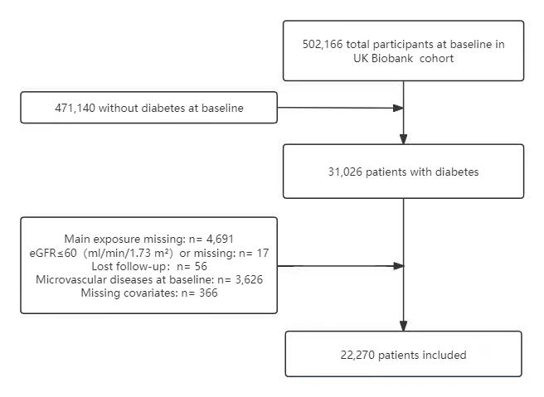
FigS2 Kaplan-Meier Survival Curves for Remnant cholesterol and Composite microvascular complications.
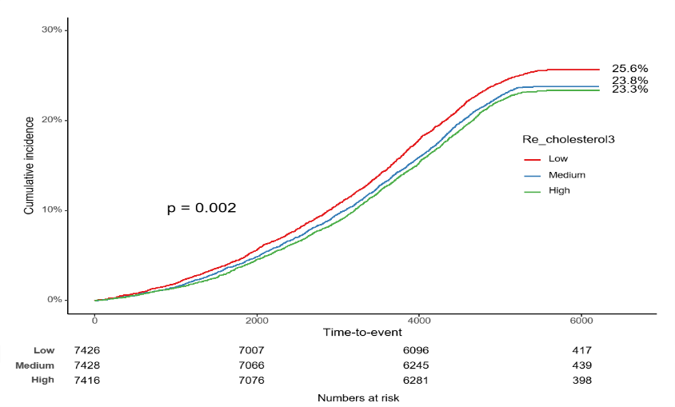
Cumulative incidence of composite microvascular complications at different cholesterol levels: Kaplan-Meier curves. The curve shows the cumulative incidence of cholesterol levels over time in the low, medium, and high groups. At the end of the study, the cumulative incidence was 25.6%, 23.8%, and 23.3%, respectively. There was a statistically significant difference between the three groups (P=0.002). The number of at-risk people for each group is shown below the horizontal axis.

FigS3 Kaplan-Meier Survival Curves for Remnant cholesterol and Diabetic nephropathy.
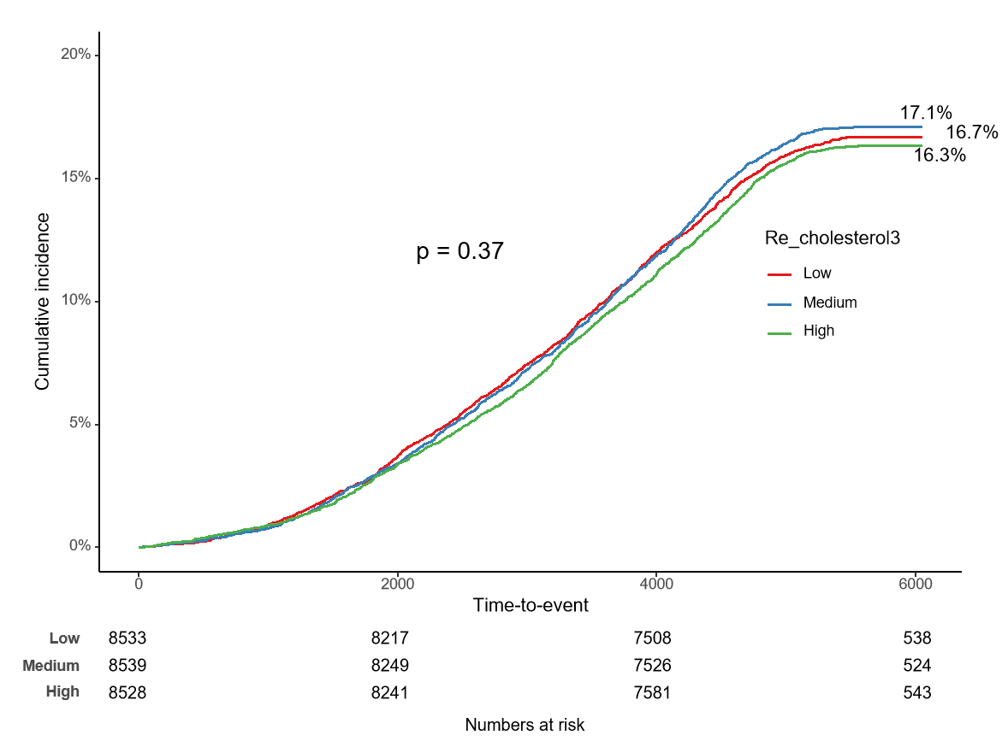
Cumulative incidence of diabetic nephropathy at different cholesterol levels Kaplan-Meier curve. The curve shows the cumulative incidence of cholesterol levels over time in the low, medium, and high groups. At the end of the study, the cumulative incidence was 16.7%, 17.1%, and 16.3%, respectively. There was no statistically significant difference between the three groups (p = 0.37). The number of at-risk people for each group is shown below the horizontal axis.

FigS4 Kaplan-Meier Survival Curves for Remnant cholesterol and Diabetic retinopathy.
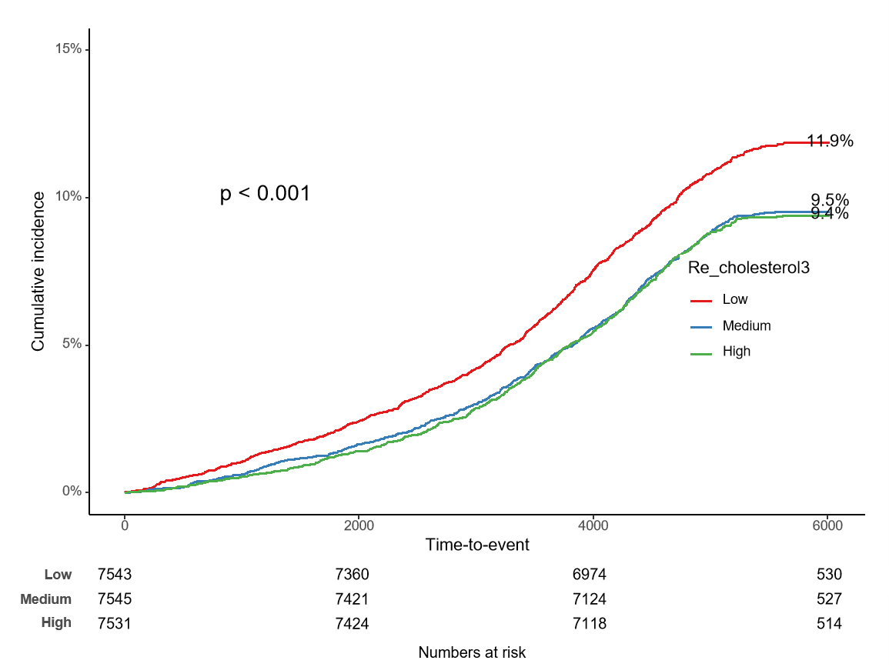
Cumulative incidence of diabetic retinopathy at different cholesterol levels: Kaplan-Meier curves. The curve shows the cumulative incidence over time in the low, medium, and high cholesterol groups. At the end of the study, the cumulative incidence was 11.9%, 9.5%, and 9.4%, respectively. The difference between the three groups was statistically significant (P < 0.001). Below the horizontal axis are the number of people at risk in each group.

FigS5 Kaplan-Meier Survival Curves for Remnant cholesterol and Diabetic neuropathy.
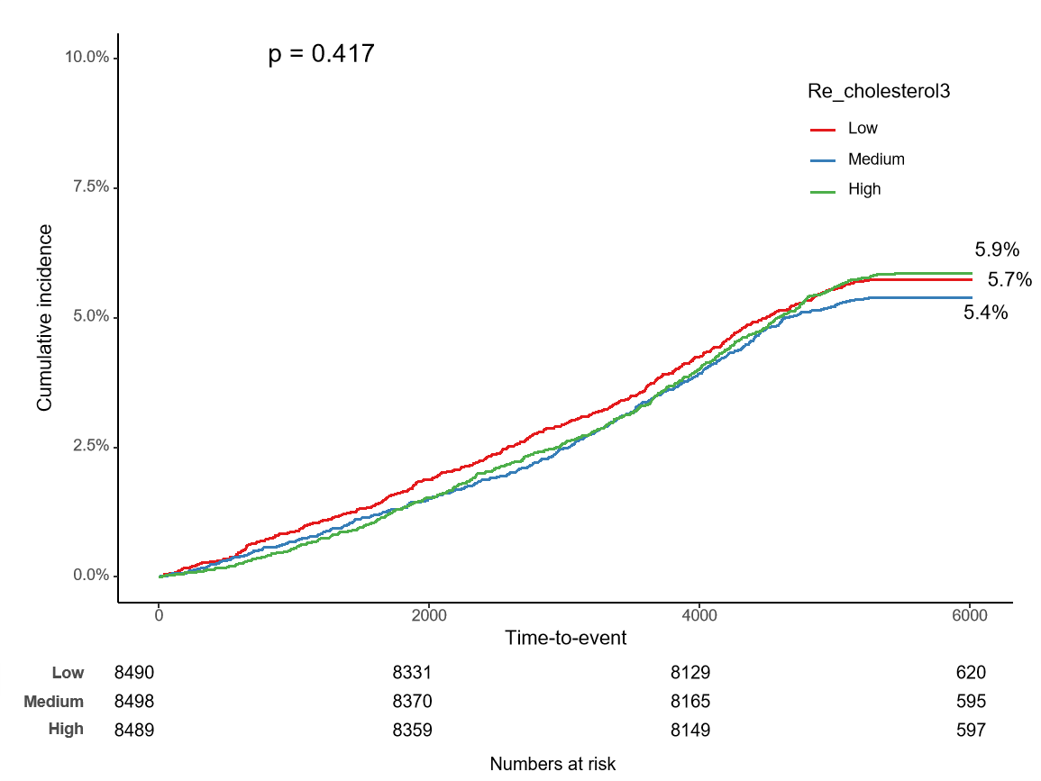
Cumulative incidence of diabetic neuropathy at different cholesterol levels: Kaplan-Meier curves. The curve shows the cumulative incidence over time in the low, medium, and high cholesterol groups. At the end of the study, the cumulative incidence was 5.7%, 5.4%, and 5.9%, respectively. There was no statistically significant difference between the three groups (p = 0.417). Below the horizontal axis are the number of people at risk in each group.

FigS6 Subgroup analyses of the associations of Remnant cholesterol with Diabetic nephropathy.
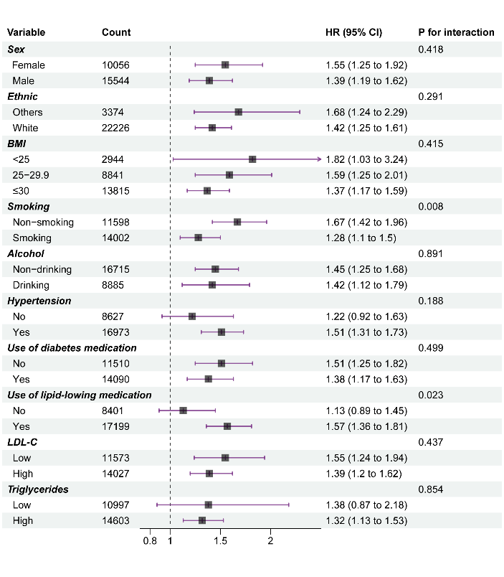
Subgroup analysis of diabetic nephropathy forest plot. The figure shows the risk ratios (HR) of different variables for diabetic nephropathy with 95% confidence intervals. There was a significant interaction between smoking status (p = 0.008) and lipid-lowering drugs (p = 0.023), and there was no significant difference in other variables.

FigS7 Subgroup analyses of the associations of Remnant cholesterol with Diabetic retinopathy.
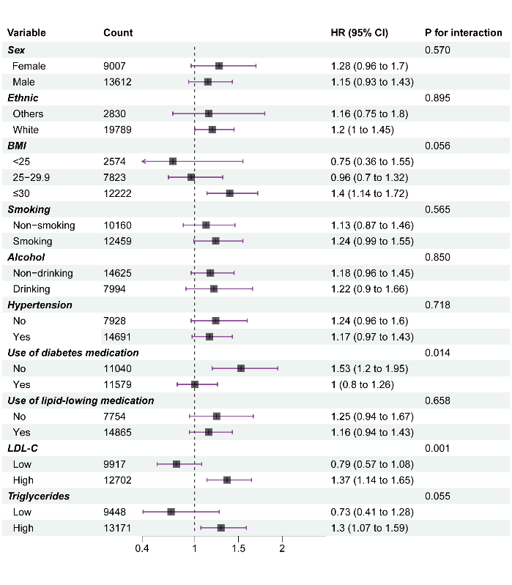
Diabetic retinopathy subgroup analysis forest plot. The figure shows the risk ratio (HR) of different variables for diabetic retinopathy with 95% confidence intervals. There was a significant or near-significant interaction between the use of glucose-lowering drugs (p = 0.014) and BMI (p = 0.056), and there were no significant differences in other variables.

FigS8 Subgroup analyses of the associations of Remnant cholesterol with Diabetic neuropathy.
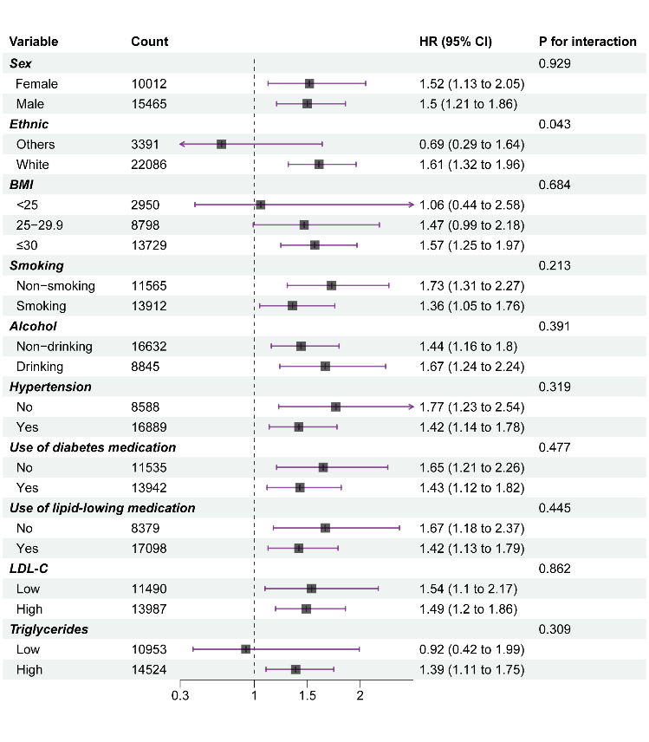
Diabetic neuropathy subgroup analysis forest plot. Risk ratios (HR) for different variables for diabetic neuropathy are shown with 95% confidence intervals. Ethnicity (p = 0.043) showed significant interactions, while there were no significant differences in other variables.

