Influence of simulated future climate CO₂ scenarios on carbon allocation in keystone Cyanobacterium Synechococcus​

Running title: Carbon allocation response of Synechococcus to elevated CO₂
Authors’ names:
Yanyan Zhang^{1,2,3}·Lincheng Huang⁴·Yongxin Liu⁴·Tangcheng Li³·Hong Du³·Faming Wang^{1,2}·Zhe Lu^{1,2*}
Authors’ affiliations:
1. Guangdong Provincial Key Laboratory of Applied Botany, Xiaoliang Research Station for Tropical Coastal Ecosystems, and Key Laboratory of Vegetation Restoration and Management of Degraded Ecosystems, South China Botanical Garden, Chinese Academy of Sciences, Guangzhou, 510650, P. R. China
2. South China National Botanical Garden, Guangzhou, 510650, P. R. China
3. Guangdong Provincial Key Laboratory of Marine Disaster Prediction and Prevention, Shantou University, Shantou, 515000, P.R. China
4. College of Marine Sciences, South China Agricultural University, Guangzhou, 510650, P.R. China

*Corresponding author:
Zhe Lu: luzhe@scbg.ac.cn, Tel: +86-2037252905
Conflicts of interest
The authors declare no competing financial interests.

Supplementary methods and materials
1. Growth patterns of Synechococcus sp. under different CO₂ concentrations
Under the three CO₂ concentrations (400, 850, and 1370 ppm), the Chl-a contents of Synechococcus sp. FACHB-410 exhibited both similarities and differences in temporal dynamics over the 31-day cultivation period (Figure S1). In terms of similarities, regardless of CO₂ concentration, the Chl-a of FACHB-410 gradually increased, entering a rapid growth phase between days 10 and 17. In addition, no significant differences in Chl-a contents were observed among the three experimental groups during the first 24 days of cultivation (p > 0.05). However, differences emerged as CO₂ concentration increased. After 31 days of cultivation, the biomass of Synechococcus sp. FACHB-410 exhibited a significant increase with higher CO₂ levels. Specifically, at 1370 ppm, the Chl-a reached 4.44 ± 0.23 mg L⁻¹, which was significantly higher than that at 850 ppm (an increase of 44%) and at 400 ppm (an increase of 61%) (p < 0.05, Figure S1).

Table S1 The composition table of BG-11 medium
Compounds | mg L⁻¹ dH₂O
NaNO₃ | 1500
K₂HPO₄ | 40
MgSO₄·7H₂O | 75
CaCl₂·2H₂O | 36
Citric acid | 6
Ferric ammonium citrate | 6
EDTANa₂ | 1
H₃BO₃ | 2.86
MnCl2·4H₂O | 1.86
ZnSO₄·7H₂O | 0.22
Na2MoO₄·2H₂O | 0.39
CuSO₄·5H₂O | 0.08
Co(NO₃)₂·6H₂O | 0.05
Adjust PH to 7.1 with 1M NaOH or HCl

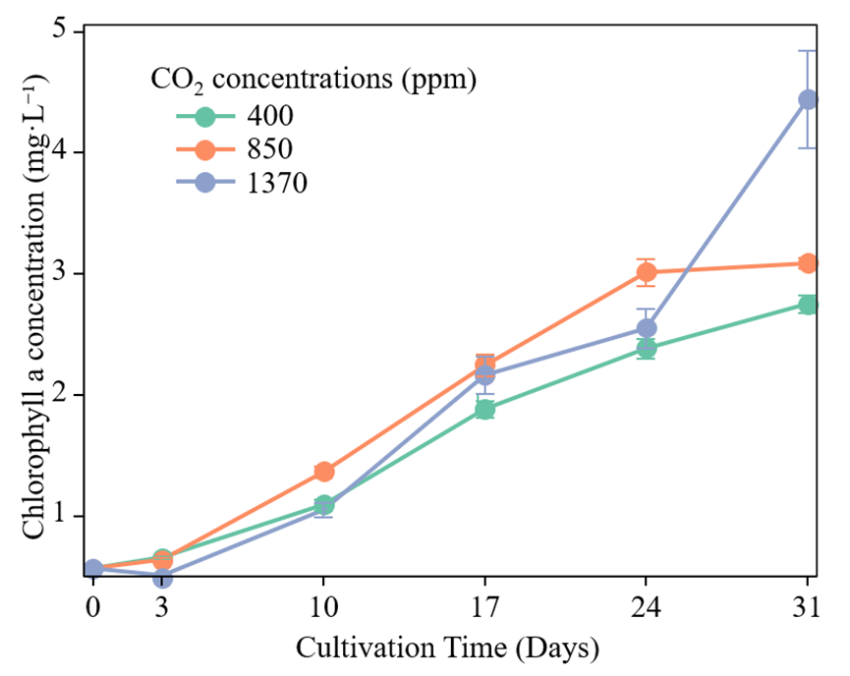
Figure S1. The growth performance of Synechococcus sp. FACHB-410 at three ambient CO₂ concentrations. Data was indicated as means ± SE (n = 3).

