Supplementary Information
Tumor Microenvironment-Responsive CA@ZIF-8/MnO2 Nanoreactor for Self-Reinforcing Cascade Chemodynamic Therapy and Immunomodulation
Yawei Li ^{1†}, Xialin Sun^{1†}, Yilin Huang¹, Shuang Mu¹, Zhengwei Zhu¹, Tingwen Zhang¹, Xianmin Feng ^{1*}, Wenhe Zhu ^{1*}, and Zhigang Xie ²
¹ Jilin Medical University, Jilin 132013, P. R. China
² State Key Laboratory of Polymer Physics and Chemistry, Changchun Institute of Applied Chemistry, Chinese Academy of Sciences, Changchun 130022, P. R. China
*Corresponding author huolizwh@163.com
†These authors have contributed equally to this work.

Experimental section
Materials
Zinc nitrate hexahydrate (Zn(NO₃)_{2▪}6H₂O), 2-methylimidazole (2-MIM), Chlorogenic acid (CA), methylene blue (MB), 5,5’-dithiobis (2-nitrobenzoic acid) (DTNB), glutathione (GSH), manganese chloride (MnCl₂), and sodium bicarbonate (NaHCO₃) were purchased from Aladdin Chemical Co. Ltd. Potassium permanganate (KMnO₄), hydrogen peroxide (H₂O₂, 30%), and dimethylsulfoxide (DMSO) were purchased from Sinopharm Chemical Reagent Co. Ltd. FBS, DMEM, PBS, DCFH-DA, MTT, DAPI, Calcein-AM and PI were purchased from Sigma-Aldrich. Annexin V-FITC apoptosis detection kit was purchased from Shanghai Beyotime Biotechnology Co., Ltd. Ultrapure water was prepared from a Milli-Q system (Millipore, USA).
Synthesis of CZM
In a typical experiment, 75 mg of zinc nitrate hexahydrate was dissolved in 2.5 mL of deionized water, on the other hand, 165 mg of 2-methyl imidazole was dissolved into 4.5 mL of methanol and 10 mg of CA was dissolved into 0.5 mL of DMF. Under stirring, the aqueous of zinc nitrate was added into the solution of 2-methyl imidazole and CA at room temperature, the synthesis solution quickly turned turbid. After 3 min, ZM NPs were formed. The solution was centrifuged at 12000 rpm for 10 min to obtain the CZ NPs. Then CZ NPs was washed with methanol three times to completely remove the unreacted reagents. The supernatants were all collected for the measurement of encapsulation efficiency and drug loading content of CA. Thereafter, KMnO₄ aqueous solution (1 mL, 50 mg mL⁻¹) was injected into the mixture, and the resultant CZM was collected by centrifugation at 12000 rpm for 10 min and cleaned with deionized water several times.
Characterization
UV was recorded on SHIMADZU UV-2450 spectrometer. TEM and SEM images were recorded by JEOL JEM-1011 electron microscope (acceleration voltage of 100 kV) and JEOL JXA-840 (acceleration voltage of 15 kV). Size was measured by Malvern Zeta Sizer-Nano ZS90 instrument. PXRD was performed by a Riguku D/MAX2550 diffractometer using CuKα radiation, 40 kV, 200 mA with scanning rate of 0.4 º min⁻¹. TGA was performed using a NetzchSta 449c thermal analyzer system at a rate of 10 ºC min⁻¹ under air atmosphere.
Detection of •OH
A series of CZM NPs solutions were prepared with different concentrations to react with the same amount of MB and H₂O₂. Subsequently, the UV-vis absorption peak of each group around 660 nm was detected which was the characteristic absorption peak of MB.
GSH depletion assay
GSH solutions with same concentration were co-incubated with different treatments for 24 h. The GSH concentration in the supernatant of each group was compared by adding DNTB probe solution and detecting the UV-vis absorbance at 412 nm.
Cellular Uptake
Cellular uptakes by 4T1 murine breast cancer cells were examined using a confocal laser scanning microscope (CLSM). Cells were seeded in 6-well culture plates (a sterile cover slip was put in each well) at a density of 5×10⁴ cells per well and allowed to adhere for 24 h. After that, cells were incubated with CA NPs for different time at 37 ºC. Subsequently, the supernatant was carefully removed and the cells were washed three times with PBS. Subsequently, the cells were ﬁxed with 500 μL of 4% formaldehyde in each well for 20 min at room temperature and washed twice with PBS again. Cells were visualized using blue channel for Hoechst 33258 and red channel for NR under a confocal laser scanning microscope.
Cytotoxicity Test
The cytotoxicity test was measured via MTT assay. 4T1 and 293T cells harvested in a logarithmic growth phase were seeded in 96-well plates at a density of 10⁵ cells/well and incubated in DMEM for 24 h. The medium was then replaced by CA or different NPs. The incubation was continued for 24 h. Then, 20 μL of MTT solution in PBS with the concentration of 5 mg mL⁻¹ was added and the plates were incubated for another 4 h at 37 ºC, followed by removal of the culture medium containing MTT and addition of 150 μL of DMSO to each well to dissolve the formazan crystals formed. Finally, the plates were shaken for 10 min, and the absorbance of formazan product was measured at 490 nm by a microplate reader. Each data point was an average of three independent experiments.
In vitro CRT, ATP and HMGB1 assay
4T1 cells were inoculated with 2×10⁵/mL in a 96-well plate for 2 h. The previous culture solution was discarded and 200 μL of fresh medium containing different NPs was added and co-cultured for 2 h. 2 mL of RIPA buffer was added, cell fragmentation was performed for 10 min, and the cell debris was collected and the supernatant was removed by centrifugation. The obtained cells were assayed for content with ATP, CRT and HMGB1 assay kits (Wuhan Saipei Biological Technology Co., LTD) according to the production protocol.
Total RNA extraction and mRNA Library Construction
Total RNA was extracted from the cells CZM NPs treated or control cells using Trizol (Invitrogen, Carlsbad, CA, USA) according to manual instruction. Total RNA was qualified and quantified using a Nano Drop and Agilent 2100 bioanalyzer (Thermo Fisher Scientific, MA, USA). Oligo(dT)-attached magnetic beads were used to purified mRNA. Purified mRNA was fragmented into small pieces with fragment buffer at appropriate temperature. Then First-strand cDNA was generated using random hexamer-primed reverse transcription, followed by a second-strand cDNA synthesis. Afterwards, A-Tailing Mix and RNA Index Adapters were added by incubating to end repair. The cDNA fragments obtained from previous step were amplified by PCR, and products were purified by Ampure XP Beads, then dissolved in EB solution. The product was validated on the Agilent Technologies 2100 bioanalyzer for quality control. The double stranded PCR products from previous step were heated denatured and circularized by the splint oligo sequence to get the final library. The single strand circle DNA (ssCir DNA) was formatted as the final library. The final library was amplified with phi29 to make DNA nanoball (DNB) which had more than 300 copies of one molecular, DNBs were loaded into the patterned nanoarray and single end 50 bases reads were generated on BGIseq500 platform (BGI-Shenzhen, China).
Bioinformatics analysis
The sequencing data was filtered with SOAPnuke (v1.5.2) by removing reads containing sequencing adapter. The clean reads were mapped to the reference genome using HISAT2 (v2.0.4). Bowtie2 (v2.2.5) was applied to align the clean reads to the reference coding gene set，then expression level of gene was calculated by RSEM (v1.2.12). The heatmap was drawn by pheatmap (v1.0.8) according to the gene expression in different samples. Essentially, differential expression analysis was performed using the DESeq2 (v1.4.5) with Q value ≤ 0.05. To take insight to the change of phenotype, GO and KEGG enrichment analysis of annotated different expressed gene was performed by Phyper based on Hypergeometric test. The significant levels of terms and pathways were corrected by Q value with a rigorous threshold (Q value ≤ 0.05) by Bonferroni.
In vivo antitumor test and safety evaluation
All the experimental procedures to mouse described herein have gained approval from the Ethics Committee of Jilin Medical University and carried out corresponding to the regulation, principles, and guidelines of Chinese law concerning the protection of animal life. Kunming (KM) female mice were obtained from Jilin University and maintained under required conditions. The 4T1 xenograft tumor models were established, and when the tumor grew to a size of ~100 mm³, 4T1 bearing Kunming mice were randomly divided into four groups with 5 mice in each group. Mice were administered different NPs with the same dosage of 20 mg kg⁻¹ CA via tail vein injection once every 2 days, respectively, and the tumor volume and body weight were measured every other day. After 12 days of observation and measurement, the mice of four groups were sacrificed, and the tumors were exfoliated for H&E and TUNEL staining. The main organs (heart, liver, spleen, lungs, and kidneys) of mice were collected for H&E staining.
Statistical Analysis
All experiments were performed at least three times and all results were expressed as mean ± standard deviation (SD). Student’s t-test was used to determine the statistical difference between various experimental and control groups. Signficant differences between the groups are indicated by * for p < 0.05, ** for p < 0.01, and *** for p < 0.001, respectively.

Results
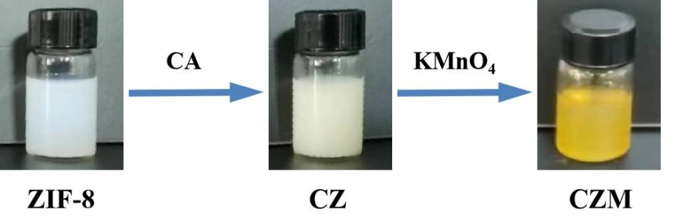
Fig. S1. The appearances of the ZIF-8, CZ, and CZM NPs solution.

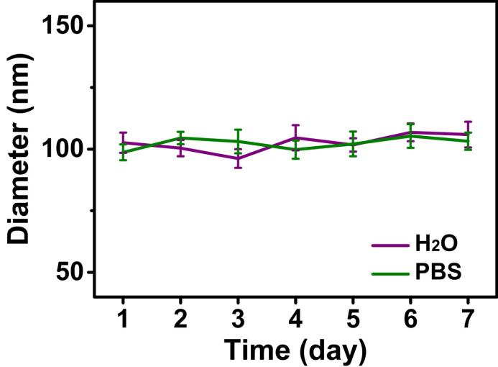
Fig. S2. Changes of hydrodynamic diameter of CZ NPs in water and in PBS with FBS (10%).

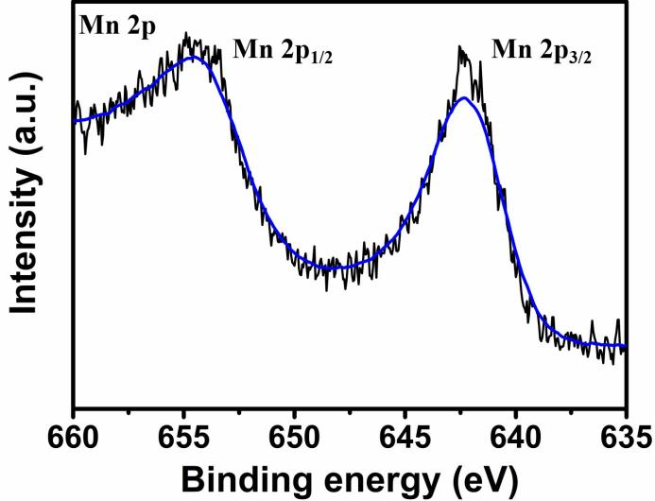
Fig. S3. High-resolution Mn 2p spectrum of CZM NPs.

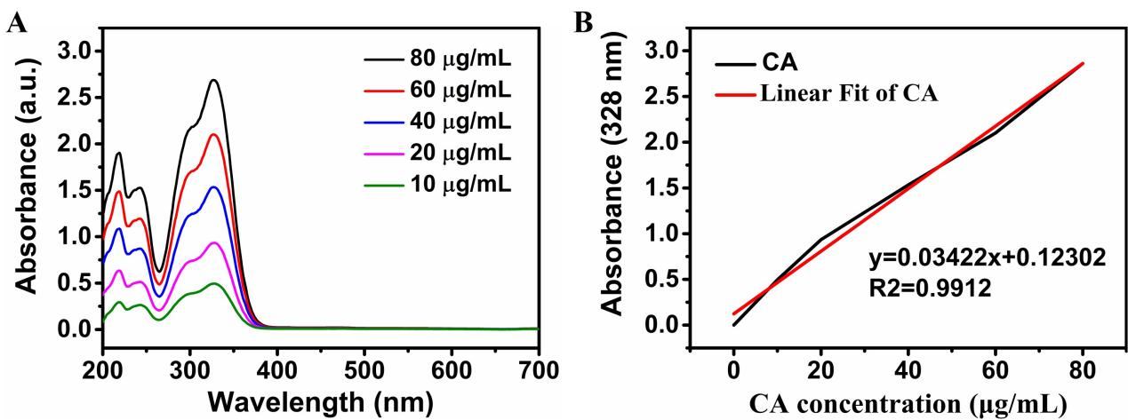
Fig. S4. The quantification of CA loading by UV-vis spectra. (A) UV-vis absorption curves of CA solutions with different concentrations. (B) The standard curve for absorbance values at 327 nm.

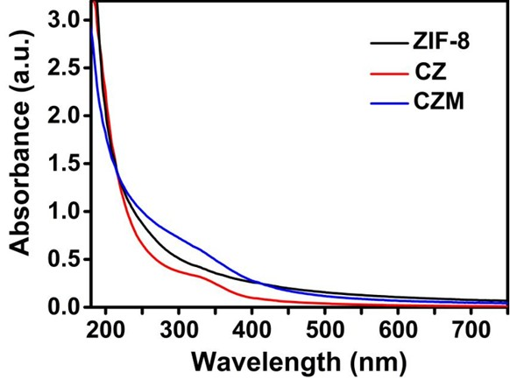
Fig. S5. UV-vis absorption spectra of ZIF-8, CZ, CZM in DI water.

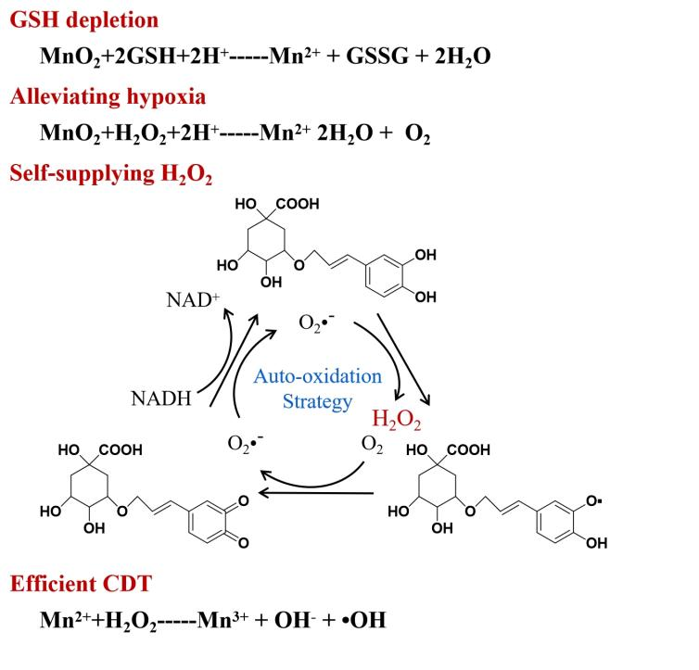
Fig. S6. Mechanisms for dual-enhanced CDT of CZM NPs.

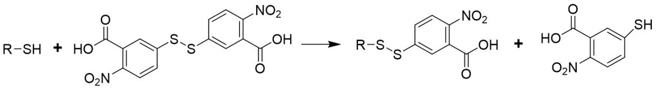
Fig. S7. The mechanism of DTNB detection.

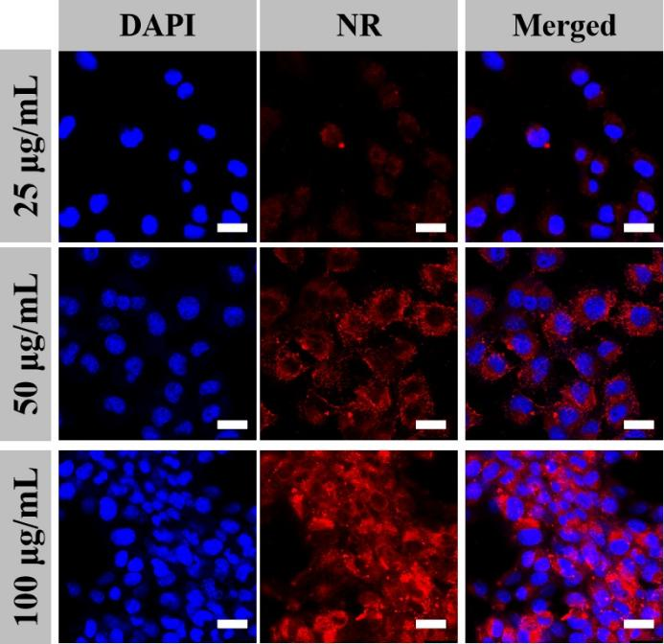
Fig. S8. CLSM images of 4T1 cells incubated with different concentrations of CZM NPs for 4 h at 37 °C. Scale bars: 20 μm.

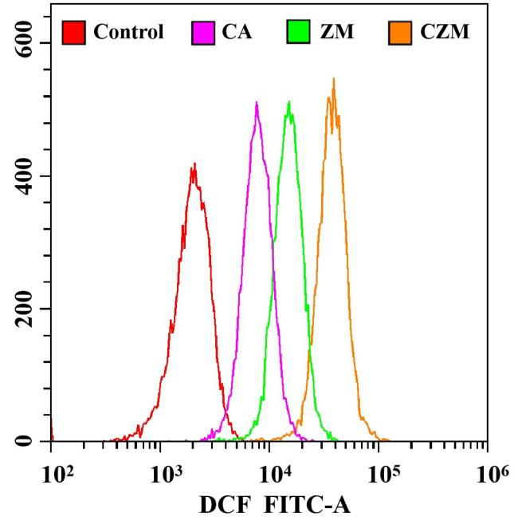
Fig. S9. Flow cytometry analysis of intracellular ROS generation after treatment with different samples ([CA] = 50 μg mL⁻¹, [Mn] = 75 μg mL⁻¹).

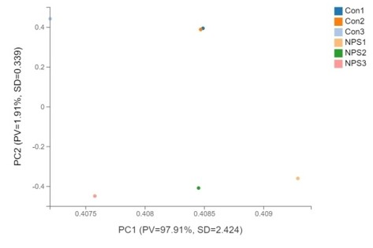
Fig. S10. Principal component analysis (PCA) of 4T1 cells based on untreated control group (Con) and CZM NPs treatment group (NPS).

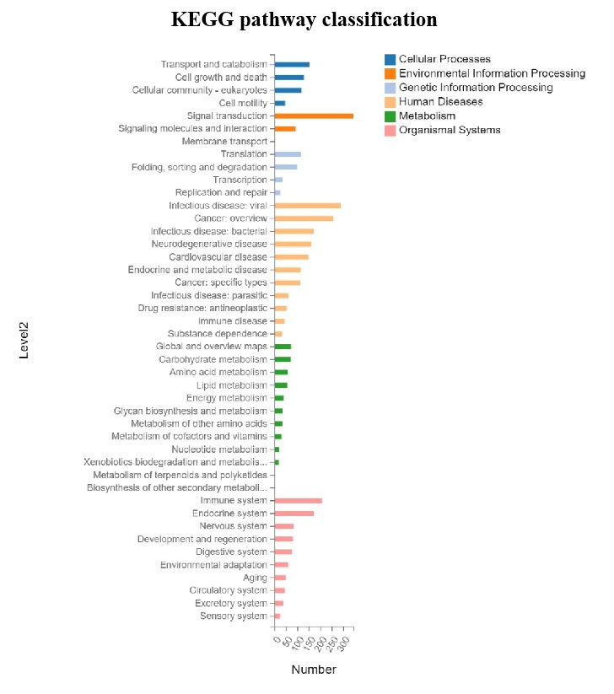
Fig. S11. KEGG pathway classification of differential expressed genes (DEGs). X axis represents number of DEGs, Y axis represents functional classification of KEGG.

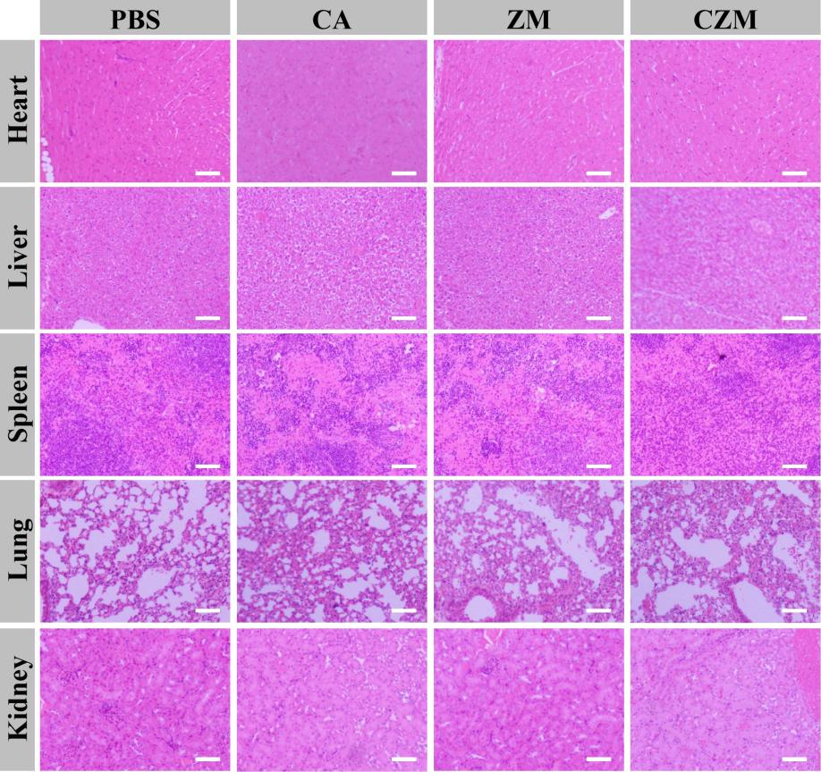
Fig. S12. H&E staining of the major organs (heart, liver, spleen, lung and kidney) of mice with 4T1 tumor xenografts after different treatments. Scale bars: 20 μm.

