Extended Data

Table 1
SAM Subcategory Comparisons
Subcategory | Control | Aphantasia | t-value | p-value | η²​_{p}
Episodic | 23.2 [22.4, 24.0] | 21.9 [21.2, 22.7] | 2.337 | .011 | 0.04
Semantic | 16.7[16.1, 17.4] | 17.4 [16.6, 18.2] | 1.319 | .095 | -
Spatial | 19.9 [19.3, 20.4] | 20.5 [19.9, 21.1] | 1.467 | .073 | -
Future | 18.5 [18.0, 19.0] | 16.0 [15.0, 16.6] | 6.450 | <.0001 | 0.26
Bold p-values represent significant differences between groups after Bonferroni correction. Symbols: η²​_{p} = partial eta squared (effect size).

Table 2
PSI-Q Subcategory Comparisons
Subcategory | Control | Aphantasia | t-value | p-value | η²​_{p}
Visual | 42 [40, 44] | 3 [2, 4] | 32.45 | < .0001 | 0.90
Olfactory | 42 [40, 45] | 13 [10, 37] | 13.24 | < .0001 | 0.59
Auditory | 35 [32, 39] | 9 [6, 13] | 11.11 | < .0001 | 0.51
Taste | 37 [34, 40] | 8 [5, 11] | 13.66 | < .0001 | 0.61
Touch | 42 [39, 43] | 12 [8, 16] | 13.38 | < .0001 | 0.60
Body Sensation | 39 [36, 41] | 12 [8,16] | 11.96 | < .0001 | 0.55
Feeling | 38 [35, 41] | 18 [13, 22] | 7.80 | < .0001 | 0.33
Bold p-values represent significant differences between groups after Bonferroni correction of the significance threshold (p = .007). Scores are shown in mean +\- 95% confidence intervals. Symbols: η²​_{p} = partial eta squared (effect size).

Table 3.
Task Behavioral Results
Task | Control | Aphantasia | t-value | p-value
Oddball Task
Accuracy (%) | .99 [.99, .99] | .99 [ .99, .99] | 0.0335 | .487
Reaction Time (ms) | 115 [111, 120] | 116 [112, 129] | 0.4034 | .344
2-Back Task
Accuracy (%) | .93 [.91, .95] | .92 [.89, .94] | 0.4773 | .317
Reaction Time (ms) | 267 [259, 276] | 270 [262, 279] | 0.4523 | .326
3-Back Task
Accuracy (%) | .79 [ .76, .82] | .77 [ .74, .81] | 0.6683 | .257
Reaction Time (ms) | 293 [282, 304] | 293 [284, 303] | 0.0745 | .470
Values are shown in mean +\- 95% confidence intervals.

Table 4.
Two-Back Frequency Band Power Changes
Frequency Band |  | Control [95% CI] | Aphantasia [95% CI] | t-value | p-value | d
Delta Power (4-7 Hz, μV²)
 | Frontal | 17.51 [16.31, 18.70] | 15.90 [14.78, 17.01] | 2.52 | .003 | .27
 | Central | 13.06 [12.18, 13.94] | 12.81 [12.13, 13.49] | 2.224 | .056 | -
 | Parietal | 11.60 [10.78, 12.43] | 11.68 [10.95, 12.40] | 0.125 | .450 | -
Theta Power (4-7 Hz, μV²)
 | Frontal | 3.69 [3.31, 4.07] | 4.193 [3.86, 4.53] | 1.197 | .025
 | Central | 3.52 [3.13, 3.91] | 3.70 [3.37, 4.02] | 0.981 | .059 | -
 | Parietal | 3.06 [2.75, 3.37] | 3.23 [2.95, 3.50] | 0.835 | .203 | -
Alpha Power (8-13 Hz, μV²)
 | Frontal | 1.90 [1.66, 2.25] | 1.96 [1.65, 2.15] | 0.323 | .373 | -
 | Central | 2.08 [1.78, 2.38] | 2.20 [1.84, 2.56] | 0.498 | .309 | -
 | Parietal | 2.28 [1.94, 2.61] | 2.46 [2.01, 2.91] | 0.649 | .259 | -
Beta Power (13-30 Hz, μV²)
 | Frontal | 0.53 [0.43, 0.63] | 0.55 [0.478, 0.63] | 0.322 | .374 | -
 | Central | 0.46 [0.41, 0.51] | 0.51 [0.45, 0.57] | 1.259 | .105 | -
 | Parietal | 0.49 [0.43, 0.55] | 0.54 [0.48, 0.60] | 1.303 | .098 | -

Comparisons between pre and post averaged frequency band power for the 2-back task. All pre post values are in mean +- 95% CI. Significant differences between groups after Bonferroni correction of the significance threshold are indicated with bolded p-values.

Table 5.
Three-Back Task Band Power Changes
Frequency Band |  | Control [95% CI] | Aphantasia [95% CI] | t-value | p-value | d
Delta Power (4-7 Hz, μV²)
 | Frontal | 19.65 [17.88, 21.42] | 16.34 [15.15, 17.52] | 3.22 | .001 | .72
 | Central | 14.66 [13.49, 15.83] | 13.02 [12.24, 13.80] | 2.56 | .007 | .49
 | Parietal | 12.81 [11.79, 13.83] | 11.72 [10.88, 12.55] | 2.191 | .078 | -
Theta Power (4-7 Hz, μV²)
 | Frontal | 4.65 [4.14, 5.16] | 5.20 [4.53, 5.87] | 1.826 | .036 | -
 | Central | 4.00 [3.57, 4.39] | 4.39 [3.94, 4.84] | 1.950 | .028 | -
 | Parietal | 3.82 [3.32, 4.31] | 4.16 [3.68, 4.63] | 1.383 | .086 | -
Alpha Power (8-13 Hz, μV²)
 | Frontal | 4.00 [3.38, 4.63] | 3.88 [3.29, 4.47] | 0.583 | .281 | -
 | Central | 4.82 [4.00, 5.64] | 4.63 [3.92, 5.35] | 0.246 | .690 | -
 | Parietal | 8.15 [6.46, 9.83] | 7.65 [6.16, 9.14] | 0.785 | .218 | -
Beta Power (13-30 Hz, μV²)
 | Frontal | 0.54 [0.46, 0.61] | 0.55 [0.49, 0.61] | 0.293 | .385 | -
 | Central | 0.57 [0.48, 0.65] | 0.61 [0.55, 0.68] | 1.259 | .107 | -
 | Parietal | 0.60 [ 0.52, 0.68] | 0.70 [0.62, 0.78] | 2.552 | .007 | -

Comparisons between pre and post averaged frequency band power for the 3-back task. All pre post values are in mean +- 95% CI. Significant differences between groups after Bonferroni correction of the significance threshold are indicated with bolded p-values.

Figure 1.

Group Conditional Waveforms
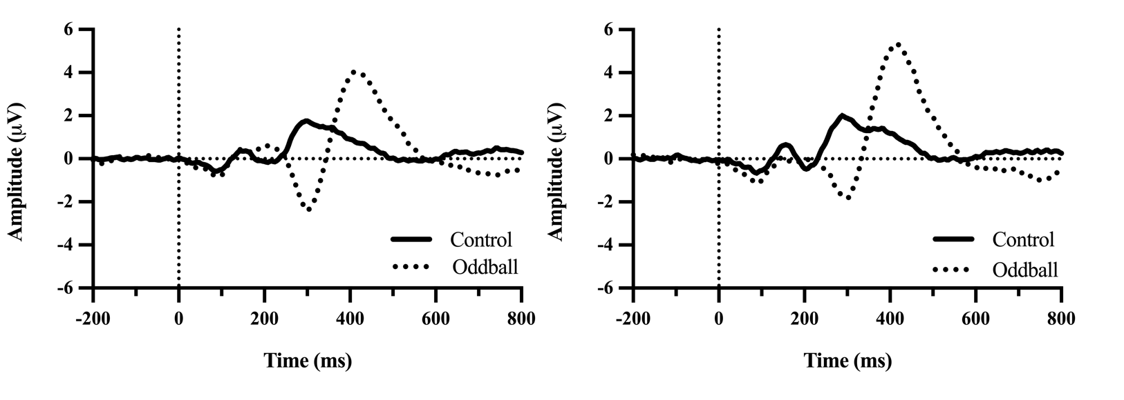
Note. Conditional waveforms for aphantasia (left) and control (right) groups.

