Supplementary Information
A Metal Hydride Compressor using Hydrogen as a Heat Transfer Fluid
Lukas Fleming^{a,b}, Maximilian Passing^{a,b}, Julián Puszkiel^{a,b,}*, Thomas Klassen^{a,b}, Julian Jepsen^{a,b}
a Faculty of Mechanical and Civil Engineering, Helmut-Schmidt-University, Hamburg, Germany
b Institute of Hydrogen Technology, Helmholtz-Zentrum Hereon, Geesthacht, Germany
* julian.puszkiel@hereon.de

Contents
Additional Information on the System Simulation 1
1D Metal Hydride Bed Model 2
Sensitivity Analysis 4
Verification by FEM Model 11
BET area measurement (surface area): Results 14
References 17

Additional Information on the System Simulation
For a better understanding of the system behavior, Figure 1 shows the hydrogen inlet and outlet flows as well as the hydrogen saturation of both tanks. While tank I is connected to the hot loop and therefore desorbed, tank II is connected to the cold loop and absorbed. In accordance with that, a hydrogen flow into the compressor system and an outlet flow leaving the compressor system take place simultaneously. When both reactions come to an end, the connection between the tanks and loops are switched over, indicated by the vertical lines. As described in the main text, the tanks are first isolated from the two loops and then equilibrated in terms of gas phase pressure. This leads to the extra spikes that can be observed during the switch over phase. Tank II is absorbing an additional amount due to the high-pressure gas phase in the just desorbed tank I. The opposite process happens in tank I since the pressure drops below the former equilibrium. When the tanks are then reconnected back to the respective other loop, those additional capacities can be desorbed and, respectively, absorbed additionally. That way, hydrogen capacity is “transferred” from one tank to the other and is not entirely lost by being re-absorbed inside the same tank. This contributes to eliminate the negative effect of “dead volume” on productivity.
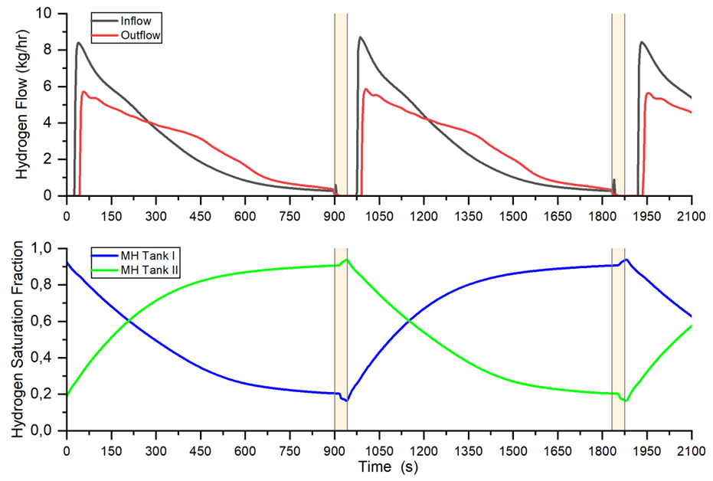
Figure 1: The upper graph shows the inlet and outlet flow of the compressor system, caused by the absorption and desorption processes in the MH tanks, shown in the lower graph. The vertical lines indicate the switch-over process by valves V1-V8. The data is taken from the simulation run 3 of the HP sensitivity analysis (Table 2)

1D Metal Hydride Bed Model
Figure 1 in the article shows that the MH material is distributed among several disc-shaped beds that are stacked upon each other. They are separated by a gap that allows the hydrogen stream to enter each bed and then leave the tank after having passed through a bed. The ACM sub-model is simplifying this geometry by adding up all the discs into one single one with a bigger diameter. The FEM analysis has shown that the processes inside such a bed are purely vertical, which shows that a 1D model is valid here. Below and above the bed, the gas phase volume (sum of all the gaps between the discs) is modeled as point mass.
Figure 2 shows the distribution of nodes inside the 1D bed model. This illustration has 6 nodes where the simulations in the work are done with 10 nodes. The MH material as well as the hydrogen stream through the bed have a spatial distribution over these nodes. In every node, the following variables are calculated using the backward finite difference method:
- rate of the hydrogen formation reaction, including equilibrium pressure and the kinetic equation
- hydrogen saturation
- heat transfer rate
- temperature of the solid and the fluid
- hydrogen mass stream, accounting for the amount of hydrogen absorbed or desorbed
The pressure drop is calculated for the bulk bed. It is including the change of porosity due to change of crystalline density with hydrogen saturation. The resulting operative pressure is distributed equally over all nodes.
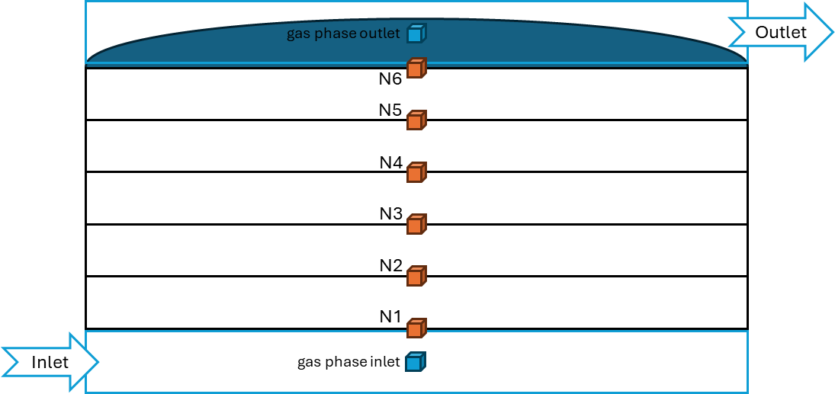
Figure 2: MH tank sub-model. The illustration shows a setup with 6 nodes in the MH bed and point mass gas volumes at the inlet and outlet.
The number of 10 nodes chosen for the simulations is a compromise between resolution of the bed height and computational effort. In Figure 3, the simulation results of an absorption reaction are compared between 1D and FEM model. Additionally, the results of a 1D simulation with 100 nodes is shown. It can be observed that the curves for 100 nodes are nearly identical to the curves for 10 nodes, except for the end phase of the reaction, where the curve for 100 nodes follows the FEM results more precisely. When running the whole system simulation in comparison between 10 and 100 nodes, the deviation in results (productivity and CoP) where less than 1% while the computation time was improved substantially. Therefore, the MH tank sub-models were simulated with 10 nodes.
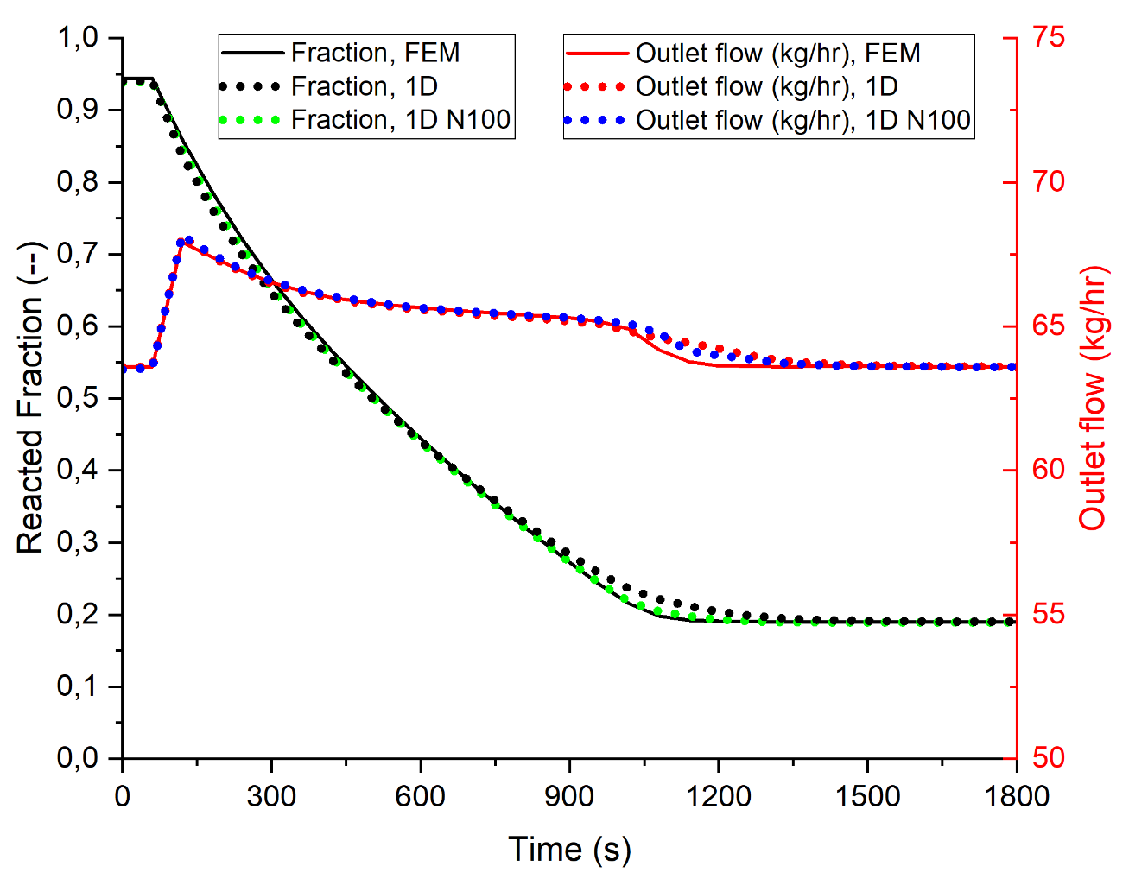
Figure 3: Comparison of simulation results between FEM-model, 1D-FDM-model with 10 nodes and 1D-FDM-model with 100 nodes.

Sensitivity Analysis
In order to carry out a sensitivity analysis using the Morris method, value ranges are required for each parameter to be analyzed. Starting from a base case taken from the studies on productivity and efficiency, reasonable value ranges were selected. They can be found in the header of Table 1. The table contains 7 columns for the parameters to be investigated and another 2 columns for the results of the simulations with regard to the CoP (isothermal efficiency) and productivity. The 32 simulation runs in the parameter columns form the sample matrix that was generated acc. to the Morris method using the R-package “sensitivity”. All entries of the sample matrix and result vectors are color coded per each column to visualize the value distribution.
The choice of parameters and their value range for the sensitivity analysis is explained in more detail below:
- P₁: Particle diameter. From the analysis of activated and cycled metal hydride powders at the Hereon research center, a particle diameter of 20 µm is a representative value. It was assumed as base value for the sensitivity analysis and the range was set to be 80 % lower and higher, yielding 4 µm and 36 µm. This range of particle sizes can normally be found in the particle size distributions. For the analysis, a uniform particle size was chosen to show the direct effect of particle diameter on the efficiency and productivity.
- P₂: Solid thermal conductivity. It is one aim of this work to show that the concept of using the hydrogen gas convective heat transfer practically eliminates the influence of the effective thermal conductivity of the MH bed, unlike in conventional MH compressors. In the heat transfer equation for porous media (equation (2) in the main text), the conductive term includes (1−ε)*k_{s}, indicating that the effective thermal conductivity depends on the porosity ε and the solid thermal conductivity k_{s}. While the influence of the porosity is analyzed via the parameter P₄, the solid thermal conductivity remains to be investigated. The value range was set to be ± 50 % of a base value of 10.1 W/(m K) [1].
- P₃: Height of the porous MH bed. The height of the bed is included in the pressure drop calculation acc. to the Ergun equation. Moreover, it is interesting to see how high the individual beds inside the tank can be designed, reducing complexity with larger bed segments. Lastly, any effects coming from a potentially deviating temperature profile can be covered by varying the bed height.
- P₄: Porosity of the MH bed. The porosity is a crucial in the pressure drop calculation. Along the porosity goes the gas phase volume inside the tank which is known to have significant effect on the performance on MH and mechanical compressors. Therefore it is important to analyze how much the porosity can be increased to reduce pressure drop while potentially causing drawbacks in performance at the same time. The P&ID of the Hydrogen Loop compressor was designed to address the problem of dead space volumes inside the MH tanks, what is to be shown here.
- P₅: Efficiency of the hydrogen blower. Through market research, an isentropic efficiency of roots blowers for hydrogen of approximately 40 % was found. The blower is a crucial component in the Hydrogen Loop compressor and therefore, any uncertainties in this regard are covered by including the blower efficiency as a parameter and varying the base value by 25 %.
- P₆: Void volume of the cold and hot loop. The piping, hydrogen blowers and heat exchangers come with significant internal gas phase volumes which, in an open system, would add to the dead space volume and reduce the compressor performance to practically zero. Any desorbed gas would increase the pressure in these volumes first, before leaving the compressor at a higher pressure level. Absorption would take the gas from the same volumes, effectively restricting the compression process to the inside of the compressor without any in- or output. The P&ID design of the Hydrogen Loop, however, does not only aim at counteracting the negative effects of dead space inside the MH beds (P₄ and P₇), but also the void volumes of the two loops. This parameter is included to show the effectiveness of the P&ID design.
- P₇: Height of the gaps between beds inside the MH tanks. This parameter is included to directly vary the void volume inside MH tank directly and to represent the engineering challenge to keep the hydrogen flow channels narrow. It has a co-dependency with the bed height because the bed height determines the number of beds and hence the number of gaps.
Other parameters that were initially considered in the analysis are the surface area of the particles a_{sf} and the heat transfer coefficient h_{sf}. Both form the interstitial convective heat transfer coefficient q_{sf} (equation (4) in the main text), which is part of the convective power term (most right-hand term in equation (3) in the main text). In pre-studies, the two parameters where each held constant and varied to observe their influence on the heat transfer. It was apparent that their variations had little to no impact on the heat transfer and reaction process because their individual values are of such magnitude (1.46 m²/g and 16-24 kW/(m² K)) that q_{sf} remains at extremely high values and in consequence, the temperature difference (T_{s} – T_{f}) is equilibrated in a short period of time at every calculation node. This led to the conclusion that any uncertainties associated with the values for these two parameters have a negligible impact on the system and are therefore not included in the sensitivity analysis.
The method of Morris was chosen for the sensitivity analysis. The background is best explained by [2] and is cited in the following paragraph:
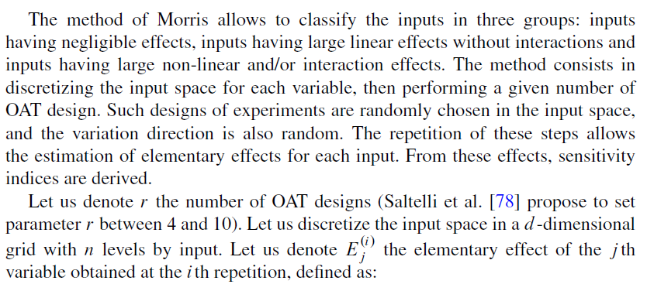
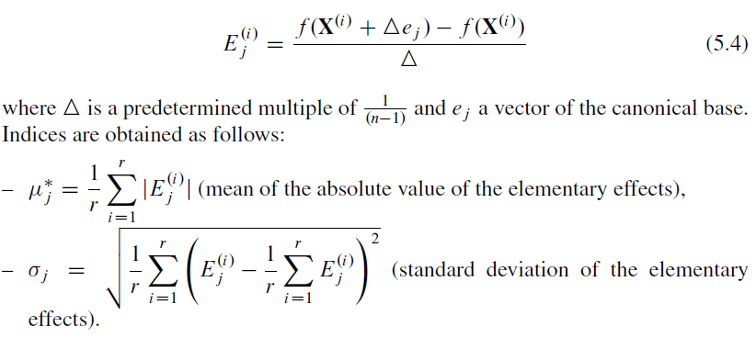
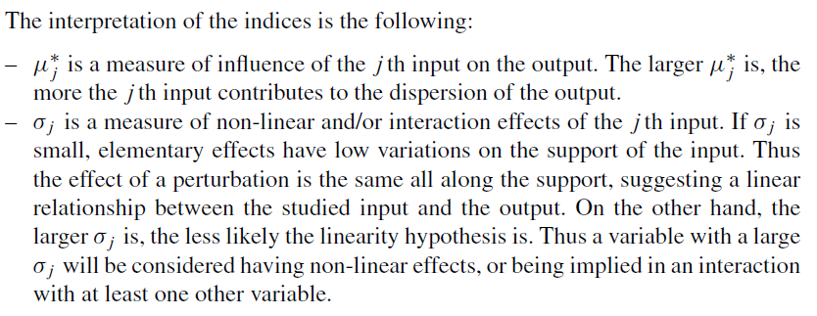
Supplementary information can be found in [3] and [4].
Table 1: Sample matrix and simulation results for the LP stage
Table 2: Sample matrix and simulation results for the HP stage
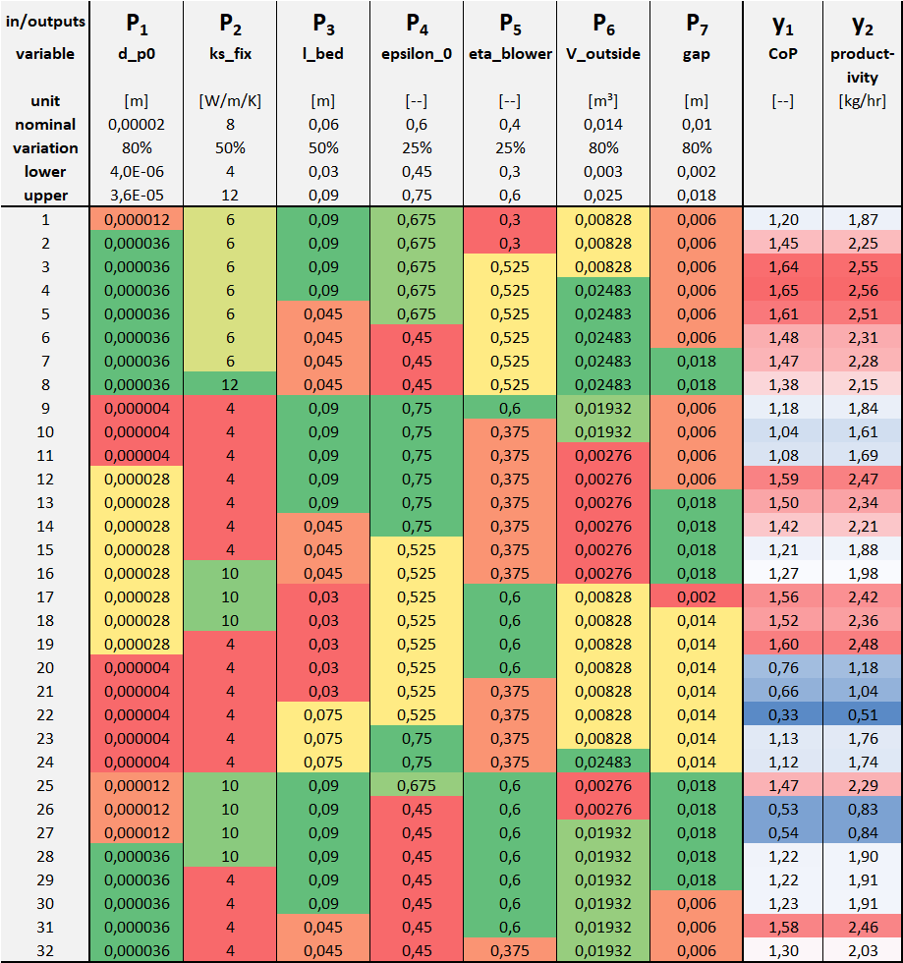

The result of the analysis is given by a vector of the standard deviation of the elementary effects σ and the mean of the absolute value of the elementary effects μ*.
Table 3: Results of the Morris method for the LP and HP stage
LP Stage |  |  |  | HP Stage
 | µ | µ* | σ |  | µ | µ* | σ
p1 | 0,33 | 0,33 | 0,13 | p1 | 0,64 | 0,64 | 0,64
p2 | -0,05 | 0,05 | 0,05 | p2 | -0,11 | 0,11 | 0,11
p3 | -0,03 | 0,10 | 0,14 | p3 | -0,13 | 0,14 | 0,13
p4 | -0,41 | 0,41 | 0,28 | p4 | 0,33 | 0,45 | 0,73
p5 | 0,19 | 0,19 | 0,08 | p5 | 0,25 | 0,25 | 0,21
p6 | 0,00 | 0,01 | 0,01 | p6 | -0,05 | 0,05 | 0,07
p7 | -0,02 | 0,02 | 0,02 | p7 | -0,06 | 0,06 | 0,04

In the discussion, we refer to the impact of certain parameters and express it in percent. This comes from calculating the effect on CoP and productivity when only that parameter was changed (one factor at a time). The following Table 4 shows which simulation runs had to be taken for comparison. They refer to the list of simulation runs in tables 1 and 2.
Table 4: Effect of P6 and P7 when varied one factor at a time
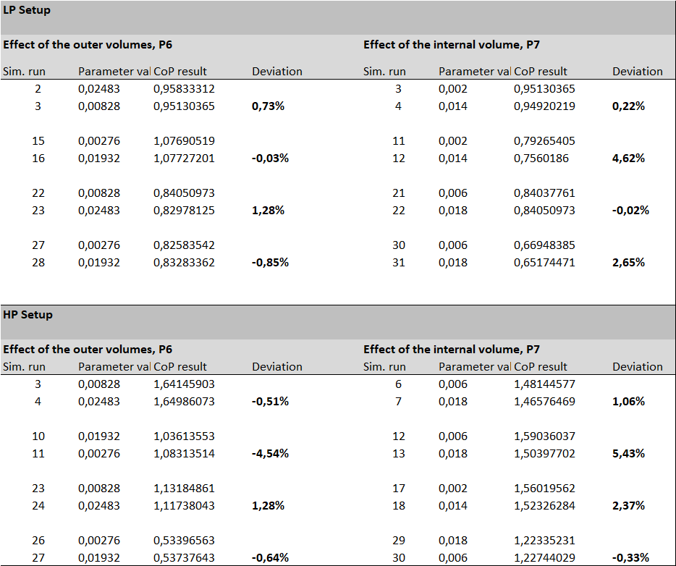

Verification by FEM Model
The verification of the 1D model within the system simulation in Aspen Custom Modeler® (ACM) was done by the finite element method (FEM) simulation software COMSOL Multiphysics®. The identical model equations were used as in the 1D system simulation. The geometry of one metal hydride disc with a height of 60 mm and a diameter of 651 mm was selected with a free gas phase gap at the inlet and the outlet and a height of 10 mm, respectively. The geometry was built as a 2D axisymmetric model. A mesh of triangles and rectangles at the wall interface for the fluid flow field, was used. The skewness quality of the mesh showed a minimum value of 0.215 and an average quality of 0.847 having a total number of 38,940 elements with an element-to-volume ratio of 7.43E-4. The heat transport and fluid dynamic variables were solved using the PARDISO solver.
An absorption and a desorption scenario were simulated via ASM and COMSOL, to be compared and to verify the validity of the 1D Model approach in the system simulation. For the absorption, an initial hydride fraction of 0.183 was set leading to an initial pressure of 30 bar at a starting temperature of 90 °C. The desorption scenario started at a hydride fraction of 0.944 resulting in a pressure of 30 bar at 10 °C initial temperature. Starting at homogeneous initial condition and after achieving a constant hydrogen flow field, the temperature of the incoming hydrogen flow is ramped within 10 s from 90 to 10 °C in the absorption and from 10 to 90 °C in the desorption case. The fluid properties of the hydrogen were taken from the COMSOL materials database.

Heat transport in porous media with local thermal inequality
Analogue to the 1D model in ACM, a thermal local inequality between solid (1) and fluid (3) phase was set, solving for each phase separately.
$\left(1-ε\right)ρ_{s}c_{p,s}\frac{∂T_{s}}{∂t}+∇q_{s}=Q_{sf}+\left(1-ε\right)Q_{s}$ (1)
ε is the porosity, ρ_s is the solid density, c_(p,s) is the solid heat capacity, q_s is the heat conduction, Q_sf is the heat transfer between solid and fluid and Q_s is the heat of the reaction. The solid heat conduction is given as (2):
$q_{s}=\left(1-ε\right){ k}_{s} ∇T_{s}$ (2)
k_s is the solid thermal conductivity. The gas phase is calculated analog to the solid phase (3):
$ερ_{f}c_{p,f}\frac{∂T_{f}}{∂t}+ρ_{f}c_{p,f}u_{f}∇T_{f}+∇q_{f}=-Q_{sf}$ (3)
ρ_f is the gaseous density, c_(p,f) is the gaseous heat capacity, u_f is the velocity of the gas and q_f is the heat conduction of the gaseous phase.
For the heat exchange between the phases, the implemented interstitial convective heat transfer for spherical particles is used (4,5,6):
$Q_{sf}=a_{sf} h_{sf} (T_{s}-T_{f})$ (4)
$h_{sf}={\left[d_{p}\frac{1}{k_{f}Nu_{sf}}+\frac{1}{10k_{s}}\right]}^{-1}$ (5)
${Nu}_{sf}=2.0+1.1 {Pr}^{1/3} Re$ (6)
Nu_sf is the Nusselt number, Pr is the Prandtl number, Re is the Reynolds number, h_sf is the heat transfer coefficient and a_sf the specific surface area. The reaction heat Q_s evolves within the porous media domain, depending on the reaction rate.

Free fluid flow and flow in porous media using Brinkmann equation
The fluid dynamics were calculated for the free hydrogen flow and in the porous metal hydride bed. The hydrogen is set as a compressible fluid. The mass conservation for the compressible flow is given in (7).
$\frac{∂(ε ρ_{f})}{∂t}+∇ \left(ρ_{f}u_{f}\right)=Q_{m}$ (7)
The inertia term, the gravity force as well as the turbulence were neglected. The flow model was selected to be valid in the Darcy’s range, as the prior flow analysis showed low velocities with dominant laminar flow.
$\frac{ρ_{f}}{ε}\frac{∂u_{f}}{∂t}=∇ \left(-pI+K\right)-\left(\frac{μ}{κ}+βρ_{f}\left|u_{f}\right|+\frac{Q_{m}}{ε^{2}}\right)u_{f}+F$ (8)
$K=\frac{μ}{ε}\left(∇u_{f}+{\left(∇u_{f}\right)}^{T}\right)-\frac{2}{3}\frac{μ}{ε}\left(∇u\right)I$ (9)
$F=-ρ_{f}β\left|u_{f}\right|u_{f}$ (10)
p is the pressure, μ is the dynamic viscosity, κ is the permeability, Q_{m} is the mass source and F is the Forchheimer drag term.
The simulation starts with no flow, which is ramped up to 63.6 kg/h of constant hydrogen flow in 1 s, to build up a steady state flow field. The outlet boundary condition is set to constant 30 bar.

Transport of diluted species
Within this module, the chemical reaction between the metallic and the hydride phase is calculated using the kinetic model [5] and the thermodynamic model from [5,6]. The pressure and temperature state variables are taken from the modules mentioned above. The reaction is only calculated in the porous media domain.

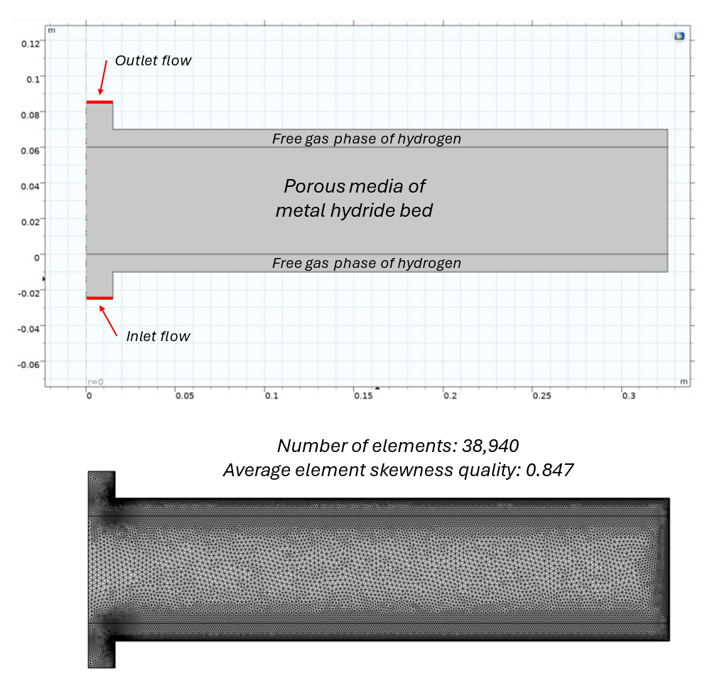
Figure 4: Schematic of the FEM geometry, indicating the porous media and gas phase domains and the flow boundaries (left side) as well as the refining of the mesh of the given geometry (right side)

Figure 5 shows the comparison of FEM and 1D-FDM for the absorption reaction of a single tank, as a supplement to the desorption (Figure 3).
Figure 5: Comparison of the absorption reaction. 1D model is set up with 10 nodes.

BET area measurement (surface area): Results
Previous treatment: The hydride-forming alloy Hydralloy®C5 was activated to full capacity of 1.6-1.7 wt.% and cycled 5 times in a prototype tank containing 15 kg of material at 30 ºC under about 35 bar and 1 bar for absorption and desorption, respectively. Then, the material, after hydrogen interaction, was slowly oxidized in air atmosphere for one week and then sieved in the range of 20 – 30 microns particle size. The oxidation does not change the morphology and textural conditions of the particles, as observed by scanning electron microscope analysis of samples without contact with the air and with contact with the air (photos and results not shown here). The sample for analysis was put into a 3/8-inch glass tube sample holder. The sample was degassed in the VapPrep unit (Micromeritics Instrument Corp.). The degassing procedure consisted of 48 hours of vacuum at room temperature, followed by ramping up to 400 ºC under vacuum and 24 hours at 400 ºC. After degassing, 3.7030 g of powder sample was weighted in the 3/8-inch glass tube. Then, the sample was cooled down and connected to the TriStar II Plus surface area and porosity analyzer (Micromeritics Instrument Corp.).
Before starting the analysis, the sample was put under vacuum at room temperature for 5 hours to ensure the complete evacuation of air introduced during the connection to the device. The analysis used an adsorptive gas nitrogen in a liquid nitrogen bath (77.3 K). The equilibration interval for the BET area calculation was 10 seconds, and the minimum equilibration delay was at a relative pressure greater or equal to 0.995 of 600 seconds. The mode used was low-area BET material in the relative pressure range (P/P0) from 0 to 0.20.
The result shows that proper parameters were obtained based on the theory and physical meaning: C= 213.93 is in the range it between 50 and 300, typical for most of the materials, the slope is positive (66.34328 ± 0.52756 g/mmol), and the Y-intercept is positive as well (0.31157 ± 0.05784 g/mmol). The C, slope, and Y-intercept verifies that the device was working correctly (no leak), and the selected pressure range was correct. The results can be seen in Fig. 6.
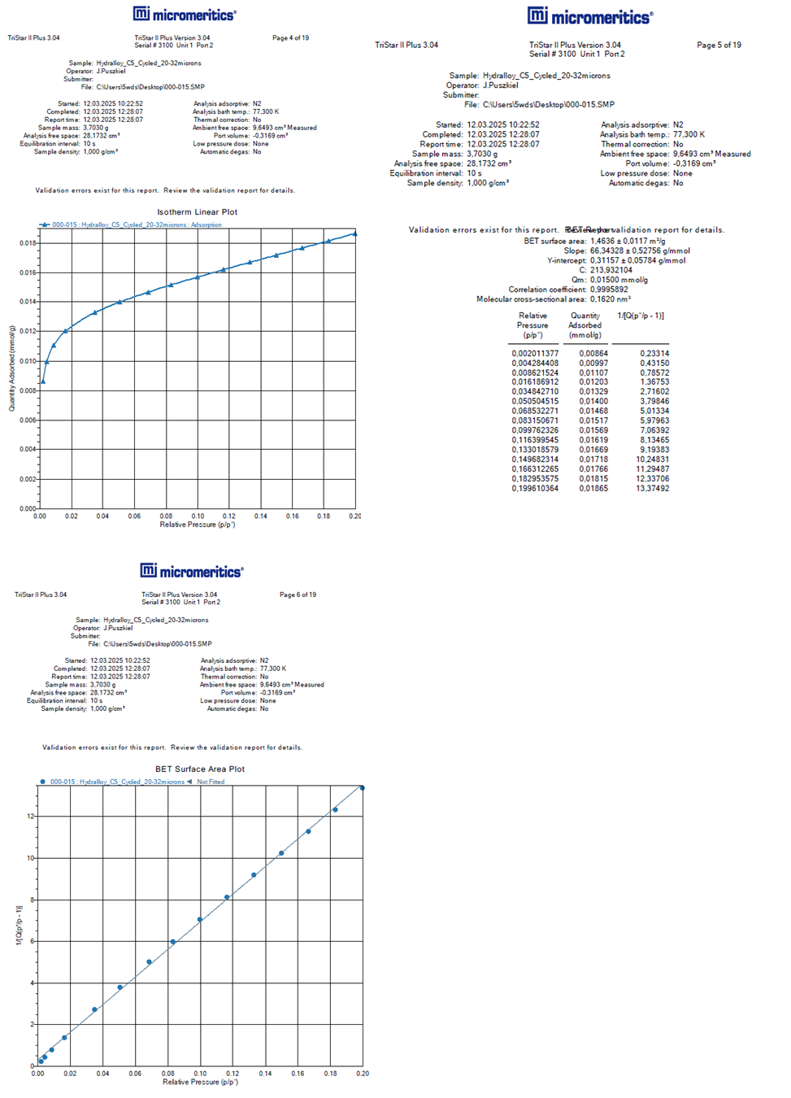
Figure 6: Results of the BET surface area measurement.

References
[1] Puszkiel JA, Neves AM, Warfsmann J, Krause PS, Kaufmann TFJ, Robelo Hoberg A, et al. On the hydrogen storage properties and life cycle evaluation of a room temperature hydride for scale-up applications: The case of an AB2-alloy. Int J Hydrogen Energy 2025;118:482–99. https://doi.org/10.1016/J.IJHYDENE.2025.03.161.
[2] Iooss B, Lemaître P. A Review on Global Sensitivity Analysis Methods. Operations Research/ Computer Science Interfaces Series 2015;59:101–22. https://doi.org/10.1007/978-1-4899-7547-8_5.
[3] Ghanem R, Higdon D, Owhadi H, editors. Handbook of uncertainty quantification. Springer International Publishing; 2017. https://doi.org/10.1007/978-3-319-12385-1.
[4] Morris MD. Factorial Sampling Plans for Preliminary Computational Experiments. Technometrics 1991;33:161. https://doi.org/10.2307/1269043.
[5] Herbrig K, Röntzsch L, Pohlmann C, Weißgärber T, Kieback B. Hydrogen storage systems based on hydride-graphite composites: Computer simulation and experimental validation. Int J Hydrogen Energy 2013;38:7026–36. https://doi.org/10.1016/j.ijhydene.2013.03.104.
[6] Passing M. Development of a thermal and hydraulic coupled hydrogen storage system based on metal hydrides for automotive application. Doctoral Thesis. Helmut-Schmidt-Universität / Universität der Bundeswehr Hamburg, 2024.

