Supplementary information

Table S1 Results of two-way ANOVA testing the effect of (three levels: -AMF; +AMF; +AMFN) and cropping (two levels: sole; mixed) on shoot biomass and P uptake of millet and chickpea in all treatments.
Table S2 Results of two-way ANOVA testing the effect of the order of AMF colonization (two levels: +AMF; +AMFN) and cropping (two levels: sole; mixed) on shoot biomass and P uptake of millet and chickpea in treatments with AMF colonization.
Table S3. Ratio of rhizosphere acid phosphatase activity (and carboxylate concentration) in the rhizosphere of plants in treatments with AMF inoculation (mean ± 2 × standard error; n=4) under the assumptions of no buffering and strong buffering by the soil. If both ratios are significantly different from 1, that mean significant difference between two treatments. For the ratios in other cases, there was no difference between two treatments.
Figure S1. AMF colonization of millet (a) and chickpea (b) in sole (Sole) and mixture (Mixed). The inoculated plant (+AMF) with a non-inoculated neighbor, or the non-inoculated plant with an inoculated neighbor (+AMFN). The labels apply to the other figures. Bars represent means ± SE (n=4). Bars with the same letter within a panel are not significantly different (P<0.05).
Figure S2. Plant biomass (shoot and root) (a, b) and P uptake (c, d) of millet (a, c) and chickpea (b, d) in the sole and mixture treatments. Plants without AMF in any of the two compartments (-AMF).
Figure S3. Shoot nitrogen (N) content of millet (a) and chickpea (b) in sole (Sole) and mixture (Mixed), and N fixation content (c), nodule number of chickpea in sole and mixture (d).
Figure S4. Comparison of expected (Exp) and observed (Obs) biomass (shoot and root) (a), P uptake (b) and N content (c) of millet/chickpea mixture per container without AMF colonization, with chickpea inoculated with AMF (+AMFC), or with millet inoculated with AMF (+AMFM).
Figure S5. N:P ratios of millet (a), and chickpea (b) in different treatments.
Figure S6. CFU of phosphate solubilizing bacteria in the rhizosphere soil of millet and chickpea in different treatments.

Table S1 Results of two-way ANOVA testing the effect of (three levels: -AMF; +AMF; +AMFN) and cropping (two levels: sole; mixed) on shoot biomass and P uptake of millet and chickpea in all treatments.
Plant species | Source of variation | d.f. | Biomass | P uptake | P concentration | N content | N fixation content | Nodule number | CFU | N:P ratio
Millet | AMF | 2 | 0.32 | <0.001 | <0.001 | 0.30 |  |  | 0.01 | <0.001
 | Cropping | 1 | 0.60 | 0.87 | 0.04 | 0.99 |  |  | <0.01 | 0.69
 | AMF*Cropping | 2 | <0.01 | <0.001 | 0.005 | 0.002 |  |  | 0.01 | 0.01
Chickpea | AMF | 2 | <0.001 | <0.001 | <0.001 | <0.001 | 0.002 | <0.001 | 0.01 | <0.001
 | Cropping | 1 | 0.001 | <0.001 | <0.001 | <0.001 | <0.001 | 0.68 | 0.83 | <0.01
 | AMF*Cropping | 2 | 0.01 | 0.16 | <0.001 | 0.24 | 0.30 | 0.32 | 0.02 | <0.01

Table S2 Results of two-way ANOVA testing the effect of the order of AMF colonization (two levels: +AMF; +AMFN) and cropping (two levels: sole; mixed) on shoot biomass and P uptake of millet and chickpea in treatments with AMF colonization.
Plant species | Source of variation | d.f. | Biomass | P uptake | P concentration | N content | N fixation content | Nodule number | CFU | AMF colonization rate | N:P ratio
Millet | AMF | 1 | 0.18 | <0.01 | <0.001 | 0.33 |  |  | 0.05 | 0.21 | <0.001
 | Cropping | 1 | 0.27 | 0.62 | 0.01 | 0.66 |  |  | 0.02 | 0.49 | 0.02
 | AMF*Cropping | 1 | <0.001 | <0.001 | 0.002 | <0.001 |  |  | 0.08 | 0.39 | <0.001
Chickpea | AMF | 1 | 0.02 | 0.12 | <0.001 | 0.92 | 0.90 | <0.001 | <0.01 | 0.77 | <0.01
 | Cropping | 1 | <0.001 | <0.001 | <0.001 | <0.01 | <0.001 | 0.54 | 0.28 | 0.71 | <0.01
 | AMF*Cropping | 1 | 0.92 | 0.12 | <0.001 | 0.85 | 0.03 | 0.14 | <0.01 | 0.03 | 0.03

Table S3. Ratio of rhizosphere acid phosphatase activity (and carboxylate concentration) in the rhizosphere of plants in treatments with AMF inoculation (mean ± 2 × standard error; n=4) under the assumptions of no buffering and strong buffering by the soil. If both ratios are significantly different from 1, that mean significant difference between two treatments. For the ratios in other cases, there was no difference between two treatments.
 | Acid phosphatase activity |  |  |  |  |  | Carboxylates
 | Millet |  |  | Chickpea |  |  | Millet |  |  | Chickpea
 | No buffering | Strong buffering | Difference | No buffering | Strong buffering | Difference | No buffering | Strong buffering | Difference | No buffering | Strong buffering | Difference
+AMF_mono/+AMF_inter | 2.50±1.94 | 2.63±1.88 | No | 1.13±0.45 | 0.85±0.26 | No | 1.33±0.91 | 2.13±0.94 | No | 1.41±0.53 | 1.26±0.96 | No
+AMF_mono/+AMFN_inter | 1.87±0.44 | 1.21±0.23 | No | 0.92±0.35 | 0.64±0.22 | No | 1.54±1.17 | 1.58±0.93 | No | 0.48±0.21 | 0.38±0.27 | sig
+AMF_mono/+AMFN_mono | 2.04±1.66 | 2.71±1.90 | No | 1.07±0.37 | 1.12±0.31 | No | 2.24±1.19 | 5.84±4.26 | No | 0.52±0.12 | 0.55±0.05 | sig
+AMFN_mono/+AMFN_inter | 2.15±1.48 | 0.84±0.56 | No | 0.90±0.32 | 0.59±0.19 | No | 0.79±0.65 | 0.32±0.28 | No | 0.98±0.57 | 0.69±0.52 | No
+AMFN_mono/+AMF_inter | 2.26±1.85 | 1.31±0.73 | No | 1.07±0.28 | 0.76±0.12 | No | 0.72±0.52 | 0.69±0.61 | No | 2.87±1.47 | 2.31±1.84 | No
+AMFN_inter/+AMF_inter | 1.62±0.74 | 2.62±1.53 | No | 0.84±0.19 | 0.81±0.32 | No | 0.89±0.35 | 1.29±0.25 | No | 2.98±0.35 | 3.26±0.41 | sig

Note: “No” represents no difference between two treatments, “sig” represents significant difference between two treatments.

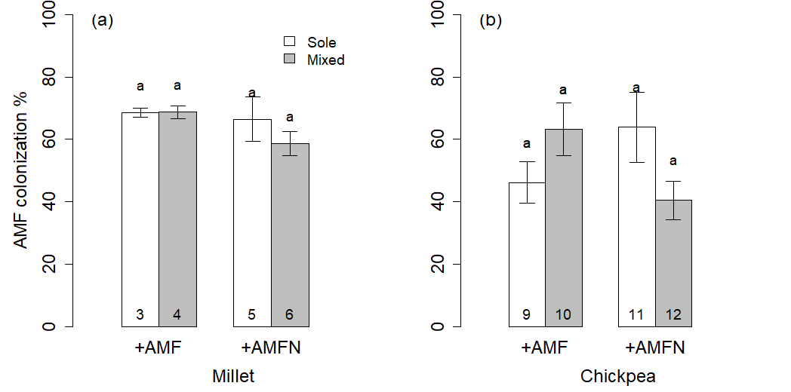
Figure S1. AMF colonization of millet (a) and chickpea (b) in sole (Sole) and mixture (Mixed). The inoculated plant (+AMF) with a non-inoculated neighbor, or the non-inoculated plant with an inoculated neighbor (+AMFN). The labels apply to the other figures. Bars represent means ± SE (n=4). Bars with the same letter within a panel are not significantly different (P<0.05).

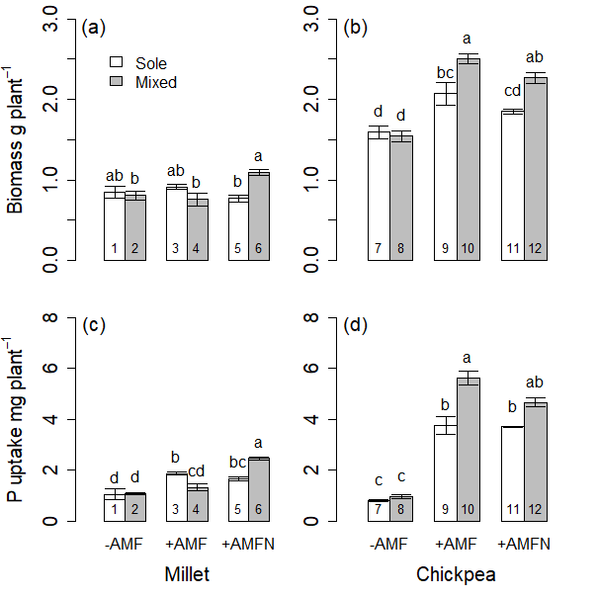
Figure S2. Plant biomass (shoot and root) (a, b) and P uptake (c, d) of millet (a, c) and chickpea (b, d) in the sole and mixture treatments. Plants without AMF in any of the two compartments (-AMF).
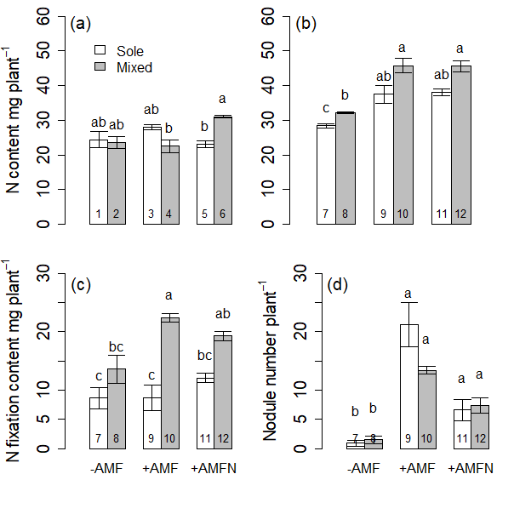
Figure S3. Shoot nitrogen (N) content of millet (a) and chickpea (b) in sole (Sole) and mixture (Mixed), and N fixation content (c), nodule number of chickpea in sole and mixture (d).

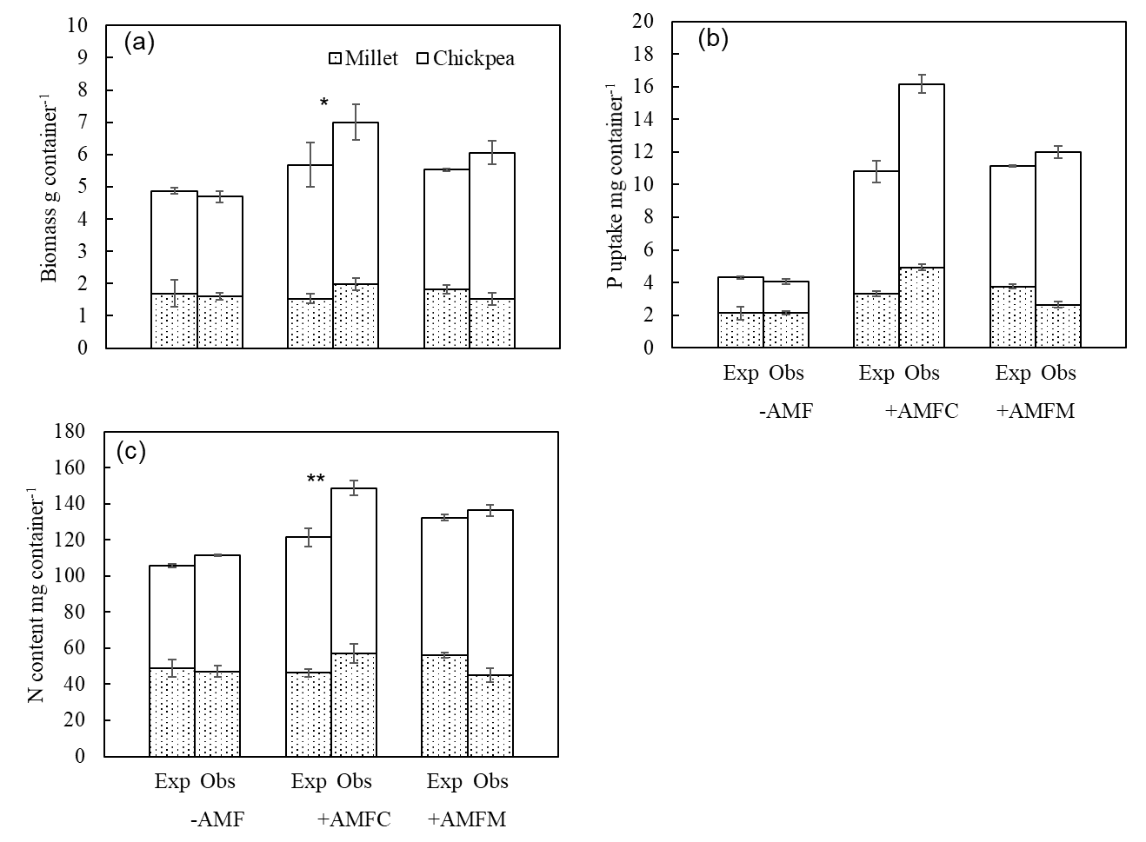
Figure S4. Comparison of expected (Exp) and observed (Obs) biomass (shoot and root) (a), P uptake (b) and N content (c) of millet/chickpea mixture per container without AMF colonization, with chickpea inoculated with AMF (+AMFC), or with millet inoculated with AMF (+AMFM).

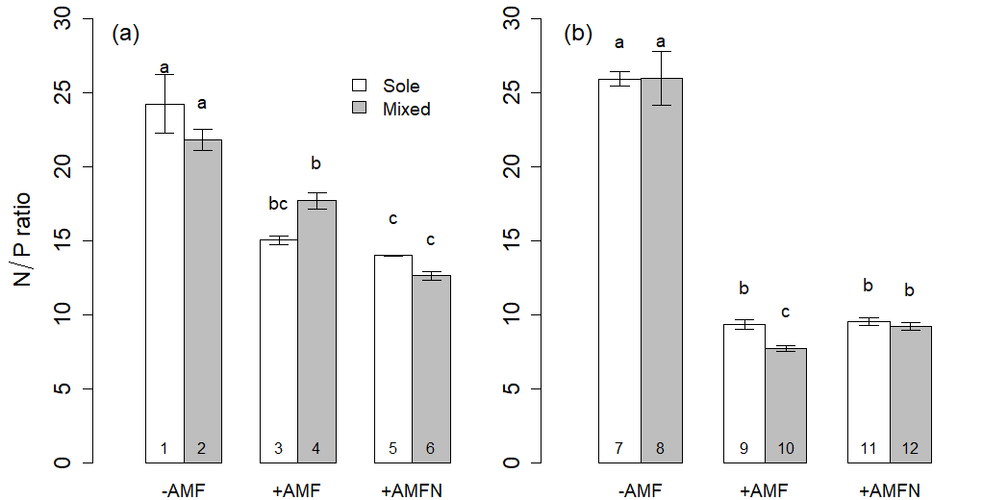
Figure S5. N:P ratios of millet (a), and chickpea (b) in different treatments.

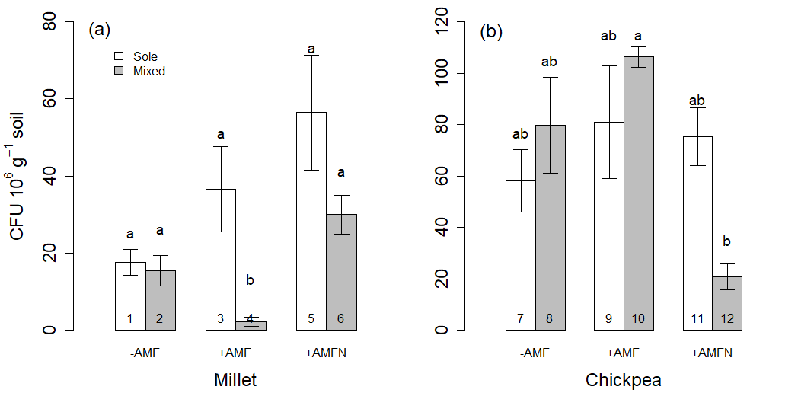
Figure S6. CFU of phosphate solubilizing bacteria in the rhizosphere soil of millet and chickpea in different treatments.

