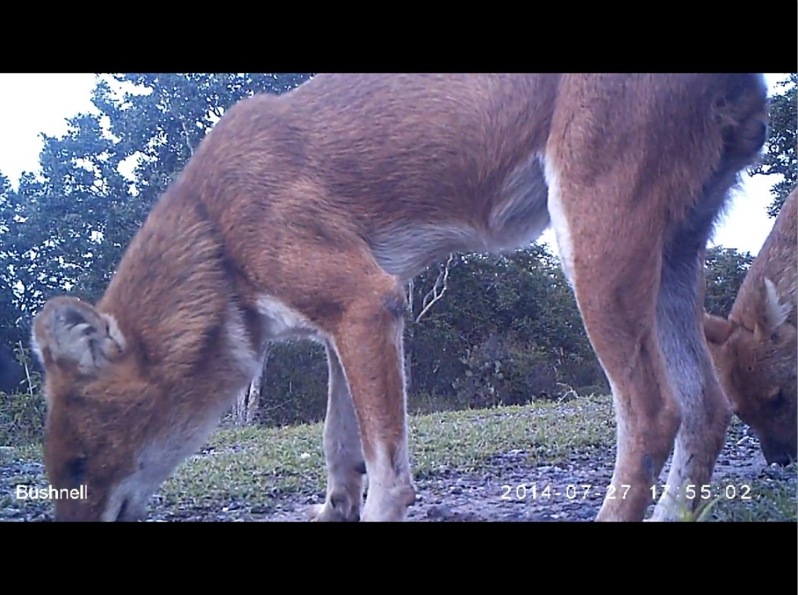
- Identified member of Pack 1 (D1♂) with much white fur and the white left forefoot.

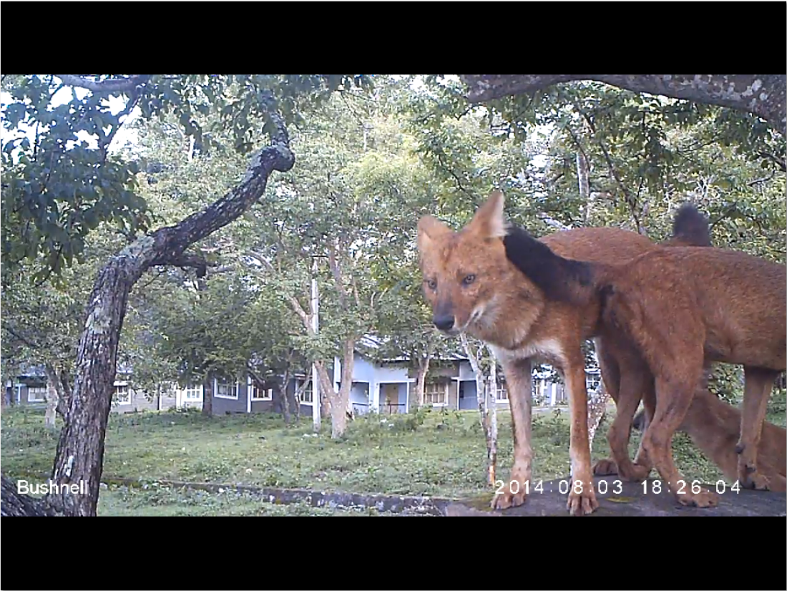
- Identified member of Pack 2 (D2♂) with much white fur and a smiley face.

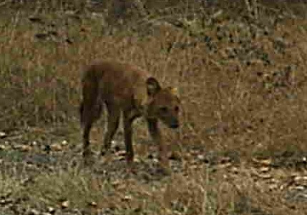
- Identified member of Pack 3 (D3♂) lacking the upper part of its left ear.

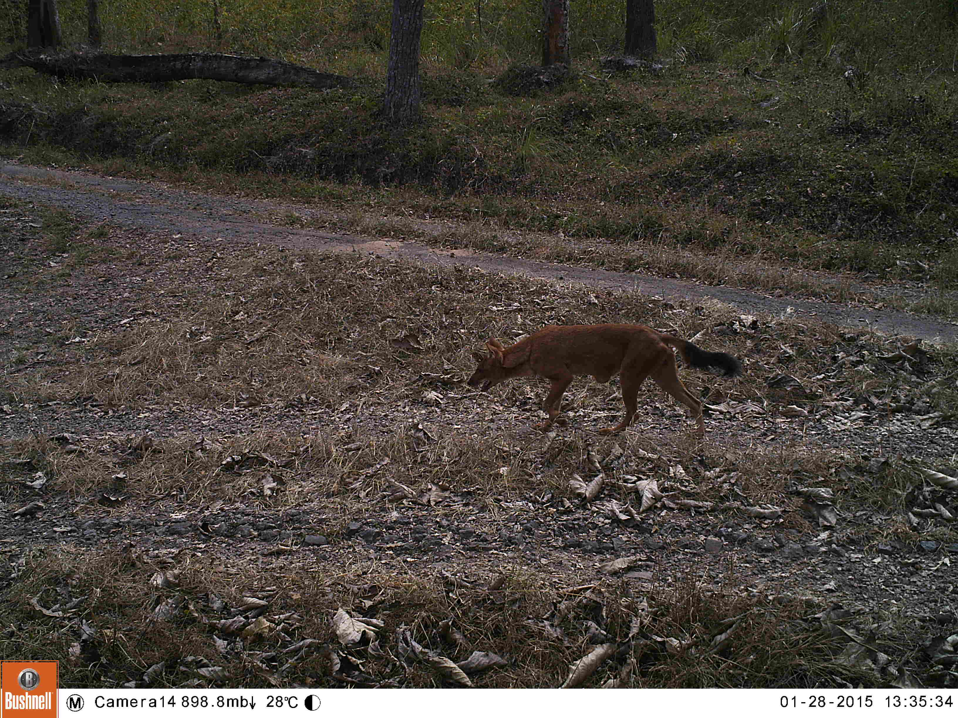
- Identified member of Pack 4 (D4♂) with a tumour on its abdomen.

SI1. Photo identification of pack members of the study

SI2. Relationship between the estimated home range sizes (MCP) and cumulative observation days for each pack
SI3. List of Human-dhole interactions (human to dhole only)
Pack name | Date | Time | Behaviour of humans
P2 | 2013/8/7 | 6:10 | Chase dholes away
P2 | 2013/8/13 | 7:09 | Throw stones towards dholes
P2 | 2013/8/14 | 7:43 | Disturb dholes by crossing nearby
P2 | 2013/8/18 | 7:10 | Throw stones towards dholes
P2 | 2013/8/22 | 8:01 | Disturb dholes by crossing nearby
P2 | 2013/10/9 | 7:08 | Throw stones towards dholes
P2 | 2013/10/22 | 12:?? | Disturb dholes by crossing nearby
P2 | 2014/1/12 | 16:50 | Disturb dholes by crossing nearby
P2 | 2014/1/13 | 15:47-17:16 | Disturb dholes by crossing nearby
P2 | 2014/1/18 | 16:34 | Chase dholes away
P2 | 2014/1/18 | 16:57 | Chase dholes away
P2 | 2014/3/7 | 18:16 | Chase dholes away
P2 | 2014/3/10 | 16:27 | Chase dholes away
P2 | 2014/3/21 | 17:?? | Chase dholes away
P2 | 2014/10/30 | 8:58 | Chase dholes away

