Figure S1 Relative abundance of 16S gut microbiota at the phylum and genus levels in juvenile grass carp fed berberine (BBR) supplemented with or without farnesoid X receptor (FXR) inhibitor Gly-β-MCA.
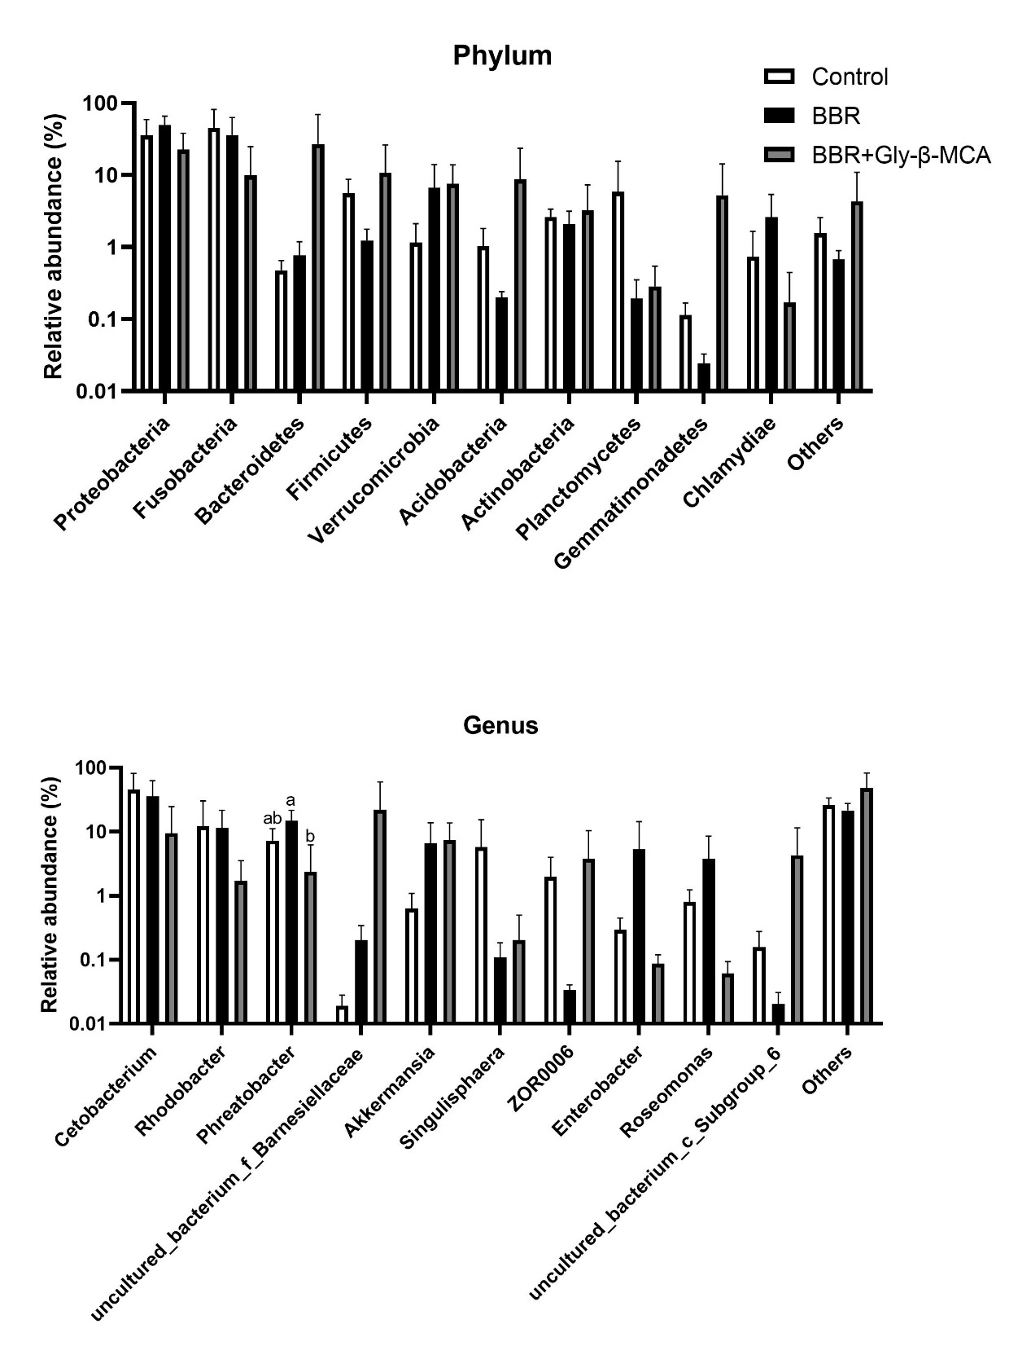

Table S1 Primers used in this study
Target genes | Forward (5’-3’) | Amplicon size (bp)
FXR-F | CGTCCAGGTGTTGGTTGAGT | 187
FXR-R | CGAACGTAGGAACATCGCCT | 187
FGF19-F | CCTGCCAGATGGCTACAACA | 91
FGF19-R | CAGGAACTGGGACGCTACAG | 91
CYP7A1-F | TCTATGACAATCCTCTGGCATACAA | 119
CYP7A1-R | CAAAGAAACGGCCCGGACA | 119
CYP8B1-F | TTCAAACGCTCTGCCTCCAT | 215
CYP8B1-R | AAATTGACCGGCAGCATTCG | 215
CYP27A1-F | ACCAGCGGTCTGGAACAAAA | 88
CYP27A1-R | AAGAGCAGCCGAACACAGAA | 88
PPARγ-F | GCATCTGTACGAGTCCTATCT | 116
PPARγ-R | GAGACTTCATGTCGTGGATAAC | 116
SREBP-1c-F | TCACTCCAAATGGTGGTCGTCAGT | 156
SREBP-1c-R | AAAGTGTTCAGACAGGCTTTGGGC | 156
FAS-F | CCTCAGCTTACAGCAGAATC | 117
FAS-R | CTCTTCAGCAAGGGAGTTTAG | 117
PPARα-F | CGCTGAGGTTCGGATATTT | 122
PPARα-R | ACGTCACCTGGTCATTTAAG | 122
ATGL-F | TCGTGCAAGCGTGTATATG | 136
ATGL-R | GCTCGTACTGAGGCAAATTA | 136
CPT-1-F | GCATCCATGACACGTTTATTC | 118
CPT-1-R | GAAGTTTCTCTTCTCTCGTCTC | 118
β-actin-F | TCCACCTTCCAGCAGATGTGGATT | 154
β-actin-R | AGTTTGAGTCGGCGTGAAGTGGTA | 154

