Supplementary Information (SI)

SURVIVAL OF PLANTS DURING SHORT-TERM BOA-OH EXPOSURE: ROS RELATED GENE EXPRESSION AND DETOXIFICATION REACTIONS ARE ACCOMPANIED WITH FAST MEMBRANE LIPID REPAIR IN ROOT TIPS

LAURA LASCHKE^{1,4}, VADIM SCHÜTZ^{1,4}, OLIVER SCHACKOW², DIETER SICKER², LOTHAR HENNIG², DIANA HOFMANN³, PETER DÖRMANN¹and MARGOT SCHULZ¹*

¹IMBIO Institute of Molecular Physiology and Biotechnology of Plants, University of Bonn, Karlrobert-Kreiten Str. 13, 53115 Bonn, Germany
²Institut für Organische Chemie, Universität Leipzig, Johannisallee 29, 04103 Leipzig, Germany
³IBG-3: Agrosphäre, Forschungszentrum Jülich GmbH, Jülich, Germany

⁴Authors contributed in experimental work equally
Corresponding author: Margot Schulz, ulp509@uni-bonn.de
orcid.org/0000-0001-7373-306X

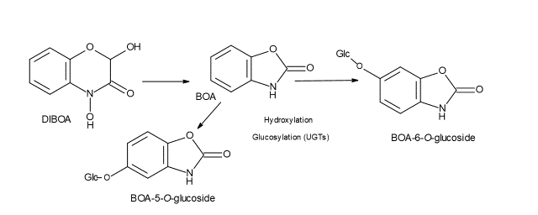
Figure 1S: Degradation of 2,4-Dihydroxy-2H-1,4-benzoxazin-3(4H)-one (DIBOA) to 2-benzoxazolinone (BOA). Plants hydroxylate BOA either in position 5 or 6. The BOA-OHs are subsequently glucosylated. The glucosides present BOA detoxification products.
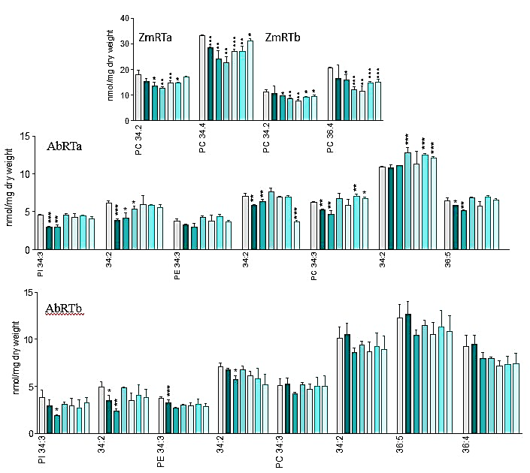
Figure 2S: Affected and not affected molecular species of major phospholipids in RTa (young root tip tissue) and RTb (older root tip tissue) samples of maize (Zm, above left RTa, right RTb) and Abutilon theophrasti (Ab, middle AbRTa, below AbRTb). Grouped columns present control and incubation times (left to right: 0 = control, 10,
20, 30, 40, 50, 60 min). PLs: phosphatidylcholine (PC), phosphatidylethanolamine (PE), phosphatidylinositol (PI).

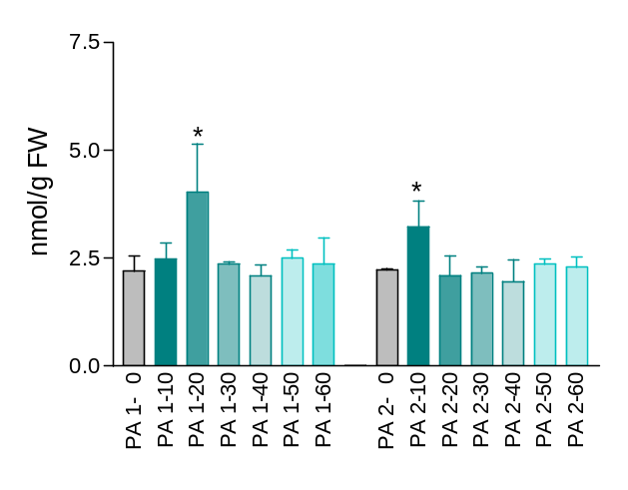
Figure 3S: Phosphatidic acid generated with low significance only in A. theophrasti after 20 min (RTa PA1) and 30 min (RTb PA2) of incubation.

SI Table S1: Primers used in the study
Gene | Primer Sequence
Cat1 forw. | ACCTGAAGCCGAGCATGTAAGGAT
Cat1 rev. | ATAATCGACCACCGACCATCAGCA
Cat3 forw. | CCGGCTCAACATGAAGGCAAACAT
Cat3 rev. | TTCTCTTGTTCCTGGCGACGACAT
FAD2.1 forw. | ACCACCTCTTCTCCACCATGCC
FAD2.1 rev. | CCTTGCGGTTGCGGTTCTCAG
FAD2.2 forw | TGCCGCTGCTGATCGTGAAC
FAD2.2 rev. | TGCGTGTCCGTGATGTTGTGG
NPR1 forw. | CTCCAGAGGGGCACAGCCGA
NPR1 rev. | CGAGAACACGCTGCCCTCCG
PR1 forw. | TCAGTCATGCCGTTCAGCTT
PR1 rev. | TTGTCCGCGTCCAGGAA
PR4 forw. | TGATGGATAGATGGCGATTGC
PR4 rev. | AGAATTGACACCGCCAAACC
Sod2 forw. | CACCAACGGCTGCATGTC
Sod2 rev. | ATGCTCCTTGCCAACAGGAT
Act1 forw. | GGGATTGCCGATCGTATGAG
Act1 rev. | GAGCCACCGATCCAGACACT

