Supplementary Information

Fig. S1 Grid search results for model and FLIm feature selection across three approaches—agnostic, anatomic, and data-centric models. Heatmaps depict classification performance across different hyperparameter configurations, with higher values indicating improved model performance. The color gradients represent the relative effectiveness of feature sets in each model category.

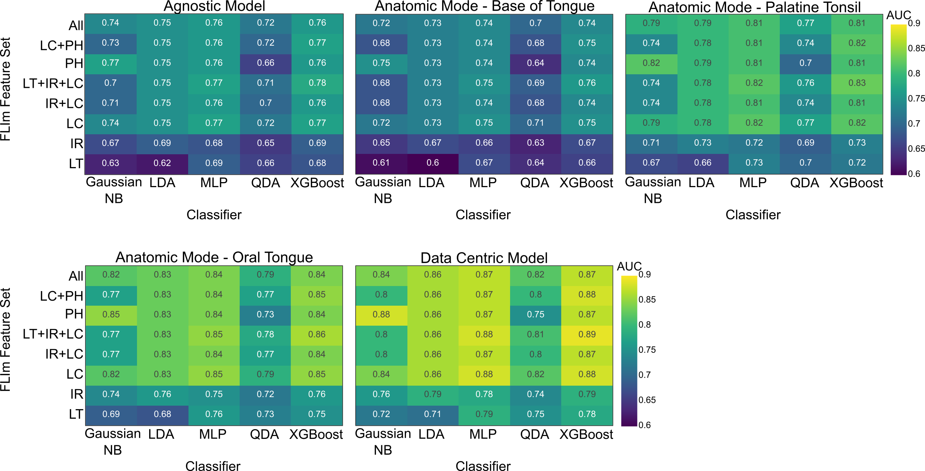
Table. SI Description of the model hyper-parameters selection used for model grid-search
Bayesian Optimization
Model | Hyperparameter | Range
DT | Number of Estimators | 50, 300
DT | Max Depth | 3, 10
DT | Learning Rate | 0.01, 0.3
DT | Gamma | 0, 5
MLP | Hidden Layer | 1, 5
MLP | Activation Function | 'relu', 'tanh', 'logistic'
MLP | Solver | adam', 'sgd'
MLP | Learning Rate | constant', 'adaptive'
MLP | Learning Rate | 1e-4, 1e-1
MLP | Max Iterations | 100, 300

Fig. S2 Surgeon variability analysis as a function of model performance and operated anatomy. The AUC values represent model efficacy across different anatomical sites, grouped by individual surgeons. Error bars indicate variability in performance within each grouping.

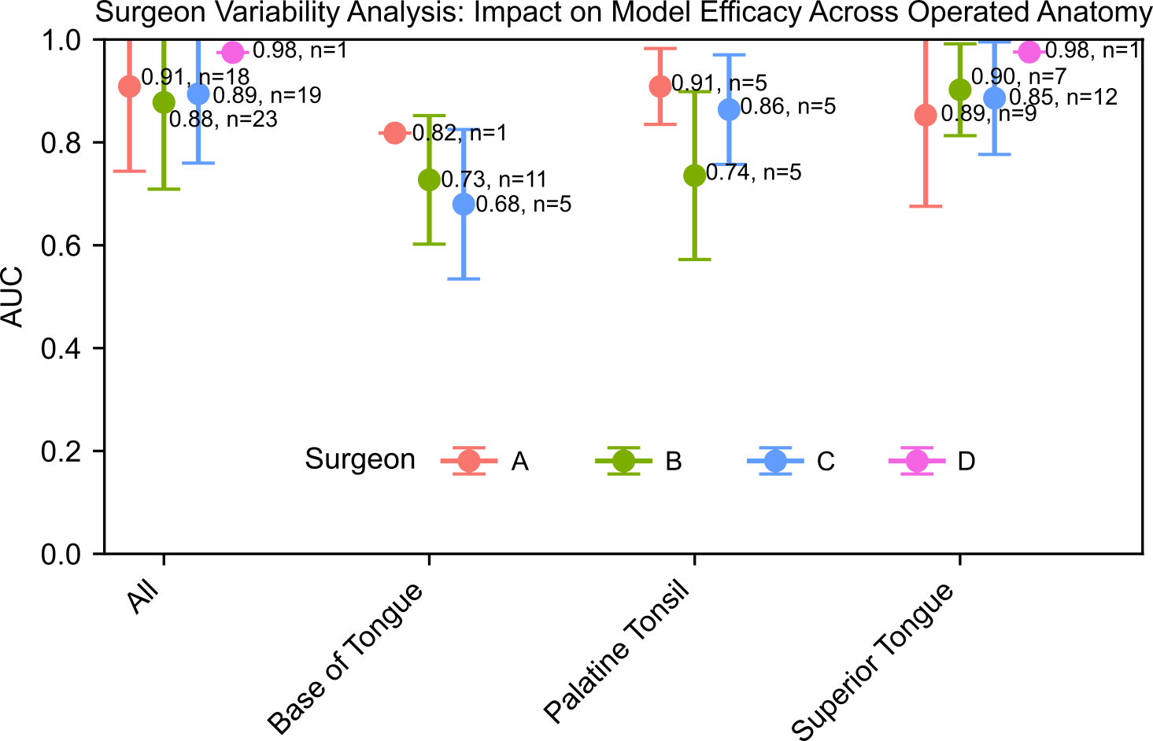
Fig. S4 FLIm point distribution within the region of interest (ROI) for margin analysis from the white light image (WLI). Blue dots represent FLIm measurement points, while P1 (magenta) and P2 (green) mark the reference points used to define the margin trace. The red dashed line indicates the linear trace between P1 and P2, aiding in spatial assessment of FLIm point distribution for margin evaluation.

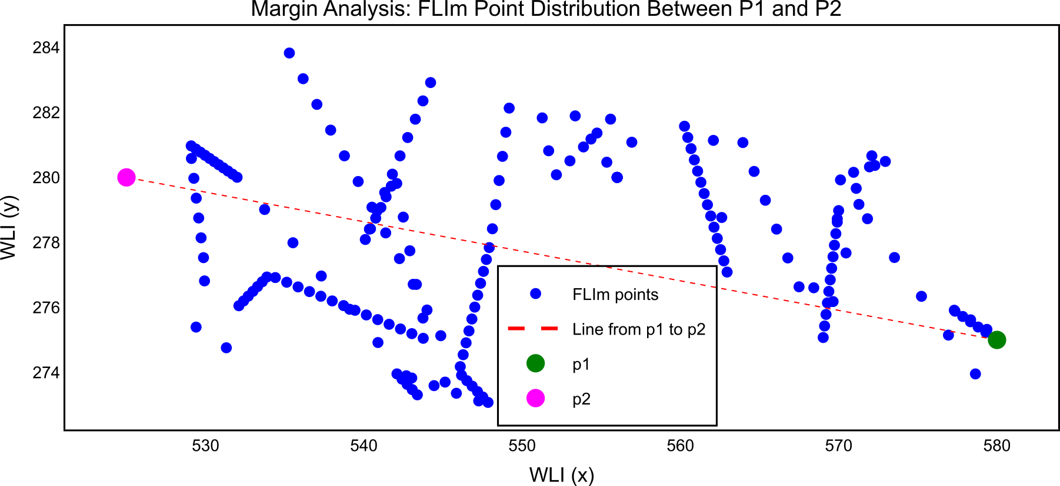
Fig. S3 Surgeon variability analysis as a function of scanning speed. Mean scan speed (points per second) is computed based on aiming beam detection coordinates in the white light image and frame acquisition speed. AUC values represent model efficacy across different scanning speeds. Error bars indicate standard deviation, capturing variability in scan speed across different cases and surgeons.

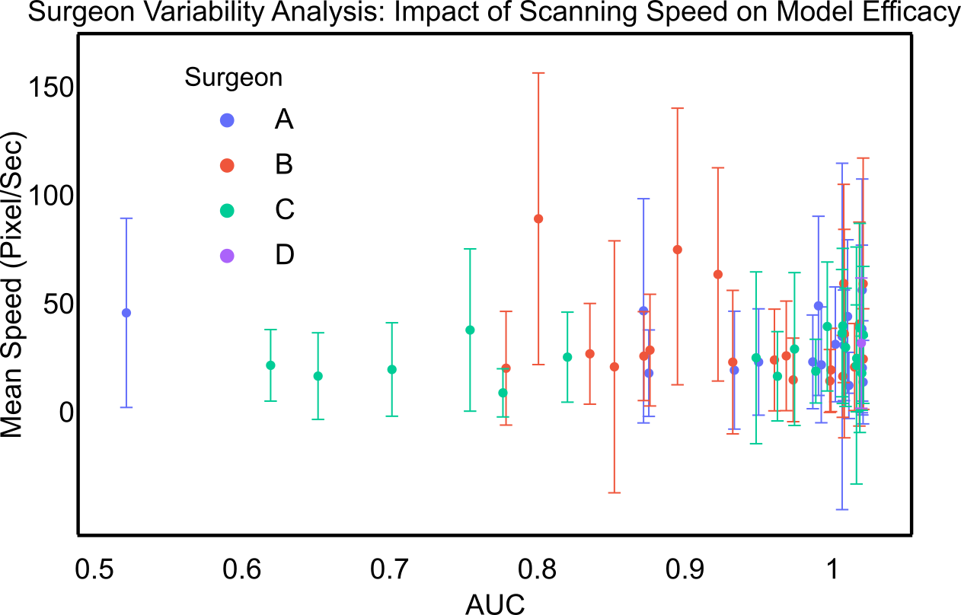

Fig. S6 Data-centric pruning analysis based on FLIm data quality. Left: Effect of kappa threshold selection on point-level classification performance using leave-one-patient-out cross-validation (LOPO-CV). The optimal kappa value balances model efficacy while minimizing low-quality data retention. Right: Characterization of FLIm points based on label quality scores, distinguishing between data with (blue) and without (red) label issues.

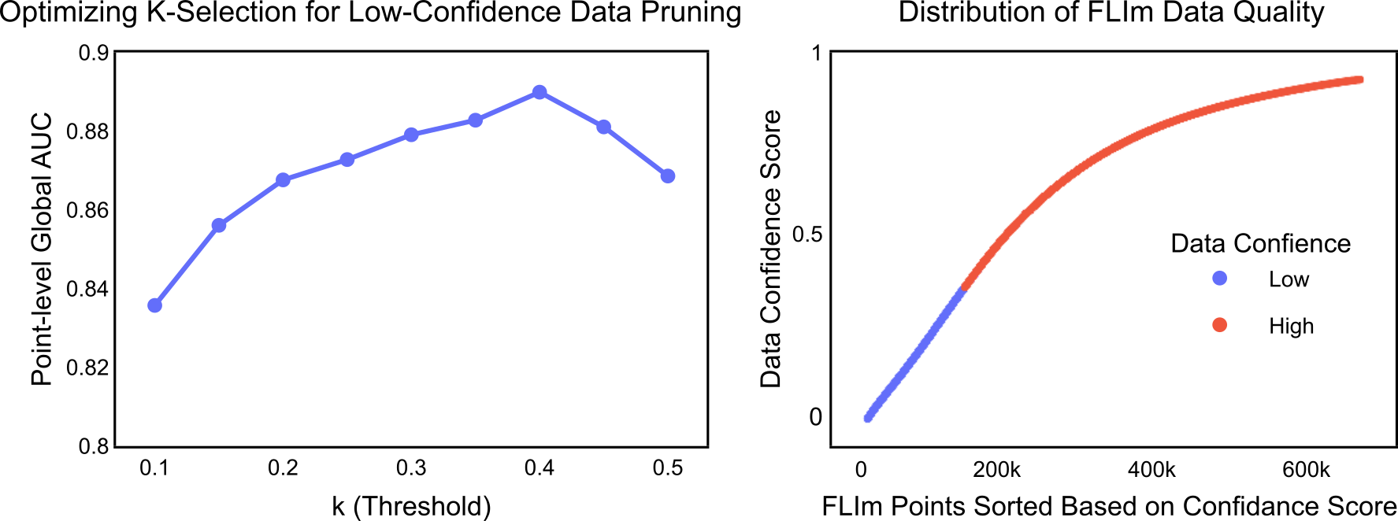
Fig. S5 Analysis of gain threshold selection and its impact on data loss and model performance. The solid lines represent the percentage of normal and cancer data loss as a function of increasing gain threshold values. Dashed lines indicate point-level and region-level AUC scores, demonstrating the trade-off between filtering stringency and classification performance.

