Extended data

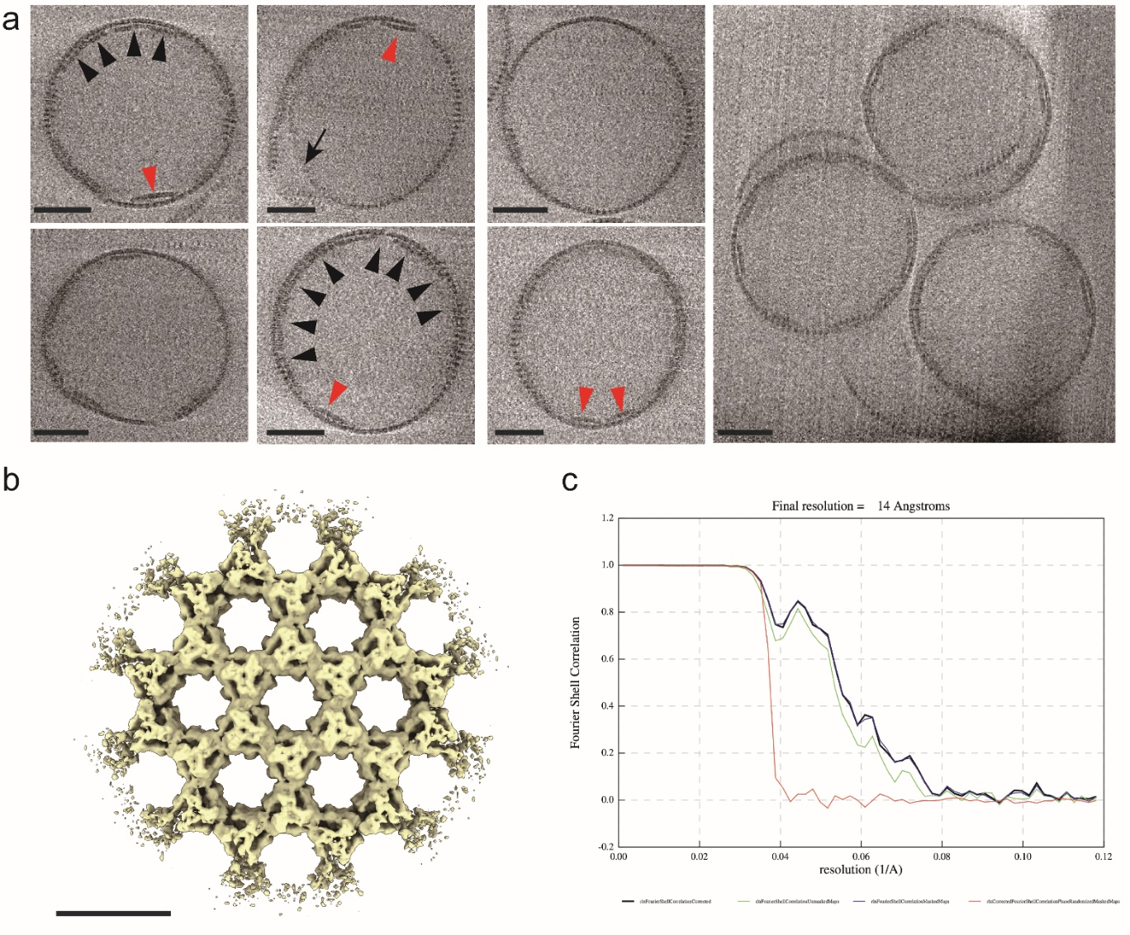
Extended Data Fig. 1 | Morphological characterization of SLPs using cryo-ET and STA. a, Representative tomographic slices of SLP. While maintaining rough spherical shape, partially multilayers (black arrowheads), sometimes exhibiting opposing curvatures (red arrowheads), and incomplete closure (black arrow) are found. The average diameter of 44 SLPs, calculated from the averages of the longest and the shortest dimensions, is 337.7±10 nm which closely resembles the reported dimension of the authentic VACV IV (~350 nm). b, STA map of the SLP lattice exhibiting a hexagonal array of repeating D13 trimers. c, Fourier shell correlation (FSC) curve of the final STA reconstruction showing an estimated resolution of 14 Å (FSC=0.143). Scale bars, 100 nm in a, 10 nm in b.
Extended Data Fig. 2 | Organization of D13 trimers in the twister assembly as characterized by cryo-ET and STA. a, FSC plot of the final STA reconstruction indicating estimated resolution of 13 Å (FSC=0.143). b, STA reconstruction showing two vertically apposed hexagonal rings, colored sky blue (upper) and blue (lower). c, Rigid-body-fitted D13 structure (PDB 7VFD) showing the tethering of D13 trimers observed at the periphery of the hexagonal rings (marked by an arrow in b). Interacting trimers display planar offset and are related by a torsional angle of 21.5°. The distances between the top and bottom centers of the trimers, as measured by centroid along three-fold symmetry axis of each trimer, are approximately 80 Å.

Extended Data Fig. 3 |. Intertrimeric distances and torsion angles in mode 1 and mode 2 interfaces of SLP. a, Intertrimeric distances and torsion angle in mode 1 interface as measured by the geometrical arrangements between the centroids along three-fold symmetry axis of each trimer. Head domains of neighboring trimers are spaced by 76.3 Å and base domains by 72.4 Å, resulting in a torsion angle of 2.64°. b, Mode 2 interface showing a similar intertrimeric arrangement, with head and base domain distances of 76.1 Å and 72.2 Å, respectively. Trimers are related by a torsion angle of 2.57°.

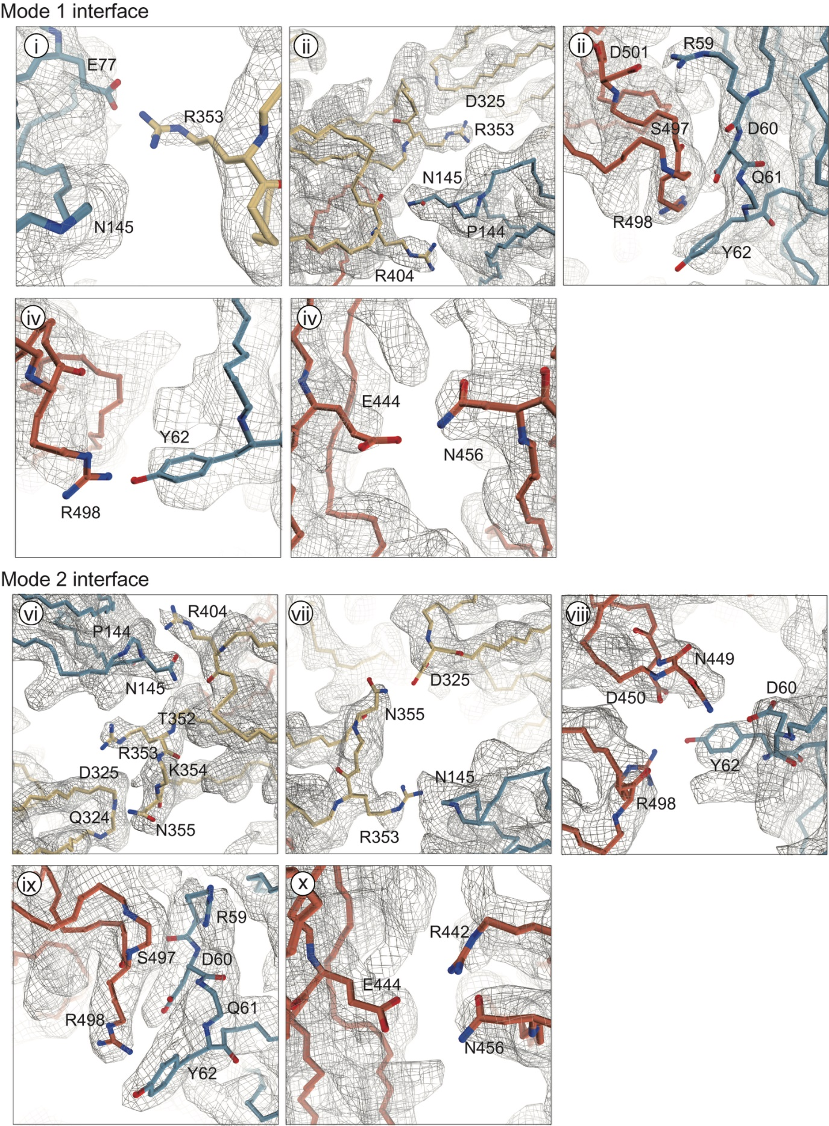
Extended Data Fig. 4 | Intertrimer interactions within SLP. Map-to-model overlays of mode 1 and mode 2 interfaces exhibit well-resolved cryo-EM densities (contoured at 3.7σ) for corresponding molecular interactions, consistent with the intertrimeric interactions described in Fig. 2b.
Extended Data Fig. 5 | Structural characterization of SLP assembled from eGFP-D13. A single particle cryo-EM map of the eGFP-D13 SLP showing a hexagonal lattice arrangement consistent with the SLP that results from the N-terminally His₆-tagged D13. No additional density is observed in the hydrophobic pocket or central base cavity, as marked by yellow dashed box and circles. Scale bar, 10 nm.

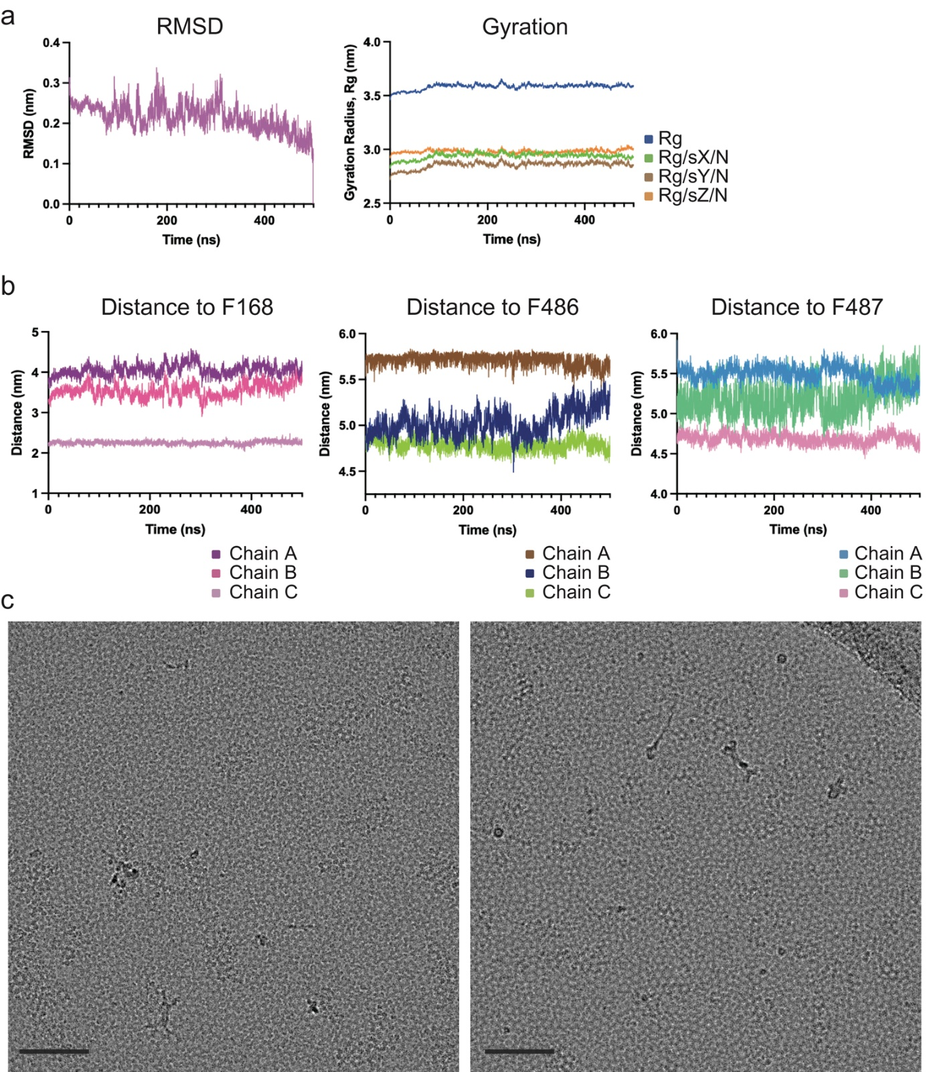
Extended Data Fig. 6 | Structural stability and functional validation of N-terminal helix insertion into the D13 base cavity. a, RMSD and radius of gyration (Rg) plots of the D13 trimer from a 500-ns molecular dynamics simulation, confirming structural stability over the simulation period. Rg values along X, Y, and Z axes were calculated for directional assessment. b, Mean distance profiles between the N-terminal α-helix and F168, F486, and F487 in each monomer (denoted by chains A, B and C). The helix remains stably positioned, particularly near F486. c, Cryo-electron micrographs of the F486A mutant showing disrupted assembly, displaying net-like aggregates instead of twister-like features of the wild type D13 assembly. Scale bar, 100 nm.

Extended Data Fig. 7 | Intertrimer interactions within the twister. Map-to-model overlays of three modes of interfaces in twister that exhibit good agreement between the molecular interactions and corresponding map densities. The Roman numerals in the panels are consistent with Fig. 3f-g. Cryo-EM densities are contoured at 4σ in mode I and II, and 5σ in mode III.

Extended Data Fig. 8 | Intertrimeric arrangements of the three modes of interface found in twister assembly. a-c, Superposition of D13 trimer structures in each mode with to previously reported D13 arrangements. Mode I (yellow), mode II (skyblue) and mode III (light pink) exhibit structural similarities with wildtype D13 doublet (PDB: 7VFG, green) asymmetric interface observed in tubular assembly (PDB: 7VFH, blue) and crystal packing (PDB: 6BEI, dark pink), respectively. d-f, Intertrimeric centroid distances and torsion angle in each interface mode. d, Head domains of neighboring trimers in mode I interface are spaced by 79.7 Å and base domains by 71.6 Å, resulting in a torsion angle of 8.3°. e, Mode II shows a similar distance between the head (79.0 Å) and base (72.7 Å) as in mode I, but with a higher torsional angle of 14.1°. f, In mode III interface, distance between the base domains is relatively higher (76.3 Å) with a strong torsion angle (23.4°) that give rise to the characteristic “twisted” morphology.
Extended Data Fig. 9 | Cryo-EM structure of the A17_{1–8}-bound D13 trimer. a, Superposition of the A17_{1–8}-bound D13 trimer structure (cyan) with the apo form (PDB: 7VFD, pink). The RMSD of 0.993 Å indicates no major conformational change occurs upon A17₁₋₈ binding. b, Cryo-EM map of the peptide-bound trimer showing additional density (pink) in a narrow surface groove of the head domain. Subunits are individually colored (yellow: head domain, blue and red: N- and C-terminal jelly roll domains), with the boxed region indicating the peptide-binding site. Unsharpened map is displayed for clarity. c, Zoomed-in view of the head groove showing peptide density surrounded by hydrophobic and polar residues. Density overlay is visualized on a hydrophobic surface rendering in the right panel.
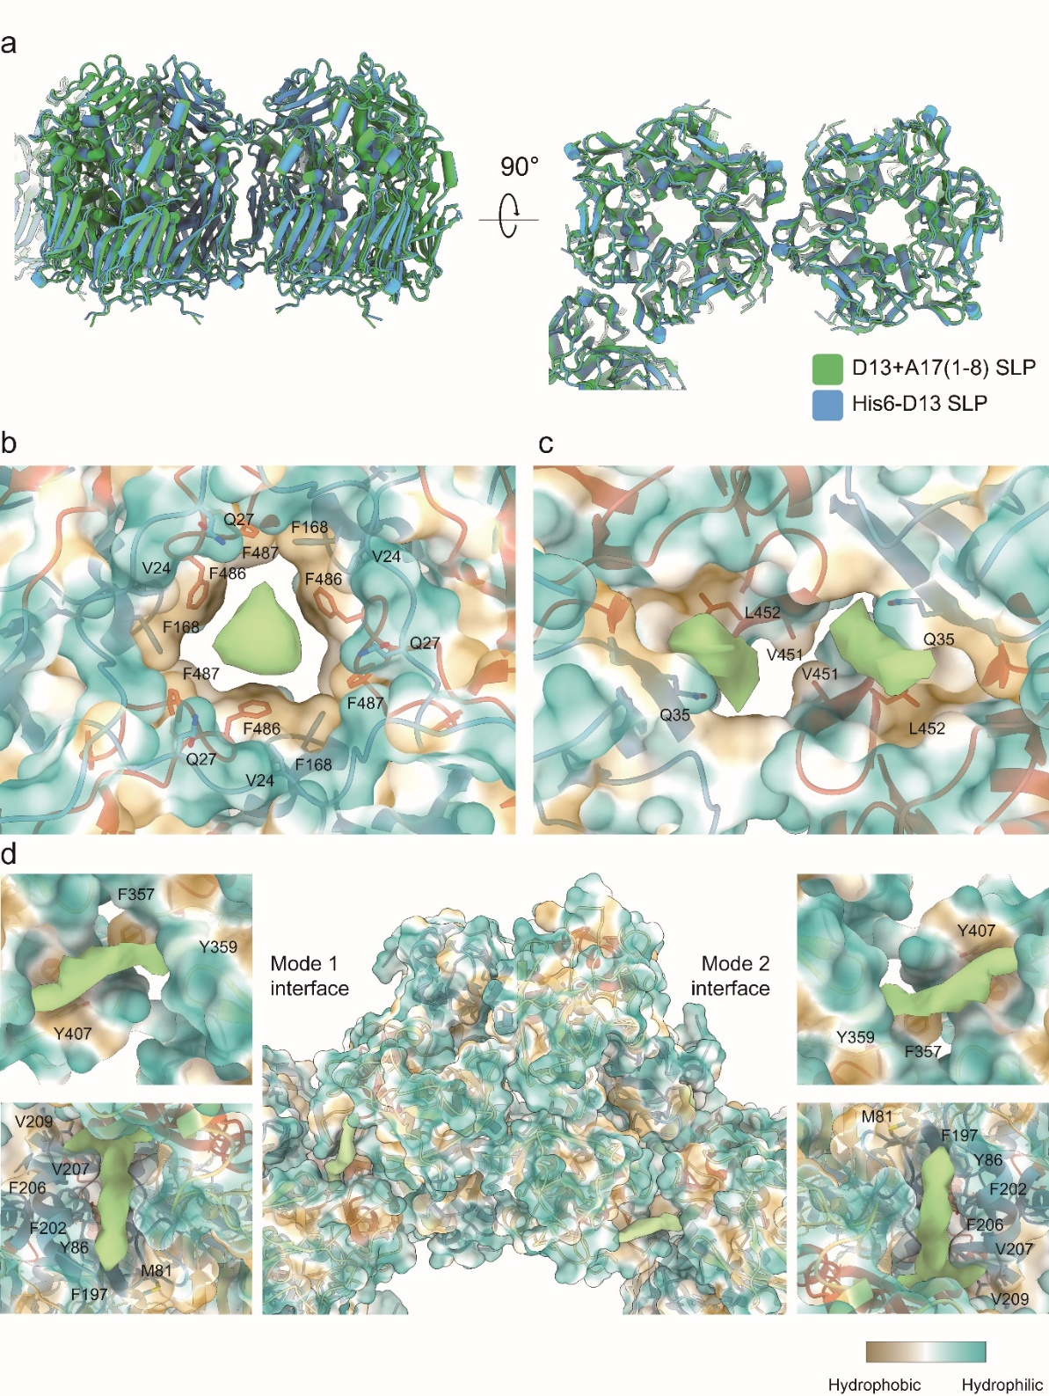
Extended Data Fig. 10 | Cryo-EM structure of the A17_{1–8}-bound D13 SLP. a, Structural comparison between A17_{1–8}-bound D13 SLP (green) and His₆-tagged D13 SLP (blue), showing an RMSD of 1.051 Å, indicating no major structural change. b-d, Additional densities observed at multiple locations. Surfaces are colored according to hydrophobicity, and nearby hydrophobic residues are shown as stick representations. b, A density observed within the central base cavity. c, A density within the hydrophobic pocket where N-terminal α-helix is bound in singular trimers. d, Densities located at intertrimeric interfaces of the head domains. These densities are located on either side of interacting trimers and surrounded by hydrophobic residues. Similar densities are observed at other symmetry-related interfaces.

