Supplementary figures

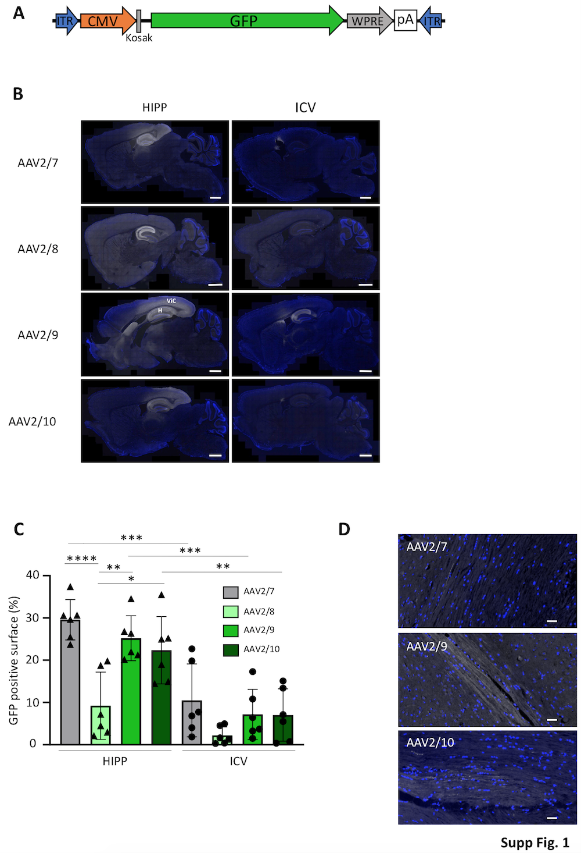

Supplementary figure 1: Selection of AAVs - (A) AAVs (2/7, 2/8, 2/9 and 2/10) encoding GFP under the control of a CMV promoter. (B) Immunodetection of GFP (white) and nuclei (blue) one month after hippocampal (HIPP) or intracerebroventricular (ICV) injection are shown on sagittal sections. H=hippocampus, ViC=visual cortex. Scale bars=1000 µm. (C) Quantification of GFP expression was done using ImageJ. (D) Immunodetection of GFP in the spinal cord GFP (white) and nuclei (blue) are shown. Scale bars=50 µm. For B and D, a slide scanner was used to to visualize the whole sagittal sections. *: p<0.05; **: p<0.01; ***: p<0.001; ****: p<0.0001.

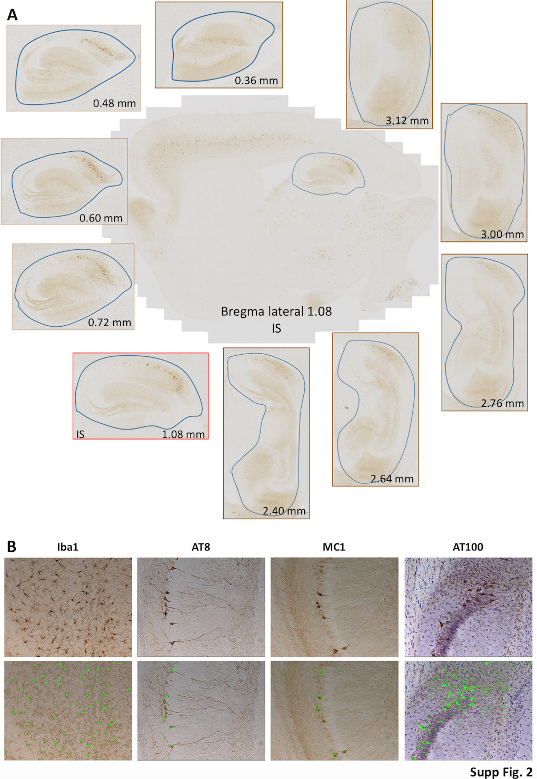

Supplementary figure 2: Set-up for the quantification of tau lesions- (A) For blinded quantification of Iba1, AT8, MC1 and AT100 immunoreactivities, the hippocampus from lateral bregma 0.36 to lateral bregma 3.12 (based on the Mouse Atlas, George Paxinos and Keith B.J. Franklin, Second Edition, Academic Press) was chosen as the quantification zone from sagittal brain sections. The injection site (IS) is shown at the center and the other bregmas are shown in periphery. Quantified areas are delimitated in blue. (B) A specific threshold was applied as shown in green (lower panel) for quantification using the Mercator software.

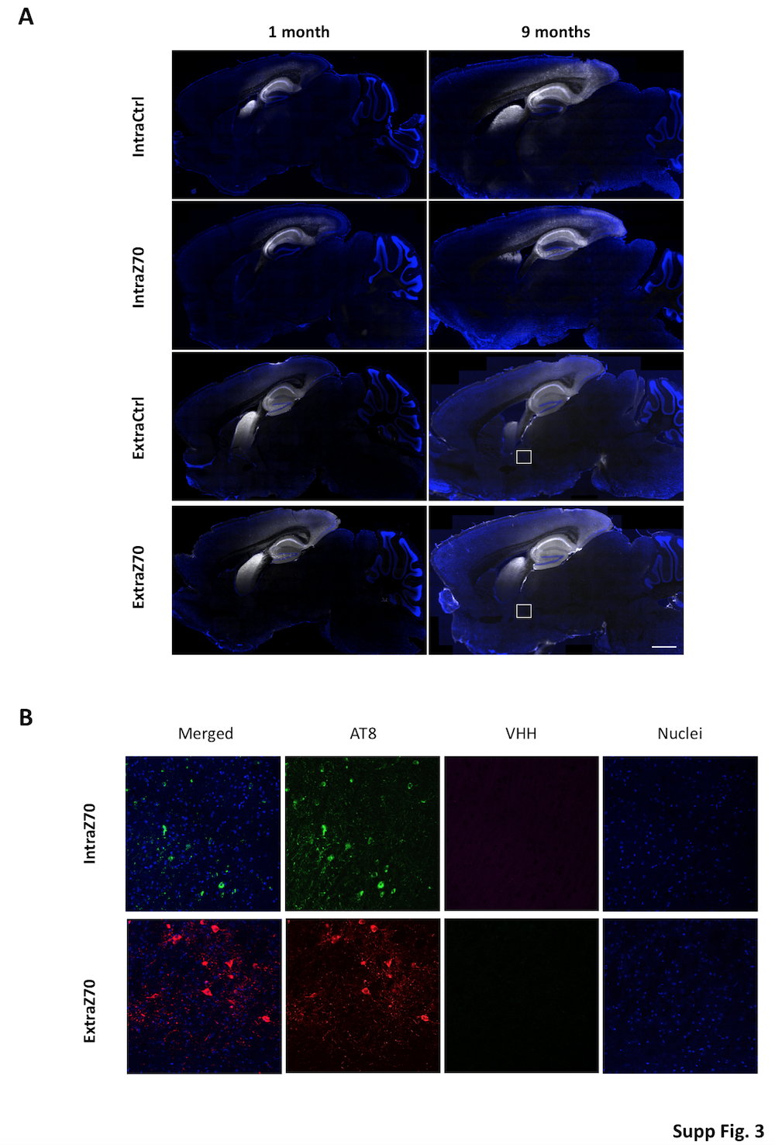

Supplementary figure 3: VHH expression- VHHs were injected in the hippocampus of Tg30 and the animals were sacrificed 1 or 9 months later. Immunodetections are shown on sagittal sections. (A) Intra- and extraVHH are visualized in gray and nuclei in blue. (B) Immunohistofluorescence were also done in the amygdala (white squares shown in C) to reveal phosphoTau (AT8, green) and VHH (purple), nuclei are visualized in blue. Mean intensity projections are shown. Scale bars are indicated in the figures.

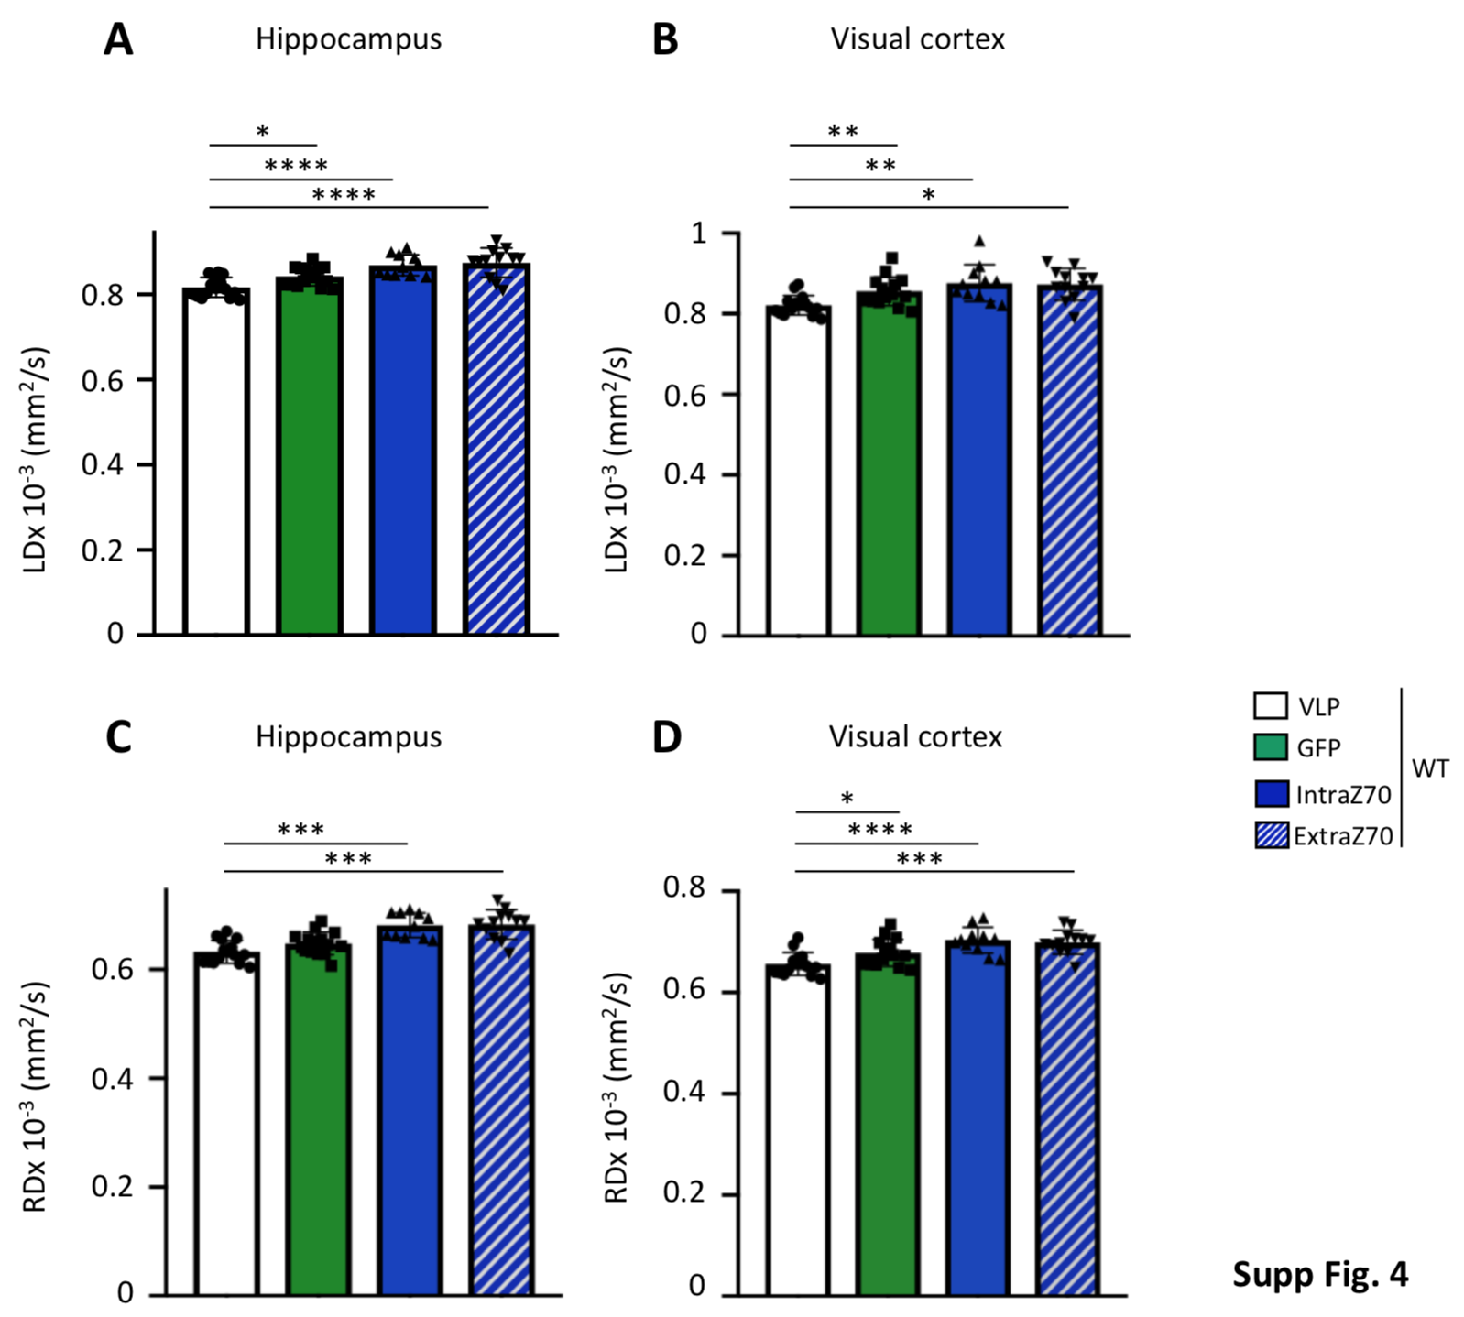

Supplementary figure 4: VHH Safety: 8 months post-injection of WT mice, MRI scans were used to determine DTI signals: LD (A, B), RD (C, D) in the hippocampus and in the amygdala. *: p<0.05; **: p<0.01; ***: p<0.001; ****: p<0.0001.

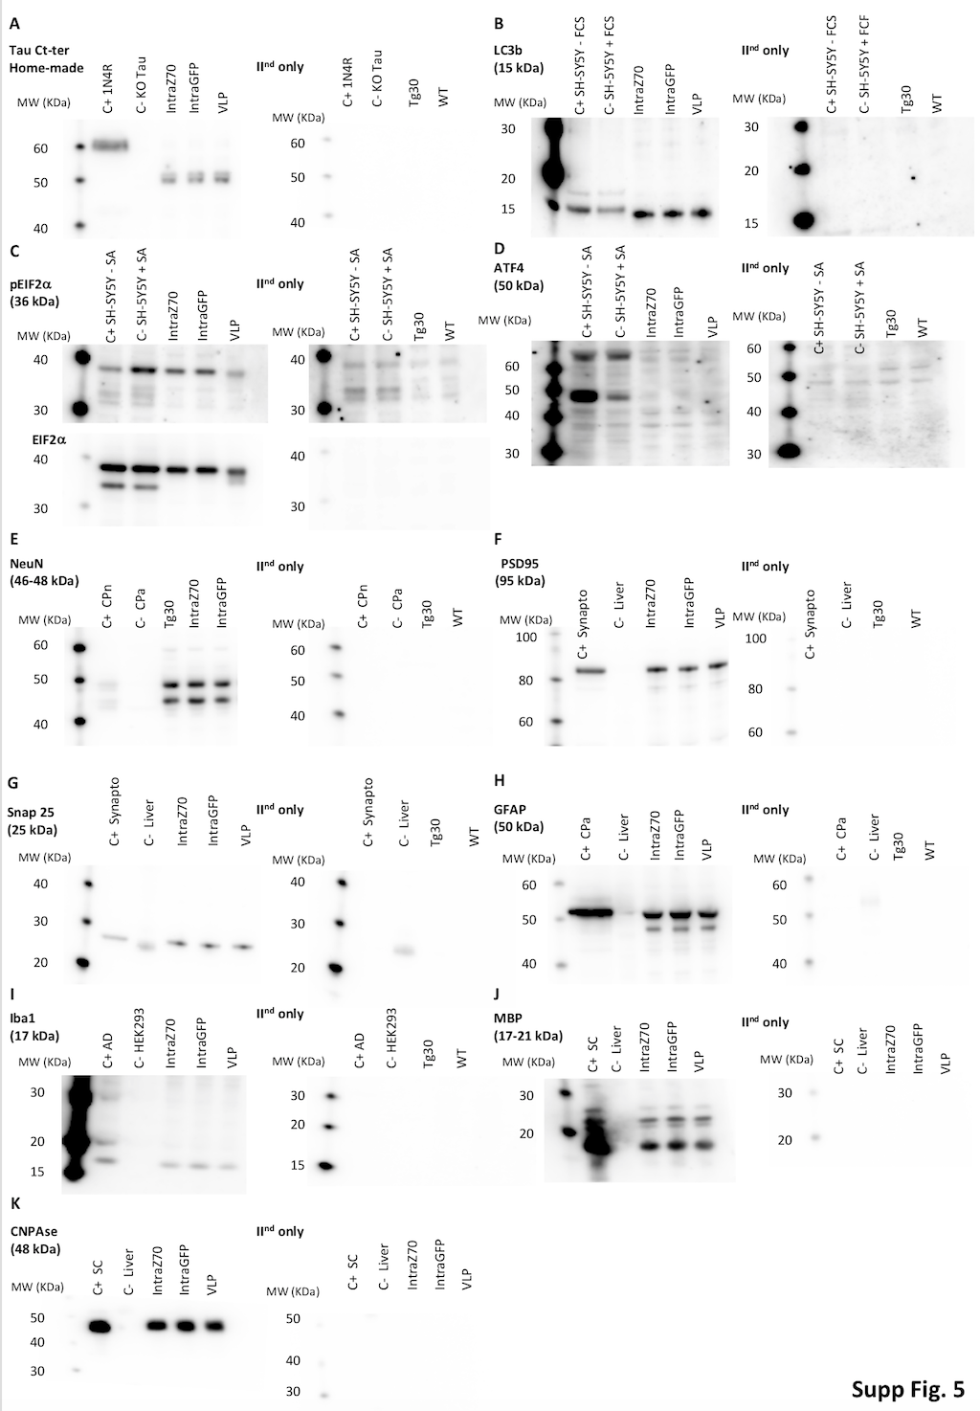

Supplementary figure 5: Antibody validation for the biochemical safety assay - Proteins were detected by SDS-PAGE using primary antibodies against TauCter (A), LC3b (B), pEIF2α and (C), ATF4 (D), NeuN (E), PSD95 (F), Snap25 (G), GFAP (H) or Iba1 (I) and detected with the appropriate secondary antibody (right panels) or secondary antibody alone (right panels). Antibody information is provided in Table 1. Positive (C+) and negative (C-) controls were used to validate the antibodies and two to three samples coming from the chronic model are shown to illustrate the quantification of Figure 4. 1N4R (HEK cell line overexpressing the 1N4R tau isoform) [78], KOTau (brain lysate of a tau knock-out mouse) [79], FCS (fetal calf serum), SA (sodium arsenate) [80], CPn (cortical primary neurons) [81], CPa (primary astrocytes) [82], Synapto (synaptosome fraction), Liver (mice liver lysate), AD (human brain lysate, Braak 6, frontal cortex).

